

BSc in Health and Social Care. Level 5
Children, Young People, and Families.
(BMHP5004_ LON.) Term 2.

Assignment Component 2.
Written Statement.
.
Childhood in the United Kingdom Compared to childhood in Ghana.

Elizabeth Owusu
Student Number: 1917244
Module: Children , Young People, and Families.
Code: BMHP_5004
Lecturer: Bianca Sanfilippo.

Date: 25/8/2021

Introduction.
The purpose of this essay is to discuss the significance of social construction of the childhood. It gives an overview of the changes in children from historical times to the present. It also includes the family as a socially constructed concept, as well as changes within families in the United Kingdom, compared to the children in Ghana. The feeling of being young is universal, it manifests itself in variety of ways that are influenced by cultural, political, economic, and personal circumstances.
From historic to contemporary times, the easy discusses the variables that have contributed to transforming the lives of children and eliminating inequalities, as well as the reasoning for how these factors improved children’s lives. It discusses contemporary efforts in the United Kingdom to help disadvantaged children, and how these can help to close the gap between children from the privileged and the disadvantage families. (Mathews, 2017).
.

Definition of a child.
According to the NPSCC, a child is a young person who is growing up in terms of social, emotional, physical, and cognitive development. A child is a person who is still developing at a vulnerable stage of life. Childhood is a social constructed concept. Childhood does not have a universal definition. It differs based on socioeconomic, sociological, religion, cultural

factors, and geographical impact. (UN, 2020).

Legally, biologically, and socially, the definition of a child varies. A child is defined as someone under the age of 18 according to the United Nations Convention on the Rights of the Child. (UNCRC, 2018). A child is also biologically defined as a person who lives from birth to puberty of 13years. Social policy defines a child as vulnerable and in need of protection. (Kahlil, 2013). (NSPCC,2015).

Biological Definition of a child
Heredity, genetics, environment, and the mothers’ health can all have an impact on an unborn child. The physical appearance of a child is influenced by the genetic make-up, DNA, and all the genes. A child’s experiences, such as his or her family home, country, or geographical region, all contribute to the aspect that shapes a child’s personality.

Background of a child.
The child’s immediate environment consists of his or her parents, relatives, and the community. The quality of the Environment and availability to services are social and economic contexts. The socioeconomic, class, racial, contextualizing social and political factors all contribute to the cultural context.
Families.
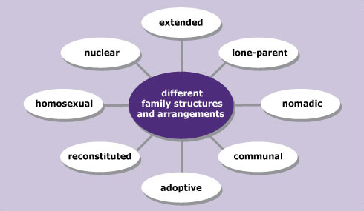
The main social group is the family, which is usually linked by kingship or marriage. The goals of family members are to offer social, emotional, and financial security to their members. The structure of family varies greatly.

By the turn of the century, 61 percent of children in the United Kingdom were living in typical households with married parents. The nuclear family paradigm continues to be the subject of public debate. Family developments in the twentieth century were conceptual, legal, and practical, with more lone parent families, there was a greater recognition and acceptance of family diversity. Divorce remarriage was more common.
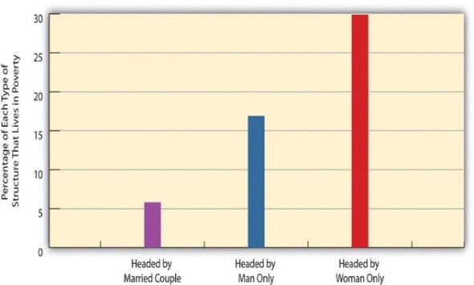
There are now more blended or constitutional families, mothers and fathers, and children who have half siblings and stepparents. (Clack, 2013). Grandparents and other relatives, some of whom live in the same house, make up extended families.
This Photo by Unknown Author is licensed under CC BY-SA-NC

.
Differences in the life of children in the UK compared to children in Ghana.

. 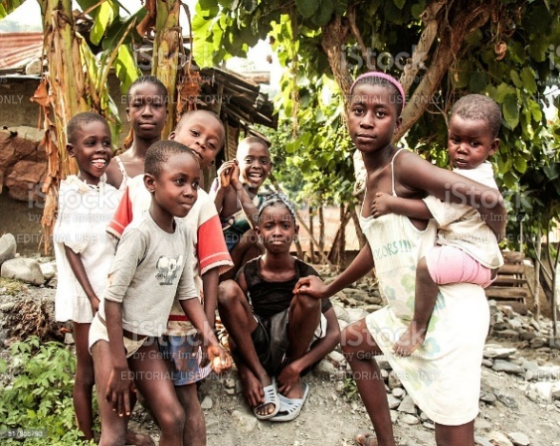 .
The Child
Young children playing in the park in the United Kingdom.
African kids playing around the house in small village Anyinatiase by the lake Bosumtwi in Ghana
Childhood in the UK compared to childhood in Ghana are not the same. They vary in different ways, politically, geographically financially, culturally, beliefs, ethically and in different forms of challenges. Many children are expected to be helpers of catering and helping with the family burden in Ghana.

Births are recorded in the United Kingdom, and the date of birth is an important part of a person’s personal and legal identification, however this is not the case in some part of Ghana. In many places, social experiences like work, migration, or marriage, as well as physical indicators, like height, facial hair, menstruation, may be more essential than age in determining significant adult status than age.
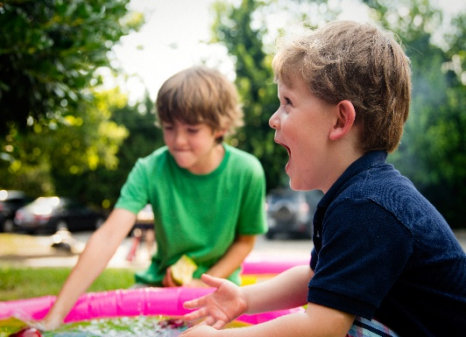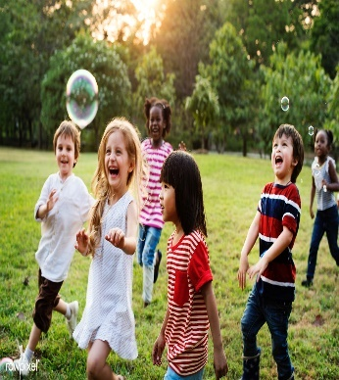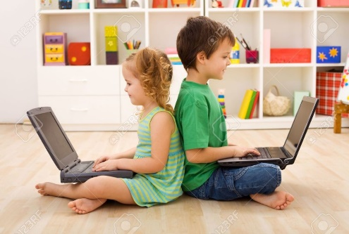
lperson-people-play-boy-kid-child-playing-family-happy-toddler-143516.jpg (5168×3448) (pxhere.com)sed under CC BY-SA-NC
person-people-play-boy-kid-child-playing-family-happy-toddler-143516.jpg (5168×3448) (pxhere.com). Children play and exploitation in the UK.
Every Child Matters Act of 2003 has been replaced by the safeguarding Act of 2014, updated, 2019, which aims to protect the health and well-being of all children. (NSPCC, 2018).

Child labour, child marriage, FGM (female genital mutation), child prostitution, and child labour are all examples of childhood experiences that differ between the two countries. Child labour is still practiced in most part of Ghana. In contrast to England, where school attendance is required until the age of 16, The recent president of Ghana made it feasible for every child to get free basic education. (UK. GOV, 2021). (BBC News, 2018).
The UK government expect children to be in education or training until 18 years old. (Gov.UK.,2021). In Ghana there is no welfare in support of children, Children are simply left to the parents of the extended family. (Unicef, 2018).
.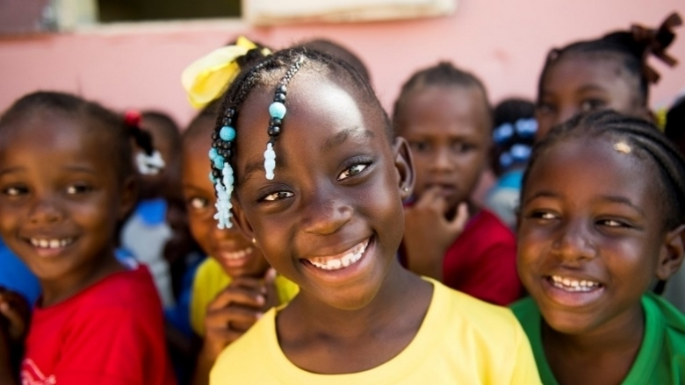
Children in Ghana have a long history of being ridiculed, humiliated, abused, and subjected to mental torment. Countless street children who are illiterate, beg on the streets, or work as child labourers to support their families or themselves. (Savage, 2010).
Children in Ghana are expected to obey elders and follow instruction, such as respect for the elderly, assist and help parents in most daily financial endings and house activities. The societal understanding of promoting the image of the family. Children are ignored their interest to the extent of preventing their education. In previous times before the 20th century, children were given away to pay debt or to serve for years to honour those debts, depending on the negotiation. Now due to economic changes and western influence, more families have now adapted to the nuclear family system and smaller family system (AfricaWeb, 2021).
Estimated 90,000 street children are in the capital Accra only. (Local NGO, 2014). According to Twum- Danso (2012), if a child does not respect his or her parents, they lose their school fees and basic needs. (Ghana, 2020). Many schools use outdated curriculum. (NGO, 2014)).
C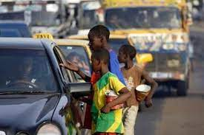 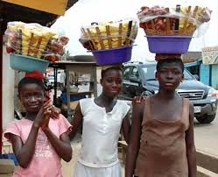.
Children are viewed as a form of insurance. The children are subjected to a great deal of stress. They are viewed as a blessing and an opportunity to fulfil the family’s aspirations and desires. Due to the immense strain, they are under, most children yearn to be adults. Children have been left to fend for themselves in every way they can. (Anon., 2020).
Fortes wrote about it in 1957, how children are initiated in cultural and traditional practices and duties, especially in the northern part of Ghana, that are seen as child labour or abuse in the UK or the Western world. (Savage, 2010).
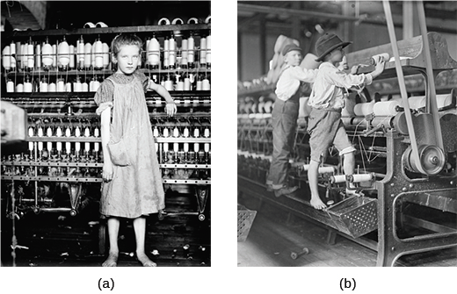
Childhood has shifted in meaning and perspective. Children had no legal rights in the 16th, 17th, 18th, and the 19th centuries, and were completely reliant on their parents, with some being forced to work as labourers. By the 18th century, children were only influenced by their families. In ancient Greece and Rome, life expectancy was only 30 years. .
This Photo by Unknown Author is licensed under CC BY-SA-NC
The concept of childhood did not exist, until the mid- eighteenth century. According to Oliver and Pitman, Aries explored the concept of childhood and claims that babies
and infants should be cared for of
biological needs, but once they were able to look after themselves, they were treated as adults (2011). Parents did not risk the emotional trauma that comes with infants and dying, so were emotionally neutral.
Between 2013 and 2019, spending on parents first born climbed by 20%, in comparison to the past. Fathers now spend seven times as much time with their children.
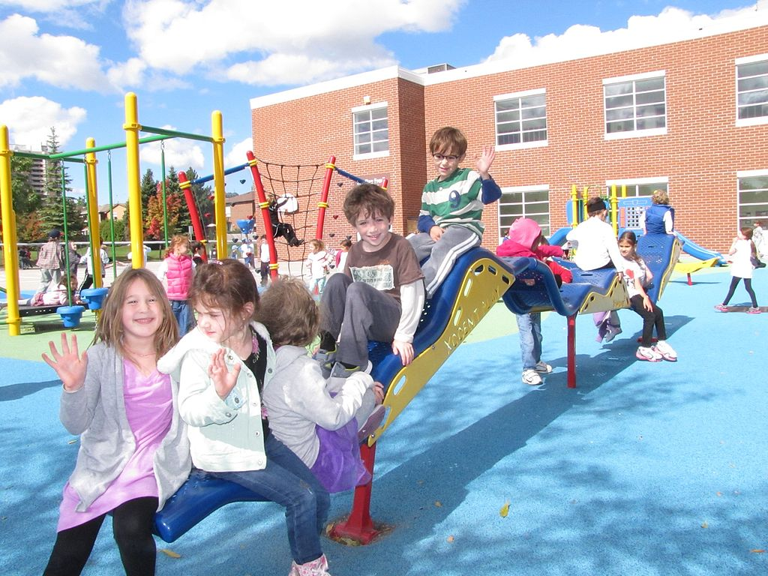
This Photo by Unknown Author is licensed under CC BY-SA
28106473313_004ddd6d8d_b.jpg (1024×1024) (staticflickr.com).
Now days children have the right to be heard. To ensure that children are always secure and cared for, social mechanisms are put in place. This age is now a child- centred civilization, with playgrounds, stores, toys, supermarkets, and even children’s trolleys. The focus is now entirely on youngsters.

History of childhood.
The welfare of the child was linked to the welfare of the family, with little consideration given to the possibility of family conflict. (Boyden, 2015). Physical perfection was prized in ancient Greek and Roman times. The infant mortality rate was so high that undesired babies, many of whom were female, were abandoned to die in the open. Children under the age of seven, primarily females, lived at home with their mothers until they were fifteen, helping with domestic chores and caring for younger siblings.
Boys were encouraged to study trades like builders, coppersmiths, and land work and rarely married before the age of thirty. From the age of seven, wealthy boys were educated and encouraged to perform music, draw, and participate in sports. (Wright 201).

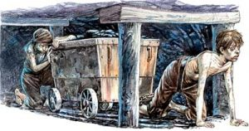
Children in child labour the Industrialization periods.
This Photo by Unknown Author is licensed under CC BY-SA-NC
When factories and mills needed workers during the industrial revolution (1760-130), they hired youngsters, especially small and delicate children who could readily travel between machines for cleaning. Child labour was cheap, and their little fingers made chores like tying in threats simple. Children were frequently chastised, punished and made to work long hours.
During the Victorian era (137-1901), Britain grew, and the gap between rich and poor widened. Society became more aware of children’s needs and contributions, and the upper and middle classes lived in a safe environment aided by nurses. Lower-class youngsters were severely exploited, with some becoming pickpockets and scavengers after working in factories or as chimney sweeps.
To alleviate poverty and establish limits on age, work hours, and education, health policies and legislation were enacted. The introduction of compulsory education followed. The treaty’s goal was to safeguard and nurture childhood rather than to promote equality for children and adults. (Boyden, 2015).
The Right of children. The United Nation Right of the Child
Through the nineteenth century, labour regulations, increasing attention to education, and other developments rarely mentioned rights, but they certainly began to lay the way for the

official debate of rights. (Steams, 2016)..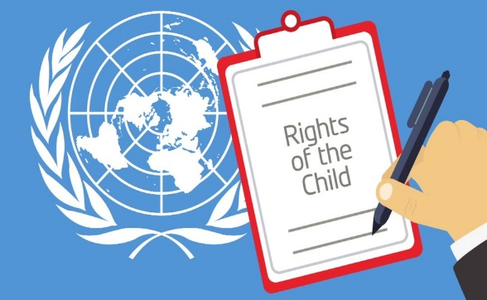
. https://www.google.com/search?rlz=1C1CHBF_en-+

The Rights of the child is the foundation of all UNICEF activities. The child has the right to be heard. (UN, 2020) It is the most comprehensive statement of children’s right ever written, as well as the most generally ratified international human rights
The Geneva Declaration on the rights of the Child (1924) emphasized the importance of providing special attention to children. (UN, 2020). This position began to change in the 18th century, with a shift in children’s actual conditions including the impact of factory labour. (Steams, 2016). Childhood was not a topic in the past, neither childhood development was a concern. The present era, the twenty- first century, is increasingly child-centred, with 90 percent of our revenue spent on children.
.
Child development.
Child development and neurology, as a discipline that studies children, were significant contributions in improving children’s lives. As a result, a child development and neuroscience emphasize the need of providing a stimulating environment and pleasant experiences for all children to support their health and well-being.
The emergence of child development and Neuroscience.
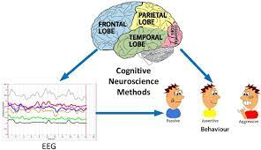.
The neuroscience believes that the external factors help to shape an individual, this perspective, instead, believes that the internal aspect of an individual are far more important to their actions. The neuroscience has now made them clear, how child development is crucial and that childhood experiences affects lifelong health and learning. (Oxford, 2019). Eric Erikson, John Watson, Jean Piaget, and John Bronfenbrenner, all place a strong emphasis on a child’s overall growth and developmental stage.

Theory of development.

.
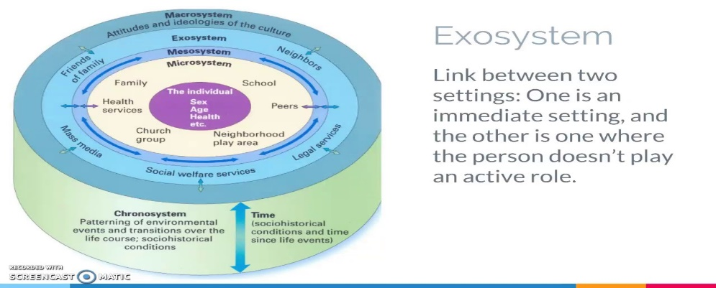

Factors that affect child development. (See the appendix.)

Early childhood development is being redefined by neuroscience, with scientific research indicating that ninety percent of a child’s brain development occurs in the first five years of life. Changes in ideas, feelings, behaviours, and abilities are all part of the experiencing process.
.

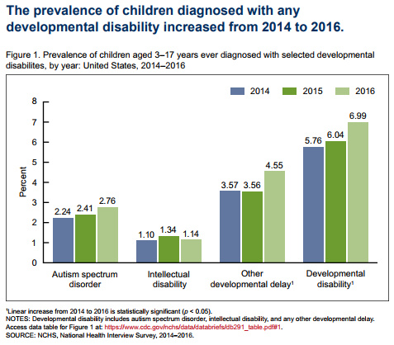
This Photo by Unknown Author is licensed under CC BY
Sociological factors
The social determinants of health, according to research, are gouped. The social and economially challenged families, children living in poverty, and those living in poor and over crowded housing are among the CYP within these clusters that require extra attention. (Raman, 2020).
Children are now seen as active social actors with their own demands and concerns, according to childhood sociology. Children are viewed as potential citizen workers in social involvementinitiatives, and tailored support is specially geared to fulfil their requirements.
Children and their families rely extensively on welfare services for their current and future well-being, in education, social services, and social assistance. Policies play an important part in their lives. (Unicef, 2019).

Policy and Legislation
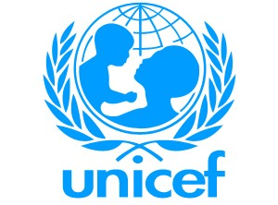
Accoding to Unicef, a child has the right to protection and parental direction. The government must secure the survival and and prosperity of the country. Every child should have a sence of self and be protected. Parents have a claim to their children.
https://www.savethechildren.org.uk/what-we-do/childrens-rights/
education-919895_960_720.jpg (960×649) (pixabay.com).
Reunification of families is promoted. Children should not be abducted, sold, or sold illegally out of their nation for any sort of abduction, protitution, or ponography. The right to privicy. Protection from violence and parental share of responsibility. Children have the right to special care for by those who respect their ethinic group, according to Article 20. (Unicef, 2019).

Systems that influence the child.
Bronfenbrenner’s ecological theory was prominent in saying that a child’s growth was influenced by a variety of Environmental circumstances. Macrosystem, Ecosystem, Mesosystem Micro system, and the Child.

See Appendix.

Maslow’s Hierarchy of Needs.

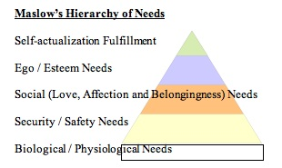
Another key idea affecting services for families and children was Maslow’s theory. According to Marslow, in other to realize full potential, a human being must have all of his or her previous needs met in a hierachical order. Food , water, and toilet are examples of psychological requirements. Needs of safety, shelter. And protective relationships that makes us feel secure. (BBC, 2019).
This Photo by Unknown Author is licensed under CC BY-SA-NC

Provisions for Interventions.
Current initiatives and techniques have been established to assist children and families as targeted interventions, such as universal services such as G’s, schools, NHS., Free school meals and Children at Risk Services. (Anon., 2018).

Adoption and fostering.
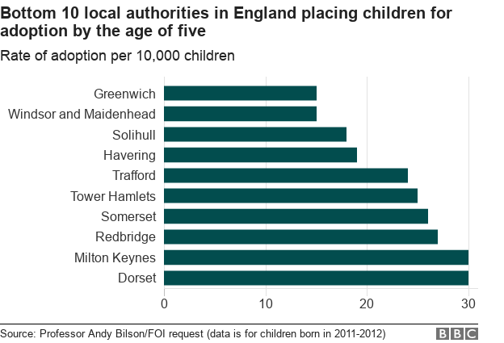
ON March 31st, 20020, an estimated 57, 380 children were living with foster families. This represents 72 percent of the 80,080 children in foster care who are not living with their families. In England, there are 444,500 foster homes.

Conclusion.
Summarizing, while children’s lives have changed and improved, many children in the United Kingdom continue to live in poverty. 2.8 million children live in poverty according to the Rowntree Freedom Foundation. (2021). With rising levels of income inequality, in England and Europe, housing, neighbourhood, and household economic strains have gotten worse. Both income disparity and housing stress are highly and positively associated with child injury death rates.

References.

AfricaWeb, H. g., 2021. ghanaweb children in GHana. [Online]
Available at: https://www.google.com/search?q=ghanaweb+children+in+GHana&rlz=1C1CHBF_en-GBGB907GB908&ei=oA0mYazWCpqpgAaurofoAw&oq=ghanaweb+children+in+GHana&gs_
[Accessed 25 August 2021].
Alhansiou, T., 2019. Global inequality in the time of climate emergency. Inequality.org, 10 June.
Anon., 2018. SOS Children,s village. International General Information.
Anon., 2020. pefhed.org. [Online]
Available at: https://www.pefhed.org/fighting-extreme-poverty-in-ghana/
[Accessed 27 August 2021].
BBC, 2019. Child in Poverty in the UK. BBCNews, 5 9.
Boyden, J., 2015. Chilhood and Policy makers. A comparactive perspective on the gloalisation of childhood201. In: T. a. F. Group, ed. Constructing and reconstructing childhood. 1 ed. s.l.:Routledge, p. 35.
Brotherly, 2020.
Ghana, N., 2020. African kids - Ghana. [Online]
Available at: https://www.pefhed.org/education-and-conflict-in-ghana/
[Accessed 25 August 2021].
guadian, T., 2019. Child Mental Health, London: The guarding.
Mathews, B. a. C.-V. D., 2017. ‘Child Sexual Abuse: Toward a Conceptual Model and Definition’, Trauma, Violence, & Abuse.. Children Haelth Research Program, 2 November, 20(2), pp. 131-1448.
Oxford, U. o., 2019. Early childhood development. Young Lives.
Raman, S. H. M. N. R. K. R. S., 2020. Where do we go from here? A child rights-based response to COVID-19. International Society for Social Pediatrics & Child Health (ISSOP) , 15 June.4(1).
Savage, J., 2010. [Online]
Available at: https://juskosave.blogspot.com/2010/04/preventing-street-child-explosion-in.html
[Accessed 23 August 2021].
Steams, P., 2016. Handbook of children's Right. 1 ed. New York, London: Taylor and Francis Group.
UN, 2020. Children and young children. Convention on the Rights of the Child, Volume 53.
Unicef, 2018. Young Carers. [Online]
Available at: https://www.youtube.com/watch?v=7aF8cHCkiXo
[Accessed 10 August 2021].
Unicef, 2019. Convention on Human right. United Nation Convention.

Theoretical approach | Principles of the theory | Theorist.
Maturation | The stages and sequence of growth and development are well-defined. Rate and maturation are affected by individual genetic and time. | (Gesell,1880-1961).
Psychodynamic | Unconscious desires control one’s behaviour, Id, Ego and Super ego are the three aspects of the mind. | (Freud, 1856-1939).
Psychological | Throughout one’s lifespan, one’s personality evolves through eight stages. Interactions with family, friends, and culture all have an impact on development. | (Piaget, 1896-1950).  (Vygotsky, 1896-1934).
Cognitive | Children’s thinking has changed qualitatively. The child is regarded as a self- directed learner who progresses through phases. | (Erikson, 1902-1934)
Behaviourist | Learning is a lifelong process. The process of development is made up of a series of conditional behaviours. It focuses on the environment rather than ancestry. Observable behaviour is regarded as crucial. | (Watson, 1878-1958) (Skinner, 1904-1990).
Ecological | Nature’s equilibrium. The child is positioned at the centre of a ring of concentric elements that influence him or her. It emphasizes and places both the surroundings and the history of the family. | (Bronfenbrenner, 1917-2005)
Information processing theory | Children are born with specialized information processing abilities that allows them to figure out developmental structure. | Naomi Chorusky, 1928.
.

Developmental factors.
Hereditary |  | Congenital | Environmental
Health of the mother |  | Infections | Lifestyle
Genetics |  | Diet | Influential people/parent. Teachers, siblings, parents
Intelligence |  | Family trait | Relationships

Bronfenbrenner’s of Ecological theory.
Health services, residents, extended family, friends, and mates make up the ecosystem.
The Laws, regulations, policies, and ideas that control society are referred to as the macrosystem, e.g., cultural norms, educational policy, and educational methods.

Exo
The Microsystem is the child. Sociocultural structures that are closed to the child. (e.g., school. Family, church
The mesosystem is comprised of the family, nursery, school and teachers, and playground, as well as their interactions

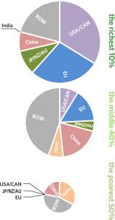 (Alhansiou, 2019).
This Photo by Unknown Author is licensed under CC BY-SA

