

A Solution of Job Shop Scheduling Problems
Based on Improved Genetic Algorithms

by
Zeyi Wan

Supervisor: Michael Dacey

November 2020

DECLARATION

I, ............Zeyi Wan……… declare that I am the sole author of this Project; that all references cited have been consulted; that I have conducted all work of which this is a record, and that the finished work lies within the prescribed word limits.

This work has not previously been accepted as part of any other degree submission.

Signed : ....................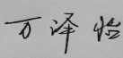.........................

Date : ...........20/11/2020................

FORM OF CONSENT

I ___________ Zeyi Wan __________ hereby consent that my Project, submitted in candidature for the M.Sc. Software Engineering (Web Development), if successful, may be made available for inter-library loan or photocopying (subject to the law of copyright), and that the title and abstract may be made available to outside organisations.

Signed _____________ __

Date __________20/11/2020_________

ABSTRACT

The workshop scheduling problem is one of the core problems in manufacturing informatization and automation, which can be defined as "how to allocate tasks to meet or optimize targets under limited resources and time constraints". Shop floor scheduling is critical to improving productivity, production flexibility, reliability, and agility of large, complex manufacturing systems. A good scheduling solution should result in significant reductions in processing costs, increased productivity, and reduced work-in-process inventory, thereby increasing a company's competitiveness. With the increasing globalization of manufacturing and the need for individualization of orders, the trend of small-lot and multiple-batch product orders is becoming more and more obvious, which requires companies to improve their production scheduling flexibility. Therefore, this project solves the shop floor job scheduling problem based on an improved genetic algorithm, and the work done in this project includes.
1) Review and refer to the literature, abstract the constraints in the problem and build a model based on the JSP problem.
2) Starting from the existing job scheduling problems, learn about the applications and limitations of Genetic Algorithm (GA) in the field of job scheduling by understanding and learning about GA, improve the deficiencies of GA such as precocity and slow convergence speed, and realize adaptive adjustment of GA operators.
(3) Conduct comparative tests. The convergence curve and the Gantt chart of job scheduling are obtained by using the traditional genetic algorithm and the improved genetic algorithm respectively to solve the job scheduling problem in the workshop, and the experimental results are compared and analyzed to verify the advancedity of the improved algorithm.

CONTENTS PAGE
1 Introduction 1
1.1 Background of Research 1
1.2 Scheduling Problems 2
1.2.1 Background of Scheduling Problems 2
1.2.2 Job Shop Scheduling Problems 3
1.3 Genetic Algorithm 4
1.4 Aim and Objectives 6
1.4.1 Aim 6
1.4.2 Objectives 7
1.5 Research Methodology 8
1.6 Report Structure 9
2 Literature Review 11
3 Design and Implementation of a Solution to Job Shop Scheduling Problems 15
3.1 Modeling of Job Shop Scheduling Problems 15
3.1.1 Scheduling Problems Description 15
3.1.2 JSP Modeling 15
3.2 Improvements to Genetic Algorithms 17
3.2.1 Encoding & Decoding Method 17
3.2.2 Adaptive and Design of Selection Operational 19
3.2.3 Adaptive and Design of Crossover Operation 21
3.2.4 Adaptive and Design of Mutation Operation 25
3.3 Process of Improving GA Algorithms 29
4 Simulation and Analysis of Improved Genetic Algorithms 31
4.1 Traditional Genetic Algorithm Example Testing 31
4.2 Improved Genetic Algorithm Example Testing 33
5 Conclusions and Reflection 35
5.1 Conclusions of this Project 35
5.2 Reflection 35

REFERENCES……………………………………………………………………37

1 Introduction

Background of Research
The manufacturing industry, as an important pillar of the national economy and the real economy, is the foundation of the country and a prerequisite for strengthening national power. When the manufacturing industry has just started to develop, due to the large number and small variety of products ordered and the simple production mode, only a small number of employees are required to perform manual scheduling based on their previous production experience for scheduling problems, and the scheduling results obtained are basically in line with expectations. Therefore, manual scheduling was one of the important measures to improve production efficiency and reduce production costs^{[1]}.

However, with the development of network globalization, the traditional factory production model can no longer meet the growing needs of today's society due to the isolation of production information, and simply increasing manpower cannot effectively solve the capacity problem. In addition, the traditional manual scheduling based on experience is no longer applicable, which poses a great challenge to the workshop operation scheduling ability. Under such circumstances, intelligent optimization of workshop operation scheduling becomes the most important issue for the whole enterprise and even the society. Reasonable job scheduling can greatly shorten the maximum order completion time, optimize equipment and machine tool utilization, and effectively reduce production costs while meeting various constraints.

Due to the important position of manufacturing industry in the national economy, the production scheduling problem in manufacturing industry has attracted extensive attention from academic circles. Because of the development of the manufacturing industry and the differences in production modes between factories, the production scheduling problem has gradually been extended to various sub-problems, and a general algorithm applicable to most of the scheduling problems has not been developed yet, therefore, the study of job scheduling issues is of great practical significance for improving the production management level of manufacturing enterprises^{[2]}.

Scheduling Problems

Background of Scheduling Problems
Scheduling problem is one of the important aspects of informationization and automation in the manufacturing industry, which is generally defined as "how to rationally allocate limited resources and time to complete production tasks in order to meet or optimize one or more objectives"^{[3][4]}. Rational scheduling is critical to improving the productivity, flexibility, and reliability of large-scale, complex manufacturing systems. A good scheduling solution not only shortens the maximum completion time as much as possible, but also reduces production cost, improves production efficiency and reduces work-in-process inventory, thus improving the competitiveness of an enterprise in the industry. With the continuous development of economic globalization and the demand for individualization in manufacturing industry, product orders are shifting to the direction of small-lot, multiple-batch, and multi-category, which makes automated scheduling more important^{[5]}.

Shop floor scheduling also has many subcategories and corresponding solution methods due to different production environments and equipment. The JSPs (Job Shop Scheduling Problems) is the problems of assigning machines and processing periods to workpieces that are being processed for a substitute and is a discrete job scheduling problem. Although the job scheduling problem has been studied for decades, no solution algorithm has been developed to obtain an exact solution. In recent years, in order to obtain a satisfactory solution in an acceptable time, researchers have invested a great deal of research in meta-heuristic algorithms that simulate nature, such as genetic algorithms that mimic the evolution of biological reproduction^{[6][7]}, particle swarm algorithms that simulate the motion of particles^{[8][9]}, ant swarm algorithms that simulate the ant pathfinding problem^{[10]}, simulated annealing formulas and conditions^{[11]}, taboo-based table to avoid repetitive search of contraindicated search algorithms^{[12] [13]} and so on. These algorithms are gaining more and more attention in the study of manufacturing system scheduling problems due to their advantages such as fast running speed, short solution time, and more satisfactory solutions^{[14][15]}. Heuristic algorithms are able to overcome the fatal flaws possessed by traditional exact algorithms and provide a major advancement in the practical production application of scheduling solutions^{[16][17]}.

In order to facilitate theoretical research, traditional JSPs have simplified the model building, such as ignoring the transport time of the workpiece between different devices and the absence of device failure. Although these simplifications are not conducive to solving real-world problems, they retain the most basic and important parts of job scheduling problems, and are highly scalable and typical, so JSP is chosen as the focus of this paper.

1.2.2 Job Shop Scheduling Problems
JSP(Job Shop Scheduling Problems) are a typical class of NP-complete problems for which there is no efficient algorithm that can solve optimally in the polynomial range^{[18]}. Rational production scheduling not only significantly increases the utilization of manpower, materials and equipment, but also improves plant efficiency and reduces production costs, therefore, the study of JSP issues is of great practical significance^{[16]}.

The job shop scheduling problem usually contains the following necessary factors such as the minimum number of workpieces, number of machines and machining time, etc. Also different constraints need to be designed according to different job shop scheduling problems, and finally the objective function is used to determine the adaptation of the scheduling output, i.e., how good or bad the result is. This kind of production scheduling problem can be generally described as^{[19]}: for decomposable operations to be processed, how to rationally allocate the processing time, production resources, and process sequence occupied by all process operations, provided that a series of constraints are met, so that the production demands of the plant can be met to the greatest extent, such as minimizing the maximum completion time, minimizing the production and processing costs, minimizing the maximum equipment load, and so on. The definition and mathematical modeling of the JSP model will be given in subsequent sections.

Genetic Algorithm
Genetic Algorithm (GA) was first introduced by John Holland in the early 1970s. Genetic algorithms were initially used to solve nonlinear problems, and John presented the first application of genetic algorithms in his book, "Applications in Natural and Artificial Systems"^{[7]}. The genetic algorithm draws on the concept of genetic evolution in biology, a model of an algorithm that can evolve by recombining information and passing it on to the next generation. This heuristic search has been shown to be effective in a wide range of applications by using finite parameters that interact in a complex and nonlinear manner.

The genetic algorithm is a stochastic search algorithm that draws on natural selection and natural genetic mechanisms in biology^{[20]}, and its basic idea is to simulate natural biological genetic mechanisms and Darwinian evolutionary theory of material selection to form a process search for optimal solutions^{[21]}, compared to traditional manual scheduling of tasks based on experience, the genetic algorithm only needs to influence the adaptation of the search direction in the overall search and optimization of the search functions and objective functions are sufficient, providing a general framework for solving complex problems that is not dependent on the specific domain of the problem, is highly robust to the type of problem, and is not susceptible to local optimal solutions when solving. The genetic algorithm operation process is roughly divided into several parts:
1) coding and initializing the population;
2) adaptation assessment;
3) population selection and replication;
4) population crossover;
5) population variation;
6) decoding and outputting the result.
The flow chart is as shown in figure1.1.

The crossover operation is the main genetic operation, which not only enables the offspring to inherit the excellent genes of the parent, but also helps to realize population change, which can enhance the possibility of the algorithm to jump out of the local optimum and realize the search for the global optimum solution; the probability of variation is often very low, and the default value of the parameter is generally small, which mainly realizes the diversity of population genes to better adapt to the environment.

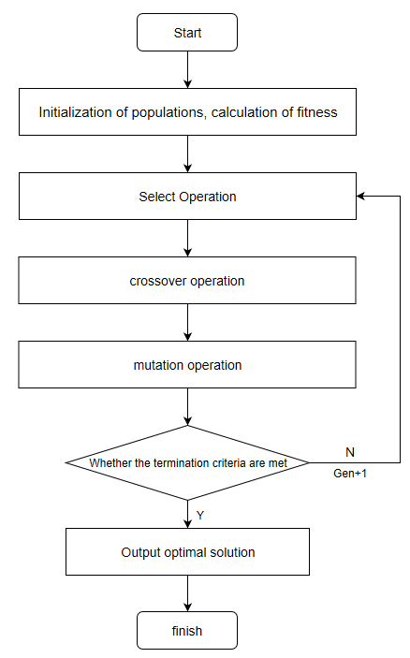
Compared with the traditional optimization algorithm, genetic algorithm firstly encodes the problem parameter as "chromosome" and then operates on it, but does not support the direct substitution into the problem solution space, which can make the genetic algorithm have no derivation and function continuity constraints to some extent. Then the genetic operations in the genetic algorithm are all random operations, and the search is performed according to the adaptation function of an individual, so no other information is needed; finally, the genetic algorithm has global search capability, which is applicable to complex and nonlinear problems. Therefore, genetic algorithms are widely used in solving production scheduling problems, robotics, image processing and other problems. However, the genetic algorithm itself has shortcomings such as precocity and tendency to converge to local optimum in the search process, which limits its further use, so this paper will solve JSP by improving the traditional genetic algorithm.

Figure 1.1 Flowchart of genetic algorithms

1.4 Aim and Objectives

Aim
For classical NP-hard problems like JSP, genetic algorithms are widely used in the JSP domain because of their simple process, random strong scalability, strong robustness and fast global search capability, which can get approximate optimal solutions in a short time. However, the traditional genetic algorithm also has its shortcomings. According to the previous studies on traditional genetic algorithms, cross-variation operation is the core part of genetic algorithm, but since the crossover and mutation probability parameter is a fixed value, it may lead to slow convergence or easy convergence to local optimal solution, which will make the job scheduling plan ineffective or not suitable for practical application. The model can be improved to achieve adaptive optimization of each parameter as the algorithm converges, speed up the convergence speed, and jump out of the local optimal convergence to the global optimal solution, which ultimately enables the model to generate a realistic and productivity-enhancing job scheduling plan. Therefore, the aim of this project is to establish a job shop scheduling model based on an improved genetic algorithm, which will be able to efficiently schedule job shop works and achieve an optimal or near-optimal solution for the maximum completion time when applied in actual production. Finally, another aim of this project is to be able to output a Gantt chart of job scheduling and to visualize the results.

1.4.2 Objectives
In order to achieve the above-mentioned aim, the following objectives will be undertaken.
- Model the project based on the JSP problem model, extract the constraint function, and give the objective function.

- To research and analyze the shortcomings of traditional genetic algorithms, using process-based coding approach to initialize populations, using elite solution retention strategy to implement population selection operations, using combination of single point crossover and sequential crossover to implement population crossover operations, using random rearrangement method to implement population variation operations, and adaptive tuning of genetic operators is implemented. Finally, simulation experiments were conducted using test data to verify the improved algorithm for solving JSPs'

- Finally, using the improved genetic algorithm to solve JSPs and verifying advantages of the improved genetic algorithm for solving jsp through repeated experiments.

1.5 Research Methodology
To achieve the objectives of the study, the following research methods were used in this paper.
(1) Literature Research
To learn and analyze the research results that have been made by the predecessors in this field, to summarize and analyze these research results, to learn from the research ideas and model design of the predecessors in this kind of problem, and to lay the foundation for the research and completion of the project.

(2) Modeling and Simulation
JSP is a class of NP difficult problems, the problem must be abstracted, and a corresponding concrete mathematical model must be established to facilitate the subsequent solution of the algorithm.

(3) Experimental verification
The use of JFreeChart to plot the adaptation curve in the calculation process of the algorithm is useful for analyzing the algorithm solution process and results and verifying the advancedness of the algorithm.

1.6 Report Structure
This paper focuses on the JSP model, analyzes the shortcomings of the traditional genetic algorithm for solving JSP, and uses the genetic algorithm as a framework to make corresponding improvements to the genetic algorithm and to realize adaptive adjustment of the genetic operator to improve the performance of the algorithm. The classical FT06 benchmark case is used to test the performance of the algorithm and analyze the test results.

Chapter 1 Introduction Part. It introduces the background and significance of this research, and introduces the workshop operation scheduling problem and genetic algorithm, including an introduction to the JSP research results, a description of JSP, an introduction to the genetic algorithm, and an introduction to the genetic algorithm process. Finally, the aim, objectives and research methodology of this paper are explained.

Chapter 2 literature review section. The main focus is on the current state of research on JSP and adaptive genetic algorithms.

Chapter 3 focuses on the analysis of JSPs, their constraints and objective functions, building the JSP mathematical models. Improves and optimizes the design to address the shortcomings of traditional genetic algorithms, improves the performance of the algorithm by using elite retention strategies, single-point sequential crossover operations and genetic operator adaption, and verifies the algorithm advancement by solving test examples.

Chapter 4 uses test cases to validate the improved genetic algorithm and to compare and analyze the performance of the algorithm before and after improvement.

Chapter 5 summarizes the results of this paper on the improvement of genetic algorithms and the advancement of solving JSPs and analyzes the shortcomings of the improved algorithms.

2 Literature Review
With the constant updating and iteration of science and technology, manufacturing is gradually becoming globalized. If the enterprises in the market want to save themselves in the fierce market competition, the front-end science and technology into production is the most important thing for their own development ^{[22,23]}. In addition, with the concept of "Internet+" being put forward ^{[24]}, the development of various industries in the society driven by Internet thinking has shown a deep integration pattern. Enterprises cannot do without production, and operation scheduling is the core of production. Reasonable operation scheduling plan will greatly improve production efficiency and reduce production cost. Due to the complexity of the job scheduling problem in the actual industrial manufacturing production environment, how to find the optimal solution or near-optimal solution to meet the requirements is a problem that needs to be solved urgently, so it is of great practical significance to study the job scheduling problem.

The job shop scheduling problem is a class of typical NP-complete problems for which there is no effective algorithm to obtain an optimal solution in the polynomial range. A job shop scheduling problem usually contains the following necessary factors, such as the minimum number of workpieces, number of machines, and machining time. Also different constraints need to be designed according to different shop floor scheduling problems, and finally the objective function is used to determine the adaptation of the scheduling output, i.e., how good or bad the result is. This kind of production scheduling problem can be generally described as ^{[19]}: for decomposable operations to be processed, how to rationally allocate the processing time, production resources, and process sequence occupied by all process operations, provided that a series of constraints are met, so that the production demands of the plant can be met to the greatest extent, such as minimizing the maximum completion time, minimizing the production and processing costs, minimizing the maximum equipment load, and so on.

The scheduling problem in the manufacturing industry is also a research hotspot today, which is of great value and significance^{[2]}. Traditional scheduling research methods mainly focus on mathematical planning, simulation and simple rules, and the scheduling results of these methods are not satisfactory enough, and it is difficult to solve more complex problems. With the complexity of factory production and different realities, the shop floor operation scheduling problem has gradually extended to several types of sub-problems, such as single machine scheduling problem, shop floor scheduling problem, flexible shop floor scheduling problem and flowing shop floor scheduling problem, etc., and the constraints of different sub-problems will also be different.

The Job Shop Scheduling Problem (JSP) is a more basic type of scheduling problem, but still belongs to the NP problem^{[25]}. The research on JSP has become increasingly mature, and the methods for its study can be roughly divided into two categories: the optimization method and the approximation method. The optimization method focuses on using accurate search to find the optimal solution, although the final solution is better, but it often brings the negative impact of high computational difficulty and long computation time, which cannot meet the demand of real-time scheduling in today's production. Using heuristic algorithms, such as genetic algorithms, whale algorithms and particle swarm algorithms, although they often cannot obtain an exact optimal solution, they can obtain an approximation of the optimal solution within an acceptable time frame, and the approximation obtained can often be fully applied in actual production and meet most of the production needs. For example, for the job shop scheduling problem, Zhan Xin ^{[26]} takes minimizing the maximum completion time as the objective function, and for the shortcomings of the traditional whale algorithm that converges too slowly, adds nonlinear convergence factors and adaptive inertia weights to the whale algorithm as the focus of improvement, and introduces the concept of quantum revolving door on the whale position update, as well as making improvements to the coding and decoding methods, so that the improved whale The algorithm is significantly better than the traditional whale algorithm in practical production applications.

Since Holland first designed and used the genetic algorithm, scholars at home and abroad have been studying it for more than forty years, and it has now entered a mature and perfect stage, and a large number of scholars have applied it to solve the workshop scheduling problem in the process of its development^{[7]}. Zhong Huichao^{[27]} firstly used K-means clustering to initialize the initial population to ensure that the similarity of individuals in each sub-population reaches the lowest level and increase the chance of obtaining the optimal solution. and convergence performance.Jia Luo^{[28]}, for example, studied the total lateness, total energy cost and minimization of disturbance to the original schedule of new arrivals to the job shop, and proposed an event-driven strategy of heterogeneous parallel genetic algorithm with two levels of parallelism, where the lower level is suitable for concurrent execution in the GPU or multicore CPU, while the code on both sides can be executed simultaneously at the upper level to achieve scheduling in the dynamic shop floor. Xiong Luo^{[29]} proposed a new MS initialization method to increase the diversity of the initial population in order to speed up the algorithm optimization process, while improving a single point mutation method to avoid random mutations that change the process order and so on, resulting in it no longer satisfying the constraints.

However, the traditional genetic algorithm still has shortcomings, such as long running time and premature convergence, so many scholars have made various improvements to the traditional genetic algorithm to address the above problems and achieved significant results^{[30]}. For example, in order to solve the problem of low scheduling efficiency due to the difficulty in determining the weights in the flexible workshop scheduling problem, Xiaoqiang Zhao and Hao He proposed an improved dynamic random search genetic algorithm ^{[31]}; Chaoyong Zhang et al. solved the multi-objective flexible workshop scheduling problem by using an improved non-dominant ordering genetic algorithm^{[32]}; the literature has studied the flexible workshop scheduling by using a hybrid genetic contraption search algorithm^{[33]}. Bo Wang and Baochun Lu proposed a fixed-point perturbation-genetic algorithm for solving the workshop scheduling problem to reduce the impact of the premature convergence of traditional genetic algorithms on the solution of the problem ^{[34]}.

3 Design and Implementation of a Solution to Job Shop Scheduling Problems

3.1 Modeling of Job Shop Scheduling Problems

3.1.1 Scheduling Problems Description
Scheduling problems can be simply described as: there are n workpieces to be machined and m machining machines, each workpiece contains k processes, where the processing machines and processing times for each process are given, how to rationally schedule each process of each workpiece and optimize certain performance indicators on the basis of satisfying the relevant constraints at the same time.

3.1.2 JSP Modeling
For the JSPs that are the focus of this paper, to facilitate the use of algorithms to solve the scheduling scheme, this scheduling problem is first described in general terms as follows:
- There are n workpieces, each of which contains multiple processes, and the process sequence is given, each of which must be performed after the previous one.
- There are m machines in total, only one for each machine.
- Each process can be only performed by one machine, and the same machine requires different times for different processes.
- The aim of the scheduling is to assign all the processes of the workpiece to be machined to the appropriate machine, to meet the sequential flow of all processes, finally to minimize the total maximum process time.

In order to facilitate the following research, the following assumptions are now made about the JSP model:
- No malfunctioning problems during processing of all machines.
- Negligible workpiece transfer time between machines.
- Temporarily stored in the warehouse after completion of the workpiece, and warehouse space is unlimited.
- The sequence of workpieces is given and cannot be changed.
- The same workpiece can only be processed by one machine at the same time.
- Only one workpiece can be processed by the same machine at the same time.
- All the workpieces arrive at their first machine at 0 time point.

The mathematical model of the constraints are as follows
- The end time of the process must be greater than or equal to the start time of the process plus the processing time of the process.
$s_{O_{ij}}+x_{O_{ij}M_{k}}×t_{O_{ij}M_{k}}≤e_{O_{ij}}$ (3-1)
- The start time of the next process must be greater than or equal to the end time of the previous process.
$e_{O_{ij}}≤s_{O_{i(j+1)}}$ (3-2)
- Each process can only be processed by one machine.
$\sum_{M_{k}∈M}{x_{O_{ij}M_{k}}}=1$ (3-3)
- The start time of the process must be greater than 0.
$s_{O_{ij}}>0$ (3-4)
Finally, the JSP studied in this paper is a single-objective job shop scheduling problem, and the most classical minimization of maximum processing time is chosen as the objective function. The objective function is as follows:
$f\left(x\right)=\min_{1≤k≤m}{(\max_{1≤i≤n}{t_{O_{ij}M_{k}}}})$ (3-5)
The symbols of the parameters involved in the above mathematical model and their meanings are shown in the following form.

Form 3-1 JSP model parameters and meanings
Parameter | Meaning
$$O_{ij}$$ | The j-th process of the i-th workpiece
$$M_{k}$$ | The k-th machine
$$s_{O_{ij}}$$ | Start time of the j-th process of the i-th workpiece
$$e_{O_{ij}}$$ | End time of the j-th process of the i-th workpiece
$$t_{O_{ij}M_{k}}$$ | Processing time of the $O_{ij}$-th process on machine k
$$x_{O_{ij}M_{k}}$$ | Decision variables, which can only have values of 0 or 1

3.2 Improvements to Genetic Algorithms

3.2.1 Encoding & Decoding Method
Since genetic algorithms do not support the direct substitution of the solution space of the problem into the algorithmic model for solution, the solution to the problem must first be abstracted and transformed into a string of numerical code so that it can be easily substituted into the model for computation. Since this step is based on the principle of DNA coding in the animal kingdom, each string of abstracted and transformed solutions is also referred to as a chromosome in the algorithm. The coding method of the genetic algorithm is the basis of the whole algorithm, and the solution space of the problem is not directly confronted with the algorithm model, but is involved in the computation after a number of chromosomes are formed by genetic coding, so the convergence speed and computation speed of the algorithm are closely related to the coding method, whether it is the selection, crossover, mutation operation of each generation in the genetic algorithm, or the ease of implementing the algorithm.

There are many coding and decoding methods for job shop scheduling problems, but the process-based coding and decoding method has the advantages of easy operation and high flexibility, so this paper chooses the process-based coding and decoding method. Each chromosome formed by using this coding and decoding method for population initialization consists of $n×m$ gene sequences representing the processes, and each chromosome represents a feasible solution, where n is the number of artifacts and m is the number of machines. Each chromosome gene sequence is composed of n*m genes representing a feasible solution, where n is the number of workpieces and m is the number of machines. The coding string formed by the process-based coding and decoding method can determine the process sequence based on the sequence of the same numbers, i.e., if each workpiece contains n processes, and the chromosome gene sequences are arranged by workpiece numbers, where a workpiece number appears for the kth time, the number represents the kth process of the workpiece. The following is a simple $3×3$ job scheduling case to further explain the process-based coding and decoding method, and the processing schedule and process constraints are shown in the form 3-2.

The case contains 3 workpieces and 3 machines, where each workpiece contains 3 processes. 3 workpieces are J1, J2, J3, which are represented by the numbers 1, 2, and 3 according to the above coding and decoding method. Assuming that a certain chromosome is represented as [2 1 1 3 2 3 3 2], the solution represented by this chromosome can be decoded according to the number of occurrences of the number representing the corresponding workpiece's process order, such as the first number 2, which appears as 1, which represents the first process of the workpiece J2, and the sixth number 3, which appears as 2, which represents the second process of the workpiece J3. The remainder of the list is similar. Form 3-3 shows the coding and decoding process, and Figure 3.1 shows a scheduling Gantt chart of the solution obtained by decoding this chromosome. From this Gantt chart, the maximum completion time of the scheduling scheme obtained for this chromosome is 13.

Form 3-2 Process schedules and process constraint tables
Process  Part | Machine (Processing time)
Process  Part | Pro1 | Pro2 | Pro3
J1 | 1(3) | 2(2) | 3(3)
J2 | 3(2) | 1(3) | 2(4)
J3 | 2(2) | 3(2) | 1(3)

Form 3-3 Decoding Diagram
chromosome | 2 | 1 | 1 | 3 | 1 | 2 | 3 | 3 | 2
Part | 2 | 1 | 1 | 3 | 1 | 2 | 3 | 3 | 2
Process | 1 | 1 | 2 | 1 | 3 | 2 | 2 | 3 | 3
MACHINE | 3 | 1 | 2 | 2 | 3 | 1 | 3 | 1 | 2
Process Time | 2 | 3 | 2 | 2 | 3 | 3 | 2 | 3 | 4
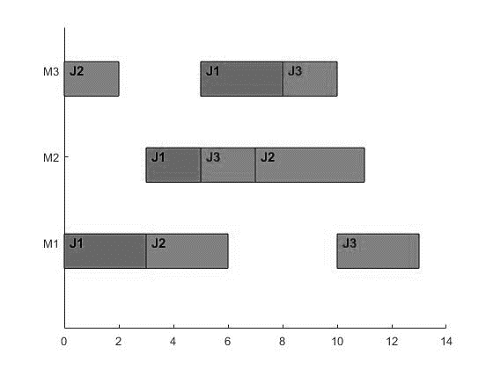

Figure 3.1 Gantt chart obtained after case chromosome decoding

3.2.2 Adaptive and Design of Selection Operational
The degree of adaptation reflects the degree to which the solution represented by a chromosome satisfies the requirements of the solution, and based on the value of adaptation, we can clearly understand how good or bad the corresponding solution is. Whether the adaptation function is properly designed or not can greatly affect the convergence speed and end condition of the algorithm. For example, in the most classical path planning problem, if the speed of the vehicle is always constant, the objective function can be designed by the total distance traveled by the vehicle, and the reciprocal of the objective function can be used as the adaptation function, the greater the adaptation, the better the path planning effect. Sometimes the population in a series of genetic operations may produce a small number of individuals can not meet the constraints, at this point in the adaptation function can be integrated into the penalty function, the penalty function is generally an absolute value of great value, so that these individuals cannot meet the constraints have a very poor degree of adaptation, so that in the next round of genetic operations to be eliminated. In the JSP problem studied in this paper, the objective function is selected as the maximum completion time, because the smaller the completion time, the more the factory can speed up the production of orders, the most direct in line with the interests of the factory, so the adaptation function can be based on the reciprocal of the objective function to design, the larger the adaptation function, the smaller the objective function, the shorter the maximum completion time. And the target function has been given in the above section, see the formula (3-5)

The selection operation is a very important step in the genetic algorithm. The algorithm model will decide whether an individual will participate in the next round of genetic evolution based on the individual's adaptation. The commonly used selection strategies include elite solution retention strategy, roulette, tournaments, ranked selection and so on. Each selection strategy has its own advantages and disadvantages, because the genes in the genetic algorithm do not necessarily reflect the nature of the problem to be solved, and the genes are not necessarily independent of each other. Optimal individuals are not destroyed by hybridization operations. However, since good gene sequences may also exist in chromosomes with low adaptation, eliminating individuals based solely on adaptation is not conducive to maintaining population diversity, so this paper selects operators using an elite solution retention strategy of fusion roulette. The specific steps of the selection operation are as follows.
- Calculate the fitness of all individuals in a contemporary population and rank and sum them
- Selecting individuals in the top 10% of fitness rankings to proceed directly to the next round of genetic evolution
- Calculate the adaptation value for each individual divided by the total adaptation value, the result is taken as the probability of an individual being selected by roulette
- Accumulate the probability of an individual being selected in order, and the remaining individuals get a selected region in the roulette wheel.
- Generate a 0-1 random number, the random number to fall to the range, the range of individuals will be selected, reserved for the next generation to carry out genetic operations
- All remaining unselected individuals are eliminated
The equation corresponding to the third step is as follows.
$N_{i}=\frac{g_{i}}{\sum{g_{i}}}$ (3-6)
where $g_{i}$ denotes the fitness value of the i-th individual in the population and $N_{i}$ denotes the probability that the i-th individual is selected. Such a selection strategy not only ensures that individuals with a high degree of adaptation can go directly to the next round of genetic operations without being destroyed, but also the remaining individuals with a low degree of adaptation but may contain good gene sequences have a probability of being selected, which ensures the diversity of the population and makes formthe algorithm model easy to jump out of the local optimal solution.

3.2.3 Adaptive and Design of Crossover Operation
Although selection can select the better-adapted individuals from the parental generation for the next round of genetic manipulation, which allows the population to evolve as a whole, selection can only select individuals from the parental population but not create new individuals, which is not conducive to maintaining population diversity. Therefore, it is necessary to generate new chromosomes through crossover operations, thus further expanding the search space of the algorithm. According to the characteristics of the process-based coding and decoding methods used in this paper, random cross-operation of chromosome sequences may make the solution represented by that chromosome incompatible with the actual operation, such as violating the given process, and may destroy individuals with a high degree of adaptation, so this paper chooses to use a cross-operation strategy combining sequential and single-point cross-operation, the algorithm steps of the crossover operation are as follows^{[35]}.
- Set a cross-probability constants $P_{c}$ for problem models and expert experience.
- Select all the individuals in the population and generate a constant r. If $r<P_{c}$, the individual is selected, and another individual is randomly selected for the crossover operation.
- Respectively name the two individuals selected in the previous step as P1 and P2, and randomly select a gene locus i, where i cannot be greater than the chromosome lengths of P1 and P2 and must be greater than 0. The gene fragments of P1 and P2 between 1 ~ i are used as crossover regions, and the gene coding fragments in the two crossover regions are recorded as A and B, respectively.
- In the parental chromosome P1, from left to right to find the same time in B also exists in the gene value, if the gene value in B also exists, the gene value in P1 will be set to 0 but the corresponding gene position remains unchanged, after the operation is no longer considered in B of the gene value, repeat the above operation until the B gene encoding processing is complete. Similarly, in the parental chromosome P2 from left to right to find the gene value also exists in A. If the gene value also exists in A, set the gene value in P2 to 0 but the corresponding gene position remains unchanged, then the operation will not take into account the gene value in A. Repeat the above operation until the gene code in A has been processed.
- Shift all the remaining genetic loci in the parental chromosomes P1 and P2 that have undergone partial deletion of gene values in the second step to the right but keep the relative positions of these loci unchanged.
- Respectively replace all the gene values in the crossover region in P1 with those in B and all the gene values in the crossover region in P2 with those in A.
Now, the crossover operation is completed, and the chromosomes P1 and P2 after the above operation are the newly generated offspring chromosomes C1 and C2. And the crossover strategy is further explained in the following diagram.

First, two paternal chromosomes were randomly selected, and their genetic codes are shown in figure 3.2.
P1 | 4 | 1 | 3 | 5 | 2 | 4 | 1 | 5 | 1 | 4 | 2

P2 | 4 | 1 | 2 | 1 | 1 | 5 | 4 | 2 | 5 | 4 | 3

Figure 3.2 Paternal Chromosome Code

Select a gene point i, i=4 in this example, to obtain the crossover region and record it as A and B. As in figure 3.5.
A | 4 | 1 | 3 | 5

B | 4 | 1 | 2 | 1

Figure 3.3 Cross-Region Gene Code

The gene sequences of P1 and P2 after step 2 are as follows figure.

P1 | 0 | 0 | 3 | 5 | 0 | 4 | 0 | 5 | 1 | 4 | 2

P2 | 0 | 0 | 2 | 1 | 1 | 0 | 4 | 2 | 5 | 4 | 0

Figure 3.4 Gene sequences of P1 and P2 after step 2

Shift all the genes in P1 and P2 to the right and the gene sequences are shown below.
P1 | 0 | 0 | 0 | 0 | 3 | 5 | 4 | 5 | 1 | 4 | 2

P2 | 0 | 0 | 0 | 0 | 2 | 1 | 1 | 4 | 2 | 5 | 4

Figure 3.5 Right-shifted P1 and P2 gene sequences
Substituting the A and B genes into the crossover region of P1 and P2 obtained the gene sequences of the offspring chromosomes as shown below.
C1 | 4 | 1 | 2 | 1 | 3 | 5 | 4 | 5 | 1 | 4 | 2

C2 | 4 | 1 | 3 | 5 | 2 | 1 | 1 | 4 | 2 | 5 | 4

Figure 3.6 offspring chromosome gene sequence

Crossover operations are one of the main methods used in genetic algorithms to generate new individuals. Crossover operations may cross over two parental individuals with low fitness to create child individuals with high fitness, which can improves the overall adaptation of the population and allows the population as a whole to evolve in a problem-solving direction. There are two important components of the crossover operation, the crossover probability component and the selection of the crossover probability value $P_{c}$ that determines whether or not an individual will participate in the crossover. If the crossover probability $P_{c}$ is too high, the crossover size will be too large and may destroy highly adaptive individuals. If no measures are taken to reduce the crossover probability and size, too many highly adaptive individuals will be destroyed, and the algorithm will converge too slowly or even fail to converge. In the other hand, a low crossover probability $P_{c}$ will also not perform well. Therefore, it is particularly important to select the appropriate cross probability. In the early stage of the algorithm operation, the overall adaptation of the population is not high because it is a randomly generated first generation population, so the algorithm needs to complete the evolution of the population as soon as possible to find the optimal solution, and since the individuals with high adaptation are not large, the crossover probability can be set a little larger to speed up the evolution of the population, improve the overall adaptation and diversity of the population as soon as possible, and expand the search space of the algorithm. In the middle and late stages of the algorithm, the number of well-adapted individuals gradually increases, and a high crossover probability can easily lead to the selection of well-adapted individuals and their destruction after the crossover operation, which is not conducive to the convergence of the algorithm. Therefore, we need to reduce the crossover probability so that the population can maintain a stable evolution without destroying a large number of well-adapted individuals. This allows the algorithm to speed up the convergence of the algorithm while improving the local search capability. In traditional genetic algorithms, the crossover probability is a constant and cannot be adaptively adjusted for the degree of the algorithm. Therefore, this paper proposes an adaptive cross-probability through literature^{[36]} to realize the adaptive adjustment of the cross-probability with the degree of completion of the algorithm, so that the algorithm has a strong global search ability in the early stage and a faster convergence speed in the late stage of the algorithm. The specific cross-probability is calculated as follows.
$$P_{c}=\left\{\begin{aligned}k_{1}-\frac{k_{1}(g^{'}-g_{avg})}{g_{max}-g_{avg}} g^{'}≥ g_{avg} \\ { k}_{2}{ g}^{'}< g_{avg}\end{aligned}\right. (3-7)$$
where $k_{1},{ k}_{2}$ are constants in the (0,1) interval;
$g_{max}$ is the maximum adaptation value of the contemporary population;
$g_{avg}$ is the average adaptation value of the contemporary population;
$g^{'}$ is the adaptation value of the better of the two individuals to be crossed.
When the adaptation of this individual is higher than the average adaptation of the population, the selection of pc will apply the first formula $P_{c}=k_{1}-\frac{k_{1}(g^{'}-g_{avg})}{g_{max}-g_{avg}}$ , otherwise apply the second formula $P_{c}= k_{2}$. In general, $k_{2}>k_{1}-\frac{k_{1}(g^{'}-g_{avg})}{g_{max}-g_{avg}}$.

3.2.4 Adaptive and Design of Mutation Operation
Biological variation is an important part of biological evolution in nature, which enables organisms within a population to maintain population diversity, thus facilitating population selection and evolution. The variation operators in genetic algorithms are designed based on this research. Variation operations can effectively reduce the similarity of populations, avoiding early maturation of populations in the early stages of the algorithm, but in the later stages or even the middle stages of the algorithm, the similarity of populations may become so high that the effect of selection and crossover operations will be greatly reduced, and even two identical chromosomal individuals may appear. It is not conducive to maintaining population diversity, which makes the algorithm prone to falling into local optimal solutions and failing to jump out of them, which requires variation operations to help the algorithm jump out of the local optimum.

The selection of variation operations is usually random and small probability, which can add new gene segments to the population, thus maintaining population diversity and expanding the search space of the algorithm. The selection of the probability of variation operation also directly affects the performance of the algorithm, and too large a probability of variation may destroy the otherwise highly adaptive individuals, making them no longer applicable, thus slowing or even preventing the algorithm from converging. Too small a probability of variation may not be able to achieve the function of the variation operation properly, and the inability to maintain population diversity makes the algorithm prone to local optimization.

The mutation operation is usually performed after the crossover operation. All individuals in the population are tested in turn to see if they meet the probability of mutation, and the selected individuals undergo mutation. The traditional mutation operation is to randomly change one or more genes in an individual's gene sequence to fit the natural phenomenon of mutation. However, the process-based coding and decoding strategy in JSP makes the traditional mutation method no longer feasible. As introduced in the crossover operation, randomly changing the gene positions may make the solution represented by a highly adaptable individual does not meet the process flow, thus making the individual no longer applicable and slowing down the convergence of the algorithm. The specific steps are as follows.
- Based on the problem to be solved and expert experience, set a probability of variation $P_{m}$, pm is generally a very small value between 0 and 1.
- If $r<P_{m}$, the individual is selected, and the following mutation operation is performed. $l_{m}$ mutation positions are randomly generated in the gene sequence of the selected individual.
- The genes at the mutated positions are removed and randomly rearranged.
- The new rearranged genes are inserted sequentially into the variant positions.
At this point, the mutation operation is complete, and the new individual will directly replace the parental individual in the next genetic operation. And the variation strategy is further explained by the following diagram.

A parental individual is selected, three mutations {2,5,6} are randomly generated, corresponding to gene values of {2,3,1}, which are removed and rearranged randomly to obtain gene fragments {1,2,3}. The schematic is shown in Figure 3.7. According to the principle of process coding, it can be seen that the process flow is $O_{31}O_{21}O_{22}O_{11}O_{32}O_{12}O_{23}O_{13}O_{33}$, which was originally represented by the parent individual, is changed to $O_{31}O_{11}O_{21}O_{12}O_{22}O_{32}O_{23}O_{13}O_{33}$ by the offspring individual after the mutation operation. This results in a completely new scheduling scheme that maintains the diversity of the population and makes it easy for the algorithmic model to jump out of the local optimum.

Parent | 3 | 2 | 2 | 1 | 3 | 1 | 2 | 1 | 3

2 | 3 | 1
1 | 2 | 3

Child | 3 | 1 | 2 | 1 | 2 | 3 | 2 | 1 | 3

Figure 3.7 Mutation operation diagram

The variation operation can be designed properly to facilitate the algorithmic model to jump out of the local optimal state and is an extremely important part of the genetic algorithm. As in the case of crossover, there are two main components of the variation operation, one is the variation step, and the other is the probability of variation pm, which determines whether an individual participates in the variation operation or not. At the early stage of the algorithm, for individuals with high adaptability, the variation probability should be lowered to protect them from destruction and to expand the search space. When the algorithm is running in the middle or late stage, the number of high adaptive individuals increases, the average adaptive value of the population is getting closer to the adaptive value of the best individual, and the similarity between the individuals increases, if the probability of variation is still small, the population may lose the struggle, some good individuals will not be represented, and the lower adaptive individuals will not be eliminated, which will make the algorithm fall into the local optimum. The efficiency of the algorithm is not improved. In order to achieve adaptive tuning of the variation operator, Srinivas^{[37]} et al. propose an adaptive variation operator that can be changed at any time with the implementation of the algorithm. The formula is as follows.
$$P_{m}=\left\{\begin{aligned}\frac{k_{3}(g_{max}-g^{'})}{g_{max}-g_{avg}} g^{'}≥ g_{avg} \\ { k}_{3}{ g}^{'}< g_{avg}\end{aligned}\right. (3-8)$$
where $k_{3}$ are constants in the (0,1) interval;
$g_{max}$ is the maximum adaptation value of the contemporary population;
$g_{avg}$ is the average adaptation value of the contemporary population;
$g^{'}$ is the adaptation value of the chosen individual to be mutated.
Although the above adaptive operators can adjust the probability of variation as the algorithm adapts, the population diversity will be destroyed, and the algorithm is prone to the phenomenon of "early maturity". In summary, an adaptive variation operator is designed based on (3-8) to solve the "early maturity" problem. The formula is as follows.
$$P_{m}=\left\{\begin{aligned}k_{3}-\frac{k_{3}(g^{'}-g_{avg})}{g_{avg}} g^{'}≥ g_{avg} \\ { k}_{3}{ g}^{'}< g_{avg}\end{aligned}\right. (3-9)$$
where $k_{3}$ are the default variation probability that constants in the (0,1) interval;
$g_{avg}$ is the average adaptation value of the contemporary population;
$g^{'}$ is the adaptation value of the chosen individual to be mutated.
From the formula (3-9), we can see that in the early stage of the algorithm, the overall adaptation degree of the population is not high, when the adaptation degree of the individuals to be mutated is smaller than the average adaptation degree of the population, the probability of variation of the individuals will decrease as the adaptation degree of the individuals to be mutated increases, which will effectively avoid the destruction of good individuals. When the algorithm progresses to the middle or late stage, the similarity of individuals in the population increases, and the difference in the degree of adaptation is not large, then it is necessary to choose a relatively large number for the initial probability of variation k3, so that the population struggle can be increased, so that the advantages of individuals with a high degree of adaptation can be preserved and reflected. Compared with other adaptive algorithms, the above improvement method not only improves the global convergence but also improves the performance of the algorithm to some extent in order to maximize the preservation of the good individuals in the population and to improve the poor individuals in the population.

3.3 Process of Improving GA Algorithms
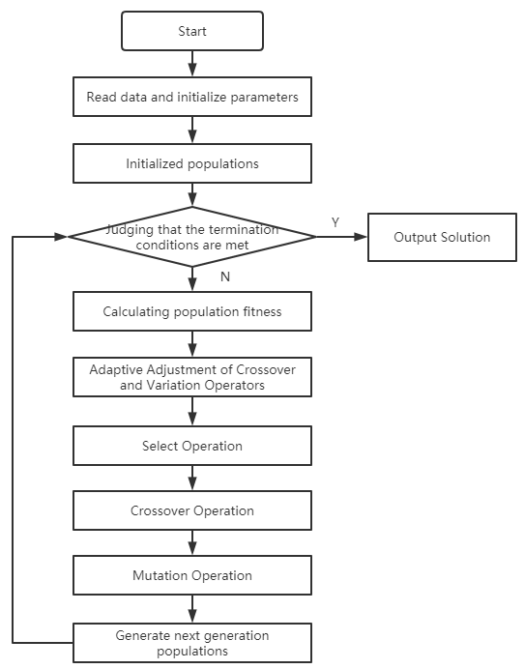
The overall flow of the algorithm is shown in the figure 3.8. Firstly, the algorithm reads the data set of the shop floor scheduling problem, sets the default probability of crossover and mutation, generates the initial population based on the coding of the process, calculates the degree of adaptation of each individual in the population according to the adaptation function, and adaptively adjusts the probability of crossover and mutation based on the degree of adaptation of the initial population. After that, a selection operation is performed to generate the parent pool, and a cross-variation operation is performed on the parent pool to generate the next generation population, and after a round of genetic operations is completed, the offspring population is judged for its degree of adaptation to decide whether to continue the next round of genetic operations or terminate the cycle.

Figure 3.8 Overall flow of the GA algorithm

4 Simulation and Analysis of Improved Genetic Algorithms

4.1 Traditional Genetic Algorithm Example Testing
Before solving the above JSP model using improved genetic algorithms, the model is first tested by solving the classical FT06 algorithm using traditional genetic algorithms. FT06 is a very classical job shop scheduling problem with six different workpieces and six different machines, each workpiece has six steps in the process, and the machines for each step are given, corresponding to the specific machining The time is shown in form 4-1, where the head of each row represents a workpiece, the head of each column represents a machining machine, and the data in the table represents the machining time of the process on the corresponding machine, e.g., 2 (3) in the first column of the first row represents the first process of workpiece 1 is processing on machine 2, and the processing time is 3 time units.
Process  Part | Machine (Processing time)
Process  Part | Pro1 | Pro2 | Pro3 | Pro4 | Pro5 | Pro6
Part1 | 3(1) | 1(3) | 2(6) | 4(7) | 6(3) | 5(6)
Part2 | 2(8) | 3(5) | 5(10) | 6(10) | 1(10) | 4(4)
Part3 | 3(5) | 4(4) | 6(5) | 1(9) | 2(1) | 5(7)
Part4 | 2(5) | 1(5) | 3(5) | 4(3) | 5(8) | 6(9)
Part5 | 3(9) | 2(3) | 5(5) | 6(4) | 1(3) | 4(1)
Part6 | 2(3) | 4(3) | 6(9) | 1(10) | 5(4) | 3(1)
Form 4-1 FT06 Example Data
As the probability of crossover and variation in the traditional genetic algorithm is constant, it is set to 0.8 and 0.05 respectively according to the size of the case and the type of the problem, and the number of generations is the termination condition of the algorithm. Figure 4.1 shows the convergence curve of the algorithm by depicting the optimal adaptation curve for each generation of the population. Figure 4.2 is a Gantt chart drawn by MATLAB by decoding the solution. From Figure 4.1, we can see that
the algorithm cannot converge to a fixed value at all, and it keeps fluctuating in a range with poor convergence. From Figure 4.2 of the Gantt chart, it can be concluded that the maximum completion time of the optimal solution obtained by the traditional genetic algorithm is 57, which is not much different from the current known optimal solution 55 of FT06, but there is still room for further optimization.

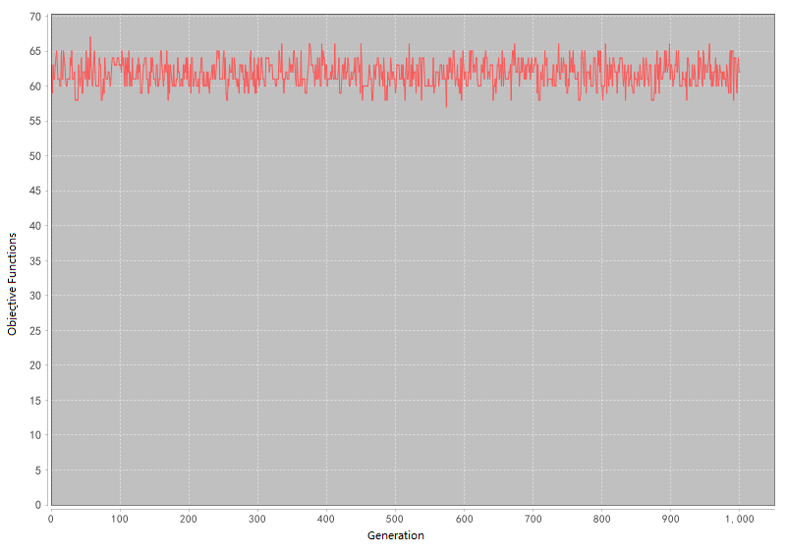
Figure 4.1 Convergence Curves for Traditional GA

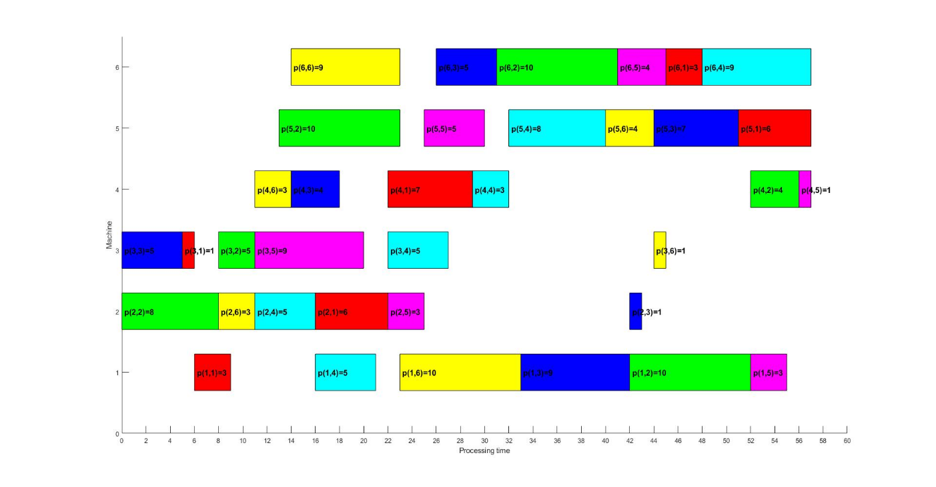
Figure 4.2 Gantt Chart for Traditional GA

4.2 Improved Genetic Algorithm Example Testing
The same FT06 example is now solved using the improved genetic algorithm to test the performance of the improved genetic algorithm. In order to make a clear comparison with the traditional algorithm, the initial parameters in the algorithm will be the same as those in the test case of the traditional algorithm. Therefore, the initial values of crossover and mutation probability are set to 0.8 and 0.05, respectively, and the adaptive adjustment of crossover and mutation probability will be based on this initial probability in subsequent genetic operations. In addition, the population size is 1000 and the termination condition for iterative generations is 1000.

Figure 4.3 shows the curves of the improved genetic algorithm for solving the FT06 case according to the objective function curve of the best individual in each generation, and it can be seen that the convergence performance of the improved genetic algorithm is greatly improved compared with the traditional genetic algorithm. The objective function curve drops several times between 0 and 10 generations, which indicates that the search range is expanded in the beginning of the algorithm, and it is easier to jump out of the local optimum. The objective function value has been 58, and the convergence speed of the algorithm started to slow down, and the convergence continued until about 250 generations, and then there was a decline to 55. Now, the objective function curve of the improved genetic algorithm has been unchanged, converging to 55, which is faster than the traditional genetic algorithm that reached the optimal solution in about 800 generations. In addition, the results obtained by the improved genetic algorithm are consistent with the results of the maximum completion time of the currently known optimal solution for the FT06 case, indicating good and improved performance of the algorithm. Figure 4.4 shows the Gantt chart drawn by MATLAB by decoding the optimal solution, which allows a clearer view of the scheduling of the process, and the maximum completion time is 55, which is also an improvement over the 57 obtained by the traditional genetic algorithm.

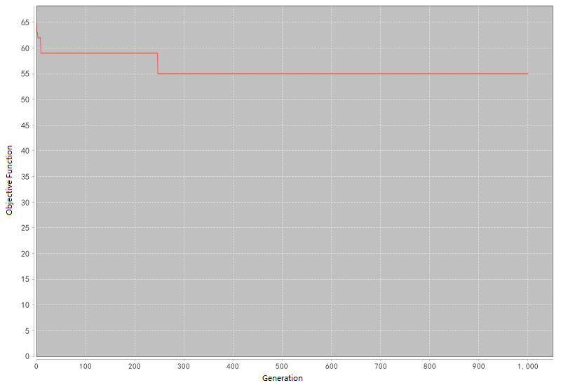
Figure 4.3 Convergence Curves for Improved GA
Figure 4.4 Gantt Chart for Improved GA
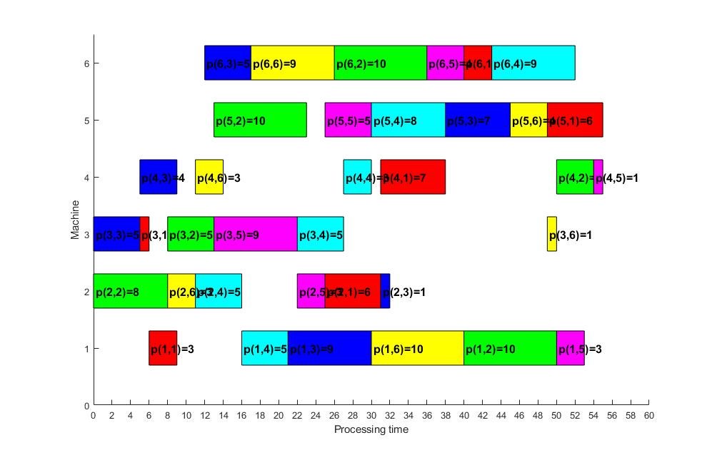

5 Conclusions and Reflection

5.1 Conclusions of this Project
The manufacturing industry is an important part of national economic development. Whether the manufacturing industry can improve the efficiency of processing production through reasonable operation scheduling scheme is the core issue of enterprise interests, so it is of great practical significance to study the workshop scheduling problem. Therefore, this paper studies the classical and malleable JSP, models the problem by consulting and referring to the literature, improves the traditional genetic algorithm, uses IDEA software to implement the program to solve the problem, conducts comparison test by FT06 example, and depicts and analyzes the algorithm solution result and convergence curve by MATLAB. The efficiency of an improved genetic algorithm for solving JSP is demonstrated.

5.2 Reflection
In this paper, JSP studies and proposes an improved genetic algorithm for solving the problem, which has a good effect in solving the problem and needs to be further studied in the following parts in subsequent research work.
Problem Level
With the progress and development of science and technology, although this paper is a malefactor of JSP, it is a little insufficient. It is necessary to study the multi-objective scheduling problem and propose corresponding efficient and intelligent optimization algorithm to solve the problem, so that the research content can be more close to the actual processing process and the theory can be applied in practice.
Algorithm level
A single optimization algorithm is effective in solving scheduling optimization problems, but it has its limitations and drawbacks. This paper improves the genetic algorithm and achieves good results in solving the problem, but it is still not comprehensive enough. The author intends to pay more attention to the study of the remaining types of intelligent algorithms in the following research work, so that the different algorithms can be mixed with each other to overcome their own advantages and obtain better problem solving ability.

REFERENCES
[1] C.Y.Zhang, "Research on the Shop Scheduling Problem with Naturally-Inspired Heuristic Algorithms,": Huazhong University of Science & Technology, 2007.
[2] X.Y.Li, "Research on the Solution Planning Methods of Integrated Process and Scheduling,": Huazhong University of Science & Technology, 2009.
[3] R.Q.Chen,S.H.Ma, Production and operations management. 3rd Edition: Higher Education Press, 2011.
[4] M. R. Garey and J. R. Sethi, "The Complexity of Flowshop and Jobshop Scheduling," Mathematics of Operations Research, vol. 1, pp. 117-129, 1976.
[5] PINEDO, "SCHEDULING THEORY ALGORITHMS & SYSTEMS," A I I E Transactions, vol. 28, pp. 695-697, 2008.
[6] L.Wang, Shop Scheduling with Genetic Algorithms: Tsinghua University Press, 2003.
[7] J. H. Holland, Adaptation in natural and artificial systems: An introductory analysis with applications to biology, control, and artificial intelligence. Oxford, England: U Michigan Press, 1975, pp. viii, 183-viii, 183.
[8] R. Eberhart and J. Kennedy, "A new optimizer using particle swarm theory," in Mhs95 Sixth International Symposium on Micro Machine & Human Science, 2002.
[9] J. Kennedy and R. Eberhart, "Particle Swarm Optimization," in Icnn95-international Conference on Neural Networks, 2002.
[10] J. Z. Benlian Xu and Q. Chen, "Ant Colony Optimization," in Conference Companion on Genetic & Evolutionary Computation Conference: Late Breaking Papers, 2010.
[11] M. Yazdani, M. Gholami, M. Zandieh, and M. Mousakhani, "A Simulated Annealing Algorithm for Flexible Job-Shop Scheduling Problem," Journal of Applied ences, vol. 9, pp. 662-670, 2009.
[12] Y. K. Lin and C. S. Chong, "A tabu search algorithm to minimize total weighted tardiness for the job shop scheduling problem," Journal of Industrial & Management Optimization, vol. 12, pp. 703-717, 2017.
[13] Z. Fu, W. Liu and M. Qiu, "A Tabu Search Algorithm for the Vehicle Routing Problem with Soft Time Windows and Split Deliveries by Order," Chinese Journal of Management ence, 2017.
[14] J. F. Wang, B. Q. Du and H. M. Ding, A genetic algorithm for the Flexible Job-shop Scheduling Problem: Springer Berlin Heidelberg, 2011.
[15] S. N. Hartmann and D. Briskorn, "A survey of variants and extensions of the resource-constrained project scheduling problem," European Journal of Operational Research, vol. 207, pp. 1-14, 2010.
[16] L.Wang, Intelligent Optimization Algorithms with Applications: Tsinghua University Press, 2001.
[17] X.W.Xing and J.X.Xie, Modern Optimization Methods: Tsinghua University Press, 2006.
[18] C.Y.Zhang, "Research on the Shop Scheduling Problem with Naturally-Inspired euristic Algorithms,": Huazhong University of Science & Technology.
[19] S.F.Wang,Y.R.Zou, "Techniques for the Job Shop Scheduling Problem: a Survey," Systems Engineering-Theory & Practice, pp. 49-55, 2003.
[20] Y.J.Ma,W.X.Yun, " Research progress of genetic algorithm," Application Research of Computers, vol. 29, pp. 1201-1206+1210, 2012.
[21] X.Bian,L.Mi, " Development on genetic algorithm theory and its applications," Application Research of Computers, vol. 27, pp. 2425-2429+2434, 2010.
[22] H.Q.Huang, " Break through the difficulties: Systematically promote the high-quality development of the manufacturing industry," in Economic Daily, 2019, p. 3.
[23] H.L.Liu,J.H.Zhang,T.Xie, " Job Shop Scheduling Problem (JSP) Research Summary Report," Equipment Manufacturing Technology, pp. 235-237, 2015-12-15 2015.
[24] R.Hou, " The focus, difficulties, key points of "Internet +"" Informatization Construction, pp. 59-61, 2015.
[25] J.H.Shi, "Design and optimization of improved adaptive genetic algorithm for flexible job shop scheduling problem in G company,". vol. China University of Mining and Technology, 2019, p. 115.
[26] X.Zhan, "Application of the improved whale algorithm in job shop scheduling,". vol. Dalian Jiaotong University, 2019, p. 61.
[27] H.C.Zhong, "Research on Workshop Scheduling based on Genetic Algorithm with Reinforcement Learning,". vol. Huazhong University of Science & Technology, 2019, p. 70.
[28] L. Jia, E. B. Didier, X. Rui, and H. Jinglu, "Solving the dynamic energy aware job shop scheduling problem with the heterogeneous parallel genetic algorithm," Future Generation Computer Systems, vol. 108, 2020-07-24 2020.
[29] L. Xiong, Q. Qian and F. F. Yun, "Improved Genetic Algorithm for Solving Flexible Job Shop Scheduling Problem," Procedia Computer Science, vol. 166, 2020-03-23 2020.
[30]Y.Y.Peng, S.J.Kong, X.Chen, R.Wang, " Research on Job Shop Scheduling Algorithm for Intelligent Manufacturing," Journal of Nanjing University of Science and Technology, vol. 41, pp. 322-329, 2017.
[31] X.Q.Zhao, H.Hao, " Improved DRSGA for flexible job shop scheduling " Journal of Nanjing University of Science and Technology, vol. 40, pp. 297-302, 2016-06-30 2016.
[32]C.Y.Zhang, X.Dong, X.J.Wang, X.Y.Li, Q.Liu, " Improved NSGA-II for the Multi-objective Flexible Job-shop
Scheduling Problem," Journal of Mechanical Engineering, vol. 46, pp. 156-164, 2010-06-05 2010.
[33] L. Xinyu and G. Liang, "An effective hybrid genetic algorithm and tabu search for flexible job shop scheduling problem," International Journal of Production Economics, vol. 174, 2016-04-15 2016.
[34] B.Wang, B.C.Lu, " Fixed Point Disturbance-Genetic Algorithm for Multi-Objective Flexible Job Shop Scheduling Problem," Machinery Design ＆ Manufacture, pp. 48-51, 2018-07-08 2018.
[35]S.L.Xie, Q.Huang, J.X.Dong, " A Method to Resolve Unfeasible Scheduling of JSP by GA," Computer Integrated Manufacturing Systems-CIMS, pp. 902-906, 2002-11-25 2002.
[36] M. Srinivas and L. M. Patnaik, "Adaptive probabilities of crossover and mutation in genetic algorithms," IEEE Transactions on Systems, Man, and Cybernetics, vol. 24, pp. 656-667, 1994-01-01.
[37] V. Rajesh and S. R., "Development and analysis of constructive heuristic algorithms for flow shop scheduling problems with sequence-dependent setup times," The International Journal of Advanced Manufacturing Technology, vol. 67, 2013-07-15 2013.

