Examine the Evidence for the Efficacy of Various Soft Tissue Techniques

Main body
Effleurage is one of the main techniques used during soft tissue massage and one of the most effective. A study done by University of Social Welfare and Rehabilitation Sciences Khonso, H. et al. (2016) showed the benefits of effleurage on elderly people with sleep disorders. From the results of the study it can be observed that the quality of sleep improved with the majority of participants who had effleurage treatment. This is due to effleurage being a relaxing massage technique it has a positive effect on individuals mental state, also it increases blood flow. This is beneficial to sleep quality as it helps improve brain function. Furthermore, research done by D. Shankari to show the effectiveness of effleurage on orthopaedic clients, before the treatment it was observed that 25 (50%) out of the 50 clients had severe back pain. After the effleurage treatment the number of clients who had severe back pain had dropped to just 16% which is 8 people. From these results it can be observed that effleurage has an effect on reduction in pain. As effleurage increases blood flow, lymphatic flow and reduces tension which all influences a reduction in pain.

Tapotement is another massage technique which is predominantly used via consistent beating on a muscle part using the fingers, cupping your hands in rhythmic but gentle motion. Research done by Warren. B. Young (2007) was done to identify if 3 minutes of tapotement and petrissage would influence nineteen participants plantar flexor, flexibility and muscle power.
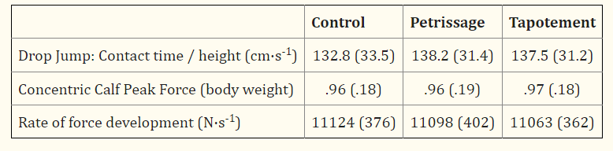
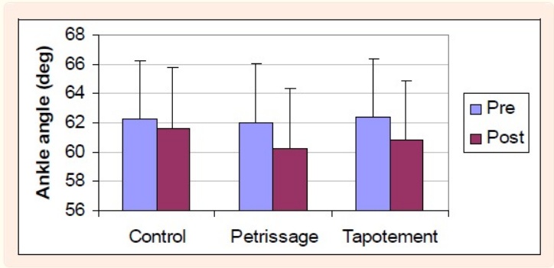
From the results it can be observed that in regards to power there was a little bit of improvement however there was not much drastic change after both petrissage and tapotement this is due to massage having no real benefit on performance it’s mainly used to help aid recovery rather than increase performance. However when you compare this to flexibility specifically in the ankle region it can be observed that tapotement and petrissage both had a big improvement in, increasing the flexibility, reasons for this is due to an increase in muscle temperature and a change in tissue compliance which helps benefit flexibility in specific regions.
In addition to this another study done by Koya Mine (2017), was done to measure 15 healthy males vertical jump both pre massage and post in order to see if any improvement is made.
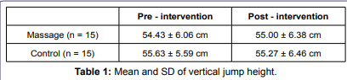
From the results it can be seen that pre massage the average score was 6.06, with post massage only giving a 32mm improvement. Although there is an increase in result there is not a significant difference that will influence performance. This is another piece of evidence that proves that massage has no significance on increasing performance instantly, but it benefits with the aid of recovery.
According to Martin, A. et al (1998) evidence suggests that effleurage, petrissage and tapotement in one treatment all promote blood lactate clearance after supramaximal leg exercise. A study was done on 10 males ages 21 to 34 years old. Each individual did a VO2 max and after received a 25 minute treatment in order to see the effects on how much massage can eliminate any lactic acid.

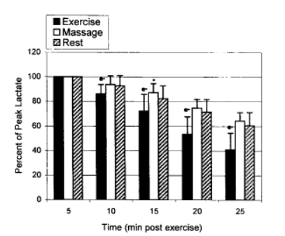
From the results it can be observed that after a 25 minute massage there was around a 60% reduction in lactic acid. This shows that massage is extremely beneficial in aiding and the duration of recovery.

Trigger pointing is another type of massage technique in which the therapist finds certain points within the body and holds on a certain point for a duration of time which then releases. An article by Montañez-Aguilera, F. Javier. Et al (2010) suggests the benefits of trigger pointing on a single 27 year old female with neck pain for a duration of 4 months. They applied trigger point techniques on the injured area. From the results it can be observed that there was a drastic improvement in ROM and a decrease in pain within the region after a single treatment of trigger pointing. This shows that trigger pointing is a useful technique in aid of recovery as it helps with the individuals ROM, reduction in pain by interrupting the pain cycle, however these are all short term effects.
In addition to this another study done by Grieve, R. et al (2010) was done to evaluate the influence on dorsiflexion in the ankle by using trigger pointing. 5 men and 15 women with restricted ROM in the ankle were tested. From the 20 participants the results all were beneficial by showing a significant improvement in the participants ROM. This is due to as the pressure is applied on the certain area it causes acute trauma on the muscle fibres which then release after a short period time, which reduces pain from previously while also allowing an increase of circulation in the area which all have a positive effect on range of movement.

From the research found it can be seen that different massage techniques all have a positive influence and give out very little negatives on an individual, improvement on range of movements and a reduction in pain. All massage techniques mentioned would be beneficial to all therapists as they all have a positive influence on the individual. From a personal perspective, soft tissue techniques can be highly effective in alleviating pain and promoting healing. As someone who has experienced muscle soreness, stiffness, or injuries, I understand how frustrating and limiting it can be to have limited range of motion or be in constant discomfort. Soft tissue techniques such as effleurage, petrissage and myofascial release have helped me alleviate pain and tension by targeting specific areas of the body and promoting relaxation and circulation.
Additionally, soft tissue techniques can be beneficial for improving physical performance in the long run and preventing future injuries. As someone who enjoys being physically active, I appreciate the importance of maintaining flexibility and range of motion in order to prevent injuries and improve overall physical function. All soft tissue techniques mentioned are effective in helping to improve flexibility and prevent injuries.

Introduction

Soft tissue techniques are manual therapy approaches that focus on the muscles, tendons, ligaments, and other soft tissues in the body. These techniques are used to alleviate pain, improve range of motion and flexibility, and promote healing. Soft tissue techniques have been studied extensively and have been found to be effective in treating a wide range of conditions, including musculoskeletal disorders, sports injuries, and chronic pain. Some commonly used soft tissue techniques include massage therapy, myofascial release, trigger point therapy, and stretching. Understanding the efficacy of various soft tissue techniques can help healthcare practitioners provide optimal care for their patients and empower patients to make informed decisions about their own healthcare.

Conclusion

In conclusion, soft tissue techniques are an important aspect of manual therapy that have been found to be effective in treating a variety of conditions affecting the muscles, tendons, ligaments, and other soft tissues in the body. Through extensive research, the efficacy of various soft tissue techniques such as massage therapy, myofascial release, trigger point therapy, and stretching has been demonstrated. By understanding the benefits and limitations of different soft tissue techniques, healthcare practitioners can provide patients with optimal care and empower them to make informed decisions about their own healthcare.
However there was also contradicting research that found that all of these techniques have no influence in a sudden improvement on performance but morefore the aid of recovery. Although soft tissue massage does not have an instant effect on performance, with continuous use of massage it will have positive effect on allowing an individual to perform at full fitness with no altercations on ROM or pain, while at the same time reducing an individual's effect on injury while participating in sport.
Overall, soft tissue techniques play a vital role in promoting healing, alleviating pain, and improving physical function, while also having a positive mental effect on individuals who receive these soft tissue techniques such as effleurage and petrissage as they are very relaxing while receiving these types of soft tissue techniques.

WORD COUNT-1350

References
Khoshno, H. et al. (2016) “The effect of effleurage massage duration on sleep quality improvement,” Iranian Journal of Rehabilitation Research in Nursing, 2(4), pp. 10–18. Available at: https://doi.org/10.21859/ijrn-02042.
Mrs D, Shankari “Effectiveness of effleurage back massage on pain and anxiety among orthopaedic patients” Narayana College of Nursing, Chinthareddypalem, Nellore. Available at: http://www.narayananursingjournal.com/
Young, W. et al. (2007) “Acute Effects of Two Massage Techniques on Ankle Joint Flexibility and Power of the Plantar Flexors” J Sports sci med. Available at: https://www.ncbi.nlm.nih.gov/pmc/articles/PMC3794491/
Mine, K. (2017) “Acute effects of quick short - duration massage on vertical jump; a crossover randomised controlled trial,” Physical Medicine, Rehabilitation & Disabilities, 3(1), pp. 1–4. Available at: https://doi.org/10.24966/pmrd-8670/100019.
Martin, A. et al (1998) “The Comparative Effects of Sports Massage, Active Recovery, and Rest in Promoting Blood Lactate Clearance After Supramaximal Leg Exercise” Journal of athletic training. 33(1), pp. 30-35. Available at: https://www.ncbi.nlm.nih.gov/pmc/articles/PMC1320372/?page=1
Montañez-Aguilera, F.J. et al. (2010) “Changes in a patient with neck pain after application of ischemic compression as a trigger point therapy,” Journal of Back and Musculoskeletal Rehabilitation, 23(2), pp. 101–104. Available at: https://doi.org/10.3233/bmr-2010-0255.
Grieve, R. et al. (2011) “The immediate effect of soleus trigger point pressure release on restricted ankle joint Dorsiflexion: A pilot randomised controlled trial,” Journal of Bodywork and Movement Therapies, 15(1), pp. 42–49. Available at: https://doi.org/10.1016/j.jbmt.2010.02.005.

