2021
University of Wales, Trinity Saint David, London.

Oluwaseun Akran

[Principles of health and social care practices]

Name: Oluwaseun Akran
Student Number: 1908389
Lectures Name: Adesewa Ajayi
Module Code: BMHP 5002
Assignment Title: Principles of Health and Social Care Assignment 2

1. Contents Page
2. Introduction………………………………………………………………………………………... 3
3. Discussion /Analysis of person – centred care
- Concepts of person-centred care…………………………………………………………. 3
- Theoretical underpinning of person-centred care…………………………………......... 5
- Ethical underpinning of person-centred care ………………………………………..........5
- Main benefit and limitation of person-centred care……………………………………… 7
- Application of person centred care to a dementia individual…………………………… 9
4. Recommendation of improving person- centred care for dementia patient……………….... 9
5. Conclusion…………………………………………………………………………………………..10
6. References………………………………………………………………………………………….11

Current Person-Centered Care Practice in Health and Social Care
Introduction
In the last few years, the United Kingdom has been facing increasing population of older people and individuals confronted with long term diseases which has put so much pressure on NHS. The health foundation (2016) indicates that the NHS is facing increasing pressure of care to people with long term conditions and older population and at the same time, the budges for the health and social are is facing intense scrutiny. It is against backdrop that the NHS considers the provision of high-quality person-centered care to meet people's needs in order for them to live a better life.
Person-centred care allows healthcare employees to work with individuals in the delivery of care. The Health Foundation (2016) argue that health and social care employees work closely with people to deliver care and also support and develop people skills and knowledge to manage and make informed decision regarding their health. This is not surprising, because person-centred care is being used to care for individual suffering from dementia in the UK (Manthorpe and Samsi, 2016). This essay therefore focuses at current person-Centred Care practices that are crucial for Health and Social care.
The remainder of the essay is divided into seven sections. Section one focuses on person-centred care concepts, followed by theoretical underpinnings of person-centred care, ethical underpinnings of person-centred care, main benefits and limitations of person-centred care, application of person-centred care to a dementia patient, recommendations for improving person-centred care for dementia patients, and a final section that concludes the section.
Concepts of person-centred care
The construct of person-centred care is not new because it has been known in healthcare sector as an important component in quality care provision to respond to people's needs. (Morgan and Yoder, 2011) indicates that person centered care is recognized as important element in the delivery of quality care and today several healthcare institutions have added person centered care to educate their employees. Thus, person-centered care work closely with individuals to deliver better care to meet individuals.

However, person-centred care has been in existence since the time of Florence Nightingale when nursing focused on individual instead of disease (Morgan and Yoder, 2011). Additionally, in the 1940s, Carl Rogers the psychologist established the concept of person-centeredness where each person possesses certain qualities, draw strength from available resources and find a way to addressing issues. Similarly, Walji et al. (2017) view the concept of person-centred care as a strategy in the healthcare where health providers ensure that people using health and social care services are seen as equal partners in the area of planning, developing as well as monitoring care in order to meet the changing needs of the people. From this perspective, it is important to note that service users and their families are recognized by healthcare providers in making decisions that may affect the needs of services. Indeed, in Scotland, the practice of person-centred care is treated at three levels. Person-centred care, according to NHS Education for Scotland, is defined as empowering healthcare staff to cut through systems and processes and focus on the needs of patients. It focuses on improving the patient experience by ensuring that the patient has everything they require to navigate their current care episode (Manthrope and Samsi, 2016) Given this interest, the person-centred care is associated with three concepts e.g., partnership between the person and healthcare provider, the patient narrative should be included, as well as documentation of the person's experience. Moreover, other concepts can be characterized by the concordance of the patient and the healthcare provide. Similarly, Walji et al. (2017) define person-centred care as a healthcare strategy in which healthcare providers ensure that people who use health and social care services are seen as equal partners in the planning, development, and monitoring of care in order to meet their changing needs. Improved health outcomes, increased safety, individual expectations, patient integration into the environment, patient as a patient, patient as an active member of society, dialogue and interaction, and sharing of experience and documentation. Below is a diagram of the concept of person-centred care.
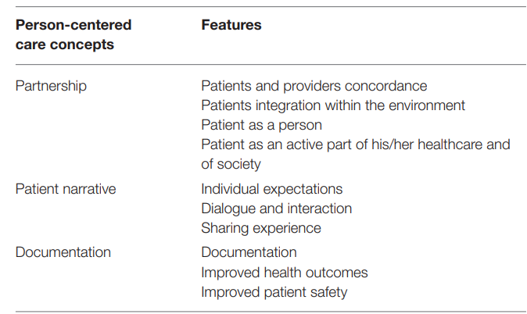
Source: Tomaselli et al. (2020) adapted by student (2021)
Theoretical underpinning of person-centred care
Person-centred care have been in the healthcare sector for a long time when Florence Nightingale separated nursing from medicine by focusing attention to individual instead of health conditions. Loughlin (2020) indicates that person-centred care focused in treating the whole body of the individual instead of a single part like disease, organ or system and to empower patients during the process, but it is only recently that healthy policy and practice of person centred care, patient expertise, co-production as well as shared decision making has been acknowledged among health practitioners. From this perspective, the theoretical underpinning of person-centred care is focused on establishing a relationship between the healthcare providers and the patients so that care needs that fit the person needs are provided.
Ethical underpinning of person-centred care
The concept of person-centred care is known to be responsive and at the same time respective to the delivery of quality care to meet the demands of individuals. According to Tomaselli et al. (2020) the use of person-centred care to treat the whole of a person considering the person preferences and principles is regarded as responsive and respectful. This is important in today’s society where there is growing number of older generation with increase healthcare conditions, person-centred care is fundamental to provide the best healthcare for individuals. Indeed, person-centred care engages individuals by empowering the individuals in decision making, plans and processes in the delivery of better healthcare.
However, unlike patient centered care which tends to focus on the medical treatment and diagnosis of the exceptional individuals, the person-centred care focuses on the treatment of the whole body of the individual instead of a single part like disease, organ or system and to empower patients during the process of planning and decision making in delivering healthcare. As Tomaselli et al. (2020) note, patient centered care only deals with the medical treatment as well as diagnosis of the person, but the person-centred care is different from the patient centred care which looks at the ethical foundation of delivering care and sees the individual not as only the patient as an active part of medical treatment and diagnosis and looks at the individual needs, family, history, strength and weaknesses. In fact, person centered care is welcomed in today’s healthcare sector because it goes beyond only treating the individual but addressing the health issues of the individual holistically in areas of his family, needs, history and strength and weaknesses.
However, the work of Ekman et al. (2011) used Amartya Sens capability approach to look at the ethical perspective of person centered care to deliver quality care. This approach emerges from Aristotle principles of human quality, thus, healthcare providers have to build on their emotional intelligence in the delivery of care to individuals. Indeed, the principles emphasizes that each individual is regarded as a partner in care an at the same time co-creators of healthcare plan. Ekman et al. (2011) argues that the ethical aspect of person centered care sees the individual as partners to the healthcare providers, thus, the healthcare providers responsibility is to listen to the individuals drawing on their experiences, conditions and also their expectations. The fact, however, is that, the patient in person centered care is acknowledged as co-partner to healthcare delivery, therefore, healthcare providers have to listen to the patients, tapping into their experiences, conditions and expectations. To this end, it is necessary to have an agreed health plan where responsibilities have to be shared between the patient and the healthcare providers. Indeed, his plan has to be regularly updated to benefit both parties.
Nevertheless, ethical consideration is a critical aspect of person-centred care. Ethics is regarded as ding things that are correct. Tomaselli et al. (2020) indicates that ethics is seen as doing the right thing, creating the right kind of relationship and at the same time destroying what is wrong in view of the basic concepts and fundamental principles of human conduct. In addition, Tomaselli et al. (2020) suggest that the relational ethics of person centered care focuses on linkages that are better than others and target stimulating growth, healing, as well as health. Similarly, Evans (2004) sees relational ethics as an action ethics which looks at interpersonal relationship e.g., engagement, mutual respect, embodiment, and interdependent environment. With this in mind, it is important that any ethical decision regarding to individual healthcare as to be made on a mutual relationship between the healthcare provider and the patient, hence, what is crucial here is the relationship factor between patient and healthcare provider.
Undoubtedly, the relational ethics is characterized by a framework of actions, mutual respect, engagement, embodied knowledge, environment and uncertainty. In fact, these characteristics of relational ethics needs to be set in a right way leading to a better ethical decision that will benefit the healthcare provider and the patient (Tomaselli et al. 2020). See relational ethics below
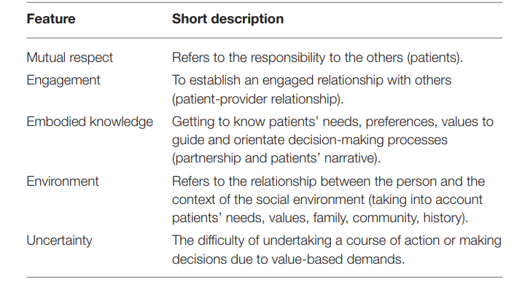
Source: Tomaselli et al. (2020) adapted by student (2021)

Main Benefit and Limitation of Person-Centred care
As discussed before, Walji et al. (2017) view the concept of person-centred care as a strategy in the healthcare where health providers ensure that people using health and social care services are seen as equal partners in the area of planning, developing as well as monitoring care in order to meet the changing needs of the people. From this perspective, it is important to note that service users and their families are recognized by healthcare providers in making decisions that may affect the needs of services. In view of this, person centered care is characterized by some benefits and this include the following:
Person-centered care recognizes the needs of a person and at the same time understand the individual or patient mental health conditions and emotions like feelings of safety, comfort as well as happiness. Additionally, with person-centred care, the healthcare provider learn of the patient responses and behaviors, therefore, it is beneficial to provide individualized care to people to enable them have a happy lifestyle.
Person-centred care establish a relationship between the patient or individual and the healthcare provider, hence, the patient is considered in any ethical decision making when planning and processing any healthcare that fit the individual health conditions.
A holistic person-centred care to meet individual healthcare demand, interconnect, the person soul, mind and body of the person. With this, the healthcare provider is seen as given equal attention to the patient emotional, mental and physical need of personalized care. In doing this, the healthcare provider is engaging the patient in ethical decision making on matters of healthcare that involve the individuals.
It is noted that a person-centred care approach assist the healthcare providers to have a close relationship with the patients. Manthorpe and Samsi, (2016) indicates that with a person-centred care, there is a close linkage between the healthcare provider and the individuals, hence, this allows the healthcare provider to know more about the patients and engages them in ethical decision making concerning their health. Indeed, co-partnership relationship between the patient and healthcare provider is fundamental in the delivery of personalized care to meet the emotional, mental and physical need of the person. The fact, however, is that caring for the needs of the persons as well as demonstrating respect brings positive responses and interaction
Person-centred care approach helps to improve the quality of life of the patients, and this is achieved by the healthcare provider paying more attention to the person emotional, mental physical and spiritual needs. According to (Tomeselli et al., 2020) Bond between the healthcare provider and the person helps to solve the emotional, mental, and physical needs of the person. Indeed, individual or patients and healthcare provider relationship is fundamental in meeting the personalized needs of the individual and also make the healthcare provider know more about the patient.
On the other hand, person-centred care is faced with some limitation e.g., employees limitation as well as reduced levels of employee experience. The lack of healthcare professional experience in delivery of personalized care to patients may affect the quality of care. In addition, high level of healthcare professional’s workloads and time pressures is a concern for personalized care. The lack of enough healthcare professionals put so much pressure on the healthcare staff, thus, leading to fall in quality of healthcare delivery which affects the emotional, mental and physical wellbeing of the patients.
Further, physical resources and environmental limitation impact heavily on the personalized care for individuals. (Tomeseli et al., 2020) argues that the unavailability of enough physical resources and environmental constraints impact on the delivery of care to individuals. Lastly, the attitude of the healthcare professionals may not supportive to the delivery of personalized care to individuals and this may impact on the emotional, mental and spiritual wellbeing of the individuals.

Application of person - centered care to a dementia individual
Dementia is acknowledged as the continuous reduction of the individual cognition, function and behavior, hence, this individual is seen depending on other people to live a normal life ad carry out their day to day activities. (Chenoweth et al., 2009) is of the view that dementia is known as the falling cognition, functions as well as behavior of a person which affects the daily working life of the person, hence, these category of persons depend on others to live a normal life. Indeed, dementia reduces the way a person live is life because the thinking and behavior of the person is interfered, therefore, these person depend on others.
However, dementia needs are complex; it may be behavioral or psychological symptoms which as hard to meet e.g. aggression, either verbal or physical, agitation, restlessness, unusual behavior, vocalization, sleep wake, cycle disturbance, screaming, crying, and repeated crying out and pacing which is hard for family members to manage (Kontos et al., 2010: Vernooij-Dassen, and Moniz-Cook, 2016) With this in mind, person centered care may be suitable to manage and provide personalized care to meet the needs of individual with dementia. Chenoweth et al. (2009) indicates that person-centred care is regarded as an alternative to conventional care to help persons with dementia to meet their unmet needs. Indeed, person centered care can help to mitigate cognitive and functional reduction. Moreover, it is important to note that the use of person centered care is now very common in residential care because it lowers the need driven dementia with compromised behavior which help maintain healthcare provider and the patient.
Recommendation of improving person-centred care for dementia patient
As discussed before, dementia is acknowledged as the continuous reduction of the individual cognition, functions and behavior, hence, this individual is seen depending on other people to live a normal life ad carry out their day to day activities. (Chenoweth et al., 2009), to this end, the use of person centered care may help to reduce the psychological and behavioral symptoms of the patient, thus, improving dementia patients with person centered care is fundamental. With this, this essay highlights some recommendations for improving person centered care on dementia patient.
The healthcare provider should treat the dementia patient with respect and dignity.
The healthcare provider should understand the dementia patient history, lifestyle, culture as well as preferences in the delivery of treatment.
The healthcare provider should look at situation in line to the person suffering from dementia in order to enable them live a normal life and take care of some activities.
The healthcare provider should organize and provide services which is line with the dementia patient in planning and making decision.
The healthcare provider should respect the dementia patient beliefs and values.
Conclusion
Person-centered care is well documented in several healthcare literatures as a treatment procedures that is far beyond the patient centered care. This is because it made the patient a co-partner in the planning and making decision in case of healthcare to the individual. This is not surprising, because with the complex needs of dementia patients, person centered care is used to provide care to dementia patients to reduce the psychological and behavioral needs. This essay has provided an understanding about current practice for person centered care within health and social care.

References
Chenoweth, L., King, M.T., , Jeon, T.H., Brodaty, H., Stein-Parbury, J., Norman, R., Haas, M., Luscombe, G. (2009) Caring for Aged Dementia Care Resident Study (CADRES) of person-centred care, dementia-care mapping, and usual care in dementia: a cluster-randomised trial, The Lancet, p 317-325
Ekman I, Swedberg K, Taft C, Lindseth A, Norberg A, Brink E, (2011) Person centered care: Ready for prime time. Euro Journal of Cardiovascular Nursery Vol. 10:p 248– 251.
Kontos, P.C., Mitchell, G.J., Mistry B., and Balton, B. (2010) Special Issue: Using Drama to Improve Person-Centred Dementia Care, CIHR, IRSC, Vol. 5, (2): p 159-168
Loughlin, M. (2020) Person Centered Care: Advanced Philosophical Perspectives, European Journal for Person Centered Healthcare 2020 Vol 8 (1): p 20-33
Manthorpe, J., and Samsi, K. (2016) Person-centered dementia care: current perspectives, Clinical Intervention in Aging, Vol. 11, p 1733-1740
Morgan, S., and. Yoder, L.H. (2011) A Concept Analysis of Person-Centered Care, Journal of Holistic Nursing, Vol. 20, (10): p 1-15
The Health Foundation (2016) Person-Centered Care made Simple: What everyone should Know about Person Centered Care (online) https://www.health.org.uk/sites/default/files/PersonCentredCareMadeSimple.pdf. Accessed 3/5/2021
Tomaselli, G., Butrigieg, S.C., Rosano, A.,Cassar M., and Grima, G. (2020) Person Centered Care from a Relational Ethics Perspective for ten Delivery of High Quality and Safe Healthcare: A Scooping Review, Frontier in Public Health, p 1-11
Walji, M.F., Karimbux, Y., and Spielman, A.I. (2017) Person-Centered Care: Opportunities and Challenges for Academic Dental Institutions and Programs, Journal of Dental Education, Vol. 81, (11): p 1265-1272
Vernooij-Dassen, M and Moniz-Cook, E. (2016) Person-centred dementia care: moving beyond caregiving, Aging and Mental Health, Vol.20 (7) p 667-668

