LDE Assignment 1

University of Wales Trinity Saint David
London Campus

Module Name: Learning In the Digital Era
Module Code: ACCA 4025

E-Portfolio: https://25304251.wixsite.com/erashid
Student Name: Ersal Nezhdet Rashid
Student ID: 2530425
Group: 1

Lecturer's Name: Koushik Modak

Table of Contents
Introduction 2
Main Body 2
Task 1: Essential Academic and Employment Skills for the future career Path 2
Task 1 (a): Report on Essential Academic and Employment Skills 2
Task 1 (b): Evaluation of Task 1 (a) based on Similarity report 6
Task 2: Collaborative Mind Map and Individual Poster 7
Mind Map (Collaborative) 7
Poster (Individual) 7
Task 3: Virtual Collaboration and RefWorks 9
Report on Virtual Collaboration 9
Step-by-step process of using RefWorks with visuals 10
Task 4: E-Portfolio Creation and Evaluation 13
Task 4 (a): E-Portfolio Creation 13
Task 4 (b): Illustrative Review of E-Portfolio tool Selection 14
Conclusion 14
References 14
Task 1a : 14

Introduction
The purpose of this report is to analyse how fundamental skills that support academic achievement are transformed into professional future career journey. It is a field where technical knowledge alone is not sufficient; personal skills must also contribute enabling individuals to transfer their abilities such as problem-solving through accurate analysis and decision-making or devising the right strategy into the business world. Academic education is the most significant factor supporting this endeavour.

Main Body

Task 1: Essential Academic and Employment Skills for the future career Path

Task 1 (a): Report on Essential Academic and Employment Skills

1. CORE ACADEMIC SKILLS AND THEIR PROFESSIONAL VALUE
In today's business world, only academic and technical knowledge may not be enough. According to industry requirements, creativity, flexibility and self-efficacy, problem solving, empathy and social skills have been the factors that determine the professional value of the individual. The report of the World Economic Forum has explained this example in the best way.
In today's business world and workplace, analytical thinking is regarded by companies as a fundamental skill, unlike any other. It forms a crucial area that includes creative thinking, resilience, flexibility, agility, motivation, self-awareness, curiosity, and lifelong learning. This underscores the importance of employees' ability and speed in adapting to changing workplaces [1].

-Core skills in 2023
The survey statistically analysed the importance that participating companies placed on the essential skills their employees should possess. The listed skills were ranked from highest to lowest according to the extent to which organisations considered these competencies as essential. The current levels of employees in these skills were also presented as average scores [1].

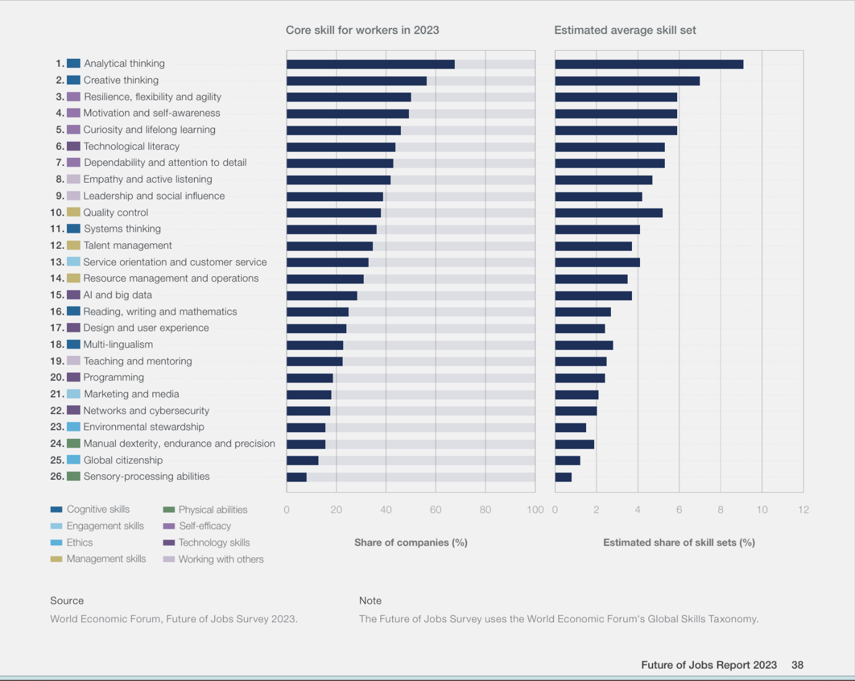
In this analysis, we can see that mental skills take precedence over technical knowledge, the importance of technological literacy and the importance of lifelong learning.

2. ANALYSIS OF CORE COMPETENCES FOR THE FUTURE
According to the conclusion I reached from the reports and research, I would like to specify the most important skills in a more explanatory way.
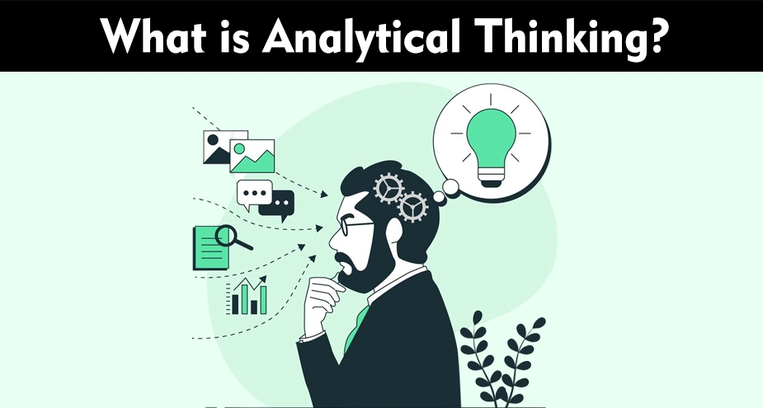
-Analytical Thinking:

- Analytical thinking involves following a logical, step-by-step approach to solving problems. By breaking information into smaller parts, individuals can understand the overall picture more easily and reach correct conclusions more quickly [2].
Individuals with analytical thinking skills, after defining a problem, proceed to the data collection phase, measuring the components of these alternatives by designing sequential solutions. The return on investment for complex business generally requires a discipline of analytical reasoning and is broad in scope:
Determining causality: Assessing whether and how one event causes another.
Benchmarking and correlation: Analysing the distribution of similarities, divergences, and hidden connections within existing data.
Sequential prediction: Following a flexible logical sequence to make accurate predictions about potential developments in the next stage.
Trend and pattern analysis: Identifying recurring patterns, regular schedules, or characteristic features within data units.[2].

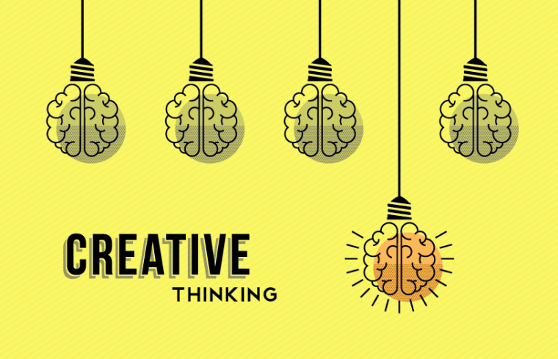
-Creative Thinking
- Creative thinking is the process of finding the optimal solution by incorporating alternative perspectives into problems, alongside an analytical approach. Unlike analytical discipline, it involves embracing the "art of creation" by developing ideas beyond conventional boundaries. [3].

-Resilience, flexibility, and agility


In the world of modernism, skills play the most key role around uncertainty. They represent an employee's ability to stand firm in a storm and to change direction.
The ability to remain resilient during crises, adapt to changing circumstances, and swiftly overcome unexpected obstacles is essential. These dynamic skills are fundamental in roles that require working under intense pressure, rapid reasoning, and providing uninterrupted, reliable support to senior management.

According to the World Economic Forum, these are among the key skills needed for 2027.
Flexible and Agile Approach: Professionals who see change as a process to be managed, rather than a threat, continue to perform at a high level even in uncertain environments.
Critical Role and Success: In the modern business world, sustainable success depends not only on technical knowledge but also on emotional resilience and rapid adaptation.[4].

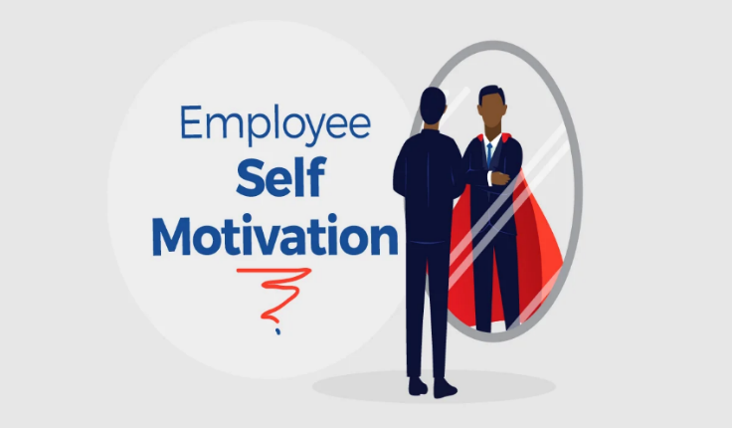
-Motivation And Self-awareness

The work environment of our day and future is reinforced by remote work. In this case, it brings a situation where not only external motivations but also a person's internal motivation becomes more important. Like working towards a service and a purpose, like adding value to one's work.
It is highly beneficial for employees to analyse their own strengths, weaknesses, core values, and emotions, and to understand how these are reflected in their behaviour at work. When a person develops a clear vision of their inner world, they can better assess the impression they make on others, establish healthier dialogues, and make rational decisions.
With a strong sense of self-awareness, we can better understand how we are perceived by others, communicate more effectively, and make more thoughtful and strategic decisions. [5].

Task 1 (b): Evaluation of Task 1 (a) based on Similarity report

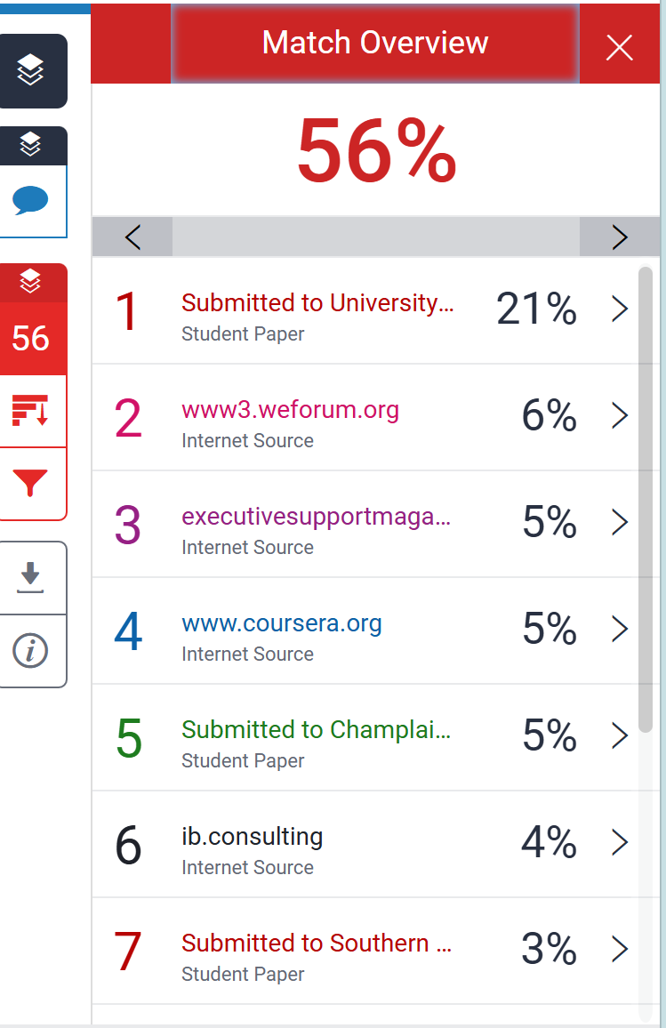
This report assesses the critical transition from academic to professional success and emphasizes that technical knowledge is no longer the sole determinant of career continuity. In conclusion, the findings show that personal characteristics such as resilience, self-awareness, and intrinsic motivation are key drivers of long-term employability.
When analysing the high similarity rate in my study, I realized I had made the reference paragraphs unnecessarily long. This reduced the weight of my own original interpretations in the text. I understood that in the future, I need to strike a balance by keeping the quotations shorter and giving more space to my own analyses and original sentences.

Task 2: Collaborative Mind Map and Individual Poster

Mind Map (Collaborative)
Mind map link: https://mm.tt/map/3952802819?t=dCVxYhEwu0

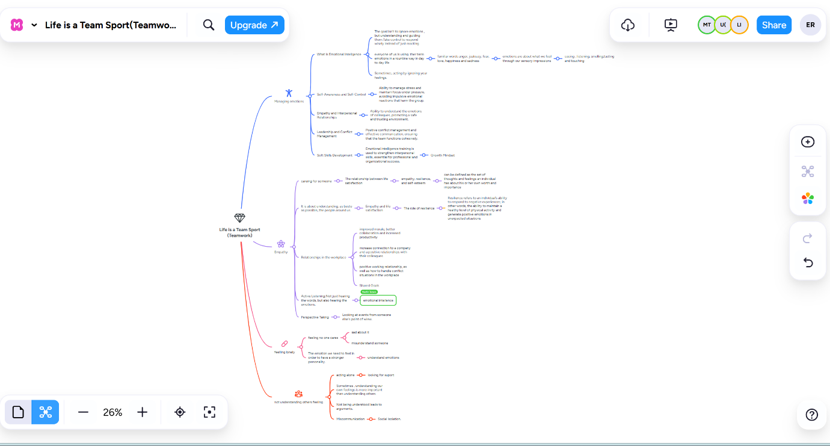

Poster (Individual)
Canva Poster Link: https://www.canva.com/design/DAHC0UV7Jhs/VF_x8G-0I3Zk0hYEv_MQmA/edit?utm_content=DAHC0UV7Jhs&utm_campaign=designshare&utm_medium=link2&utm_source=sharebutton
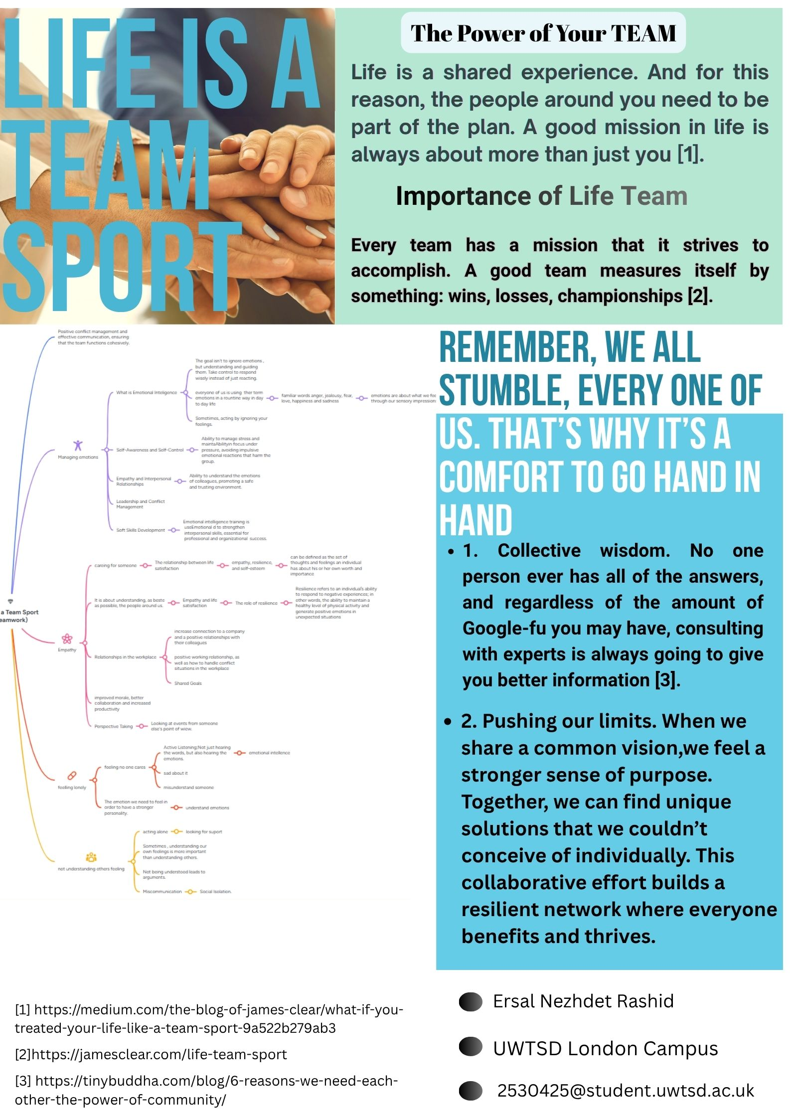

Task 3: Virtual Collaboration and RefWorks

Report on Virtual Collaboration
Topic 1: Forming a Team
Virtual Collaboration and Team Dynamics
Virtual team dynamics are ways in which the personal characteristics and interpersonal behaviours of team members impact on how they interact, communicate and collaborate to achieve shared tasks [1]. The first stage of Tuckman’s stages of group development is the "Forming" stage [2], when a virtual team is first established. Each individual tries to learn about each other, but their communication is primarily shallow with no visible structure or involvement from anyone [3].
The forming stage in a virtual environment comes with its own challenges. The lack of physical interactions face to face tends to enhance negative presumptions and makes developing rapport in members of the group harder. A saying from researchers states that “distance breeds distrust” [4]. To counter this and develop a highly effective team you must build what is called “vulnerability-based trust” [5]. This kind of trust only exists when people feel psychologically safe to be completely honest and open with their co-workers. Genuine vulnerability involves having the bravery to “show up and be seen” [4]
The unfortunate reality of virtual working is that it can lead people to pretend they’re online. Anxious or ashamed and wanting to seem overconfident in front of their team, members may mask their authentic selves, or they withhold what they don’t know. Nevertheless, projecting an authentic self is essential. Authenticity is the bedrock of true trust and deeper professional bonds [5]. Also, being authentic is a great way to improve team morale and time management: when people tell the rest of their colleagues what they can do and prewarn if it won't be feasible delivering on time these tasks will flow quickly.
This can be an important phase in establishing the new team and generating engagement, so objective setting needs to be key here. Teams should leverage the FAST framework to ensure everyone’s aligned toward the same vision. Goals need to be Frequent, Ambitious, Specific and Transparent [2]. When done correctly, FAST goals will lend guidance to your team on the direction the business should take even when you are physically apart. Real dialogue, vulnerability-driven trust, and FAST goals help these virtual teams move out of their ambivalent forming stage to become an effective unit.

Step-by-step process of using RefWorks with visuals

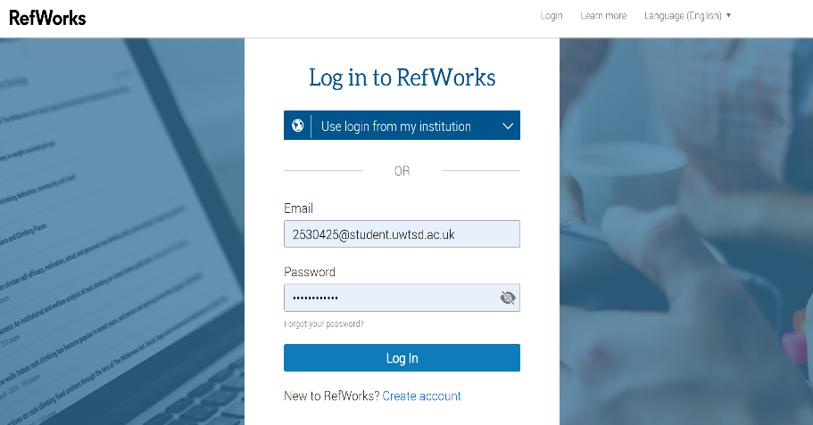

First, to log into my RefWorks account, I entered my registered account information.

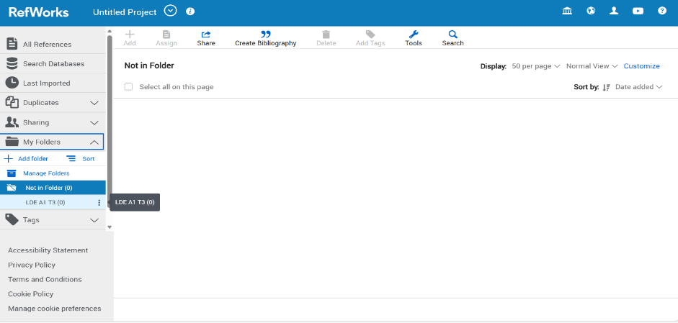

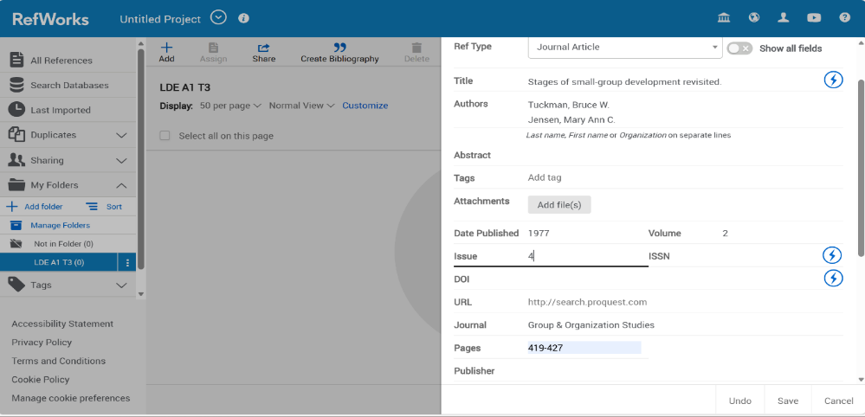
I prepared my workspace by creating a dedicated folder.

Next, I manually inputted the literature details. I filled in the necessary metadata fields, including authors, publication year, and page numbers.

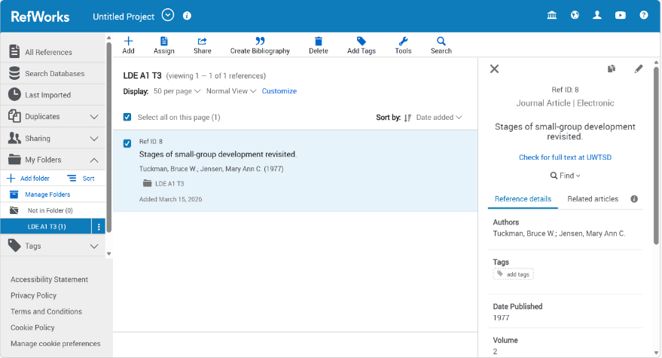

Once saved, the sources appeared in my project folder, confirming the data was correctly stored and ready for citation.

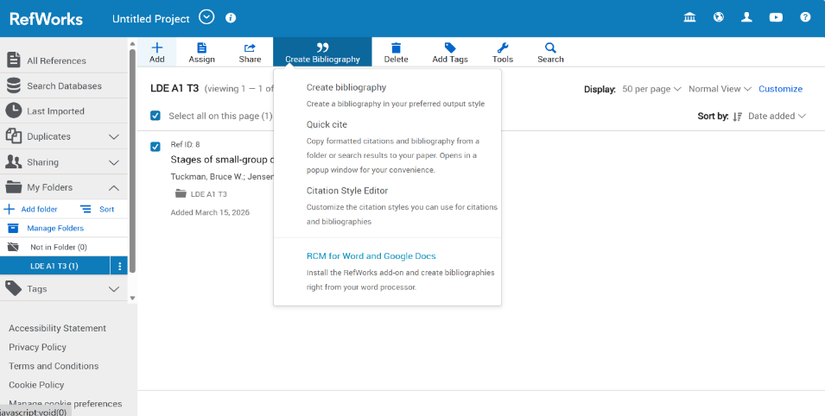
To generate the reference list, I selected the items and used the 'Create Bibliography' dropdown menu function.

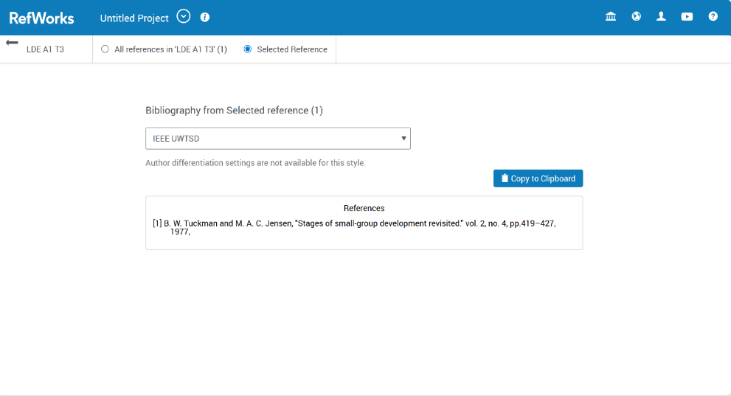 I applied the 'IEEE UWTSD' formatting style. The system automatically generated a correctly structured, numbered reference list for my summary.

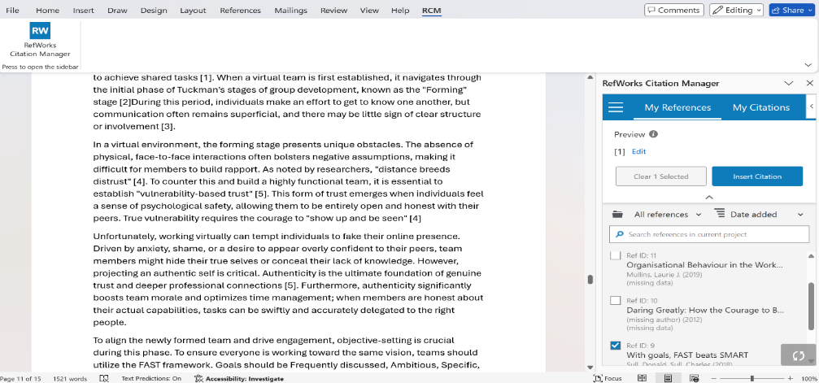

Using the RCM plugin in Word, I inserted numbered in-text citations into my report.
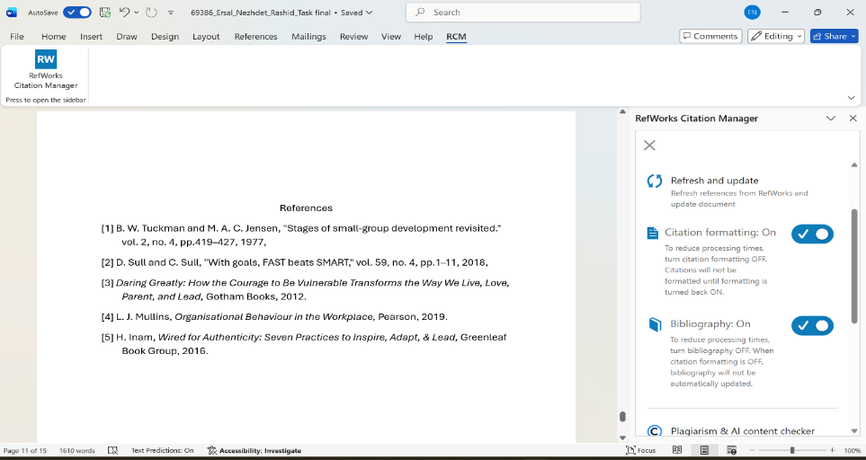 Finally, the tool automatically generated a complete, formatted reference list at the end.

Task 4: E-Portfolio Creation and Evaluation

Task 4 (a): E-Portfolio Creation

E-Portfolio Link: https://25304251.wixsite.com/erashid
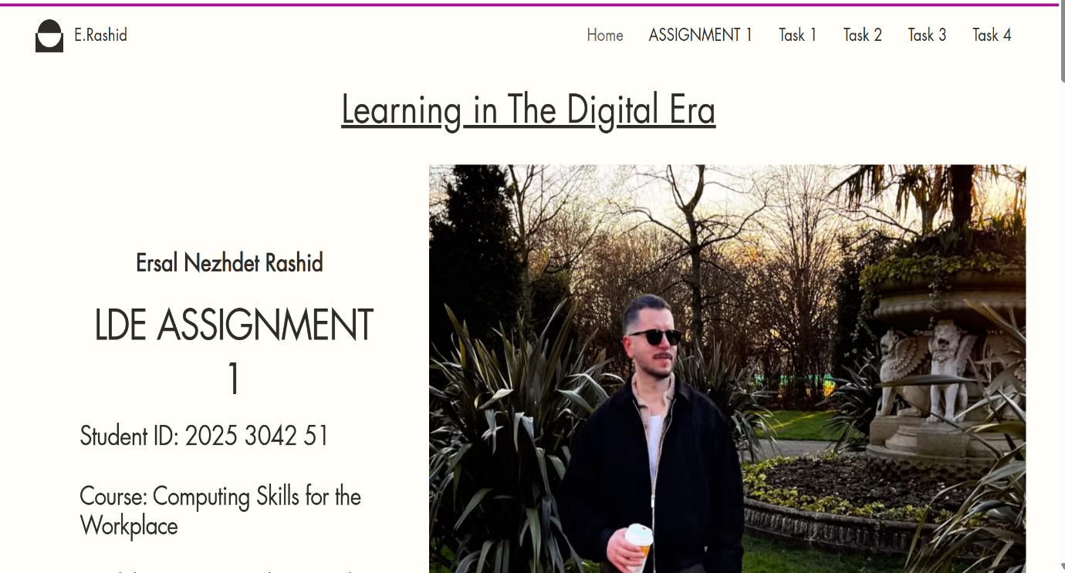

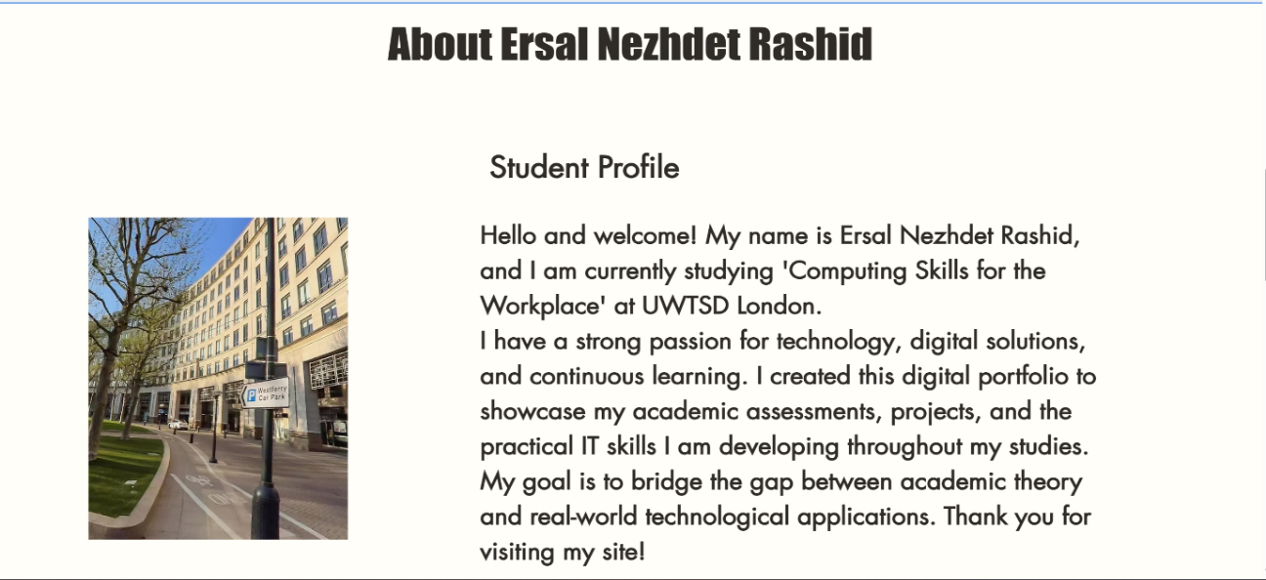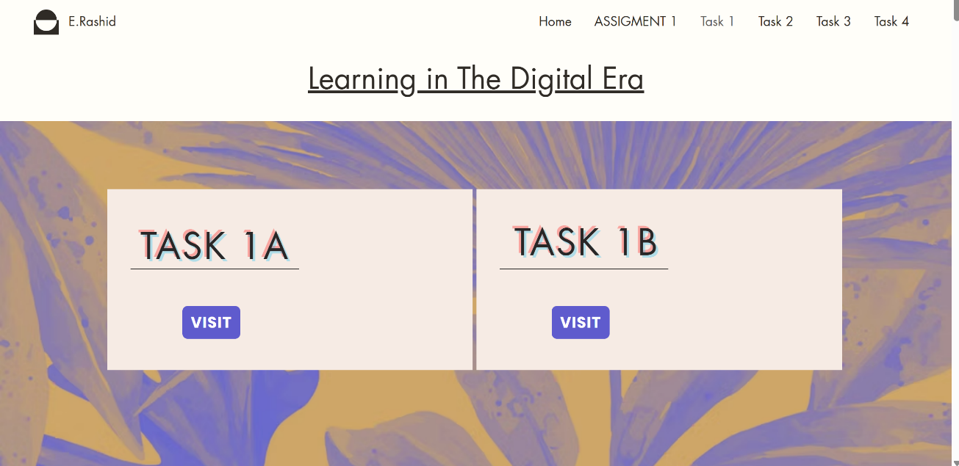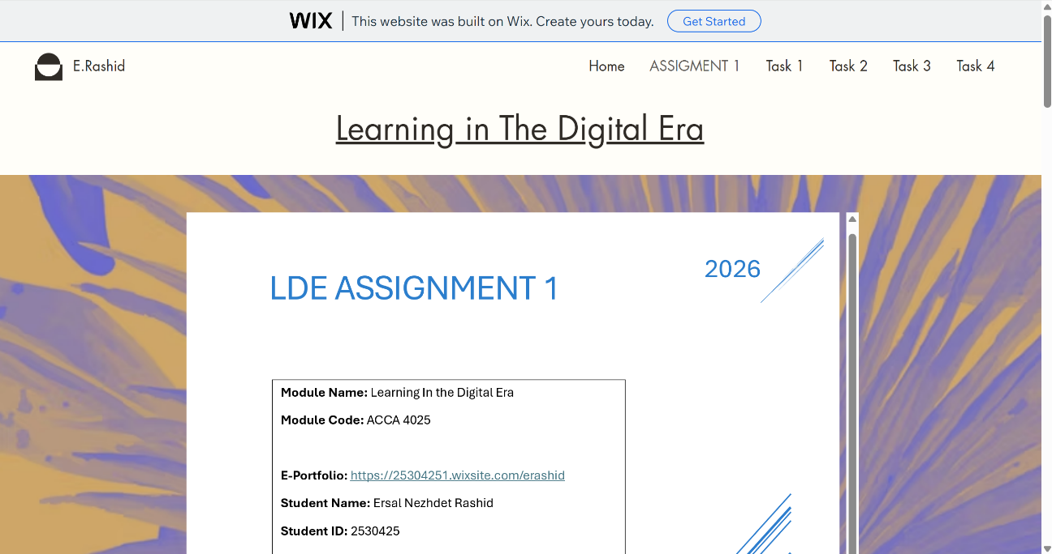

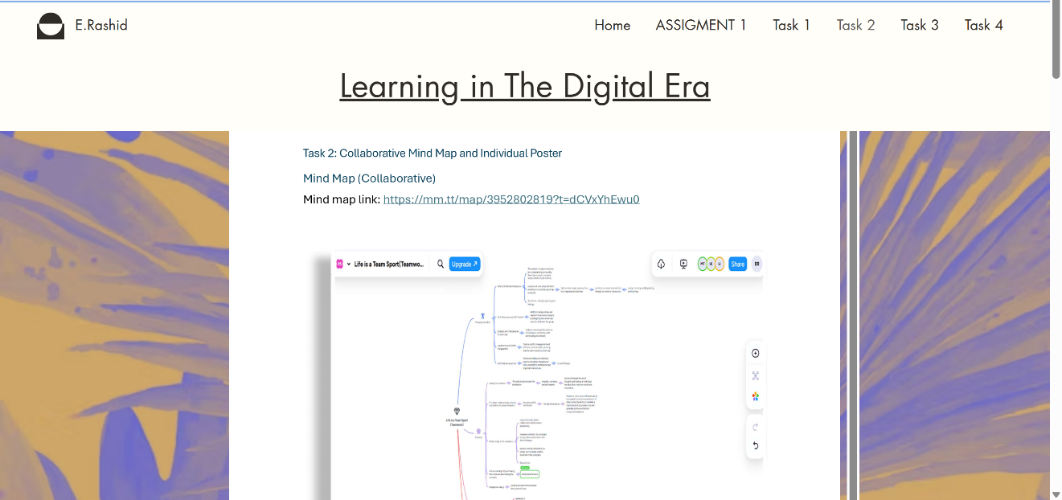

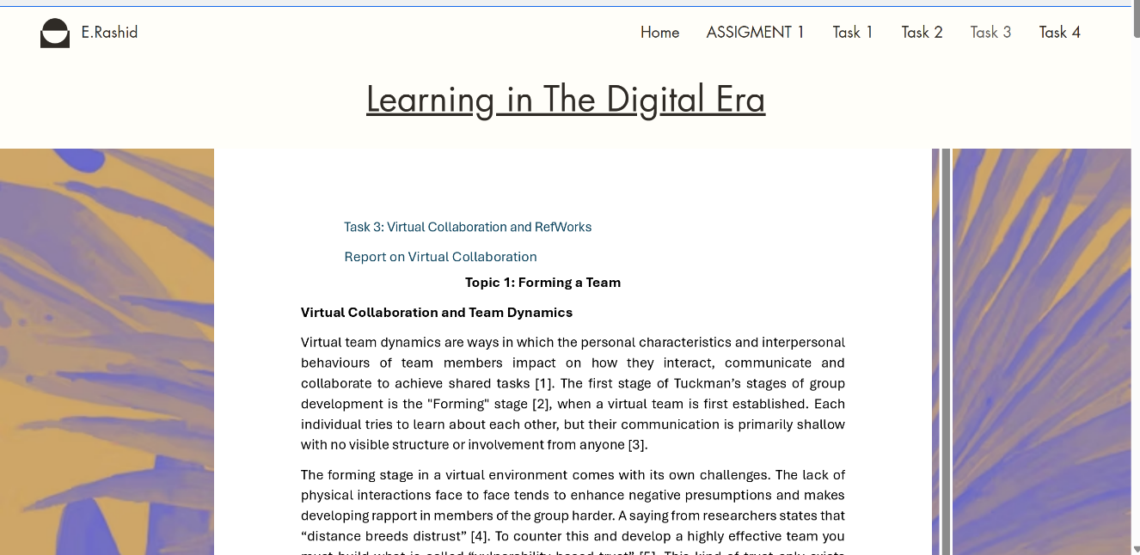

Task 4 (b): Illustrative Review of E-Portfolio tool Selection

I used the Wix platform to develop my e-portfolio; however, I found the interface to be less intuitive than I expected. During the design phase, I experienced delays and frequent freezes, negatively impacting both my productivity and motivation. Furthermore, the navigation system and options sections were complex. A simpler and more user-friendly menu would have been more beneficial. In conclusion, while Wix offers extensive customization tools, I believe its operational inefficiencies and complex interface make it a platform I would not choose for future projects.

Conclusion
In conclusion, this assignment effectively highlighted the essential competencies and digital applications needed in today's work environment. This work fostered a deeper understanding of the necessity of teamwork, alongside cognitive skills. Furthermore, RefWorks and e-portfolio applications significantly contributed to my digital literacy. Taken together, these tasks underscore the importance of continuous learning, clear communication, and adaptability to technological change for success in the digital age.

References

Task 1a:

[1] | W. E. Forum, “Future of Jobs Report,” World Economic Forum, Cologny/Geneva, 2023.
[2] | C. Staff, “Coursera,” 15 Jan 2026. [Online]. Available: https://www.coursera.org/articles/analytical-thinking.
[3] | T. K. Academy, “The Knowledge Academy,” [Online]. Available: https://www.theknowledgeacademy.com/blog/what-is-creative-thinking/.
[4] | D. Haig, “Executive Support Magazine,” 25 September 2025. [Online]. Available: https://executivesupportmagazine.com/resilience-flexibility-and-agility/.
[5] | L. Augusta, “Forbes,” 15 March 2023. [Online]. Available: https://www.forbes.com/councils/forbescoachescouncil/2023/03/15/how-to-increase-self-awareness-in-the-workplace/.

Task 3a:
[1] B. W. Tuckman and M. A. C. Jensen, "Stages of small-group development revisited." vol. 2, no. 4, pp.419–427, 1977,
[2] D. Sull and C. Sull, "With goals, FAST beats SMART," vol. 59, no. 4, pp.1–11, 2018,
[3] Daring Greatly: How the Courage to Be Vulnerable Transforms the Way We Live, Love, Parent, and Lead, Gotham Books, 2012.
[4] L. J. Mullins, Organisational Behaviour in the Workplace, Pearson, 2019.
[5] H. Inam, Wired for Authenticity: Seven Practices to Inspire, Adapt, & Lead, Greenleaf Book Group, 2016.

