Information Engineering Report
Student:
Ivaylo Hristov - 1905387
Teacher:
Anupam Mazumdar
Course:
Information Engineering – L4T2

Contents
ERD 3
MS Access forms 4
Login Form 4
Main navigation window 6
Staff from 7
MS access queries 8
Absence query 8
Emergency query 8
First aid certificate query 8
MS Access reports 9
Absence reports 9
Bank details reports 10
Courses report 11
Macros 12
Save record button macro 12
Add new staff button macro 12
Delete current record macro 13
Relationships 14

ERD
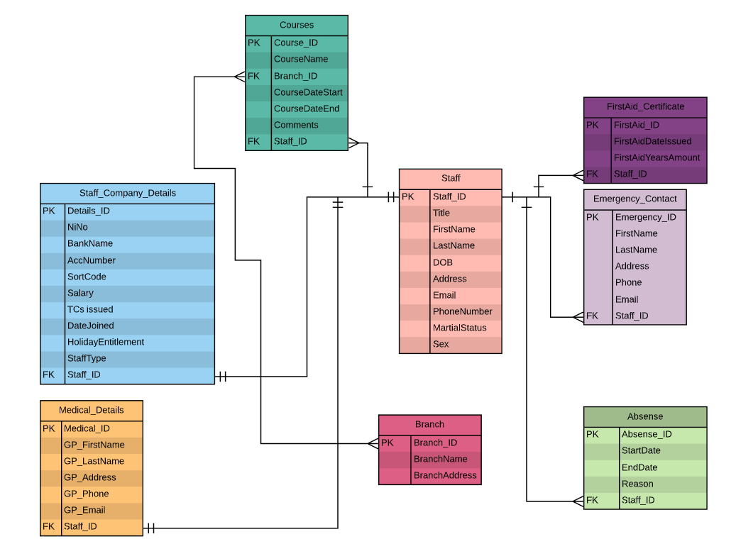
It represents the dataflow of the information inside of the project.
The main table from where it all derives is “Staff” table. The staff table holds all the personal information about a member of staff. The “Staff_ID” field is passed almost across every table, because each operation requires some information from “Staff” table to make its operation to make useful sense.
Table “Staff_Details” holds strictly related to only one entity of “Staff” about payment and work details.
Table “Medical_Details” holds strictly related to only one entity of “Staff” about medical and doctor’s data.
So, the relationships between “Staff” and these two tables are one-to-one.
The relationships between “Staff” and other tables is one-to-many, because a member can have more than one entity from these table related to him.
- First Aid Certificate table- a member can be a holder of one or more certificates. He can be a Pool guard, First Aider and Karate instructor.
- Absence – a member can have many reasons through the year to not show up at work.
- Courses – a member of staff can attend many courses to teach or attend.
- Emergency contact – a member can have many contacts in case of emergency. i.e. his partner, mother, sister or friend.

MS Access forms

Login Form
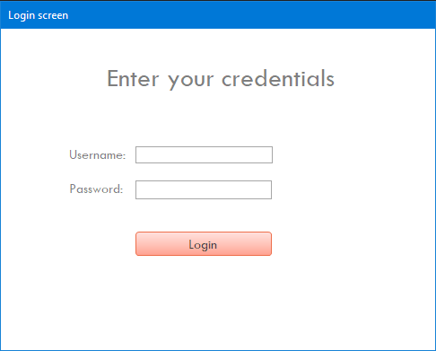
This is the first form, which pops up on the screen as soon as you load the database file. The user must enter administrative credentials to log inside the database and make changes. The default administrative credentials are
- For username – “admin”
- For password – “admin”
If the user enters wrong details, the login form will not let the user inside until he provides correct credentials.
There is validation for username and password. The login form will let the user know if he enters wrong details. 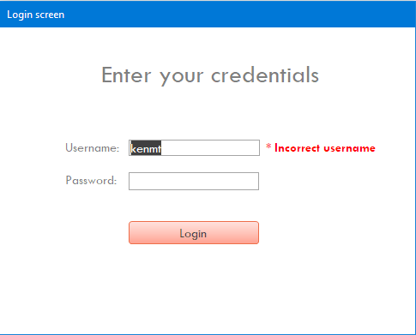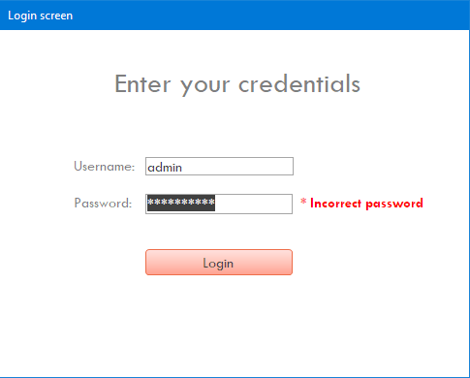

Main navigation window
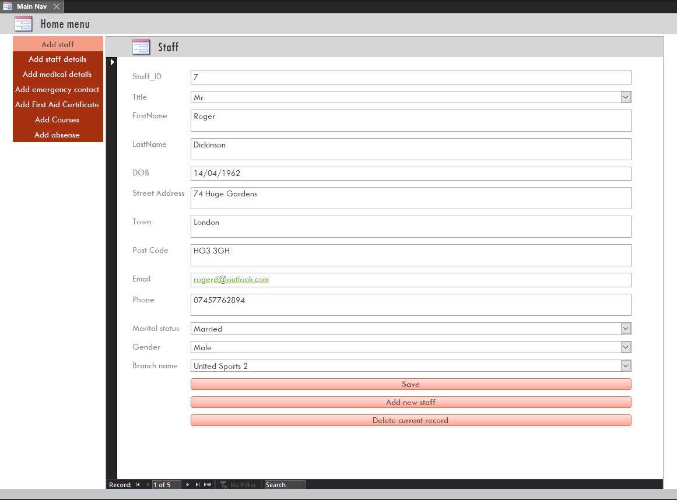
This window gives the opportunity to the user to add/edit/delete data to all the tables. He can navigate through the different forms with the red navigation menu on the left side of the window.
The first opportunity is to create staff personal details. The user can enter the requested information inside this “Add staff” form. Once ready, he should click “Save” button to save the record inside a related table. Then, the user can open a new entry with “Add new staff” button or navigate through the record with the buttons ribbon on the bottom of the form to select which record to be deleted/edited. The same logic applies for all the forms inside this navigation window.

Staff from
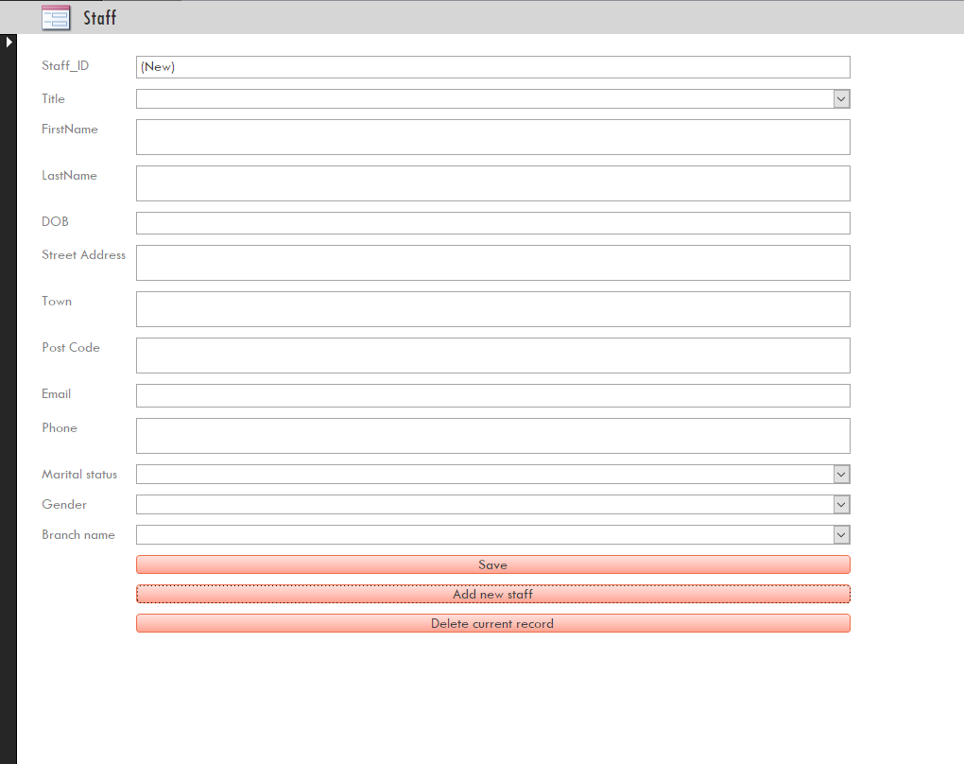
Staff form is the parent of all the forms. It is related to the main “Staff” table where all the information inside the project derives.

MS access queries

Absence query
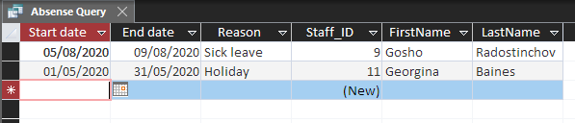
Pull from the database of the entries, related to absent workers, reason and absence timespan.

Emergency query
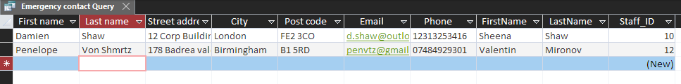
Pull from the database of the entries for all emergency contacts and their related staff details.

First aid certificate query
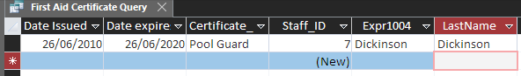
Information about each staff, who holds any first aid or similar kind of certificate.

There are many opportunities to create different queries according to the user need, so these are just a few examples, which are created inside the database file.

MS Access reports
Again, there will be few examples for simple reports about various information related to the database file.

Absence reports
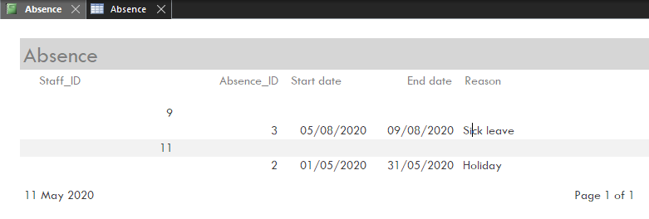
Report, which shows all the absent workers, lifespan of absence and reason

Bank details reports
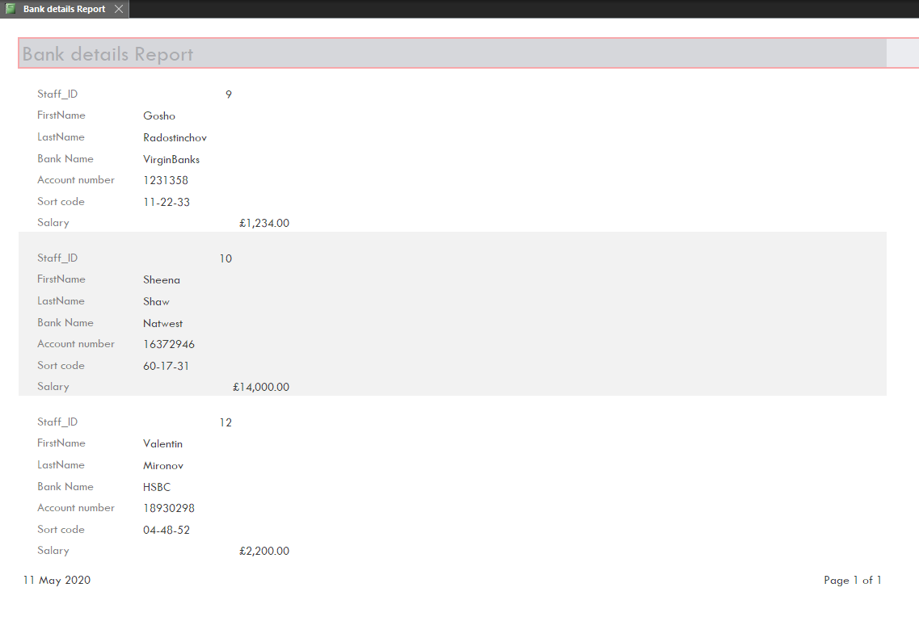
This report shows the bank details to pay in salary and their bank account details.

Courses report
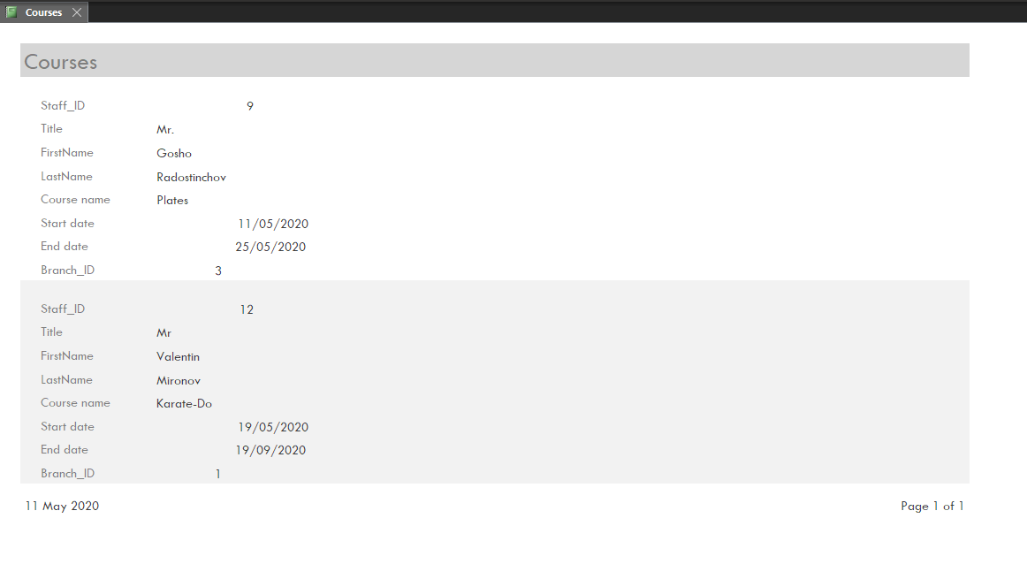
Report shows all the courses, which workers are currently enrolled in.

Macros

Save record button macro
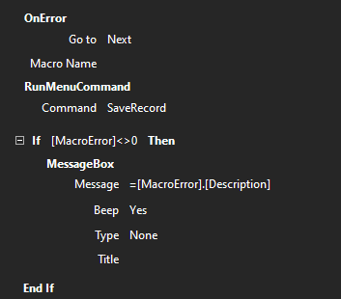

Add new staff button macro
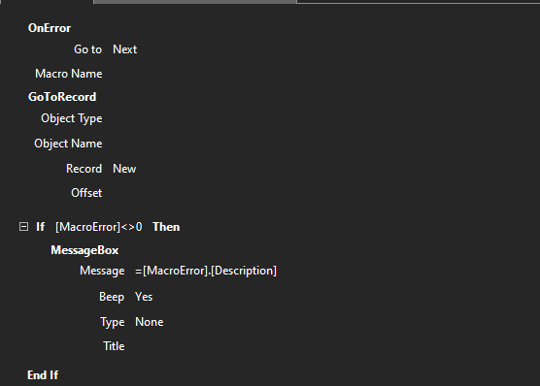

Delete current record macro
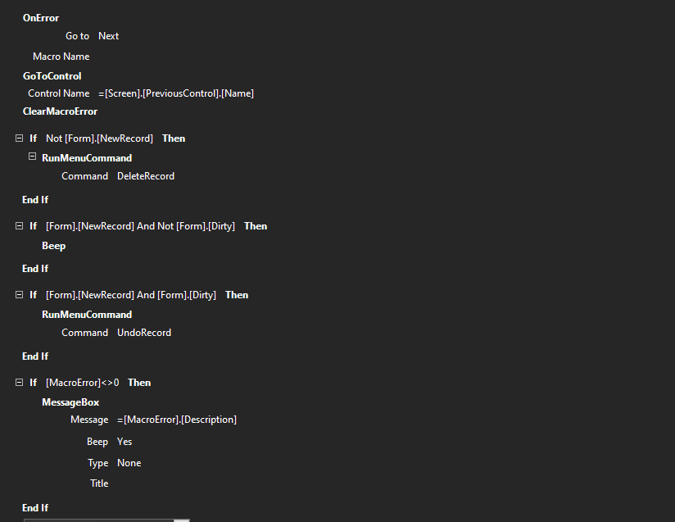

Relationships
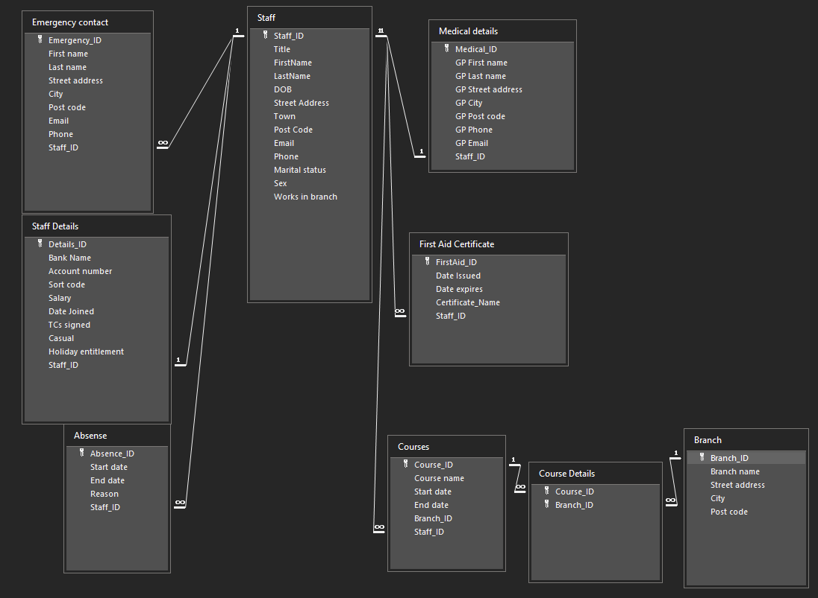
It shows all the relationships between the tables of the database file.

