Evaluation of the arena trial at COTEC
ACDA6021

Quinn Dunbar
2217666

Executive Summary
A trial was conducted at the Cranfield Ordnance Test and Evaluation Centre in order to characterise an unknown munition, The trial was setup as an arena trial as defined in ITOP-4-2-813. However, the standards within ITOP-4-2-813 were not adhered to and hence there are many improvements that could be made to the trials procedure. The arena was below the specified diameter and arc and hence less data could be gathered form the collected fragments. Insufficient velocity foils of an overly large size were used, and high-speed video was entirely absent, reducing the amount of velocity data that could be gathered. Only one array of pressure sensors were set up and hence there was no redundancy for pressure capture, and this was demonstrated by a fragment strike on one of the sensors, reducing the amount of available data by a third. Finally, explosive residue recovery was attempted, but the use of Fourier transform infrared spectroscopy was an unsuitable analysis method, resulting in inconclusive results. Overall, no part of the trial was setup to the requirements of ITOP-4-2-813.

Contents
Executive Summary 2
Table of Figures 3
1. Introduction 4
2. Arena setup 5
3. Sensor setup 8
3.1. Time zero determination 8
3.2. Fragmentation Velocity Capture 8
3.3. Blast Pressure Capture 9
3.4. Explosive Residue Sampling 10
4. Conclusions 11
References 12

Table of Figures
Figure 1 - The arena used in the trial. Photograph by L. Smith 5
Figure 2 - Arena setup as per ITOP-4-2-813 [1] 6
Figure 3 - Velocity foil location on witness pack. Foil 1 has not been hit by a fragment. Photograph by L. Smith 9
Figure 4 - Mounting for pressure sensors 10

Introduction
A trial was carried out at Cranfield Ordnance Test and Evaluation Centre (COTEC) to determine the identity of a mystery munition. An arena trial was chosen as it could be set up to capture a number of data types that could then be evaluated to determine the munition’s identity. However, due to a number of factors, such as not knowing the nature of the munition, the trial setup was not optimal. This works looks at various ways the trial could have been improved to provide more, clearer data.

Arena setup
The purpose of an arena trial is to allow for the capture of fragmentation from a munition. This allows for the analysis of fragmentation spread and velocity along with the characterisation of the fragmentation itself. The methodology of arena trials is defined in ITOP-4-2-813 [1], and this was the standard the trial was based on.
The arena was set up in a 113º arc, with a radius of 1.5m, consisting of 3 packs of strawboard arranged one-high, covering 15º of elevation. This does not match the requirements of ITOP-4-2-813, as it specifies a semi-circular arena covering 190º. 190º is required as this allows for the capture of fragmentation caused by the “polar” regions of the munitions, i.e. the top and bottom. The radius of the arena was also not as defined in ITOP-4-2-813, as this specifies a minimum radius of 2m, with greater distances as the mass of explosive under test increases [1].
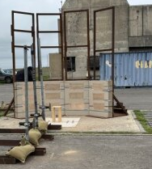
Figure 1 - The arena used in the trial. Photograph by L. Smith

The requirement for the capture of fragmentation from the poles of the munition highlights another mistake in the setup of the trial. ITOP-4-2-813 requires that the longitudinal axis of the munition runs horizontally through the munition, whereas for this trial the munition was setup such that the longitudinal axis was vertical. The result of this was that the fragmentation formed at either end of the munition was not captured, and this was of particular importance as the munition used was a pipe bomb which has characteristic fragmentation produced at each end, i.e. the endcaps. It also meant that the fragmentation pattern was not accurately represented in the witness packs, as the detonation did not occur symmetrically through the centre of the arena.

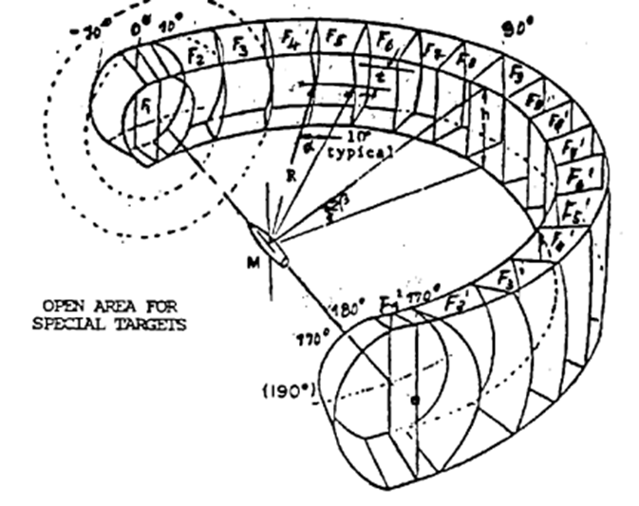
Figure 2 - Arena setup as per ITOP-4-2-813 [1]

Strawboard is made to a precise standard of density and size that allows for fragmentation momentum to be calculated from the depth of penetration into a stack of strawboard [2] [3]. To keep the strawboard to specification, strawboard packs are wrapped in plastic to prevent moisture ingress. The strawboard used in this trial was not wrapped and had been kept in an iso container for an unknown period of time, and hence showed signs of moisture ingress resulting in it not being possible to make calculations based on penetration depth as the density of the board was not known.
The precision of the measurements for the arrangements was also low as the distance measurements were taken manually using a tape measure. A total station is the recommended instrument for taking the spatial survey of an arena, as it offers a higher resolution than a tape measure and allows for all measurements to be taken from a single reference point, reducing errors caused by misreading of the tape measure [4].
The firing height was also not well-defined as a 50cm high firing table was produced for the munition to be fired from, and hence 50cm was assumed as the firing height. However, due to the orientation of the munition and the fact that as its nature was not known its detonator position was also not known, it is unlikely that this was the true firing height. This introduces error in the fragment collection, as the firing height is needed when reconstructing the fragmentation pattern, and is used to determine the location of ricochet stops, as suggested in ITOP-4-2-813. However, this trial also lacked ricochet stops, resulting in further error if the fragmentation pattern were to be reconstructed, due to additional fragments in the witness packs that were the result of ricochet from hitting the ground rather than having travelled directly from the munition.
Overall, the accuracy of the arena was low due to every measurement being taken from an approximate location of where the munition was intended to be placed and the low accuracy provided by using a tape measure to determine distances. As such any calculations that require distance, such as fragment and blast wave velocities, along with comparisons of pressures at a given stand off distance, will have an unknown amount of error in the measurements and hence lead to high uncertainty in the calculated values.

Sensor setup

Time zero determination
Time zero (T0) is the time from which measurements begin, and is used in the calculation of blast wave and fragment velocities, as well as being a trigger for the logic analyser collecting data from the sensors setup in the arena, and can be assumed to be the time at which the detonation occurred for this trial.
For this trial a break wire was used to set the T0. Break wires pose a number of disadvantages for determining an accurate T0. The break wire measured the moment the casing broke, but specifically the area of the casing it is attached to. Without information on the location of the break wire with respect to the point of detonation, there is a time lag between the detonation and the wire breaking that is unaccounted for. This can lead to incorrect measurements of fragment velocity, as the some fragments may already be in flight before T0 occurs [3].
Having multiple measurements for T0 can increase reliability of a trial, as for this trial, if there was an error where the break wire did not trigger the logic analyser, all data would be lost. There are multiple other triggers that could have been employed on the trial. The first is using a Pearson coil, an inductor that is placed around the firing cable to the detonator that triggers when the firing pack is activated. For this to provide an accurate T0 a high-voltage detonator would be required as these have precise detonation timing. This trial however used an L2A2 low-voltage detonator which have a variable detonation delay by nature of their construction, as such using a Pearson coil would not necessarily produce a more accurate T0 [3]. Another T0 trigger that can be used as a backup is the use of a High Speed Video (HSV) camera, that can be programmed to record T0 when it detects the flash from the detonation, A HSV camera was not used in this trial, and the additional data it could have provided is discussed in the next section.

Fragmentation Velocity Capture
Fragmentation velocity was measured using “make” velocity foils, a conductive mesh that records a hit when a fragment makes contact due to the fragment making an electrical connection between the parts of the foil which is recorded by a datalogger, and from the time of the impact and the distance from the munition to the witness packs, the fragment velocity can be calculated. This only works for the first impact onto a foil, as this is assumed to be a fragment flying directly level from the munition to the foil, whereas subsequent impacts are likely caused by fragments travelling further than the radius of the arena and hence their velocities cannot be calculated as the distance travelled is unknown. This is of particular note as the velocity foils used in this trial were of a relatively large size, around 30 x 15 cm, which resulted in only one data point being recoverable from large areas of the arena, severely reducing the amount of data that could be analysed about the velocity of the fragments. Only 12 foils were set up, and these were not able to be arranged optimally as the size and nature of the munition was not known, so they were arranged in an even spread across the witness packs, resulting in some of the foils not being hit at all, further reducing the available data.

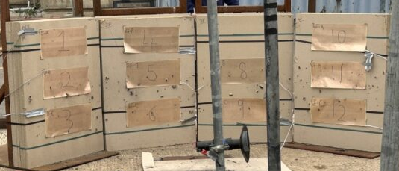
Figure 3 - Velocity foil location on witness pack. Foil 1 has not been hit by a fragment. Photograph by L. Smith

This setup for the capture of velocity data does not match the requirements set by ITOP-4-2-813, which states the need for at least 37 channels linked to velocity foils, and the use of HSV [1]. HSV allows for more accurate fragment velocity measurements, as it is possible to track a fragment over a distance allowing for a calculation of velocity regardless of its start and end point, as long as it travels at a known angle and distance with respect to the camera, this leads to lower uncertainty than the velocity calculations based on velocity foil data, where the distance travelled by the fragment can only be estimated. HSV also allows for calculation of the velocity of multiple fragments, whereas each foil can only record one [5].

Blast Pressure Capture
Three pressure gauges were set up at 1 metre intervals from the firing position. They were aligned to be along the centreline of the munition and in-line with each other at staggered heights to prevent them experiencing wash caused by the pressure wave interfering with the sensor stand ahead of them. The first sensor was struck by a fragment, so only two thirds of the desired data was recorded. This highlights the need for redundancy in sensor arrays to account for any sensors damaged by the explosion and hence prevent the loss of data, with the best way to achieve this being setting up multiple identical pressure sensor arrays at different points along the circumference of the arena [4].
Pressure sensors will not only record the pressure produced by the blast wave, but also other sources of pressure changes, particularly the initial ground shock, reflected blast waves and ringing. The sensors were mounted in rubber isolation mounts that decouple the sensors from the stands they were attached to and hence reduces the amount of noise added to the sensor output by ringing caused by the vibration of the stand when it is hit by the blast. The sensors were mounted in a conical disc shroud, and arranged perpendicularly to the expected wavefront, so as to measure the incident rather than reflected pressure produced. The conical shroud acts to cut through the wavefront, reducing diffraction effects caused by the sensor being in the wave’s path [4]. To reduce the amount of reflected pressure waves produced, the blast pad should be free of obstructions as far as reasonably possible and the distance from large structures to the detonation point should be maximised.

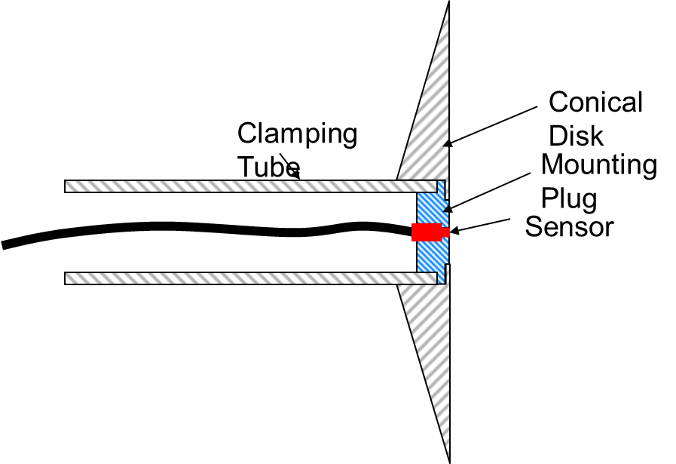
Figure 4 - Mounting for pressure sensors

The gauges used were of the integrated electronic piezo electric type. These sensors have the amplifier built into the same unit as the sensor diaphragm and hence reduce the amount of noise picked up by the electrical signal prior to amplification. It also allows for simpler cabling runs, as there is no requirement to wire the sensors to a separate amplifier that also needs protecting, and amplified signals retain better signal integrity over the length of a cable, allowing for longer cable runs [3].

Explosive Residue Sampling
To aid in the identification of the munition, swabs were taken of the arena pre- and post-blast, with the intention being for the pre-blast swabs to give a background and hence reduce the chance of false positives from contamination already present. Unfortunately, this is not a reliable way of performing trace explosive residue recovery, as the amounts are small so the difference from baseline would be hard to detect without high sensitivity methods.
The swabs were then analysed by Fourier-Transform Infrared Spectroscopy (FTIR) after being extracted using acetone. FTIR is unsuitable for trace analysis due to its low accuracy at that threshold [6]. There is also the lack of a chromatographic stage to consider, that would allow the multiple compounds present on the swab to separate and be analysed individually, as it was all compounds were analysed at once, resulting in an FTIR trace from which no concrete information could be gathered.
A more robust method would be required, such as a liquid chromatography-mass spectrometry method that would allow for separation of the compounds present and characteristic identification of each [7]. It would also allow for the quantification of the amount of each substance present, and hence indicate which explosive was present in the device, as there would be an increase in the used explosive between the pre- and post-blast swabs.

Conclusions
The trial was not setup in line with the requirements set by the standard it was supposed to follow. Insufficient instrumentation was used, so the desired data could not be captured to a high degree of fidelity. A lot of these issues arise from the munition under test being an unknown quantity to those setting up the arena, so estimations had to be made and additional instrumentation was not utilised so as to prevent the nature of the munition being revealed. Unsurprisingly this leads to a poor trial set up and similarly poor data which impacts the ability to analyse the data to generate any useable information about the capabilities of the munition, as is the intention of an arena trial.

References

[1] | US ARMY DEVELOPMENTAL TEST COMMAND, “Static Testing of High Explosive Munitions for Obtaining Fragment Spatial Distribution,” US Department of Defence, Washington, D.C., 1990.
[2] | J. Read, P. Quinlan, S. Bloodworth, R. Hazael and R. Crichley, “Sustainable and economical alternatives to fragment capture materials in explosive and ballistic trials,” Forensic Sci Med Pathol, vol. 20, no. 4, 2024.
[3] | L. Groom and J. Mungham, Writers, Data Capture & Evaluation. [Performance]. DSTL, 2025.
[4] | S. Darcy-Page, Writer, Capturing an Event and COTEC Range Day. [Performance]. COTEC, 2025.
[5] | C. Suk, Y. Ogata, Y. Wada and K. Katsuyama, “Observation of the dynamic movement of fragmentations by high-speed camera and high-speed video,” in 21st International Congress on: High-Speed Photography and Photonics, Taejon, 1995.
[6] | S. Zitrin and T. Tamiri, “Analysis of Explosives by Infrared Spectrometry,” in Forensic Investigation of Explosions, CRC Press, 2011.
[7] | R. Strobel, “Recovery of Material from the Scene of an Explosion and Its Subsequent Forensic Laboratory Examination—A Team Approach,” in Forensic Investigation of Explosions, Boca Raton, CRC Press, 2011.

