Student number 2542847

DS 1 Template

My Screenshots/Photos
- Please add 4–6 screenshots or photos of your digital life.
- You can use your phone or laptop.
- For each screenshot, write one or two sentences explaining what it shows.

Screenshot/Photo 1
Outlook Email
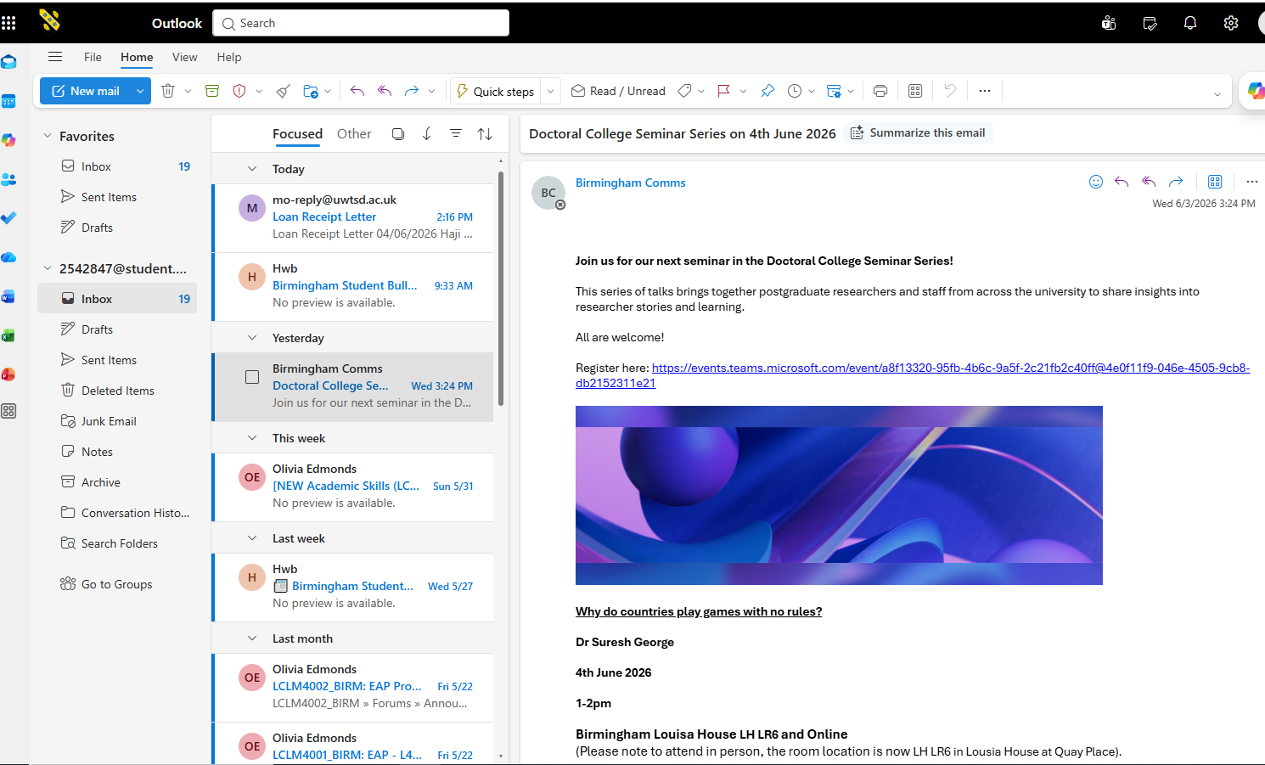
Email management organize emails with folders categories rules and focus

Screenshot/Photo 2
Moodle
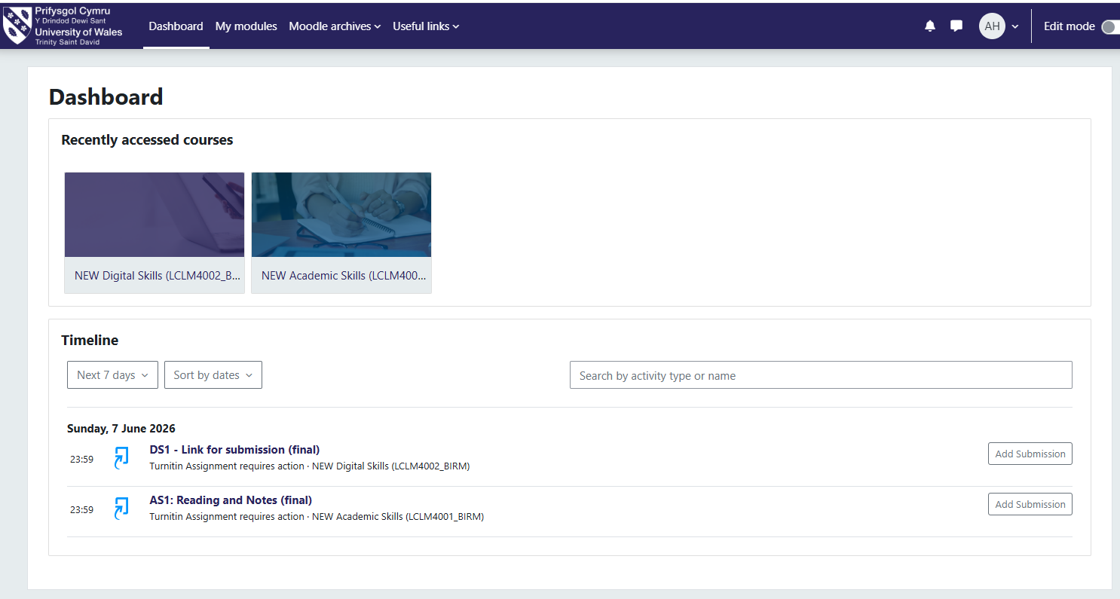
Moodle is learning management system used by universities training providers

Screenshot/Photo 3
UWTSD hub
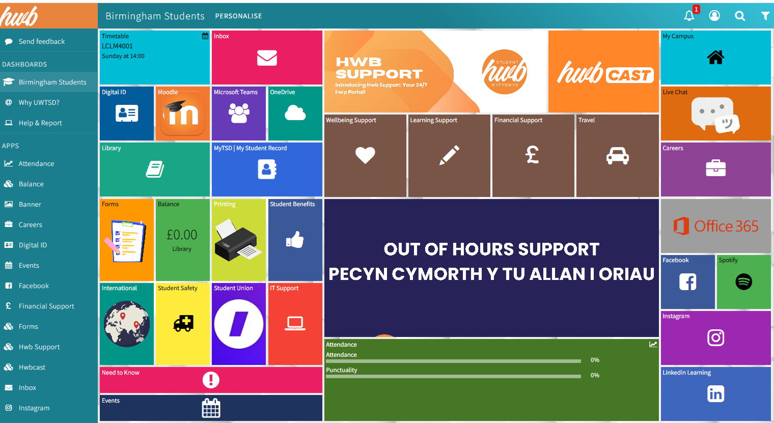
Is useful because it gives you one place access important university services and information

Screenshot/Photo 4
tiktok
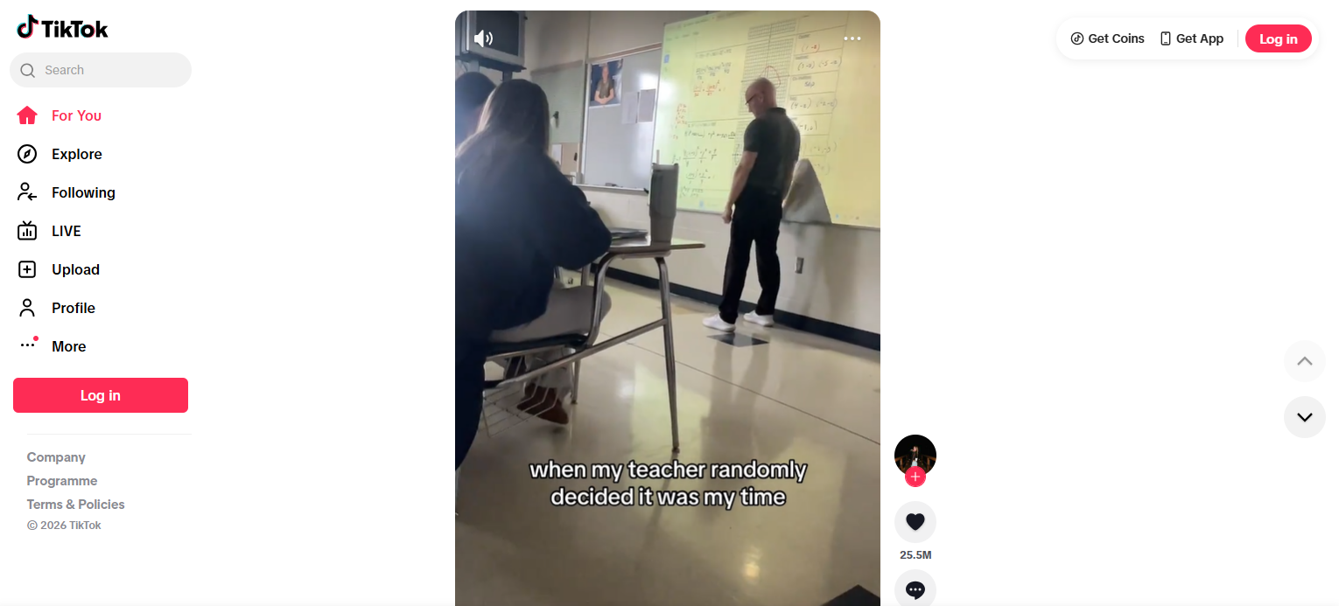
TikTok is entertainment platform provides a wide variety of short videos includes comedy music sports and creative content

Screenshot/Photo 5
snapchat
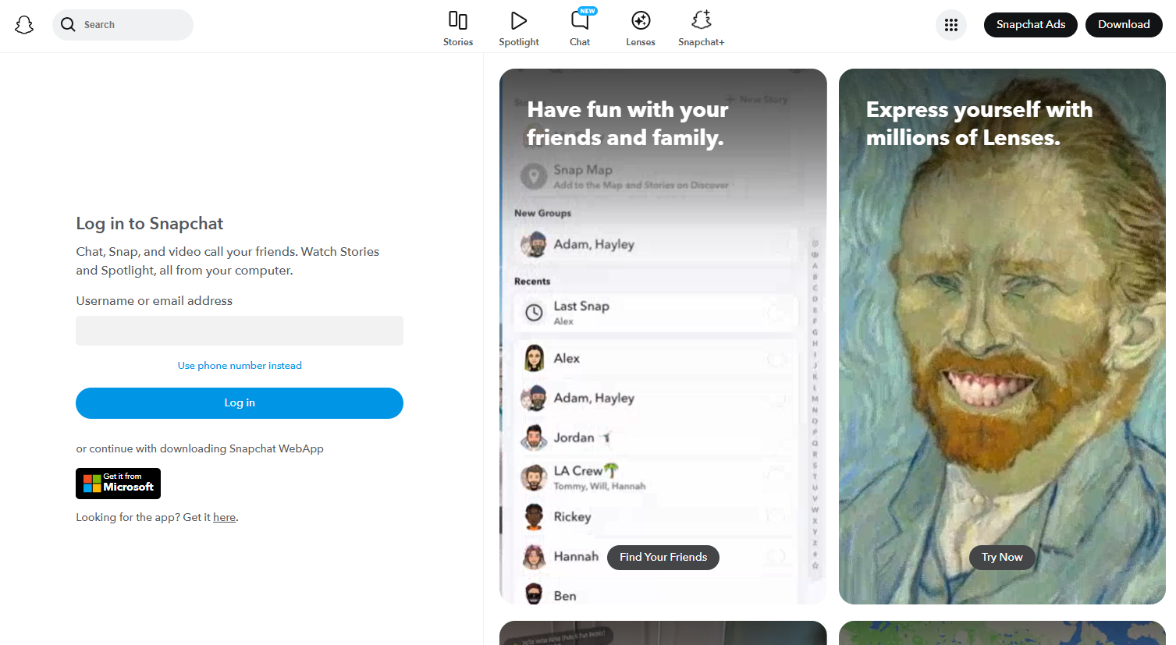
Snapchat offers several benefits especially for staying connected with friend and families it’s got quick communication sends photos and videos you can also send instant messages and photos

Screenshot/Photo 6
gmail
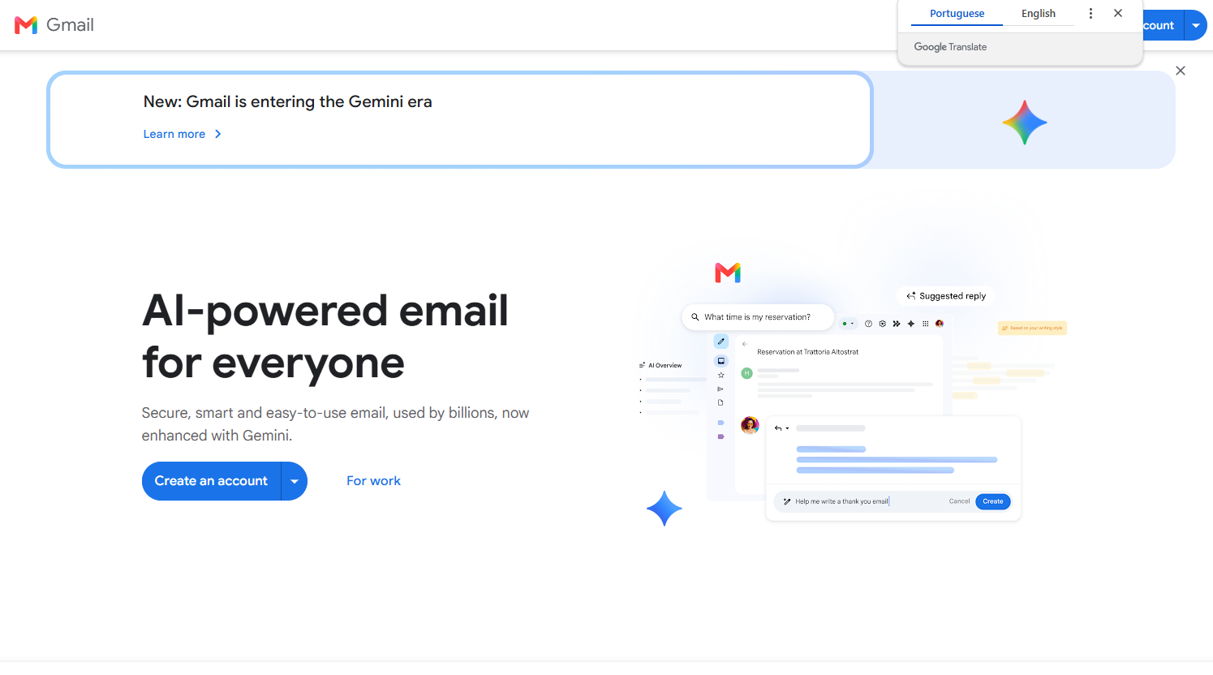
Free email accounts create and use email large storage capacity provides substantial storage for email sand attachment easy organization access from anywhere any country available on any device any computer any software

My short Reflection
- Write 5–8 simple sentences about your digital life.
- You can use the sentence starters below if helpful.
1 Easy communication stay in touch with friends and families and colleague through email messaging and video calls
2 Access information finds news education resources and answers to question quickly online
3 Productive use digital tools to manage task calendars documents and project
4 Collaboration I like to work and learn with others remotely using shared documents
5 Career opportunity I search for jobs build professional network and work remotely
6 Online learning study courses watch tutorial and develop new skills
7 Entertainment I enjoy videos music and games and social media plat forms
8 convenience I shop and bank and pay bills and book services

Sentence starters
- I use digital tools to …
- I feel confident when I …
- I want to improve …
- I often use these tools: …
- I sometimes feel nervous about …
- I hope this module will help me …
- Digital skills are important for me because …
You can write more if you want.

Submission Checklist
Before you submit, please check:
​​​ ☒ I added 4–6 screenshots
☒ I wrote short sentences for each screenshot
☒ I wrote my short reflection
☒ My work is my own
☒ My file opens correctly
​​☒ My file opens correctly

