

BA(Hons) Leadership and Management Skills for the Workplace
Module Name: Organisational Culture
Student Name: Guy Massamba
Module Code: LCLM 5005
Lecture Name: Dr Toyin Adisa
Assignment Title: Organisational Culture
Submission deadline:09/12/2025

Overview
This report is a critical analysis of the role of organisational culture in structure and decision making in Toyota with special consideration to WebCulture integration. Basing the analysis on the cultural model proposed by Schein, Hofstede dimensions and the typology of cultures suggested by Handy, it is possible to note that Toyota has the hybrid culture of clan and hierarchy supported by digital communication rules and virtual teamwork integrated into The Toyota Way. Continuous improvement that is driven by WebCulture alongside such practices as nemawashi and global decision-making, improves transparency, cross-functional coordination and global responsiveness. Nevertheless, the agility can be curtailed by strong consensus norms and path dependency as historical events in times of fast change to digital and the environment. The report identifies how the cultural orientation of Toyota to globalization, Industry 4.0, hybrid work and sustainability demand have redefined its work and performance strategy. It suggests recommendations to increase digital leadership power, support regional autonomy, incorporate sustainability metrics into WebCulture practices, and promote psychological safety so that innovation is possible. On the whole, the culture of Toyota is an effective strategic resource that needs to be renewed constantly.

Table of Content
1. Introduction 4
2. The Role of Organisational Culture in Shaping Structure and Decision-Making 4
3. Identifying Types of Organisational Culture Using Frameworks 5
3.1 Schein’s Three-Level Model 6
3.2 Hofstede’s Cultural Dimensions 7
3.3 Handy’s Typology 8
4. Adaptation of Organisational Culture to the External Environment 8
5. Organisational Culture as a Barrier to Effective Functioning 9
6. Impact of Organisational Culture on Organisational Performance 9
7. Recommendations for Improvement 10
8. Conclusion 11
Reference 12

1. Introduction
Organisational culture is another strategic control system that influences the extent of authority, how problems are framed, and trade-offs in decision-making (Mullins, 2007). The Toyota Way of WebCulture-driven continuous improvement and respect for people, institutionalised in the Toyota Production System (TPS) and nemawashi consensus-building (Liker, 2012). In this report, WebCulture refers to the digital communication norms, virtual collaboration practices and internet-enabled information flows that shape how employees interact, learn and make decisions. Such duality promotes efficiency and dynamic problem solving (Assens, 2021). However, when followed too strictly, it can impede strategic agility (Denison, 2014). The use of Schein, Hofstede, and Handy indicates that Toyota is a blend of a clan and hierarchical structure that governs global operations in terms of structure, coordination, and performance (Johnson, 2017).

2. The Role of Organisational Culture in Shaping Structure and Decision-Making
The organisational culture in Toyota is based on a hybridisation of the clan and hierarchy orientation, structure and human values. As Handy (1993) typology defines, hierarchical cultures put more stress on stability and order whereas clan cultures focus on collaboration and belongingness (Handy, 1993). The global matrix structure of Toyota reflects such duality in that the head office in Japan has strategic control and consistency, and regional subsidiaries in Europe, North America, and Asia are locally autonomous (Gong, 2022). This balance maintains quality and efficiency without stifling contextual flexibility that displays the concept of a role culture with a human face as developed by Handy (Schein, 2010).
This balance is institutionalised by the Toyota Way through WebCulture (digital-enabled continuous improvement) and the Respect of People (Liker, 2012). These principles entrench participative decision making in the chain of command. The system of the and on is an example, where the frontline employees have the power to stop production after they find faults, which is a representation of decentralised power and shared responsibility. Therefore, the process of decision making demonstrates a mutual responsibility to learning and growth instead of being a top-down control.
The ethos of decision making that Toyota has incorporated also incorporates a tool known as Nemawashi or pre-decision consensus-building, which as explained by Schein (2010) can be seen as cultural respect towards inclusion and harmony (Schein, 2010). This opportunity, which aligns with low power distance and collectivist dimensions as Hofstede (2001) suggests, is biased towards the consideration of deliberation and quick implementation of decisions when everyone is on the same page. The philosophy of thinking slowly first and then acting fast ensures that there is accuracy in implementation as well as cohesion (Hofstede, 2001).
Moreover, Toyota has cross-functional teams that help in enhancing collaboration among the engineering department, production, and design, decreasing silos and increasing innovativeness (Bortolotti, 2015). Finally, Toyota does not control via bureaucracy but rather by common norms, accountability to each other and cultural discipline that ensures adaptive efficiencies and long-term resiliency in international actions.

3. Identifying Types of Organisational Culture Using Frameworks
To comprehend the organisational culture of Toyota, it is essential to use a multi-framework strategy to both portray the visible organisational practices and assumptions. Using the three-level model provided by Schein (2010), the cultural dimensions introduced by Hofstede (2001), and the typology presented by Handy (1993), it is possible to see how the cultural logic, which is ingrained at Toyota, determines behaviour, structure, and performance in the global context (Handy, 1993).

3.1 Schein’s Three-Level Model
The framework created by Hofstede (2001) indicates that Toyota has low power distance that promotes openness, high collectivism that promotes shared responsibility through the use ofNemawashi, and high uncertainty avoidance that promotes standardisation and quality control (Hofstede, 2001). Innovation and sustainability are supported by long-term orientation (Alvesson, 2022). These characteristics combined create a good balance between control and flexibility, but too much uncertainty avoidance may become an impediment to quick innovation and responsiveness.

3.2 Hofstede’s Cultural Dimensions
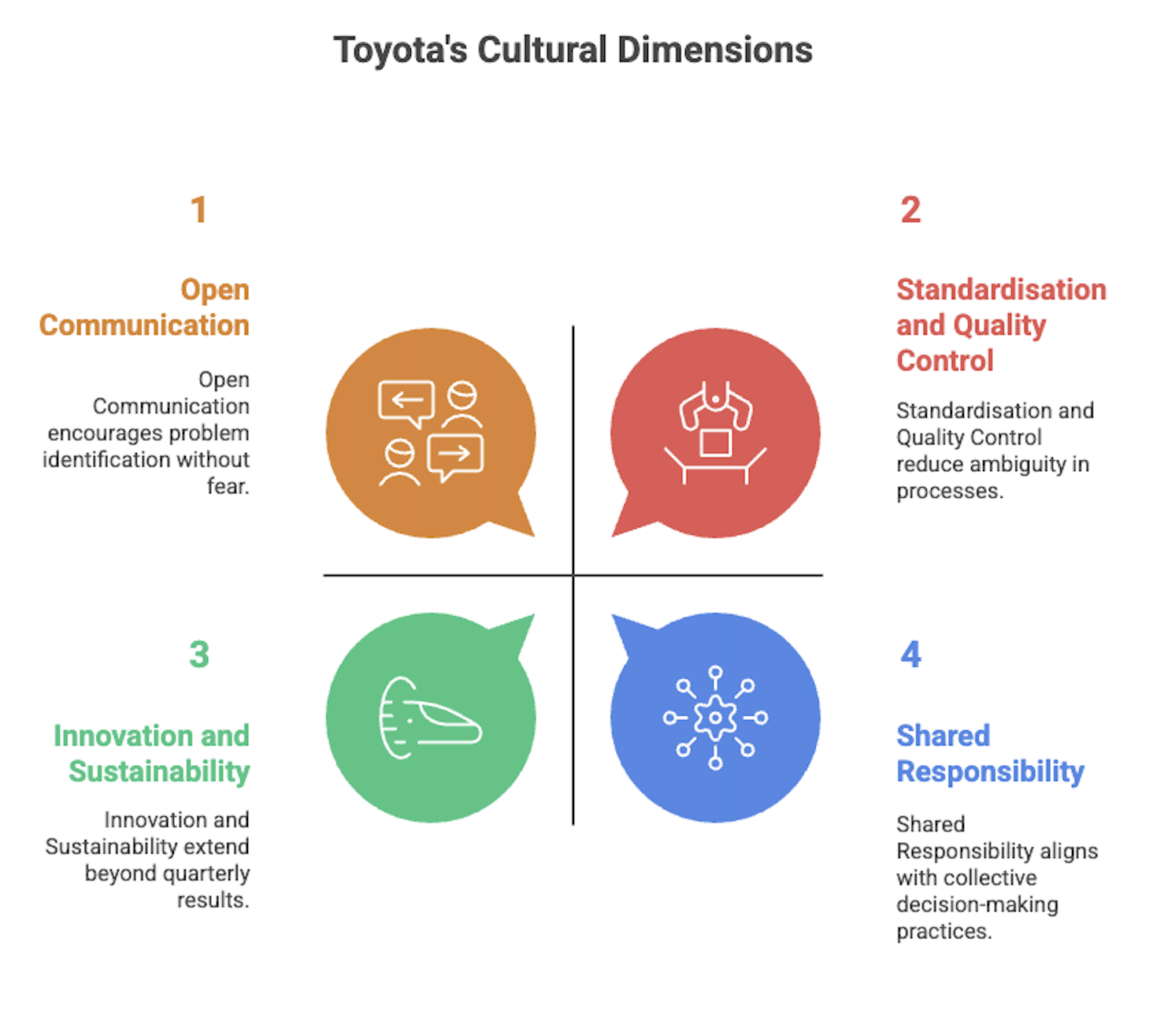
Figure 1: Toyota’s Cultural Dimensions
Toyota is a hybrid model in the Role and Task culture theory proposed by Handy. Role culture demands chain of command, protocols and quality production, and Task culture succeeds due to cross-functional WebCulture-driven digital collaboration teams that encourage teamwork and creativity (Kono, 1998). WebCulture further strengthens Toyota’s task culture by enabling real-time digital collaboration, virtual problem-solving, and transparent knowledge sharing across global units.This synergy puts discipline and flexibility in balance, removing the trade-off between bureaucracy and innovation and making decisions about the organization that are swift, predictable, and reliable worldwide.

3.3 Handy’s Typology
Within Handy’s Role and Task culture theory, Toyota embodies a hybrid model. Role culture ensures hierarchy, procedures, and manufacturing consistency, while Task culture succeeds due to cross-functional WebCulture-driven digital collaboration teams that encourage teamwork and creativity (Kono, 1998). This synergy balances discipline with flexibility, eliminating the bureaucracy–innovation trade-off and enabling agile, reliable global decision-making.

4. Adaptation of Organisational Culture to the External Environment
The organisational culture of Toyota, which is based on Japanese collectivism and The Toyota Way, has been modified to deal with globalisation, digitalisation and sustainability pressures. The strategy of the company can be viewed as an example of the concept of globalisation, i.e.,the preservation of universal principles of WebCulture-enabled continuous improvement and Respect for People, but adjusting the behaviour to the regional context (Bortolotti, 2015). In the U.S., Toyota, in turn, incorporates participative management with a more pronounced focus on personal responsibility and inclusion of diversity, such that there is cohesion among more than 370,000 employees without compromising the cultural authenticity (Denison, 2014).
Sustainability of the environment is now a part of the cultural aspect of the environment. By the means of the so-called Toyota Environmental Challenge 2050, the company renders its activities carbon neutral and circular, making the concept of WebCulture-enabled continuous improvement not limited to process but to ecological efficiency (Toyota, 2025). At the same time, the adoption of Industry 4.0 the AI-based approach to quality control, robotization, and smart factories demonstrates how digital innovation can be combined with the human-centred spirit at Toyota to balance between the traditional monozukuri craftsmanship and the algorithmic accuracy (Bortolotti, 2015).
After the pandemic, Toyota exhibited flexibility further by hybrid work, online collaboration, and wellness, making its shop floor culture resilient and connected (George, 2024). Nonetheless, there are still difficulties: the localisation is too high, and the value is too likely to be diluted, and the centralisation is too small, and the responsiveness is restricted. The ability of Toyota to remain successful relies on the fact that culture is considered a dynamic capability which constantly learns and adjusts to the different global conditions.

5. Organisational Culture as a Barrier to Effective Functioning
The organisational culture of Toyota, as much as it is praised as being great and resilient, encourages rigidity. Its high value on consensus-building (nemawashi) and respect to a superior can prevent any fast decision-making and lock out dissent (Liker, 2012). This tendency toward loyalty rather than conflict coupled with encouragement of unity is capable of slowing down the escalation of the problem. This weakness was revealed by the 2009-2010 recall crisis over unintended vehicle acceleration when workers did not want to question and act as quickly as possible regardless of authority and report problems (Forbes, 2025).
Furthermore, cultural pride of Toyota in the framework of The Toyota Way may result in the establishment of the so-called path dependency, according to which the success of the past restricts the flexibility of the approach to novelty. Because, as Yang (2025) notes, Toyota is a company that seeks their perfectionist-level incremental improvement, the process of digital innovation frequently opposes the experimental, fast-paced culture thereof (Yang, 2025). Denison (2014) also caution that advanced cultures do run the risk of promoting internal consistency over responsiveness (Denison, 2014).
However, cultural cohesion within Toyota also offers stability, trust and moral continuity. It is thus imperative that adaptive leadership and reflective learning is used to balance tradition and transformation so that cultural rejuvenation can be in line with digital agility.

6. Impact of Organisational Culture on Organisational Performance
The global success of Toyota cannot be separated with the organisational culture that defines the operational excellence, employee engagement, and innovation. Some of these values, such as WebCulture-driven continuous improvement practices and Genchi Genbutsu (go and see), are translated into high-quality products, cost effectiveness, and customer satisfaction (Bortolotti, 2015). The Toyota human-centered culture promotes a sense of shared responsibility, unlike other firms that are entirely technology or finance-oriented and this maintains a self-reinforcing loop of betterment and accountability (Denison, 2014).
Values based on respect bring morale, retention, and psychological safety, which is emphasized in the Toyota Sustainability Report (2024), which improves loyalty and productivity (Toyota, 2025). Incremental, process-based innovation thrives through WebCulture-enabled digital collaboration teams (Jones, 2003). Nevertheless, the conservative nature of decisions made by Toyota could become an obstacle to digitalisation and EV changes. To maintain competitiveness, it must thus combine its disciplined and lean culture with digital flexibility, where its history of quality will thrive in the age of intelligent mobile mobility that is sustainable.

7. Recommendations for Improvement
- Dynamic stability brings cultural renewal. Maintain pillars of Preserve Toyota Way, including WebCulture-led continuous improvement and Respect for People, and renew ritualised routines. According to Schein (2010), the changes in practices are to evolve without weakening the fundamental assumptions; Toyota ought to time-box nemawashi and institutionalize reviews of the changes after their implementation to eliminate procedural drift (Schein, 2010).
- Lean–agile digital fusion. Combine TPS and agile-at-scale EV, data, and software platform with digital leadership training. According to Deloitte (2025), lean-agile hybrids can help to speed up value delivery in Industry 4.0 and ensure quality (Deloitte, 2025).
- Cross-cultural agility. Enhance regional decision making authority and bicultural leadership pipelines through rotational programmes in order to minimize ethnocentric bias (Deloitte, 2025).
- Psychological safety. Institutionalise norms of speak-up, blameless reviews, and swifter feedback loop; Edmondson (2018) associates safety with the speed of innovation.
- Sustainability integration (Edmondson, 2018). Integrate carbon, circularity, and safety KPIs into WebCulture improvement targets to match cultural identity with net-zero targets(Deloitte, 2025).

8. Conclusion
The organisational culture of Toyota is one of the pillars of its international success, as it has been shaped by WebCulture-driven continuous improvement and Respect for People into structuring, decision-making, and performance excellence. This culture has given rise to discipline on its operations, engagement of its employees, and trust by the customers, which has maintained the leadership of Toyota in quality and reliability. Nevertheless, the discussion points to a vital two-sidedness: the hierarchical and consensus-based aspects of its culture allow it to be very stable and controlled but at the same time, it may restrict agility and innovation in the context of the swift digital and environmental change. The task Toyota has, then, is not to forget its cultural origins but to transform them, introducing agility, inclusivity and sustainability to its classic lean model. The ever-cultural renewal, in tandem with global and digital reality, will guarantee that the values of Toyota have become a strategic asset instead of a liability, and help the enterprise to continue to be competitive and purpose-driven in an ever more dynamic and unpredictable world.

Reference
- Alvesson, M. and Blom, M., 2022. The hegemonic ambiguity of big concepts in organization studies. Human Relations, 75(1), pp.58-86.
- Assens-Serra, J., Boada-Cuerva, M., Serrano-Fernández, M.J. and Agulló-Tomás, E., 2021. Gaining a better understanding of the types of organizational culture to manage suffering at work. Frontiers in psychology, 12, p.782488.
- Bortolotti, T., Boscari, S. and Danese, P., 2015. Successful lean implementation: Organizational culture and soft lean practices. International Journal of Production Economics, 160, pp.182-201.
- Cameron, K.S., 2011. Diagnosing and changing organizational culture: Based on the competing values framework.
- Deloitte (2025) Deloitte insights. Available at: https://www2.deloitte.com/insights (Accessed: 31 October 2025).
- Denison, D., Nieminen, L. and Kotrba, L., 2014. Diagnosing organizational cultures: A conceptual and empirical review of culture effectiveness surveys. European Journal of Work and Organizational Psychology, 23(1), pp.145-161.
- Edmondson, A.C., 2018. The fearless organization: Creating psychological safety in the workplace for learning, innovation, and growth. John Wiley & Sons.
- Forbes (2025) Forbes. Available at: https://www.forbes.com/ (Accessed: 31 October 2025).
- George, A.S., 2024. The fourth industrial revolution: a primer on industry 4.0 and its transformative impact. Partners Universal Innovative Research Publication, 2(1), pp.16-40.
- Gong, L., Jiang, S. and Liang, X., 2022. Competing value framework-based culture transformation. Journal of Business Research, 145, pp.853-863.
- Hofstede, G., 2001. Culture's consequences: Comparing values, behaviors, institutions and organizations across nations. Sage publications.
- Handy, C., 1993. Understanding organizations. Penguin Uk.
- Jones, D.T., 2003. Lean thinking: banish waste and create wealth in your corporation.
- Johnson, G., Angwin, D., Regner, P. and Scholes, K., 2017. Exploring Strategy: Text and Cases (11).
- Kono, T. and Clegg, S., 1998. Transformations of corporate culture: Experiences of Japanese enterprises (Vol. 83). Walter de Gruyter.
- Liker, J.K. and Convis, G.L., 2012. The Toyota way to leanleadership: Achieving and sustaining excellence through leadership development. (No Title).
- Mullins, L.J., 2007. Management and organisational behaviour. Pearson education.
- Schein, E.H., 2010. Organizational culture and leadership (Vol. 2). John Wiley & Sons.
- Toyota (2025) 7 environmental report 2018 Toyota Environmental Challenge 2050. Available at: https://global.toyota/pages/global_toyota/sustainability/report/er/er18_07-13_en.pdf (Accessed: 31 October 2025).
- Yang, Z., Dong, M., Guo, H. and Peng, W., 2025. Empowering resilience through digital transformation intentions: synergizing knowledge sharing and transformational leadership amid COVID-19. Journal of Organizational Change Management, 38(1), pp.59-81.

