

L6 - Independent Project (EEE)
Independent Project
Research
Proposal Assessment Brief

Spanswick, Adam S2218236

Contents
Table of Content Figures 2
Table of Content Tables 2
Project Title 3
Caster 3 Process Bay Water Mould Test Stand 3
Abstract 3
Introduction 3
Aim of Project 7
Existing Method 7
Project Purpose 7
Objectives 7
8
Project Design 8
Resources & Planning 12
Resources 12
Planning 12

Table of Content Figures

Figure 1 Tata Steel Port Talbot [1] 3
Figure 2 Port Talbot Layout 4
Figure 3 Casting process 5
Figure 4 Closed water Layout 5
Figure 5 Mould Cooling Flows/Pressures 6
Figure 6 Process Bay Workshop 8
Figure 7 PID-08-01-73-10-318-00 9
Figure 8 3D CAD Water stand 9
Figure 9 Flow/Pressure Bench LF Technologies 10

Table of Content Tables
Table 1 Time Line Planning 12

Project Title

Caster 3 Process Bay Water Mould Test Stand

Abstract

The Purpose of the project is to design a water test stand is to do pressure and Flow test of mould as required. Mould water test stand consisting of pumps, valves and associated instrumentation for flow and pressure testing of mould. The system is designed for flow testing of either complete test stand or any particular face of the mould. Pressure testing is envisaged to identify any leakages in the mould.

Introduction
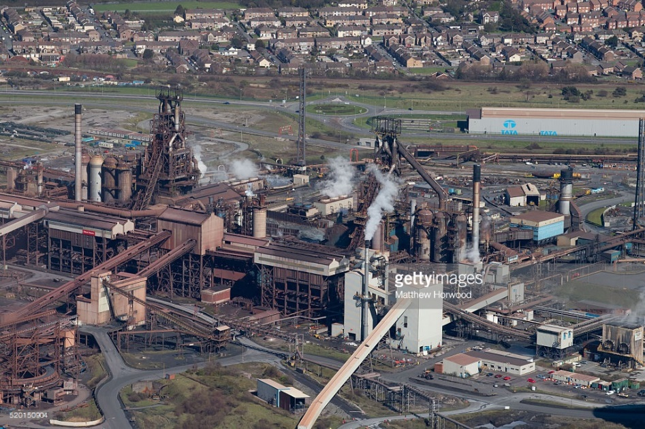

Figure 1 Tata Steel Port Talbot [3]
Port Talbot Steel Works and its 3600 employees produce some 4.7 million tonnes of steel per annum, where about 3 million of it is rolled on site and the rest sent to Llanwern. The steel is produced and coat finished on site and then delivered either direct to the customer or to other TATA sites where further production processes are implemented prior to customer issue.
The site is divided up into several departments and plant areas that carry out specialised processes that collectively produce strip steel. My project will be based at the Casting Department.
• Raw Materials
• Iron Making
• Steel Making
• Casting
• Hot Rolling
• Cold Rolling
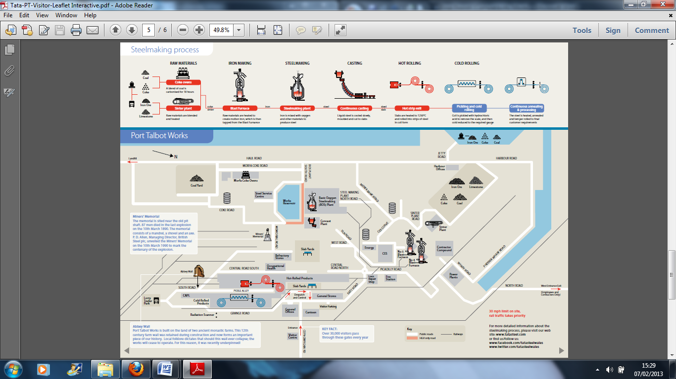
Figure 2 Port Talbot Layout

Continuous Casting Plant
The Continuous Casting Plant, Consists of moulds and forms molten steel into a solidified slab, it is also where the basis of this project is set.
The remotely adjustable mould (RAM) is a specialist piece of plant that actually produces the formed shape of the new steel slab. It is here in fact that the liquid steel solidifies to give an outer hard skin and molten inner core, similar to that of an egg, where the shell is the solidified steel and the yolk is the still-molten metal.
The solidification process occurs when the molten steel is cooled quickly by the use of continuously cooled water. The ‘closed water’ system doesn’t actually come into contact with the steel but instead passes through a Copper water jacket. Copper is used for its excellent conductivity of heat, therefore giving us the quickest cooling results possible.
The RAM is capable of forming steel slab at various widths to suit the customers’ needs. Known as section changes, the sides of the mould taper and are driven at increments in order to adjust the slab width whilst casting.

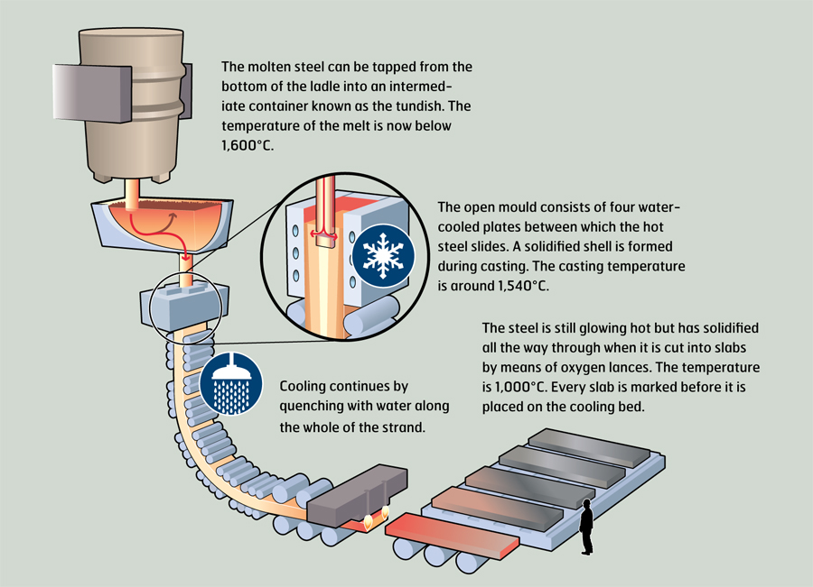
Figure 3 Casting process
As previously mentioned these moulds are cooled using Mould Cooling water as shown in image below:
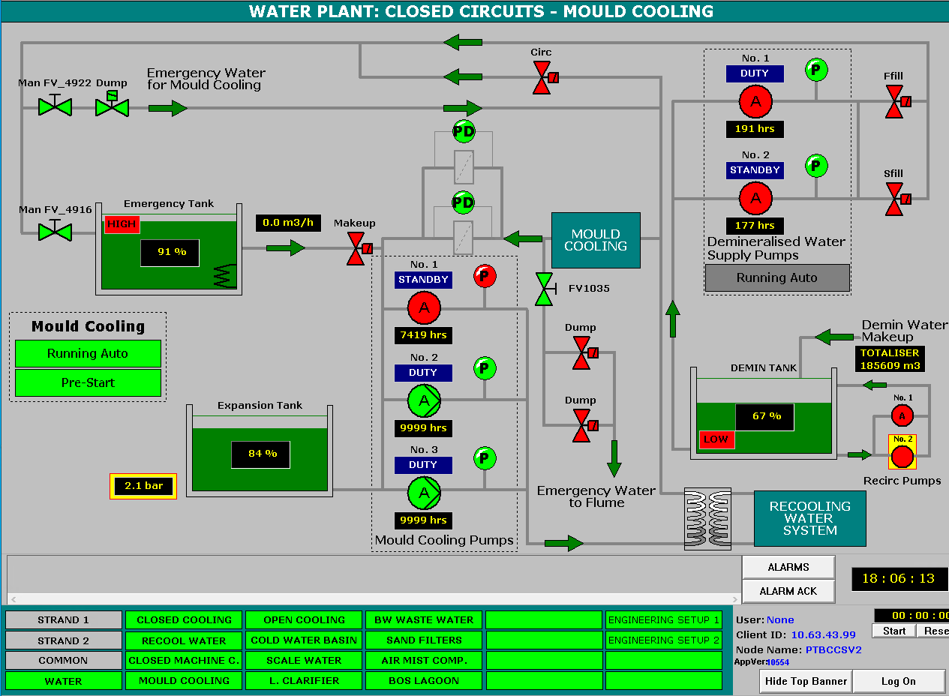
Figure 4 Closed water Layout

The moulds when in the caster are put under pressure of around 6.8 BAR. This is delivered at a flow rate of 23065L/min. We require making certain flows on each zone of the mould and pressures. This used for our SIF Test which is requirement under safety legislation as one of our safety barriersAs you can see on the below image there are required flows for each areas of mould cooling. The Mould cooling is split into four sections;
- Wide Loose
- Narrow South
- Wide Fixed
- Narrow North
These zones all have different flow rates and pressures due to the size of the copper plates etc.
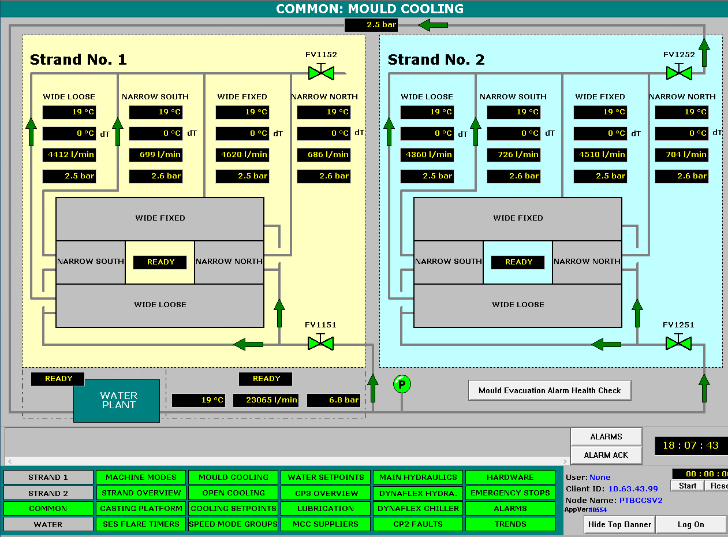
The main area of the mould we are seeing substantial failure rates are the narrow south & North end plates. This is purely down to these plates moving during casting to allow us to section change to different widths of steel. The pressure generated by the steel in the mould is causing these to fail substantially.
Figure 5 Mould Cooling Flows/Pressures

Aim of Project

The Main Purpose of the Project is to help drive reliability and performance within the casting process within Tata steel. We have had a lot of Instability around these moulds in past 24 months around end plate water leaks occurring whilst the mould are in operation in the Casters.

Existing Method

The existing method for water check on the mould are only do a basic water check on our mould over the process bay . This consist of just make sure flow is exiting on the return legs of each system. We have no way if checking flow rates or pressure until it is placed in the Casters. This is just inlet and outlet system with one pump to help get flow of water through plates. Over the years this is through experience seeing a good flow rate return.

Project Purpose

The main project purpose is to build a water test stand for Caster 3 moulds of the process bay workshop. The main design will be to pressure test each of these zones of the mould under the same condition they are put under in the Casters in operation. We will then be able to make sure we have the correct flow/ pressure requirements for casting process.

Objectives

The main objectives of the project are ;
- To improve safety of these Moulds. – These failure can cause serious events such as loss of life. As water and molten steel can be like thermal explosion.
- To improve reliability – This will help us achieve our goal as a industry to make 4.7 million tonnes of steel.
- Cost Saving – This mould refurbishments can cost between 200 hundred thousand pounds each.
- To improve quality of steel – These mould cooling system can help us produce quality high grade steels if cooling jackets are operationally 100%.

At end of the project I am hoping to deliver on all of the above outcomes. We are aiming for the water test stand to be installed and commissioned by end march next year.
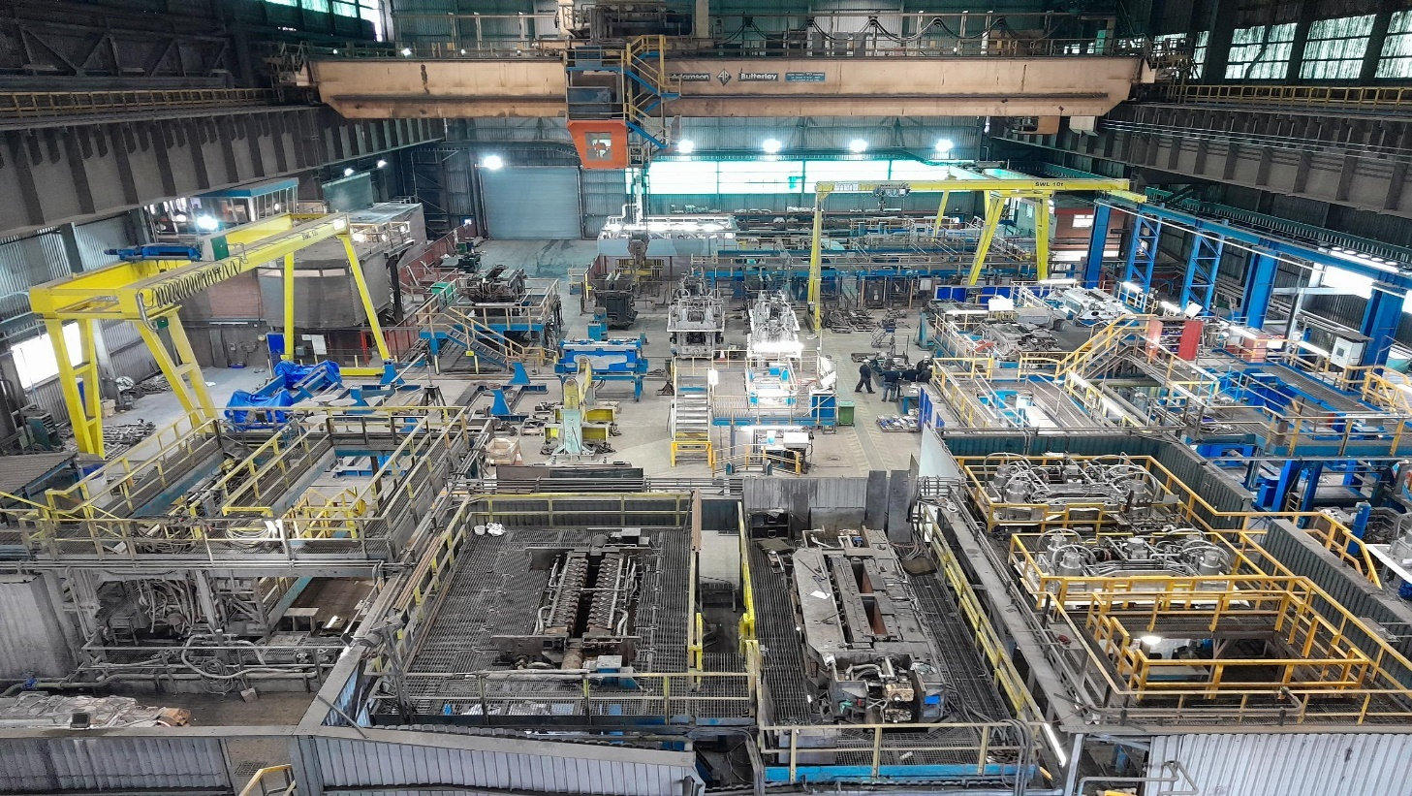
Figure 6 Process Bay Workshop

Project Design

The project design will consist of designing a water test stand in process bay which is exact replica of the Casting process where the mould is situated during casting.
We require the water test stand to be exactly the same as the Casting stand as we need to make sure all condition are same under testing and commissioning of moulds.
The water plant will supply the necessary water to respective mould during its testing activity. The mould water testing system consists of the following:
- Two Feed pump (P1 & P2) – Flow Test & Pressure Test
- One water storage tank

The system will be controlled by the new PLC located in the Caster 2 test Stand MCC.

- This water system is controlled via the local operator station (HMI). This will have functionality for start/stop of test, test selection modes and healthy/running indications for each motor unit etc.

The variable speed drives on the pumps will help achieve these goals and the automated valves will help deliver the sequencing required.

The project will be on a much larger scale as outline on drawing below shows.

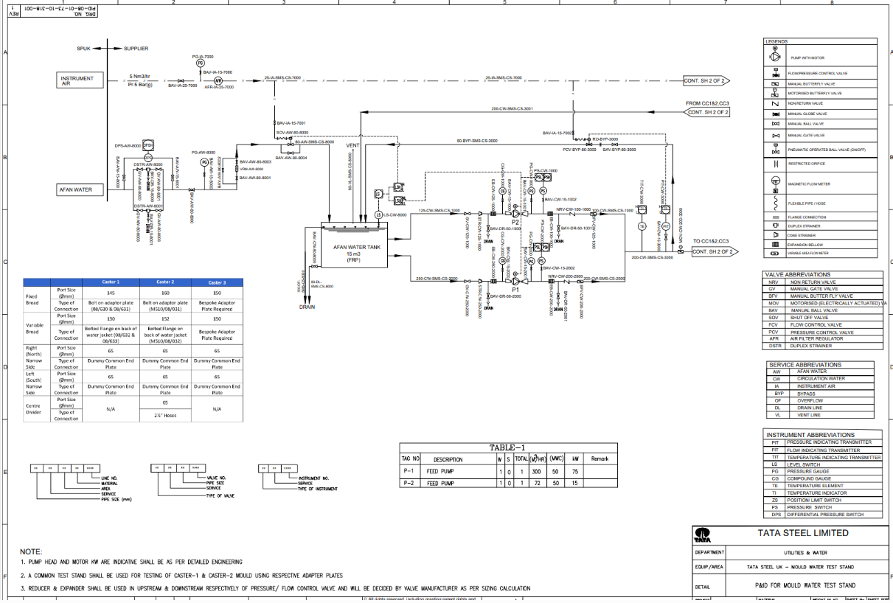
Figure 7 PID-08-01-73-10-318-00

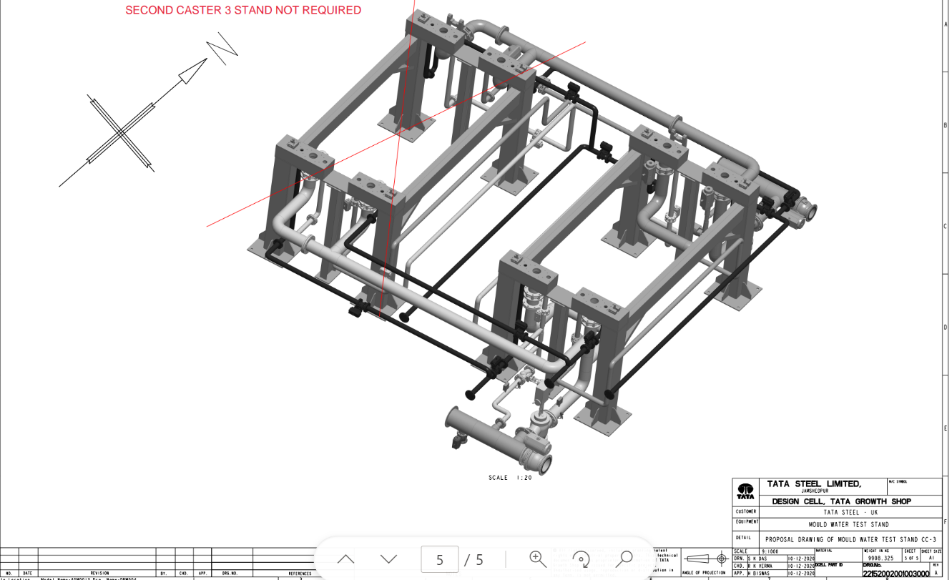
Figure 8 3D CAD Water stand

A basic outline of the design on a smaller model is like what I have researched below from LF Technilogies for a standalone test bench.
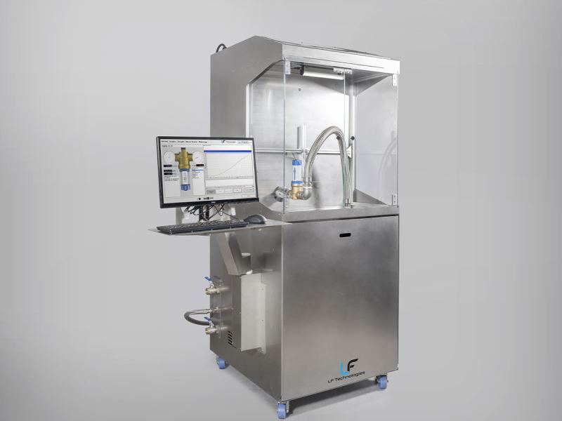
“LF Technologies has designed a stand-alone test bench for pressure reducing valves equipped with a multi-stage centrifugal pump driven by a variable speed drive. A pressure sensor, placed at the inlet of the flow meter, allows the pressure to be controlled by varying the speed of the pump from 0.5 to 16 bar.
Figure 9 Flow/Pressure Bench LF Technologies
The pressure reducer to be tested is installed on the bench using suitable fittings.
Two sensors measure the ΔP between upstream and downstream of the test piece. The flow rate is varied from 0 to 11,000l/h by means of a motorised valve.
A circulator and a heat exchanger cool the water in the tank placed in the bench, and the temperature is monitored via a temperature sensor.
The program installed on the control PC was developed under LabVIEW. It allows to control the test pressure (via a pump) and the flow rate (via a proportional valve), but also to measure, display curves and record :
- the inlet and outlet pressures
- flow rate;
- temperature.” [1]

Research analysis will be required for all outcomes of the project. A few things which will need research are listed below;
- Pumps
- Motors
- PLC Software
- PLC Hardware
- Electrical Components (Safety Relays)
- HMI Interface
- Valves
- Pressure Transmitters
- Flow Meters
- Cabling
- Pipework
- Storage Tank
- Isolators
- Junction Boxes
- FCV (Flow control Valves)

I will obtain a lot of my research from outside tenders who will supply a lot of the components. I will also consult with team member of the project team on best solution of components on market from the internet.

Research analysis will also need to be carried out around legislation of the project. There will be multiple of areas which will needs researching such as;

- “Electricity at Work Regulations 1989
- Supply of Machinery (Safety) Regulations 2008
- Control of Substances Hazardous to Health 2002 (COSHH)
- Pressure Systems Safety Regulations 2000 (PSSR)
- Provision and Use of Work Equipment Regulations 1998 (PUWER)
- Lifting Operations and Lifting Equipment Regulations 1998 (LOLER)
- Management of Health and Safety at Work Regulations 1999
- Health and Safety at Work etc Act 1974 (HASAWA)” [2]

Resources & Planning

Resources

Resources required for the project are ;
- Auto Cad Development
- Siemens PLC
- Factory IO
- Excel
- Labour
- Material
- Funding
- Tools/equipment
- Human Resource

Planning

Below is Timeline planning of the project proposal
Table 1 Time Line Planning
 | Timeline Planning | Start: |  | Jul-23 |  |  | End: |  |  |  |  | Sep-23
 | What | Who
 | Short Term Tasks - Weeks |  | Done | WK41 | WK42 | WK43 | WK44 | WK45 | WK46 | WK47 | WK48 |  | WK49 | WK50 | WK51
H&S | Risk Assessment for Cable Installation | AS/MP/DG
H&S | PUWER - Machinery Safety Risk Assesment | AS/MP/DG
H&S | SWP to create | All
H&S | Investigate feasability of achieving CE Mark approval | AS/DG/NP
Design | PLC Programming / HMI development | AS/NP
Design | Develop Project Plan | NP/MP
Design | PID Drawings to develop and complete | AS/NP
Design | General drawings to complete | AS/NP
Procurement | Delivery of Cable installation equipment | DG
Procurement | Procurement of installation consumables | AS/NP/MP
Offsite Manufacture | Main Panel to fabricate and return | JW
Construction | Installation of Cable equipment and instrumentation | MP
Construction | Correct tag identification to be put in place | MP
Construction | Main Panel to install | JW
Maintenace Concept | Maintenance Task Identification | MP/DG
Maintenace Concept | Job Catalogue Entry to SAP (Maintenance Plans) | AS/NP
Spares | Create Spares list for maintenance plan | MP/DG
Spares | Create Stock Numbers | AS/NP
 | Longer term tasks - Months |  | OCT | NOV | DEC | JAN | FEB | MAR | APR | MAY
 | Investigate feasability of achieving CE Mark approval | DG/NP
 | PLC Programming / HMI development | NP

Bibliography

[1] | “Flow/pressure bench | LF Technologies (lf-technologies.com),” [Online].
[2] | “https://plantandsafety.co.uk/engineering-testing-inspection-and-certification/health-and-safety-legislation-and-regulations,” [Online].
[3] | “Aerial pictures of Tata steel, Port Talbot - Matthew Horwood Photography (matt-horwood.com),” [Online].
[4] | “Flow/pressure bench | LF Technologies (lf-technologies.com),” [Online].

