Charles Llewellyn - 1812724
Process Improvement Methodologies
Introduction into Six Sigma
Six Sigma is a process and quality improvement technique created by Bill Smith and Bob Galvin working for telecommunications company Motorola in 1986, the technique was implemented by Motorola chiefs to improve business quality and profits in an extremely competitive market. Six Sigma is seen as a simpler approach to quality improvement unlike other quality improvement techniques like Total Quality Management which has hundreds of improvement techniques, Six Sigma tends to concentrate more trusted methods that have been around for decades to improve quality.
Six Sigma involves the training and certification of experts in Six Sigma to implement the system in businesses, experts are known as ‘champions’ or can come under a grading belt system where a ‘black belt’ or sometimes ‘master black belt’ will be experts in the field, as creators Motorola said: "that leadership directly influences the quality of products"(1) this shows one of key principals of Six Sigma is to improve the business’ management systems and then the improvements will filter down the chain as a result.
Six Sigma is different to other cost reduction techniques which typically lower cost as result of lowering quality, Six Sigma aims to remove costs that don’t add value to the overall process, this idea is mentioned in a study by Tom Pyzdek a leading expert in Six Sigma improvement techniques:
‘Six Sigma focuses on defect prevention, cycle time reduction, and cost savings, Six Sigma identifies and eliminates costs which provide no value to customers, waste costs.’ (2)

Six Sigma techniques are not meant to affect the quality of the process or product, Six Sigma aims to improve the overall process around the process or product to save on production time or defect costs.

One of the key principals of Six Sigma is lower the companies defects or errors rate to as close to zero as possible:
‘The Six Sigma standard of 3.4 problems per million opportunities’ (3)
Lowering the defect or error rate to as close to zero as possible can have massive economic impacts on a business, especially if that company operates on a mass volume production basis. In a study carried by a Six Sigma expert Tom Pryzek around the cost of poor quality it can be seen the higher the sigma level of the business the less that business spends on the cost of poor quality:
‘Companies operating at three or four sigma typically spend between 25 and 40 percent of their revenues fixing problems, companies operating at Six Sigma typically spend less than 5 percent of their revenues fixing problems’ (4)

The savings a company could see by operating at Six Sigma level based on this information would be incredible especially with companies that have multi-million- or billion-pound revenues. The information from the study is also shown graphically below where you can see the percentage of revenue spent on poor quality significantly decreasing with the level of sigma operated.
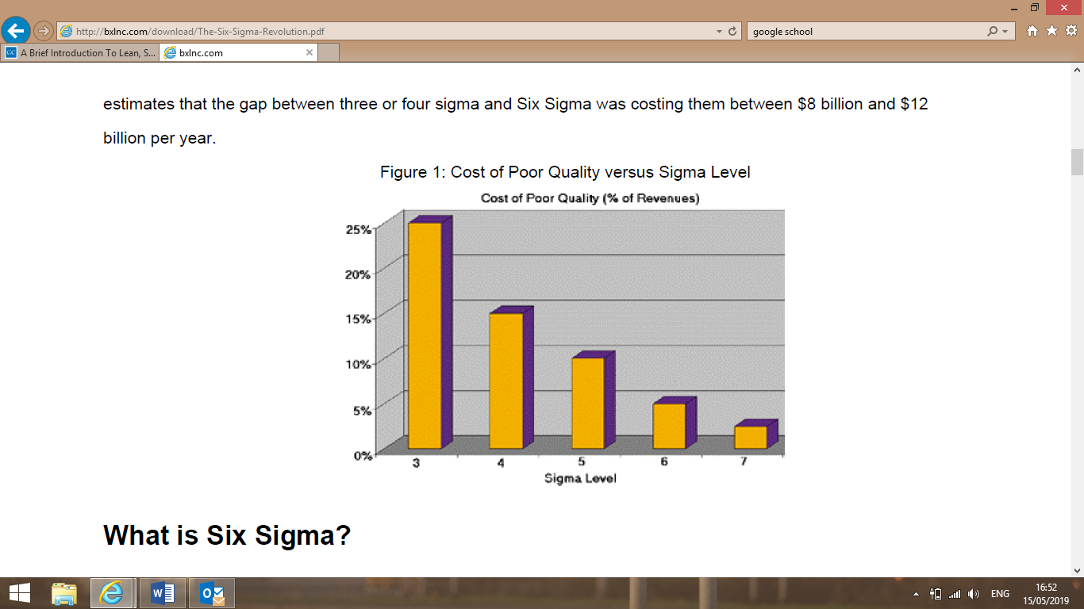

(5)

DMAIC
Six Sigma process improvement has many improvement tools, some methods used by high ranking champions or ‘black belts’ can include using advanced computer data programs to measure and improve processes but one of the main simpler models that is used is called DMAIC – define-measure-analyse-improve-control. DMAIC is a data driven and life cycle approach to improving processes, DMAIC is seen by experts as an important improvement tool to be used under the Six Sigma umbrella:
‘DMAIC is an integral part of Six Sigma. It is systematic, and fact based and provides a rigorous framework of results-oriented project management’ (6)
Define
The define element can be identified as defining a problem that has been occurring, this could relate to a common defect or error that has been occurring on a production scale, it could also then relate to for a service defining where there is a delay or even a step that is in the current process that isn’t needed or doesn’t add value to the service itself .
The define element could then also relate to defining an overall goal or objective for the business, normally these objectives depend at what level of the operation you are looking to improve. At the very top the objective could be improving profitability, decrease expenditure, improvement the return on investment ratio or even obtaining a greater market share. Then at operation level the objectives could be reduce overall defects, increase volume or reduce non-value adding steps in production.
Defining what adds value to the product or service is key to this element of DMAIC, often a tool called ‘Capturing Voice of Customer VOC’ to see what the customer feels adds value to the product or service. Using VOC customers can be split into 2 sections internal and external, with internal customers being part of the organisation and external being those who are not. There are a few tools that can be used to gather the information required from customers, surveys can sent out, interviews can be arranged with customers where the voice of the customer can be heard. Focus groups are also a good way to obtain the information, the discussions can held to focus on specific problems or topics to gather more in-depth information, a measurement tool ‘Critical to quality CTQ’ is often used to measure what is important to the customer, an example of a CTQ tree is shown below.
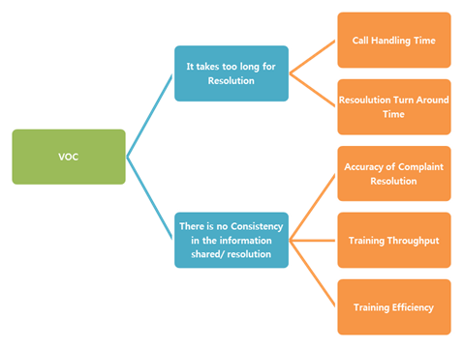

(6)

VOC information gathering tool could be used in my area of work to improve our process, as the department I work for in TATA Steel as a service provider for the rest of the sites operations we could use this tool to establish an improvements we could make, essentially our customers are surrounding departments in the steel works so we could hold focus groups with departments that depend heavily on ourselves to improve the service provided.
Below shows a basic example of a CTQ tree that is relevant to my works area, with the customer being the Blast Furnaces who rely on us to produce steam to run a turbine blower that supplies air to the furnaces which is vital for that process:
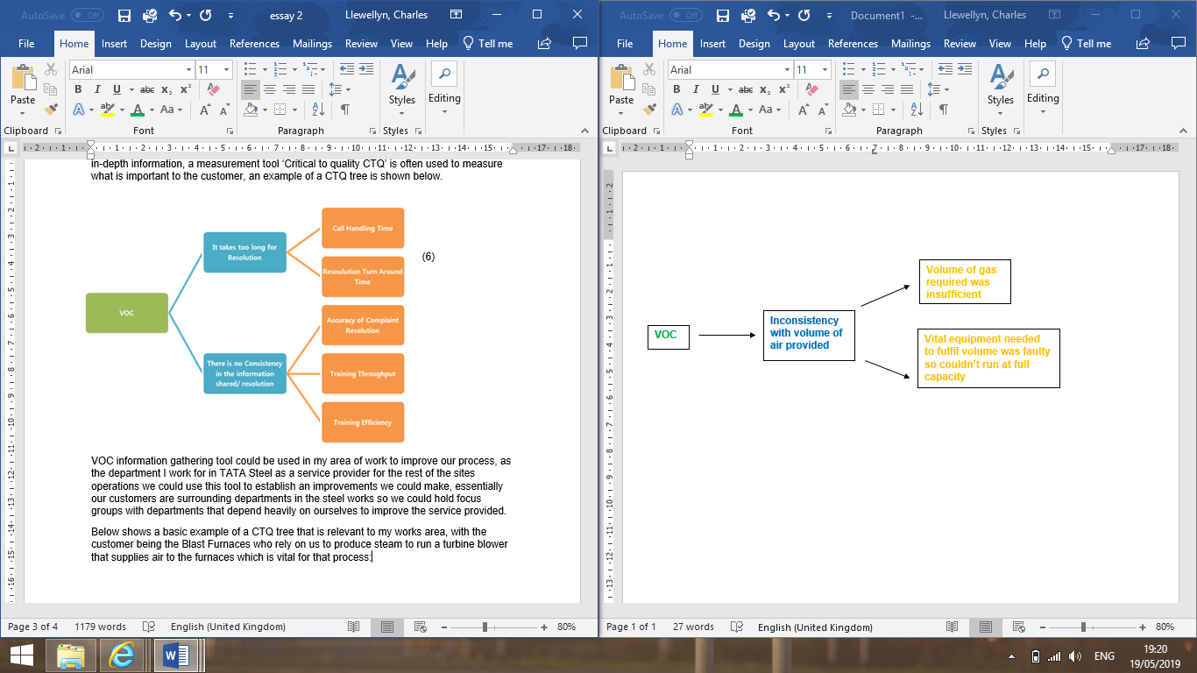

Another tool often used for the define element of Six Sigma is KANO analysis, KANO analysis is about prioritizing customers requirements. These requirements are split into 5 sub requirements.
- Basic – the most important for the customers needs, these requirements are expected to be included. If these requirements are not included highly likely the customer will be dissatisfied.
- Performance – ‘A direct positive correlation exists between satisfaction levels and the degree of presence of these performance requirements. The more performance requirement elements needs are met, the better it is for the product or service’ (7)
- Indifferent – these requirements will either satisfy or dissatisfy the customer if they included or not.
- Reverse – these requirements often depend on the opinion of the customer, some requirements included may dissatisfy customers if included.
- Delighter – these requirements when included are unexpected and can greatly satisfy the customer.
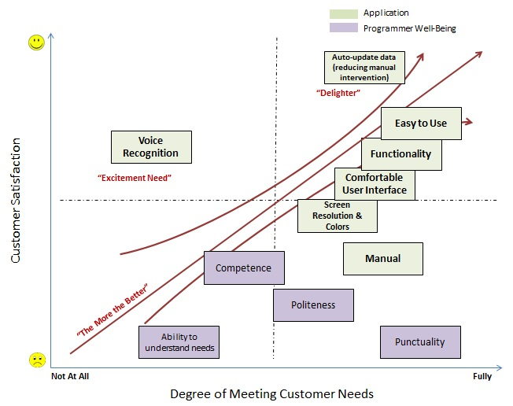
Below shows an example of a KANO analysis graph:
(8)

Measure
The measurement element of DMAIC is based around evaluating the existing system and current performances and targeting an improvement for the system. With this element it is important to establish the goal and to use suitable indicators to track the improvement, often this will arise as result of data collection and comparison. In the measurement element we are also able to start to identify waste opportunities.
One tool used for measurement analysis is SIPOC – supplier, input, process, output and customer. SIPOC is a process mapping tool that can be used to set projects goals with detailed steps of how to complete those goals included, SIPOC can also be used to identify problems or areas that are not needed or that don’t add any value to the process.
SIPOC can be defined as:
- Supplier – provider of inputs for process
- Input – material, information or other relevant resources needed
- Process – actual process of converting input into product or service
- Output – product or service from process
- Customer – recipient or product or process
Below shows an example of a SIPOC diagram:
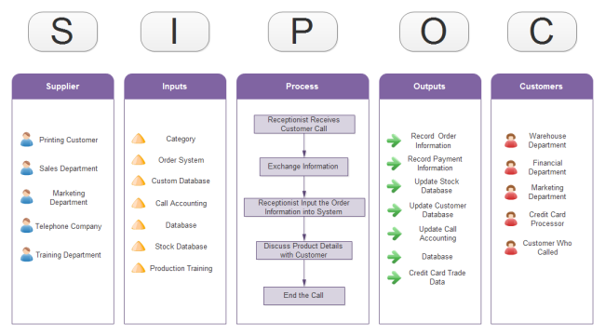
(9)

Pareto Chart Analysis is another commonly used tool to analysis measurement for Six Sigma, Pareto Chart Analysis can be used to measure profits or errors. The key principal of this type of analysis is concentrate on the top 80% of drivers in errors and 20% drivers in products that contribute to profit, ‘many businesses discover that 80% of their profits are driven by 20% of their products’ (10) this shows that pareto analysis could be used to maximize potential products that drive profits.
Then in terms of defect limitation which is a key principal of Six Sigma pareto analysis can be used to target common defects that account for 80% of the total defects, sometimes the analysis can show that it isn’t just one product that is causing 80% of defects it may be one or two products. Below shows a pareto chart where there are several defects contributing to the 80% of total defects.
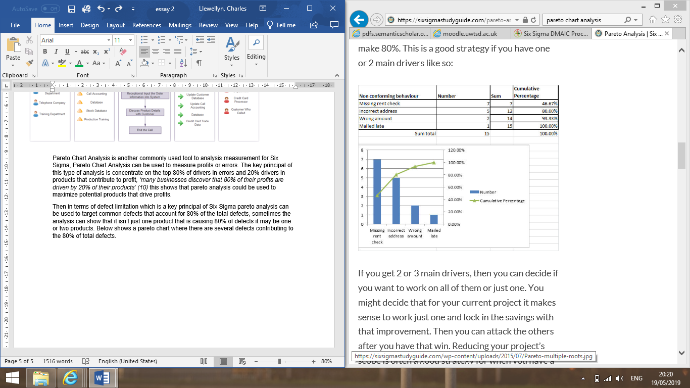

(11)

Analyze
The analyse element of DMAIC is based around identifying ways and ideas of closing the gap between the company’s current system performance and the target performance, often this comes down to selecting more precise areas of the business that need to be improved. Statistical information is often used to gage and compare current performance to the determined target performance. At this stage possible evidence or reasoning behind failures is analysed again often using statistical tools.
One tool used to analyse information is the 5 why’s questioning technique, the theory behind 5 why’s is very basic essentially you find an issue and keep asking why till you get to the root cause of the issue. 5 why’s is a great analysis tool as it considers that often there is more than one reason why an issue or failure is occurring and 5 why’s gives the chance for further analysis of more than one possibility. Below there is an example of the 5 whys technique being applied in relation to my works area.
The megawatt generation from one of the alternations has dropped.
Why?
Because the amount of steam generated from the boilers has decreased causing the amount of steam passing through the alternator to decrease.
Why?
Because there has been a decrease in the amount of primary fuel Blast Furnace Gas available
Why?
Because the Blast Furnace hasn’t been able to produce a consistent level of gas required to meet our demand of gas
Why?
Because raw material produced by the Sinter Plant isn’t to the right standard
Why?
Sinter Plant is very old and outdated so can’t produce to standard required
Another tool commonly used for analysing data is called Failure Mode Analysis FMEA, FMEA identifies several different potential causes that could casing defects or errors for a product or process and ranks them in order using a scoring-based model. FMEA allows you to prioritize issues with larger scores, the score is calculated by doing the sum of (Severity x Occurrence x Detect Ability) the score then calculated is called Risk Priority Number RPN with higher the score the greater the ranking in importance.
Severity – the importance economically or physically the defect has on the business, this is set by the authors depending on their judgement of the issue.
Occurrence – frequency the issue or defect is occurring
Detect Ability – ability and workings of control measures in place to defect issue beforehand.
This tool would be great to use in my current works area as you can compare different failures or defects in terms of their severity, the failures or defects could then be compared against capital costs to fix. This would work well in my works area as would give clear indication of severity of some defects in comparison to others.
Improve
The improve section of DMAIC is all about finding ways to improve the current system, often this comes down to finding new approaches to doing existing tasks either cheaper or faster. Statistical methods are often used to validate improvements, benefits and limitations of new approaches are then considered.
KANBAN which is a just in time production approach developed by Japanese car manufacturing giants Toyota is often a system which is implemented at the improve stage of DMAIC. KANBAN is a system designed to limit inventory level in relation to the demand of the product required, the KANBAN system replies heavily on commination and efficiency of interworking departments in companies. KANBAN aims to convert processes into a ‘pull system’ where stock is only produced on demand, below shows the rules that must be followed in relation to a efficient KANBAN system:
- The last process requests the previous process the number of items that needs to be processed
- The preceding process sends the items only after KANBAN is received
- No goods are sent or received without KANBAN
- No KANBAN moves with a defective product (12)
- Always attach KANBANs with some goods or request
- As the process matures, the number of KANBANs should be reduced
This system has been implemented into TATA Steel in recent years in a bid to limit the amount of money wasted in holding inventory, especially in an industry like steel production stock is extremely valuable and the storage costs associated with holding the inventory is massive. However, it is very hard to implement a perfect KANBAN system in a steel works because of the process time involved with each part of production, especially with some parts of the process taking a lot longer than others to produce a perfect KANBAN system would be very hard to implement.
Control
The control element is around controlling the new system that has been implemented, this involves creating better control of any new systems, policies, procedures or changes to budgeting or spending made. The control element also involves placing people in charge of elements so there is more accountability of results or short falls. The most important part of the control section is having a plan in place to oversee the continues improvement over time, statistical information is often used to measure this.
A mistake proofing process called ‘Poke Yoke’ is often a tool used at the control stage to limit and eliminate the potential for future problems to occur, there are 3 key mistake proofing techniques used shutdown, control and warning:
- Shutdown – Shutdown or stop a process immediately on occurrence of a failure
- Control – Eliminate the occurrence of failure in a process
- Warning – Proactively notify the occurrence of failure in a process before it occurs (13)
There are also then 3 methods used to predict and detect:
- Contact method – Contact with the part in the process highlights the errors
- Fixed-value method – Errors are detected in the process through counting
- Motion-step method – Errors are detected by a motion or lack of it in the process (14)
Other methods like control plans or audit plans are also implemented at this stage to confirm control, creating working procedures or standardized plans of work are also often implemented to ensure control of DMAIC systems are maintained for continuous improvement.
Lean Six Sigma
Lean Six Sigma is a cost reduction method that focuses on reducing waste from the activity, lean can be applied to a product or prosses. One of the main principals of lean is to reduce activates that don’t add value to the product or processes, lean looks to remove steps that are wasteful and concentrates on steps that add value to the product or process. ‘In any process, almost 80 – 85% activities are non-value adding activities. The aim of LEAN approach is to identify them in the process. And use specific lean tools to eliminate or reduce them. Thus, Lean improves process efficiency’ (15) this shows when applied correctly lean can be a hugely beneficial tool to use to reduce costs or process time.
Lean Six Sigma has successfully been applied to many service processes like the health care system, the information taken from a case study shows how beneficial lean process improvement has been for this Medical Centre in America:
‘SPA included the reduction of missing doses, errors, and patient-specific waste by 30%, 50%, and 30% respectively, and the reallocation of two technician full-time equivalents’ (16)
The case study was based on a sterile products area prosses in a Medical Centre shows a massive increase in productivity of the entire operation, these improvements will have massive economic benefits for the Centre. Implementing a system like this in my works place would be very beneficially especially in a massively competitive market like the steel industry where any saving in cost or process production time is massive, also when taking into consideration the volume of production we have any cost savings per unit would be incredible based on our total production units.

  - Renee O'Farrell . (2016). Who Started Six Sigma?. Available: https://smallbusiness.chron.com/started-six-sigma-16865.html. Last accessed 21/04/2019.
  - Thomas Pyzdek. (2000). The Six Sigma Revolution. Available: http://bxlnc.com/download/The-Six-Sigma-Revolution.pdf. Last accessed 21/04/2019.
  - Renee O'Farrell . (2016). Who Started Six Sigma?. Available: https://smallbusiness.chron.com/started-six-sigma-16865.html. Last accessed 21/04/2019.
  - Thomas Pyzdek. (2000). The Six Sigma Revolution. Available: http://bxlnc.com/download/The-Six-Sigma-Revolution.pdf. Last accessed 21/04/2019
  - Thomas Pyzdek. (2000). The Six Sigma Revolution. Available: http://bxlnc.com/download/The-Six-Sigma-Revolution.pdf. Last accessed 21/04/2019
  - M. Sokovic a, D. Pavletic b, K. Kern Pipan. (2014). Quality Improvement Methodologies – PDCA Cycle, RADAR Matrix, DMAIC and DFSS. Industrial management and organisation. 43, 3.
  - Six Sigma DMAIC. (2017). Six Sigma DMAIC Process - Define Phase - KANO Analysis. Available: https://www.sixsigma-institute.org/Six_Sigma_DMAIC_Process_Define_Phase_KANO_Analysis.php. Last accessed 21/04/2019.
  - Six Sigma DMAIC. (2017). Six Sigma DMAIC Process - Define Phase - KANO Analysis. Available: https://www.sixsigma-institute.org/Six_Sigma_DMAIC_Process_Define_Phase_KANO_Analysis.php. Last accessed 21/04/2019.
  - Ted Hessing. (2015). Pareto Analysis. Available: https://sixsigmastudyguide.com/pareto-analysis/. Last accessed 21/04/2019.
  - Ted Hessing. (2015). Pareto Analysis. Available: https://sixsigmastudyguide.com/pareto-analysis/. Last accessed 21/04/2019.
  - Ted Hessing. (2015). Pareto Analysis. Available: https://sixsigmastudyguide.com/pareto-analysis/. Last accessed 21/04/2019.
  - Ted Hessing. (2015). Pareto Analysis. Available: https://sixsigmastudyguide.com/pareto-analysis/. Last accessed 21/04/2019.
  - Six Sigma DMAIC. (2017). Six Sigma DMAIC Process - Control Phase Poka Yoke- . Available: https://www.sixsigma-institute.org/Six_Sigma_DMAIC_Process_Define_Phase_KANO_Analysis.php. Last accessed 21/04/2019.
  - Six Sigma DMAIC. (2017). Six Sigma DMAIC Process - Control Phase Poka Yoke- . Available: https://www.sixsigma-institute.org/Six_Sigma_DMAIC_Process_Define_Phase_KANO_Analysis.php. Last accessed 21/04/2019.
  - Ankit Rastogi . (2018). A Brief Introduction To Lean, Six Sigma And Lean Six Sigma. Available: https://www.greycampus.com/blog/quality-management/a-brief-introduction-to-lean-and-six-sigma-and-lean-six-sigma. Last accessed 21/04/2019.
  - Ankit Rastogi . (2018). A Brief Introduction To Lean, Six Sigma And Lean Six Sigma. Available: https://www.greycampus.com/blog/quality-management/a-brief-introduction-to-lean-and-six-sigma-and-lean-six-sigma. Last accessed 21/04/2019.

