Assignment Title: Task 1 Business plan, and reflection
Certificate in Higher Education – Skills for the Workplace
Module: Managing Enterprise
Words count 1757
Module code: BMSW4011
Lecturer: Mel Squire
Student Name: Florentina Barbulescu
Student ID Number:2324276

Table of Contents
1. Introduction 2
2. Product/Service Proposition 2
3. Business Name and Type of Ownership 3
4. Mission Statement, Aim, and Objectives 4
5. Physical Location and Rationale 5
6. Human Resources 5
7. Marketing Activities 6
8. Market Research 8
9. Financial Resources 8
10. Biggest Threats and Mitigation Strategies 9
11. Individual Reflection 10
Gibb’s Reflective Model 10
12. References 12

Introduction
Flo's Coffee Shop is a local coffee shop that supplies gourmet coffee, organic and fairly traded coffee, baked goods, and locally sourced teas. This business plan for Flo’s Coffee Shop, a coffee shop targets to bring high quality, fairly traded products to the community. The vision of a new business, Flo's Coffee Shop, is to distinguish itself from other massive chains by offering customers several exclusive coffee experiences and contributing to the local economy by investing in local suppliers and following environmentally friendly policies. The plan provides information regarding the business product offering, business ownership, mission, marketing, customer analysis, financial forecasts, and human resource management. Therefore, the report seeks to show the possibilities of Flo's Coffee Shop being viable in the prevailing market.
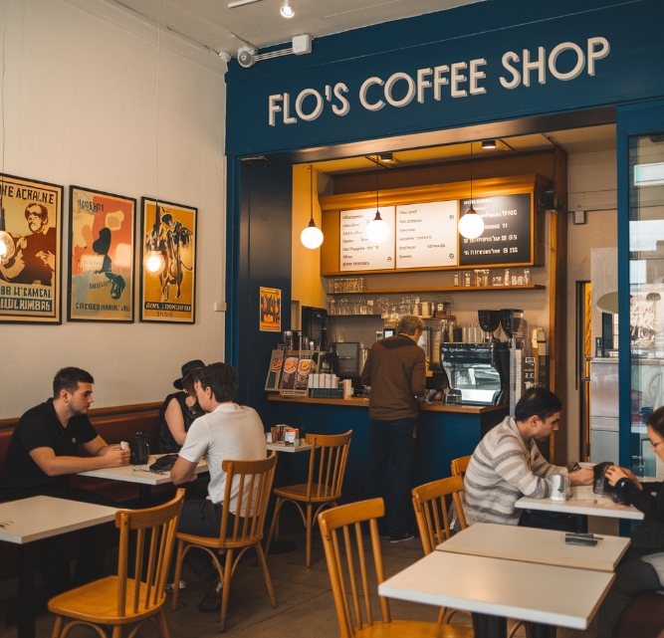
Figure 1: Shop of FLO’s Coffee

Product/Service Proposition
The types of products that Flo's Coffee Shop sells are carefully selected to be high quality, fairly traded coffee, and freshly baked specialty goods. The coffee is roasted fresh from sturdy origins to bring out both the quality of the beans and the environmental consciousness of the individual farms. The brand offers coffee, but they also offer locally sourced teas and homemade baked goods made with organic products. Innovate amenities including a free Wi-Fi connection accompanied by comfortable seating arrangement make it appropriate for students and other workers (Hutt and Speh, 2021).
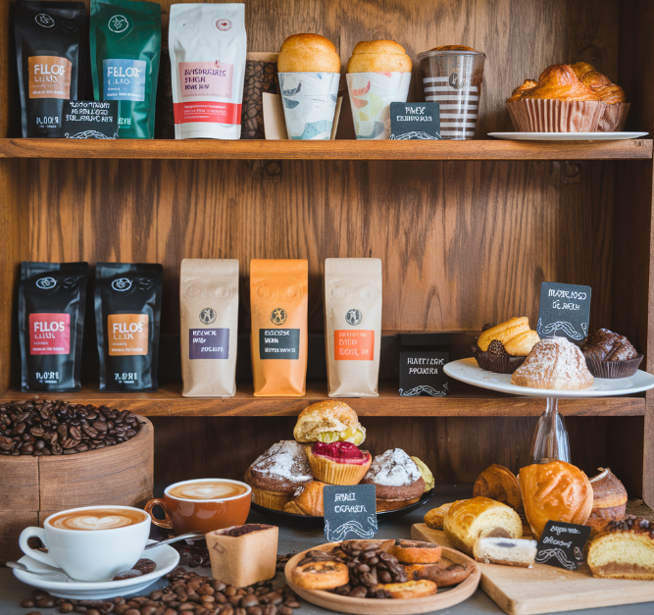
Figure 2: Products of Flo’s coffee

Business Name and Type of Ownership
Business Name: Flo's Coffee Shop
Type of Ownership
Flo's Coffee Shop will be under the level of a sole trader. The ownership structure is suitable for small operations since it entails that the owner operates and controls the business (Adeleke, 2020). One of its benefits is that the business has fewer costs at the start as well and it is easy to operate it under the current law as a sole trader rather than a partnership or a limited company. However, the main disadvantage is that the owner is fully liable for the enterprise, so one's property can be used when repaying the enterprise's debts (Mills, 2024).

Mission Statement, Aim, and Objectives
Mission Statement
” To provide a comfortable environment for the community to have a good cup of coffee with the values of a local producer and freshly baked goods to encourage people to socialise.”

Aims
The vision of Flo’s Coffee Shop is to be the desired coffee shop in the target market by providing great product quality and appeal and a friendly environment for the community.
Objective
Our main goal of marketing during the business startup within the first year of operation is to foster customer loyalty.
- To establish a customer base of 50 regular customers within the first quarter of the year.
- To achieve a 15% increase in overall sales within the next year.
- To source locally to guarantee consistently reliable and high-quality suppliers of food items.
- To host a loyalty program in the first 6 months to build customers' repeatability.

Unique Selling Proposition (USP)
Flo’s Coffee Shop’s competitive strategy is built around delivering an experience and product that is sustainably and locally sourced. They do not buy from chain suppliers like most franchises, and always ensure to adopt the best environmental conservation practices (Jones and Talbott, 2022). We have a focus on a comfortable atmosphere for anyone in the UK seeking quality coffee and a comfortable working space for all, from freelancers to students to members of the community.

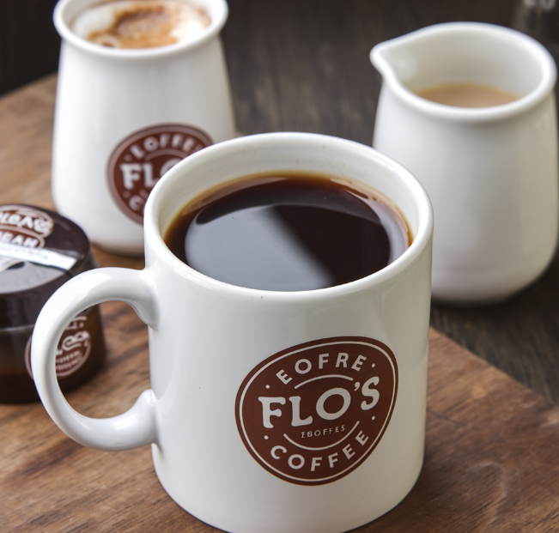

Physical Location and Rationale
This business will be situated upstream in the Cardiff university area and a business section to be able to attract as many customers as possible, especially students working individuals, and other members of the public. This area receives many feet traffic hence one is assured of many clients during the day. The choice of the location is based on its accessibility, openness, and surroundings with the world where people are is a great place for that (McCamley and Morland, 2021). This location can also be said to be strategic hence aiding the company’s vision of being among the favorite in the local community.
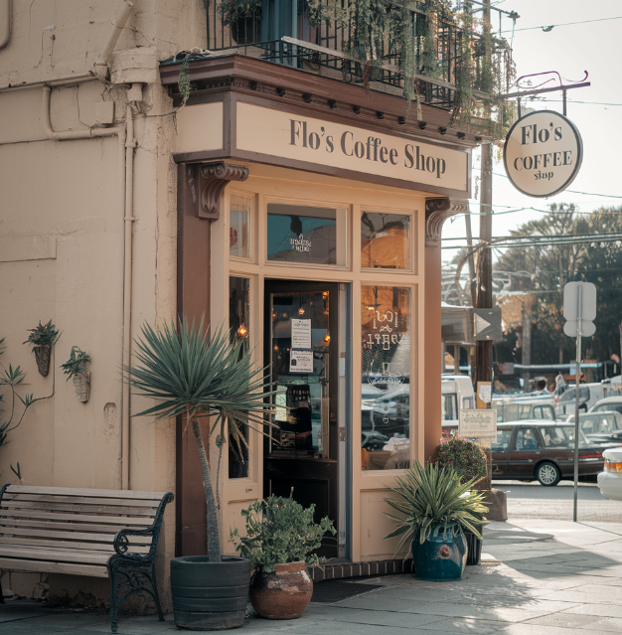

Human Resources
In the early days, the company staff of Flo's Coffee Shop will consist of five workers to manage the store effectively. They comprise one full-time manager, two part-timers – baristas, one full-time kitchen assistant who is in charge of baking food, and one cleaner. The team will be recruited from within the local market through the use of job post ads on websites and social media and with nearby universities for part-time positions (Son et al., 2021). The manager will have work experience in the industry while the baristas and kitchen staff will be trained in-house. This will be a small, team that will guarantee efficiency, high customer satisfaction, and warmth to all customers (Sawa and Pandrianto, 2020).

Figure 3: Organisational Chart

Marketing Activities
For the promotion of Flo’s Coffee Shop, will apply an integrated marketing communication. First of all, will develop bright posters for placements in the district and on the territory of the university, indicating the advantages of our café and the date of the official opening (Saleh et al., 2020). Brand identification will be important with the mark and acquired color used in all relevant items (Swain, 2021). In addition to this, Facebook and Instagram accounts will be used to interact with the target market through nice pictures of the products sold and the welcoming ambiance of the brand (Berčík et al., 2021). Also, we will launch a customer reward program to justify loyalty, as well as engage social media personalities to advertise our coffee shop.
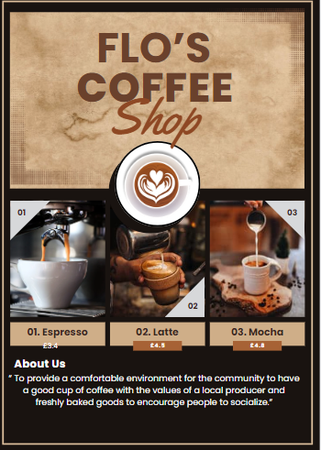

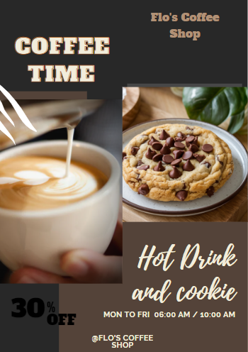

Market Research
To market Flo's Coffee Shop many strategies will be used. Market research for Flo's Coffee Shop called for detailed research on buyers, competitors, and the business environment. Surveys were administered to the population of local consumers to establish their coffee-drinking behaviors and their preferences for specialty drinks and other related edible items. Secondary research was also used together with the analysis of various reports and trends within the coffee shop industry (Didonet and Fearne, 2023). There will be a clear brand identity through an eye-catching logo and recognition of visual identity throughout the brand's media (Sinambela et al., 2022).
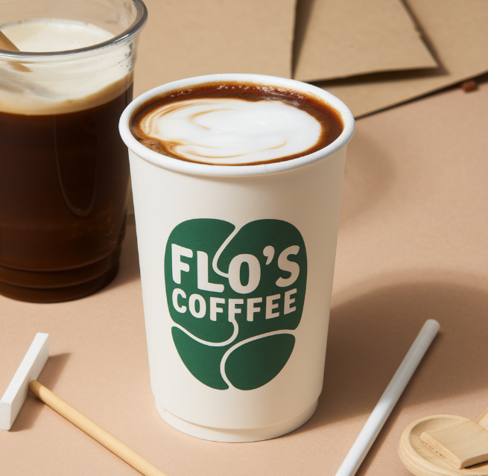

Financial Resources
Category | Estimated Costs/Revenue (£)
Initial Investment | £ 26.500
Equipment (coffee machines, grinders, etc.) | £12,000
Initial Inventory (coffee beans, pastries) | £4,000
Renovation & Décor | £6,000
Marketing & Promotion | £3,000
Legal & Regulatory Fees | £1,500
Total Initial Investment | £26,500
Monthly Operating Expenses
Rent | £1,800
Utilities (electricity, water, etc.) | £300
Employee Salaries (1 manager, 2 baristas) | £6,000
Inventory Restocking | £2,000
Marketing | £400
Miscellaneous Costs | £250
Total Monthly Operating Expenses | £10,750
Projected Monthly Income
Coffee Sales | £15,000
Snack Sales | £4,000
Total Projected Monthly Income | £19,000
Projected Monthly Profit | £8,250

The total cost for Flo's Coffee Shop stands at £26,500 with equipment, inventory, and marketing as the major costs at the start-up level. The gross monthly operational expenditure is £10,750 which would be spent on rent, staff salary, and restocking of the inventory. From coffee and snacks sales with a projected £ 19000 per month the breakdown of profit at £ 8250 per month depicts its positive aspect depicting it can sustain in the prevailing competition.

Biggest Threats and Mitigation Strategies
The urge that exerts lots of pressure on the success of Flo's Coffee Shop is competition from well-experienced coffee chains and other cafe houses. This competition may affect customer acquisition and also customer loyalty. Thus, to counter this problem, Flo's Coffee Shop will aim at targeting customers' value for money by offering, various specialty products, quality customer relations, and great ambiance (Gerhart and Feng, 2021). By passionately promoting a product, incorporating loyalty programs as well as organizing and participating in local events we can capture the audience’s attention (Surya et al., 2021).

Individual Reflection

Gibb’s Reflective Model
Description
When making the business plan, practical research was carried out to analyze different features of the business, including market, financial, and marketing factors. These comprised of specifying the company's product line and determining its potential consumers on the market and its rivals. All these needs were supposed to be met based on an analysis of the working process of businesses in the sphere of coffee shops.
Feelings
At first, the process seemed rather challenging and that was especially so due to the tasks involved in strategic business plan formulation. However, research became more systematic as its structure was defined, and the confidence intensified. Regarding this, the prospect of dreaming and this coffee shop's plan, for it and all that it could bring coupled with the enjoyable offers outweighed the actual hard work involved. It also left a business dream, which focused on determination and innovation in addressing issues.
Evaluation
Several business skills were learned through this process at the organizational level. An increase in financial knowledge was observed mostly regarding the production of cash flow estimates and the consequences of costs. Experience in market research and analysis or knowledge was also developed which contributed to a better understanding of the major target groups and better strategies for marketing campaigns.
Analysis
Mapping of personal entrepreneurial characteristics produced the understanding that critical thinking and creativity are essential strengths. This flexibility proved invaluable when it came to problem-solving with regard to the main products at the source coffee shop. From the market research experience, it was possible to interact with potential customers due to good interpersonal communication skills. However, identifying areas of nascent development like risk assessment and long-term strategic planning pointed to the growing areas that required more attention.
Conclusion
However, the concerns are expected to be experienced in the course of implementing the business plan. The threat of interactions with well-established brands is high, meaning that the company has to learn to innovate or adapt frequently. Further, the concern with the budgets and financials, including finances in general and the internal cash available is of immense importance, especially at the formative stages. Creation of this strong customer base will also be a challenge especially due to issues of marketing and creating awareness to the communities.
Action Plan
To overcome these challenges, strategies will be employed, therefore, a proactive approach will be used. This also entails adopting tangible and well-defined targets for acquiring as well as interacting with the customers. Periodically checking on financial forecasts will assist in better management of resources to avoid the company moving into the red line. More specifically, daily conversations with fellow businesspeople, many of whom are now our advisors, and visiting relevant seminars and workshops to consider aspects of strategic planning, will also help build a better skill base.

References

Adeleke, A., 2020. A case study of the marketing tools coffee shop owners use to sustain businesses. Open Journal of Business and Management, 8(02), p.726.
Berčík, J., Neomániová, K., Gálová, J. and Mravcová, A., 2021. Consumer neuroscience is a tool to monitor the impact of aromas on consumer emotions when buying food. Applied Sciences, 11(15), p.6692.
Crick, J.M. and Crick, D., 2020. Coopetition and COVID-19: Collaborative business-to-business marketing strategies in a pandemic crisis. Industrial Marketing Management, 88, pp.206-213.
Didonet, S.R. and Fearne, A., 2023. The impact of market information use on entrepreneurial performance: insights from the UK food industry. Journal of Small Business and Enterprise Development, 30(5), pp.967-986.
Drummond, C., O'Toole, T. and McGrath, H., 2020. Digital engagement strategies and tactics in social media marketing. European Journal of Marketing, 54(6), pp.1247-1280.
Eid, R., Abdelmoety, Z. and Agag, G., 2020. Antecedents and consequences of social media marketing use: an empirical study of the UK exporting B2B SMEs. Journal of Business & Industrial Marketing, 35(2), pp.284-305.
Gerhart, B. and Feng, J., 2021. The resource-based view of the firm, human resources, and human capital: Progress and prospects. Journal of Management, 47(7), pp.1796-1819.
Hutt, M.D. and Speh, T.W., 2021. Business marketing management: B2B. South-Western, Cengage Learning.
Jones, S.H. and Talbott, S., 2022. Sole Traders? The Role of the Extended Family in Eighteenth-Century Atlantic Business Networks. Enterprise & Society, 23(4), pp.1092-1121.
McCamley, C. and Morland, L., 2021. Lone not lonely: Conceptualising the lone consumer servicescape through specialty coffee. Marketing Theory, 21(3), pp.371-389.
Mills, K.G., 2024. Small businesses are important to the economy. In Fintech, Small Business & The American Dream: How Technology Is Transforming Lending and Shaping a New Era of Small Business Opportunity (pp. 15-30). Cham: Springer International Publishing.
Saleh, H., Surya, B., Annisa Ahmad, D.N. and Manda, D., 2020. The role of natural and human resources on economic growth and regional development: With discussion of open innovation dynamics. Journal of Open Innovation: Technology, Market, and Complexity, 6(4), p.103.
Sawa, B.S. and Pandrianto, N., 2020, December. Creativity Process of Naming the Coffee Menu as a Part of Marketing Communications. In The 2nd Tarumanagara International Conference on the Applications of Social Sciences and Humanities (TICASH 2020) (pp. 326-331). Atlantis Press.
Sinambela, E.A., Darmawan, D. and Mendrika, V., 2022. Effectiveness of efforts to establish quality human resources in the organization. Journal of Marketing and Business Research (MARK), 2(1), pp.47-58.
Son, J.H., Kim, J.H. and Kim, G.J., 2021. Does employee satisfaction influence customer satisfaction? Assessing coffee shops through the service profit chain model. International Journal of Hospitality Management, 94, p.102866.
Surya, B., Menne, F., Sabhan, H., Suriani, S., Abubakar, H. and Idris, M., 2021. Economic growth, increasing productivity of SMEs, and open innovation. Journal of Open Innovation: Technology, Market, and Complexity, 7(1), p.20.
Swain, T., 2021. Branding: The Fast & Easy Way To Create a Successful Brand That Connects, Sells & Stands Out From The Crowd. Thomas Swain.

