Catalin Iordache (1920305)
BA Business Management ( Birmingham)
Community Engagement Assignment

Table of content
Professor Dale Clarke
[
Introduction
Mission and values
Swot analysis
The role of the Food and Beverage Manager
Conclusion

Marriott

INTRODUCTION
In a highly competitive world of travel and tourism, one of the leading companies of hospitality from the United States , the Marriott Corporation has planned and opened in the summer of the year 2000.
Undertaking a preview on the political , historical and legal system at this point will ensure that the presentation will follow the steps of the PESTEL.

The geographical and geopolitical landscape presented at the time within the region of the Balkans with the war in the ex republic of Yugoslavia as not very attractive, the republic of Bulgaria was in an economic downturn , as the IMF had given them a grant and the 1997 inflation above 300 % which made the prices volatile. The Republic of Moldova was under communist rule and so was the Ukraine.
Romania had a growing inflation as well but as well as the Republic of Bulgaria, they had started the negotiations for the entry into the European Union and NATO.
The legislation regarding the tourism industry and the hotel/ hospitality industry was from 1985, meaning the standards had not been modified since then. With the forceable entry of Romania into the European Union, this assured the business community that stability and a good code of practice from the Government for all businesses.
In Bucharest there were only two hotels that had the five star designation. Both in old buildings, with some renovations during the years and no room for improvement. They The Hilton and The Intercontinental had little room around there location for further constructions. The Intercontinental had at the time 3 conference rooms and 3 restaurants, along with 283 rooms , the construction was done in 1975. The Hilton Hotel has 272 rooms and at the time only 4 restaurants.
The Marriott opened with only 200 rooms and two restaurants ready opened in August of 2000. What they foresaw was the expansion of the business with the ongoing talks that were taking place with tech giants like ORACLE and HP among others. With there expanding business they find a location for there executive committee members that were going to become expats in Bucharest. By November , the hotel had all of the 402 rooms opened for public and 8 conference rooms and only one of the five restaurants were still closed. The hotel at the end of the year was working at 80% booking and all the Conference rooms were booked until the April of 2001.
Marriott as well as other major Hospitality companies has a program of keeping there most important guests within a logbook that gives the hotel relevant information about there needs and desires.
Establishing a foothold in Romania, was an investment that took into account the entry in the EU, the good cooperation with the American Congress and the Business environment from the U.S.
Another of the advantages that the investors had was the fact that the building was new and at a short distance from the centre of the city with its tourist attractions and governmental buildings, but without the busy roadblocks that were occurring even then.
Form the economic point of view , the Marriott Corporation had only two players on the 5 star hotel industry in Romania. The Continental Corporation which owned the Intercontinental and the Hilton Corporation that owned Hilton Courtyard. The Marriott business consultants predicted that the expanding market after the E.U. entry would bring business on a sustain increasing level.
The workforce that Marriott was going to hire was selected from other hotels, including the 5 star ones, new employees that had never worked into a hotel before and the core came from outside the country as a task force to open the hotel. 80% of that task force remained to manage different departments of the hotel. Some lower level managerial tasks were given to some other members of the personnel that had previously worked into the business.
The Marriott started as a family business and everyone of the employees had a number of privileges given by the company ( life insurance, health insurance)as well as an informal communication system( the managers were always within the hotel on open the floors on the open area). This helped escalation of potential risky situations regarding costumers or hotel property to be avoided or eliminated.

The Marriott brand operates in the hospitality business, it has started in the United States of America , in the year 2001 it had opened 2000 hotels worldwide. It had different types of hotels for different types of costumers. The classic luxury hotels like the Ritz-Carlton , Ritz-Carlton reserve, St. Regis, J.W.Marriott and W hotels. the premium hotels the Sheraton, for the Marriott Vacation Club - Delta hotels, Le Meridien and Westin. Renaissance and Gaylord were city hotels that were right in the heart of the city, they were small in space and rooms easily placed into busy metropolis. the family hotels , Four Point by Sheraton , Courtyard Hotels, Fairfield Inn & Suites. For the lower classes and the young there were these brands: AC Hotels, Aloft Hotels, Moxy Hotels.
MISSION AND VALUES

One of the core values of the company that as embedded ever since the beginning was:
"Take care of the associates and they will take care of the costumers" - that translated in trainings and cross-trainings that were done on a regular basis, the possibility to become an ambassador for the hotel , sell its products and services to anyone, without the limitations of an office, paying higher wages than the hospitality market in the region, allowing the associate to improve and innovate, giving the associate a discount in every Marriott hotel an incentive when travelling , by giving them a large discount on the reservations.
" Good food and good service at a fair price" - by the trainings and the movement of skilled people , who would teach others, the Marriott Business ensured that all the necessary components were there for the costumer when it arrived in any hotel. the service would be impeccable and the food would taste the same. the recipes for the main restaurants and bars were the same worldwide, but every hotel could bring there own.
" We embrace change" - in a world that has passed from he land line to the mobile connection telephones, from the ping driven computer internet to the wi-fi laptop within a generation, the Marriott has seen its fair share of changes. In the year 2000, they were looking at vegan food, no meat food, for the growing number of costumers that were possibly going to pass thru the hotel. in an everchanging world were the Company was offering services it was very important for them to be among the first to see the change and be able to adapt and succeed.
"We act with integrity"- the business community that worked with Marriott knew they had a steady , reliable client and a partner. Every costumer that walked into a Marriott Hotel was seen as a partner, the Company tried to give the best services it could offer - " to go above and beyond" the costumer expectations.
https://www.marriott.co.uk/culture-and-values/core-values.mi
SWOT Analysis
Strengths
- the Company was founded in 1927, it had the knowledge of the business and the competence to overcome any business strategy that the competition would try to impose. By having nearly 2000 hotels world wide they had a ground breaking coverage of the worlds and the people to help them. some of the Marriott costumers had expressed their desire to have a hotel in Romania, as the number of costumers given to other hotels like( Hilton or Intercontinental) grew and as they were loosing costumers
Weaknesses
- the companies that were offering the 5 star accommodations had a long history within the country. as a new player on the market , the Marriott relied only on the existing costumers that belonged to the brand and had to overcome the existing forces on the market. being an American company unfamiliar with the law and the regulations meant that it would have to uphold.
Opportunities
- one of the major opportunities for the Company was the fact that the United States of America had a growing economic interest. the company would come with a new perspective and a fresh new look on an emerging market where they could.
Threats
the emergence of Romania from a communist country to a neo-communism governed country
that had to learn to embrace and actively work on the legislative and executive laws so that the country would work under the established rules of the market - capitalist economy.
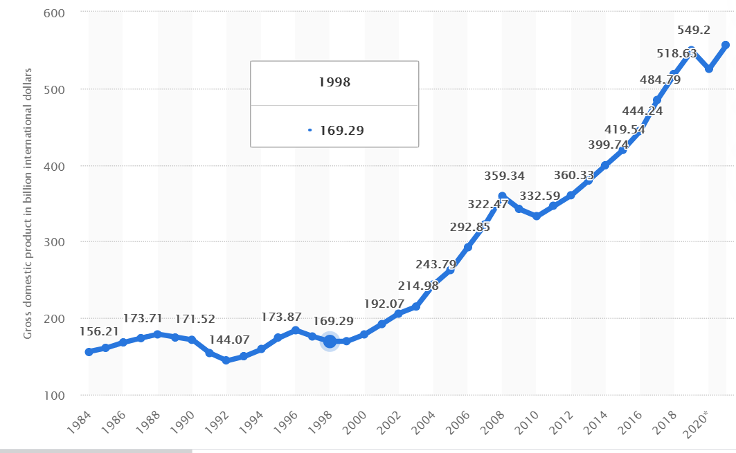
The negotiations with the European Union entry of all the former communist countries was an
arduous process that extended several years with setbacks.

Gross domestic product (GDP) in Romania 2021
Published by H. Plecher, May 19, 2020
https://www.statista.com/statistics/373193/gross-domestic-product-gdp-in-romania/

As it can be seen in the chart , the GDP grew from 2000 and it has continued its trend, for a countries economy that means that business in also developing, including the hospitality business.

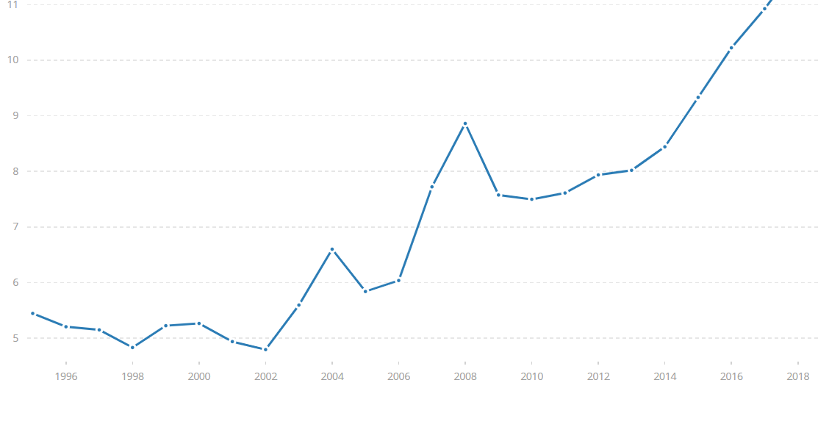
International tourism, number of arrivals - Romania
World Tourism Organization, Yearbook of Tourism Statistics, Compendium of Tourism Statistics and data files.

https://data.worldbank.org/indicator/ST.INT.ARVL?locations=RO

As the analysts predicted, the Romanian economy had a upgoing trend since 2002 and the Marriott company, had foreseen a growing market within it.
The Role of The Director of Food and Beverage (F&B)

The Director of Food and Beverage had the task of keeping the restaurants and all the people that were linked with them in a state of being prepared for what happened in the hotel at any time. To be able to prevent crisis and to keep the costumers appropriately served in the restaurants. The job encompassed:
Development and maintaining budgets. From the employee assessment and engagement to the costumer’s satisfaction plans. Maintains a positive corelation between costs of the food and beverage department and prices.

Creates and nurtures a property environment that emphasizes motivation, empowerment, teamwork, continuous improvement and a passion for providing service. By providing a learning, proactive coaching and counseling to the team members. Responds proactively and quickly to employee concerns, ideas, builds mutual trust, encourages respect and cooperation. Develops goals and plans to keep the selling and departmental goals, organize and accomplish the tasks that drives the business. Provides leadership by having vision and direction to bring together and priorities departmental goals. Synchronizes clear expectations with the employees and team leaders and ensures that appropriate rewards are given if expectations are exceeded.
https://sites.google.com/site/narisasethiportfoliointernship/home/my-company

Conclusion
the Marriott Company on a high scale is an organized company by the principles of hospitality set by the founders. The mission core and values are being passed down from the headquarters to each hotel and the costumers or guests are being treated fairly, just like the associates of the hotel. The associates are being valued for their strengths and knowledge. On a microscale, a hotel to hotel viewpoint, everyone is assured that it will be helped and backed-up by its colleagues. That it would have all the necessary trainings done and that he will be guided towards a career that will satisfy him or her. The managers must be interested in the internal as well as external costumers of the hotel, more prevalent on the internal.

Bibliography

- https://data.worldbank.org/indicator/ST.INT.ARVL?locations=RO
- https://sites.google.com/site/narisasethiportfoliointernship/home/my-company
- https://www.marriott.co.uk/culture-and-values/core-values.mi
- https://www.statista.com/statistics/373193/gross-domestic-product-gdp-in-romania/

