The major environmental factors affecting organisations.
Human resource management in context.
Joshua Pryer - 1351781

Contents
Executive Summary 2
1. Introduction 3
2. Three Factors facing NHS Wales Shared Services Partnership ‘NWSSP’ 4
2.1 Political factors facing NHS Wales Shared Services Partnership (NWSSP) 4
2.2 Economic factors facing NHS Wales Shared Services Partnership (NWSSP) 6
2.3 Technological factors facing NHS Wales Shared Services Partnership (NWSSP) 8
3.0 Conclusion 11
4.0 Recommendations 12
6. References 13

Executive Summary

Introduction
The report will outline 3 factors from the PESTLE management and diagnostic tool, this will include an in-depth analysis of the impact that the Political, Economic and Technology factors have relating to NHS Wales Shared Services Partnership ‘NWSSP’ corporate and HR strategic direction.
NHS Wales Shared Services Partnership have used the management and diagnostic tool PESTLE, to deter the external factors affecting the organisation. PESTLE is combination of the following:
P – Political
E – Economic
S – Social
T – Technology
L – Legal
E - Environmental
Once the tool has identified factors, the organisation can then assess the impact on strategy and may influence any business decisions.
Table 1 below identifies the advantages and disadvantages of the use of PESTLE as a tool for the organisation:
 | Advantages | Disadvantages
1) | The framework is easily understood in order to cover the 6 headings of PESTLE. | The framework would need to be used frequently to be effective. This is due to possible changes in Political factors, for example that Government Policy may change.
2) | Creates the organisation to think strategically and on the external factors affecting the organisation. | Data must be sourced from credible organisations i.e. Government or Office of National Statistics – or the information may just be an assumption.
3) | The tool can assist with identifying possible threats for the future and the business can work on minimise such large impact on the organisation. i.e. Brexit Planning.

Table 1

2. Three Factors facing NHS Wales Shared Services Partnership ‘NWSSP’

2.1 Political factors facing NHS Wales Shared Services Partnership (NWSSP)
“Organisations in both the private and public sectors have to plan responses to the political pressures emanating from these bodies, using appropriate strategies, policies and practises if they are to prosper or at least survive. In the political sphere, there is increasingly active government involvement in labour markets. This too provides opportunities and threats to organisations as employers.” (Farnham, Political Context, 2015)
On the 28th of October 2019, it was confirmed the UK leaving the European Union has been further delayed until 31st of January 2020. However, the EU has now offered a ‘Flextension’ meaning if a deal agreement was made by all involved in UK Government, the EU would allow an earlier exit prior to the 31st January 2020. This provides uncertainty on organisations across the UK, who are attempting to workforce plan for Brexit with or without a deal. (BBC, 2019)
NHS Wales Shared Services Partnership’s vision for 2019 to 2022 is to create a fully skilled workforce by having a strong succession plan. A possible risk of Shared Services not being able to achieve this would be the uncertainty on Brexit and Right to Work documents required by EU nationals in the future. (NHS Wales Shared Services Partnership, 2019)
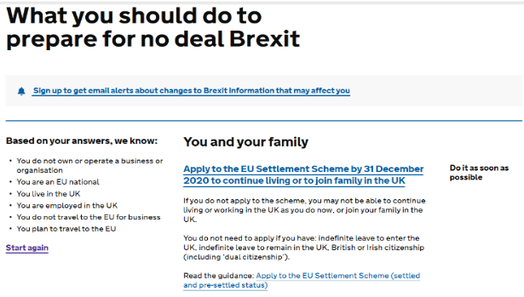
The UK Government put together and have undertaking a heavy marketing campaign ‘Plan for Brexit by visiting www.gov.uk/brexit’. The website provides Businesses, UK citizens and EU nationals advice on Brexit such as travel advice, business preparation and immigration support on status post Brexit.
The UK Government put together and have undertaking a heavy marketing campaign ‘Plan for Brexit by visiting www.gov.uk/brexit’. The website provides Businesses, UK citizens and EU nationals advice on Brexit such as travel advice, business preparation and immigration support on status post Brexit.

Image 1
NHS Wales is the biggest employer in Wales and currently employs more than 90,000 people with almost 80,000 working full time. (Welsh Government, September 2018) Shared Services is a provision of NHS Wales which provides Recruitment, Payroll, Legal & Risk and Procurement services to all other Health Boards and Trusts under the NHS Wales umbrella.
From the 90,000 staff employed by NHS Wales, the service has a minimum of 1,462 EU nationals, who are directly employed which equates to 1.6% of the workforce. (BBC News, 2019)
NHS Wales Shared Services Partnership are assisting with EU nationals directly employed with gaining permits under the settlement scheme which must be completed by 31st of December 2020. As of 2021, new immigration rules come into force with EU/EEA/Swiss citizens coming to the UK for longer than 90 days will be required to apply for European Temp leave to remain. (CIPD, 2016)
49.9% of the Welsh budget 19-20 has been spent on health and social services in Wales. The Welsh Government has provided £7.4bn to NHS Wales and its services. (BBC News, 2019) With a General Election on the 12th of December 2019, who knows how the next UK Government will set the budget and what it will mean for health and social care services in Wales moving forward into 2020 and post Brexit.
Conservatives current manifesto mentions strengthening the NHS by boosting its finances by additional £33.9bn by 2023-24. Alongside this, promising additional nurses, doctors, upgrading old hospitals and creating new ones. The Labour Party who are the opposition also commit to supporting the NHS financially but are yet to reveal actual figures.
Set aside the upcoming UK General Election, there has been a policy set by Plaid Cymru for the National Assembly 2021 elections of a proposal of creating a health and social care single system for Wales. (Nursing Times, 2019)
To conclude, NWSSP as well as all NHS boards in Wales will experience difficulties over the next 12 months in the build up to exiting the EU and the changes that will come shortly after Brexit taking place. The organisation has done nearly 3 years of workforce planning since the referendum in 2016 and will continue to prepare even with the uncertainty around ‘what will happen next?’

2.2 Economic factors facing NHS Wales Shared Services Partnership (NWSSP)
“Shared services. Those working in shared services undertake a lot of HR administrative tasks and provide information and advice through intranets and call centres to clients.” (Farnham, Developments in the HR Function: Shared Services, 2015 (4th Edition))
The organisation ‘NWSSP’ is an independent organisation, which is the centralised hub ‘Shared Services Hub’ for the 7 Health Boards, 2 Trusts and 1 Public Health organisation in Wales. This is managed and owned by NHS Wales. (NHS Wales/About Us, 2009)
Shared Services is a support organisation for Public Health Wales, Health Boards and Trusts which umbrella under NHS Wales. The customers have highlighted that £600m of savings are required, to support the sustainability and future of NHS Wales.
Employment Services part of NWSSP employs 329 staff which umbrella departments which include recruitment, payroll, legal, accounts and risk. (NHS Wales Shared Services Partnership, 2016-2017) As NWSSP develops and expands, the aim is to transfer 129 staff to Matrix House in Swansea.
“In the economic sphere, a number of indicative trends are discernible. One is market uncertainty arising out of recession and slow macro-growth in the 2010s. This, in turn, is likely to be offset eventually by an economic upturn and, most probably, the continued globalisation of business activities. The economy is also affected by Government macro-economic policies, such as fiscal policy, monetary policy and its own economic activities, as well as by international economic forces.” (Farnham, The Economic Context, 2015)
The Guide to Welsh Public Finances from Welsh Government highlights the devolved or otherwise public services funding in Wales are funded from a combination of tax, borrowing and income generation. The diagram below shows that between 2016 – 2017 the main sources of funding for the devolved services in Wales. (Wales Audit Office, 2018)
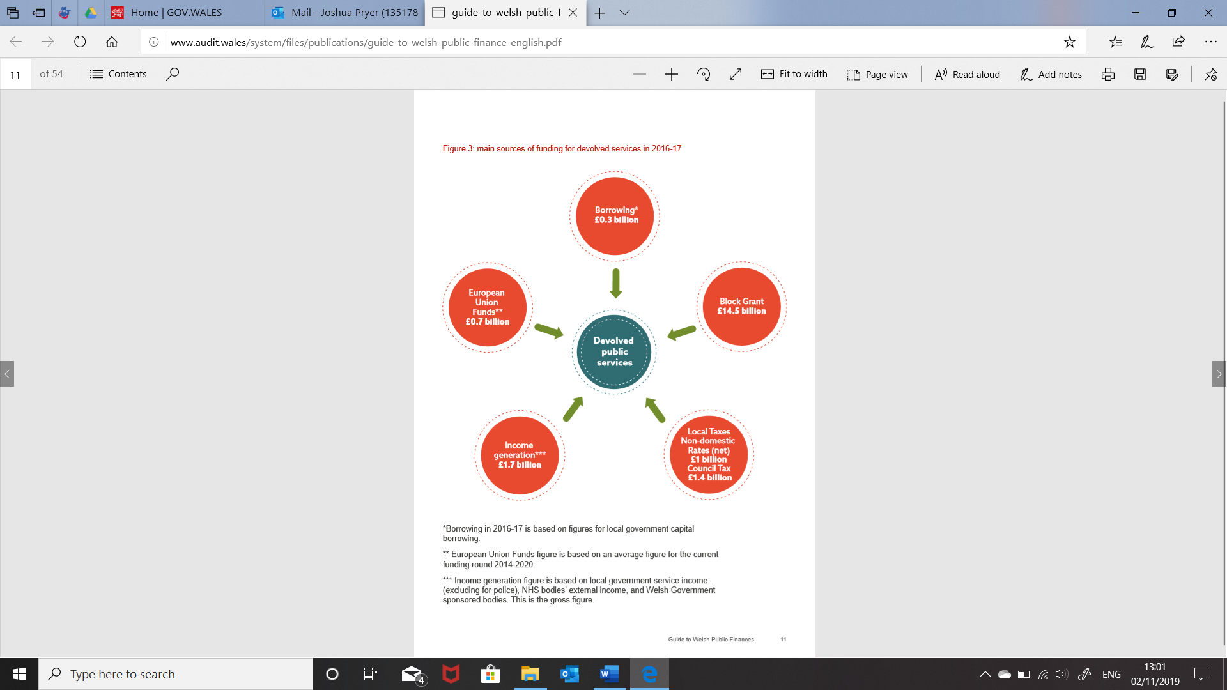

Diagram 1
Following the referendum in June 2016, financial support may change from the European Union if Brexit is to go ahead. The UK Government makes no direct decision about how much money is allocated to Welsh Public Services in Wales. The decision comes from evaluating previous spends and any changes from the block grant. The Barnett formula is used and asks 3 simple questions in terms of for funding in Wales (see below):
- How much has the UK Department’s budget changed by?
- What percentage of the policy area the UK Department is responsible for has been devolved?
- What is the population of Wales compared with England?
The Barnett formula can be seen below on how the budget is set for Wales and its Public Services. (Wales Audit Office, 2018)

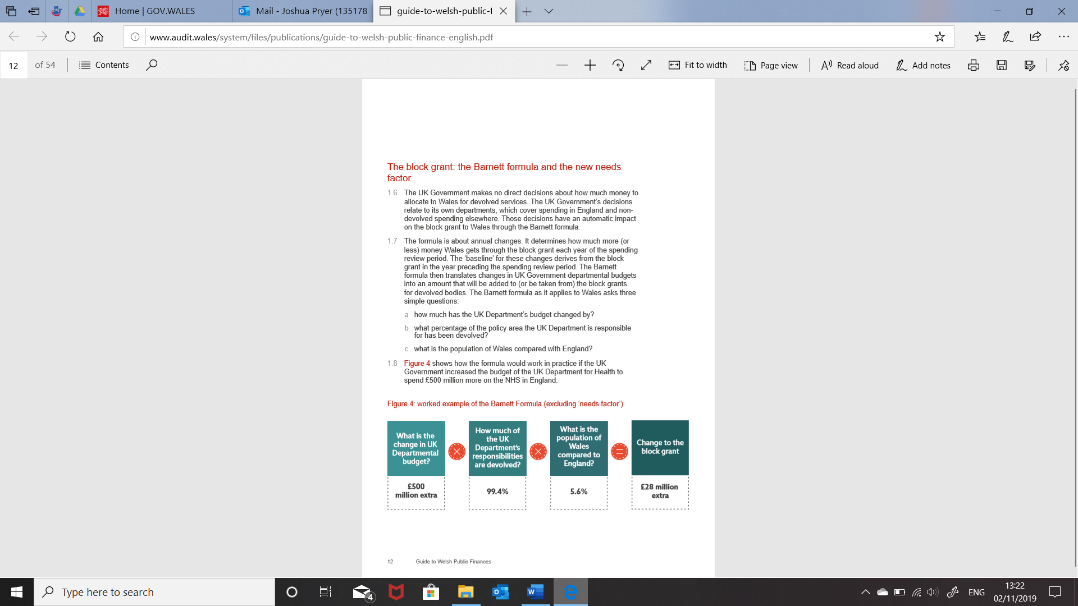
Diagram 2
NHS in Wales are experiencing numerous implications with pressure on the service, finances and workforce. To add to that that pressure, there has been a price inflation and technological developments, with the NHS facing extraordinary cost rises in wages, rising demand, outdated infrastructure and workforce issues with recruitment and retention. This was revealed during a 2017 report from the Welsh Confederation. (The Welsh NHS Confederation, 2017)
With uncertainty surrounding Brexit and the implications it may have in Wales and the health service. Public Health Wales raised those concerns in a recent report in October 2019. Public Health are concerned of the “likely disruption” that Brexit may have on medical supplies and any possible price hikes on items like food.

2.3 Technological factors facing NHS Wales Shared Services Partnership (NWSSP)
“Technological change is one of the most visible and pervasive forms of change and it brings in its wake new products, processes and materials, so awareness of technological developments is essential for most organisations. Technology directly impacts on transportation, energy use, communications, entertainment, healthcare and so on. Technological innovations effects not only operational systems but also the finance, administrative & HR function.” (Farnham, Technological Contexts, 2015)
NHS Wales Shared Services Partnership (NWSSP) have as an organisation develop their technology. In the annual review in 2016 – 2017, the organisation had successfully rolled out their new recruitment system of Trac with no detrimental loss of service which was achieved. (NHS Wales Shared Services Partnership Annual Report, 2016 - 2017)
However successful the roll out of this new technology was, it has been revealed that it has not been as successfully used by managers. Statistics show that Key Performance Indicators (KPI’s) are not been achieved, see table 2 below (NHS Wales Shared Services Partnership Annual Review 2016-2017, 2016/2017):
Task | Target | Actual
Time to approve vacancy | 10 days | 11.1 days
Time to shortlist applicant’s | 3 days | 7.2 days
Interview Outcome | 2 days | 5 days
Conditional Offer Letter | 5 days | 3.1 days

Table 2
Knowledge and training may well be a factor for not achieving the KPI’s of the time for approving vacancies and processing, shortlisting and providing interview outcome. This is due to Pay Progression & Personal Development Review (PADR) target being under at 77.1% NWSSP expected compliance rate of 85%+. (NHS Wales Shared Services Partnership, 2016 - 2017)
According to the World Economic Forum in May 2017, it was revealed that 90% of organisations currently have an IT skills shortage. However, it is estimated by 2020 that there will be 1.5 million new digitalised jobs across the globe. Technology will play a key role in nearly all aspects of our lives and it is estimated that 65% of children studying in primary schools now, will find them in occupations that do not even exist today. (World Economic Forum, 2017)

Other technology developments since the roll out of Trac, is that e-contracts are released from the system once a start date has been added by the Appointing Manager for the Applicant. Since the launch of Trac in 2016-2017 financial year, it recently had an interface makeover in August 2019 to make it a more modern system and easily accessible for Managers to manage (see image 2 below). 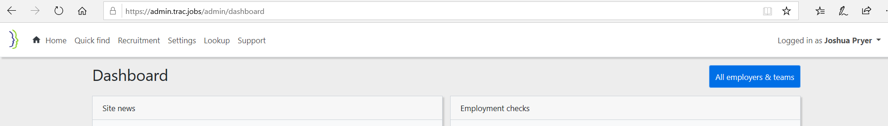
Image 2
E-payslips can be accessed from Electronic Staff Record portal which payroll make available 4 working days before pay day. See image below: (Electronic Staff Record - NHS, 2019)
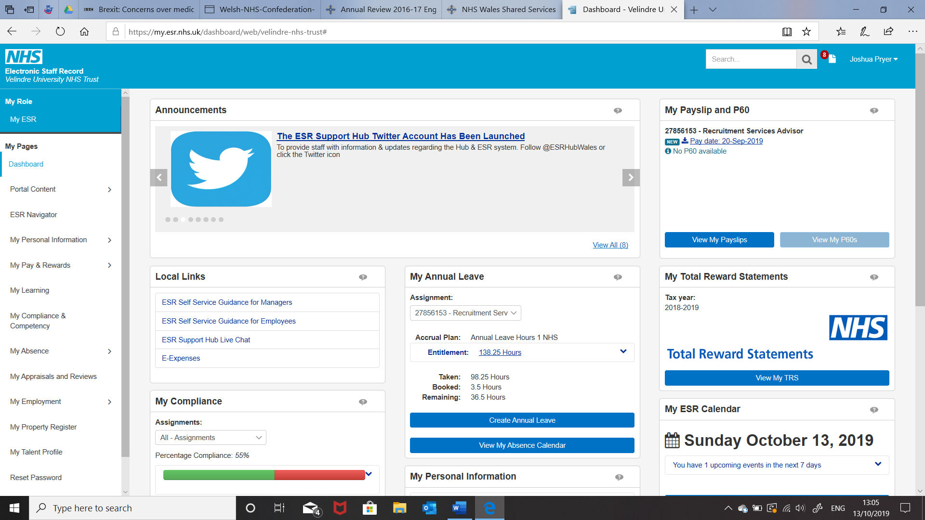

Image 3
Challenges facing NWSSP are the further developments in technology globally and the competition to keep up with current trends. A recent report from Public Health Wales organisation working alongside NWSSP revealed the financial challenges NHS Wales face. This includes the technological advances and the outdated infrastructure which putting pressure on the service and its workforce. (The Welsh NHS Confederation, 2017)
Recently, a local authority in Wales announced they were using a Robot to process DBS information and update employee information. The robot costs an annual fee of £10,000 to run which very cost effective for their organisation and a possible future use within NWSSP in the future. (Wales Online, 2019)
Technology developments ‘the boom’ shows no sign of slowing down. A report by McKinsey Global Institute revealed that up to 800 million global workers will their jobs by 2030 by automation of roles. (McKinsey & Company, 2017)
A further study by Deloitte in 2014, revealed that up to 35% of the jobs being undertaken by humans in the UK could go to robots by 2034. (Deloitte LLP, 2014) Below are several jobs that have already disappeared or are at high risk of being phased out:
- Switchboard Operator
- Bridge Toll Collector
- Check-out Cashier
- Railway Station Ticket Seller
- Factory Workers.
Other technology changes NWSSP have considered are ‘Chatbox’, where the automated service can provide prompt responses to customer enquiries. The aim is limit number of calls to NWSSP i.e. Recruitment, Payroll, IT and Procurement Helpdesks.

Organisations are currently having to battle to battle with the consistent developments of technology. From public sector such as NHS to colleagues at local council i.e. Cardiff Council. On their homepage there is are contact details, create your own searches or a live chat option.

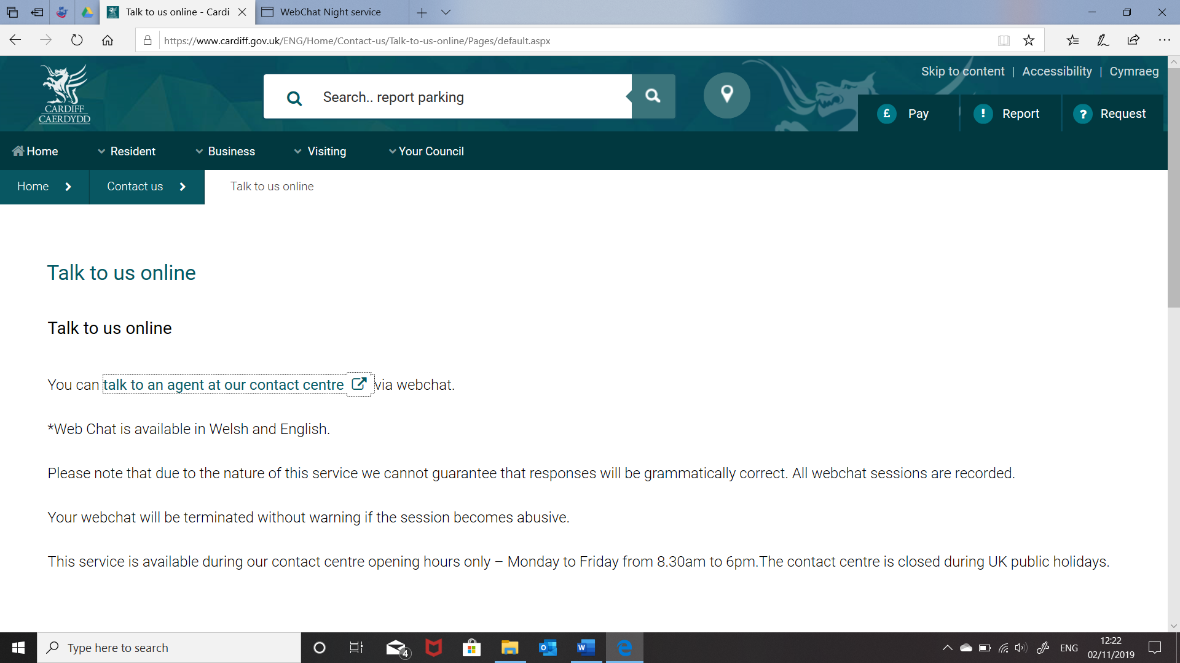
Image 4

3.0 Conclusion
To conclude, the PESTLE tool has identified 3 factors that are currently and will have a long-lasting effect on NHS Wales Shared Services Partnership ‘NWSSP’. Later in the report the conclusion will conclude with recommendations and an action plan of how the organisation can move forward.
Politically with uncertainty surrounding Brexit and the latest of announcement of a General Election, public sector organisations can only continue to workforce plan for the unexpected and ensure preparations are made for both ‘no deal’ and ‘deal’ Brexit.
Economic part of PESTLE is a growing factor for NWSSP surrounding funding from central Government to Wales post General Election on the 12th December and outcome of Brexit. As highlighted in the report, when Welsh Assembly Government hold their own election in 2021, there is currently talks of making a ‘Single health and social care industry for Wales’ and not rely on funding from central Government in Westminster.
Technology factors facing NWSSP are the development in technology with possible roles been taken to robots or other technology advances and the implication of the older workforce not being able to adapt to its use of various technology equipment used in roles.
PESTLE as a tool has identified the three important factors facing NWSSP at present which has been discussed in the report and concluded here with recommendations and an action plan to follow.

4.0 Recommendations
1) | Political – Due to uncertainty surrounding Brexit, continue the great work of workforce planning and recommend being ahead of the game and creating a ‘Workforce Planning Team’ who can focus on the latest Government discussions surrounding workforce planning implications associated with Brexit.
2) | Economic – Be financial aware of possible constraints that may become a future pressure as Government parties promise XXXX amount to the NHS if they were to win a General Election.
3) | Technology – Prior to introducing new technology to such a large organisation, a recommendation would be to create a Task & Finish Group to identify challenges that organisation may face before introducing the latest technology device.

6. References

BBC (2019). EU approves another Brexit extension [Recorded by BBC Global News Podcast]. London. Retrieved November 10, 2019, from https://www.bbc.co.uk/programmes/p07s98hw
BBC News. (2019, October 11). Retrieved November 10, 2019, from https://www.bbc.co.uk/news/uk-wales-50003821
BBC News. (2019, November 13). Retrieved November 14, 2019, from https://www.bbc.co.uk/news/election-2019-50405348
CIPD. (2016). Retrieved November 10, 2019, from https://www.cipd.co.uk/news-views/brexit-hub/workforce-trends
Deloitte LLP. (2014). Agiletown the Relentless March of Technology. London: Deloitte LLP. Retrieved November 9, 2019, from file:///C:/Users/joshu/AppData/Local/Packages/Microsoft.MicrosoftEdge_8wekyb3d8bbwe/TempState/Downloads/london-futures-agiletown.pdf
Electronic Staff Record - NHS. (2019). Retrieved October 13, 2019, from https://my.esr.nhs.uk/localresponse/?TAM_OP=W3login&USERNAME=unauthenticated&ERROR_CODE=0x00000000&METHOD=GET&URL=%2Fdashboard%2Fc%2Fportal%2Flogin&HOSTNAME=my.esr.nhs.uk&FAILREASON=&PROTOCOL=https
Farnham, D. (2015 (4th Edition)). Human Resource Management in Context. Insights, Strategy and Solutions. London: Chartered Institute of Personnel and Development. Retrieved October 10th, 2019
Farnham, D. (2015). Human Resource in Context. Insight, Strategy and Solutions. London: Chartered Institute of Personnel Development. Retrieved November 10, 2019
Farnham, D. (2015). Human Resource Management in Context. Insights, Strategy & Solutions. London: Chartered Institue of Personnel and Development. Retrieved November 9, 2019
Farnham, D. (2015). Human Resource Management: Insight, Strategy & Context. London: Chartered Institute of Personnel and Development. Retrieved November 9, 2019
McKinsey & Company. (2017). Jobs lost, jobs gained: What the future of work will mean for jobs skills, and wages. Retrieved November 9, 2019, from https://www.mckinsey.com/featured-insights/future-of-work/jobs-lost-jobs-gained-what-the-future-of-work-will-mean-for-jobs-skills-and-wages
NHS Wales Shared Services Partnership. (2016 - 2017). Annual Review. Wales: NHS Wales Shared Services Partnership. Retrieved October 13, 2019, from http://www.nwssp.wales.nhs.uk/sitesplus/documents/1178/Annual%20Review%202016-17%20English%20and%20Welsh%20new.pdf
NHS Wales Shared Services Partnership. (2016-2017). Annual Review Report. Wales: NHS Wales Shared Services Partnership. Retrieved October 10, 2019, from http://www.nwssp.wales.nhs.uk/sitesplus/documents/1178/Annual%20Review%202016-17%20English%20and%20Welsh%20new.pdf
NHS Wales Shared Services Partnership. (2019). Intergrated Medium Term Plan 2019 - 2022. Wales: NHS Wales Shared Services Partnership. Retrieved November 10, 2019, from http://www.nwssp.wales.nhs.uk/sitesplus/documents/1178/imtp%202019-2022%20Compressed.pdf
NHS Wales Shared Services Partnership Annual Report. (2016 - 2017). Annual Report. Wales: NHS Wales Shared Services Partnership. Retrieved October 12, 2019, from http://www.nwssp.wales.nhs.uk/sitesplus/documents/1178/Annual%20Review%202016-17%20English%20and%20Welsh%20new.pdf
NHS Wales Shared Services Partnership Annual Review 2016-2017. (2016/2017). Wales: NHS Wales Shared Services Partnership. Retrieved October 10, 2019, from http://www.nwssp.wales.nhs.uk/sitesplus/documents/1178/Annual%20Review%202016-17%20English%20and%20Welsh%20new.pdf
NHS Wales/About Us. (2009). Retrieved October 10, 2019, from NHS Wales - Structure: https://www.wales.nhs.uk/nhswalesaboutus/structure
Nursing Times. (2019, September 30). Retrieved November 14, 2019, from https://www.nursingtimes.net/news/policies-and-guidance/health-and-social-care-staff-should-have-parity-of-pay-in-wales-says-report-30-09-2019/
The Welsh NHS Confederation. (2017). Finance and NHS in Wales. Wales: The Welsh NHS Confederation. Retrieved October 11, 2019, from https://www.nhsconfed.org/-/media/Confederation/Files/public-access/Welsh-NHS-Confederation-Finance-Briefing.pdf
Wales Audit Office. (2018, July). Retrieved October 29, 2019, from http://www.audit.wales/system/files/publications/guide-to-welsh-public-finance-english.pdf
Wales Audit Office. (2018, July). Retrieved October 29, 2019, from http://www.audit.wales/system/files/publications/guide-to-welsh-public-finance-english.pdf
Wales Online. (2019, September 29). (E. Bradfield, Editor) Retrieved October 11, 2019, from https://www.walesonline.co.uk/news/local-news/welsh-council-becomes-first-use-16903745
Welsh Government. (September 2018). Staff directly employed by NHS . Welsh Government. Retrieved November 10, 2019, from https://gov.wales/sites/default/files/statistics-and-research/2019-03/staff-directly-employed-by-the-nhs-30-september-2018-167.pdf
World Economic Forum. (2017, May 10). Retrieved November 9, 2019, from https://www.weforum.org/agenda/2017/05/science-of-learning/

