

Programme: Master of Business Administration

Module name: International Marketing: Principles and Practices
Module code: LCMB7026 international marketing principles and practices
Lecturer name: Tushara Balendran

Student name: Prit jenishbhai Jariwala
Student ID: 2503896

Word count: 5308 words
Submission date: 24th April 2026



AI use acknowledgement

Note: One acknowledgement is needed for each used AI tool.

I acknowledge the use of ChatGPT (https://chatgpt.com/) on [Date] to write my
notes into submission format. I used the prompt(s):
- Please write up these bullet points as an essay paragraph at university level.
- Please check the following text in reference to chosen country.
I confirm that I have not presented any AI generated text as my own work. I confirm I have copies of my drafts, notes, and other resources I used before, and after the use of AI tools which I may be asked to provide in evidence.

Table of Contents
1.0 Section 1: 4
1.1 PESTEL Analysis in Spain and Russia 4
1.2 Comparison of social factors in Spain and Russia 9
1.3 STP (Segmentation, Targeting, and Positioning) in Spain 12
1.4 STP (Segmentation, Targeting, and Positioning) in Russia 14
1.5 International Marketing Mix (7Ps) in Spain 16
1.6 International Marketing Mix (7Ps) in Russia 19
1.7 Company’s adaptation considering cultural and economic factors 22
1.8 Brand’s directional development strategy in Spain 23
1.9 Ethical issues related to this brand’s marketing mix in Spain 23
1.10 Way this company should go forward with their international marketing strategies 24
Section 2 25
Reflective account using Gibbs 25
References: 29

1.0 Section 1:

1.1 PESTEL Analysis in Spain and Russia
Political
Spain
In the context of Zara, Spain’s stable parliamentary democracy within the European Union provides a predictable regulatory environment that supports efficient operations. By 2025, Spain is set to receive over €160 billion from the EU Recovery and Resilience Facility, strengthening digital and sustainable initiatives aligned with Zara’s strategy. Political stability and strong trade relations enable smooth supply chain management, while EU regulatory harmonisation reduces uncertainty and allows Zara to expand seamlessly across European markets (Reuters, 2025c).
Russia
In the context of Zara, Russia’s highly centralised political system creates a challenging and unpredictable business environment, where state control significantly influences economic activities. Following the escalation of geopolitical tensions since 2022, over 1,000 multinational firms have exited or suspended operations by 2025–2026, highlighting substantial political risk. Ongoing international sanctions from the European Union and allied countries have led to trade restrictions, capital controls, and regulatory instability, limiting Zara’s ability to operate efficiently and maintain consistent market presence (Reuters, 2025a).
Economic
Spain
Even though the growth rate of the GDP in Spain slightly declines to about 2.3% in 2025, as compared to the impressive 2.8% in 2024, it is still robust and boosted by the positive factors of savings, interest rates, and EU funds, which enhance the overall stability of an economy. Inflation has now stabilised at 2.4% to 2.9% and unemployment has now reduced to 9.9% but this is still relatively high compared to the other EU members (Reuters, 2025d). Tourism also plays a significant role in the economy of Spain since it is estimated that the country has 90 million international tourists visiting it in 2025 and the figure will go a long way in enhancing retail spending and expansion of service industry. The retail sale is expected to grow by an average of 4-5% per annum that will be supported by an increase in household spending and growth of wages.
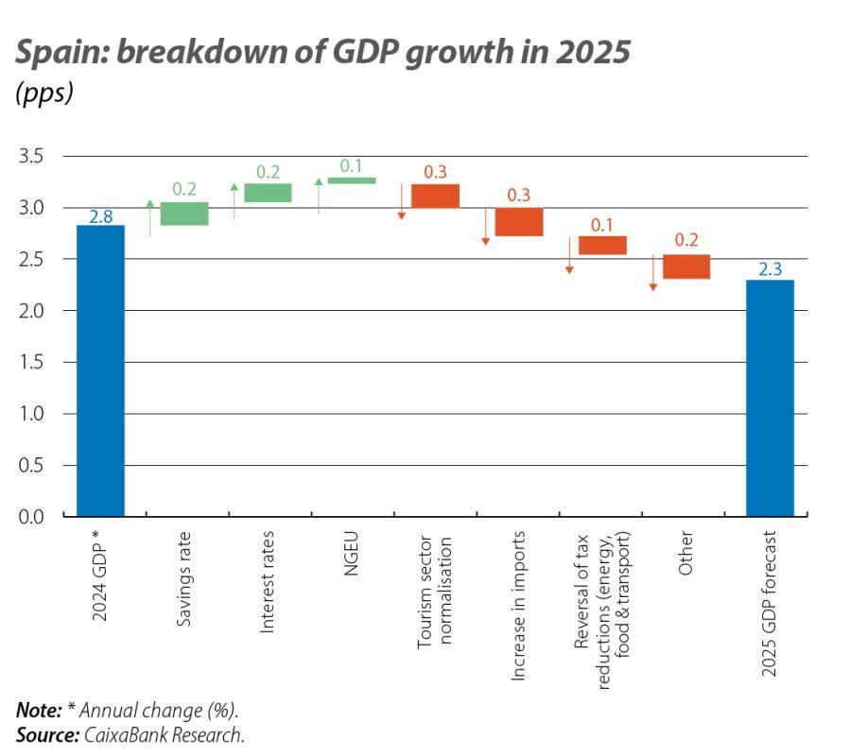
Fig 1: Spain GDP Growth
Source: (CaixaBank Research, 2024)
Russia
In the context of Zara, Russia’s economy remains constrained by sanctions and structural challenges, although GDP is still projected to grow at around 2.0–2.5% in 2025. However, high inflation of approximately 6–7% reduces consumer purchasing power and increases price sensitivity, directly impacting Zara’s pricing strategy. Additionally, volatility in the Russian rouble creates difficulties in maintaining stable pricing for imported fashion products. As consumer behaviour shifts towards essential spending, demand for discretionary items such as fashion has slowed, limiting growth opportunities for Zara in the market.
Social
Spain
In the context of Zara, Spain’s population of around 49.5 million, with a high concentration in urban areas, creates strong demand for retail and fashion products. Spanish consumers are highly fashion-conscious, with fast fashion deeply embedded in lifestyle and self-expression, supporting Zara’s rapid product turnover model. Additionally, about 60% of consumers consider sustainability in their purchasing decisions, aligning with Zara’s eco-friendly initiatives. High digital penetration, with over 85% internet usage, further enhances Zara’s omnichannel strategy through strong engagement in social media and mobile commerce.
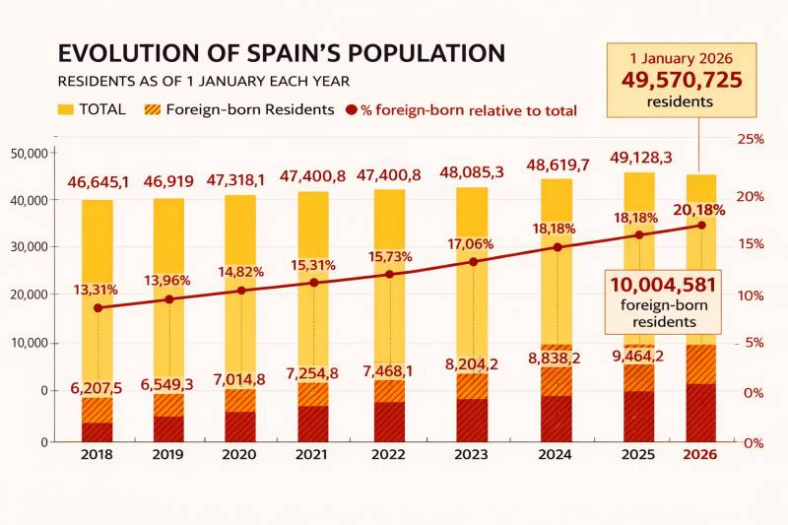
Fig 2: Spain Population
Source: (Murcia Today, 2026)
Russia
In the context of Zara, Russia’s population of approximately 146 million offers a large but uneven consumer base, with retail demand concentrated in major cities such as Moscow and St. Petersburg. While consumers are brand-driven and associate international brands with status and quality, rising economic pressures and inflation have increased price sensitivity. This shift towards value-for-money purchasing behaviour limits demand for discretionary fashion, requiring Zara to adopt more pricing-focused and value-oriented strategies in the Russian market.
Technological
Spain
In the context of Zara, Spain’s advanced digital infrastructure supports strong online retail performance, with internet penetration exceeding 85% and e-commerce accounting for over 20% of total retail sales in 2025. Around 70% of online transactions are conducted via smartphones, highlighting the rapid growth of mobile commerce, which enhances Zara’s omnichannel strategy. Additionally, EU-funded investments in artificial intelligence and big data improve logistics and supply chain efficiency, enabling Zara to respond quickly to changing consumer demand.
Russia
In the context of Zara, Russia’s technological environment remains developing and uneven, with internet access reaching around 80–85% in urban areas. E-commerce contributes approximately 15–18% of total retail sales in 2025, driven mainly by local platforms. However, technological progress is constrained by limited access to Western technologies due to sanctions, which restricts Zara’s ability to fully leverage advanced digital systems and optimise its global omnichannel operations in the market.
Environmental
Spain
In the context of Zara, Spain’s push for carbon neutrality by 2050 is reinforced by the need to reduce ~283 Mt CO₂ emissions to just ~29 Mt residual levels, requiring up to 137 Mt of carbon removal, thereby intensifying pressure on Zara to adopt sustainable and circular practices. In Spain, over 55–60% of consumers consider sustainability in their purchasing decisions, encouraging Zara to adopt eco-friendly materials and circular practices. Government policies promoting recycling and waste reduction further require Zara to align its operations with sustainable standards.
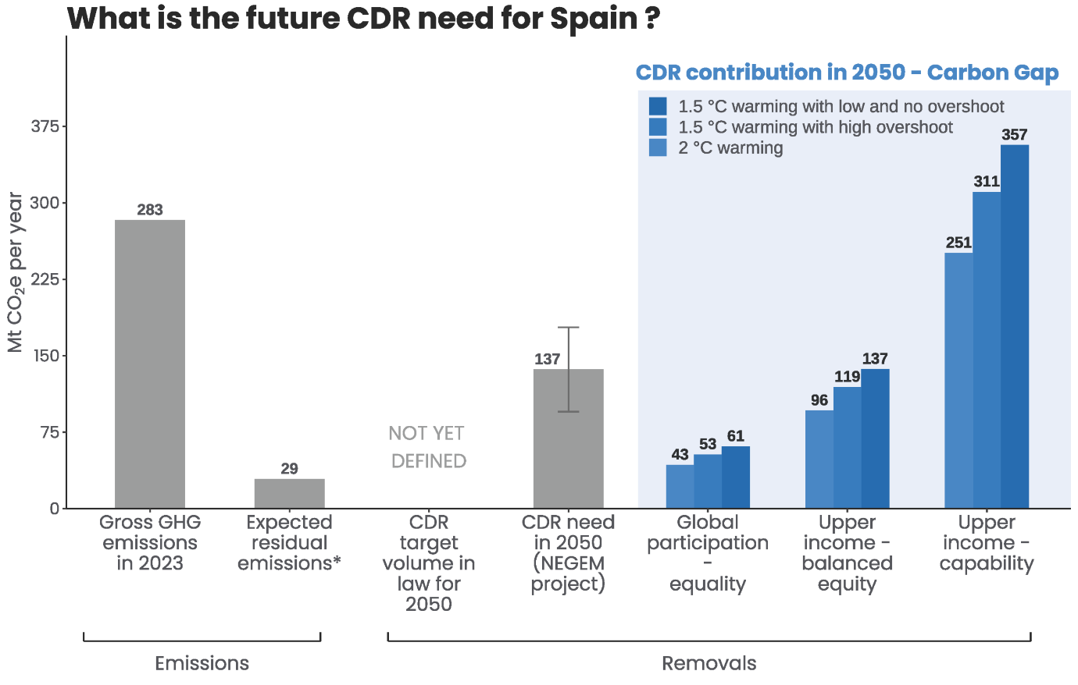
Fig 3: Spain carbon neutrality
Source: (Carbon Gap, 2025)
Russia
In Russia, the environmental regulations are relatively weaker and people are slowly becoming aware of the issue. There are environmental policies, which are not as strictly applied as in the EU. The issue of sustainability is increasing among consumers, but it takes the second place behind price and functionality factors. Emissions in the industry are still high and the shift to sustainable production is delayed (Reuters, 2025h). Nonetheless, there are domestic programs developing to enhance the environmental quality and decrease wastages.
Legal
Spain
In the context of Zara, Spain operates under strict legal frameworks set by the European Union, including labour laws, consumer protection regulations, and data privacy rules such as General Data Protection Regulation. These regulations increase operational costs, with minimum wages exceeding €1,100 per month in 2025, but also ensure high standards of product quality, transparency, and intellectual property protection. This strong legal environment creates a fair and reliable market, supporting Zara’s brand reputation and long-term operations.
Russia
The Russian political environment is a complex legal environment. They can be unpredictable and regulations are likely to alter the policy about the foreign businesses on a regular basis (Reuters, 2026c). Other types of legal obstacles are granted by sanctions and trade limitations, which limit access to the marketplace and non-rigid operations.

1.2 Comparison of social factors in Spain and Russia
Consumer Behaviour
Spain
Fashion consumption is highly practiced among Spanish consumers with high disposable income and stable economies, as evidenced by the consumer behaviour. Household consumption expenditure grew by about 3.2% in 2025 with the result being a better consumer confidence (Arteaga Ortiz et al., 2025). The high retail density in the fashion industry has also remained advantageous as more than 61% of purchases have been impacted by in-store experiences even with the rise of online platforms. It is projected that the e-commerce market in Spain will expand with a steady rate of USD 121.26 billion in 2025 to USD 181.59 billion in 2031 (CAGR 6.83%), which supports the increasing role of online shopping along with high store consumption of fashion goods.
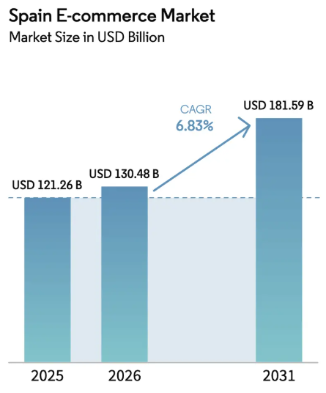
Fig 4: Spain E-Commerce Market
Source: (Mordor Intelligence, 2026)
Russia
Economic volatility and the shift in consuming priorities are major determinants of consumer behaviour in Russia. By 2025, real wage increases had decreased to about 1.52, and household spending on non-essential goods had decreased by some 8%, as the financial behaviour was cautious. Nevertheless, the online market is not weak, and more than three-quarters of customers shop online at least once a month. Fashion segment represents about 14% of the total e-commerce transactions, however average basket size has declined by an average of 15%, a sign of constrained budgets (Reuters, 2025i).
Culture
Spain
Aesthetics, lifestyle and social interaction are highly valued in Spanish culture and fashion is strongly connected with the identity and with the personal expression. Dressing styles tend to be comparatively dependent on social environments, occasions and seasonal fashions, which adds to frequent buying patterns (Ahsan and Zara, 2026). The impact of social media and the content of influencers directly influences the fashion choices of 68% of Spanish consumers in 2025, which underscores the influence of digital culture on consumption. Cultural transformation to sustainability is also strong, the second-hand fashion market expands by more than 18% every year, which demonstrates changing values towards reusing and circular fashion.
Russia
The great power distance (93) and uncertainty avoidance (95) are the characteristics of the Russian culture, which emphasize the hierarchy, fear of risks, and pragmatism, and in this case, the tendency to consume fashion that is focused on status, but is long-lasting and utilitarian (Reuters, 2026b). Meanwhile, the environmental factors influence cultural preferences greatly with long winters creating the need to wear layers of practical and durable clothes. The consumption of fashion is lower compared to that in Spain, where the consumer often makes smaller purchases that are more deliberate. As younger generations become more exposed to trends around the world via digital medium, more widespread cultural orientations focus more on utility as opposed to early adoption of trends.
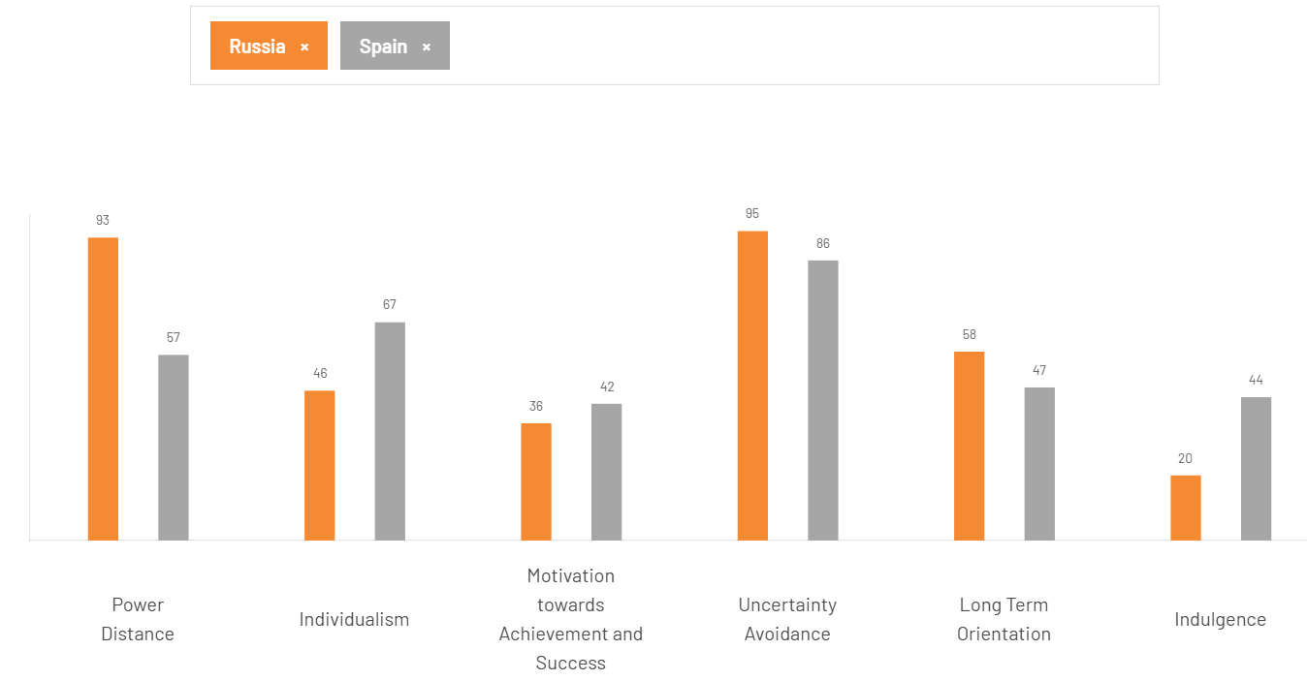
Fig 5: Cultural Comparison Tool
Source: (Self-Developed)

1.3 STP (Segmentation, Targeting, and Positioning) in Spain
Segmentation
In Spain, Zara uses a multi-dimensional approach to segmentation that focuses on the demographic, geographic, psychographic and behavioural segments to encompass a wide but fashion oriented consumer market. The demographics of the brand are mostly centered on consumers between the ages of 18 and 40, which is the segment that constitutes a large portion of the active fashion market in Spain. Spain has a high customer base in the fast fashion consumption segment as the number of people between 16 and 44 in 2025 is approximately 64% (Trading Economics, 2026). Geographically, Zara will focus on the most urbanised markets like Madrid, Barcelona, and Valencia in which more than 80% of retail expenditure is centralised because of their high income levels and lifestyle orientation. Zara has psychographicaly divided consumers in terms of lifestyle and attitudes, especially focusing on trendy consumers who appreciate style, price, and convenience.
Targeting
In Spain, Zara uses a differentiated targeting approach and the company is mainly targeting urban, middle to upper-middle-income consumers who are interested in fashionable clothing at affordable prices. The brand aims at millennial and Gen Z buyers who are extremely interested by fashion trends and online opportunities, and more than 68% of young shoppers in Spain in 2025 would be guided by social media in buying clothes. Meanwhile, Zara also offers services to working people who need to have fashionable but affordable casual and formal outfits (Tunceli, 2025). A wide selection of products such as women, men, and children lines allows the brand to appeal to several segments at the same time without altering the brand image.
Positioning
In Spain, Zara positions itself as a high-end fast-fashion, runway-based trend and delivers latest trends at reasonable rates and pays to a growing extent to sustainability and innovation. The brand is unlike the other brands by integrating speed, style, and accessibility such that new collections find their way into the stores in weeks instead of months. By 2025, Zara is further streamlining its positioning by incorporating sustainability into its value proposition, where more than half of its collections are created using more sustainable materials as part of initiatives like its eco-conscious collections (Wiltshire and Cousins, 2026). Moreover, the image of a modern and customer-oriented brand is enhanced by the high level of the use of the omnichannel, such as innovative e-commerce platforms and new flagship stores.
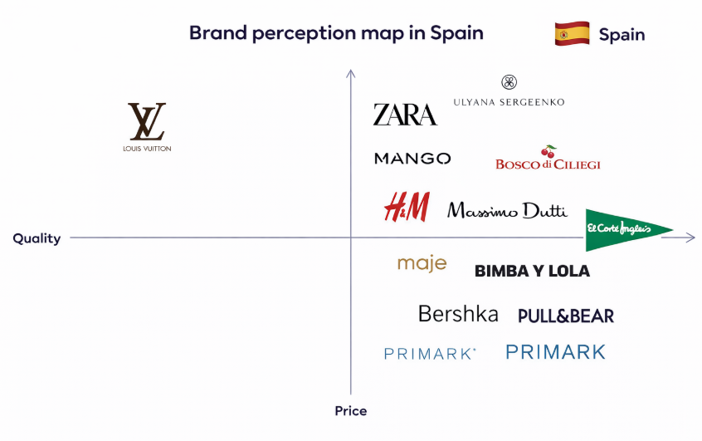
Fig 6: Positioning Map in Spain
Source: (Self-Created)

1.4 STP (Segmentation, Targeting, and Positioning) in Russia
Segmentation
The segmentation used by Zara in Russia is more sophisticated and uneven due to economic differentiation and the size of the territory. On the demographics, the brand is targeted at customers between the age groups of 20-45 and especially the urban middle class who make a considerable proportion of the discretional spending despite economic strain. The population of the Russian people is about 146 million, which is very concentrated in large urban areas, where Moscow and St. Petersburg alone account almost 25-30% of the total retail sales in 2025. Geographically, Zara focuses on these urban centres where they have the highest purchasing power and exposure to world fashion trends (The Guardian, 2026). Psychographicaly, consumers have been categorized according to their desire to own international products and contemporary lifestyles because about 57% of the urban consumers believe that global brands have better quality and prestige.
Targeting
Zara utilizes focused targeting approach in Russia, focusing mainly on the middle-income, urban consumers that are interested in international fashion brands but are still sensitive to prices. The brand is focused on younger professional and aspirational consumers that are guided by fashion trends around the world and through digital media, especially in urban regions where more than 85% of the population has access to the internet (Auskalnis, 2025). Moreover, approximately three-quarters of consumers in Russia (72%) use online platforms prior to purchasing fashion items in 2025, which means that digital targeting strategies are crucial. Another type of consumers that Zara is aiming at are those who appreciate brand prestige because international labels can be seen as a symbol of social status.
Positioning
Zara brands itself as an affordable international fashion brand in Russia which incorporates worldly fashion with a sense of perceived prestige at a relatively low price in relation to luxury brands. This positioning of the brand focuses on the elements of modernity, quality and trendiness and is aimed at those consumers who want to exude status through their clothing but at relatively lower cost than paying the high prices of a premium brand. In contrast to Spain, though, the positioning of Zara in Russia is not so concerned with sustainability but with value and brand image (BBVA Research, 2025). As noted in 2025 more than 58% of Russian shoppers are sensitive to price and quality more than ethical aspects when buying clothing, which will support the necessity to shape the brand as a value-oriented strategy. The store design, product assortments, as well as pricing strategy of Zara, are tailored to capture this balance between aspiration and affordability. This positioning enables Zara to have good brand recognition and desirability among its target market despite market and geopolitical challenges.
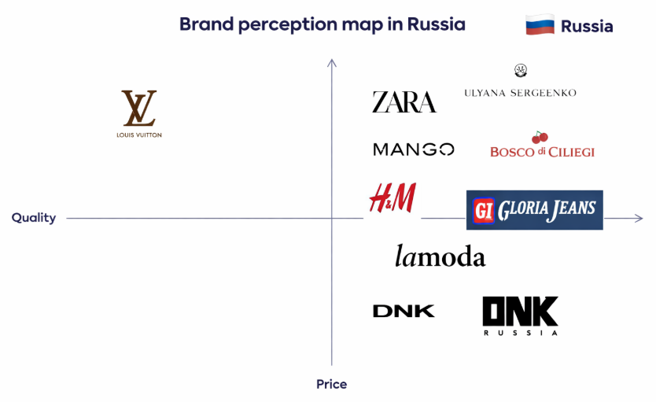
Fig 7: Positioning Map in Russia
Source: (Self-Created)

1.5 International Marketing Mix (7Ps) in Spain
Product
The product strategy at Zara in Spain is driven by the need to provide trendy and good quality fashion with a high product turnover. The brand does new collections every few weeks, in line with Spanish consumer preference of frequent changing styles. By 2025, more than half of the product range will be made with sustainable materials as a result of the growth of consumer preference towards sustainable fashion (Business Insider, 2025). The product line comprises of casual wear, formal wear, and seasonal range, to suit the diverse customer requirements in a fashion conscious market.
Price
In Spain, Zara has a mid-range pricing policy, as it is between mass-market and premium fashion brands. The stable inflation rate of about 2.0%-3.1% in 2025-2026 in Spain is a factor to support the stable pricing strategy of Zara that is between the mid-range and the value-based pricing strategy in line with the constant consumer buying power (Dzreke and Dzreke, 2025). This approach will enable Zara to appeal to a large client base without having to compete with low-cost fast fashion stores.
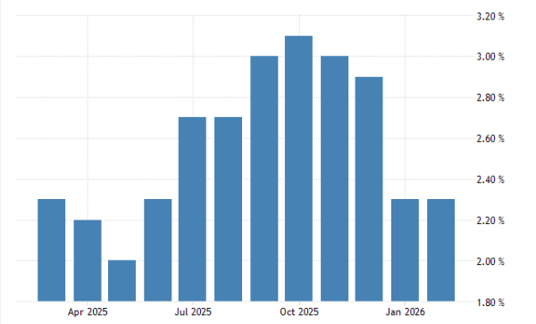
Fig 8: Spain Inflation
Source: (Trading Economics, 2026)
Place
Zara applies an effective omnichannel distribution model in Spain, where it incorporates an extensive chain of flagship stores in large cities like Madrid and Barcelona with a sophisticated e-commerce platform. The urbanisation rate and retail density in Spain allow the physical stores to perform well, and online stores play a major role in the fashion retail with a figure of more than 20% in 2025 (European Commission, 2025). The association of online and offline channels and the presence of click-and-collect services increase the ease and availability of the customer.
Promotion
Zara practices a low-advertising promotional strategy in Spain, which is highly based on brand image, store experience, and online interaction, as opposed to conventional advertising. Influencer partnerships and social media platforms offer an important means of targeting younger consumers: more than 65% of Spanish shoppers are guided by online content (Financial Times, 2025). The rapid product cycles are also utilized by the brand to create urgency and exclusivity to drive more store visits and purchases.
People
In Spain, Zara invests in high-quality staff that has undergone training and thus provide a high-quality and consistent customer experience. The staff is educated to know about fashion secrets and help clients, which leads to a good brand image. As labour standards increase and the minimum wage reaches about 1,134 euros per month in 2025, Zara will keep labour standards and will still be able to provide high-quality services, which are a necessity in a competitive retail setting (Gaudó, 2025).
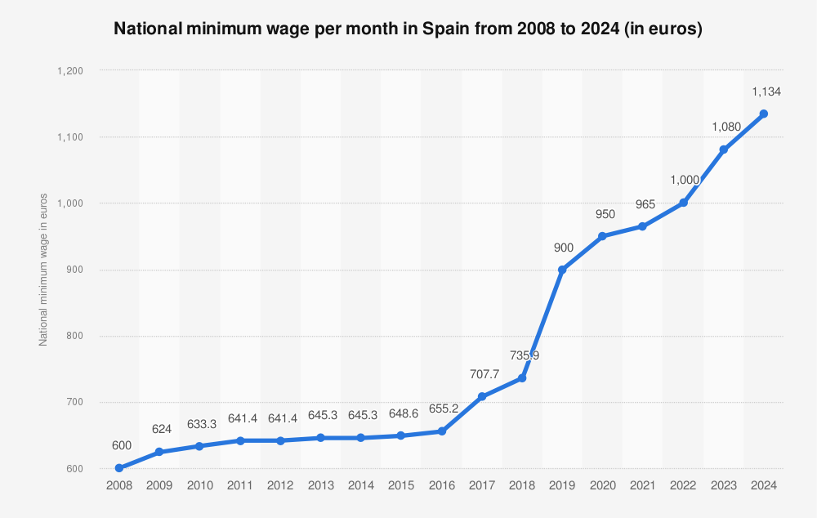
Fig 9: Minimum Wage per Month
Source: (Statista, 2026a)

Process
The process strategy of Zara is established on an effective and reactive supply chain that facilitates quick designing, manufacturing, and distribution. The brand has the luxury of being close to its headquarters and its key logistic hubs in Spain that it takes 2-3 weeks to get products designed and delivered to stores (IMARC Group, 2025). The advanced data analytics and instant sales monitoring enable Zara to adjust the inventory within a short period of time based on the demand of consumers to reduce the rates of waste and optimize the efficiency of the operations.
Physical Evidence
Physical evidence found at Zara in relation to modern and minimalist store design and prime retail location was in Spain. Its flagship stores are located in major cities that are characterized by high traffic, and this enhances the brand and experience visibility among the people. Store layouts are constantly updated based on new collections, and it helps to strengthen the image of Zara as a dynamic and trend-oriented brand (Limaye, 2025). Furthermore, the seamlessness of digital elements in stores aids the better omnichannel experience.

1.6 International Marketing Mix (7Ps) in Russia
Product
The product strategy in Russia is more functional and long-lasting than it is in the home market at Zara. Because of the long winters and colder climate in the country, the brand shapes its collections to incorporate heavier fabrics, outerwear and layered clothes. Although Zara does not change its fast fashion concept, the product cycles are somewhat modified to accommodate seasonal demand trends (Maheshwari et al., 2025). The need to adapt products to climate is significant in the context of 2025 Russia where around 40-45% of clothing demand will focus on the fall and winter types.
Price
The unstable inflation rate in Russia of between 5% and above 10% indicates a high price sensitivity, which helps to strengthen the value-for-money and the price-driven pricing model of Zara. The low-cost strategy and moderate pricing of Zara make it affordable and a world-renowned brand. A value-for-money is a key factor because of the nature of adjusting the prices to the fluctuation of the exchange rates and the purchasing power (Masnec et al., 2025). One of the most notable ones is the discount-based purchasing in which around 60-65% of the customers will be active in pursuing promotions and this will influence Zara pricing strategy and markdown strategy.
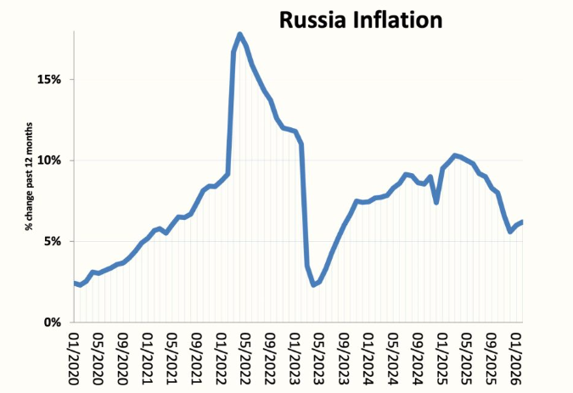
Fig 10: Russia’s Inflation Rate
Source: (Economics Help, 2026)
Place
Previously, Zara distribution strategy in Russia was grounded on high-end stores in the large cities such as Moscow and St. Petersburg where most of the fashion retailing activity has been focused. However, geopolitical tensions and sanctions have impacted physical retail like stores are either closed or reconstructed through the formation of local alliances. E-commerce cannot be neglected and online sales are part of total sales and account approximately 15-18% however, they are dominated by local online shops and not global systems (Musty et al., 2025).
Promotion
Zara continues using its low-advertising strategy in Russia but it adapts promotion using digital and aspirational branding. The strategies of marketing are aimed at preservation of brand image and universal popularity but not intensive advertising. Online and social media are a part of this influencing consumers, and approximately 70% of urban shoppers use digital materials prior to purchasing. Promotional activities however tend to focus on the use of discounts and special sales periods to appeal to price sensitive consumers.
People
In Russia, Zara uses local employees to provide customer service, which is in line with the cultural expectations. The employees are trained to keep the brand standards and yet they should accommodate local consumer behaviour which is more transactional and price conscious (Nordin et al., 2025). The minimum wage in Russia has grown considerably since 2011 (approximately 4,300 rubles) up to 2025 (around 22,000 rubles), but the comparatively low labour costs in Western Europe keep working to Zara with its low cost staffing policy.
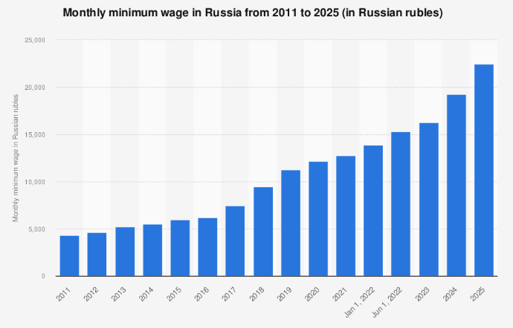
Fig 11: Minimum Wages in Russia
Source: (Statista, 2026b)
Process
The speedy fashion supply chain in Zara struggles with Russia as it is impacted by logistical inconvenience, sanctions and restricted entry to foreign suppliers. The delivery period is also increased compared to the delivery in Spain making the speed advantage of traditional model in Zara decrease (OECD, 2025). It has compelled the company to rely more on local sourcing and altered logistics networks that have impacted on efficiency. There is also the issue of inventory management when the demand and the economic future are uncertain.
Physical Evidence
The Zara stores in Russia are branded as the image of an international high-end brand, and their interiors are referred to the modern designs and the best retail spots in supermarkets over high-end shopping areas (Pérez-Bou and Bauzá, 2026). This adds prestige to the brand in the eyes of the consumers who equate international retailers with status. Physical presence has however declined over the last few years due to the closures and operational adjustments of stores, with some attention shifting to digital platforms and other types of retail forms.

1.7 Company’s adaptation considering cultural and economic factors
By striking a balance between its business activities and the cultural preferences on the one hand and the economic factors on the other hand, Zara is highly adaptive in its international strategy when the markets in Spain and Russia are compared. GDP in Spain is steadily increasing at rates of approximately 2.8-2.9 and clients are fashionable and eco-friendly, Zara will be engaged in trend-based collections, sustainable fibres, and omnichannel experiences (Pratama et al., 2025). But in Russia where price is more elastic and inflation has been greater at approximately 67%, Zara is shifting to somewhat more useful and durable goods, varying of prices, and promotion discounts to maintain demand. Culture is also important to adaptation, with Spanish consumers being more self-expressive and frequent buyers compared to Russian consumers which are more pragmatic and brand-conscious. This dual aspect of reacting enables Zara to be appropriate in diverse markets without losing the characteristic of fast fashion (Zhou, 2025).

1.8 Brand’s directional development strategy in Spain
The directional development strategy of Zara in Spain is consistent with the market penetration and product development, where it aims at consolidating its presence in an already established market (Purba et al., 2025). As fashion e-commerce now drives more than 20% of the overall retail volume and the digital presence is more than 85% higher than internet penetration, Zara remains undeterred with digital development, store renewal, and sustainability efforts. The brand is dedicating itself more to collections that are eco-friendly, and over half of its products use sustainable materials, as the demands of the responsible fashion market continue to grow. Moreover, Zara uses the best technologies to provide the customer experience: real-time inventory systems and integrated online-offline services (Reuters, 2025b). It is a strategy that will help the company to create a deeper sense of customer loyalty, a higher frequency of purchase, and continue to be competitive in a crowded yet well-priced domestic market.

1.9 Ethical issues related to this brand’s marketing mix in Spain
In spite of good market position, Zara encounters a number of ethical issues in Spain regarding its fast fashion business model. Environmental impact is one of the central issues because the fashion industry produces about 10% of the world carbon emissions, which is a concern with regard to sustainability regardless of the green activities of Zara. Also, the problems of supply chain transparency and labour practices in outsourced manufacturing are also a critical issue as consumers are demanding more ethical sourcing and fair labour conditions. These ethical issues can directly affect brand perception in Spain, where sustainability in purchase decisions has been identified (around 55-60% of consumers) (Reuters, 2025j). Moreover, fast fashion has a quick production cycle that promotes overconsumption, which is not compatible with new principles of the circular economy. Although Zara has made steps in the direction of sustainability, such issues of ethics confirm the necessity of ongoing enhancement of responsible marketing practices.

1.10 Way this company should go forward with their international marketing strategies
To achieve the desired objectives in the future, Zara requires striking a more balanced and sustainable balance in its international marketing strategy, and must include digital innovation, localisation, and ethical responsibility. The firm should also utilise more data analytics and artificial intelligence to personalise customer experiences and optimise inventory management across markets. In the meantime, Zara should improve its localisation policy where products, prices, and promotions are based on specific cultural and economic conditions in specific countries (Reuters, 2025k). Sustainability will remain an essential initiative, and further investment will be made in circular fashion, recycling, and transparent supply chains to support the needs of conscious consumers. In addition, Zara should diversify by focusing on stable and high growth markets and adequately balancing risks in politically volatile markets. The strategic direction will also enable Zara to be competitive globally, not mentioning that it will also be able to stay informed of the evolving consumer values and market dynamics.

Section 2

Reflective account using Gibbs
Description
In this assignment, I had to analyse the international marketing strategies of Zara through comparison of its activities in Spain and Russia. The assignment required the use of such techniques as PESTEL, STP, and the 7Ps marketing mix to review how the brand fits within various macroeconomic and cultural settings. I started with the collection of secondary data through academic journals, industry reports, and reliable online sources that were published in 2025-2026. I concentrated on gathering pertinent statistics of economic performance, consumer behaviour and digital trends in the two countries. Having arranged the data, I made the report divided into main parts, which allowed me to follow the logical order and to correspond to the assignment requirements. I then critically evaluated the distinction between the two markets especially concerning the consumer culture, the economic environment and the marketing strategies and then presented my findings in an organized and scholarly form.
Feelings
Initially, I felt overwhelmed by the complexity of comparing two significantly different markets, particularly due to the geopolitical uncertainty surrounding Russia, which made the task seem challenging and unclear. I struggled at first to identify reliable and up-to-date data sources for recent years such as 2025 and 2026, which affected my confidence in the early stages of the assignment. However, as I progressed with my research, I gradually became more confident in my ability to locate credible sources, interpret data effectively, and apply it within an academic context. I found the topic increasingly engaging, especially when analysing how Zara adapts its strategies across different cultural and economic environments. This process helped me connect theoretical frameworks such as PESTEL and STP with real-world business practices, making the learning experience more practical and meaningful. By the end of the assignment, I felt a strong sense of achievement and improved confidence, as I developed a clearer understanding of international marketing dynamics and strengthened my analytical and research skills.
Evaluation
In retrospect, I think this was one of the strengths of my work whereby I used constructed structures to structure the analysis. The application of PESTEL allowed me to compare the macro environmental variables in Spain and Russia in a systematic manner, whereas STP and the 7Ps enabled me to assess the strategic responses of Zara in each of the countries. I also got a chance to use the appropriate and up-to-date statistics that strengthened the validity of my analysis. Nevertheless, my research was not very smooth, especially when it comes to finding consistent and current information about Russia because of low levels of transparency and geopolitical barriers. Moreover, I also understood that sometimes I was more inclined towards descriptive analysis than critical assessment which could have been enhanced with more academic theories and in-depth interpretation. In spite of these difficulties, I am sure that the general structure and clarity of the report were high.
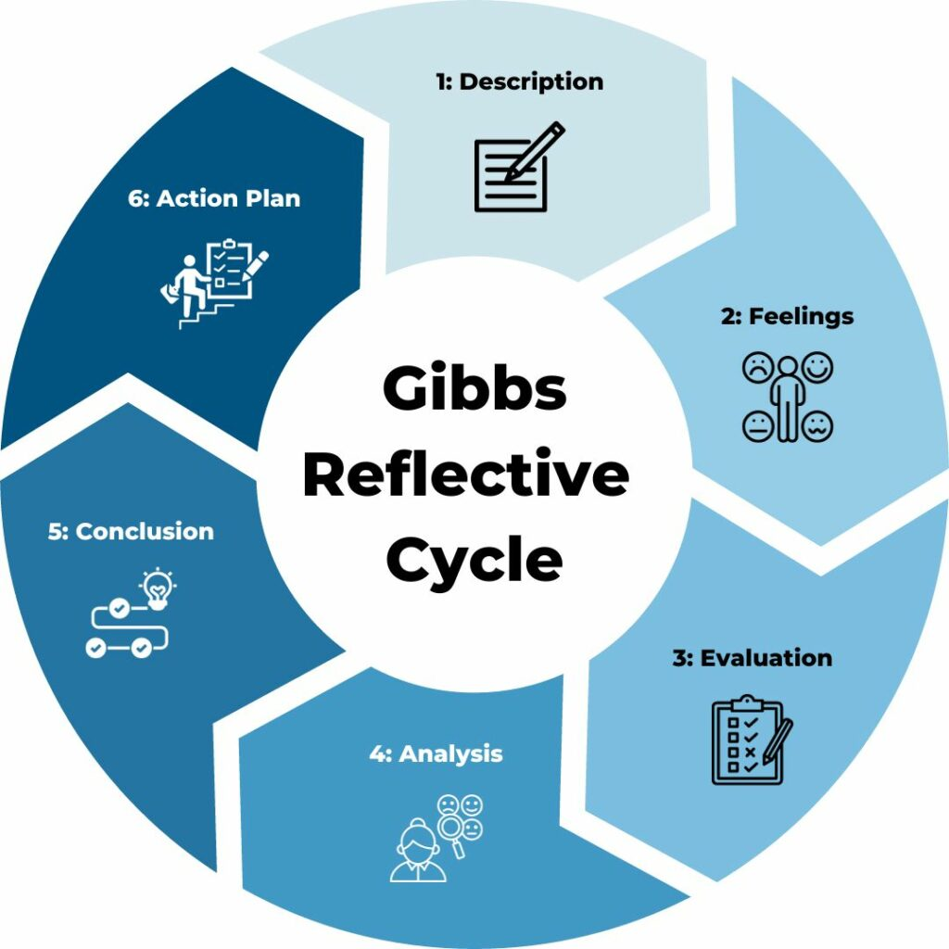
Fig 10: Gibbs Reflective Cycle
Source: (TSW Training, 2026)

Analysis
This assignment enhanced my understanding of how external environmental factors shape international marketing strategies, particularly in the context of Zara. It highlighted the importance of balancing standardisation and localisation, as Zara adapts its marketing mix according to cultural and economic conditions—focusing on sustainability, trend-driven products, and omnichannel engagement in Spain, while emphasising affordability, durability, and value-for-money in Russia due to higher price sensitivity and economic constraints. This demonstrates that flexibility is critical in global marketing, as a uniform strategy cannot effectively address diverse market dynamics. Additionally, the assignment reinforced the growing importance of digital transformation, with both markets increasingly relying on e-commerce, although driven by different factors such as advanced infrastructure in Spain and necessity-based adoption in Russia. Furthermore, I recognised that international marketing decisions are significantly influenced by external risks, including political instability, regulatory uncertainty, and economic volatility. Overall, this experience strengthened my ability to critically evaluate market environments and apply theoretical frameworks to real-world business situations.
Conclusion
Finally, this assignment has made a great contribution to my knowledge of international marketing and strategic analysis. I have acquired the skills of implementing major frameworks on practice and acquired the understanding of how global brands get adjusted to various market conditions. Though I managed to create a well-organised and fact-oriented report, I admit that I can do a better job with more critical analysis and using academic theories. On the whole, the experience has equipped me with skills in research, analytical, and academic writing that will be required in further studies and professional tasks in the sphere of business and marketing.
Action Plan
In future assignments, I plan to adopt a more structured and proactive approach to improve the overall quality of my work. Firstly, I will expand my research by using a wider range of academic databases such as Google Scholar, alongside industry reports and credible sources, to ensure that my analysis is supported by reliable, current, and high-quality data. This will help strengthen the academic depth and credibility of my arguments. Secondly, I aim to enhance my critical thinking skills by moving beyond descriptive writing and engaging in deeper evaluation and interpretation of information, applying relevant theories and models more effectively to support my analysis. I will focus on explaining the implications of findings, comparing perspectives, and providing more critical insights rather than simply presenting facts. In addition, I recognise the importance of effective time management, so I will begin the research and planning stages earlier in order to allow sufficient time for drafting, reviewing, and refining my work. This will help improve coherence, clarity, and overall presentation. I also intend to develop my academic writing skills further by practising proper structuring, improving the flow of arguments, and maintaining a formal tone throughout. Moreover, I will pay closer attention to referencing by ensuring consistency and accuracy in Harvard style, which will enhance the professionalism and academic integrity of my work.

References:
Ahsan, H.R. and Zara, G., (2026). Impact of Islamic Cultural Principles on Firm Performance: The Mediating Role of Product Innovation. Al-Qamar, pp.1-32.
Arimany Serrat, N., Arribas-Ibar, M. and Erdoğan, G., (2025). Fast fashion sector: business models, supply chains, and European sustainability standards. Systems, 13(6), p.405.
Arteaga Ortiz, J., Cerviño, J. and Fernández del Hoyo, A., (2025). Essentials of International Marketing.
Auskalnis, J.T., (2025). Ethical Elegance: Navigating Consumer Morality and Production Practices in Fashion Through Analysing Shein, Zara, & Vivienne Westwood.
BBVA Research (2025) Spain Economic Outlook December 2025. Available at: https://www.bbvaresearch.com/en/publicaciones/spain-economic-outlook-december-2025/
Business Insider (2025) Russia faces potential recession amid inflation pressures. Available at: https://www.businessinsider.com/russia-on-brink-recession-inflation-economy-minister-putin-2025-6
CaixaBank Research (2024) Spain 2025: dynamic growth, albeit slightly lower than in 2024. Available at: https://www.caixabankresearch.com/en/economics-markets/activity-growth/spain-2025-dynamic-growth-albeit-slightly-lower-2024
Carbon Gap (2025) Carbon Removal Policy in Spain. Available at: Carbon Removal Policy in Spain
Dzreke, S. and Dzreke, S.E., (2025). The Symbiotic Dance–How Agile Supply Chains and Strategic Marketing Orchestrate Brand Responsiveness to Evolving Consumer Demands. Advances in Business & Industrial Marketing Research, 3(3), pp.151-162.
Economics Help (2026) Russia’s economic problems 2026. Available at: https://www.economicshelp.org/blog/220766/economics/russias-economic-problems-2026/
European Commission (2025) Economic forecast for Spain. Available at: https://economy-finance.ec.europa.eu/economic-surveillance-eu-member-states/country-pages/spain/economic-forecast-spain_en
Financial Times (2025) Spain unemployment trends and labour market performance. Available at: https://www.ft.com/content/ee2b05f2-3cf1-4d45-874d-3552a5f43555
Gaudó, M.L., (2025). The ROLE of DIGITAL COMMUNICATION in GLOBAL FASHION BUSINESS: ZARA’S BRANDING STRATEGY.
IMARC Group (2025) Russia e-commerce market report 2025–2033. Available at: https://www.imarcgroup.com/russia-ecommerce-market
Limaye, A., (2025). ZUDIO'S DIVES IN BLUE OCEAN: Creating Uncontested Market Space in India's Retail Sector with Blue Ocean Strategy. MET SRUJAN, 1(1), pp.125-132.
Maheshwari, N., Mishra, D. and Chaudhary, H., (2025). Zara’s “The Jacket” Controversy: Balancing Marketing and Sensitivity. SAGE Publications: SAGE Business Cases Originals.
Masnec, L., Hrustek, L. and Kutnjak, A., (2025), October. The Role of Sustainable Marketing in the Transformation of the Textile Industry Towards a Circular Economy. In 10th International Scientific Conference (CRODMA 2025): Book of Papers (pp. 149-159). Varaždin: Croatian Direct Marketing Association.
Mordor Intelligence (2026) Spain e-commerce market size & share analysis. Available at: https://www.mordorintelligence.com/industry-reports/spain-ecommerce-market
Murcia Today (2026) Spain’s population hits 49.6 million with foreign-born milestone. Available at: Spain population article
Musty, B., Lestari, E.D., Rifani, H., Santika, V.Z. and Sugiana, N.S.S., (2025). THE IMPACT OF DIGITAL TRANSFORMATION ON GLOBAL BRANDING AND CUSTOMER SERVICE: A STUDY OF ZARA FASHION. Jurnal Komputer Bisnis, 18(1), pp.68-74.
Nordin, N., Nordin, N. and Nordin, N.I.A., (2025). Back to Her Roots, Building Kelantan’s Future with a Riba-Free Vision: The Emergence of Zara Prima Sdn. Bhd. International Journal of Entrepreneurship Case Study (IJECS), 4(1), pp.41-53.
OECD (2025) OECD Economic Surveys: Spain 2025. Available at: https://www.oecd.org/en/publications/oecd-economic-surveys-spain-2025_abc5c435-en.html
Pérez-Bou, S. and Bauzá, V., (2026). Designing the future of retail: Zara’s architectural journey from mainstream to phygital luxury experience. Journal of Global Fashion Marketing, 17(2), pp.172-193.
Pratama, R.A., Maulana, R.A. and Marlina, L., (2025). Etika Bisnis Islam dalam Praktik Fast Fashion: Studi Kasus Zara. Jurnal Bisnis dan Manajemen (JURBISMAN), 3(1), pp.227-232.
Purba, E., Manik, L., Khan, Z.T. and Sembiring, P.S., (2025). The Influence of Price and Product Quality on Consumer Decisions in Purchasing Zara Brand Clothing in Medan 2024. Maroon Journal De Management, 2(3), pp.158-168.
Reuters (2025a) Russian weekly inflation trends show slowing growth. Available at: https://www.reuters.com/markets/europe/russian-weekly-inflation-lowest-level-since-start-year-2025-03-19/
Reuters (2025b) Inditex global strategy and expansion performance. Available at: https://www.reuters.com/business/retail-consumer/zara-owner-inditex-meets-fourth-quarter-sales-forecast-2025-03-12/
Reuters (2025c) Spain circular fashion and textile waste policy developments. Available at: https://www.reuters.com/sustainability/spains-top-fashion-retailers-launch-trial-collect-clothes-waste-2025-2024-10-10/
Reuters (2025d) Spain retail demand and consumer trends analysis. Available at: https://www.reuters.com/business/retail-consumer/spain-retail-sales-rise-62-year-on-year-june-2025-07-29/
Reuters (2025e) Russian central bank cuts interest rate as inflation subsides. Available at: https://www.reuters.com/markets/europe/russian-central-bank-cuts-key-rate-by-200-bps-inflation-subsides-2025-07-25/
Reuters (2025f) Russia revises GDP growth figures and economic outlook. Available at: https://www.reuters.com/markets/europe/russia-raises-2024-gdp-growth-figure-43-2025-04-11/
Reuters (2025g) Russian companies expect inflation above 10% in 2025. Available at: https://www.reuters.com/markets/europe/russian-companies-expect-2025-inflation-above-10-central-bank-survey-shows-2025-01-24/
Reuters (2025h) Russia economic growth forecast revised for 2025. Available at: https://www.reuters.com/business/finance/russia-slashes-2025-economic-growth-forecast-15-25-2025-08-27/
Reuters (2025i) Russian prices rise and inflation trends continue in 2025. Available at: https://www.reuters.com/markets/europe/russian-prices-up-95-2024-continue-grow-2025-statistical-data-shows-2025-01-15/
Reuters (2025j) Inditex transport emissions increase amid expansion. Available at: https://www.reuters.com/business/retail-consumer/zara-owner-inditexs-transport-emissions-jump-2024-2025-03-14/
Reuters (2025k) Zara owner Inditex meets fourth-quarter sales forecast. Available at: https://www.reuters.com/business/retail-consumer/zara-owner-inditex-meets-fourth-quarter-sales-forecast-2025-03-12/
Reuters (2025l) Spain’s top fashion retailers launch trial to collect clothes waste. Available at: https://www.reuters.com/sustainability/spains-top-fashion-retailers-launch-trial-collect-clothes-waste-2025-2024-10-10/
Reuters (2025m) Spain targets budget deficit of 2.1% of GDP by 2026. Available at: https://www.reuters.com/business/spain-targets-budget-deficit-21-gdp-2026-2025-11-18/
Reuters (2025n) Spain retail sales rise year-on-year in June 2025. Available at: https://www.reuters.com/business/retail-consumer/spain-retail-sales-rise-62-year-on-year-june-2025-07-29/
Reuters (2026a) Inditex logistics and investment strategy update. Available at: https://www.reuters.com/business/retail-consumer/zara-owner-inditex-reports-9-sales-growth-start-first-quarter-2026-03-11/
Reuters (2026b) Russia economic constraints and energy sector impact. Available at: https://www.reuters.com/business/energy/russia-fails-capitalise-oil-rally-due-weather-drone-attacks-according-data-2026-03-18/
Reuters (2026c) Zara owner Inditex reports sales growth at start of 2026. Available at: https://www.reuters.com/business/retail-consumer/zara-owner-inditex-reports-9-sales-growth-start-first-quarter-2026-03-11/
Statista (2026a) Spain: National minimum wage per month. Available at: https://www.statista.com/statistics/456403/spain-national-minimum-wage-monthly/
Statista (2026b) Minimum wage in Russia from 2011 to 2025. Available at: https://www.statista.com/statistics/1269963/russia-minimum-wage/
The Guardian (2026) The Russian economy is stagnating: implications for growth. Available at: https://www.theguardian.com/world/ng-interactive/2026/feb/06/the-russian-economy-is-finally-stagnating-what-does-it-mean-for-the-war-and-for-putin
Trading Economics (2026) Russia inflation rate (CPI). Available at: https://tradingeconomics.com/russia/inflation-cpi
TSW Training (2026) Gibbs reflective cycle. Available at: https://www.tsw.co.uk/blog/leadership-and-management/gibbs-reflective-cycle/
Tunceli, A., (2025). Boycott Zara: Analysing Consumer Behaviour and Social Media Backlash After Marketing Failures.
Wiltshire, J. and Cousins, C., (2026). Fashion Marketing: Strategies, Trends and Innovation. Kogan Page Publishers.
Zhou, J., (2025). Marketing Strategy for a Fast Fashion Brand Based on SWOT: The Case of ZARA. Finance & Economics, 1(6).

