Task 1
The story I chose to read to the children was ‘Dillad Tedi Twt’. I was reading the story to a class of reception children and chose this story as I wanted the children to learn new Welsh vocabulary. ‘Dillad Tedi Twt’ was chosen over ‘Dyma’r Dillad’ because although I wanted to teach the children different items of clothing in Welsh, ‘Dillad Tedi Twt’ provided an opportunity to learn more clothes whilst also recapping the children’s previous knowledge about the weather. Building on previous experiences is something that the Welsh Government (2015) suggests pupils do as part of their time in the foundation phase.
The learning objective for the lesson was for the children to identify and understand what different items of clothing were called in Welsh. This links to the curriculum as the Welsh Government (2015) suggests that children should be able to present simple information; which they did in the activity following the story.
Reading the story to the children gave them an opportunity to experience a story read by a familiar voice which is something that the Welsh Government (2015) state children should experience in the foundation phase. This story provides children with a chance to progress in their learning as they listen to a story that is being read whilst also visually following the print on the whiteboard as it was read out loud (Welsh Government, 2015). The story also allowed for children to listen and respond simply to what they heard, as questioning was used throughout the story to gain an understanding of what the children already knew (Welsh Government, 2015).
(Word Count 265)
Task 2
https://youtu.be/1iRswTNei-U
Task 3
The introduction to the lesson where I read the story was a positive part of the lesson. The children were largely engaged and were keen to answer questions throughout the story. As the children were of such a young age, behaviour management was sometimes an issue as they don’t enjoy sitting still for periods of time. By asking questions throughout the story I tried to keep the children engaged throughout as part of an active learning process. The questioning gave opportunities for the children to activate their prior knowledge in relation to the weather; this allowed the children to gain some confidence using Welsh that they already knew. Giving the children confidence is supported by Maslow’s hierarchy of needs as he suggests that self-esteem is needed for children to be motivated (McLeod, 2018). Using questioning is also supported by Vygotsky’s social learning theory, as he suggests that questioning and discussion-based learning helps to construct an active learning environment (Neff, Date Unknown). By allowing the children to become more confident with their Welsh they were then more willing to try and learn new vocabulary in Welsh. Boosting the children’s confidence links to Bandura’s theory; which suggests that self-confidence contributes significantly to motivated performance; which in this instance was learning new vocabulary (National Research Council, 1994).
Whilst reading the story there were more opportunities for me to use Welsh within my questioning. Despite using ‘Sut mae’r tywydd?’ throughout the story, the children could have heard more Welsh from me. Introducing story time in Welsh and asking the children ‘Beth mae’r Tedi Twt yn wisgo?’ instead of asking in English. Although the children weren’t expected to ask questions, it could’ve enhanced the Welsh lesson as the children would become more familiar with other phrases related to the learning objective. The more Welsh used by me could encourage the children to use more Welsh around the classroom. De Houwer (2009) supports this, as she suggests that children under six typically learn languages without formal instruction. Therefore, in future I could use more incidental Welsh and more topically related Welsh throughout the lesson (appendix 1). The more Welsh used around the classroom the more normal the children could perceive using Welsh. However, teaching children of such a young age I did not want to introduce too much Welsh in one lesson. I also wanted the learning objective to be obvious throughout the lesson by concentrating on specific vocabulary. Introducing too much vocabulary in small time could be overwhelming for the children and as Singleton (1989) suggests; the children’s learning of a second language is at the expense of their first language. Therefore, suggesting that introducing too much language to soon could inhibit the children’s learning of their first language.
The story itself provided the children with an opportunity to extend their Welsh oral skills as they broadened their vocabulary. The items of clothing introduced to the lesson within the story were within the children’s linguistic abilities. This became evident as they were all able to identify different items of clothing during the main activity. The Welsh Government (2015) supports this as it suggests that children should listen to Welsh being spoken and learn to use vocabulary to the best of their ability. Following the questioning used in the introduction, the children went into focus groups and took part in a drilling activity. This involved me holding up an item of clothing, saying the item out loud and then getting the children to repeat the item as group and individually. This worked as a teaching method as the children not only enjoyed shouting out the item but were able to recall the items during the activity where the gingerbread man had to be dressed. This type of teaching and learning is audio-lingual which links to Skinner’s behaviourist method of teaching. Despite this method being less commonly used in modern day teaching; I felt for a task of this nature it was an appropriate way to learn the new vocabulary quickly. Not only did this method help the children learn the new vocabulary but, it also improves the children’s pronunciation of the words as they repeat after me. As Ellis (1992) suggests, this behaviourist approach can help produce correct responses by building up habit strength. Whilst this activity links to Skinner’s behaviourist approach; it also has links to Vygotksy’s sociocultural theory. This activity involves the children and ensures they’re actively learning. The children are working in pairs which allows them to help each-other, which links to Vygotsky’s zone of proximal development. During the activity if a child was unsure which item of clothing to use, their partner could help them as the more knowledgeable other in a situation.. As a teacher I have scaffolded the children’s learning by providing them with the vocabulary they need through a drilling activity; then allowed them to try and complete the activity without my help. The children are still working within their zones of proximal development as they work in pairs to achieve their potential. Saville-Troike (2012) supports this as she suggests that interpersonal interaction between learners is evident within Vygotsky’s sociocultural theory and it underpins the zone of proximal development.
The children were able to see a real-life link to the learning as they began to associate the different clothes with the appropriate weather. Learning items of clothing in Welsh is immediately seen as relevant as people wear different types of clothing every day; throughout the school day children are also asked to put their coats on or are asked where their coat might be. Research shows that relevant learning means effective learning (Briggs, 2014). By teaching the children clothing vocabulary it will allow for progression in the future and questions could be asked in Welsh. For example, in the future the teacher could ask, ‘Ble mae cot?’. By teaching the children something that they will be able to hear and use on a regular occasion it brings more meaning to the learning. Their vocabulary can then continue to grow as the teacher can move forward by asking the children whether they like certain clothing in Welsh.
The children’s behaviour throughout the lesson was fairly good; they were engaged throughout and enjoyed both the story and the main activity. However, during the main activity participation levels perhaps dropped a little because pupils were sharing resources. In a setting with such young children more resources would have improved the activity, ensuring that all children were actively taking part. Despite this, the children were working together most of the time or taking it in turns to find items of clothing. The resources prepared for the lesson enhanced the children’s learning and made learning the new vocabulary more fun and interactive. I carefully chose items of clothing from the story that were suitable for the children to learn. I prepared enough resources for one gingerbread man between two children; however, in future I would ensure that I had enough resources for each child in their groups. This would ensure that children were more engaged throughout the activity and could therefore enhance their individual learning experiences. As the Welsh Government (2015) state, children learn through first hand experiences with active learning opportunities to extend the children’s development. Therefore, suggesting that more resources would have given the children a better first-hand experience and allowed them to be even more active learners during the activity. Even though the children would then be working more independently, it would still allow for the children to help each other if needed. Therefore, still incorporating Vygotksy’s socio-cultural theory and the zone of proximal development.
Despite the activity being relatively simple and the audio-lingual method being less common in modern teaching, I believe that it was a good activity for the children to begin their understanding of clothes in Welsh. It was their first lesson on the topic of clothes and all children were able to identify different items of clothing in Welsh; therefore, achieving the learning objective. DCELLS (2008) supports the learning from this lesson as it states that children should show they can understand basic words, which they did during the main activity. The drilling method used to learn the vocabulary was successful in this instance and necessary for the children to become confident with the new vocabulary. O’Grady (2005) supports this as he suggests that the repetition element gives children a chance to understand what is being said without damaging their confidence. In the future I would continue to recap on children’s previous knowledge of Welsh because confidence is important; without confidence a child’s acceptance of a lack of progression in a language has potential for less motivation in future learning (Dweck cited in Hood and Tobutt, 2015). However, after looking at research following the lesson, I found that a survey suggests the most popular element of learning languages for children was songs (Hood and Tobutt, 2015). Following this, in future I would try to include a song where appropriate to help the children learn about the topic in a way they enjoy. Overall the lesson aim was achieved and the task was successful; I would however use more resources in future and use more incidental Welsh throughout the lesson (appendix 1). The lesson had a strong emphasis on oral communication which links to Successful Futures. Donaldson (2015) suggests that there should be a focus on learning Welsh primarily as a means of communication through oral communication and understanding. DCELLS (2008) also support this as they suggest that hearing and understanding are the first important building blocks towards acquisition of any language; which the introduction and the task provided within the lesson.
(Word Count 1604)

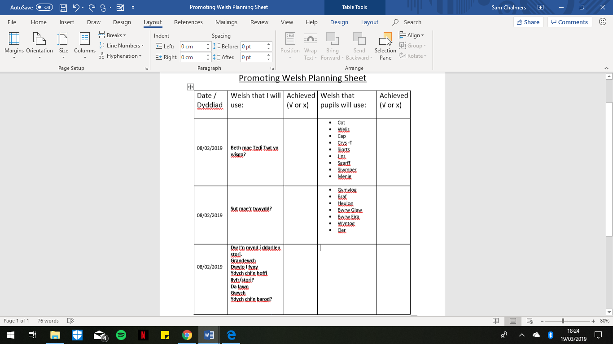
Appendix 1

Reference List
Briggs, S. (2014) How to Make Learning Relevant To Your Students (And Why It’s Crucial To Their Success. Available at: https://www.opencolleges.edu.au/informed/features/how-to-make-learning-relevant/ (Accessed: 16th March 2019).
DCELLS. (2008) Welsh Language Development. Cardiff: Crown.
De Houwer, A. (2009) An Introduction to Bilingual Development. Bristol: Multilingual Matters.
Donaldson, G. (2015) Successful Futures. Cardiff: Crown.
Ellis, R. (1992) Second Language Acquisition & Language Pedagogy. Clevedon: Multilingual Matters.
Hood, P. and Tobutt, K. (2015) Teaching Languages in the Primary School. 2nd Ed. London: Sage.
McLeod, S. (2018) Maslow’s Hierarchy of Needs. Available at: https://www.simplypsychology.org/maslow.html (Accessed 15th March 2019).
National Research Council. (1994) Learning, Remembering, Believing: Enhancing Human Performance. Washington DC: The National Academies Press.
Neff, S. (date unknown) Learning Theories Website. Available at: http://jan.ucc.nau.edu/~lsn/educator/edtech/learningtheorieswebsite/vygotsky.htm (Accessed: 15th March 2019).
O’Grady, W. (2005) How Children Learn Language. Cambridge: Cambridge University Press.
Saville-Troike, M. (2012) Introducing Second Language Acquisition. Cambridge: Cambridge University Press.
Singleton, D. (1989) Language Acquisition. Clevedon: Multilingual Matters.
Welsh Government. (2015) Foundation Phase Framework. Cardiff: Crown.

