Workplace Culture and its impact on Organisational Efficiency | BMSK 5005  Azmah Qurban  1711197  Dr Eric Osei
Executive Summary

This assignment has looked at the external and internal factors affecting an organisation linking this to an organisation. The organisation used is Modality Partnership. The tools used to conduct the external analysis is PESTLE and for internal analysis McKinsy’s 7S. It further looks at the ethical stance of the organisation and how the culture of the organisation compares to a competitor. Lastly it concludes the finding and proposes recommendations to enhance the workplace culture and services.

Table of Contents

Task 1 PESTLE Analysis 2
Political Factor 2
Economic Factor 3
Social Factor 4
Technology Factor 4
Legal Factor 5
Environmental Factor 5
Task 2 McKinsey’s 7S 6
Shared Values 6
Strategy 7
Structure 8
Styles 9
Staff and Skills 9
Task 3 Ethical Stance Analysis 10
Task 4 Comparison of Culture 11
Recommendations and Conclusion 11
Reference List 12

The organisation discussed in this assignment is Modality Partnership. Founded in 2009 through two practices of 25 thousand patients coming together. It has now evolved into being the largest National GP super partnership in the United Kingdom. Looking after over 450 thousand patients across 8 regions and still growing. While embracing the NHS ethos the partnership provides core primary care services to patients as well as a broad range of additional specialist NHS medical services and private services. Modality Partnership is nationally recognised as an innovator and leader in transforming primary care services (The King’s Fund, 2019). This Assignment will look at how the external and internal factors affect the organisation and what the ethical stance of the organisation is. Further looking at the culture of the organisation and comparing it to a competitor.

Conduct an external environmental analysis of the organisation using an appropriate tool i.e. PESTLE, Porters Five forces etc and examine the implications of the external influences such as legal requirements on your area of work.

The tool used to analyse the external factors is PESTLE. Conducting an external environment assessment allows organisation to determine the impact the factors will have on the business. The advantages of a pestle analysis are to help understand the external factors and see how they may affect the organisation. It allows organisations to determine the long-term effects on the performance and activities of the business as well as reviewing strategies already in place. By identifying solutions to problems, it allows businesses to evaluate the risks associated to the market and gain a strategic advantage over competitors (NIBUSINESSINFO, 2019). External factors are factors that the business has limited control over.

Political

Perera (2017) explains the political factors determine the extent in which the government may influence the economy or a certain industry. The political factors effecting business are often given a lot of thought and importance as several aspects of government policy affect business. It is important for managers to keep up to date with the changing legislations at local and international level and be ready to deal with the change that may affect the business. Changes in the government policy make up the political factors.
The effects of the global financial crisis have taken a toll on the UK making it difficult for many organisations to fund their business resources, areas to work and their staff. In turn, many employers have had to resort to downsizing to keep their organisations running. This means making their employees redundant. Although downsizing can aid in better managing funds, it is likely that the quality of work and provisions will decrease (Ashman, 2013). Modality Partnership work with numerous amounts of staff to create a welcoming environment for their patients. With the effects of downsizing affecting many people’s livelihoods; Modality has ensured its staff that their roles within the workplace are secure and this will not be affecting employees at this moment in time. This message was sent to all staff through secure NHS mail. If Modality were to introduce downsizing within the organisation it would affect them negatively.
Due to the lack of funding provided to the NHS, staff are unable to provide the high-level of care needed for patient satisfaction. The failure of successive governments and the short-term agendas create a negative impact on the NHS leading to hospitals struggling to meet the demands (BMJ, 2017). Modality is currently in the process of trying to bridge the gap between primary and secondary care. This is only possible through upsizing so that they can provide a wide range of community services and outpatient services closer to home (Modality Partnership, 2019). Rather than downsizing, Modality is upsizing in the means to provide extra essential care to their patients.

Economic

These factors are determined by the economy’s performance that have a direct affect on the economy. Perera (2017) highlights that the economic factors are critical for organisations. Some of the factors highlighted are disposable income, poverty, tax rates, employment and unemployment rates, population growth, customer attitudes, perception and purchase behaviour. Modality have practices in many different areas and how they deal with the practice population varies. Depending on the area the practice is based in the service is catered to the needs of the patients. For example, a practice in a deprived area will have a higher level of illness and death rates and have greater needs to services whereas a better off area the needs of patients will be different. Better off areas have a working-class patient population that may require services outside of normal working hours. Modality offer extended hour surgeries in the evenings and weekends to meet this demand.

Social
These factors examine the social environment of the market, For example looking at the culture trends. Demographics and population (Perera, 2017). The influence in the social factor comes from growing patient expectations from quality and experiences, as the public is becoming more health literate the demand for services is growing. Modality provide a variety of services such as GP, Nurse, Mental health workers, Dietitians, sexual health appointments etc to meet patient demands and signpost patients in the right direction. With the growing ageing population and the consequent demand Modality offer home visits and work closely with social workers to look after their elderly patients.
Changing local demographic where the practices are in the area, Modality need look at the needs of the patients and put in place services to suit the patients. For example, in an area where there is a large Muslim population, they have female GP’s on site as many ladies only feel comfortable to see a female GP.

Technology

These factors relate to the innovation in technology that may affect the operation of the industry (Perera, 2017). Harrison Et Al (1997) looks at the potential pressures that will affect the NHS in the future, highlighting the introduction of new technologies as being the most difficult to quantify. New technologies and systems have become a very important part of the NHS as this allows data to be shared between services efficiently minimising processing times.
Modality have an IT department that looks after the information systems advertising their services through practice website and text messages. According to NHS UK (2019) services should be advertised to inform patients and staff should direct them to the services available online to create ease of access. Patients have the choice to book appointments online, request prescriptions and can also view their medical records via the patient access website. Patient data is stored on the system and is only available to the patient upon requesting an online username and password from their practice. This benefits the practice as it reduces call volumes and waiting times at the practice. Modality is offering video consultations to patients in partnership with push doctor highlighting the importance of a digital service to patients and embracing the technological advancements which will benefit the patients in terms of choice, access and convenience (Wickware, 2019).
Legal

These factors can be both internal and external. There are certain regulations, principles and guidelines that organisations must follow, and these vary depending on the organisation (Perera, 2017). Modality has a set of policies and procedures adhering to laws around confidentiality, data protection and health and safety etc. Modality ensures all staff members are trained in first aid, CPR and safeguarding. This protects modality and ensures security for all staff members and the safety of patients.

Environment

These factors include all those that influence or are determined by the surrounding environment. Certain industries such as farming, tourism, agriculture are more dependent on these factors. Factors that may affect the business environment in certain industries can include climate, weather geographical location and global changes in environment (Perera, 2017). Modality has a no smoking policy around its practices to promote clean air and reduce tobacco’s carbon footprint. Modality use electronic data sharing to reduce the use of printing and paper.

Conduct analysis of the internal context of your organisation, using appropriate tools (eg: McKensy’s 7S framework) and explain the impact on the performance of the organisation.

To conduct an internal analysis the tool used is McKinsy’s 7S. This looks at the internal seven elements of the organisation. Developed in the 1980’s by Mckinsey consultants Tom Peters, Rovert Waterman and Julien Philip with the help of Richard Pascale and Anthony G. Atos (Ravanfar, 2015). McKinsy’s 7S model helps to identify if the entire element are aligned to allow the organisation to achieve its objectives. The elements are sometimes categorised as soft and hard. Hard areas are more tangible and specifically designed whereas the soft elements are less tangible and can be difficult to define precisely (Cadle, Paul, Turner, 2010).

Shared vales

Shared values are the organisations values that are created by the organisations leaders and are then adopted by the other members of the organisation. Values may be referred to as core values and these are shared and followed by all members of the organisation when acting on behalf of the organisation. These values describe what an organisation is, what it does and what it aspires to be (Singh, 2013).
Modality’s Values:
Commitment – “This value radiates from our day to day care for our patients and to our team members. We work with dedication and enthusiasm to deliver the best quality care possible. To us, excellent quality means putting passion into our work and we always strive to our best. At the end of the day, being committed to our work means being committed to each and every one of our patients and our team members” (Modality Partnership, 2019).
Accountability – “We all have willingness to take responsibility for our own actions. Our work means we need to be accountable for what we do and how we do it. We have a duty of care to each and every one of our patients and team members and we make sure we do this by upholding this value in everything we do” (Modality Partnership, 2019).
Respect – “Respect if of paramount importance in all we do. We maintain our patient’s dignity at all times and support our tea to do the same in their professional practice. We believe respect is mutual with our patients and team members, we treat each other with compassion and empathy” (Modality Partnership, 2019).
Excellence – “We strive to exceed the expectations of all our patients by committing to deliver excellence in quality and value in every aspect to our work. We will enhance quality and outcomes for all of our patients by educating them about their health and empowering them to become partners in their own healthcare” (Modality Partnership, 2019).

Strategy

This is the organisations plan for building and maintaining a competitive advantage over competitors (Singh, 2013).
Modality’s Strategy:
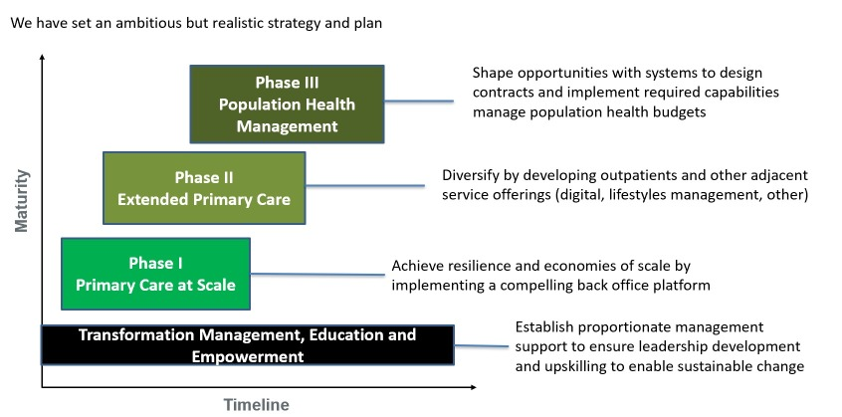
Modality Partnership Intranet. (2017)

Structure

This is how the company is organised, how departments and teams are structured including who reports to whom (Ravanfar, 2015).
Modality partnerships structure is geographical, as it has several divisions this is the best suited structure to the organisation. Geographical structure allows the different divisions to operate in different ways to meet the local demands. Although at each practice level Modality have a functional structure.

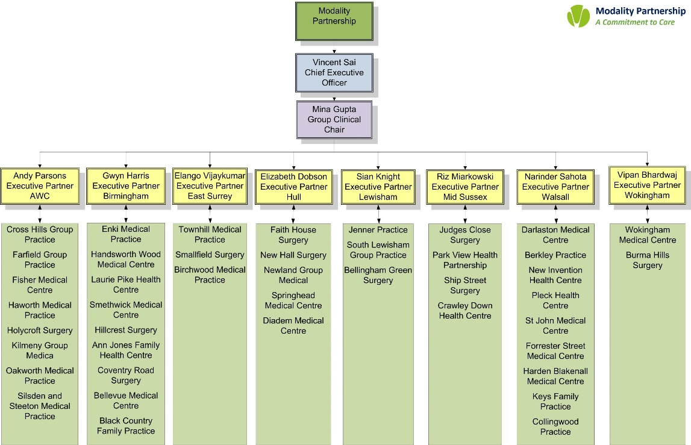
Modality Partnership Interanet, (2019)
System

This is the daily activities and procedures that staff uses to get their job done. A work system allows everyday tasks to be done and is a basic framework to produce services and products (Singh, 2013).
Modality Partnership uses Systmone as their computer system to book appointments and manage patient information as all sites use the same system it makes cross organisational information sharing easy and efficient and patients can visit any of the modality sites.
Modalities have policies and procedures to carry out tasks which allow all the practice to work in the same manner and to the same standards and efficiency.

Styles

The style of leadership adopted (Singh, 2013).
Modality Partnership leadership style is top down, bottom up. All major decisions are made by the board of directors, but staff opinions and suggestions are always taken on board. Annual staff surveys help identify areas for improvement and these are then implemented and reviewed.
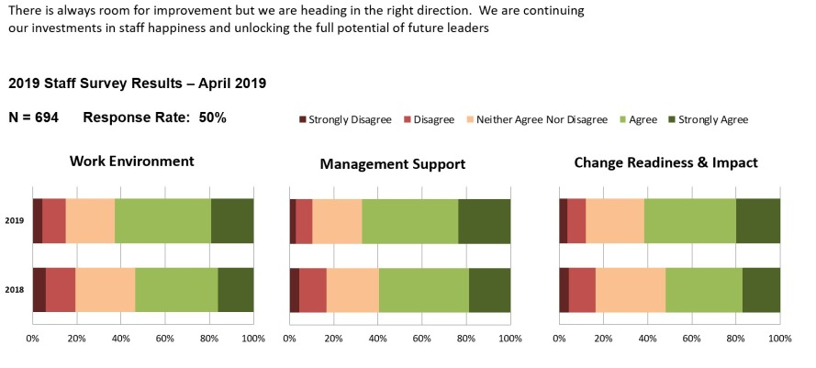
Modality Partnership Intranet, (2019)
Staff and Skills

The Employees and their general capabilities. The actual skills and competencies of the organisation’s employees. (Singh, 2013).
Modality employ a wide range of workers with different skill sets. At ground level there are reception staff who manage the front desk and the day to day office duties. Admin staff who work to complete the back-office duties. Managers to oversee the overall practice activities. GP’s, Nurses, Health Care Assistants, Specialist doctors who run the community service clinics, HR team, IT team are some of the staff employed by Modality. Everyone is trained in their field of work and ongoing training is always available to upskill staff and keep them up to date.

An analysis of the organisation’s ethical stance.

Ethics as explained by Shaw (2007) are also known as morals where individuals decide what is right and wrong. These are demonstrated in individual behaviours for example honesty, loyalty, integrity, respect and concern for others.
Business ethics are the systems of moral and ethical beliefs that direct the values, behaviours and decisions of a business organisation and the individuals within the organisation (Business Case Studies, 2019). Kamali (2019) suggests to create long lasting effect employers must build a foundation of ethical behaviour in order to attract and retain highly skilled staff. Some Ethical requirements for business are codified into law and environmental regulations, an example of this is minimum wage. Business ethics has attracted an enormous amount of interest from consumers and pressure groups as they are increasingly demanding businesses to be more ethical and ecological in the way they do business due to this the importance of business ethics is recognised by businesses more. This also benefits the organisation to build and maintain a positive reputation (Businessballs, 2019).
Everyone in the health care profession faces ethical decision making. These dilemmas concern medical treatments, practices and other matters within the health care. There are many ethical challenges that Modality and other health care professionals face every day. Some examples of these are Patient privacy, confidentiality, end of life issues, and transmission of disease and staff satisfaction (BMJ, 2017). Modality has a very strict policy on confidentiality, and this is reviewed regularly to keep it up to date. All staff are trained to maintain confidentiality in all aspects of their work and patient privacy is given a great deal of importance. Patients are provided with the option to speak to a member of the team away from reception if needed. The protection of patient data is one of the most ethical and legal issues in the healthcare field (The University of Texas at Tyler, 2016). Patient information is kept safe by using protected passwords and all medical records locked in a secure place at Modality.
Modality values their staff and encourages them to progress. Work recognition is very important and Modality have care award schemes where staff can nominate other team members for their commitment and work. This encourages staff to perform better and achieve greater goals.

A comparison of your chosen organisation’s culture to that of a competitor.
The Cultural web is a tool used to see and understand the different influences that affect the organisation (Alvesson and Sveningsson, 2015).
The Competitor organisation selected to compare cultures is MMP Medical. MMP Medical is a super practice based in Birmingham. In comparison to Modality’s geographical structure the structure of MMP Partnership is a functional structure where tasks are divided up into groups and allocated to specific roles. Each department has a manager who must answer to an executive, a level up in the hierarchy. These managers look after matters relating to this department across the different sites of MMP (Aquinas, 2008). This structure works well within MMP as it centralises the operational departments such as HR, Finance, IT and Governance allowing staff at practice level to deal with the day to day demands of the practice.
The vision of MMP Partnership is to improve and develop an excellent GP service, where local GP’s work to provide a long-term personalised care to patients in the community and build a patient doctor relationship so patients see the continuity in care. MMP’s core purpose is “to work within a culture of quality to constantly improve the care and service we give our patients” (MMP, 2019). Modality on the other hand have the vision to bring secondary care services into the community as well as provide core GP services. The control system in both organisations is similar as employees work to certain frameworks and standards allowing them to deliver the same level of service to their patients. Both practices have logos that promote their identity and build a professional image.
Recommendations to further enhance your organisation’s workplace culture in the future.
In conclusion through using the pestle analysis and McKinsy’s 7S framework is it evident that there are many factors combined in creating a successful organisation. Each of these steps are different and are individually essential to ensure the best positive outcomes for the business to run to a good standard; especially in the health care sector. With the increasing emphasis on standards and commissioning practices must ensure that they are working to the guidelines provided and are assessed on their performance. In view of this to further enhance services organisations must look at providing transparency within the organisation this will build employee trust in the organisation. Communication is the biggest key in a successful organisation. Another idea is to provide flexibility to employees this will benefit staff morale and reduce the turnover. By retaining experienced staff work is done to a high standard and training new staff is made easy through them.
Reference List
Alvesson, M and Sveningsson, S. (2015) Changing Organisational Culture: Cultural Changes Work in Progress. Second Edition. Routledge: London.

Aquinas P.G. (2008) Organisation Structure and Design. Excel Books: India.

Ashford, I. (2013) The Face-to-Face Delivery of Downsizing Decisions in UK Public Sector Organisations: The envoy role. [Online] Available at: https://www.tandfonline.com/doi/full/10.1080/14719037.2013.785583?casa_token=IEMe2hkGN3EAAAAA%3AZUAlHKkSAx_mSR8BEsZKNI6oZokDjexdN1s62QcwvxRCl5gv7G3oS0-xnvQ01a128RN2HmVtZ7JCGg [Accessed: 5th November 2019].

BMJ (2017) Political Crisis in the NHS. Kings fund: London.

Businessballs (2019) Introducing Ethical Leadership. [Online] Available at: https://www.businessballs.com/organisational-culture/corporate-responsibility-and-ethics/#what-is-ethical- [Accessed: 05 November 2019].

Business Case Studies (2019) Business ethics and corporate social responsibility An Anglo American. [Online] Available at: https://businesscasestudies.co.uk/business-ethics-and-corporate-social-responsibility-an-anglo-american-case-study/ [Accessed: 04 November 2019].

Cadle, J. Paul, D. Turner, P. (2010) Business Analysis Techniques: 72 Essential Tools for Success. BCS: UK.

Harrison Et AL., (1997) ‘Can the NHS Cope in the Future?’ Education and Debate. 314 [On;ine] Available at: https://doi.org/10.1136/bmj.314.7074.139 {Accessed on 1st November 2019].

Kamali, A. (2019) Technology Trends in Materials Management: A Systematic Review of the Use of Technology in Materials Management to Achieve Competitive Advantage. US: Xlibris Corporation.

Midlands Medical Partnership (2019) About. [Online] Available at: http://www.mmpmedical.com/about/ [Accessed: 7th November 2019].

Modality Partnership (2019) What is important to us. [Online] Available at: https://modalitypartnership.nhs.uk/about-us/our-values [Accessed: 4th November 2019].

NHS UK (2019) Improving access to general practice. [Online] Available at: https://www.england.nhs.uk/gp/gpfv/redesign/improving-access/ [Accessed: 6th November 2019].

NIBUSINESSINFO, (2019) Strategic planning for business growth. [Online] Available at: https://www.nibusinessinfo.co.uk/content/pestle-analysis-example [Accessed on: 31st October 2019].

Perera, R. (2017) The PESTLE Analysis. Nerdynaut: India.

Ravanfar, M.M. (2015) Analysing Organisational Structure Based on 7s Model of Mckinsey Volume 15 issue 10. [Online] Available at: https://pdfs.semanticscholar.org/9fd1/4d415ed96b1dcafa9d84ddde97ecabe5dbda.pdf [Accessed: 5th November 2019].

Shaw, W. (2007) Business Ethics 6th Ed. USA: Thompson Wadsworth.

Singh, A. (2013) A Study of Role of McKinsey’s 7S Framework in Achieving Organizational Excellence. Vol 31. Issue 3. Organisational Development Journal: Chesterland. [Online] Available at: https://search-proquest-com.ezproxy.uwtsd.ac.uk/docview/1467437673?accountid=130472&rfr_id=info%3Axri%2Fsid%3Aprimo [Accessed: 6th November 2019].

The Kings Fund (2019) Supporting new NHS Care Models. [Online] Available at: https://www.kingsfund.org.uk/projects/supporting-new-nhs-care-models/modality-partnership-sandwell-and-west-birmingham [Accessed: 31st October 2019].

The University of Texas at Tyler (2016) Ethical Issues in Healthcare. [Online] Available at: https://online.uttyler.edu/articles/ethical-issues-in-healthcare.aspx [Accessed: 5th November 2019].

Wickware, C. (2018) Super practice partners with Push Doctor to offer GP video consultations. [Online] Available at: http://www.pulsetoday.co.uk/news/gp-topics/it/superpractice-partners-with-push-doctor-to-offer-gp-video-consultations/20037442.article [Accessed: 6th November 2019].

