Developing Innovation and Creativity for Business Advantage

Student Name: Abdul Samad
Student ID: 1918548
Lecturer: Khaza Ahmed
Module Code: BMSW6102

Table of Contents
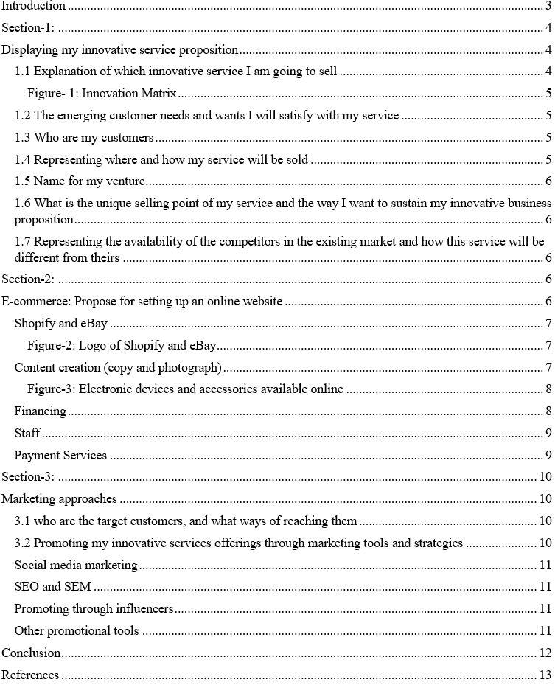

Introduction
Starting up an innovative online service venture by analysing the emerging customers’ needs is quite challenging when it is a business of electronic accessories and gadgets as now this market is quite competitive and many strong competitors are operating their business dynamically. In this situation, I have developed a new online venture named Easy Tech that will serve customers 24/7, a unique and different market offering. This report includes the strategies and techniques applied to identify and reach the target market using proper strategies. This repost covers how marketing and promotional activities are done for this innovative service offerings.

Section-1:

Displaying my innovative service proposition
In this section, there will be a broad discussion on introducing an innovative service that is innovated to satisfy the customers by considering their emerging needs as now the customers are more concentrated in a point where they get quicker and more efficient services.

1.1 Explanation of which innovative service I am going to sell
Just imagine you are doing your urgent work by using technological devices in the middle of the night and what if suddenly, your devices start malfunctioning? From where can you get the service to make your device ok in the middle of the night? Won't this hamper your whole effort? The answer is "Yes". Most of us may have this aggravating experience of having a technological device disturbed in the middle of a deadline at an odd time. This is where I will swoop in with my innovative service offering.
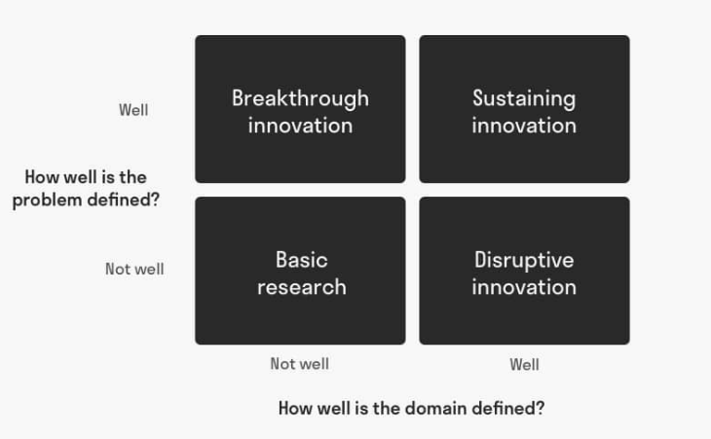

Figure- 1: Innovation Matrix
Source: (Janse, 2022)
Consumers won't have to deal with the hassle of making a trip to the shop or worrying about a broken cable at inconvenient times because the 24-hour mobile accessory service will be provided, and as per Oliver (2010), if customers get the desired service when need thy become satisfied and loyal. I have applied the innovation matrix to identify what sort of innovation I am going to make with my new service and venture. After analysing, it was found that my innovative service belongs to the sustaining innovation component section of innovation matrix. Additionally, incremental innovation is a part of the term "sustaining innovation." For most innovation, a new product or service must perform much better than it now does (Kyffin and Gardien, 2019). Improving and extending current options are the goals of this section and problems are properly defined and the way forward is clearly marked in the innovation matrix so that is similar to my innovative venture.

1.2 The emerging customer needs and wants I will satisfy with my service
The COVID-19 outbreak has a devastating and awful impact on us, forcing us to be more dependent on technological devices in many ways, as per Adov and Maeots (2021). Every facet of our life, from ordering food to working, is done online on our technological gadgets, which require specific gear like a high-tech microphone, helmet, camera or other electronic devices (He et al., 2021). As the electronic precuts are being greatly used, customers face many technical disruptions and disintegrations while using them, which is a problem to solve, and this is where I will go to them with my service and will satisfy them.

1.3 Who are my customers
The customers of this service are likely to be persons who spend most of their day working with, using, or just enjoying electronic devices for personal or professional reasons. It's a common problem for those who spend most of their time in front of a computer or other electronic gadget that they cannot take care of their electronic devices on time because of time and other issues. By taking my service, they will no longer have to be panicked about fulfilling their technological need and can concentrate on their work.

1.4 Representing where and how my service will be sold
Upon completing all necessary marketing and promotion efforts, the service will be made available on eBay and Shopify for purchase by the general public, as these two are the most commonly used and prevalent e-commerce platforms. The choice of selecting eBay and Shopify was based on their preferences and fame, and according to Allen (2015), it’s a good idea to begin the business at a location that locals already utilise as by starting locally, it is possible to enjoy competitive advantages in terms of order taking and fulfillment. Even though it's a small-scale operation, begin at this stage. For my new venture to be successful, it must be based on a solid foundation that has been well researched and is ready to go.

1.5 Name for my venture
The name for the venture is Easy Tech, which is selected based on the theme that highlights the easiness that will be provided through this service offering whenever and wherever customers want, which is the specialty of this name.

1.6 What is the unique selling point of my service and the way I want to sustain my innovative business proposition
Why should this concept differ from others selling electrical device accessories in marketspaces? This is a unique concept since here, an actual endeavor is being made to do business by offering rapid and efficient delivery of high-quality electronic components or accessories anytime, anywhere, 24/7. As long as this venture can continuously introduce new and interesting electronic items and maintain its inventory up to date with the latest tech facilities, it will be successful and sustain its growth.

1.7 Representing the availability of the competitors in the existing market and how this service will be different from theirs
Yes, a noticeable number of ventures are working in this market as this market is now a type of hot cake, especially in a busy business area where this business is planned to be started. As mentioned earlier, a considerable number of competitors are already there, and they are competing, but this service will be superior among them for various reasons. Because most similar services only operate for a limited time a day, this service will be available 24/7. This service provides top-notch quality, lucrative warranty, eye catchy packaging and customer-friendly delivery inspired by business purpose to offer a high-value proposition.

Section-2:

E-commerce: Propose setting up an online website
According to Abed (2021), since the Covid-19 epidemic has turned people away from conventional methods of commerce, every company needs to provide its service or product to customers over the internet to succeed. This business aims to serve the customers anytime, anywhere they want, for that Easy Tech will start on the SaaS, marketplace, and market space platforms.
Strength  High revenue from sales stream is possible for ongoing market demand  Innovative product and service by Easy Tech for technological innovation of this Era  An online platform is a place to conduct business by triggering customers easily.  The benefits of Strategic Alliance help to provide the best product to the customer. | Weakness  Have a chance to drop in profit for the highly competitive platform.  High promotional costs to enter into the customer mind increase Easy Tech’s expenses  Less knowledge as a newcomer is their weakness to trigger out the customers
Opportunity  East tech has its market feasibility for the high market demand  Technological Innovation of this Era is the opportunity to flourish in the market of Easy Tech. | Threats  Users' resilience may change and that can be a massive threat to easy Tech  More competitors in the electronics industries create a barrier to flourishing.  Need more capital to compete with ongoing market trends.  Software piracy is one of the threats to flourish the market of Easy Tech.

Shopify and eBay
Shopify has been selected as the SaaS platform for this innovative service offering, while eBay has been chosen as the marketspace. As a result, besides the local service takers, customers who wish to shop from other countries may expect their orders to arrive quickly. Easy Tech's availability on a correct marketspace like eBay and a SaaS (service as a software) platform like Shopify are crucial since they provide a vast opportunity to attract more potential customers by offering robust service offerings to different spaces (Yang et al., 2010). According to Butler et al. (2022), at the present age, it's important to remember that certain people are more likely to trust one program or piece of software than another.


Figure-2: Logo of Shopify and eBay
Source: (Your stores - Shopify, 2022; eBay Stores | eBay, 2022)

Content creation (copy and photograph)
According to Baltes (2015), content is the most vital aspect for online availability. The next stage in launching this business on various platforms like SaaS and market space was developing content quickly. To put it simply: Content is king since it's the only thing that attracts visitors to become prospective customers and eventually purchasers. Consequently, after an extensive investigation, careful and focused procedures were performed to provide the most significant material as a final result for an ideal online appearance and advertising. Customers' content consumption habits were also considered while building this e-venture’s website. A vast number of mobile and laptop users prefer video and pictorial material over text and have a short attention span while browsing the web. To make it simpler for users to access and see the app and website, the website and SaaS were created in a fashion that featured more graphical material than textual.
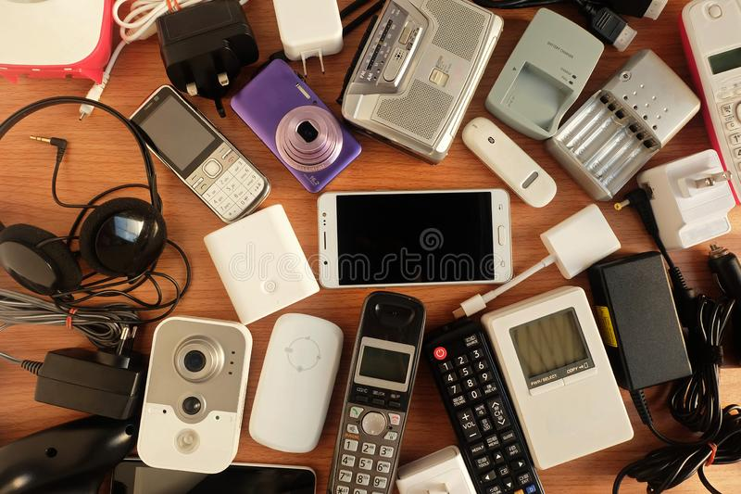

Figure-3: Electronic devices and accessories available online
Source: (10,864 Electronic Gadgets Stock Photos, 2022)

Financing
According to Schwienbacher (2014), as the cost of obtaining a domain or upgrading to a premium package for more features and functionality is not a silly matter, setting up an online venture is for those who are willing or able to invest in the process. Financing was in place prior to the start of production to ensure that the company could operate without interruption (Cassar, 2014). For starting the venture, I needed an initial capital to purchase the necessary equipment, inventories and to bear the staffing cost and the amount I assumed to be needed was £50000. In order to purchase initial necessities, this venture depended on savings from different sources. All necessary supplies and requirements had to be procured and stored in a safe and secure location after successful financing as according to Gómez et al. (2015), for every company, particularly those dealing with sensitive items like this service offering, adequate storage and packaging is essential. All that was required was a wide range of current, attractive and fashionable electronic accessories and the necessary packing materials. Angel investors and my savings played a prominent role in financing this venture. Mainly, I got the financial support from NGO who provided me the maximum portion of that capital.
Product | Cost
Storage rent | £12000
Computer | £27000
Planning for local authority | £1300
Telecommunication connection and set up | £1200
Application | £8,000
Electronics | £3390
Website Development | £10000
Fashionable electronic accessories | £12220
Application maintenance software | £2000
Necessaries Equipment | £19600
Staffing Cost | £50000
Total set up cost | £146,710
Table 1: Cost of setting Easy Tech
Source:

Staff
Any company, whether large or small, needs efficient staff to succeed; a strong group of staff creates the actual difference from the competitors, as per Rodrigues da Costa and Maria Correia Loureiro (2019). It was imperative that a small group of staff, consisting of the manager and some order fulfillment personnel capable of handling many quick deliveries, be assembled once everything had been organised. Approving orders, keeping track of inventory, and placing reorders for items will be organized and accounted by the manager of the company. Discussion of any new developments or initiatives was also conducted weekly.

Payment Services
In order to make things easier for both the parties, including who provides the services and who takes the services, payment methods were kept as simple as possible. Cash-On-Delivery (COD) was one option offered in this service offering, allowing customers to see the product before making a purchase and avoiding the risk of PCI-DSS compliance to enhance the number of loyal and delighted customers. Besides COD, customers can pay via the credit or debit card provided by the banks where they have accounts. So, it is clear that for ensuring customers smooth purchasing experiences we have added flexible payment systems.

Section-3:

Marketing approaches
According to McArthur and Griffin (2019), there would be no business if business persons don’t effectively promote their services. Promotion and marketing are sometimes confused, but they're not the same, as per Eastman et al. (2012). Marketing is a chain of activities needed to be performed by the markets, whereas promotion is an activity of overall marketing activities (Andrews and Shimp, 2017). Let’s take a look at some of the marketing and promotional strategies of Easy Tech, but before that, let’s see who are the target customers and the ways of reaching them. This is a unique notion in that a real effort is being made to conduct business by enabling speedy and effective delivery of high-quality electronic components or accessories anytime, anyplace, and 24 hours a day, seven days a week.

3.1 who are the target customers, and what ways of reaching them
When promoting the services to the targeted customers, numerous strategies were used to reach them. The initial step was to study the consumer base through tools like google analytics and interview customers. Once the market research was completed, this venture could get a better knowledge of the customers' needs in the new technological field market. Basically, the customers of this service are likely to be persons who spend most of their day working with, using, or just enjoying electronic devices for personal or professional reasons. Additional activities included keeping a close watch on the competitors and reaching potential customers through Search Engine Optimisation (SEO) as a professional approach.

3.2 Promoting my innovative services offerings through marketing tools and strategies
After fixing the target customers and how to reach them, this service proving business named Easy Tech moved up to the promotional activities of its service offerings as, without proper promotional activities, it is not possible to sustain in the market (Krizanova et al., 2019). As today it is tough to make a customer loyal and a permanent purchaser who won’t switch, business persons and markets adopt diverse strategies and tactics to attract them and satisfy them to create loyal customers, as per Gremler and Brown (2019). To promote the service offerings of Easy Tech, some marketing and promotional activities are performed.

Social media marketing
Easy Tech used social media marketing as a robust digital marketing strategy. According to Vinerean (2017), as having a website or a SaaS appearance isn't sufficient to attract all the targeted customers, marketers must adopt social media marketing through Facebook and Instagram. The social media presence of Easy Tech must be robust. Each social media platform was treated as though it were an extension of the company's brand, with extensive postings on Facebook and beautiful marketing images and videos on Instagram. As a result, they decided to sell the service in a manner that appealed to young people, as they were the majority of those who utilised social media.

SEO and SEM
As an online venture, Easy Tech will need to significantly market and advertise its service offerings to its target audience as letting the targeted customers know about the market offering properly no business can gather customers (Dwivedi et al., 2015). Search Engine Optimisation and (SEO) and SEM (Search Engine Marketing) can be great assistants to businesses like Easy Tech. These two promotional tools can enhance the promotional strengths and get the name of Easy Tech on the top page of Google.

Promoting through influencers
Deploying an influencer would be ideal for promoting Easy Tech's service since the young generation is more inclined to follow their peers' and influencers' advice and style than anybody else (De Veirman et al., 2017). Paying a fee to the influencers to make a review of the service is precisely what this company did. The influencers received packages and payment for sponsored advertisements, and after posting a review on their blogs and posts, purchases began to flow (Racz, 2020).

Other promotional tools
Printing digital and paper posters and posting them on the online media and to appropriate places, where the users are using electronic devices, and at these places, some individuals are using digital gadgets often, are examples of a more conventional strategy.

Conclusion
The tech businesses are now excessively competitive, where I will be launching a new innovative online service that will fulfill the customers' emerging needs. To ensure my business growth, I have made a proper plan to target my customers and satisfy their needs by identifying them correctly. For this, I have applied several marketing and promotional strategies and tools to attract my customers, which is a must to sustain in the market. These enterprises will be profitable and continue to develop as long as it can launch new and exciting electronic things on a regular basis and keep its inventory up to date with the most recent technological advances.

References
Abed, S.S., 2021. A literature review exploring the role of technology in business survival during the Covid-19 lockdowns. International Journal of Organizational Analysis.
Accounts.shopify.com. 2022. Your stores - Shopify. [online] Available at: <https://accounts.shopify.com/store-login> [Accessed 13 July 2022].
Adv, L. and Mäeots, M., 2021. What Can We Learn about Science Teachers’ Technology Use during the COVID-19 Pandemic?. Education Sciences, 11(6), p.255.
Andrews, J.C. and Shimp, T.A., 2017. Advertising, promotion, and other aspects of integrated marketing communications. Cengage Learning.
Butler, S., Gamalielsson, J., Lundell, B., Brax, C., Mattsson, A., Gustavsson, T., Feist, J., Kvarnström, B. and Lönroth, E., 2022. Considerations and challenges for the adoption of open source components in software-intensive businesses. Journal of Systems and Software, 186, p.111152.
Cassar, G., 2014. The financing of business start-ups. Journal of business venturing, 19(2), pp.261-283.
De Veirman, M., Cauberghe, V. and Hudders, L., 2017. Marketing through Instagram influencers: the impact of number of followers and product divergence on brand attitude. International journal of advertising, 36(5), pp.798-828.
Dwivedi, Y.K., Kapoor, K.K. and Chen, H., 2015. Social media marketing and advertising. The Marketing Review, 15(3), pp.289-309.
Eastman, S.T., Ferguson, D.A. and Klein, R. eds., 2012. Media promotion & marketing for broadcasting, cable & the Internet. CRC Press.
Gómez, M., Martín‐Consuegra, D. and Molina, A., 2015. The importance of packaging in purchase and usage behaviour. International journal of Consumer studies, 39(3), pp.203-211.
Gremler, D.D. and Brown, S.W., 2019. Service loyalty: its nature, importance, and implications. Advancing service quality: A global perspective, 5(1), pp.171-181.
He, W., Zhang, Z.J. and Li, W., 2021. Information technology solutions, challenges, and suggestions for tackling the COVID-19 pandemic. International journal of information management, 57, p.102287.
Janse, B., 2022. Innovation Matrix. [online] toolshero. Available at: <https://www.toolshero.com/innovation/innovation-matrix/> [Accessed 21 July 2022].
Kyffin, S. and Gardien, P., 2019. Navigating the innovation matrix: An approach to design-led innovation. International Journal of Design, 3(1).
Krizanova, A., Lăzăroiu, G., Gajanova, L., Kliestikova, J., Nadanyiova, M. and Moravcikova, D., 2019. The effectiveness of marketing communication and the importance of its evaluation in an online environment. Sustainability, 11(24), p.7016.
McArthur, D.N. and Griffin, T., 2019. A marketing management view of integrated marketing communications. Journal of Advertising Research, 37(5), pp.19-27.
Oliver, R.L., 2010. Customer satisfaction. Wiley international encyclopedia of marketing.
Racz, R.G., 2020. Social Media Influencer Advertising versus Advertising on Social Media Account of a Brand. Evidence from an Experimental Design. Journal of Media Research, 13(3), pp.45-54.
Rodrigues da Costa, L. and Maria Correia Loureiro, S., 2019. The importance of employees’ engagement on the organizational success. Journal of Promotion Management, 25(3), pp.328-336.
Schwienbacher, A., 2014. Financing the business. In The Routledge companion to entrepreneurship (pp. 217-230). Routledge.
Stores.shop.ebay.com. 2022. eBay Stores | eBay. [online] Available at: <http://stores.shop.ebay.com/_sl.html?_fe=1> [Accessed 13 July 2022].
Vinerean, S., 2017. Importance of strategic social media marketing.
Yang, S.J., Yoo, B.J. and Jahng, J.J., 2010. Does the SaaS model really increase customer benefits?. Asia pacific journal of information systems, 20(2), pp.87-101.

