

BA BUSINESS MANAGEMENT
Assessment 1
Blogging to communicate



Module Code: LCBB4004
Module: Marketing Fundamentals
Lecturer :Mohammad Rahman
Student ID: 2123374
Student Name: Maria-Alexandra Chesoiu

Table of Contents

1.Overviewing the background of Aurelia Skincare 3
2.Product range of Aurelia Skincare 4
3.Pricing strategy of the company 9
4.Description of the places of Aurelia Skincare 10
5.Promotional strategy of Aurelia Skincare 12
6.Reference 14

1.Overviewing the background of Aurelia Skincare

The cosmetics and skincare industry in the UK has a growing economy that helps them to accelerate their growth rate in the competitive world. However, the research has shown that this industry has an 18% of growth rate within the organisational context. Every industry is trying its best to invent some new particles within the organisational context so that it will make the organisations more attractive and effective for the customers. The cosmetics industry is one of the oldest industries in the UK that has changed vastly within a certain time. In recent times, Probiotics is one of the most renowned terms in the cosmetic industry, and the company that had at first taken the initiative to use this was Aurelia Skincare. This company was established in the year 2012, by Claire Vero. She had imposed her experience in generating this company for women so that the skincare routine will be enhanced (Cosmeticsbusiness, 2016). The mission Claire was to introduce the newest concept of acknowledging skincare activities for individuals and can provide an effective result for women. Claire uses the purest ingredients for her products that are sourced sustainably from different places in the world (Vero, 2018).
Claire had spent her 10 years at the forefront of pharmaceutical excellence that had evoked her to develop a new concept of skincare products. Aurelia Skincare company uses PROTIDA technology that affects the skin positively in an advanced way. This technology basically calms down the side effects of stress and pollution. It also triggers the immunity of the skin cells so that overstimulation can be resolved easily. The skincare products contain live bacteria whereas here Claire used non-live bacteria. This bacteria is used in the form of glycoprotein and heals cell-to-cell communication. The perceptions of the scientific-led skincare process had been formulated by Aurelia Skincare. Since 2013, it has been able to establish connections with 150 key industries and achieved consumer awards for this revolution (Aurelia London, 2013). The company has over 50 employees working with them and a revenue of $5M-$10M in the UK cosmetic industry (Medina Azaldin, 2020). The report has shown that the company has total assets of £68,339 within the company (Vero, 2018). The uniqueness in providing the services is the key factor for the success of the company within the highly competitive industry. There are various competitors present in the UK market and they are Pai, DERMALA, REN, and others (Owler, 2019).

2.Product range of Aurelia Skincare
Aurelia skincare company specialised in providing all skincare products that can make the skin healthier along with that protect the skin from all types of pollutants and stress. The unique ingredients have differentiated the company from its respective competitors and also made it more acceptable for the customers (InsightAce Analytic, 2020). The company has face serums, face cleaning products, different moisturisers, and others that can provide protection to the consumers’ skin from different particles of the environment.
The Miracle Cleanser
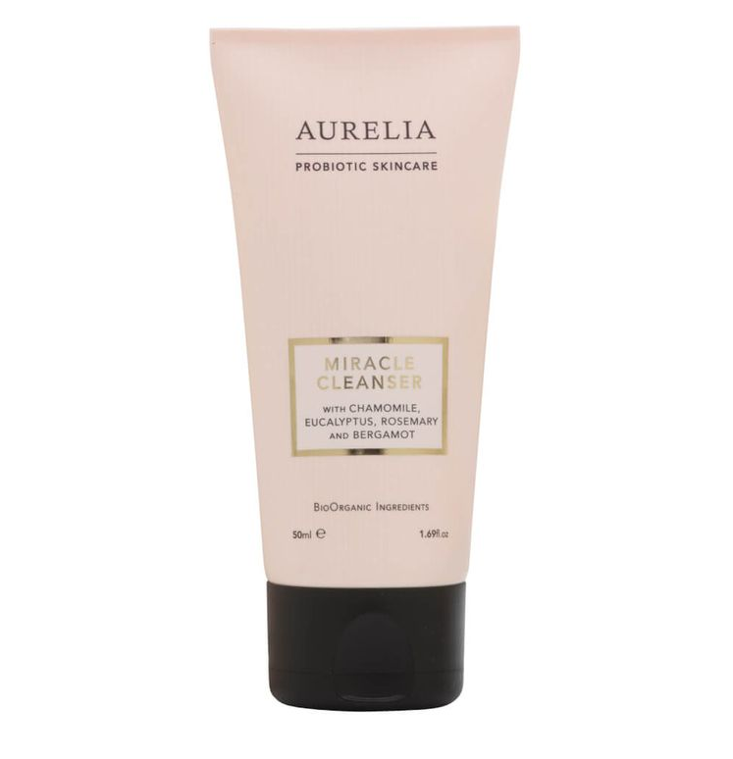
Figure 1: Aurelia Cleanser
(Source: InsightAce Analytic, 2020)
The cleanser basically goes into the consumer’s skin to remove all impurities gently without making any saviour problems in the skin. The cleanser is one of the most-rated products in the organisational context and many customers have given feedback that it is the best product. This product contains different natural ingredients that can satisfy particular requirements of the consumers. It has hibiscus extracts as an antioxidant and shea butter to soften the skin effectively. It also has rosemary as well as eucalyptus extracts along with bergamot’s aromatic blend. The product is applicable for every type of skin and its creamy texture is able to delight the skin efficiently (InsightAce Analytic, 2020). Women use to carry daily makeup whenever they visit the office or go out for different purposes so this product is one of the most effective ones to clean those makeups by mixing it with micellar water.
Cell Revitalise Moisturiser (Day)
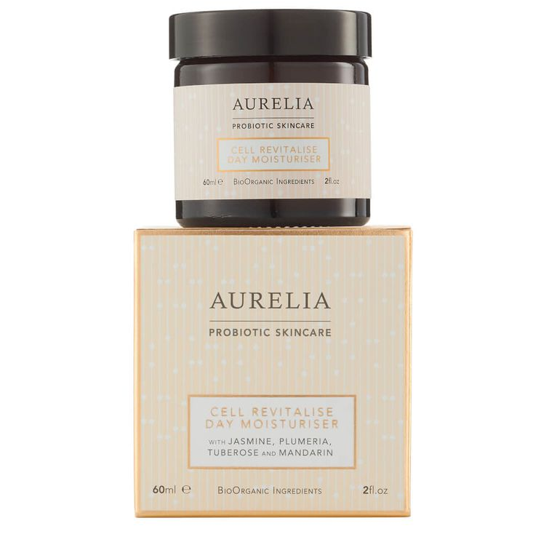
Figure 2: Day Moisturiser by Aurelia Skincare
(Source: Owler, 2019)
This is another most renowned and accepted product of Aurelia in the UK as it is able to provide softness to the skin by enhancing the hydration process. It is also effective under the makeup of individuals and helps them to get a shield for the skin from various ingredients of the makeup (Galina. 2018). There are many environmental aggressors present that can be harmful to the skin so it is essential for individuals to use a protective daily moisturiser for their skin. This product includes peptides, omegas, as well as antioxidants for the protection of the skin. It has a sweet fragrance of tuberose and jasmine that also attracts a large number of customers to purchase it for them. This moisturiser does not clog pores as the whipped texture melts into the skin significantly (Owler, 2019). The moisturiser has nourishing effects on the skin so it is acceptable for every type of skin of individuals.
CBD Super Serum
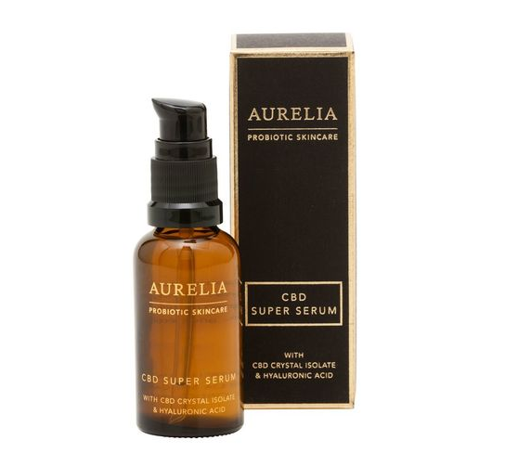
Figure 3: CBD Super Serum
(Source: InsightAce Analytic, 2020)
Serum plays a vital role to prepare the skin before applying any kind of products to the skin and the specialty of this serum is it contains CBD that is also known as cannabidiol. Cannabidiol is a non-psychoactive component that developed from a plant named Cannabis sativa plant. This product basically uses Purified crystals of CBD in the place of CBD oil to maintain enhanced efficacy (InsightAce Analytic, 2020). The breakouts cannot be curbed within the skin as this serum is lightweight and instantly gets absorbed within the skin. It also reduces the redness of the skin as it includes hyaluronic acid as the base component. The irritated and stressed skin of any individual can use this product to build up strong hydration in the skin (InsightAce Analytic, 2020). It is able to rebalance the skin type by resetting it after travelling for a long day significantly.
The Probiotic Concentrate
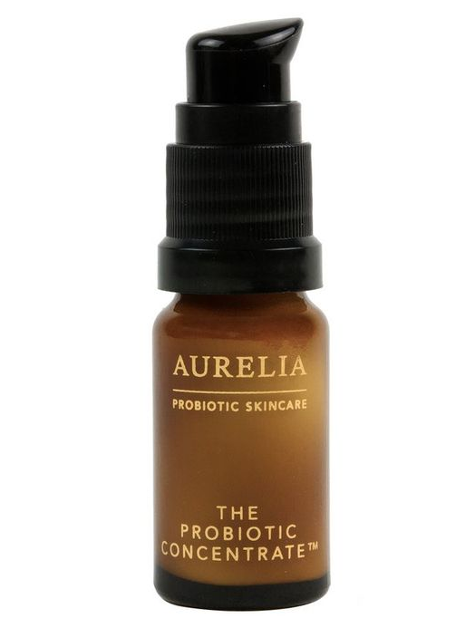
Figure 4: The Probiotic Concentrate
(Source: Owler, 2019)
This is one of the most effective and unique products of the organisation that instantly triggers and becomes reactive in different complexions. This product has probiotic ingredients along with a gentle dose of salicylic acid as well as lactic acid. It basically treats hyperpigmentation, dullness, blemishes, and fine lines of the skin. It can be used directly on the skin or can be used by mixing with moisturiser, face oil, or serum for making fresh-looking skin. This product can be effective for different skin types that are in need of intensive TLC (Owler, 2019).

Botanical Cream Deodorant
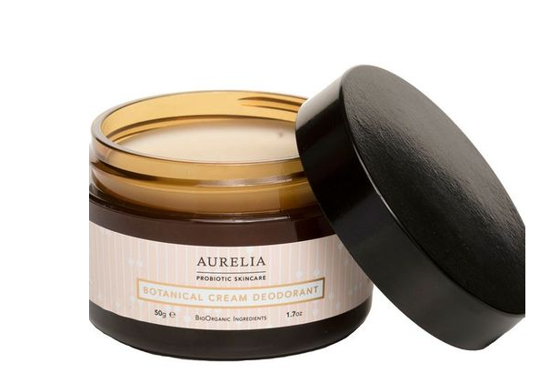
Figure 5: Botanical Cream Deodorant
(Source: Owler, 2019)
The botanical cream deodorant is one of the cult products that does not use aluminium as a deodorant but it has been able to establish itself as the most popular one. This product basically contains two major products one is kaolin clay and another one is arrowroot powder. It helps individuals to avoid bad smells and make their underarms dry. It also removes the odour-causing bacteria from the underarms of individuals (Owler, 2019). There are various deodorants that are in the form of spray but this is in the form of clay that has differentiated this product from other deodorants (Owler, 2019). It is able to provide an uplifting and fresh scent to the consumers so that they can stay fresh all day alone.

3.Pricing strategy of the company
Pricing is one of the most important factors for organisations that can influence the purchasing behaviour of the customers particularly (Teng et al., 2020). It determines the affordability of the customers within the organisational context so that the selling rate of the company can be measured effectively. The organisation has tried to establish an affordable pricing for the products that will be helpful for women to purchase the products. The skincare products are mainly useful for women so keeping the prices lower can attract a large number of women to purchase the products from the company. There are various discounts and offers are provided to women on an occasional basis. In the beginning of the organisations’ establishment, the company had set its pricing strategy as the competitive one. After three years of establishment, the competition rate of the cosmetics industry had increased by 14% that had created a problematic situation for Aurelia Skincare.
Claire had decided to transform the pricing strategy and it was set as the lower pricing strategy. It helps the customers to get effective products at an affordable price. In the year the company had faced a significant downfall in the revenue by 24% due to change in the pricing strategy of the company (Media Samosa, 2020). However, the popularity among the customers has helped them to revive their revenue rate and increase the selling rate of the company. The company also provides Friday sales to the customers along with some extra discounts in the month of Christmas. The competitiveness of the company also gets enhanced with the help of this change in the pricing strategy of the company particularly.
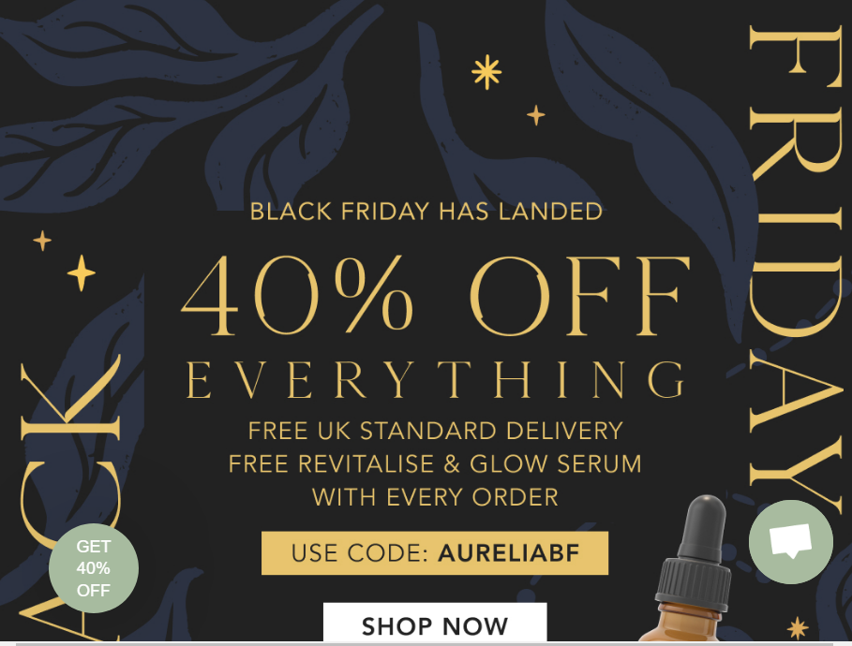
Figure 6: Black Friday sale
(Source: Aurelia London, 2013)

4.Description of the places of Aurelia Skincare
The place in the marketing process basically identifies the existence of the organisation’s products so that the customers can purchase the products easily (Mohseni et al., 2018). The company here uses different portals to obtain a particular position within the organisational context.
Personal website of Aurelia Skincare
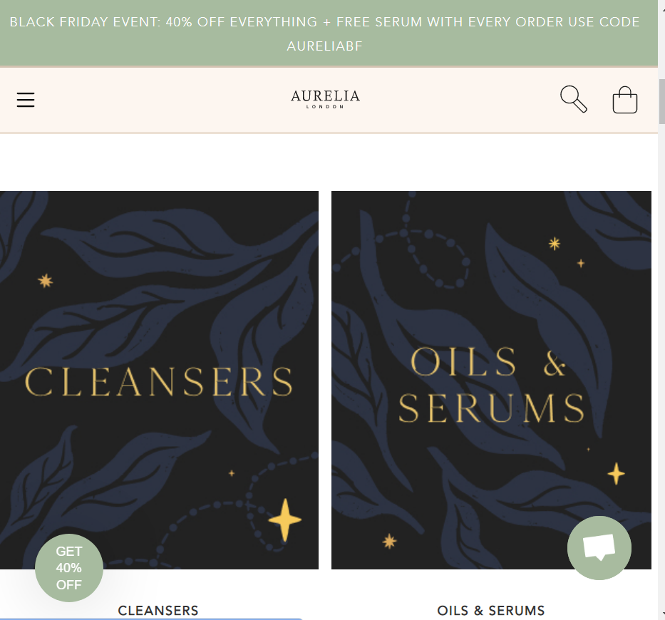
Figure 7: Official website of Aurelia Skincare
(Source: Aurelia London, 2013)
The company has its personal website by which they can provide all types of information to the customers and assist them in purchasing the suitable product. However, it also provides the price details along with the ingredients that are included within the products particularly. It helps the company to target a large number of customers altogether and concentrate on the growth rate of the company particularly. The official website has also helped the company to influence the purchasing behaviour of women regarding the probiotic skincare products. The URL of Aurelia Skincare company is: https://www.aurelialondon.com/
Acknowledgement of e-commerce platforms
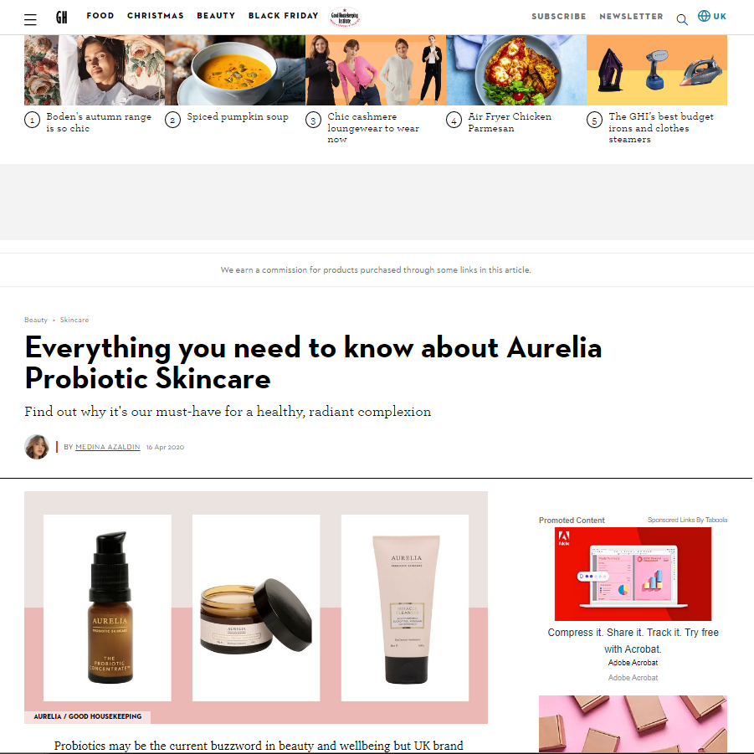
Figure 8: Presence in the e-commerce platforms
(Source: Medina Azaldin, 2020)
The company is also able to spread its existence in the e-commerce platform where there are other products as well. Teh customers also get the chance to compare the same type of products with each other and identify the better one for them. However, the presence of the products and information in the e-commerce platforms have enabled the selling rate of the company and its products within the organisational context. The URL of ecommerce site is: https://www.goodhousekeeping.com/uk/beauty/skincare/a31131162/aurelia-skincare/

5.Promotional strategy of Aurelia Skincare
Promotional activity is one of the most important practices that can keep up the brand awareness among the customers in an enhanced way (Olanrewaju and Babalola, 2019). The marketing process of the company is changing on a daily basis and acknowledgment of advanced technologies has been able to bring in an effective success rate to the company. Aurelia Skincare company basically observes social media platforms as well as they use celebrity promotional strategies as well (Cheah et al., 2019). The company has identified Instagram as the most appropriate social media platform for the company. The company uses this platform to communicate with the customers and make them understand the uniqueness of the products in comparison to other skincare products. It helps them to understand the acceptance rate of the customers for the particular products.
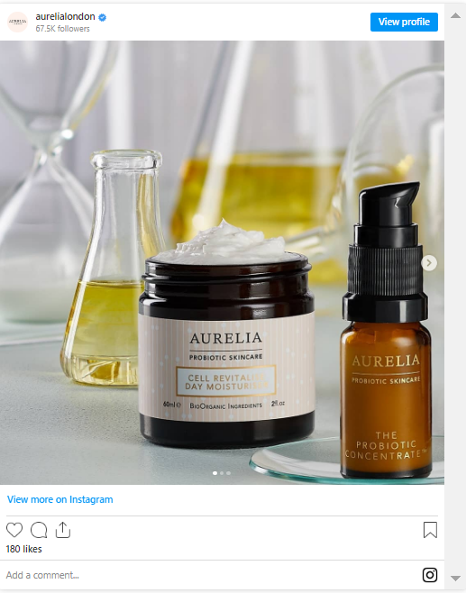
Figure 9: Instagram post of Aurelia Skincare
(Source: Medina Azaldin, 2020)
The company has used some interesting games for the customers and it is kind of a quiz contest. This process helps the customers to understand their skin types and get the products as per the suitability. This process has helped the company to acknowledge a great interest of the consumers within the organisational context and keep up the selling rate of the organisation (Bradley, 2018).
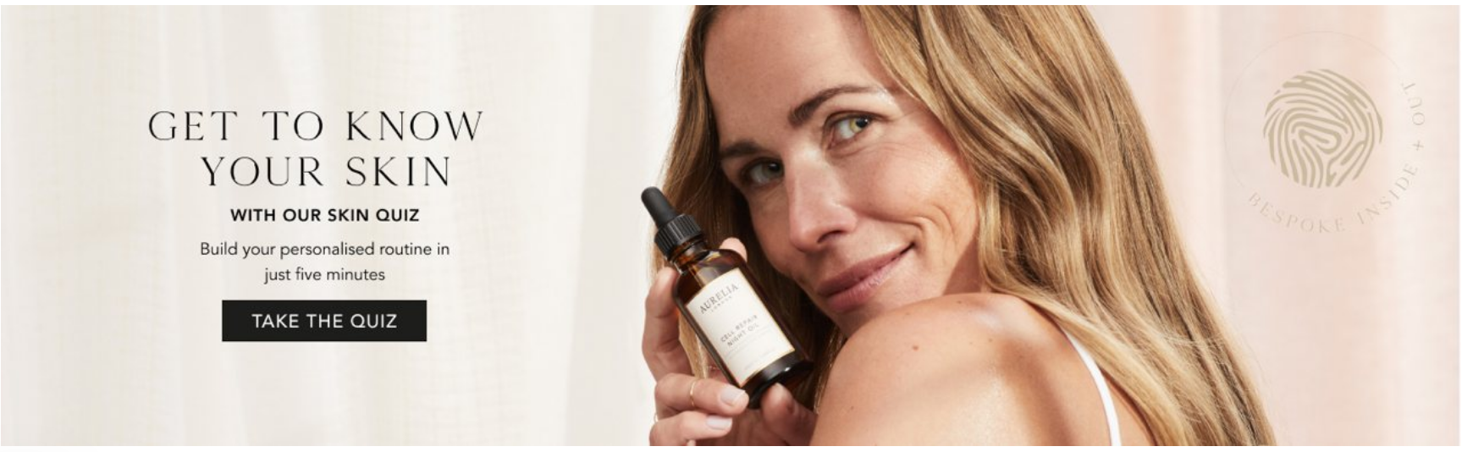
Figure 10: Skin Quiz of Aurelia Skincare
(Source: Aurelia London, 2013)
In the traditional marketing tool the company basically uses magazine promotions in order to bring in the product details in front of the customers who are not so active in the social media or online marketing platforms. It includes different renowned magazines such as Vogue, Glamour, ELLE, and others.
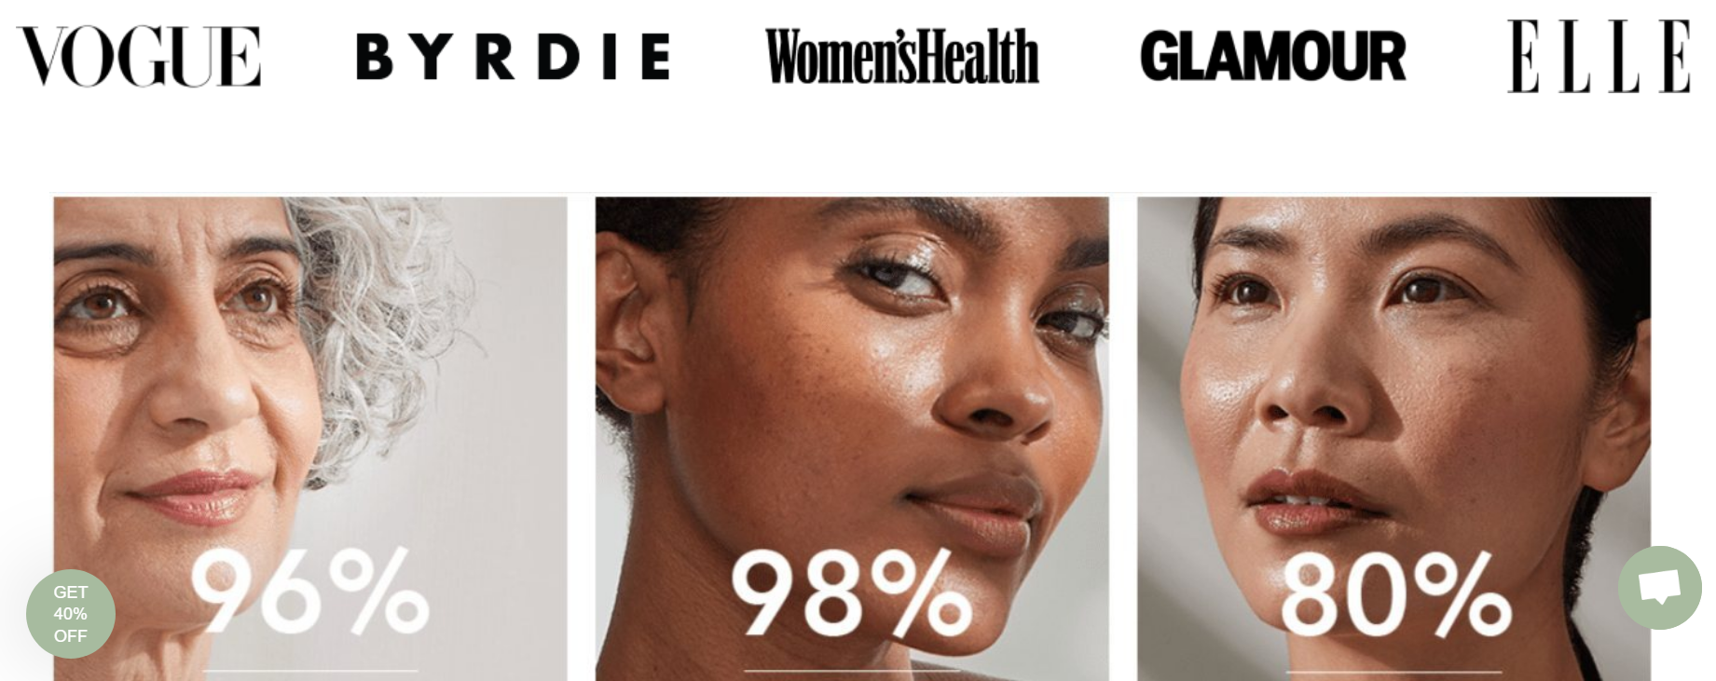
Figure: Magazine marketing
(Source: Aurelia London, 2013)

6.Reference
Aurelia London. (2013). [online] Available at: https://www.aurelialondon.com/
Bradley, J. (2018). The Importance of Promotional & Marketing Strategies. [online] Available at: https://smallbusiness.chron.com/importance-promotional-marketing-strategies-57205.html ‌
Cheah, J.H., Ting, H., Cham, T.H. and Memon, M.A., (2019). The effect of selfie promotion and celebrity endorsed advertisement on decision-making processes: A model comparison. Internet Research, 29(3), pp.552-577.
Cosmeticsbusiness, (2016). Aurelia Skincare. [online] Available at: https://www.cosmeticsbusiness.com/company/single_company/Aurelia_Skincare/42242
Galina. (2018). Aurelia Probiotic Skincare. [online] Available at: https://thecuriositygap.co.uk/aurelia-probiotic-skincare-review-and-q-a-with-the-beauty-brand-founder-claire-vero/
InsightAce Analytic, (2020). Skin Microbiome Market 2020| Aurelia Skincare Ltd., Gallin�e, ELSI Beauty, Mother Dirt, Esse Probiotic Skincar. [online] Available at: https://www.openpr.com/news/2067443/skin-microbiome-market-2020-aurelia-skincare-ltd-gallin-e
Media Samosa (2020). Aurelia stands against shaming of women with Be your own Beautiful campaign - Media Samosa. [online] Media Samosa. Available at: https://mediasamosa.com/2020/03/20/aurelia-be-your-own-beautiful-campaign/ [Accessed 19 Nov. 2022].
Medina Azaldin (2020). Everything you need to know about Aurelia Probiotic Skincare. [online] Available at: https://www.goodhousekeeping.com/uk/beauty/skincare/a31131162/aurelia-skincare/ [Accessed 19 Nov. 2022].
Mohseni, S., Jayashree, S., Rezaei, S., Kasim, A. and Okumus, F., (2018). Attracting tourists to travel companies’ websites: the structural relationship between website brand, personal value, shopping experience, perceived risk and purchase intention. Current Issues in Tourism, 21(6), pp.616-645.
Olanrewaju, O.S. and Babalola, O.O., (2019). Streptomyces: implications and interactions in plant growth promotion. Applied microbiology and biotechnology, 103(3), pp.1179-1188.
Owler. (2019). Aurelia Top Competitors or Alternatives. [online] Available at: https://www.owler.com/company/aureliaskincare
Sandler, E. (2019). British skin-care brand Aurelia acquired by Hong Kong based H&H Group. [online] Available at: https://www.glossy.co/beauty/british-skin-care-brand-aurelia-acquired-by-hong-kong-based-hh-group/#:~:text=The%20brand%20declined%20to%20site,growth%20between%202016%20and%202017. [
‌Teng, Y.M., Wu, K.S. and Chou, C.Y., (2020). Price or convenience: What is more important for online and offline bookings? A study of a five-star resort hotel in Taiwan. Sustainability, 12(10), p.3972.
Vero, C. (2018). Secrets of my success: Claire Vero, founder of Aurelia Probiotic Skincare. [online] Available at: https://www.standard.co.uk/business/secrets-of-my-success-claire-vero-founder-of-aurelia-probiotic-skincare-a3801921.html

