ACDA6000 Applied Programmable Logic Controllers Assignment

Factory Control

Charlie Rainey

2414414

Total Word Count: 4,133

Abstract
A workshop has been designed on Factory io to replicate a workshop that has an automated box sorting station. There are four different boxes that are being sorted and these are large boxes, medium boxes, small boxes and palletizing boxes. To sort these four boxes the workshop must have four conveyor belts, two pushers and a conveyor scale. There must also be safety precautions in place such as sirens, warning lights, stop and start buttons as well as an emergency stop button. To keep track of what is going on counters were included to count the number of boxes at each point and a HMI screen to allow user control. Once the workshop was built, the PLC program was written on TIA portal. A siemens PLC was used and the code was written in ladder logic. Using TIA portal, the code can be uploaded onto the PLC on Factory io and the workshop was fully operational. In the end the workshop had the ability to sort all four boxes out by height as well as weight whilst including user safety such as an E-stop, a stack light to show system operation and a warning siren. Finally, the HMI included two screens one was a fault and warning screen and the other was an engineering screen with data entry points.

Contents Page

Table of Contents
Abstract 2
Contents Page 3
Introduction 5
Background Research 6
Design 8
Methodology 14
Results 30
Conclusion 38
References 39

Figure 1 – Box sorting factory 8
Figure 2 - Starter panel and safety features 9
Figure 3 - Box emitter 10
Figure 4 - Pusher 0 (Large boxes) 10
Figure 5 - Pusher 1 (Medium & Small boxes) 11
Figure 6 - Conveyor scale wheel sorter (Medium & Small boxes) 12
Figure 7 - Factory io PLC 13
Figure 8 – Ladder Logic network 2 14
Figure 9 - Ladder Logic network 3 15
Figure 10 - Ladder Logic network 4 16
Figure 11 - Ladder Logic network 4 continued 17
Figure 12 - Ladder Logic network 4 continued 18
Figure 13 - Ladder Logic network 5 18
Figure 14 - Ladder Logic network 6 19
Figure 15 - Ladder Logic network 7 20
Figure 16 - Ladder Logic network 8 21
Figure 17 - Ladder Logic network 9 22
Figure 18 - Ladder Logic network 10 23
Figure 19 – Ladder Logic network 11 24
Figure 20 - Ladder Logic network 12 25
Figure 21 - Ladder Logic network 13 26
Figure 22 - Ladder Logic network 14 27
Figure 23 - Ladder Logic network 15 27
Figure 24 - Ladder Logic network 16 27
Figure 25 - Ladder Logic network 17 28
Figure 26 - Ladder Logic network 18 28
Figure 27 - Ladder Logic network 19 29
Figure 28 - Pusher 0 activated 30
Figure 29 - Large box separated 31
Figure 30 - Palletizing box separated 31
Figure 31 - Pusher 1 activated 32
Figure 32 - Medium box separated 32
Figure 33 - Small box separated 33
Figure 34 - HMI Root screen 34
Figure 35 - HMI Error screen 35
Figure 36 - HMI Engineer screen 36
Figure 37 - Operational Flow chart 37

Introduction
To complete this report multiple different tasks have been completed all to do with PLCs (programmable logic controllers). The first task was to research multiple different PLCs that are still used in industry to understand how they work and what positives and negatives of each PLC are. Once a fundamental understanding was established about what PLCs are and how they operate, a factory process was designed and created on Factory I/O, where the process is capable of sorting four different cardboard boxes by size and weight. A 3D manufacturing simulation called Factory I/O is used to teach automation technologies. Its user-friendly design enables the rapid construction of a virtual factory utilising a variety of standard industrial components [1]. There are numerous sceneries in Factory I/O that range in ability from beginner to intermediate and are inspired by common industrial applications. Since PLCs are the most used controllers in industrial applications, using Factory I/O as a PLC teaching platform is the most typical scenario [1]. But among many other technologies, it can also be utilised with microcontrollers, SoftPLC, and Modbus [1].
Once the factory process was designed to get the PLC to talk and communicate with the components to allow the process to operate as designed the PLC program had to be written. To write this TIA portal was used and the program was written in ladder logic. A PLC is programmed using a programming language called ladder logic, sometimes referred to as ladder diagram or LD. It is a graphical PLC programming language that uses symbolic notation to define logic processes [2]. Ladder logic gets its name from the fact that it is composed of logic rungs that resemble ladders [2]. Ladder logic uses a network of connected switches, coils, and relays to simulate and regulate the behaviour of electromechanical devices [3]. It is a useful tool for creating and putting into practice automation solutions because it offers a simple way to express intricate control sequences and logic functions [3].
The final task is to implement a HMI into the factory process. The HMI has three different screens that can be viewed. The HMI is there to allow the user to view what is going from a screen and basically monitor the process and see if something was to go wrong as there will be a warning screen to show if any alarms are going off. The design, development, and evaluation of interfaces between people and machines are the key areas of study in human-machine interaction (HMI) [4]. While it includes interactions with various machines like robots, self-driving cars, and smart home devices, it is closely linked to human-computer interaction (HCI). HMI aims to create user interfaces that are easy to use, efficient, and enjoyable [4]. This involves understanding both what machines can and cannot do, along with the needs and preferences of users [4].

Background Research
In industry there are currently various different types of PLCs that are used all over the world, some more common than others and each differing from another slightly. Each PLC have their own positives and negatives and the method of programming each PLC differs. Research will be carried out into a number of different PLCs to understand how they operate and which one is more suitable for the factory process on Factory I/O.
One brand stands out for its inventiveness, dependability, and state-of-the-art technology in the quickly developing field of industrial automation: Siemens PLC. Siemens PLC has come to represent quality, adaptability, and unparalleled performance as industries all over the world strive for more intelligent and effective production systems [5]. In the field of industrial automation, Siemens PLC is a representation of excellence. It is essential to the success of industries all over the world because of its contemporary benefits, which range from flexibility and dependability to sophisticated integration and real-time monitoring. with its emphasis on sustainability, performance, and innovation [5]. The only real downsides to siemens PLCs are that some of the older module’s program cannot be migrated over by the latest software of TIA portal not only this but some of their new PLCs can be quite expensive however the quality is in the price [6].
Industrial automation and control systems frequently employ Allen-Bradley programmable logic controllers. These PLCs are made to make operating machinery and equipment in factories, power plants, and other industrial environments easier [7]. One kind of computer that may be configured to carry out particular tasks in response to input from sensors or other devices is an Allen-Bradley PLC. Several programming languages, including Ladder Logic, Structured Text, and Function Block Diagram, can be used to program Allen-Bradley PLCs [7]. There is a wide range of benefits to using Allen-Bradley PLCs which make them so popular in industry. Some of these range from being user friendly and easy to program to the ability to be used in small, medium and large applications as well as the PLC having a large number of I/O points [8]. Just like all PLCs there are a few downsides which include its limited processing power and limited expandability [8].
The Japanese company Mitsubishi PLC is renowned for its comprehensive instruction sets and simple programming ideas. It is quite good at discrete control and motion control, especially when it comes to stepper and servo motor placement control. However, because analogue modules are more costly and programs are more complicated, its analogue signal processing and communication control are comparatively weaker [9]. The Mitsubishi PLC's advantages are its rich instruction sets, easy-to-use programming, and accurate positioning control [9]. Its disadvantages are its complicated analogue signal processing and comparatively poor communication capabilities [9]. A lot of users understand that Mitsubishi PLCs are excellent for controlling a smaller more basic process, and struggles in more complex processes and harsher environments unlike the siemens PLC which will thrive [10].
Omron PLCs are well known for being dependable and adaptable. They serve everything from small-scale machinery to huge production lines [11]. Long-term performance is guaranteed by their robust design without sacrificing quality. The NX series, for example, has sophisticated features including data logging and fast processing [11]. For industries that need exact control over the operations of machinery, these features are essential. Automotive, pharmaceutical, and aerospace are just a few of the many industries that Omron PLCs operate in [11]. Omron meets a wide range of application needs with its small products and sophisticated settings. Their products improve accessibility and flexibility by effortlessly integrating with third-party systems [11]. Because of its huge memory capacity and self-diagnostic features for reliable operation, Omron is a great choice for industrial automation [12]. It offers a broad range of modules covering control, communication, memory storage, power supply, and networking to satisfy various industrial applications [12]. Some of the downsides that will occur when using an Omron PLC is its high cost and complex software.
The PLC platform from ABB is a tried-and-true technology for a variety of automation requirements. From simple control to sophisticated systems, its scalable PLCs, I/O modules, and HMIs provide solutions [13]. It operates reliably even in severe conditions because it is made for long-term use. The AC500 version facilitates effective engineering and sustained automation with integrated machine safety, cybersecurity readiness, remote access, and compliance with important industrial standards [13]. ABB PLCs are designed to survive challenging industrial settings, guaranteeing continuous operation even in the face of severe circumstances including temperature swings, dust, and vibrations [14]. Configuring and maintaining ABB PLCs is simple thanks to user-friendly programming tools like ABB's Automation Builder [14]. This facilitates faster commissioning and decreases downtime. ABB PLCs can accommodate a wide range of needs, from small-scale installations to large-scale industrial setups. Their modular design lowers upfront investment risks by enabling enterprises to start small and grow as needed [14].
After extensive research the chosen PLC will be siemens due to its compatibility with Factory I/O and easily available. It is easy to use and writing the code in ladder logic will make it easier to fully understand and code the process that is needed. The PLC offers a sufficient number of I/O ports for the process and by selecting this PLC there will always be the ability to upgrade components or even expand the process further.

Design
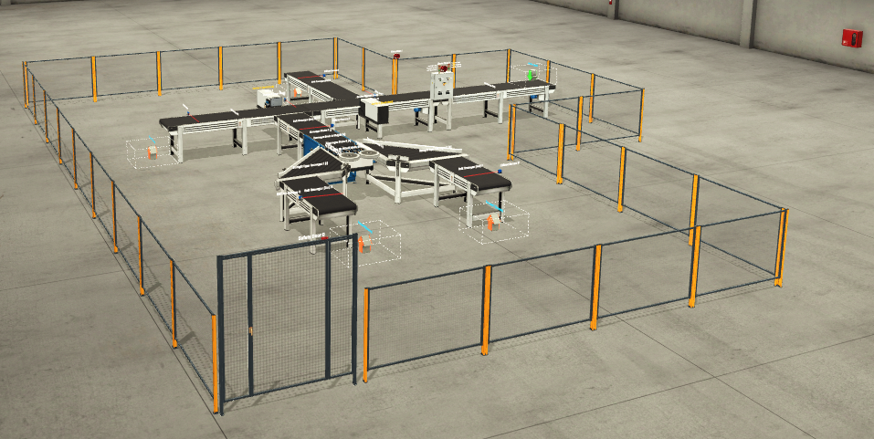
Figure 1 – Box sorting factory

Figure 1 shows the box sorting process that has been created on Factory I/O. To make the process work properly multiple different components have been used. The four different cardboard boxes are emitted on the green arrow onto the first conveyor belt. When the start button is pressed the boxes will move along the conveyors and depending on height will be pushed onto their own conveyor belt. The medium and small boxes get pushed together and then go onto a conveyor scale where they get seperated by weight rather than height. Each box gets collected by the package removers which are the orange arrows. Diffuser sensors have been used through out to trigger the pushers and to keep count of how many boxes are on the conveyor belt process.

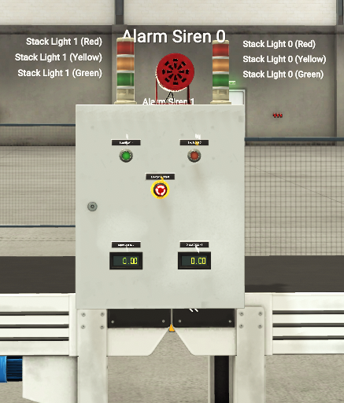
Figure 2 - Starter panel and safety features
Figure 2 shows the panel to start the conveyor belt process and all the safety procedures that are in process when it operates. The green button gets pushed to start the process and the red button is to stop the process when it is finished. Not only this there is an E-stop that can be pressed in case of an emergency which will stop everything completely. Other safety precautions in place is an alarm siren that gets sounded when the process starts up to alert those in the area as well as two stack lights. The stack light will be red when the process isn’t operating, will be red and yellow as it’s about to start and then will turn green to show the conveyors are running. There are also two counters on the panel one to display how many boxes have been sorted in total and the other to display how many boxes are on the conveyors at one time.
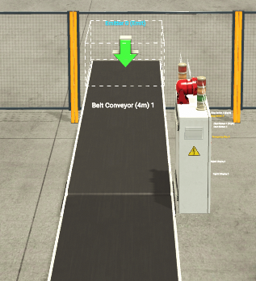
Figure 3 - Box emitter
Figure 3 shows a close up of the box emitter, this is the start of the process where the box starts and proceeds along the conveyor belts. Four different size boxes are emitted at random, these sizes are large, medium, small and palletizing.

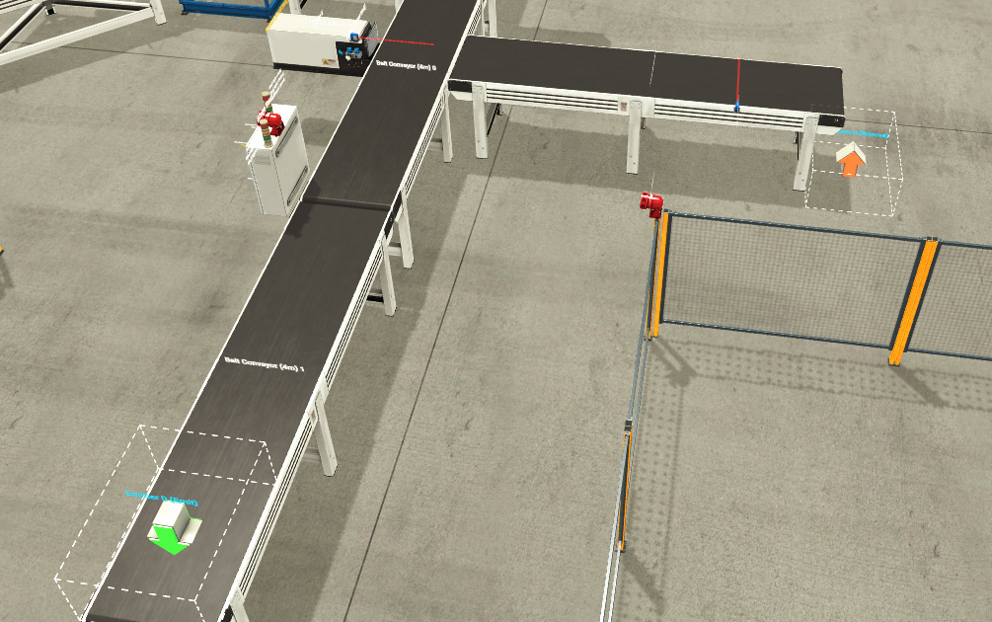
Figure 4 - Pusher 0 (Large boxes)
Figure 4 shows the first stage of the process, all boxes will move along the conveyor and approach the diffuse sensor. Here the diffuse sensor is up high when only the large box will trigger it. If the large box triggers the sensor, then the pusher will activate and push the large box off the main conveyor onto its own separate conveyor to be collected. The medium, small and palletizing box will pass through onto the next stages of the process.

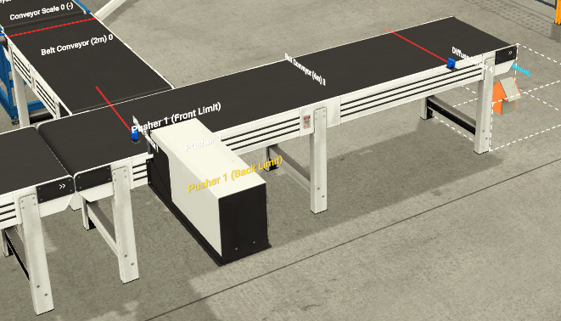
Figure 5 - Pusher 1 (Medium & Small boxes)
Figure 5 shows the second stage of sorting the boxes. The medium, small and palletizing boxes pass the first pusher and approach this pusher. Here the diffuser sensor has been lowered to the point that the medium and the small box will trigger the sensor meaning they will be pushed onto the next stage of the process to be sorted. The palletizing box is small enough to pass under and continues down the conveyor to be collected by the package remover which can be seen at the end.
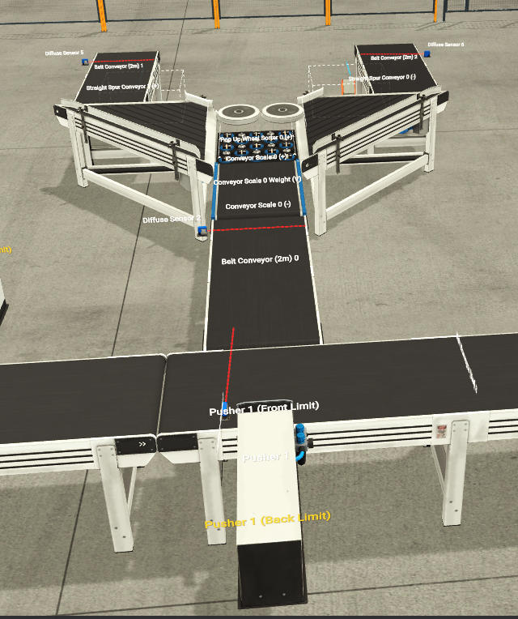
Figure 6 - Conveyor scale wheel sorter (Medium & Small boxes)
Figure 6 shows the final part to sorting all four of the boxes. This final part sorts the medium and small boxes but this time they get sorted by weight rather than size which is how they were previously sorted. When both boxes are pushed onto this conveyor they reach the conveyor scale. They temporarily stop on the conveyor scale which weighs them. If the box is over 9kg which the medium box is then the pop-up wheel sorter operates to the right and the box will continue to the conveyor on the right and gets collected by the package remover at the end of the right conveyor. If the box is under 9kg which the small box is then the pop-up wheel sorter operates to the left and the box will continue to the conveyor on the left and gets collected by the package remover at the end of the left conveyor.

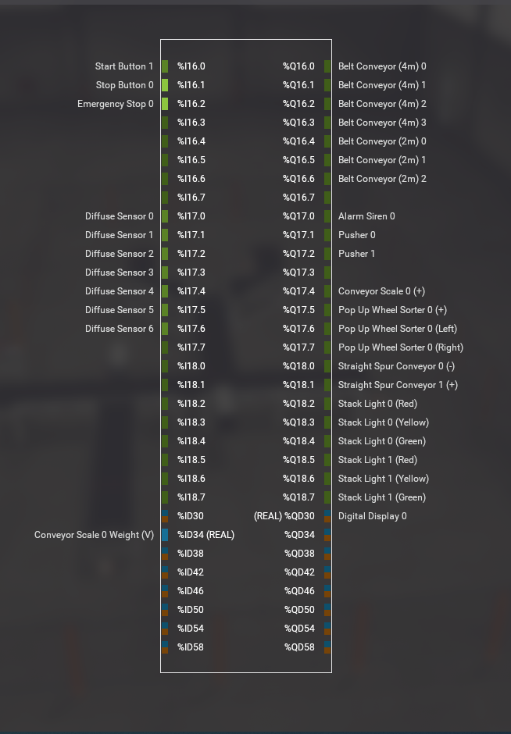
Figure 7 - Factory io PLC
Figure 7 shows what the PLC looks like on Factory I/O which is the brain behind the process working. As you can see all the outputs have been put into their respective place and this allows the operation of all pushers, sensor, etc.

Methodology
For the Factory I/O system to work the PLC must be coded accurately to allow full operation of the box sorting process. To write this code TIA portal was used and the code was written in ladder logic which will all be shown below.
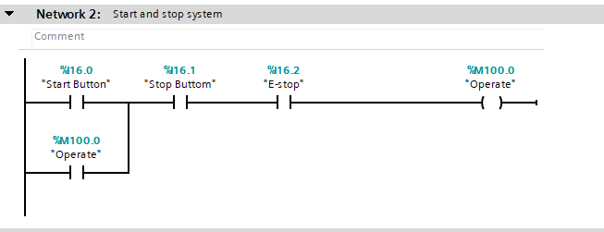
Figure 8 – Ladder Logic network 2
Network 2 to allow the system to start and stop by manual control if either the panel buttons or HMI buttons are pressed. The system will not start if any alarms are alert. When the start button is activated I16.0 sets M100.0 and when the stop button is activated I16.1 re-sets M100.0.

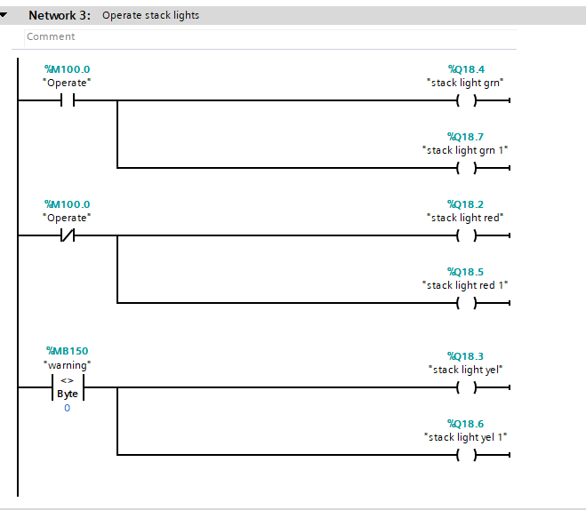
Figure 9 - Ladder Logic network 3
Network 3 is for the operation of the safety stack light, to show the operator whether the process is running or stopped. Q18.4 and Q18.7 is for the green lights to illuminate when M100.0 is open (system operating). Q18.2 and Q18.5 illuminate when M100.0 is closed (system stopped). The yellow lights operate when there is a warning activated.
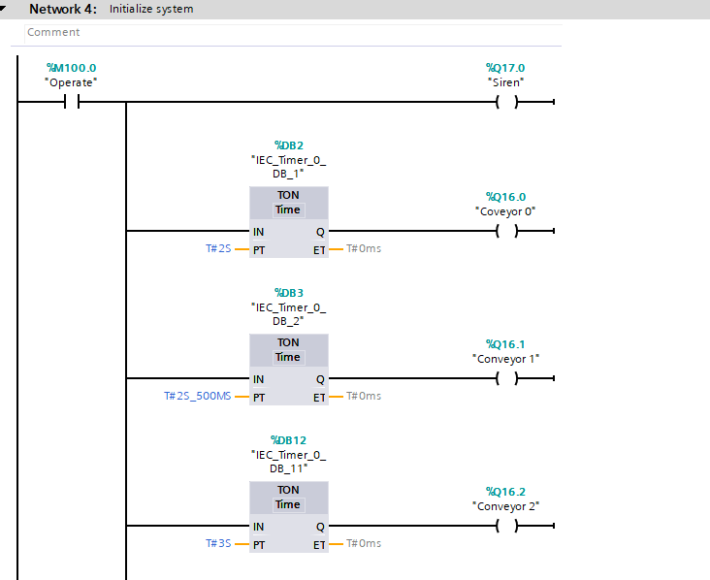
Figure 10 - Ladder Logic network 4

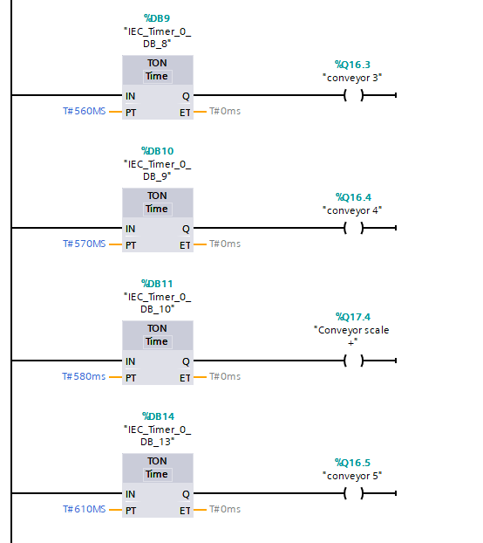
Figure 11 - Ladder Logic network 4 continued
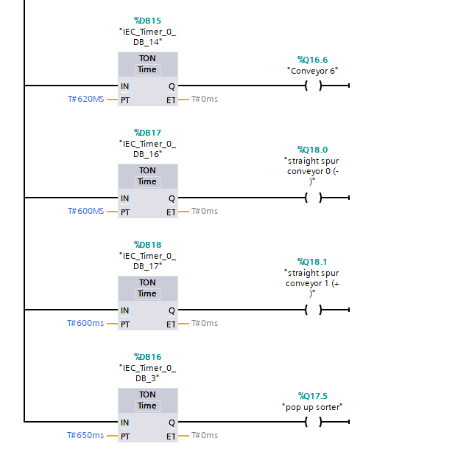
Figure 12 - Ladder Logic network 4 continued
Figure 10,11 and 12 all show network 4. This is a startup sequence for all conveyors, sorters and the siren. A TON timer is added for each one to make sure they all come on one after another to prevent the system from crashing if they all turned on together due to a high inrush of current.
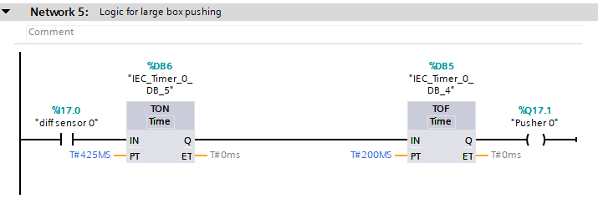
Figure 13 - Ladder Logic network 5
Network 5 will activate pusher 0 when a large box is detected and push the box onto its own conveyor belt. If the diff sensor I17.0 is activated by the large box it will send a signal to the pusher to push the box to its correct path. There will be a delay before the pusher is activated by the TON timer and the TOF timer moves the pusher back in.

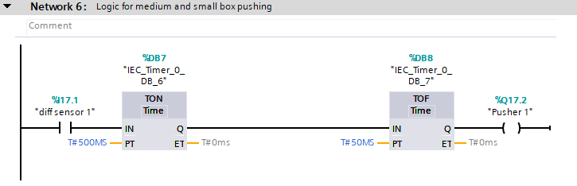
Figure 14 - Ladder Logic network 6
Network 6 will activate pusher 1 when a small or medium box is detected and push the boxes onto its own conveyor belt. If the diff sensor I17.1 is activated by the small or medium box it will send a signal to the pusher to push the box to its correct path. There will be a delay before the pusher is activated by the TON timer and the TOF timer moves the pusher back in.

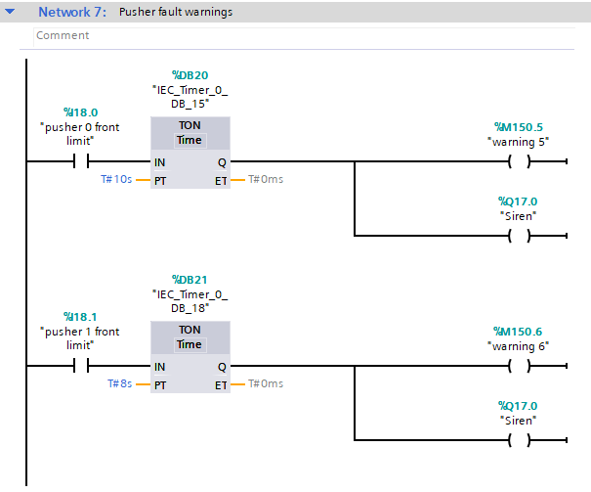
Figure 15 - Ladder Logic network 7
Network 7 will look for any faults in the operations of either of the pushers. If a problem is detected a warning will be sent to the HMI and sirens will be activated to alert the operator. If i18.0 or I18.1 detect anything they will send a warning to the corresponding output and trigger Q17.0 the siren.

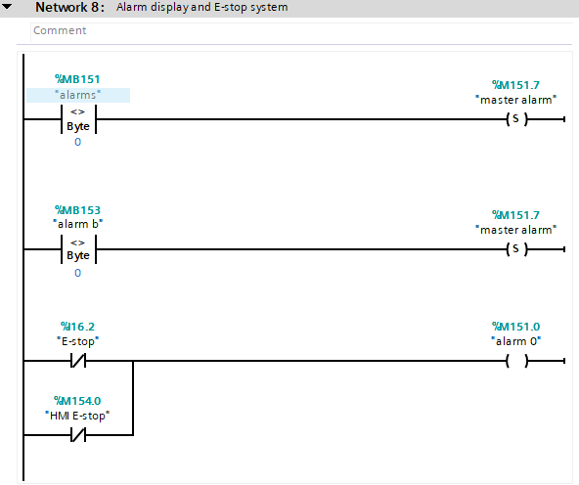
Figure 16 - Ladder Logic network 8
Network 8 activates both the master alarm and the E-stop for the panel and the HMI screen. Both can be triggered manually by the operator or the by the system. MB151 and MB153 will trigger the master alarm and I16.2 and M154.0 will trigger alarm 0.

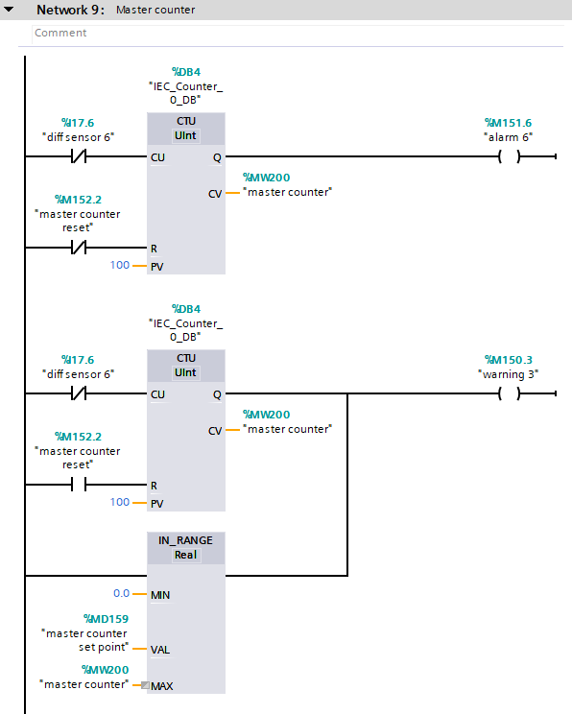
Figure 17 - Ladder Logic network 9
Network 9 sets up the master counter and will count each box that gets sorted and display on the HMI and on the panel. When diff sensor 6 I17.6 is triggered, it will send an input to the system and the system will count the inputs as the master counter MW200. Finally, M152.2 will allow a full reset of the master counter.

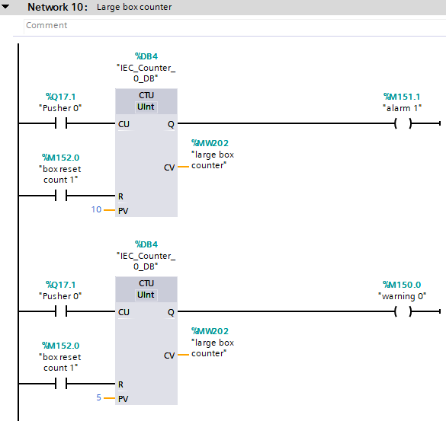
Figure 18 - Ladder Logic network 10
Network 10 is to track and count the number of large boxes. When pusher 0 Q17.0 is activated, it will send a signal to MW202 to count the number of large boxes increasing by each push. The large box counter can be reset by M152.0.

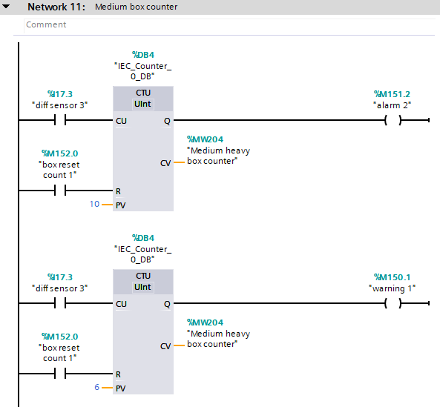
Figure 19 – Ladder Logic network 11
Network 11 is to track and count the number of medium boxes. When diff sensor 3 I17.3 is activated, it will send a signal to MW204 to count the number of medium boxes increasing by each push. The medium box counter can be reset by M152.0.

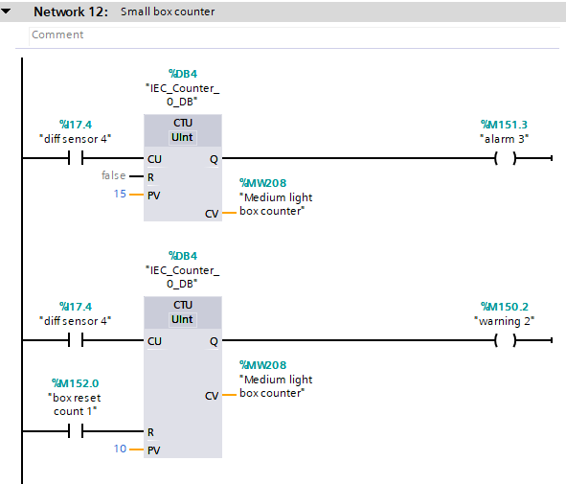
Figure 20 - Ladder Logic network 12
Network 12 is to track and count the number of small boxes. When diff sensor 4 I17.4 is activated, it will send a signal to MW208 to count the number of small boxes increasing by each push. The small box counter can be reset by M152.0.

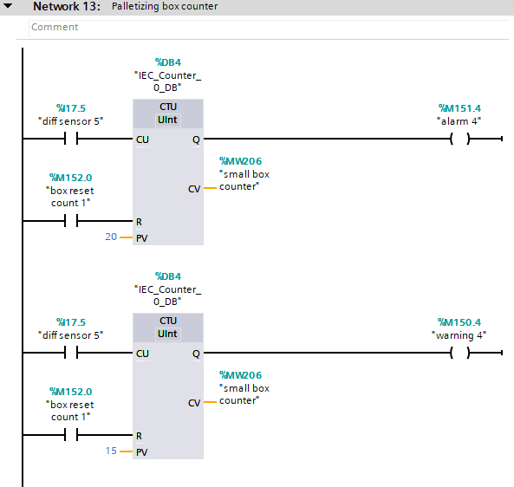
Figure 21 - Ladder Logic network 13
Network 13 is to track and count the number of palletizing boxes. When diff sensor 5 I17.5 is activated, it will send a signal to MW206 to count the number of palletizing boxes increasing by each push. The palletizing box counter can be reset by M152.0.

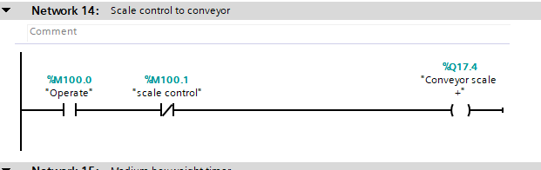
Figure 22 - Ladder Logic network 14
Network 14 controls the conveyor scale to ensure the medium and small boxes are weighed before being sorted by the pop-up wheel. M100.0 operates the scale and then M100.1 weighs the box before moving onto the next section.

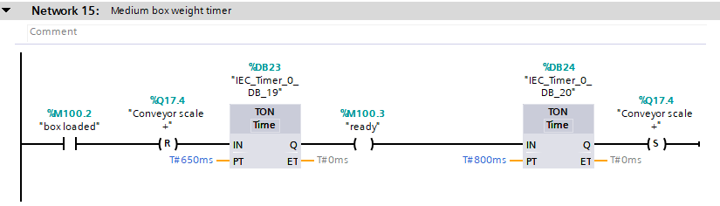
Figure 23 - Ladder Logic network 15
Network 15 ensures that the box has enough time on the conveyor scale to be weighed accurately before moving off the scale. Once M100.2 is triggered the scale will recognise a box is on the scale then the TON timer DB23 will wait 650ms before weighing the box and once the box is weighed DB24 waits 800ms before moving the box to allow the system enough time to understand what’s going on so everything will work correctly.

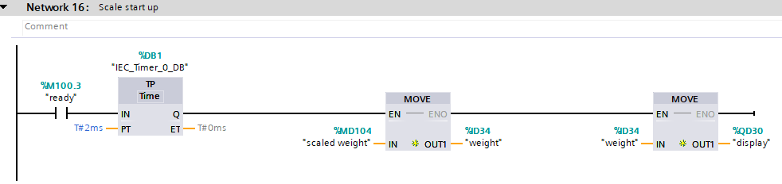
Figure 24 - Ladder Logic network 16
Network 16 ensures the conveyor weight to be transferred properly through to the pop-up wheel sorters further on in the sequence so the weight has been read accurately with no mistake. The weight moves from MD104 to ID34 to QD30 so it can be displayed properly.

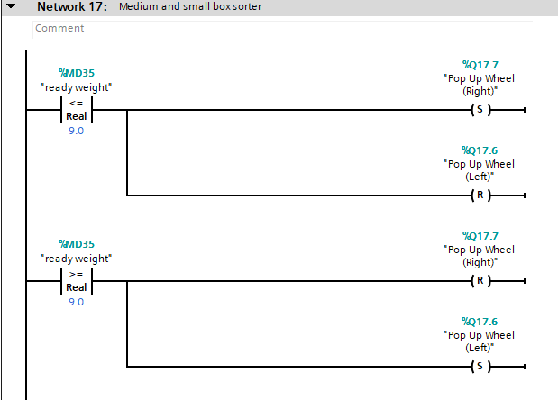
Figure 25 - Ladder Logic network 17
Network 17 is where the weight gets taken and depending on if the value is over or under 9kg which pop up wheel will operate. If MD35 the real weight is under 9.0kg then the pop-up wheel left Q17.6 will operate and if MD35 is over 9.0kg then the pop-up wheel right Q17.7 will operate.
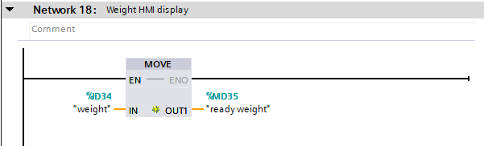
Figure 26 - Ladder Logic network 18
Network 18 is to enable that the weight of the box is displayed on the HMI. This allows the operator to understand what is going on and which direction the box will go on the pop-up wheel sorter.

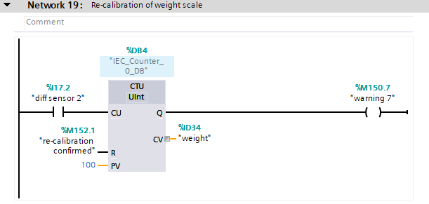
Figure 27 - Ladder Logic network 19
The final network is to trigger a warning to the operator if the scale will need to be recalibrated. To allow accurate readings each time the conveyor scale will need recalibration every so often.

Results
After the workshop process was built on Factory I/O and the PLC code was constructed on TIA portal, it was time to test the process and see if it runs correctly and separates all four cardboard boxes by size and weight like desired.
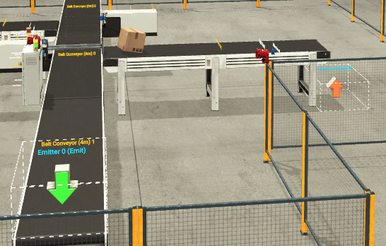
Figure 28 - Pusher 0 activated
Figure 28 shows the large box that has triggered the diffuser sensor and the pusher is in motion pushing the large box onto its own separate conveyor to be collected. As previously mentioned, the large box is the only box that can trigger this pusher due to the height of the diffuser sensor.

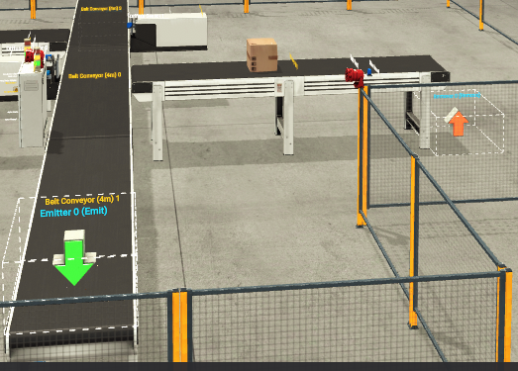
Figure 29 - Large box separated
Here the large box has been pushed out the way completely and is moving along on its own conveyor belt to be collected. There is one more diffuser sensor here that will be triggered, once triggered it will recognise a large box and add that to the counters.

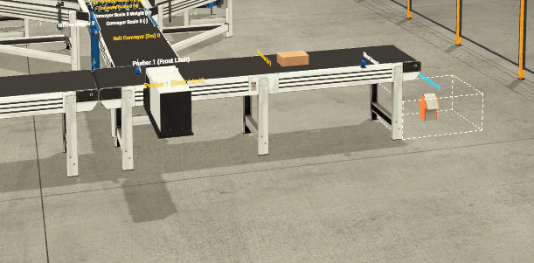
Figure 30 - Palletizing box separated
Figure 30 shows the palletizing box and how it has gone past both diffuser sensors without triggering them and avoid being moved by any of the pushers. As this is the lowest box of them all it goes straight under with no problem to the end and gets collected by the package remover. Just before it goes off the conveyor to be collected it triggers its own diffuser sensor to recognise the box and correct the master counter.
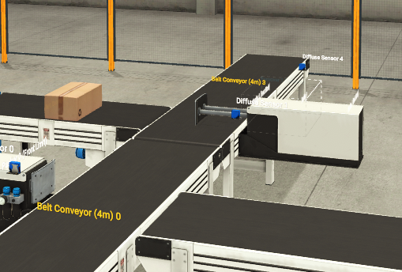
Figure 31 - Pusher 1 activated
Figure 31 is showing pusher 1 activated. This pusher activates for the medium and small boxes moving these to their own section to be separated by weight. Pusher 1 works on the same principle as pusher 0 where the medium and small boxes break the beam of the diffuser sensor which then activates the pusher to move forward.

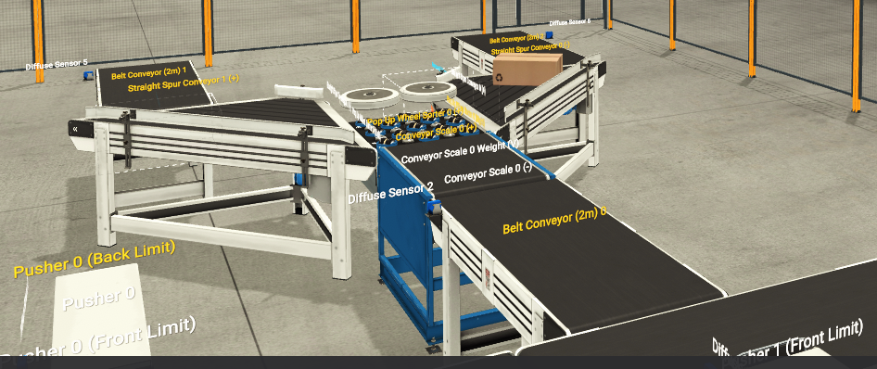
Figure 32 - Medium box separated
Once the medium box has been pushed to this section it gets separated by weight. The box moved along the conveyor scale belt where its weight gets taken. If the box weighs above 9kg it gets moved to the right and if the box weighs less than 9kg it gets moved to the left. As the medium box weighs 10kg the pop-up wheel sorter will activate to the right and as shown the box goes to the conveyor on the right-hand side to be collected. Once the medium box moves along the conveyor on the right to be collected it triggers its own diffuser sensor which will tally onto the master counter.

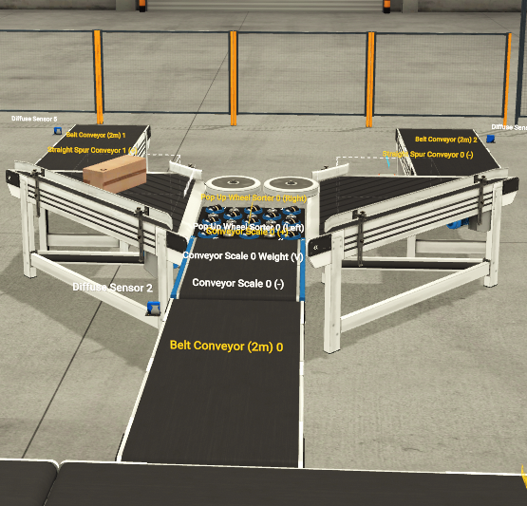
Figure 33 - Small box separated
Figure 33 shows the same as figure 32 but this time it is a small that has been separated by weight. The box moves along the conveyor scale to be weighed and once the weight is recognised under 9kg the pop-up wheel sorter activates to the left. The small box weighs 8kg which is why 9kg was the chosen weight to be the decider as it is even between 10 and 8kg. Once the small box moves along the conveyor on the left to be collected it triggers its own diffuser sensor which will tally onto the master counter. This here is the end of the process with the large and the palletizing box being separated by size and both medium and small boxes being separated by weight.

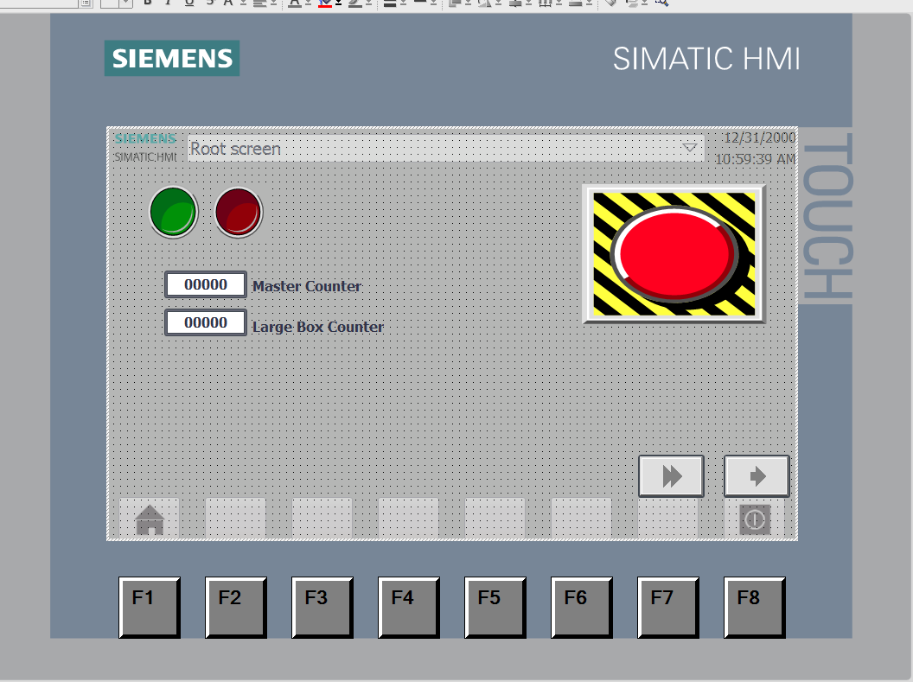
Figure 34 - HMI Root screen
Figure 34 shows one of the three HMI screens on TIA portal. This is the HMI root screen which is an interactive view of the panel in the workshop on Factory I/O. This screen has the stop and start push buttons, the E-stop and the master counter as well as a large box counter.

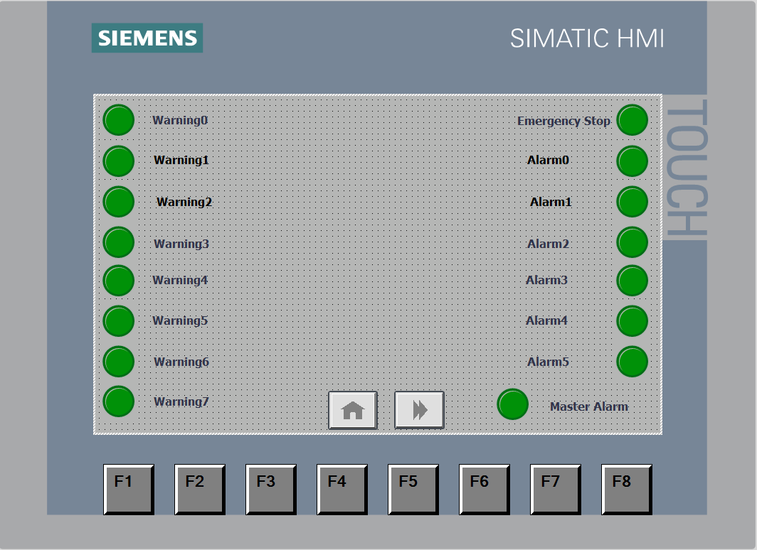
Figure 35 - HMI Error screen
Figure 35 is the second HMI screen which is the error screen. If anything was to go wrong on the process on Factory I/O then this will show what alarm or warning is activated to easily identify the problem. There are multiple LEDs that will light up if that warning or alarm was to be triggered.

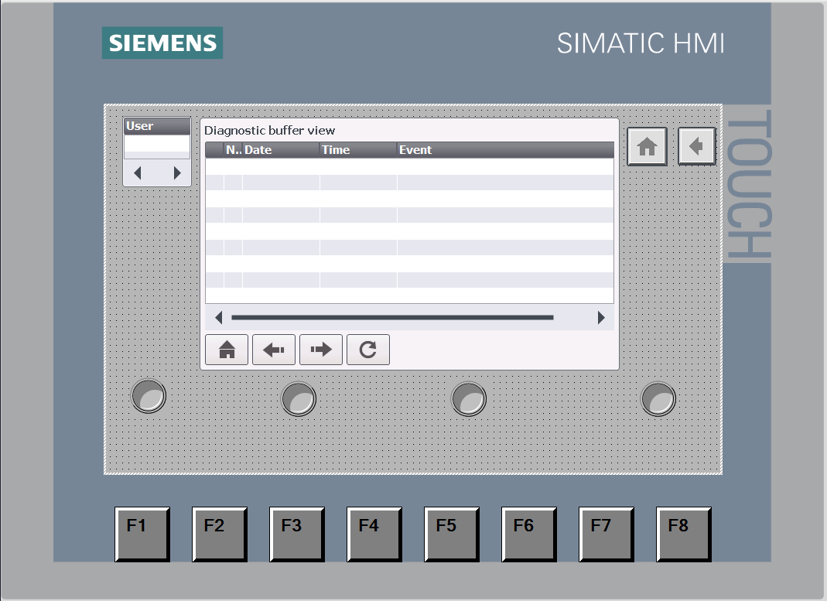
Figure 36 - HMI Engineer screen
Figure 36 shows the final HMI screen which is the engineer screen. This screen is here for the engineer to sign into to allow access to viewing the full process and take control of the HMI and view the root or error screen.

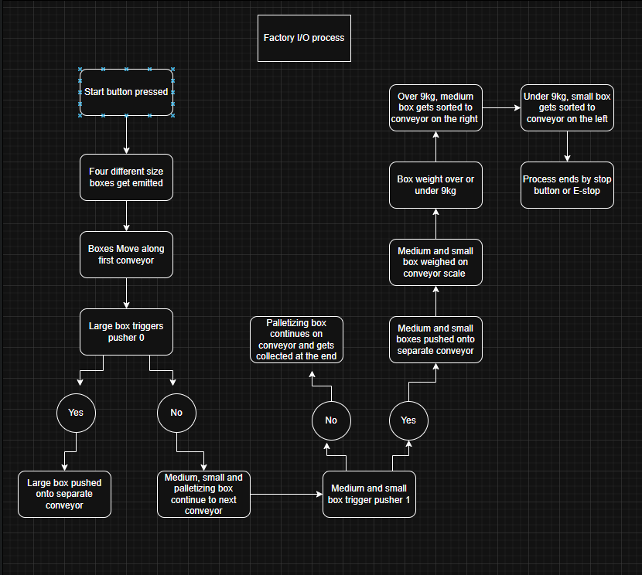
Figure 37 - Operational Flow chart
Figure 37 shows a flow chart of operation and how the process should separate the four different boxes by size and weight. This flow chart matches the operation of the Factory I/O process which shows that the factory and PLC coding was a success as it operates as planned.

Conclusion
This assignment demonstrated the design, implementation, and testing of an automated factory control system using programmable logic controllers. Using Factory I/O and Siemens TIA Portal, we developed a fully functional box sorting process that accurately classifies four different box types based on physical size and weight. The project combined industrial automation principles with practical PLC programming techniques, reflecting systems commonly found in real-world manufacturing environments.
We chose a Siemens PLC programmed with ladder logic because of its reliability and compatibility with Factory I/O. The ladder logic program was organized into specific networks, which made it modular, easy to read, and straightforward to troubleshoot. Each network handled a particular function, including system start/stop control, safety management, conveyor sequencing, box detection, sorting logic, and data management. Using timers was crucial for controlling startup sequences and ensuring stable operation. This helped avoid high inrush currents and mechanical issues, showing an understanding of real-world electrical and mechanical limitations.
The sorting process was robust and accurate. We successfully separated large boxes by height using diffuser sensors and pushers, while medium and small boxes were sorted by weight using a conveyor scale and a pop-up wheel sorter. Palletizing boxes skipped the height-based sorting stages and were correctly identified and counted at the end of the process. The results showed that all four box types were consistently sorted to their correct locations, confirming both the physical design and the PLC control logic.
Safety and operator interaction were also important parts of the system. We implemented emergency stop functionality, warning sirens, stack lights, and fault detection to ensure safe operation. We also integrated an HMI, which provided clear visualization of system status, alarms, counters, and operational controls. Having multiple HMI screens for regular use, fault monitoring, and engineering access improved usability and followed good human-machine interface design practices.
Overall, the project met all objectives and showed a strong grasp of PLC-based automation, control logic design, safety systems, and HMI integration. The completed system is scalable and could be expanded by adding advanced diagnostics, network communication, or adaptive control strategies, giving it a solid foundation for more complex industrial automation applications.

References
[1]
Factory I/O, “Factory I/O - Documentation,” docs.factoryio.com. https://docs.factoryio.com/

[2]
peter, “Ladder Logic Tutorial for Beginners - PLC Academy,” PLC Academy, Sep. 04, 2017. https://www.plcacademy.com/ladder-logic-tutorial/

[3]
Schneider Electric, “Ladder logic programming and its importance,” Schneider Electric Blog, Aug. 05, 2022. https://blog.se.com/industry/machine-and-process-management/2022/08/05/ladder-logic-programming-a-detailed-insight/

[4]
D. Mourtzis, J. Angelopoulos, and N. Panopoulos, “The Future of the Human–Machine Interface (HMI) in Society 5.0,” Future Internet, vol. 15, no. 5, p. 162, Apr. 2023, doi: https://doi.org/10.3390/fi15050162.

[5]
asta lee, “The Modern Advantages of Siemens PLC: Revolutionizing Automation with Innovation and Efficiency,” Il vostro negozio unico per barriere di sicurezza, forniture elettriche e strumenti per l’automazione, Mar. 18, 2025. https://isscasolutions.com/it/the-modern-advantages-of-siemens-plc-revolutionizing-automation-with-innovation-and-efficiency/

[6]
A. Ismail, “Siemens PLC System Overview,” Instrumentation and Control Engineering, Nov. 17, 2021. https://automationforum.co/siemens-plc-system-overview/

[7]
PLC Department, “An Introduction to Allen-Bradley PLCs,” PLC Department, Aug. 24, 2023. https://www.plcdepartment.com/blogs/plcblog/an-introduction-to-allen-bradley-plcs?srsltid=AfmBOopO_3scFO_5fZ0G6C7GdT1Fw0uEGJ-Ezrhpxt1LQ_UjFEmuwzNS
[8]
WatElectronics, “Allen Bradley PLC : Architecture, Circuit,Working, Types & Its Uses,” WatElectronics.com, Feb. 13, 2023. https://www.watelectronics.com/allen-bradley-plc/

[9]
A. Beam, “Comparison and Analysis of Mitsubishi PLC and Siemens PLC,” Asbeam.com, 2025. https://www.asbeam.com/news/siemens_plc-cn.html

[10]
Chenjianxiang, “How do Mitsubishi and Siemens PLCs compare in terms of hardware scalability?,” KOEED, 2026. https://koeed.com/blogs/%E6%96%B0%E9%97%BB/how-do-mitsubishi-and-siemens-plcs-compare-in-terms-of-hardware-scalability?srsltid=AfmBOopWBy7AV7HZ_7Q_omiumBoUXOyWuCxspb1ROYC0NunPU7t8o7YK

[11]
Industrial Electrical Warehouse, “Omron PLC vs Top Brands: Which is the Best Choice?,” Industrial Electrical Warehouse, May 27, 2025. https://industrialelectricalwarehouse.com/blogs/news/omron-plc-vs-top-brands?srsltid=AfmBOoqPfyFdpXQwckYCFLQHXJ8FXCpK-RBHmnEzcE5WTRlF_pphIPTE

[12]
DO Supply, “Comprehensive Comparison and Analysis: Omron C200H Series vs. Omron C500,” DO Supply, Jan. 15, 2024. https://www.dosupply.com/tech/2024/01/14/comprehensive-comparison-and-analysis-omron-c200h-series-vs-omron-c500/?srsltid=AfmBOorgi_Tio6BO-FJ-vrxdFTXzpD1787y5F6qMHCSR-XtvQ68XYJS4

[13]
ABB, “PLC Automation | ABB,” ABB Group, 2026. https://www.abb.com/global/en/areas/motion/plc

[14]
M. F. Smith, “5 Things You Should Know About ABB PLCs: Revolutionizing Automation- ampsqr blogs,” ampsqr blogs, Dec. 27, 2024. https://www.ampsqr.com/blogs/5-things-you-should-know-about-abb-plcs/

