Use of Welsh in the classroom
Below are two examples of times where welsh has been used in the classroom. This feedback has been written by my mentor during Placement 1.

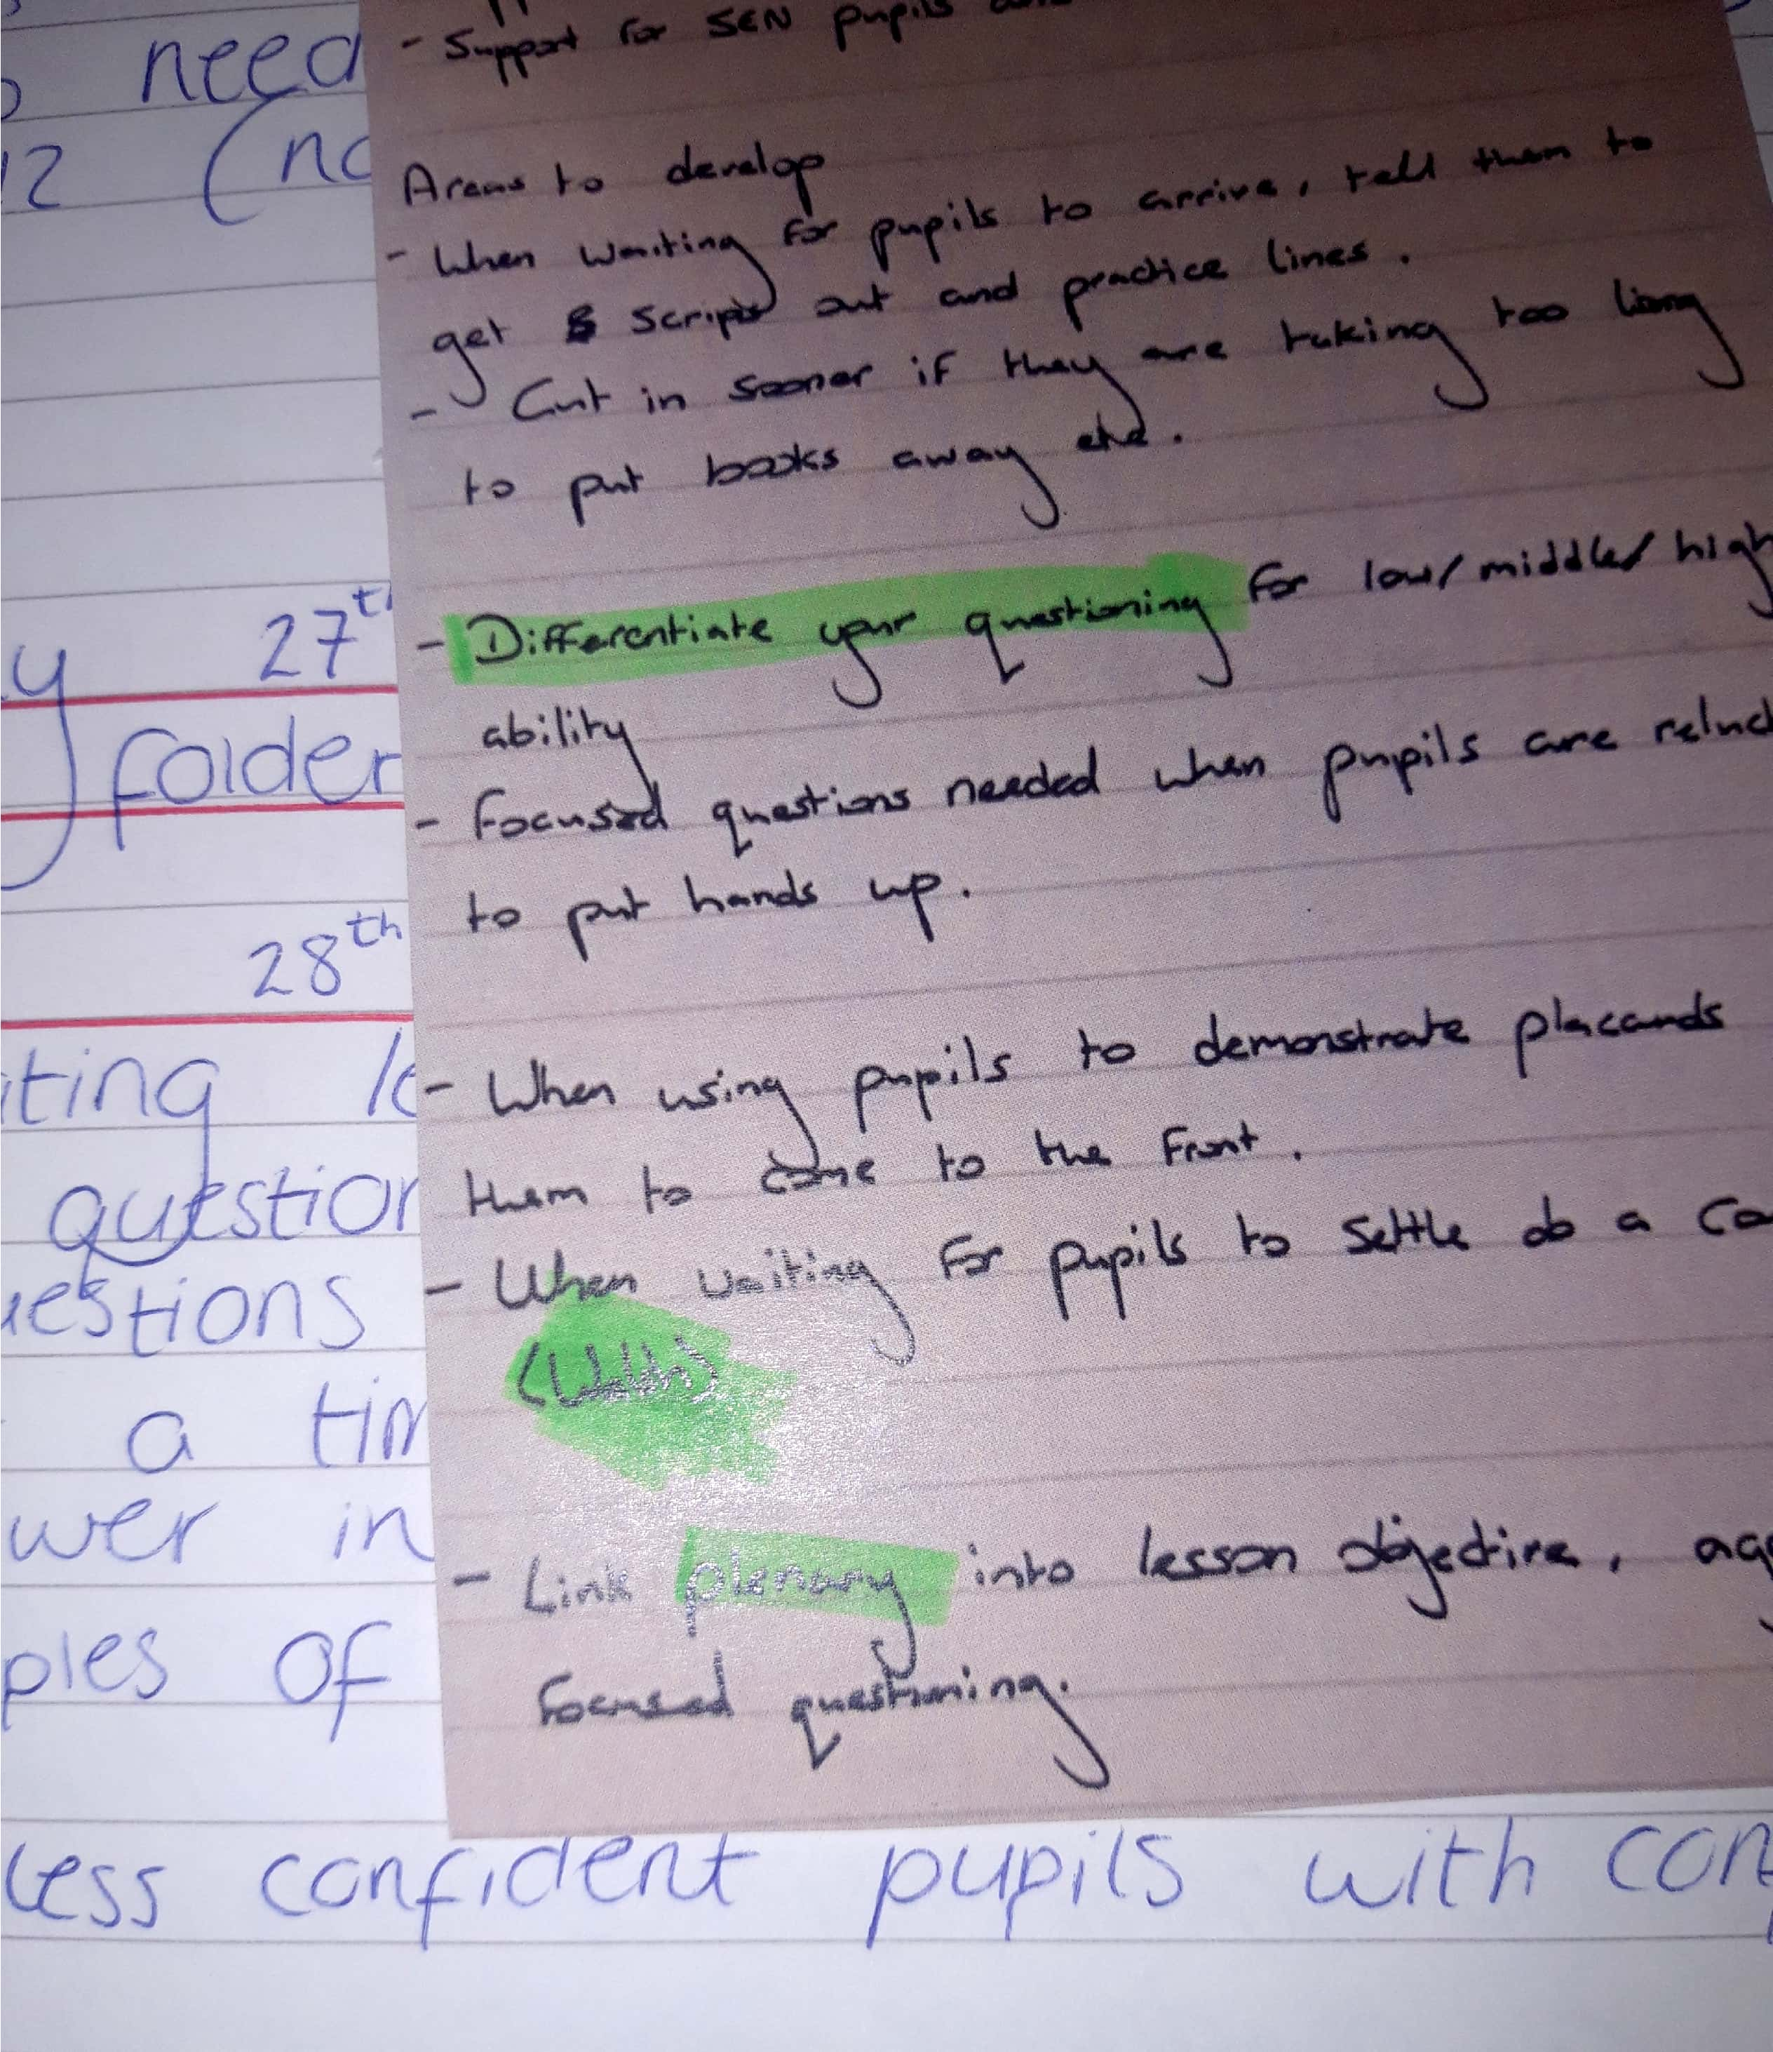
Example 1 reads: “Excellent use of bilingualism by asking pupils to play numbers game in welsh, we might have to share this one with the welsh department”
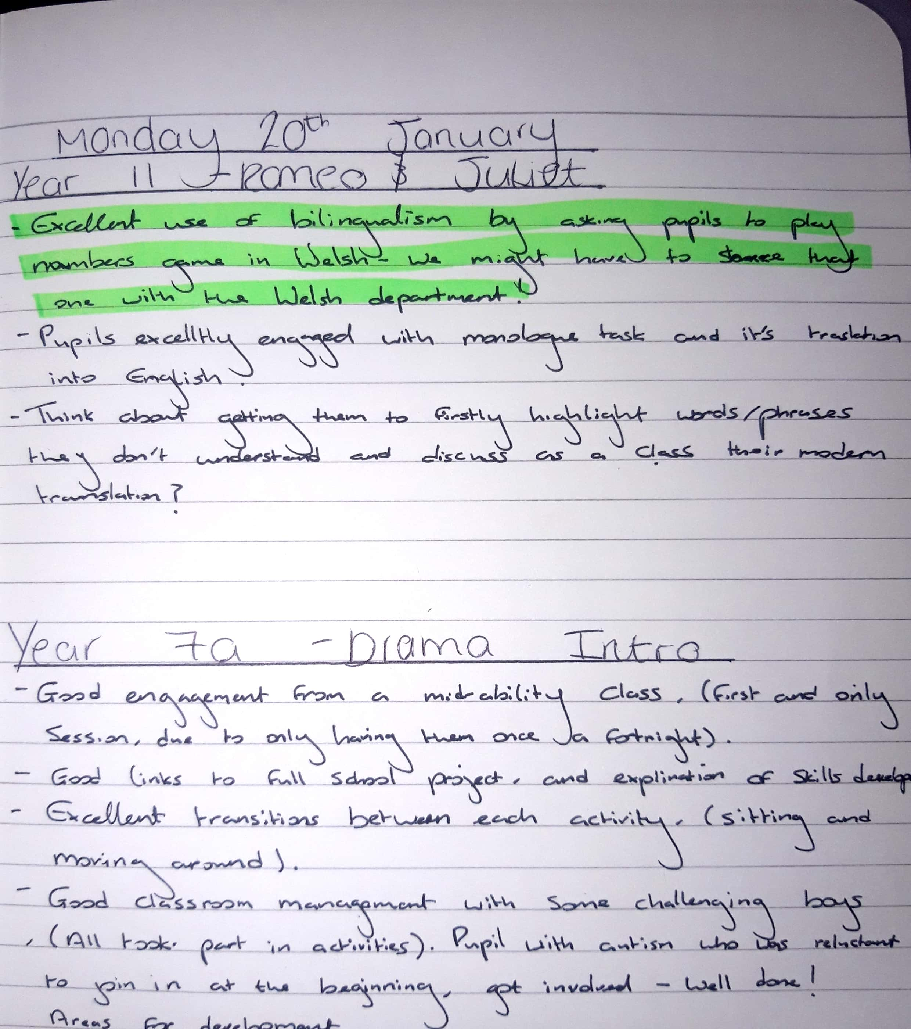
Example 2 reads: “When waiting for pupils to enter, did a count down in welsh”

