Bethan Phillips
2008452 |
A Guidance Handbook for Early Years Keyworkers During Childhood Transitions.
Human Development – EAEE4003/C

Contents.
- What is transitions? …………………………… 3
- The Role of the adult! ……………………… 6
- The needs of the child! ………………………….. 7
- Partnerships. ………………………………… 10
- Interventions. 12
- Proposed Outcomes. 13
- Concusion 14
- Reference list 15

A Guidance handbook for early years keyworkers during childhood transitions.

What is transition?
Transition is a change that may affect the daily routine of a persons life. As we all know children will experience many transitions or changes especially during their early years. It is the journey which a child goes through during their lives.

the process of changing, or a change from one form or condition to another ( Cambridge Dictionary 2020)

The biggest of these is when a child starts a pre-school or nursery setting. When transitioning it can be as simple as moving from one room to another, or a bigger change would be starting school. Many children will take these transitions in their stride while others require more help to feel secure and settled. It is important that early years practitioners are aware that these transitions are a momentous experience and that both the child and member of the close family feel valued and welcomed when going through this.
Getting transition right is vital for every child and is not a single event that merely ‘happens’. Transition should be viewed as a process rather than an event that involves children, practitioners and parents together. Transition has been described as an ongoing journey rather than a destination. (Early Years Matters,2020)

There are many aspects that can affect the transitional period for instance social structures, community and family. As pointed out by brofenbrenner in his ecological system theory.
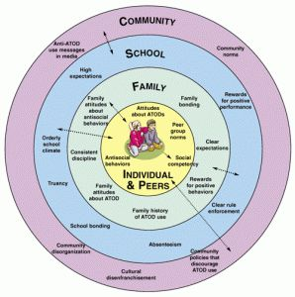(Source: Pinterest, 2020)

The child may struggle with behaviours if, for example the childs parents have divorced, which will then cause the child to feel insecure, this can be explained in brofenbrenners theory also, which would be under the chronosystem part of the theory ( see image above.)
An effective way to help with transitions is to plan activities to give the child and families an opportunity to find out more information and routines of the setting, and for everyone involved to familiarise themselves with who and what is most important to the child to feel happy and secure. It is also good practise to provide policies to the parent/carer ensuring that they are approachable if they have any questions or concerns.
It can also be helpful to arrange a few visits to the setting (open days), so that the child can familiarize themselves with the layout of the setting/classroom and they can see where certain things are, for instance where they put their bags and coats. The keyworker can also provide a small booklet or leaflet with photographs of staff and some information about them, so that the children can take home to look at. Likewise ask the families to do something similar in regards to the child, expressing likes and dislikes and any worries the child might have.
Another idea would be to include ideas from previous children and families on what helped them with the transitions. Especially if the children are anxious, it can sometimes help if they have seen how others have coped in the situation.
Throughout the whole transition period the child is at the forefront of everything and keyworkers should consider their voice to meet the child’s individual needs.

The role of the adult!
The role of the adult is to build relationships with the child, but also to build relationships with others such as family, health visitors, and other key worker, these can include social workers and speech and language.
A key person is a named member of staff with responsibilities for a small group of children who helps those children in the group feel safe and cared for. (Early Years Matters 2020.)
According to Rose (2012) effective communication forms a fundamental part of the early years practitioners role and arguably drives the entire process. The needs of every child will be different, they will need to be identified and met in order to encourage independence and confidence, to help them settle into their new routine and surroundings.
The practitioner also has a responsibility when it comes to the child moving onto the next stage of education. Practitioners may be asked to go with a child when transitioning to help the child with their new setting, so they feel happier as some children will have other issues such as adhd, autism, speech and language, and others. Having a familiar adult with them on visits will help the child feel comfortable and more likely engage in the activities that are given. The emotional wellbeing of the child needs to be taken into consideration during transitions also, as there could be underlying factors, so in order to prevent as little disruption as possible it may be useful to produce a small handbook/guide for the child on what to expect within their next setting/class. Bowlby identified the fact that children need to feel secure and to develop socially in his theory of attachment. It explains how a child can become attached to their mother.
“Bowlby believed that patterns of making relationships are formed in the very early stages of a childs life, through their very first relationship with their main attachment figure.” (Mickelburgh,2011)
Welsh government states the professional standards is to raise standards of teaching and improve learner outcomes throughout wales. (Welsh Government 2017). This handbook outlines the values that all practitioners must demonstrate.

The Needs Of the Child.
Children Should be included and cared for in a secure, loving and positive environment. All children should feel equal and be given the same opportunities regardless of ethnicity, culture, religion, home language, family background, special educational needs disability, gender or ability. Children will come to rely on their keyworker and therefore develop an attachment with the said key worker, and this attachment will help supporting transitions. When a child moves from reception to year 1 it will be a bigger transition again to what they’ve had before. This is hen they will move from Early years foundation stage (EYFS) to key stage 1. This can be daunting for any child, but the keyworker will be there to guide and support. The child may feel comfortable by seeing how previous children have taken to the change, this ca be done by showing photographs and work of previous year 1 pupils – providing the correct permissions have been given.
The welsh government have set up the curriculum so that all schools can develop their own curriculum that enable learners to develop towards the four purposes of the curriculum – which is the starting point and aspiration for every child and young person in wales. (Welsh Government,2020.)
The four purposes are designed using integral skills, these are:
- Creativity and Innovation.
- Critical Thinking and Problem Solving.
- Personal effectiveness.
- Planning and organsising skills.
These four purposes aswell as the mandatory cross-curricular skills of literacy, numeracy and digital competence, will allow every child to grow at their pace without feeling insecure.
(Source: Twinkl Website, 2020.)

All learners will grow in confidence knowing that they will not be compared to others, everyone will feel equal to one another.
Other ways in which a child will learn these skills is through play, as children will get to be creative as possible, and explore topics while using their imagination. Learning through play will help children with their self-esteem, but also it will improve emotional flexibility, increases empathy, compassion and sharing. It is through playing that children will become aware of others. All this in turn will provide a structure for transitions as children will have more empathy towards their keyworker and peers.
Maria Montessori believed that education is viewed as a process which should occur in harmony with the child’s individual developmental pace. It is a holistic approach emphasizing all aspects of developmental, rather than on attaining specific pieces of information. (Learning Theories,2020.)
Piaget believed that children construct their own knowledge through people, places and the things of the world. Children need the opportunity to be able to do things for themselves – A child may be interested on how things grow, if a child is allowed to actually plant a garden at school, the process of digging, watering, observing and actually experiencing growing things will help them to construct a knowledge of growing things that they cannot ever achieve merely by being read to and looking at pictures. (Mooney,2013).
Practitioners are always encouraged to consider and support the child’s individual needs. Likewise maslow’s hirearchy of needs theory shows the needs of the child and what is needed for the next stage.

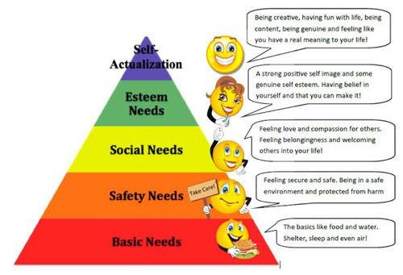( Source: Pinterest,2020.)
As shown in the image above maslow’s hirearchy of needs has 5 sections, these are the basic needs or physiological needs, the safety needs, the social needs or love and belonging, the esteem needs, and self actualizastion.

Partnerships.
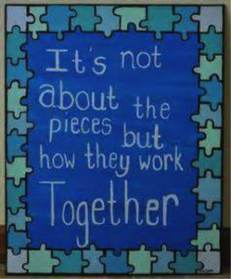 {source: Puzzle pieces,2020]

Partnerships are to be encouraged throughout from relationships with the child, parents/carers, other family members, aswell as multi-agencies such as health visitors, social services, speech and language therapists (SALT) and other health care professionals if needed. As a keyworker it is your role to ensure that parents are actively involved In the transition process from day one, and that they continue to be involved with discussions on how the child is settling into the new class or setting and how they are coping with new routines. It is not always possible to provide daily communication, however, the parent/carer should feel valued enough that they are able to approach the key worker at anytime they feel necessary, especially with any queries or concerns they may have. It is also handy to be able to share ideas and information with parents, in order to build the trust and communication further.
When working with any multiagency it is essential to have parental permission, as the parent still needs to be involved with discussions regarding their child. With this multiagency approach it is important that all involved are proactive in order to provide the best possible support for the child. If there are any areas where the child has a delay in development then there are assessments such as wellcomm, that can be taken to identify what areas require attention. This will then enable the keyworker to inform parents/carers of their findings and to discuss which multiagency will be involved in the next steps to help their child. There should always be a strong link between the child and the keyworker, so that the child feels happy and secure. This in turn will ensure the child settles in quickly into their new routine and to feel as confident as they can.

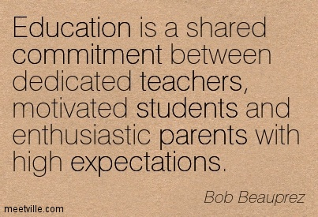[source: quotemaster.org,2020]

Interventions.
The action of becoming intentionally involved in a difficult situation, in order to improve it or prevent it from getting worse. (Cambridge Dictionary,2020).
The interventions for transitioning can be different types of activities that will help the child. For example for a child transitioning from reception to year 1, a child could have a little handbook off the teacher or keyworker that explains all about them and to go through this on the child’s visit to the class. Also as homework the keyworker could ask the child to do a small poster of things that they like and dislike to make the transitions smoother. All staff must work together to ensure the best possible chances in the short and long term. Commitment is required from all concerned.
The Reggio Emilia approach to early childhood education views young children as individuals who are curious about their world and have the powerful potential to learn from all that surrounds them. (Stoudt,2020)
This approach has been used in Italy since the end of the second world war, and has been adapted by many countries and settings over the years. Many people still visit to gather ideas for their own teaching.

Proposed Outcomes.
Every child is unique and develop at different rates, they have different skills, characteristics, abilities, backgrounds and experiences. Where one child will excel at language and numeracy another may favour the creative aspects of learning. Either way each child will transition in different ways, but the most important thing for a practitioner to remember is that all children want to feel safe and happy.
The proposed outcome is to provide both the child and parent/carer the emotional support needed throughout the transitions in order that there is continuity in their care, and their development and learning. It can be emotional for all involved, so ensure all involved are happy. Also the practitioner or keyworker will need to ensure that all involved have a positive experience.
The main outcome will always focus on the child and how and what they have learned. It is important that child feels like they have a voice so they can inform the key worker immediately if they feel unhappy during transitions.
By observing the child, then the outcomes can be adapted to suit the child’s personal needs.

Conclusion,
In conclusion to this handbook, transitioning from reception to year one can be stressful and emotional for the child, but as outlined as long as the keyworker provides a safe, secure, and happy environment in which the child feels they have a voice in decisions, then the transitioning period should be a smooth process. Likewise the inclusion of parents/carers and all other organisiations involved in the process, the key is communication and trust. Observation allows the practitioner to observe the child and discuss any concerns with the parent/carer.

