Student: Geraint O’Donovan
Student number: 1910632

Dissertation – Research Methodology and Planning

Title: A study looking at the effect of technological advances upon crime statistics and a decreasing number of burglaries, theft from and of a motor vehicle and theft from a shop offence in England and Wales from 1980 to current time period?

Introduction
This chapter of the dissertation will look to identify what research methods have been used whilst exploring the topic of the effect of technological advances upon crime statistics and a decreasing number of burglaries, theft from and of a motor vehicle and theft from a shop offence’ in England and Wales to current time period. Furthermore, the type of methodology used for further research will be highlighted and a review will be provided as to how the analysis of the dissertation will be portrayed. The benefits and limitations of using this style of research will also be identified.

Research types
This study looking at the effect of technological advances upon crime statistics and a decreasing number of burglaries, theft from and of a motor vehicle, theft from a shop offence’ in England and Wales from 1980 to current period, has used several different research methods. Quantitative research is defined as being the use of statistics to help identify trends within the research topic and to easily display information. (DeFranzo, n.d.) Qualitive research is defined as being exploratory research to try gain an understanding people’s opinions to allow for the user to develop ideas for their research. (DeFranzo, n.d.) Inductive research is defined as being the gathering of data to search for patterns within that data to allow for conclusions to be made. (Bhandari, 2022) Exploratory research is used when there is little knowledge around the topic and used to help the understanding of that topic. (George, 2021) To complete this dissertation, quantitative research will initially be used to gather the statistics of existing crime data, inductive and explorative research will then be used to try identify patterns in the crime data, and exploring different theories to see if technology improvements have decreased theft crime.

Research Strategy
This dissertation initially relied solely on secondary existing data that has been produced by The Office for National Statistics (ONS) through the Crime Survey of England and Wales (CSEW) and The Home Office police recorded crime. However, one important factor needed to be taken into consideration is how the existing crime data has been collected and reported. To ensure that this dissertation is ethical and accurate, it is therefore essential that the data has been reported and gathered in the same way. Golebiewski and Boyd (2019, pp. 1-51) imply that data can be manipulated, resulting in the person using the information can be easily misled. The ONS states that the benefits of police recorded crime is that it covers a wider range of the population and a wider range of crimes including lower volume crime. Moreover, the ONS states police recorded crime provides a good indication into the demands placed upon police, and for well reported crimes it can provide a good insight into that trend in crime. (Office for National Statistics, 2021) However, a negative is that it only covers crimes reported to the police and then recorded afterwards, furthermore across the United Kingdom police forces record crimes in different ways. (Office for National Statistics, 2021) Furthermore, as a result of the differing ways of how the police record crimes and its reliance upon a victim wanting to report an incident, the ONS do not class police recorded crime as a national statistic. (Office for National Statistics, 2021) The CSEW provide an estimate of crime statistics for England and Wales based upon a sample size of 34,500 interviews, with samples taken from each people in each police force area. (Crime Survey for England and Wales, 2019) However, as a result of the COVID 19 pandemic this survey as of 2020 has now changed to become telephone operated, highlighting another change in the process of collecting data. The ONS (Office for National Statistics, 2021)
Data comparison between both the CSEW and the Home Office police recorded crime is vastly different. CSEW data only available since 1980 and is consistently higher than police recorded crime which is available since 1898 and police recorded crime also provide a full breakdown of crime types. The historical comparison between CSEW and Home Office statistics is clearly displayed in Figure 1, interesting, since 2015 statistics show that the statistics are becoming more similar.
Figure 1: Comparison between CSEW and Home Office police recorded crime
This dissertation will only focus on the Home Office police recorded crime to make the analysis of the data as accurate as possible. As police recorded crime provides an indication to the demands on police, this will provide an interesting comparison to see how technological advancements have impacted theft offences and potentially demand placed on the police.
Inductive quantitative research was initially completed using both The Home Office and CSEW data sets to help identify the trend of theft offences since 1980 to the current time period. Moreover, attention was specifically paid to burglaries, theft from and of a motor vehicle, and theft from a shop as these offences were identified as being the most likely offences to have been affected by a technological improvement. The police recorded crime data show that total recorded crime has increased from a level of 82,426 total crimes in 1898 to a peak of 6,013,759 total crimes in 2004, before decreasing to 5,437,337 total crimes in 2020. Theft offences currently make up around 25% of total crimes in 2020 as displayed in figure 3.

Figure 2: Home Office police recorded theft offences
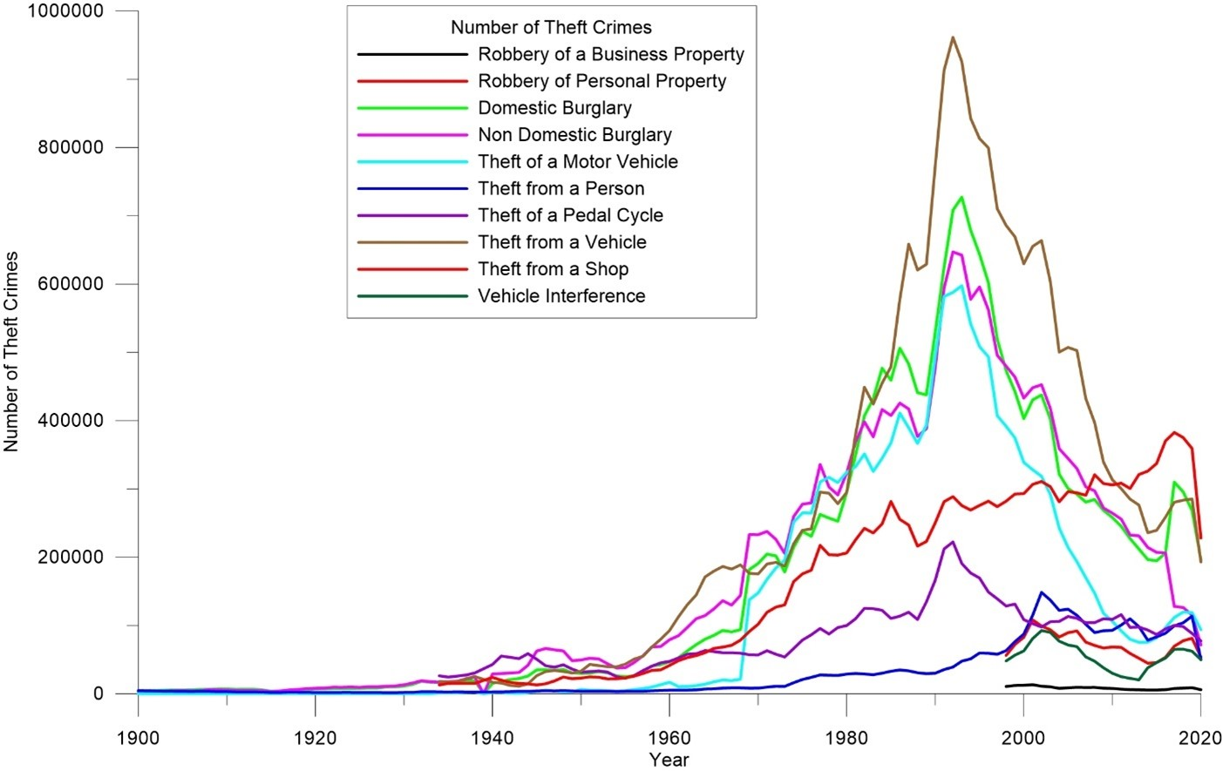
Figure 2 displays a historical linear graph of all recordable theft offences. Robbery of a business property, robbery of personal property and vehicle interference have been disregarded from this dissertation as they have only been recorded as separate offences since 1998. Furthermore, theft from a person and bicycle theft are also being disregarded because these are some of the lowest recorded theft offences and because it is expected that these offences will be the least likely offences to be affected by an improvement in technology.
The initial quantitative research of the Home Office data sets was then further backed up by inductive and exploratory research into sources and publications to try understand why the statistics show a decreasing trend, and if these trends could be corroborated to a technological improvement.

Data collection and analysis
Police crime recorded data has already been downloaded from the Home Office website and plotted in a graphical format against the time period. This data only displays burglaries, theft from and of a motor vehicle and theft from a shop. The benefits of having this data in a linear graph is that it clearly identifies the crime pattern for these offences and makes it easier to understand rather than having a long numerical list. Figure 3 displays a decreasing trend in theft offences since 1992 but a decreasing theft crime as a percentage of total crime since 1980.

Figure 3: Comparison between Home Office total recorded crime and theft crime
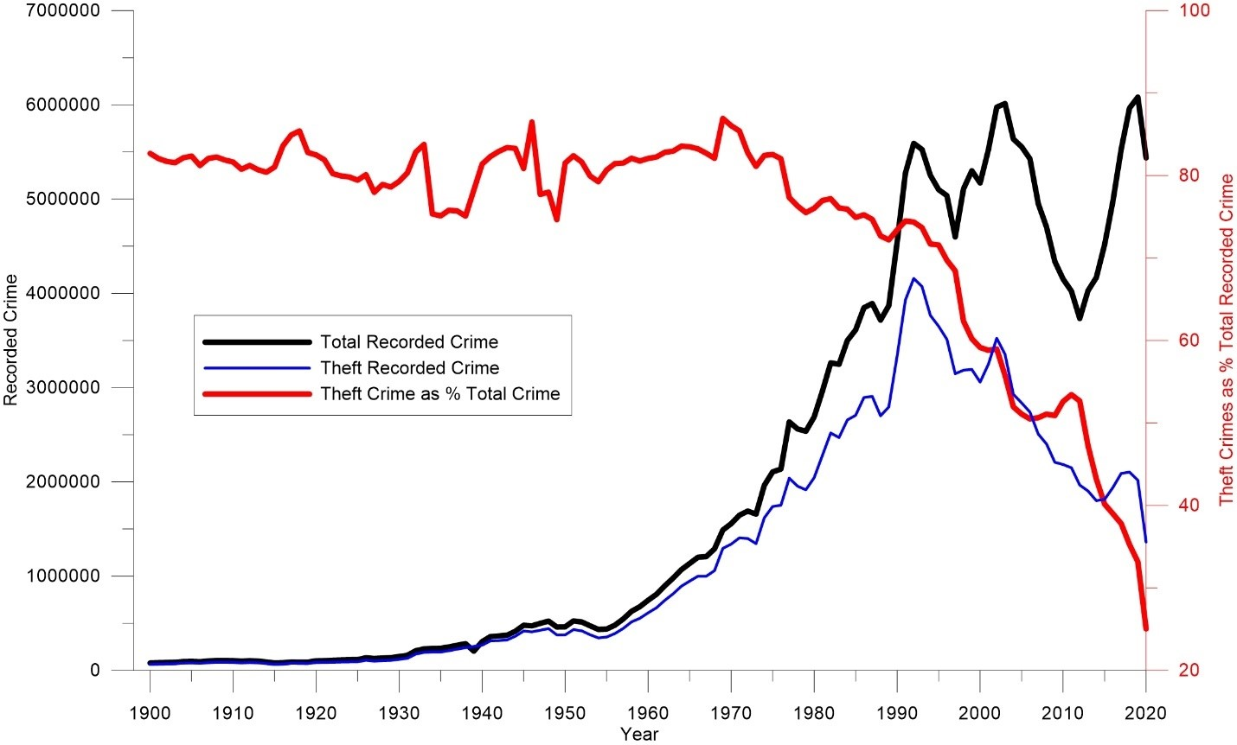
Moreover, it also allows for the year a significant technological advancement was introduced, to be plotted on the same graph to give a visual timeline of these technological advancements versus the crime trend. Furthermore, once a correlation has been identified between a technological advancement and a change in the crime statistics, this dissertation will attempt to further back up this analysis with other publications and sources.

Benefits and limitations
The benefits of the methodology of this research is that it relies on existing quantitative secondary data that is already available to the public. Therefore, consent was not required from any source as to how the data was collected, making the research, less time consuming and entirely ethical. However, the negative of this methodology is that this exploratory research may not produce the conclusive results to depict that technological advancements do have a positive impact upon the stated theft offences.

Conclusion
To conclude this chapter has identified that the inductive quantitative research of existing data produced by the Home Office will form the bedrock and basic methodology of this dissertation. Inductive and exploratory research via publications and other sources will then look to further back up any analysis, to help depict the reasons why a technological advancement has had a positive impact upon the statistics of the nominated theft offences. The limitations of this is that the inductive and exploratory research may not provide conclusive results to depict the exact reasoning as to why theft offences have decreased. As criminology is such a varied topic it is likely that there are several social, economic, policing factors along with technology advancements that may have had an effect.

Word count: 1374

References:
DeFranzo, S., n.d. Difference between qualitative and quantitative research.. [online] Snap Surveys Blog. Available at: <https://www.snapsurveys.com/blog/qualitative-vs-quantitative-research/> [Accessed 7 March 2022].
DeFranzo, S., n.d. Difference between qualitative and quantitative research.. [online] Snap Surveys Blog. Available at: <https://www.snapsurveys.com/blog/qualitative-vs-quantitative-research/> [Accessed 7 March 2022].
Bhandari, P., 2022. Inductive Reasoning | Types, Examples, Explanation. [online] Scribbr. Available at: <https://www.scribbr.com/methodology/inductive-reasoning/> [Accessed 7 March 2022].
George, T., 2021. Exploratory Research | Definition, Guide, & Examples. [online] Scribbr. Available at: <https://www.scribbr.com/methodology/exploratory-research/> [Accessed 7 March 2022].
Golebiewski, M. and Boyd, D., 2019. Data voids: where missing data can easily be exploited. Data and Society. [online] Data & Society Research Institute, pp.1-51. Available at: <https://apo.org.au/sites/default/files/resource-files/2019-10/apo-nid265631.pdf> [Accessed 6 March 2022].
Office for National Statistics, 2021. Crime in England and Wales QMI - Office for National Statistics. [online] Ons.gov.uk. Available at: <https://www.ons.gov.uk/peoplepopulationandcommunity/crimeandjustice/methodologies/crimeinenglandandwalesqmi#:~:text=victims%20to%20report.-,Because%20of%20concerns%20over%20the%20quality%20and%20consistency%20of%20crime,designation%20as%20National%20Statistics1.> [Accessed 6 March 2022].
Office for National Statistics, 2021. Crime in England and Wales - Office for National Statistics. [online] Ons.gov.uk. Available at: <https://www.ons.gov.uk/peoplepopulationandcommunity/crimeandjustice/bulletins/crimeinenglandandwales/yearendingmarch2021> [Accessed 6 March 2022].
Office for National Statistics, 2021. Crime in England and Wales QMI - Office for National Statistics. [online] Ons.gov.uk. Available at: <https://www.ons.gov.uk/peoplepopulationandcommunity/crimeandjustice/methodologies/crimeinenglandandwalesqmi#:~:text=victims%20to%20report.-,Because%20of%20concerns%20over%20the%20quality%20and%20consistency%20of%20crime,designation%20as%20National%20Statistics1.> [Accessed 6 March 2022].
Crime Survey for England and Wales, 2019. Crime Survey for England and Wales. Crime Survey for England and Wales, pp.1-10.
Office for National Statistics, 2021. Crime in England and Wales QMI - Office for National Statistics. [online] Ons.gov.uk. Available at: <https://www.ons.gov.uk/peoplepopulationandcommunity/crimeandjustice/methodologies/crimeinenglandandwalesqmi#:~:text=victims%20to%20report.-,Because%20of%20concerns%20over%20the%20quality%20and%20consistency%20of%20crime,designation%20as%20National%20Statistics1.> [Accessed 6 March 2022].

