Assignment Title: Hotel Organisational Audit
Program: BA International Hotel Management
Module: Management and Organisational Behaviour
Module code: BMIH5004
Student name: Syed Ariful Islam
Student ID number: 2109020
Lecturer Name: Julia Ault

Contents
Introduction 1
Organisational Overview 1
Discussing organisational Structure, cultures, and goals 2
Organisation structure 2
Organisational culture 4
Organisational Goal of Premier Inn Hotel 5
Discussing recent change initiatives, their impact and how all these were managed 5
Recent change initiatives and their impact 5
How changes were managed 6
Discussing Organisation’s strategic direction and current business performance 7
Organisation’s strategic direction 7
Current business performance 9
Conclusion 9
References 11

Introduction
Hospitality management refers to an area of hospitality which involves the activities of seeing the overall operations of hotel activities (Mullins and Dosser, 2013). To maintain the overall activities hotels audit which is known as the process of all activities such as reviews of customers, records, and collates all financial activities that need to be placed and pass the information of these to account heads (Stephen, 2022). So, these reports aim to critically evaluate chosen organisational activities with relevant theories. This report discusses the organisational goals. Also, organisational structure and culture which discuss in this report. this report discusses the recent change initiatives of the organisation and how these can impact the operation and how well these are managed after applying new initiatives. Lastly, the organisation’s strategic direction and current business performance are discussed in this report as well.

Organisational Overview
For this report, Premier Inn Hotel is selected for the analyses its overall activists. Premier Inn Hotel is the biggest hotel chain and largest hotel brand in the UK. It operates hotels in several places with more than 72000 rooms and 8000 hotels in the UK (Heery, 2020). It was first opened in Germany, Frankfurt and then it expands the business. Because of these well-known services, it becomes a more popular hotel in the UK.
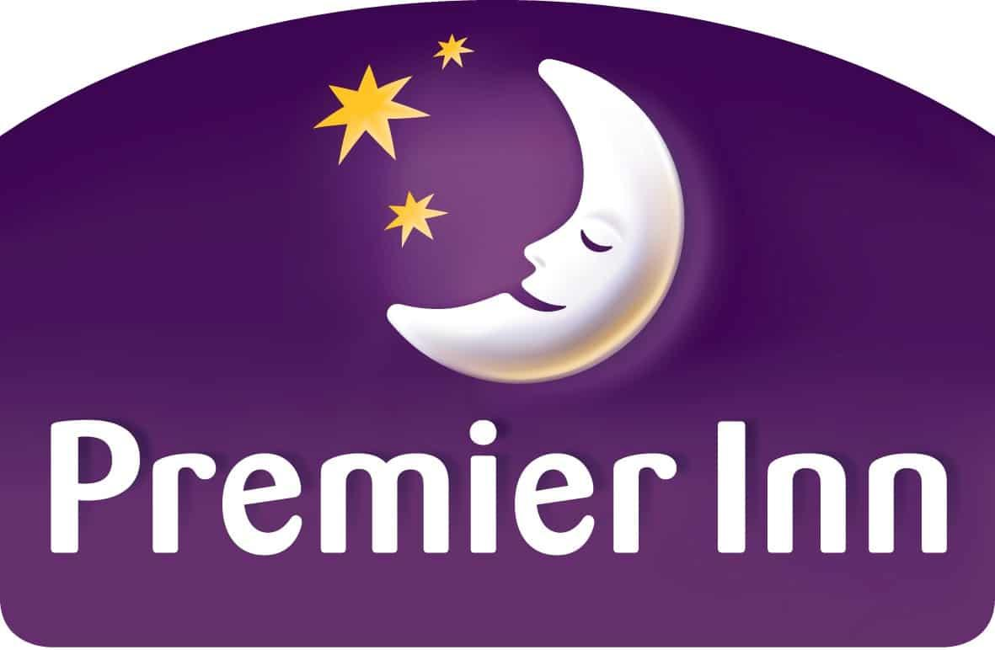
Figure 1: Premier Inn Logo.
Source: (Stephen, 2022).

Discussing organisational Structure, cultures, and goals

Organisation structure
Several organisational structures are found to operate business operations well. Different organisations apply different kinds of structures to make the best output for their company (Boddy,2014). Some kinds of organisational structures are discussed below:
Hierarchical organisation structure: This kind of structure follows a pyramid-shaped organisational chart where the command comes from top to button and is linked with each other for passing the command (Turi and Sorooshian, 2019).
Functional organisation structure: This kind of structure is like the hierarchical structure where command comes from the higher position which is in the top position but this kind of structure has a separate department which is managed independently (Fisher, 2020).
Flat organisation structure: This kind of structure applies a few levels between upper management and staff level and this kind of structure is best for the start-up business to operate their operational activities as well.
Divisional organisation structure: In this kind of structure companies have control over their resources but each division has its activities.
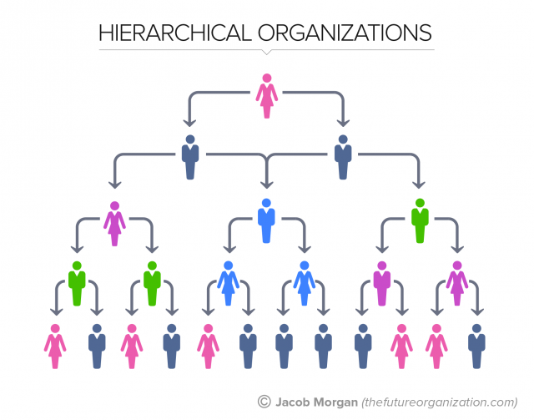
Figure 2: Hierarchical organisational structure.
Source: (Kofjac and Bavec, 2020).
From the above discussion, it shows several kinds of organisational structure. From this kind of structure, Premier Inn hotels follow the hierarchical organisational structure to operate their hotel business (Mullins, 2016). This company use this structure to use a top-down approach with a long chain of command. In the Primer Inn hotel, the top position holder is the CEO of this company then comes the next position of the executive board member. After these two positions, the role is known as regional manager and area manager. These position holders pass the command in the lower level such as the general manager of the hotel. The hotel general manager passes the command department manager of the Premier Inn hotel. The team leader takes the command from the department manager and this team leader commands staff to complete the operation. This structure which is followed by the premier inn hotel provides some pros and cons for their business. if it comes to pros, it has a better-defines level of authority and responsibility which also helps to motivate employees for their career paths and chances for promotion and provides each employee with a speciality which motivates this employee to work well. But it has also cons which can slow down innovation due to increased bureaucracy.

Organisational culture
Organisational refers to a collection of expectations, practices and values that inform and guide the activities of all members of an organisation. Handy's culture model shows the four types of culture Which are power culture, role culture, task culture and person culture.
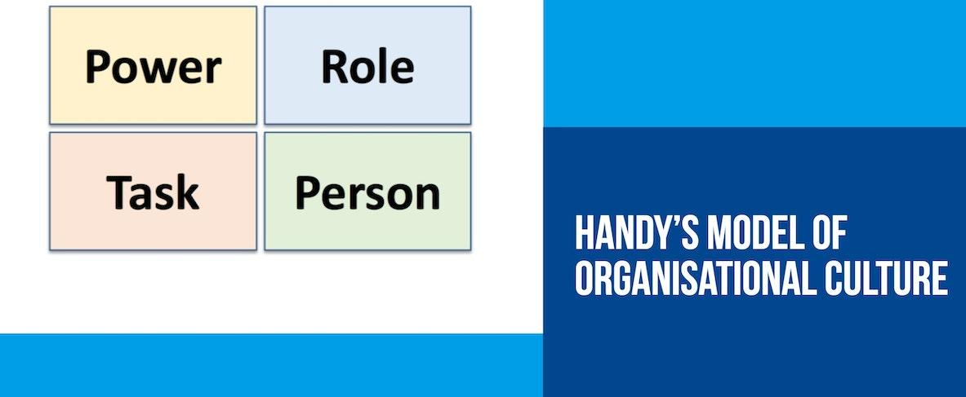
Figure 3: Hendy’s Model of organisational culture.
Source: (Bell, 2019).
Power: This kind of culture is normally used by small companies and has one person who makes the decisions for their organisations.
Role Culture: This kind of culture is normally used by big companies that follow hierarchical and bureaucratic organisations (Muijen, 2020). The organization's approach to work is based on a person's role or a specific task that needs completion.
Task culture: from this culture, it was found that organisation judges people’s performance by their work results and how many problems these people solve (Bell, 2019). In this, culture organisations provide value and reward for people’s talents, problem-solving skills, and creativity.
Person Culture: This kind of culture concern individuals’ talents and skill which are the greatest assets for any organisation (Muijen, 2020).
Premier Inn Hotel follows the hierarchical structure for their organisation which is related to the Role culture (Mullins,2020). For that reason, this company follows the role culture in tier companies where specific persons maintain their roles to utilise better output for this company. This role culture enables employees to have inner satisfaction to do their job properly. This culture helps to get motivated by this culture. this culture enables a great career path for employees which helps this employee to make good careers and chances for promotion and provides each employee with a speciality which motivates this employee to work well.

Organisational Goal of Premier Inn Hotel
Premier Inn hotel has its mission and vision which help to achieve its goals for achieving success. The main mission of this company is to make a place where everyone has that potential and where no barrier occurs and this company aims to provide meaningful contributions to their customer to get the best quality of service from their organisation (Heery, 2020). On the other side, the vision of the premier inn hotel is a force for good which is the heart of everything, working on net zero carbon and providing a comfortable and affordable place that can help this customer to live well and work well to create a greater impact making a better world.

Discussing recent change initiatives, their impact and how all these were managed

Recent change initiatives and their impact
Premier Inn Hotel changes several things to operate well operation and manage to increase customer engagement. The most recent initiative which is taken by the premier inn hotel is that this company join the race to zero which committed to achieving a net zero carbon mission by 2050 (Hampton, 2020). To cut carbon this company has been working to implement 100000 energy-efficient bulbs and purchase renewable energy to install energy-efficient appliances as well as use solar panels. This activity can increase the brand value of this company for these initiatives also this can help to increase customer engagement for their good reputations.
Another change invites are applied by this company to build sustainability in their company. This sustainability activity is applied by this company to reduce GHS gas, reduce wastewater, reduction energy which can offer the best environment for future generations. This kind of initiative can create a great impact on the environment as well as the company’s operation. This kind of activity encourages the customer to take the services from this company. The increasing customer engagement helps this company make the best profit and make this company a profitable business.
This company also changes their marketing initiatives. Recently this company are focused on online marketing, Search engine optimization and email marketing which help this company reach its company name to every corner of the world (Hampton, 2020). For that reason, a traveller who comes to enjoy their free time and needs to stay in the hotel, this customer can easily know the name of this hotel and their information which encourage this customer to take the services at affordable prices from this company.

How changes were managed
To get clear information Lewin’s model is the best for describing this. How Recent change was managed is shown through the aid of Lewin’s model given below:
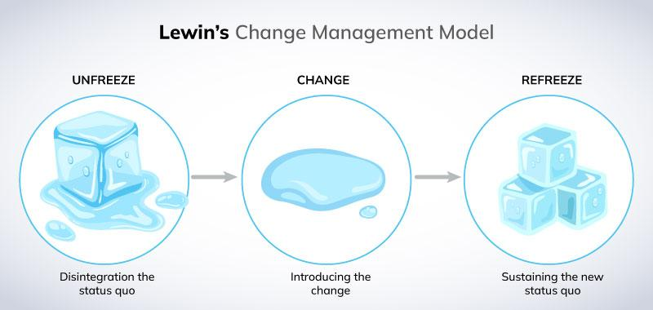
Figure 4: Lewin’s model.
Source: (Prokosch, 2019).
Unfreeze: In this phase, the organisation tries to make stakeholders believe that changes are essential for their betterment (Muijen, 2020). Before applying new initiatives, premier inn hotel showed the positive impact of new initiatives such as the et zero carbon journey can help to make a better world, also sustainability approaches can secure better outcomes for the future generation which helps to think all stakeholders that these changes must be needed for betterment.
Change: In tis phase, this company apply their changing initiative to make it real for instance, this company signed an agreement to join Race to Zero which is committed to achieving a net zero carbon mission by 2050 (Hampton, 2020). Also, this company start applying their steps to adopt sustainability approaches which help to make a better world for future generations. also in this stage, this company take the steps to apply online marketing strategies to promote their brand name for this business to be profitable.
Refreeze: This phase shows that after applying the changing initiatives its need for daily practices is effectively aligned with a long-term goal (Prokosch, 2019). The head of the company needs to support the employee to maintain the changes in the effective manager which can provide a great opportunity for this company to make the highest engagement of the customer as well as contribute to making a better world.

Discussing Organisation’s strategic direction and current business performance

Organisation’s strategic direction
McKinsey 7s framework is the best approach to discuss Premier Inn Hotel’s strategic direction which is given below:
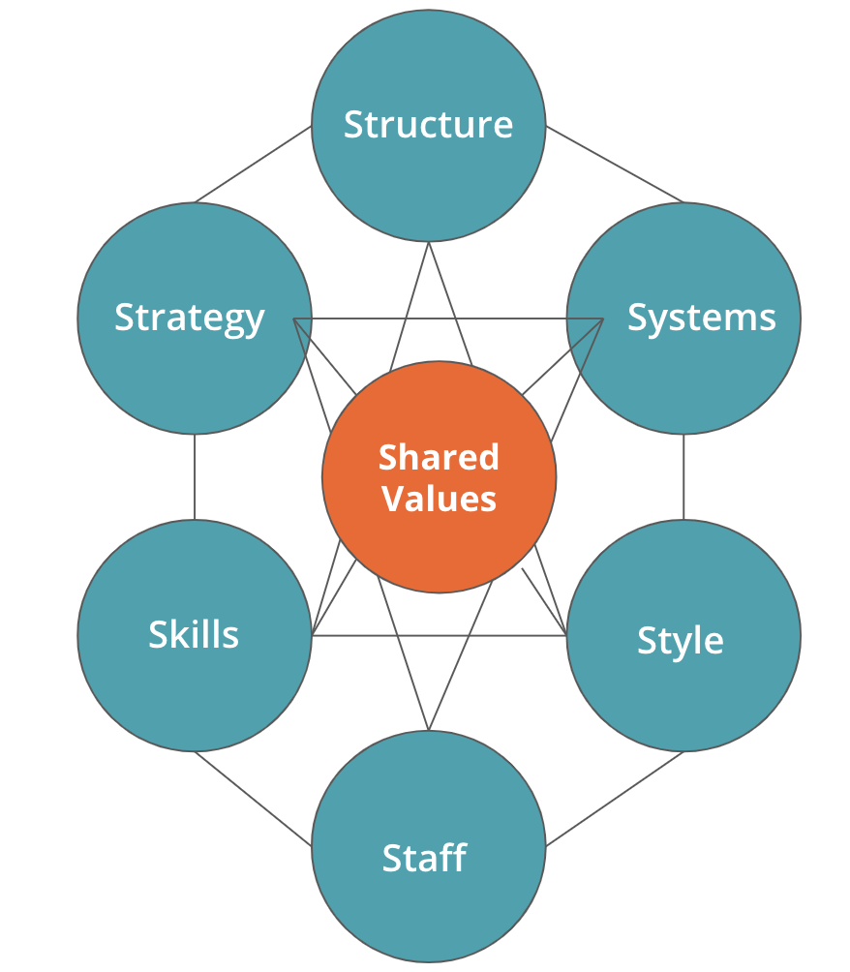
Figure 5: McKinsey 7s framework.
Source: (Hanafizadeh and Ravasan, 2021).
Structure: Premier Inn Hotel uses a Hierarchical organisational strutter to operate their business operation where the main command comes from the top position holder which Is carried by the CEO then it passes the lower order to maintain a good operation environment in the company.
Strategy: This company has a value pricing strategy that aims to provide affordable prices that encourage customers to choose this hotel for taking their services. However, this company offers a price discrimination strategy that allows the lowest rate on Friday, Saturday and Sunday nights which helps to increase customer engagement and increase the overall revenue of this company (Prokosch, 2019).
Systems: This company uses BART systems which help to do booking and billing systems. Which helps to understand the budget process and replace the use of speed tests. Also, this company offers an online booking system that helps all over the world customer to book a room from anywhere in the world.
Style: This company establish of code of conduct for their employee and customer who are involved with their company and this can help to maintain well operational environment and help their employee to give their best output (Hampton, 2020). For the customer, some terms and conditions have been implemented by this company such as a maximum of two adult people and children under 16 years can stay in a single room and
Staff: This company hire experienced and well-skilled staff to operate their business who can server good customer service to their targeted customer. This staff of well-skilled customer can help this organisation to increase customer engagement and helps this business to make a profit from their business.
Skill: This company offer a training programme for their staff which helps this staff to gain more skill and knowledge that help them to provide the best output for this company. This company offer several kill development programme o hotel managers which helps employees to increase their skill for their future career growth (Hanafizadeh and Ravasan, 2021).
Shared values: This organisation consists of some shared values which help this company to achieve its goals. This company aim to make a place where everyone has that potential and where no barrier occurs and this company aims to provide meaningful contributions to their customer to get the best quality of service from their organisation (Heery, 2020).

Current business performance
Premier hotels face 1 billion dollars in the past year due to covid 19. Pandemic. For this pandemic, this company needed to shut down the business. But this company currently recover from this situation. Recently the BSI score of this hotel is 88.7 which is most score among other hotel businesses in the UK. From the owner of this company, whiteboard reported that the statutory revenue of this company is USD 2.6 billion in its new financial result that 27% ahead of the pre-pandemic level (Bell, 2019).

Conclusion
This report has been prepared with the aim to discuss the overall activities of the premier inn hotel where this organisation follows the hierarchical organisational structure. Applying this structure, it has a better-defines level of authority and responsibility which shows in this report. This company follows a role culture that helps to enable employees to have inner satisfaction to do their job properly. Premier Inn hotel has its mission and vision which help to achieve its goals for achieving success. From the McKinsey 7s framework, it is found that This company has a value pricing strategy that aims to provide affordable prices that encourage customers to choose this hotel for taking their services.

References
Bell, C. (2019). The Impact of Participative and Directive Leadership on Organisational Culture: An Organisational Development Perspective. Mediterranean Journal of Hospitality Management, 5(23).
Boddy, D. (2014) Management: An Introduction (6th Ed), Harlow, Pearson
Fisher, D.R., Campbell, L.K. and Svendsen, E.S. (2020). The organisational structure of urban environmental stewardship. Environmental Politics, 21(1), pp.26–48.
Hampton, M.P. (2020). Recent change initiatives of Premier Inn Hotel. Annals of Tourism Research, 25(3), pp.639–660.
Hanafizadeh, P. and Ravasan, A.Z. (2021). A McKinsey 7S Mode. International Journal of Hotel Management, 7(4), pp.23–63.
Heery (2020). Premier Inn Hotel Environment. Informes de la Construcción, 28(279), pp.17–22.
Kofjac, D. and Bavec, B. (2020). Hierarchical Organizational Structure Optimization – Human Resource Management Case Study. Organizacija, 48(3), pp.177–186.
Muijen, V. (2020). Organizational culture. Hove Uk: Psychology Press.
Mullins, L (2020) Organisational Behaviour in the Workplace (12th edition) Harlow: Pearson
Mullins, L and Dosser, P. (2013) Hospitality Management and Organisational Behaviour (5th Ed) Harlow, Pearson.
Mullins, L. (2016) Management and Organisational Behaviour (11th edition) Harlow: Pearson
Prokosch, H.-U. . (2019). Applicability of Lewin´s Change Management Model in a Hospitality Setting. Methods of Information in hotel management, 48(05), pp.419–428.
Stephen (2022). Hotel Audit Guide. New York: DIANE Publishing.
Turi, J.A. and Sorooshian, S. (2019). The impact of organisational structure on organisational learning. Middle East J. of Management, 6(2), p.204.

