  Component One:  What are the key skills required when working in the housekeeping team? 750 words (+/- 10%)  Contribution to Overall Module Assessment: 25% | Student No: | Anwara Begum 2125645
 | Module Title: Operating Hotel Facilities
 | Module Code: BMIH4006
 | Lecturer: | Kathryn Flynn
As I’m still learning about hotel operations and housekeeping but in my point of view this department is one of the top key selling department in the whole hotel operation. Under this housekeeping department the majority of hotels produce more money than any other department can, whether directly or indirectly and this is the reason that a minimum of 50% to around 65% of a hotel's total revenue comes from the sale of rooms, sold repeatedly it generates the majority of a hotel's earnings (Raghubalan and Raghubalan, 2016). Housekeeping key skills given below:
Attention to detail: Housekeepers must pay close attention to detail to ensure that all areas are cleaned and dusted thoroughly, and no areas are missed (Casado, 2012). Example, I ensure that all surfaces are dusted, floors are vacuumed, and that bathrooms are cleaned to a high standard before guests arrive.
Academic Skill: Housekeeping stuff need academic skill like academic certificate, previous work experience so that he can read, write and speak properly (Tra, 2020) to the guest. Example, if guest ask something I can note it down or any kind of information I can gave the guest properly if I have proper academic skill.
Time management: Housekeepers must be able to manage their time effectively to ensure that all cleaning tasks are completed within the designated time frame (Insights, 2021). Example, I must be able to prioritize the tasks, such as cleaning guest rooms after checking out, while also ensuring that public areas are clean and well-presented, I will again check the room before guest check in.
Communication Skill: Housekeepers must have good communication skills to be able to work effectively as part of a team (Thomas J A Jones and H William F, 2008). Example, I need to communicate with other housekeeping staffs or housekeeping manager to ensure that tasks are coordinated, completed and updated efficiently.
Physical Fitness: Housekeeping can be physically demanding, so it's important that housekeepers are physically fit and able to carry out tasks (Shawn, 2021). For example, Guest arrives with more than two luggage lifting and carrying this to the room, stuff need to physically fit for doing this.
Customer Service: While housekeepers may not interact with guests as much as other hotel staff, they still play an important role in providing excellent customer service (jill, 2020). For example, I will ensure that guest rooms are well-stocked with amenities and if any guest requests for extra towels or pillows and anything wants to replace, I will do it immediately.
Problem-Solving: Maintain clean, organized, and effective workplace, housekeeping stuff refers to the practice of managing tasks, activities and handle the many difficulties or problems that could occur in housekeeping, problem-solving abilities are essential (Morch, 2022). Example, an issue arises with a vacuum cleaner not working properly. Guests are experiencing delays and dissatisfaction since the vacuum machine is not cleaning up room is still not ready. Finding the problem, analyse and report it quickly and find the alternate solution to keep the room clean or if possible offer another room to the guest.
Situation Handle Skill: Housekeeping stuff need to manage the situation smartly whatever they face in their shifts (Jones and Wiley, 2005) .Example: a guest complain about the public floor is not cleaned properly or complain some other things, they need to calm down and politely handle the situation so that guest feel honour and positive, say sorry many times after listening guest complain.
Industry examples where these skills are applicable include:
Hotel housekeeping: Housekeepers in hotels are responsible for cleaning guest rooms, hall room, public areas, and other hotel areas that are instructed. They must be able to manage their time strongly, patience, well dress up and fit to ensure that all cleaning tasks are completed efficiently and met high standard (Raghubalan & Raghubalan, 2016).
Hospital Housekeeping: Housekeepers in hospitals are responsible for cleaning patient rooms, seats, public areas, and other areas of the hospital, ensure that all areas are cleaned and sanitization properly. If they need they might ware protection cloths “Personal protective equipment” to ensure hygiene. (Housekeeper | Health Careers)
Cruise Ship Housekeeping: Housekeepers on cruise ships are responsible for cleaning guest cabins, Captain Cabins, public areas, and crew cabins. They must be able to work effectively as part of a team and manage their time, to ensure that all cleaning tasks are completed within the given time frame. (Cruise Ship Jobs - Housekeeping, Accommodation Jobs, no date)
Applying theoretical knowledge in housekeeping is essential to ensuring that cleaning and maintenance tasks are completed effectively and efficiently. It also helps to promote a high standard of hygiene and cleanliness, which is essential in the hospitality industry.

References:
10 Types of Emergency Situations Encountered in Hotels (no date). Available at: https://setupmyhotel.com/train-my-hotel-staff/securityandloss/770-types-of-emergency-situations-in-hotels.html (Accessed: 27 February 2023).
Andrews, S. (2008) Textbook of Hotel Housekeeping Management and Operations.
Casado, M.A. (2012) HOUSEKEEPING MANAGEMENT.
Cruise Ship Jobs - Housekeeping, Accommodation Jobs (no date). Available at: https://www.cruiseshipjob.com/hotel.htm (Accessed: 27 February 2023).
Duncan, C. (2022) Improve Communication in the Hospitality Industry – 9 Tips | DeskAlerts. Available at: https://www.alert-software.com/blog/communication-in-hospitality-industry (Accessed: 5 March 2023).
Hayes, F. and Uuld, T. (2010) Customer Care for Housekeepers By Calgary Immigrant Women’s Association Essential Skills Curriculum Project. Available at: www.ciwa-online.com.
Insights, C. (2021) ‘16 Housekeeper Skills for Your Career and Resume - CLIMB’, 6 August. Available at: https://climbtheladder.com/housekeeper-skills/ (Accessed: 27 February 2023).
Jones, T.J.A. and Wiley, J. (2005) F o u r t h E d i t i o n Professional Management of Housekeeping Operations.
Raghubalan, G. and Raghubalan, S. (2016) ‘HOTEL HOUSEKEEPING Operations and Management 3rd Edition’.
Thomas J A Jones, F.I. and H William F, R.E. (2008) Professional Management of Housekeeping Operations.
Tra, T. (2020) Action plan for training new Housekeeping Employee: Case Hotel Indigo Helsinki 2020 Laurea.
Williams, B. (2019) ‘Hotel Housekeeping 101: Tips & Tricks for Clean Hotel Rooms – Alliance Online Blog’. Available at: https://www.allianceonline.co.uk/blog/2019/06/hotel-housekeeping-101-tips-tricks-for-clean-hotel-rooms/ (Accessed: 5 March 2023).

Word Count | 776

Component Two:
Contribution to Overall Module Assessment: 25%
In this scenario – You have just been promoted to team leader for a floor within the hotel. A guest complains that on their arrival, their room had not been properly cleaned. Create an action plan and answer the following questions.

Problem | Why did it happen? | What are you going to do? | How will you prevent this from happening in the future? | What measures would you introduce to improve team effectiveness?
A guest complains that on their arrival, their room had not been properly cleaned | There could be several reasons why the room was not properly cleaned.  It could be due to miscommunication between the housekeeping staff, lack of motivation, lack of importance or attention towards work, insufficient training, or lack of supervision. | As a team leader, my primary responsibility is to ensure that the guest's complaints are solved promptly and pleasingly.  I will take immediate action to solve the issue by apologizing to the guest and instructing the housekeeping team to clean the room immediately. According to (Hayes and Uuld, 2010) housekeepers will personally inspect the room to ensure that before guests arrives every rooms and floors meets the hotel's cleaning standards. I will also check the room is properly ready before guests arrives.  In the mean time I will ask the guest have some Tea or Coffee and make offer to switch the room if guest wanted to, and again apologize this occurrences will never happen again with a sad face.  After finish everything successfully I will tell the guest have a great day with simple smile. | To prevent similar incidents from happening in the future, I would take the following measures:  1. I will conduct regular training sessions for the housekeeping staff to ensure that they understand the hotel's cleaning standards and protocols.  2. Establish clear communication channels between the housekeeping staff and other departments to ensure that there is no miscommunication (Raghubalan and Raghubalan, 2016).  3. I will make sure the stuffs attaining the training session.  4. I will ask them what they learn from the training session if they miss any I will consult with them again.  5. Implement a checklist system to ensure that each room is cleaned and inspected thoroughly before being made available to guests (Krishna Chaudhary, no date).  6. I personally Conduct regular inspections to ensure that the cleaning standards are being met before guest arrival. | To improve team effectiveness, I would take the following measures:  1. I will establish clear performance expectations for the team, with specific goals and targets.  2. I will Conduct regular training sessions to enhance the team's skills and knowledge.  3. Provide regular feedback to the team members, both positive and constructive, to help them improve their performance.  4. Encourage teamwork and collaboration and recognize and reward team members who contribute positively to the team's success (Andrews, 2008).  5. Give them best performer awards every months announce name in front of the whole team so that others get encouragement from this.  6. Create a friendly environment so that team member does not hesitate to share any work problem with me.

Component Three:
Contribution to Overall Module Assessment: 50%
Your task is to create and prepare a presentation following the detailed scenario provided below.

As the floor housekeeping manager and given the recent guest complaints you need to put together a basic training presentation for your colleagues within the housekeeping team to get the best out of them, ensure that brand standard is being achieved and that Health and Safety procedures are also being followed.

Basic cleaning Procedures:
- Use safety precautions while cleaning
- Prepare equipment and get the space ready for cleaning
- Dust all surfaces such as furniture, lamps, and picture frames.
- Wipe down surfaces counters, tables, and desks with a disinfectant.
- Clean mirrors and windows with a glass cleaner.
- Sweep or vacuum all floors in all areas of the hotel.
- Mop or steam clean hard floors such as tile or wood.
- Vacuum carpets and rugs regularly to remove dirt and debris.
- Clean and disinfect bathroom including toilets, sinks, and showers.
- Replace towels, used linens and washcloths with clean ones.
- Refill supplies such as toilet paper, soap, and shampoo.
- Ensure that the mattress and pillows are free from stains and odors.
- Tuck in sheets and make sure the bed is neatly made.
- Sanitize glasses, mugs, telephone device, electronics, doorknobs, light switches, and elevator buttons and TV remote.
- Use appropriate equipment vacuum cleaner, mop, dusting clothes, duster, ozone gun, brushes, window wiper, dish washer, etc
- After the cleaning process is over, all equipment should be washed, dried, stored properly and the working area should be always left neat & tidy.
Training Notes: In this training my colleagues will learn how to use and maintenance of besic cleaning technical equipment and supplies effectively. It is essential in the hotel industry to ensure that guests are provided with a clean and comfortable environment, when guests see the hotel room at a glance they feel clean and hygiene it will bring positive impact (Masson, 2020).

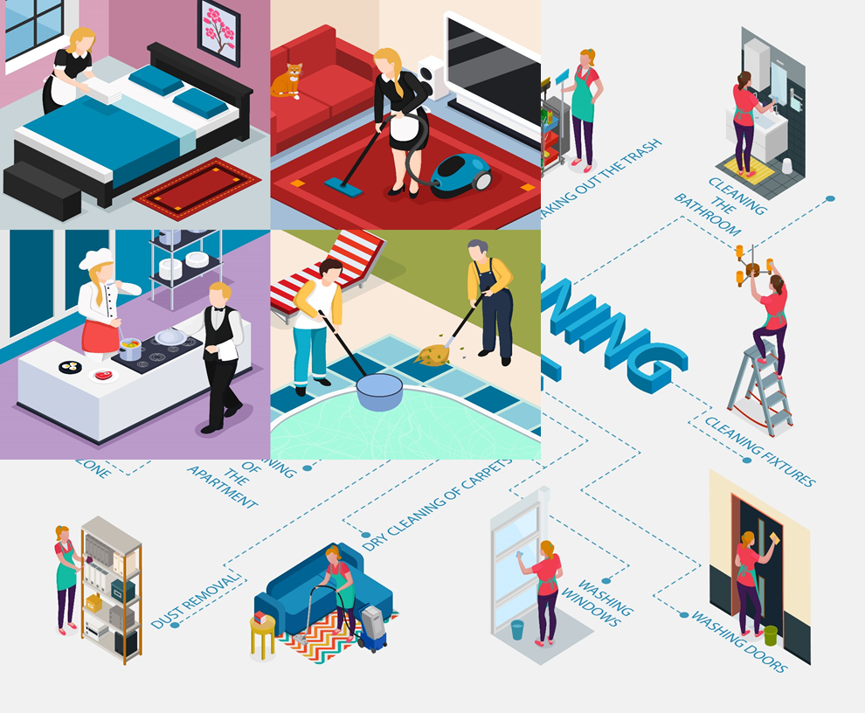
Figure 1: Housekeeping Hotel cleaning Procedures and equipment.

Health, Safety and emergency protocols:
- Use Alarm, first aid box, calm down
- Find a safe place for hideout
- Proper handling and disposal of hazardous materials
- Fire safety procedures
- Emergency response procedures
- Use Gloves, Masks, Fire extinguishers
- The Occupational Safety and Health Administration (OSHA) provides guidelines for housekeeping to ensure a safe working environment (OSHA Worker Rights and Protections | Occupational Safety and Health Administration)
- Always adjust the mattress with your leg and not with your back to avoid any injuries.
- Maintain good housekeeping practices
- Avoid slippery conditions and use slip-resistant footwear
- Call Police
- Arrange fire demo fire safety act.
Training Notes: Through this training my team will know how to prevent accident and avoid casualty. Safety and health policies' primary objective is to prevent workplace accidents, sicknesses, and fatalities as well as the pain and financial stress that these incidences can bring on for employees, their families, and employers. where to report and maintenance issues and safety hazards.
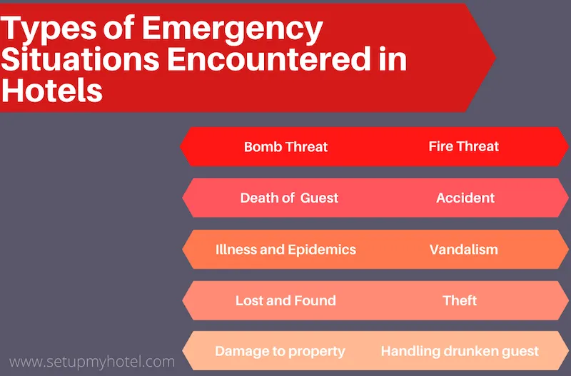
Figure 2: Types of Emergency situations Encountered in hotel (10 Types of Emergency Situations Encountered in Hotels)

Bed making and room set up.
- Bed making should take 5-7 minutes (Pillow, Bedsheet, and other decorative items) this time depends on the bed size, used by the hotel (Babinski, 2020).
- Report to the Executive Housekeeper if you notice stains or tears in the bedspread.
- Replace Pillowcase and Bed Sheet after guest checkout.
- Tuck in sheet and blanket
- Make sure you have the correct size bedsheets, blanket, pillow, and pillowcase.
- Fold in all of the corners.
- Adjust the mattress with your leg not with your back to avoid any injuries
Training Notes: In this training session my team will get expert hotel bed-making suggestions. Through this training my team make the best impact on guests when they first see the bed, lying down and feel relaxed.

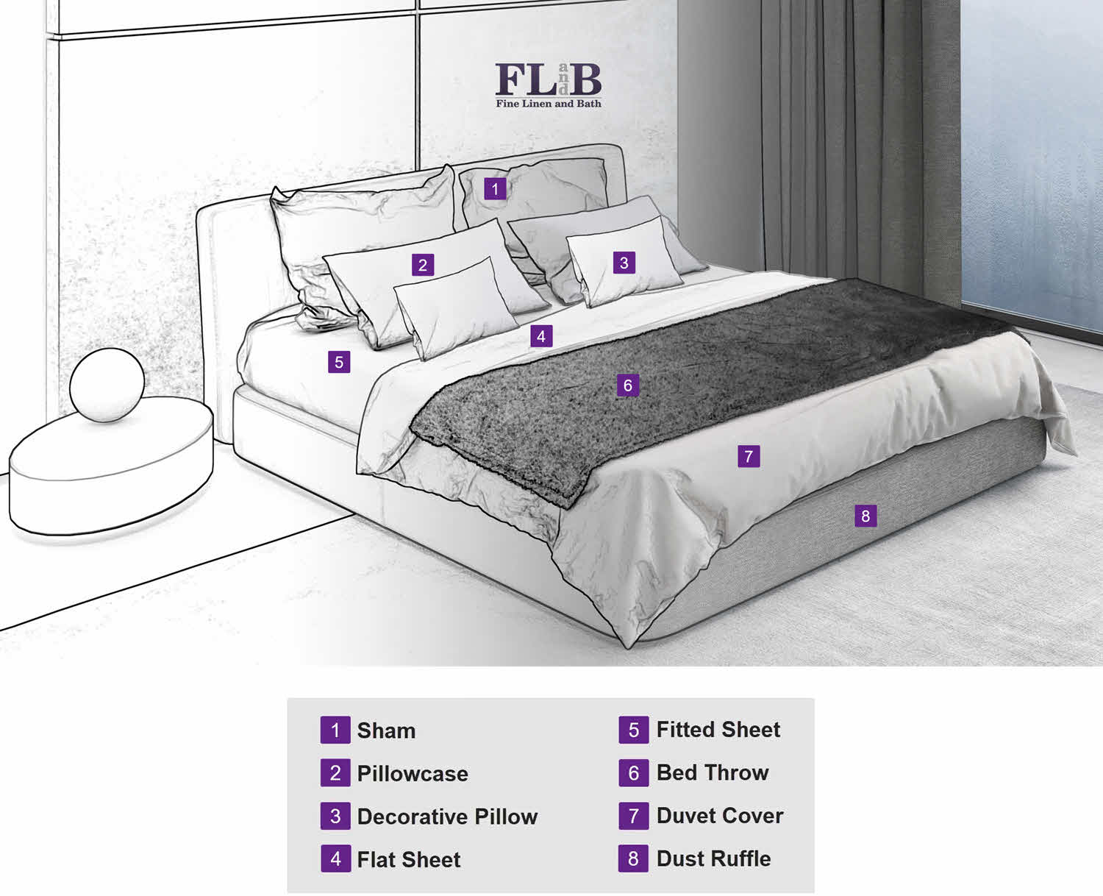
Figure 3: Hotel Bed Making (Babinski, 2020)

Waste management and recycling:
- Use refillable soaps, shampoos, and conditioners.
- Use washable cloth products and dishware instead.
- Use water filters instead of plastic bottles.
- Reduce and reuse supplies packaging materials.
- Reduce the number of plastic & paper products.
- Switching to LED lights
- Data analysis of waste is to perform waste audit.
- Food waste management- kitchen, Breakfast, Buffet, Lunch, Dinner.
- Guest waste management- food scraps to plastic to metal and glass.
- Make A proper Plan
Training Notes: The need for waste management in hotels is critical because garbage disposal is becoming more and more challenging. Also, it makes sense from a business perspective. Using resources wisely allows for significant savings on raw materials. Selling used materials, as well as reusing and recycling useful ones, might help you make extra money. As a result, as the amount of garbage produced decreases, the cost of waste disposal also decreases (Lawson, 2018).

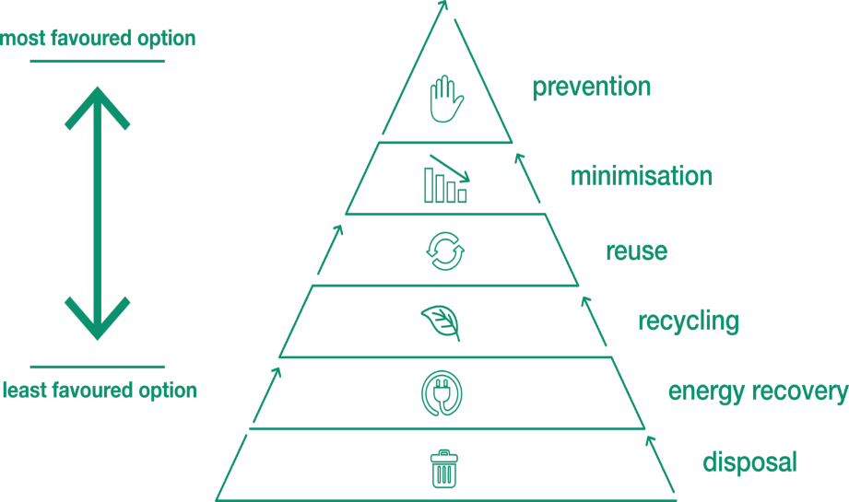
Figure 4: The Rise of Holistic Waste Management Practices (Guide to Waste Management - Recycle Track Systems, no date; Yang and Ge, 2016)

Interpersonal and communication skills:
Developing Interpersonal and Communication Skills training for the hotel industry:
Importance of First Impressions: Greeting guests with a smile, maintaining eye contact, proper grooming and using appropriate body language.
Active Listening: Listening to what guest is saying without interrupting, asking questions to clarify points, and responding appropriately.
Handling Difficult Situations: Carefully Handle guest complaints, conflicts and emergencies situations.
Cultural Awareness: Importance of cultural awareness and sensitivity, understanding different communication styles and customs.
Teamwork and Collaboration: Work together effectively, communicate openly and honestly, share the knowledge and support each other.
Training Notes: Effective interpersonal and communication skill training is necessary for success in the hotel industry. Through this training my colleagues will be able to interact with guests and colleagues in a professional and courteous manner, while also being able to convey information clearly and effectively (Duncan, 2022). Interpersonal and communication skills training can help hotel employees develop these skills and improve their overall performance (Williams, 2019).

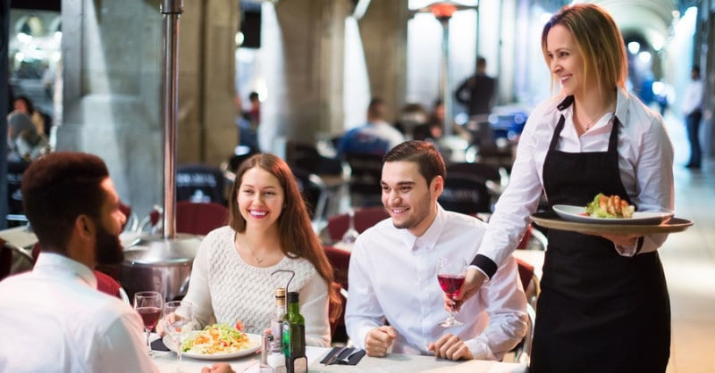
Figure 5: Hotel Stuff doing Eye Contact and Smiling while serving foods (Morgan, 2021)

Time management:
Stay away from time-wasting activities: Constantly checking your e-mails Multitasking or doing more than one thing at a time, Worrying and unnecessary planning, Lots of meetings, Internet, Social Media, Gossips.
Maintain a daily or Monthly schedule is one of the key time management techniques to become a successful hotel stuff.
Why waste time: Lack of motivation, Due to leader, low wages, unsatisfied, no work routine, no incentive to work hard.
Use technology to save time: Proper use hotel of software, telephone, mobile, Computers, internet, cleaning equipment etc.
Set Prioritise: Housekeeping stuff should create a Priority Matrix for Hotel Operations The priority Matrix (Jobs, 2023).
Allocating a fixed time slot to each task. Cleaning guest rooms, restocking supplies, and attending to any special requests from guests.
Monitor Progress: It is important to monitor progress in order to stay on track and ensure that tasks are being completed on time. This can be done by regularly checking the schedule, using a timer to keep track of how long tasks are taking, and keeping track of completed tasks on a checklist.
Take Breaks: Taking breaks is important for maintaining energy and focus. Housekeeping staff should take short breaks throughout the day to rest and recharge. This can help to prevent burnout and increase overall productivity.
Training Notes: Time management is a critical skill for success in the hotel industry, where staff must be able to do multiple tasks and priorities while still providing excellent service to guests. Time management skills training can help hotel housekeeping staff to develop their overall performance which will ultimately lead to greater guest satisfaction and a more successful hotel operation (Nolan, 2018).
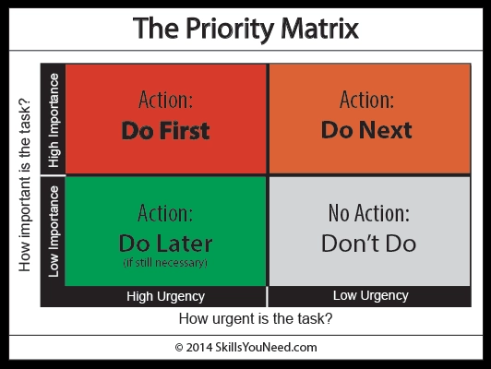
Figure 6: The priority Matrix (Jobs, 2023)

Employee engagement: It is an indicator of how much dedication employee showing or engaging into their work and giving their best outcome for the company. Employee engagement and having effective strategies that boost employee engagement can bring positive impacts on staff turnover rate, work culture, customer relationships, productivity, as well as company profitability.

Gallup, a leading research and consulting firm, has developed an employee engagement model that can be applied to various industries, including hotel housekeeping.

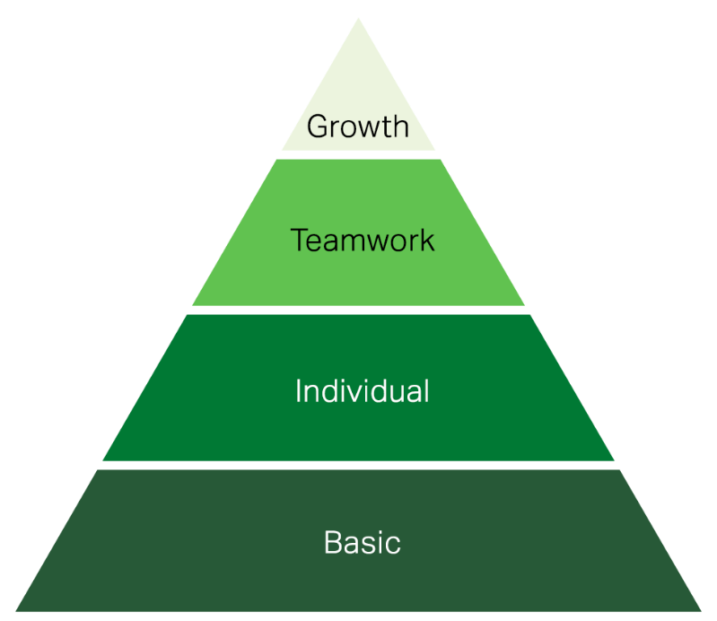
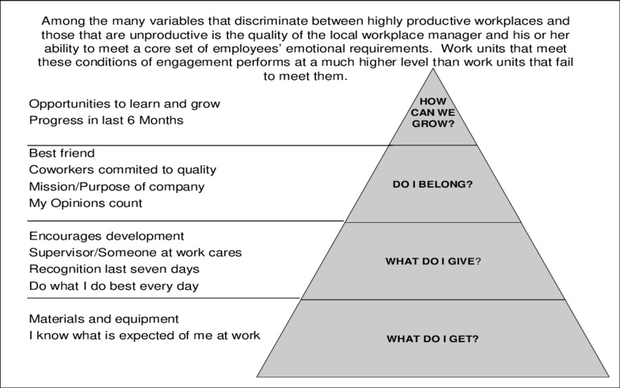
Figure 7: The Employee Engagement Model Gallup (How to Improve Employee Engagement in the Workplace - Gallup, no date)
Figure 8: Gallup’s four dimensions of employee engagement (Joubert and Roodt, 2014)

Gallup employee engagement model can be applied in the hotel housekeeping industry is demonstrated by the Ritz-Carlton Hotel Company (Luxury Hotels and Resorts | The Ritz-Carlton). The Ritz-Carlton has won numerous awards for employee engagement, and their approach has become a best practice in the hotel industry.
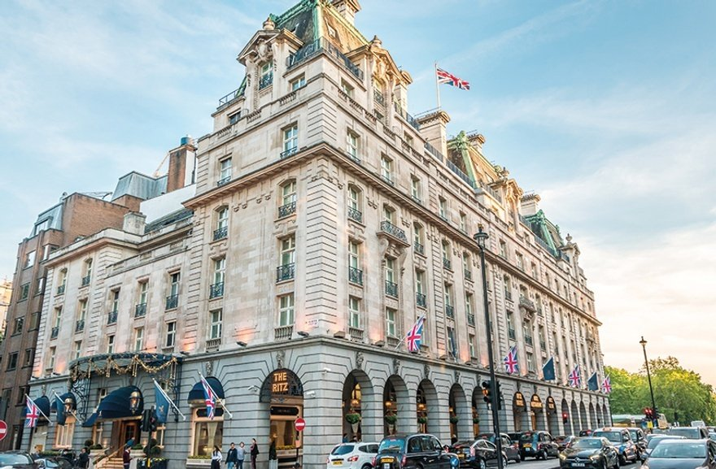
Figure 9: Hotel the Ritz-Carlton London (The Ritz London | 5 Star Luxury Hotel in Mayfair London)

Clear Expectations: The Ritz-Carlton provides clear expectations for housekeeping employees through their "Gold Standards," which outline the company's service values and quality standards. Housekeeping employees receive training on these standards, and they are reinforced through regular coaching and feedback (Robison, 2008).

Tools and Resources: The Ritz-Carlton provides housekeeping employees with the necessary tools and resources to perform their jobs effectively, including state-of-the-art cleaning equipment and supplies. The company also provides ongoing training and development opportunities for its housekeeping staff (Blandino, no date).

Positive Feedback and Recognition: The Ritz-Carlton has a culture of recognizing and celebrating employee achievements. For example, the company has a program called "Catch Me at My Best," where employees can nominate each other for outstanding service (Wan, 2015). The company also recognizes employees who receive positive feedback from guests through its "Wow Stories" program.

Opportunities for Development: The Ritz-Carlton provides housekeeping employees with opportunities for development and career advancement. The company offers a variety of training and development programs, including a housekeeping apprenticeship program and cross-training opportunities in other departments (Wan, 2015).

Supportive Management: The Ritz-Carlton has a strong culture of supportive management, with managers who are dedicated to coaching, mentoring, and developing their teams (Robison, 2008). Managers regularly check in with housekeeping employees to provide feedback and support, and they work to create a positive and inclusive work environment.

Overall, the Ritz-Carlton's approach to employee engagement in housekeeping is a best practice in the hotel industry. By implementing these elements of the Gallup employee engagement model, the Ritz-Carlton Hotel Company has successfully created an engaged workforce within their hotel housekeeping department. This engagement translates into a high level of service quality, guest satisfaction, and employee retention, positioning the Ritz-Carlton as a leader in the hospitality industry. Housekeeping managers can create a culture of engagement and motivation among their employees, which can lead to higher job satisfaction, productivity, and guest satisfaction.

References
10 Types of Emergency Situations Encountered in Hotels. (n.d.). Retrieved February 27, 2023, from https://setupmyhotel.com/train-my-hotel-staff/securityandloss/770-types-of-emergency-situations-in-hotels.html
Babinski, M. (2020, April 5). How to Make a Perfect Bed [Complete Bedding Essentials Guide. https://flandb.com/blogs/by-flandb/building-your-perfect-bed
Blandino, S. (n.d.). How the Ritz-Carlton Delivers Exceptional Customer Service | Stephen Blandino. Retrieved June 6, 2023, from https://stephenblandino.com/2016/07/how-the-ritz-carlton-delivers-exceptional-customer-service.html
Duncan, C. (2022, April 12). Improve Communication in the Hospitality Industry – 9 Tips | DeskAlerts. https://www.alert-software.com/blog/communication-in-hospitality-industry
Guide to Waste Management - Recycle Track Systems. (n.d.). Retrieved February 28, 2023, from https://www.rts.com/resources/guides/types-waste-management/
How to Improve Employee Engagement in the Workplace - Gallup. (n.d.). Retrieved February 28, 2023, from https://www.gallup.com/workplace/285674/improve-employee-engagement-workplace.aspx
Jobs, S. (2023, February 1). Best Time Management Tips for Hotel Managers | SOEG Hospitality. https://www.soegjobs.com/time-management-tips-hotel-managers/
Joubert, M., & Roodt, G. (2014). A COMPREHENSIVE ENGAGEMENT PREDICTIVE MODEL fulfilment of the requirements for the degree PHILOSOPHIAE DOCTOR in Human Resources Management in the FACULTY OF MANAGEMENT at the UNIVERSITY OF JOHANNESBURG.
Lawson, E. (2018, March 29). Effective Ways of Waste Management in the Hotel Industry and Its Importance – Hotel-Online. https://www.hotel-online.com/press_releases/release/effective-ways-of-waste-management-in-the-hotel-industry-and-its-importance/
Luxury Hotels and Resorts | The Ritz-Carlton. (n.d.). Retrieved February 28, 2023, from https://www.ritzcarlton.com/
Masson, T. (2020). The Airbnb Cleaning Handbook: Airbnb’s manual to its Enhanced Cleaning Protocol and Instructions ( + PDF) | Rental Scale-Up. Https://Www.Rentalscaleup.Com/. https://www.rentalscaleup.com/the-airbnb-cleaning-handbook/
Morgan, A. (2021, July). Communication And Interpersonal Skills in Food And Beverage Service. https://www.oneeducation.org.uk/communication-and-interpersonal-skills-in-food-and-beverage-service/
Nolan, R. (2018, June 4). 10 practical time-saving tips for hospitality managers. https://blog.typsy.com/10-practical-time-saving-tips-for-hospitality-managers
OSHA Worker Rights and Protections | Occupational Safety and Health Administration. (n.d.). Retrieved June 1, 2023, from https://www.osha.gov/workers
Robison, J. (2008). How The Ritz-Carlton Manages the Mystique. https://news.gallup.com/businessjournal/112906/how-ritzcarlton-manages-mystique.aspx
The Ritz London | 5 Star Luxury Hotel in Mayfair London. (n.d.). Retrieved June 7, 2023, from https://www.theritzlondon.com/
Wan, A. (2015, December 8). The Ritz-Carlton: Ladies and Gentlemen Serving Ladies and Gentlemen - Technology and Operations Management. https://d3.harvard.edu/platform-rctom/submission/the-ritz-carlton-ladies-and-gentlemen-serving-ladies-and-gentlemen/
Williams, B. (2019). Hotel Housekeeping 101: Tips & Tricks for Clean Hotel Rooms – Alliance Online Blog. https://www.allianceonline.co.uk/blog/2019/06/hotel-housekeeping-101-tips-tricks-for-clean-hotel-rooms/
Yang, L., & Ge, X. (2016). Biogas and Syngas Upgrading. Advances in Bioenergy, 1, 125–188. https://doi.org/10.1016/bs.aibe.2016.09.003

