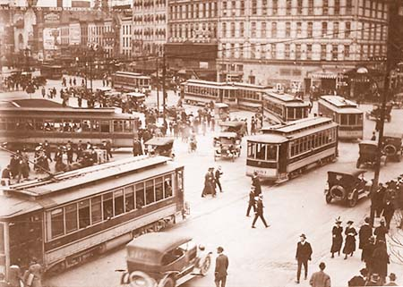
Expectations compared to reality
Detroit many years ago when the roads did not have one-way systems, lights and pedestrian crossings. You can see the people running across the road. All forms of transport were going in different directions. It is obvious from this picture that the roads were very dangerous and unorganised.
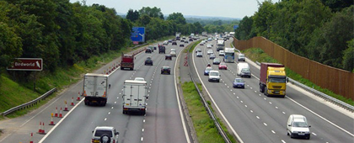
Roads today have been arranged in to one-way systems which have signs which tell you the direction for where you want to go. From this picture you can see that there are cones telling people not to move off past them. There is land in the centre with a metal bar going through the centre to stop other vehicles flying across and hitting in to the traffic going in the opposite direction on the motorway. In the twentieth century cars have become the most frequently used mode of transport in history.

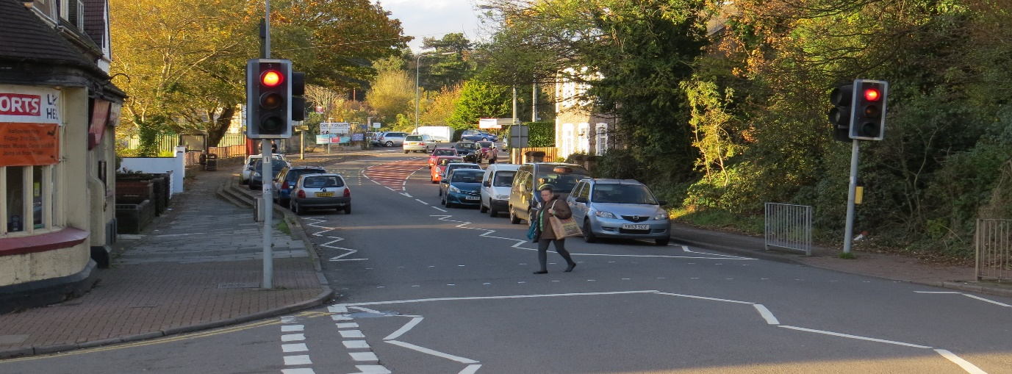
The picture above shows cars following one after the other. This is the systems of today where cars stay behind the traffic lights when they turn to red. As you can see this will allow pedestrians to cross the road whilst all the cars have stopped waiting for them to cross from one side to the other. Lines and zigzags have been printed on to the floors telling the cars not to stop in that area specifically and it tells them where to stop behind the lights.
In historic years cars were used occasionally by those who were wealthy meaning that those who were less fortunate did not get a chance to be able to drive one. In the 1800s it was dangerous to drive the gasoline powered vehicles which would throw out 20 miles per hour. Although this is a small amount of power compared to now, in them days they were deemed as a dangerous amount of speed. People did not understand the effects of taking corners at high speeds which would roll vehicles, kill people and cause severe consequences. This proved that the change from horse and carriage was very dangerous. The nature of horses has now become something that is rare on the roads swapping between them and cars today. Horses could be potentially dangerous if they get out of control and start to become stressed and scared in their environment.
Today we have lights to control traffic telling cars to go and stop. The green, amber and red signals help vehicles travel from one destination to another without any crashes helping those stay safe on the roads. Vehicles now travel in one-way systems and all go in specific directions. Pedestrian crossings are used to help people cross the roads safely. Lines and signs are now everywhere to tell those when to stop and hazards ahead. This includes road works and work exits for heavy goods vehicles. One-way system signs crossings and beacon lights to help those cross the roads. Roads are made from tarmac and are made as smooth as possible to stop cars from receiving flat tired and blow outs.
There were no lights to help pedestrian’s cross roads and no paths for them to walk on. The roads were made from mud and included horse manure all over the roads from horses. Traffic would cross each-other and pedestrians would walk out in to the road weather there was any vehicles there or not. Crossings took a long time to overcome with horse and carriages not knowing weather they can cross without making multiple noises and checking from left to right multiple times before proceeding to travel further.
Today we have vehicles hitting speeds of around 257 mph. The Bugatti chorion is one of the biggest contenders. Comparing that to historic times there has been 237 mph added on top of the previous 20 mph in them days.
They did not think of the consequences when deciding to create things and health and safety did not exist then to keep the public safe. Although there is not much information about the health and safety of roads, it is obvious that this production was very popular resulting in many vehicles being brought over the years.
Majority of people did not have a license because they did not exist in the 1800s which meant that majority were inexperienced and did not understand what they were doing. Compared to today you must take fifty hours of driving lessons and two tests to be allowed to drive. Not all people can understand driving and majority of people struggle to pass these tests. This makes you think about how many people were driving and not knowing what they were doing.
Detroit was the first to put stop signs around the city and create health and safety for those who lived in them days. The roads were dirt tracks to begin with and although I cannot find any information about the first time applying tarmac to make roads, you can see that this product has worked very well with the roads today.
In my opinion they did not have any idea of what they wanted to do with vehicles and how well this organisation would be in the future.
They did not know that the future of vehicles would have so much money included and how many jobs that they would create in the future.
I have researched what the prices for a horse in the 1830s. I have concluded that this would be around 50 shillings which would equal to 1,528.35 in the 2000s. in them days this would have equalled to £2.50.
In about 10 years 2028 Mercedes and Audi believe that by 2026 fully autonomous driving will be ready to be used on the roads. In my belief I think that these vehicles are too futuristic for the roads today. Manufacturers try to better themselves everyday.

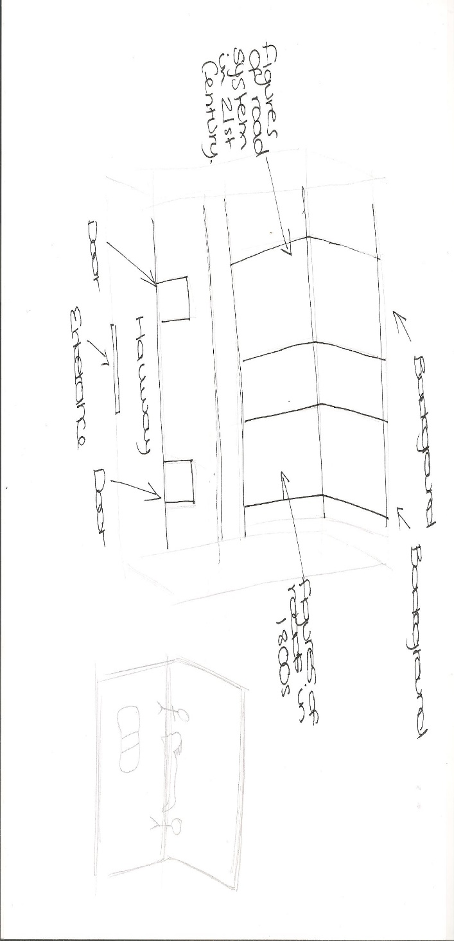

Using the images included in this document I would have a floorplan which would show two roads. This would be the same road, but both pictures would be from different times in history. The first room would include the roads now in the 21st century. The road would clearly show the lights and one-way systems. It would show that people can cross the roads easily and the roads are adapted very well for people to use daily.
The second room would include a picture of a road with figures in the middle of it. This will show how unorganised the roads were and the dangers that people in those days faced daily. It will show that that there are no lights and systems in place. People had to cross the roads without any assistance and all the transport would travel towards each other in dangerous positions.
Comparing all the pictures, you can see that in them days there were practically a couple of vehicles on the roads. They did not have lots of vehicles and not many people could drive. In the 21st century pictures you can see that it is the opposite. You cannot see any horses on the roads and there are many vehicles in a line waiting at the traffic lights. In the room I would include the history on the first pavement road that was created to travel between factories for the vehicle industry.

Bibliography

A History of Roads Hardcover – October 1, 1972 by G Hindley
Detroitnews.com
http://blogs.detroitnews.com/history/2000/02/16/detroits-street-names-honor-early-leaders/
https://news.bournemouth.ac.uk/2015/08/20/a338-roadworks/
https://penarthnews.wordpress.com/2014/11/13/new-road-layout-to-ease-cogan-congestion-is-unveiled/
hidden history by Joe Moran
https://www.fhwa.dot.gov/infrastructure/back0506.cfm
roadswerenotbuiltforcars.com/the-petition-that-paved-america/ carltonreid / on March 21, 2012
http://www.triplenine.org/Vidya/OtherArticles/ABriefHistoryofRoadBuilding.aspx https://www.youtube.com/watch?v=IGehJ3cu4XU
medieval.ucdavis.edu > Money
www.concertina.com/calculator
https://www.digitaltrends.com – Alexander Kalogianni january 12 2016- 3:00am

