Name: Fatema Khatun
Student Number: 2432006
Module Code: LCHS4003
Module Name: Introduction to Health and Social Care
Lecturer’s Name: Aishat Bakre
Assignment Title: Written Assignment
Date: 21st November 2025

Table of Contents

Introduction 1

Effective Communication 1

Administrative Skills & Record Keeping 2

Collaborative Working 3

Conclusion 4

Reference 6

Exploring Communication, Administrative Skills and Collaborative Working in Mrs Mann’s Care

Introduction

Mrs. Mann, a 72-year-old woman recovering at home from hip replacement surgery, receives support from domiciliary care twice a day and regular visits from a community physiotherapist. Her primary language is Urdu, requiring her daughter's assistance for interpreting healthcare information. An internal assessment was initiated due to complaints about poor documentation and communication issues regarding medication changes. This report investigates three critical aspects of health and social care practice in Mrs. Mann's context, the importance of effective communication in interacting with service users and their families, the need of strong administrative skills for proper data management and record keeping in compliance with relevant laws, and the importance of collaboration among healthcare professionals like GPs, physiotherapists, and caregivers, alongside strategies to enhance multi-agency practice and address common challenges.

Effective Communication

Safe, person-centred care emphasises the importance of effective communication, especially for individuals with language or cultural barriers. Effective communication fosters confidence, safety and wellbeing by allowing service users to understand their care and make informed decisions (QCS, 2024). Conversely, poor communication can lead to errors and anxiety, as for Mrs. Mann's case, where unclear communication resulted in a missed medication adjustment. Berlo's SMCR model (1960) provides a framework for understanding communication (as seen in Figure 1 below), focusing on the critical components of Sender, Message, Channel, and Receiver, each influenced by various factors essential for successful communication.
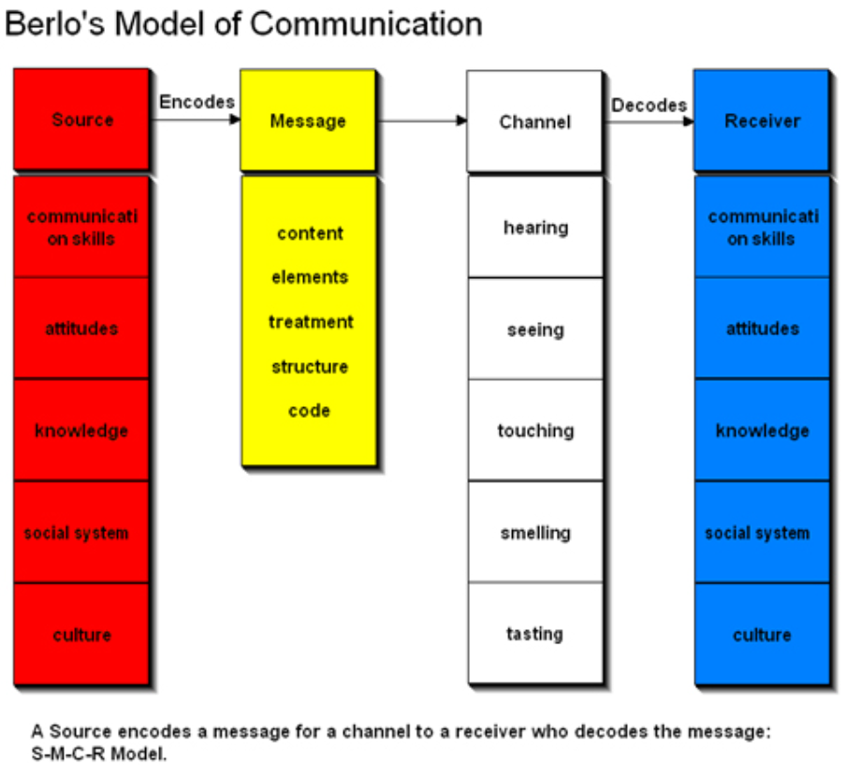
Fig 1. Berlo’s model of communication (Social Engineer, 2022).

Effective communication depends on the 'Sender's' ability to convey messages clearly through skills in speech, attentive listening and adaptability to the audience. These capabilities are shaped by the Sender's attitudes, such as respect and cultural awareness. Staff are able to provide appropriate advice when they possess sufficient knowledge of the subject. Additionally, cultural elements like language, religion and customs, influence both how information is sent and interpretated. Furthermore, social systems include values, beliefs and laws which plays a vital role in shaping the Sender's approach to communication.
(Journalism University, 2024). The information shared is referred as the 'Message', which includes essential information like pain management guidelines. It highlights Mrs. Mann's potential understanding to information despite language barriers via tone, body language, and gestures. The way message is conveyed is referred as the 'Treatment'. A respectful and patient delivery of the message improves understanding and trust. The 'Structure' involves organising the message into clear, step-by-step instructions to help understanding. Finally, the 'Code' refers to the language or symbols used for communication, including visual aids and languages like English or Urdu (Kumar. R, 2024).

The delivery of a message is facilitated by the 'Channel,' which emphasises the significance of the five senses in communication. Effective communication is reliant on various methods beyond verbal interactions, including explanations (hearing), mobility guidance (touching) and physiotherapy demonstrations (seeing). The 'Receiver' plays a crucial role in decoding the message, influenced by their communication skills, culture, and social context. Successful communication occurs when the sender's message is understood by the receiver. The case of Mrs. Mann highlights the importance of employing qualified translators due to her limited English proficiency and the potential cultural differences that affect her ability to communicate effectively (Kumar. R, 2024). To ensure accessibility for non-English speakers and prevent discrimination, providers must comply with the Equality Act 2010 by making necessary adjustments such as offering visual aids, interpreters or translated materials (GOV UK, 2010). The NHS emphasises clear and culturally appropriate communication, allowing patients like Mrs. Mann to understand their care, make informed choices and build trust in their healthcare providers (NHS, 2025a).

Administrative Skills & Record Keeping

A key component of safe practice is having strong administrative skills, especially precise record keeping. The case of Mrs. Mann illustrates the negative effects of inadequate record keeping and slow communication, which led to a missed medication review. Since records serve as the primary means of communication between professionals, they must be accurate, factual, current and available to all parties involved in treatment. Good records provide continuity and enable prompt decisions on mobility, discomfort and the course of rehabilitation (Mathioudakis. A, Rousalova. I, Gagnat. A. A, et al., 2016). Several frameworks serve as guidelines for record keeping duties. According to the Data Protection Act of 2018, “personal information must be gathered legally, kept accurate, secure and used only when absolutely necessary” (GOV UK, 2025). Because Mrs. Mann's records include sensitive information, they must be protected from improper sharing or unauthorised access. In order to foster transparency and confidence, service users are entitled to request corrections and to know how their information is used.

Legal information processing is also governed by the Caldicott Principles. According to these guidelines, personal data should be accurate, shared only with those who need to know, accessible only when care is required and service users should be made aware of how their data is handled (GOV UK, 2020). By following these guidelines, Mrs. Mann's privacy remains secure while crucial information is disclosed to facilitate safe decision making.
Following these guidelines lowers the possibility of improper data exchange or disjointed notes, which is especially crucial in community based care where several agencies and specialists are engaged. Transparency, trust and involvement in care are further encouraged by giving service users explicit explanations of how their data is maintained and used.

Accurate documentation is crucial, according to professional standards like the NMC Code and CQC standards. According to the NMC Code, documents must be current and completed at the time or as soon as possible (NMC, 2023). In order to facilitate safe, coordinated care, the CQC mandates that providers keep accurate, comprehensive and detailed records (CQC, 2025). These frameworks also emphasise the need for records to be readable, dated, signed and securely stored so that authorised staff may access them promptly. This reduces the possibility of missing details, contradicting recommendations or redundant work. Professionals show accountability and consistency by adhering to these guidelines. By ensuring prompt communication between the physiotherapist, GP and domiciliary care team, improved record keeping in Mrs. Mann's case may have helped avoid the medication adjustment delay. Improved adherence to these criteria would also make it easier for staff to monitor her development, allowing for timely modifications to her care plan and lowering clinical risk.

Collaborative Working

In order to guarantee that Mrs. Mann receives safe, coordinated, and person-centred care, effective collaborative working is crucial. Joint teamwork allows for an integrated approach to rehabilitation, pain management and everyday life responsibilities because she depends on many providers such as domiciliary carers, her GP and physiotherapist. Restoring mobility, boosting confidence and avoiding difficulties like falls are the common goals of multi-agency collaboration, which guarantees that each professional contributes their experience. Plans for shared care are essential to this collaboration. All providers can better understand how to support Mrs. Mann thanks to these plans, which outline agreed upon interventions, duties, and progress monitoring arrangements (NHS, 2025b). For instance, as part of personal care, carers might reinforce the mobility exercises that the physiotherapist recommends on a daily basis. Frequent verbal and written communication help this process. Coordinated responses to new needs are made possible by progress notes and prompt updates to general practitioners about changes in pain or mobility. To guarantee that information is up to date and distributed across organisations phone consultations or digital communication tools are helpful.

Multi-agency collaboration can be difficult. Uncertain role boundaries, a lack of communication time and rough documentation are some examples of obstacles. Professionals may not be able to accurately assess Mrs. Mann's symptoms or progress due to language issues, especially if family members are the only ones who can communicate. Professional interpreters, good documentation and shared electronic medical records can all help to overcome these obstacles and improve accuracy and clarity. Professionals are encouraged to evaluate their work on a regular basis and modify care plans as necessary (Catalystgrp, 2025). Duplication or care gaps can be prevented by making sure that roles and tasks are clearly assigned. Better results, continuity of treatment and fewer return to the hospital are all facilitated by collaboration. By ensuring that care feels coordinated and constant, it also improves the experience of service users. In Mrs. Mann's case, improved collaboration would guarantee prompt medication adjustments, steady rehabilitation and a shared understanding of her cultural and communication requirements.

Conclusion

In conclusion, the case of Mrs. Mann serves as an example of how crucial it is for health and social care providers to have strong coordination, accurate administration and excellent communication. To improve safety and participation in decision making processes, methods of communication must be easily accessible, culturally aware and tailored to Mrs. Mann. Furthermore, according to relevant legislation such as the Data Protection Act of 2018, the Caldicott Principles, the treatment Quality Commission (CQC) standards, and the Nursing and Midwifery Council (NMC) Code, careful record keeping is essential for guaranteeing continuity of treatment and reducing risks. By coordinating priorities and ensuring mutual understanding, collaboration among carers, physiotherapists, general practitioners and families improves safety and rehabilitation outcomes. When taken as a whole, these ideas promote safe, person-centred care and assist Mrs. Mann in retaining her independence while she recovers.

Reference
(Catalystgrp, 2025). Importance of regular review and adaptation of care plans. Catalyst Care Group. Available at: https://catalystgrp.co.uk/blog/importance-of-regular-review-and-adaptation-of-care-plans/ (Accessed: 7 November 2025).

(CQC, 2025). Regulations for service providers and managers. Regulation 17: Good governance - Care Quality Commission. Available at: https://www.cqc.org.uk/guidance-regulation/providers/regulations-service-providers-and-managers/health-social-care-act/regulation-17 (Accessed: 7 November 2025).

(GOV UK, 2010) Equality Act 2010. Available at: https://www.legislation.gov.uk (Accessed: 7 November 2025).

(GOV UK, 2020). The caldicott principles. GOV.UK. Available at: https://www.gov.uk/government/publications/the-caldicott-principles (Accessed: 7 November 2025).

(GOV UK, 2025) Statute Law Database. Data protection act 2018. Available at: Legislation.gov.uk. https://www.legislation.gov.uk/ukpga/2018/12/part/3/chapter/2 (Accessed: 7 November 2025)

(Journalism University, 2024). Understanding the SMCR model of the Communication Process • Journalism University. Journalism & Mass Communication Hub. Available at: https://journalism.university/integrated-communication-practices/understanding-smcr-communication-process/ (Accessed: 7 November 2025).

(Kumar. R, 2024). Berlo’s SMCR model of communication. JMC Study Hub. Available at: https://jmcstudyhub.com/berlos-smcr-model-of-communication/ (Accessed: 7 November 2025).

(Mathioudakis. A, Rousalova. I, Gagnat. A. A, et al., 2016). How to keep good clinical records. Breathe (Sheffield, England). Available at: https://pmc.ncbi.nlm.nih.gov/articles/PMC5297955/ (Accessed: 7 November 2025).

(NHS, 2025a) Reasonable adjustment flag - NHS england digital. Available at: https://digital.nhs.uk/services/reasonable-adjustment-flag (Accessed: 7 November 2025).

(NHS, 2025b). NHS choices. Available at: https://www.england.nhs.uk/medicines-2/regional-medicines-optimisation-committees-advice/shared-care-protocols/ (Accessed: 7 November 2025).

(NMC, 2023). Read the code online. Available at: The Nursing and Midwifery Council. https://www.nmc.org.uk/standards/code/read-the-code-online/ (Accessed: 7 November 2025).

(QCS, 2024) Effective communication in health and Social Care. QCS. Available at: https://www.qcs.co.uk/effective-communication-in-health-and-social-care/ (Accessed: 7 November 2025).

(Social Engineer, 2022) Communication models. Security Through Education. Available at: https://www.social-engineer.org/framework/information-gathering/communication-models/ (Accessed: 15 November 2025).

