
Strategic planning for Microsoft Coporation
Strategic Management (BMMB7013)

May 9, 2019
UWTSD
Joshua Peterson – P145427

Contents
Executive Summary 3
1.0 Introduction 5
1.1 Literature Review 5
1.2 Background of Microsoft 5
1.3 Scope of Report 6
2.0 Strategic Analysis 7
2.1 Macroenvironment 7
Political 7
Economic 7
Social 8
Technological 8
Legal 8
Environmental 8
2.2 Industry and Competitors 9
Power of Suppliers 9
Threat of New Entrants 9
Threat of Substitutes 10
Power of Buyers 10
Competitive Rivalry 10
2.3 The Organisation 11
Xbox Play Anywhere 11
Backwards Compatibility 11
2.4 SWOT Analysis 12
Strengths 12
Weakness’s 12
Opportunities 12
Threats 12
3.0 Strategic Choices 13
3.1 Innovation 13
3.2 Acquisition 14
3.3 Cost Leadership 15
3.4 New Markets 15
4.0 Strategy in Action 17
4.1 Unfreeze 17
4.2 Change 18
4.3 Refreeze 19
5.0 Conclusion 20
Bibliography 21
Appendices 25
Appendix A - Exploring Strategy Framework 25
Appendix B - Layers of the Business Environment 25
Appendix C - Porters 5 Forces 26
Appendix D - Porters Generic Strategies 26
Appendix E - Ansoff’s Matrix 27
Appendix F - Boston Matrix 27

Executive Summary
Microsoft corporation develops, licenses, and supports a range of software products and services.
Microsoft recorded unit sales for the Xbox One in 2018 to be 6.96 million, substantially lower than their competitors as Nintendo recorded unit sales of 17.05 million for the Nintendo Switch and Sony with their PlayStation 4 at 18 million unit sales.
This report will perform an external and internal analysis of Xbox using models such as the Layers of the Business Environment, PESTEL analysis, Porter’s Five Forces and SWOT analysis.
The key finding from the SWOT analysis are; increased number of middle-class consumers in foreign markets, increased amount of exports from the US, technological advancements within the industry and the how the power of the consumer is high in this industry.
Strategic Choices were put forward for Xbox for various reasons such as;
- Investigating new international markets in order to improve brand exposure and increase sales outside of their domestic market.
- Investigate acquiring smaller gaming companies in order to obtain their assets and personnel to produce products exclusively for them.
- Optimizing a cost-leadership approach in order to obtain increased sales by countering the power of the consumers within the industry.
- Create new products which would rival the Nintendo Switch in the portable gaming market.
Xbox need changes due to declining sales compared to rival competitors.
The report investigates how the proposed changes would be implemented into the company.
It is advised that Xbox implement these changes slowly as they do not want to disrupt their current activities within the industry.
Considering all stakeholders is important, especially those who would have a bigger impact of the potential success of the change such as employees and managers.
The report also puts forward recommendations post-change in order to continue business growth. The company should continue to innovate new products and expand into new markets.

Introduction
This report will investigate the strategic direction of Microsoft and analyse external and internal factors that could potentially affect Microsoft. From this, options will be created to meet customer expectations and create sustainable competitive advantage. This report will also put forward robust recommendations for Microsoft to move forward.

1.1 Literature Review
This report is structured around a three-part framework which is the exploring strategy framework (Appendix A). This framework is made up of understanding the strategic position of Microsoft, which will include the use of models to understand both external and internal factors affecting the company. Assessing strategic choices which will analyse Microsoft’s current resources and capability and produce viable options for them to pursue in the future. Finally, how Microsoft will cope with the changes being suggested and the potential impact it may have on their stakeholders (Johnson, et al., 2017).

1.2 Background of Microsoft
Microsoft corporation develops, licenses, and supports a range of software products and services, such as; operating systems, business-solution applications, desktop and server management tools, video games and consoles, and mobile devices.
Microsoft reported revenues of US$110,360 million for the fiscal year which ended in June 2018, an increase of 14.3% over FY2017. The company reported a net margin of 15% in FY2018, compared to 26.4% in FY2017. The company currently has over 131,000 employees (MarketLine, 2019).
“Microsoft enables digital transformation for the era of an intelligent cloud and an intelligent edge. Its mission is to empower every person and every organization on the planet to achieve more.” (Microsoft, 2019).

1.3 Scope of Report
In terms of scope this report will be delving deeper into business-level strategy. This report will be focusing on business-level strategy, focusing on market positioning to help the company potentially gain a competitive advantage in its own industry or other industries (Corporate Finance Institute, 2019).
Narrowing the Scope even further this report will focus on Horizon One of the three Horizons framework, focusing on the core business’s which are already identified with the company. This report will focus on improving performance of these business’s in order to maximise their remaining value (McKinsey & Company: Strategy and Corporate Finance, 2009).
This report will investigate the strategic business units (SBU) of Microsoft. An SBU is a fully functioning unit that has its own vision and direction. SBU’s operate as an independent entity but must report directly to parent company about the status of their operations (The Economic Times, 2019). The SBU which this report will focus is Xbox.
Xbox is a video gaming brand, which has released three different generations of consoles. These consoles are known as the Xbox, Xbox 360 and the Xbox One. These consoles allow access to play many video games, including exclusives which are only available on the Xbox family. These consoles also allow access to the use of apps such as Microsoft Edge and streaming sites like Netflix and Now TV (Microsoft, 2019). Microsoft recorded unit sales for the Xbox One in 2018 to be 6.96 million, substantially lower than their competitors as Nintendo recorded unit sales of 17.05 million for the Nintendo Switch and Sony with their PlayStation 4 at 18 million unit sales (Statista, 2019).

Strategic Analysis
This segment of the report will analyse Microsoft’s current position in the gaming market. This report will make use of the layers of the business environment (Appendix B) (Johnson, et al., 2008).

2.1 Macroenvironment
This section of the report will cover the first outer layer of the business environment which is the Macroenvironment. To perform this analysis a PESTLE analysis is recommended as it groups potential affecting factors into six categories; Political, Economic, Social, Technological, Legal and Environmental and will be separated according to their negative or positive influence on the company (Srdjeci, et al., 2012).

Political
Political factors such as international trade rising can influence Microsoft. As of 2016 there was estimated to be $15.82 trillion worth of goods being shipped out of the US and in 2017 that number grew to an estimated $17.31 trillion, showing a steady increase. However, the amount being of imports from other countries has increased from $16.01 trillion to $20.01 trillion (Central Intelligence Agency, 2019).
This can have a huge impact on Microsoft, in terms of sales for the Xbox One. This means that the demand for American goods is improving, which means there is a greater market for the console. However, there is also the threat of foreign competitors being able to capitalise in the steady increase in global trade.

Economic
Economic factors can also have a major influence on Microsoft. Such as the rise of Global Middle Class. The likes of China, India and Brazil have propelled their countries to equal the size of industrialised countries such as the UK or the US. It is forecasted that by 2050, these countries will account for nearly half of the world output (Yueh, 2013).
This can be considered an opportunity for Microsoft as this means that there is a bigger middle-class population with more disposable income. This could potentially create more demand for luxury products such as the Xbox One.

Social
Social factors can have an affect on Microsoft, such as how consumers are purchasing more products and services in the “leisure” market. This is backed up by the increased amount of spending in the gaming industry in the UK. In 2017, £790 million was spent in the UK alone on boxed software, this increased by 3.1% from the previous year where consumers spent £766.7 million (Statista, 2019).
This can be an opportunity for Microsoft as their sales continue to grow, showing that there is increased demand for products in their market.

Technological
Technological factors have a huge affect on the gaming industry, due to the forever changing need to improve upon their hardware and software to consumer interest high. This is emphasised on the need for the major companies in this sector to release new consoles. PlayStation have already started to release their next generation specs for their new console to be released the PlayStation 5, highlighting the support for 8K television’s and a new 8-core AMD chipset which is set to create significant improvement as it runs 19 times faster than previous generations of console (Lynch, et al., 2019).
This highlights that this factor can both be an opportunity and a threat to Microsoft. An opportunity due to the possibilities which Microsoft can improve upon the Xbox One and increase demand, however a threat due to the console having competitors which can steal their market share if they do not keep up with their competition.

Legal
Microsoft could potentially improve their patents to improve upon their position in the market. Patents are government licensing over the making, using or selling of an invention over a set period. The use of a patent to improve upon the performance of the Xbox One over their competitors would improve the products position in the market drastically.

Environmental
Environmental factors can have another impact on the consumer perspective of Microsoft. This ultimately can influence the potential demand for the products and services Microsoft offer. However, Microsoft can use this as an opportunity due to their outlook on looking after their environment. Offering sustainable packaging, reducing paper waste and reducing their logistics and manufacturing footprint, to reduce their global footprint (Microsoft, 2019). This will have a positive impact on the way consumers perceive Microsoft and their products, such as the Xbox One.

2.2 Industry and Competitors
This next section of the report will cover the next two layers of the business environment, which is the industry analysis and analysing their competitors. To cover this section of the report, Porters 5-forces (Appendix C) model will be used to cover all industry factors. The factors covered in the 5-forces are Power of Suppliers, Threat of New Entrants, Threat of Substitutes, Power of Buyers and Competitive Rivalry (The Veterinary Record, 2014).

Power of Suppliers
Power over suppliers can have a direct impact of how much Microsoft are paying for their supply. When a company has few suppliers then they are unable to command better terms with their suppliers. However, when a company produces at larger volumes and has a diverse number of suppliers then they can demand better terms with their suppliers (Porter, 2008).
When analysing Microsoft and their supply they use a diverse range of suppliers to get the best terms possible. Microsoft have stated that they foster greater levels of diversity in their supplier base to reflect the global diversity of their customers (Microsoft, 2019). From this, Microsoft have a range of suppliers to choose from and show that they can gain better terms from them due to competition.

Threat of New Entrants
Threat of new entrants is assessing how easy it is for rival companies to enter the gaming industry and steal market share. Economies of Scale can have a factor in this industry as the greater volume a company like Microsoft produces their product will affect the cost and efficiency they produce the product, making it difficult for new entrants (Kirchner, 2012).
Due to this, companies with less resources and substantially less funding will struggle to enter the market. However, Google have announced that they will be entering the gaming market with a new console the Google Stadia. Highlighting that there are potential threats of new entrants into the market (Metro, 2019). This shows that tech giants, such as Google and potentially Apple have the resources to enter the market.

Threat of Substitutes
The threat of substitutes are products or services which can affect Xbox’s sales and steal their market share but are not considered a direct competitor. These competitors tend to offer a slightly different product/ service or offer it at a lower price (Wu, et al., 2012).
The threat of substitutes who offer products at a lower price are minimal now, with no clear competitor operating in this market. This forces consumers to purchase older generation consoles which Microsoft operate in with the Xbox 360. However, this console can no longer be purchased by Microsoft and can only be bought from second-hand retailers.

Power of Buyers
In terms of Xbox, their buyers are consumers. This can be considered the flipside of supplier power, where the consumers can demand better quality products and potentially drive down prices, thereby forcing the companies to compete aggressively with one another (Pringle & Huisman, 2011).
This is evident in the gaming industry. In 2008, despite the Xbox 360 (11.16 million units) outselling the PlayStation 3 (10.46 million units), neither console came close to the amount of sales made by Nintendo Wii (24.09 million units). This was due to the Nintendo’s innovative nature and appealed to most families with their use of family friendly games and motion control. Another potential factor affecting buyers is the price of the consoles, as in 2014, the first full year for sales of the PlayStation 4 (14.59 million units) and the Xbox One (7.91 million units) (Statista, 2019), the Xbox One sold less due to its higher price tag of £429.99 compared the PlayStation 4’s price tag of £349.99 (Williams, 2013).

Competitive Rivalry
Competitive rivalry is the current competitive struggle for market share amongst competitors in the same industry (Porter, 1998).
Firstly, it is important to point out that this industry is currently in the maturity stage of the industry life. This stage points out that there low growth for these companies now and higher entry barriers and dominating market share for companies in this industry is key for success (Vereynne & Meyer, 2010). The industry can also be considered an oligopoly due it being dominated by a few firms and they have power over their suppliers and their buyers (Johnson, et al., 2017).
From this, the industry is made up of three key players in Nintendo, Xbox and PlayStation. Nintendo, however, tend to operate within a niche market as their consoles offer different benefits to those offered by Xbox and PlayStation as they focus on travelling and family orientated experiences. Xbox and PlayStation on the other hand battle it out to produce the most powerful console for their consumers. However, as shown in the buyer power section that pricing can have a huge impact on sales.

2.3 The Organisation
This section of the report will focus on Microsoft’s capabilities and resources, giving them distinctive capabilities within the gaming industry and what sets them apart from their competition. The use of a VRIO framework will be used to demonstrate how the company’s capabilities and resources can create competitive advantage (Chinho, et al., 2012). This section will identify the capabilities and then apply them to the framework.

Xbox Play Anywhere
Xbox play anywhere is an exclusive feature which is only available on the Microsoft owned systems. Games compatible with the feature digitally purchased on the Xbox One system will allow the consumer to play their game on their PC or Laptop. This capability is valuable to the consumer as it them the freedom to play their favourite games while travelling without having to bring the entire console (Microsoft, 2019). The capability is rare as they are the only console to allow their games to be played on different hardware. This feature would be very costly for the likes of Sony to imitate due to Microsoft only allowing Xbox games to be played on their Windows systems. The service is not quite organized to capture value as it only offers a few games from the Xbox Store and does not include disc-copies of the games.

Backwards Compatibility
Backwards compatibility is a feature from Xbox which allows Xbox One players to play games from older generation Xbox’s such as the Xbox and Xbox 360 (Microsoft, 2019). The capability is valuable as it gives consumers the possibility to play old games on their new console. The capability is rare as their competitors do not use this feature on this console. However, the capability is not costly to imitate as there are no barriers for competitors to use a similar feature.

2.4 SWOT Analysis
To summarise this section a SWOT analysis will be performed in order to make it clearer as to what strengths, weaknesses, opportunities and threats Xbox have.

Strengths
The internal strengths for Xbox are;
- High Barriers of New Entry.
- Very Low Threat of Substitutes.
- Industry is in an Oligopoly.
- Industry is in the Maturity Stage.
- Valuable Resources and Capabilities such as; Xbox Play Anywhere and Backwards Compatibility.

Weakness’s
- Power over Buyers is low.
- Competitive Rivalry is high.

Opportunities
- Increase in overseas exports could improve international sales.
- Increase in middle-class population could result in improved sales.
- Increased consumer spending in leisure market could improve sales.
- Technological advancements could result in competitive advantage for Xbox.
- Possibility to improve consumer perspective by using recyclable packaging and reducing carbon footprint.

Threats
- Increase in domestic imports could create more competition within the US.
- Failure to keep with technoligcal advancement could result in competitive disadvantage.

Strategic Choices
After analysing the strategic position of Xbox. This section of the report will analyse different possible choices for Xbox to consider moving forward. This section will be split into four sections; Innovation, Acquisitions, Cost Leadership and New Markets. This section of the report will consider Porters Generic Strategies, Ansoff’s Matrix and Boston Matrix Appendix D, E and F).

3.1 Innovation
Innovation is key in gaining a competitive edge in the console industry. Nintendo and PlayStation have been trying new possible solutions to attract consumer interest, with the use of motion control, virtual reality and portability. However, Xbox on the other hand have not been applying radical change to their consoles, instead offering new services to their existing consoles.
The Xbox One can be considered to be on the decline at this stage of its lifecycle, when comparing it to the Boston Matrix due to reduced sales since launch and is becoming a Cash Cow for Microsoft at this stage (Moles & Terry, 1997). So, it may be the right time to start looking into other product for the company to move on to.
When looking at corporate strategy directions it may be possible for Xbox to penetrate an existing market with a new product or service (Haq, et al., 2008). Xbox have the resources and capabilities to produce new viable alternatives to their existing products. Xbox could try to enter the portable console market, which is currently dominated by the Nintendo Switch. The Nintendo Switch offers high definition gaming which can be both plugged in to the television and used as a handheld device. However, the variety of games available on the Switch is limited, compared to the Xbox games library.
Due to this, if Xbox were to enter the portable gaming market then they could gain an advantage due to their variety of games available. However, the Nintendo Switch may continue to dominate this market if Xbox do not deliver a product of high quality. This is evident due to PlayStation failing in this market with their PlayStation Vita.
The possibility of entering the portable gaming market can be measured upon previous testers within the industry. Of course, the Nintendo Switch has been a huge success for Nintendo, however this does not necessarily mean the same will happen for Xbox, especially considering how the PlayStation Vita suffered in terms of sales and reception from consumers (Statista, 2019). So, this strategic choice must be considered with a lot of scepticism, however the argument can be made that there is room in this market for a strong competitor to the Switch, however the product must be delivered and ready to compete with the Switch in terms of marketing and customer value.

3.2 Acquisition
Mergers and Acquisitions can have many benefits for a company who see value in another company. In Xbox’s case it would be to gain key personnel and talent in the hope that the acquired company can help innovate and develop future products to become a success (Leanord, 2019).
Acquiring new gaming developers can be a critical factor effecting sales in the console market. Each console manufacturer has their own exclusive rights to certain games. PlayStation own Insomniac Games, which develops games such as Marvel’s Spider-Man, The Last of Us and the Uncharted series and Santa Monica which develops the God of War series. These developers give PlayStation a huge advantage in the market due to them bringing consumer demand for the PlayStation as these games are only available on PlayStation (PlayStation, 2019).
Xbox, on the other hand have a much more limited range of exclusive games, with their standout titles being the Gears of War, Halo and Forza franchises. However, they lack in console exclusives compared to the PlayStation 4.
It could be suggested for Xbox to make partnerships or potentially acquire third-party developers, so that only Xbox would receive the rights to their games. A potential suiter which would complement Xbox’s multiplayer focused approach would be Epic games. Epic Games are a third-party developer, whose games are available across all console platforms and have created quite a successful following due to their huge success in FortNite. Epic games have also purchased Psyonix which developed the award-winning Rocket League (Thielmeyer, 2019).
Xbox acquiring Epic Games would potentially increase demand for their console due Epic games being so popular in the gaming market. However, there is always the possibility of a clash in culture between the two firms and Epic Games struggle to produce their best work under new management.

3.3 Cost Leadership
After the results in Strategic position showed that there is a lot of power in the buyer power, it may be suggested for Xbox to take a cost leadership approach. Cost-leadership is when a company offers the lowest cost product or service to their buyers (Murray, 1988)
Through Xbox adopting a cost leadership approach before the start of the next generation of consoles would help Xbox gain a huge market share. Xbox could offer a cheaper console like the way that the iPhone operates in the mobile phone industry with their iPhone XR. By offering a budget console for consumers so they can choose which console is right for them. Also, looking at the console specification’s PlayStation announced for their new console, some of the features may not be relevant to everyday consumers, such as the use of 8K resolution. Xbox could offer a console without this feature and at a lower price and this could influence the market share of the console industry.
Considering how well the iPhone XR is performing for Apple as the product makes up 38% of the iPhone sale (Eassa, 2019), this questions whether a similar product could perform well in other technological industries. This highlights that offering a budget version of their next console could increase consumer demand, however this could be costly if consumers do not see the value in the product if the product is missing vital features.

3.4 New Markets
It may possibly a solution to enter new markets and focus on market development (Hussain, et al., 2013). As shown in the Strategic Position segment of the report there is greater emphasis on consumer spending in developing countries due to their higher disposable income.
Despite this Xbox struggled to sell Xbox One units at launch in Japan (38,000 units), compared to the PlayStation 4 selling 322,000 units. This shows that Xbox struggle to dominate foreign markets.
This could be down to lack of knowledge in these markets, disregarding culture and consumer expectations in these countries or potentially consumer loyalty to Nintendo and PlayStation products (Tassl, 2014).
By exploiting emerging markets, Xbox will have greater demand in their products, highlighting the need to not only perform domestically, but internationally. However, if Microsoft continue to disregard the culture in these foreign markets then they may continue to suffer.

Strategy in Action
This section of the report will analyse why action is needed, barriers against change and reasons as to why the change may be unsuccessful or successful. It is important that Microsoft do not deteriorate their competitive action due to their failure to respond to changes in the business environment, this is known as strategic drift (Summut-Bonnici, 2015). This section of the report will make use Lewin’s Three Step Change model (Schein, 1996), whilst making heavy reference to the Kubler-Ross change curve (Change Management Coach, 2019)

4.1 Unfreeze
Xbox need to change as they are falling behind their opposition in terms of sales and market share. Therefore, the proposed changes in Section 3.0 have been put forward in order to rectify the Xbox’s low sales in both the domestic and international markets.
When considering the Kubler-Ross change curve the company will go through a lot of shock due to the proposed changes and could potentially affect many stakeholders within the organisation such as employees and managers. It is vital to ensure that these stakeholders are kept informed to ensure that the changes will not only create value to the company, but to them as well. This is because these stakeholders can be considered key players in terms of ensuring that the changes are a success (Newcombe, 2003). This is vital as the company will try to remove any negative impact that these stakeholders have which could lead to increased frustration and decreased morale.
Each proposed strategic choice brings with it an avenue to achieve business growth and maximise shareholder wealth. This can be through business expansion through acquisition, increased product portfolio or expanding into new markets. These choices have been considered to improve shareholder wealth and improve Xbox’s sustainability.
Of course, there will be resistance to these changes due to them offering a potential clash in culture or potentially changing the Xbox business model, however without these changes, then Xbox may continue to suffer under the same routine problems.

4.2 Change
This section of the report will delve into how the change will be carried out and looking into ongoing factors which may affect the proposed changes.
When considering the Kubler-Ross change curve model this stage of the cycle would be to experiment the changes and gaining an understanding of how they would fit into Microsoft’s core structure. By the end of this stage the company should gain an understanding of how to work within the new system.
Due to the amount of changes being offered and the current position which Microsoft is in regarding Xbox, it could be recommended for Xbox to take an incremental approach towards these changes (Doherty, et al., 2014). This is due to Microsoft being in a healthy financial position and by spreading the time it takes for each strategic choice, will help narrow the focus for each change and also break down the scope of the change into separate activities, rather than trying to rush them through all at once.
It is important for the company to be ready for these changes and plan in order to maximise their potential. This will involve scoping the right companies to acquire, ensuring that they carry out market research in both domestic and foreign markets in order to ensure they deliver the right products and product features to be able to forecast sales.
For Xbox to carry out these changes, they will need some resources available for them to move forward. Firstly, they will need funding to both be able to acquire new companies, but also to improve upon their marketing and sales campaign in emerging markets. They will also need funding, personnel and inventory space for new products such as a portable gaming device or the budget console.
Another factor effecting both the Acquisition and new market proposals Is how culture could potentially affect these changes moving forward. Firstly, in terms of the acquisition choice. It is important that the company they are acquiring fits nicely within Microsoft’s corporate strategy and their corporate culture. If an issue was to arise between the two companies then Microsoft would need to have a contingency plan in place to cool the potential issues or this could derail the acquisition and lead to a loss of investment for Microsoft. Then there is the issue that if Microsoft do not develop an understanding for foreign markets and their culture, without enough marketing and knowledge of their cultural background then the Xbox may suffer in terms of sales in these markets, highlighting the need for market research prior to heavy investment in new markets.

4.3 Refreeze
This section is the final stage of the change process. This section will then convert the changes into the company’s culture and develop ways to sustain the change.
When considering the Kubler-ross model then this is the stage at which Xbox would be looking to integrate these changes into their culture and strategic direction moving forward.
Following these changes into Microsoft’s strategic planning for Xbox. Due to the forecasted increased sales and improving their net profit, Microsoft will hope to improve shareholder value. However, these changes will need to be implemented into the company’s culture.
Following the companies transition through these changes. It is important that the company continues to innovate new products to appeal to consumer expectations, further improves their position in international markets and ultimately improve brand exposure and look for new ways for business growth.

Conclusion
In conclusion, this report has performed an external and internal analysis of Xbox and has pointed out their Strengths, Weakness’s, Opportunities and Threats. This report then focused on the increased number of middle-class consumers in foreign markets, increased amount of exports from the US, technological advancements within the industry and the how the power of the consumer is high in this industry.
Following this analysis, several strategic choices were made for the company to use moving forward. Xbox should investigate entering new international markets in order to improve brand exposure and increase sale outside of their domestic market. They could also investigate acquiring smaller gaming companies in order to obtain their assets and personnel to produce products exclusively for them. There is also the opportunity for Microsoft to take a Cost-Leadership approach for the Xbox and potentially increase their sales due to the buying power of their consumers. Finally, there is the option for Xbox to innovate a new console which rivals the likes of the Nintendo Switch in terms of portability.
Following the strategic choices which were put forward for Xbox, this report analysed how the company would implement these changes, highlighting why the changes are needed such as the declining sales Xbox are having. They would need to plan for these kinds of changes and implement them over a long period of time, so they don’t disrupt the companies ongoing activities. They must ensure that they consider all stakeholders, considering those which could have a bigger effect on disrupting the efficiency of the change. Finally, this report has analysed how Xbox could implement these changes into their corporate culture and expand on them further once completed to further purse business growth and shareholder maximisation.

Bibliography
Central Intelligence Agency, 2019. The World Factbook. [Online]
Available at: https://www.cia.gov/library/publications/resources/the-world-factbook/geos/xx.html#field-anchor-economy-imports
[Accessed 06 May 2019].
Change Management Coach, 2019. Kubler-Ross Five Stage Model. [Online]
Available at: https://www.change-management-coach.com/kubler-ross.html
[Accessed 09 May 2019].
Chinho, L., Hua-Ling, T., Ya-Jung, W. & Kiang, M., 2012. A fuzzy quantitative VRIO-based framework for evaluating organizational activities. Management Decision, 50(8), pp. 1396-1411.
Corporate Finance Institute, 2019. Strategic Analysis. [Online]
Available at: https://corporatefinanceinstitute.com/resources/knowledge/strategy/strategic-analysis/
[Accessed 06 May 2019].
Doherty, T., Horne, T. & Wooten, S., 2014. Managing public services - implementing changes: a thoughful approach to the practice of management. 2nd ed. Abingdon: Routledge.
Eassa, A., 2019. Apple's iPhone XR Is (Still) Dominating U.S. iPhone Sales. [Online]
Available at: https://www.fool.com/investing/2019/04/27/apples-iphone-xr-is-still-dominating-us-iphone-sal.aspx
[Accessed 08 May 2019].
Haq, F., Wong, H. & Jackson, J., 2008. Applying Ansoff’s growth strategy matrix to Consumer Segments and Typologies in Spiritual Tourism. s.l., International Business Research Conference.
Hussain, S., Khattak, J., Rizwan, A. & Latif, M., 2013. ANSOFF matrix, environment, and growth-an interactive triangle. Management and Administrative Sciences Review, 2(2), pp. 196-206.
Johnson, G., Scholes, K. & Whittington, R., 2008. Exploring Corporate Strategy Text & Cases. 8th ed. Edinburgh: Pearson Education Limited.
Johnson, G. et al., 2017. Exploring strategy: text and cases. 11th ed. Harlow: Pearson Education.
Kirchner, M., 2012. Porter's Five Forces in the Finishing Industry. Products Finishing, 76(12), pp. 52-53.
Leanord, K., 2019. The Advantages of Company Mergers. [Online]
Available at: https://smallbusiness.chron.com/advantages-company-mergers-22476.html
[Accessed 08 May 2019].
Lynch, G., Boyle, E. & Hood, V., 2019. PS5: All the games, specs, news, and rumors for Sony’s Playstation 5. [Online]
Available at: https://www.techradar.com/news/gaming/consoles/ps5-release-date-news-and-features-1213409
[Accessed 07 May 2019].
MarketLine, 2019. Company Profile: Microsoft Corporation. London: MarketLine.
McKinsey & Company: Strategy and Corporate Finance, 2009. Enduring Ideas: The three horizons of growth. [Online]
Available at: https://www.mckinsey.com/business-functions/strategy-and-corporate-finance/our-insights/enduring-ideas-the-three-horizons-of-growth
[Accessed 06 May 2019].
Metro, 2019. What is Google Stadia? - When is it out and how much will it cost?. [Online]
Available at: https://metro.co.uk/2019/03/20/google-stadia-much-will-cost-8955120/
[Accessed 06 May 2019].
Microsoft, 2019. Environment. [Online]
Available at: https://www.microsoft.com/en-us/environment/product/lifecycle
[Accessed 07 May 2019].
Microsoft, 2019. Facts About Microsoft. [Online]
Available at: https://news.microsoft.com/facts-about-microsoft/#BusinessOrganization
[Accessed 06 May 2019].
Microsoft, 2019. Procurement. [Online]
Available at: https://www.microsoft.com/en-us/procurement/diversity-overview.aspx?activetab=pivot1%3aprimaryr3
[Accessed 07 May 2019].
Microsoft, 2019. Xbox. [Online]
Available at: https://www.xbox.com/en-US/xbox-one/backward-compatibility
[Accessed 07 May 2019].
Microsoft, 2019. XBOX. [Online]
Available at: https://www.xbox.com/en-GB
[Accessed 06 May 2019].
Microsoft, 2019. Xbox Play Anywhere. [Online]
Available at: https://www.xbox.com/en-US/games/xbox-play-anywhere
[Accessed 07 May 2019].
Moles, P. & Terry, n., 1997. Boston Matrix. In: The Handbook of Internatioanl Financial Terms. s.l.:Oxford University Press.
Murray, A., 1988. A contingency view of Porters "generic strategies". Academy of Management Review, 13(3), pp. 390-400.
Newcombe, R., 2003. From client to project stakeholder: a stakeholder mapping approach.. Construction management and economics., 21(8), pp. 841-848.
PlayStation, 2019. Only On PlayStation. [Online]
Available at: https://www.playstation.com/en-gb/explore/ps4/only-on-playstation/
[Accessed 08 May 2019].
Porter, M., 1998. Competitive strategy: techniques for analyzing industries and competitors. New York: Free Press.
Porter, M., 2008. The Five Competitive Forces that Shape Strategy. Harvard Business Review, 86(1), pp. 25-40.
Pringle, J. & Huisman, J., 2011. Understanding Universities in Ontario, Canada: An Industry Analysis Using Porter's Five Forces Framework. The Canadian Journal of Higher Education, 41(3), pp. 36-58.
Schein, E., 1996. Kurt Lewin's Change Theory in the Field and in the Classroom: Notes Toward a Model of Managed Learning. Systems Practice, 9(1), pp. 27-28.
Srdjeci, Z., Batcetic, R. & Srdjevic, B., 2012. Identifying the Criteria Set for Multicriteria Decision Making Based on SWOT/PESTLE Analysis: A Case Study of Reconstructing A Water Intake Structure. Water Resources Management, 26(12), pp. 3379-3393.
Statista, 2019. Global unit sales of current generation video game consoles from 2008 to 2018 (in million units). [Online]
Available at: https://www.statista.com/statistics/276768/global-unit-sales-of-video-game-consoles/
[Accessed 06 May 2019].
Statista, 2019. Value of the games industry market in the United Kingdom (UK) from 2011 to 2017, by sector (in million GBP). [Online]
Available at: https://www.statista.com/statistics/273511/consumer-spending-on-games-industry-products-in-the-uk-by-sector/
[Accessed 07 May 2019].
Summut-Bonnici, T., 2015. Strategic Drift. Wiley Encyclopedia of Management, 12(1).
Tassl, P., 2014. Outrageously Bad Xbox One Sales In Japan Result In Executive Casualty. [Online]
Available at: https://www.forbes.com/sites/insertcoin/2014/11/29/outrageously-bad-xbox-one-sales-in-japan-result-in-executive-casualty/#5c480a975adb
[Accessed 08 May 2019].
The Economic Times, 2019. Definition of 'Strategic Business Unit. [Online]
Available at: https://economictimes.indiatimes.com/definition/strategic-business-unit
[Accessed 06 May 2019].
The Veterinary Record, 2014. Assessing the industry using Porter's five forces. The Veterinary Record, 174(1), p. 3.
Thielmeyer, M., 2019. Epic Games' Acquisition Of 'Rocket League' Leaves Players With Many Questions And Few Answers. [Online]
Available at: https://www.forbes.com/sites/maxthielmeyer/2019/05/06/rocket-league-epic-games-questions/#6d0c822b25b6
[Accessed 08 May 2019].
Vereynne, M. & Meyer, D., 2010. Small business strategy and the industry life cycle. Small Business Economics, 35(4), pp. 399-416.
Williams, A., 2013. Xbox One and PS4 Launch Price – Compared to the classics. [Online]
Available at: https://www.trustedreviews.com/opinion/xbox-one-and-ps4-launch-price-compared-2904537
[Accessed 07 May 2019].
Wu, K., Tseng, M. & Chiu, A., 2012. Using the Analytical Network Process in Porter’s Five Forces Analysis – Case Study in Philippines. ScienceDirect, 57(1), pp. 1-9.
Yueh, L., 2013. The Rise of the Global Middle Class. [Online]
Available at: https://www.bbc.co.uk/news/business-22956470
[Accessed 06 May 2019].

Appendices

Appendix A - Exploring Strategy Framework
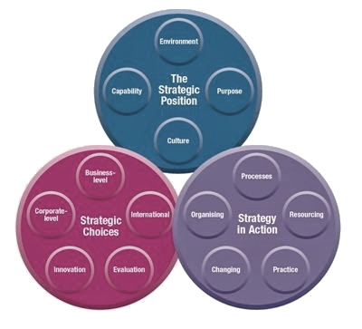

Appendix B - Layers of the Business Environment
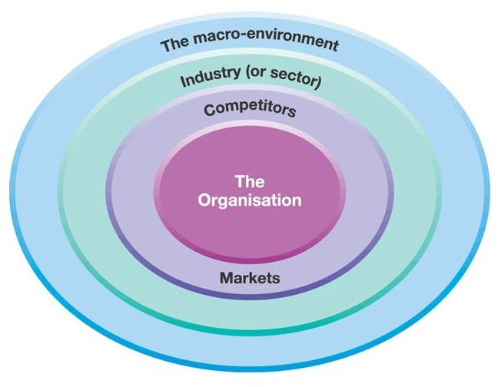

Appendix C - Porters 5 Forces
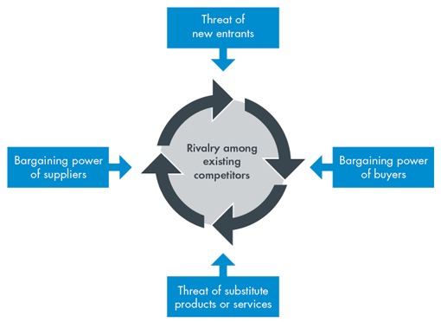

Appendix D - Porters Generic Strategies
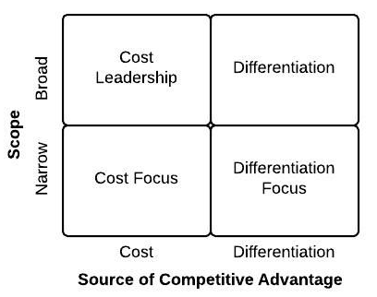

Appendix E - Ansoff’s Matrix
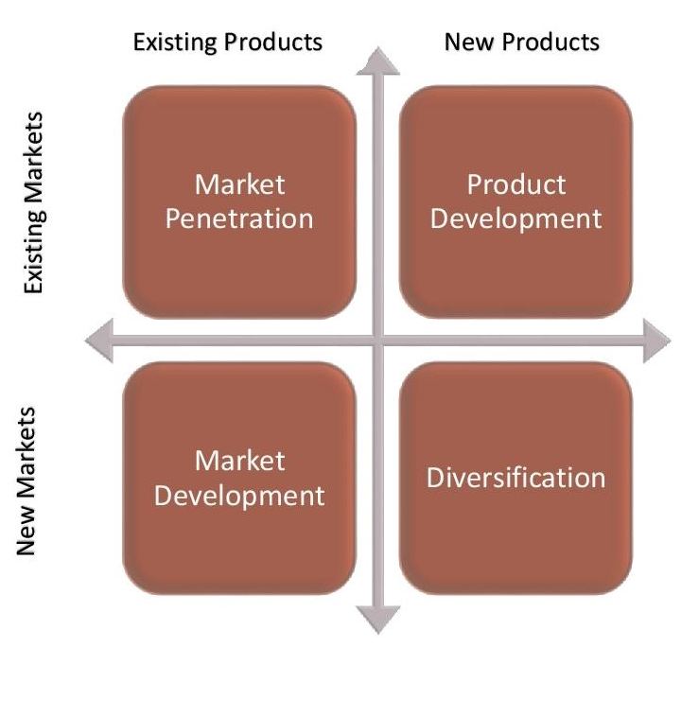

Appendix F - Boston Matrix
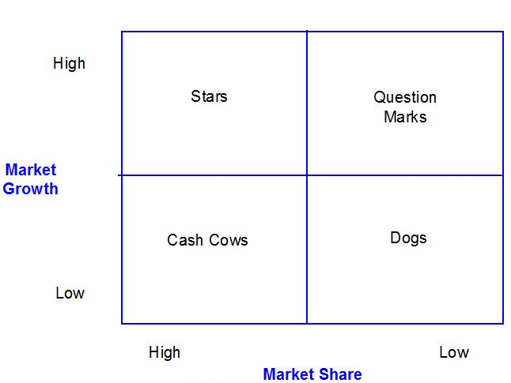

Appendix G – Lewin’s Three Step Model
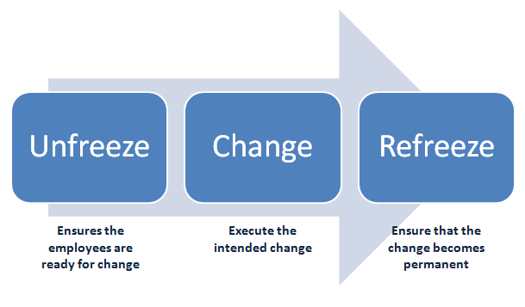

Appendix H – Kubler-Ross Change Curve


