Operations Management for Tourism, Leisure, and Events (BMTP5019)

Scott De Lloyd (2203611)

Deborah Jenkins

Table of Contents
Operational Events Plan - Introduction about operations management: 3
Operational Planning and Procedures - Event Plan, Logistics and Event Set Up: 6
Operational Policies and Procedures including Legal Aspects: 10
Emergency Plan including Emergency Procedures & Risk Assessment relating to Purple Book: 11
HR & staffing Operations - Talent Selection: 12
Workforce Planning 13
Skills Audit and Training Plan 14
Financial and Budgeting - Event budgeting and Financial Evaluation: 14
Financial forecasting 15
KPI’s and Yield management 15
Appendix 17
Reference list 18

Operational Events Plan - Introduction about operations management:

In today's changing business world, organisations are always striving to optimise their operational processes to improve efficiency, productivity, and overall performance. This goal is especially important in the context of entertainment and event management, where accuracy and smooth execution are critical to success. The Swansea Arena, a major facility in the centre of Swansea, Wales, is a monument to the event industry's junction of operations management and marketing. “Business efficiency is not just a buzzword; it is a fundamental element that paves the way for operational excellence, customer satisfaction, and a competitive edge.” Training (2023). This perspective underscores the significance of not merely treating business efficiency as a buzzword but as a tangible and strategic driver for success in the multifaceted landscape of event management.

Swansea Arena serves as a multifaceted event space, hosting a diverse array of concerts and conferences. The arena has swiftly become a focal point for both local and international events, attracting a broad spectrum of audiences. The success of such a multifaceted venue, not only on the quality of the events it hosts but also on the seamless integration of operations management principles within its various departments, with a particular emphasis on the pivotal role played by the marketing department. “Marketing within events relies heavily on communication whether this be in directly informing potential customers of a product offering, in creating a brand image in the marketplace, or through customer feedback and market research.” Masterman (2005, p. 27). This underscores the crucial role that effective communication strategies play in the overall success of the arena's events and the establishment of a strong brand presence.

Operations management is a method of designing, planning, and executing processes that translate thoughts into actions, guaranteeing effective resource utilisation. Operations management is critical to ensuring the seamless flow of activities at Swansea Arena, ranging from ticketing and security to logistics and facility maintenance. The complicated interplay between the operations management team and the marketing department is especially visible when staging large-scale events that need meticulous preparation and execution. As expressed by exeed college, (2019), “Operations management ensures appropriate staffing of employees to resources to get maximum results.” This captures the core of how operations management serves as a crucial driver in optimising the allocation of human resources to diverse activities, assuring the overall performance and effectiveness of the arena's operations during events.

Swansea Arena's marketing team is tasked with building captivating narratives around events to drive ticket sales. Beyond traditional promotional techniques, the marketing team has a big impact on the total customer experience by creating campaigns that resonate with a wide range of target demographics. From social media participation to effective partnerships with sponsors, the marketing department has a significant impact on public opinion of Swansea Arena and its events. According to a study (Rani, 2023), “Storytelling is not merely a marketing buzzword; it is deeply rooted in human psychology. Studies have shown that emotionally engaging content is more likely to be shared.” This insight emphasises the necessity of incorporating emotive and engaging narratives into advertising strategies, reaffirming the idea that storytelling is more than simply a fad; it is a critical factor that drives audience engagement and the effectiveness of promotional efforts.

The connection between operations management and marketing is most visible in the event industry, where event success is determined by meticulous planning, organisation, and execution. To deliver a smooth and delightful experience for customers, the marketing department relies on the operational efficiency of ticketing systems, seating arrangements, and other logistics. In certain circumstances, such as music concerts, preventative tactics have been utilised in event planning to analyse the hazards involved and implement steps to prevent damage. As highlighted by event practitioners (Hutton et al., 2015), “event practitioners to formulate anticipatory planning for celebratory-type events, The physical environment could be controlled, to a certain extent, through event design, safety guidelines, and legislation.” This emphasises the necessity of proactive preparation in reducing potential hazards and guaranteeing the safety and success of various events.

While the integration of operations management and marketing is critical, it is not without obstacles. Coordinating the various demands of both departments, particularly during peak demand periods, necessitates careful planning and communication. Furthermore, technological improvements and altering customer preferences create ongoing challenges and possibilities for these departments to adapt and innovate. Embracing digital platforms, leveraging data analytics, and implementing sustainable practices are some of the ways operations management and marketing may interact for mutual gain. As explained Biljana Teohareva (2012), “Certain information can be extracted from the customer profiles, as for example, which products a particular customer or a group of customers prefers, what are the characteristics of the loyal customers, whether age, income, marital status or other factors have an impact on buying preferences.” This highlights the importance of using consumer data to adjust marketing tactics and operational choices for improved efficiency and satisfaction with consumers.

The joint efforts of Swansea Arena's operations management and marketing departments have strategic effects that go beyond particular events. A well-executed event not only generates immediate cash returns, but it also promotes brand loyalty and excellent word-of-mouth marketing. Swansea Arena's integration of operational and marketing strategies allows it to stand out in a competitive market and position itself as a preferred venue for a wide range of events. As stated by Gayeski (2000, p. 378), “event's success is underpinned by the key competitive factors, which is communication, managerial leadership, and teamwork. This underlines close inter-linkages between the event's team performance and team management” (Belbin, 2010), “with event managers being concerned not only with seamless information and knowledge exchange” (Gayeski & Rowland, 2005), “but also with building human interactions within the team” (Yankelovich, 1999). This highlights the need of excellent communication, leadership, and cooperation in ensuring the overall success of Swansea Arena events.

During the initial planning phase, the event's objectives are thoroughly defined, including audience participation, artist satisfaction, and financial goals. A detailed budget is developed to ensure the flawless execution of various areas, including equipment rental, manpower, marketing campaigns, and contingency plans. As highlighted by Beebe and Masterson (2003), “Communication plays a crucial role during the delivery of an event being a fundamental element of effective project management”. Forsyth (2009), “argues that event managers should adopt a communicative approach in their leadership as a means of understanding the complexity of interactions within (i.e., a team member to a team member)” This emphasises the significance of excellent communication tactics in guaranteeing the smooth planning and execution of the music event at Swansea Arena.

Operational Planning and Procedures - Event Plan, Logistics and Event Set Up:

The logistical issues revolve around the comprehensive selection and confirmation of Swansea Arena as the event venue. This includes getting the required approvals and adhering to local regulations. The complexities of event planning include factors such as musical sound rustication technological limitations, where the use of soundproofing techniques provides suitable sound quality.

Pre-show preparations include the use of flashing lights and customised headphones for children to cater to the different demands of the audience. Additionally, the arrangement of noises around the arena is a purposeful marketing move that creates an immersive experience that customers enjoy. This rigorous preparation not only adheres to safety protocols, but it also helps to the overall success of the event by increasing audience involvement and satisfaction.

Ensuring seamless parking and accessible transportation options is a critical facet of event planning and marketing. The convenience of these logistical elements significantly influences the overall visitor experience and, consequently, the success of the event. Beyond practicality, prioritising accessibility is a powerful statement about inclusivity and commitment to attendee satisfaction. This is particularly true for individuals with disabilities, as well-executed arrangements contribute to a positive customer experience. Clear and timely communication about parking details, transportation schedules, and special provisions for disabled attendees should be integrated into marketing materials. Such upfront information not only manages expectations but also showcases a commitment to attendee well-being. Proximity of parking facilities to the venue and the potential for front-of-the-door services, especially for disabled individuals, further add to the positive image of the event and the hosting company. By attending to these details, event organisers not only enhance attendee happiness but also fortify a robust company perception, fostering loyalty and positive word-of-mouth marketing within the community.

This beneficial connection with well-organised logistical arrangements may be utilised in marketing campaigns to reach a bigger audience and enhance engagement. A seamless and accessible event experience not only enhances satisfaction but also creates a positive ripple effect through word-of-mouth marketing, fostering community engagement and long-term success. “Developing a clear and consistent personal brand that reflects one’s values, strengths, and unique selling proposition (USP). This includes creating a memorable name, logo, tagline, and visual elements that convey a cohesive message across different platforms” (Philbrick & Cleveland, 2015). Furthermore, “Businesses leverage digital channels such as search engines, social media, email and their websites to connect with current and prospective customers” (Desai, 2019).

These logistical considerations align with “the most commonly referenced objectives in Supply Chain Management (SCM), as highlighted in the literature. Objectives such as improved demand planning” (Frochlich & Westbrook, 2002), “reduction of lead time” (Buxmann, von Ahsen, Diaz, & Wolf, 2004), “speed of delivery, control, and reliability” (Ross, 2004; Schnetzler, Nobs, & Sennheiser, 2004), “quality of service” (Hoffman & Mehra, 2000), “and reduction of costs, encompassing production, transportation, and purchase costs” (Buxmann et al., 2004), “as well as inventory-driven costs and product returns costs” (Callioni, de Montgros, Slagmulder, Van Wassenhove, & Wright, 2005). All contribute to the efficiency, safety, and overall success of events held at Swansea Arena. Integrating these SCM objectives into the logistical planning ensures a well-organised and effective execution of events.

In event planning, teamwork between stage and production companies is critical for creating a suitable stage layout that improves both venue aesthetics and audience visibility. These teams' thorough examination of sound and lighting components results in a professional and immersive visual experience. The marketing department's engagement is critical since it guarantees alignment with the overall company aims. The visual elements developed by the stage and production teams are critical in preserving brand continuity, improving audience perception, and becoming essential components of future promotional efforts.

Additionally, the marketing team must align promotional strategies with budget constraints and financial considerations associated with the event. Collaborating with legal teams ensures adherence to regulatory requirements, while cooperation with HR guarantees that backstage areas cater to performers' needs, fostering a positive working environment. This comprehensive approach by the marketing department enhances the overall success of the event by integrating technical execution with brand representation, audience satisfaction, financial viability, legal compliance, and HR considerations.

The logistics of collecting necessary equipment and supplies include coordinating with reputable suppliers for visual equipment, stage materials, and other event necessities. Staffing is also crucial, which includes recruiting and training volunteers, collaborating with professional crews for technical and logistic assistance, and forming a specialised event management team to handle various aspects of the event. “Events are becoming an element in improving the image of tourist destinations, attracting visitors, and stimulating the local economy. Spreading information about events in advance is very important. The use of social media marketing tools helps destinations manage” customer relationships (Todua & Urotadze, 2022). The marketing and promotion plan includes the creation and distribution of captivating promotional materials to raise awareness and enthusiasm about the music event. Event marketing can become one of the effective strategies for increasing brand awareness. The success of a brand in the market is impossible without increasing its awareness (Seturi & Urotadze, 2017). Not only can the event attract a large number of visitors, but it also has the potential to expand the customer base (Five benefits of event marketing, 2023).

A strong ticketing system is put in place to efficiently handle access and attendance. Rehearsals and run-throughs are methodically executed, guaranteeing the ideal incorporation of technical aspects, and addressing any possible concerns prior to the event day.

Beyond marketing’s primary focus on pre-event promotion, the marketing team oversees brand representation, ensuring consistency with promotional materials. They actively engage in on-site promotional activities, manage social media interactions for real-time updates, and facilitate feedback collection from attendees. Adaptability to unforeseen circumstances is a key function, involving collaboration with other departments to implement contingency plans effectively. This holistic involvement ensures that the event aligns with the brand image, marketing objectives, and overall promotional strategy, contributing to a successful and memorable experience for attendees.

While the primary focus of the marketing team is on pre-event activities, such as promoting the event and driving ticket sales, their involvement extends seamlessly into on-site management on the day of the event. Beyond the initial promotional phase, the marketing department takes on a multifaceted role in overseeing critical aspects related to the event's presentation, branding, and overall customer experience.
During the event, the marketing team shoulders various responsibilities. The marketing team works diligently to maintain the effective representation of the brand during the event, ensuring consistency with pre-event promotional materials. Active strategies, including social media interactions, contests, or promotional activities, are implemented to engage attendees and enhance their overall experience. The marketing department actively seeks feedback from event attendees, aiming to gather valuable insights for future improvements and to assess the overall success of the event. Planned on-site promotional activities, partnerships, or sponsorships are executed as part of the comprehensive marketing strategy developed for the event.

The marketing team showcases adaptability in dealing with unforeseen circumstances, collaborating with other departments to implement contingency plans effectively, this can link from events being cancelled or postponed, “further observed that a person losing $100 will lose more satisfaction than a person will gain satisfaction from a $100 windfall” (Kahneman and Tversky 1979). “This means that buyers are more sensitive and more responsive to loss” (Martins & Monroe, 1994; Monroe & Lee, 1999; Scitovszky, 1944).

In summary, although the marketing department's primary role revolves around pre-event promotion, their involvement seamlessly extends to on-site management. This ensures that the event not only aligns with the brand image but also continues to meet and exceed the marketing objectives, contributing to a successful and well-executed experience for both the audience and stakeholders.
Operational Policies and Procedures including Legal Aspects:

Successfully executing a music concert in Swansea Arena requires a well-defined set of operational policies and procedures, delicately braided with legal issues. (Vipin Nadda, Arnott and Sealy, 2020), “Every corporate or special event requires a governing entity to provide proper handling for any kind of situation. A proper understanding of various laws and legislation may not only help with identifying possible challenges, but it may also assist in mitigating situations when they do occur.” Legal compliance is critical, which includes obtaining the right permissions and licences, adhering to local rules, and having a thorough awareness of noise ordinances and crowd control procedures. This not only aids in predicting potential issues, but also in minimising them when they arise. A thorough awareness of numerous regulations and legislation helps considerably to the event's overall success and safety, which is consistent with Swansea Arena's dedication to legal compliance and good event management.

Team adaptability is a core aspect of team efficiency in general (Burke et al., 2006) and especially in emergency teams. (Fernandez et al., 2008), Extrapolating data from group research (Kozlowski and Bell, 2008,) leads to two alternative hypotheses: (1) team competences are mainly generic (Bedwell, Ramsay and Salas, 2012) so that teams that are more efficient in a routine situation will also be more efficient in an emergency situation (Smith-Jentsch, Salas and Brannick, 2001), or (2) team performance is mainly situation-specific, (Bowler and Woehr, 2006,) so that little, if any, correlation should be found between routine and emergency situations. Likewise, quality of leadership might predominantly result from a generic individual competency or, alternatively, is largely situation dependent (Tschan et al., 2006). Health and safety measures demonstrate a seamless integration of adaptation concepts. These protocols are rigorously constructed, including an emergency response plan, medical services collaboration, and strong security measures such as baggage inspections when entering Swansea Arena. Venue operations are meticulously planned, including access points, exit strategies, and facility maintenance requirements. This use of adapting concepts within emergency teams emphasises the significance of predicting various circumstances and maintaining team efficacy in both normal and emergency situations.

Coordination, defined as “the process of interaction that integrates a collective set of interdependent tasks” (Okhuysen & Bechky, 2009, p. 463), is central whenever individuals have to collaborate to fulfill a shared goal (Gittell, 2002). At its core, coordination or the management of task dependencies (Malone & Crowston, 1994) is a relational process that occurs through networks of relationships (Gittell, 2011; Gittell et al., 2008). Operational processes, such as creating a precise event plan and coordinating with vendors, help to ensure that events go smoothly. Effective communication and guest services are prioritised, with clear communication channels developed and extensive guest service arrangements. The integration of risk management techniques includes obtaining extensive event insurance coverage, finalising contractual agreements, and getting legal counsel to assure compliance.

Embracing environmental sustainability, waste management plans, and sustainable practices are implemented. Post-event procedures include thorough evaluations and proper documentation, while contingency planning addresses unforeseen circumstances. This comprehensive approach aims to guarantee legal adherence, safety, and the overall success of music events at Swansea Arena, with due diligence given to legal consultations and continuous improvement.

Emergency Plan including Emergency Procedures & Risk Assessment relating to Purple Book:

The meticulous planning and execution of a music event at Swansea Arena necessitates a robust Emergency Plan, meticulously tailored to align with the guidelines stipulated in the Purple Book. Through a comprehensive Risk Assessment, potential hazards related to crowd size, venue layout, and equipment are identified and prioritized based on severity and likelihood. According to Moore and Lakha (2006), "Emergency management is the practice of providing immediate response strategies and plans that are targeted, bespoke and specific to a major incident." Emergency planning and management for particular incidents can be divided into four distinct phases, as outlined by Alexander (2002): preparation, response, recovery, and mitigation.” Mitigation strategies and contingency plans are strategically devised to ensure swift and effective responses to potential risks.

The Emergency Procedures are intricately detailed, delineating roles and responsibilities for the Emergency Response Team, communication protocols, evacuation procedures, and protocols for handling medical emergencies. Emphasis is placed on purple book compliance, ensuring that all legal and regulatory aspects are rigorously adhered to. Crowd management measures, weather contingencies, and ongoing training and drills contribute to the overall preparedness and safety of the event.

Implementing strong safety procedures not only protects individuals within Swansea Arena but also acts as a compelling marketing element, ensuring that potential visitors have a safe and well-organised experience. This proactive strategy not only helps the arena's overall preparation but also acts as a unique selling point, encouraging positive word-of-mouth and improving the venue's market standing.

A robust communication plan guarantees clear and timely dissemination of information to both staff and attendees. Post-emergency procedures, including debriefing sessions and thorough documentation, form integral components to facilitate continuous improvement and learning from each event. This comprehensive Emergency Plan underscores the commitment to safety, compliance, and efficient response, safeguarding the success of music events at Swansea Arena. Regular updates and reviews further enhance the plan's adaptability to evolving circumstances and emerging insights.

HR & staffing Operations - Talent Selection:

Workforce selection is a critical component of HR and staffing operations at Swansea Arena, and it is closely linked with the venue's overall marketing goals. This method entails a purposeful combination of HR knowledge with marketing intelligence to construct a workforce with both the necessary abilities and a dedication to the brand's values and customer-centric focus “The availability of employees who can interact effectively with customers on innovations cannot be taken for granted” (Swink, 2006), “nor can employees who can protect intellectual property in collaborative efforts” (Mehlman et al., 2010).

HR works collaboratively with the marketing department to create job descriptions that highlight not only technical capabilities but also attributes that represent the venue's distinct personality. The recruiting process uses targeted marketing methods and spans several channels, including social media and event industry networks, to attract individuals who succeed in their jobs and contribute to Swansea Arena's broader marketing narrative.

The chosen team works as more than just event workers; they are brand ambassadors, impacting the guest experience and contributing to favourable word-of-mouth marketing. This collaborative talent choice is critical to delivering Swansea Arena's commitment to excellent events, improving brand perception, and encouraging positive community participation.

Workforce Planning

In the context of Swansea Arena's HR and staffing operations, workforce planning appears as a vital component with direct impacts on the venue's marketing efforts. This strategic strategy entails aligning staffing demands with the dynamic requirements of various events held at the arena, resulting in a specialised and competent workforce “Two out of five workers in the hospitality industry are part-time; this is more than twice the proportion of all other industries” (Employment and Training Administration and U.S. Department of Labor, 2010).
HR employees work with the marketing department to predict staffing needs depending on the kind and size of planned events. Understanding the specific needs of each event, from concerts to conferences, allows Swansea Arena to construct teams with skills and cultural fit.

Effective employment planning not only improves operational efficiency but also enhances the entire guest experience, effortlessly matching with the venue's marketing goals. This strategic alignment means that Swansea Arena has a dynamic and talented team ready to offer excellent events, enhancing brand reputation while promoting positive engagement in the community, “Most part-time employees receive lower wages than their full-time colleagues and do not receive benefits” (Inman and Enz, 1995)

Skills Audit and Training Plan

In Swansea Arena's marketing-driven landscape, HR and staffing operations strategically use skills assessments and training programs to match the workforce with the venue's promotional objectives. “High R&D intensity is often taken as an indica-tion of the importance of knowledge and technology in a firm or industry” (Caves, 2007). “Training another human capital investments are often significant complements to knowledge gained through R&D, as employees at all levels may need to skill-fully interact with advanced technology and con-duct advanced operating procedures” (Kor, 2006). A skills audit is a detailed review of the present workforce's abilities, highlighting strengths and places for development. This data supports the creation of tailored training plans, ensuring that employees have the skills needed to improve the overall event experience and contribute to the venue's marketing story.

HR collaborates with the marketing department to coordinate training activities, whether it's improving customer service abilities or adding social media expertise, the training strategy is designed to strengthen the employees in areas critical to supporting marketing efforts. This proactive strategy not only improves operational efficiency but also has a direct influence on Swansea Arena's marketing performance, cultivating a vibrant and competent workforce capable of producing excellent events and strengthening the venue's brand recognition.

Financial and Budgeting - Event budgeting and Financial Evaluation:

Event planning and financial evaluation are critical in guaranteeing the success of various events at Swansea Arena, where financial management and marketing interact strategically. The financial side goes beyond simple cost analysis and becomes a dynamic tool that matches with the venue's marketing goals.

Event budgeting entails detailed planning, forecasting, and resource allocation to satisfy operational and marketing objectives. Financial choices are made in close collaboration with the marketing department to maximise promotional impact, allocating money efficiently to improve the overall guest experience.

Financial evaluation becomes an essential component of post-event analysis, determining the return on investment for marketing methods used. This continuous approach enables Swansea Arena to fine-tune future marketing approaches, ensuring that budgetary decisions not only improve operational efficiency but also strategically boost the venue's marketing efforts, supporting long-term success and community involvement.

Financial forecasting

Financial forecasting is of the most importance for financial management and marketing strategy in Swansea Arena's ever-changing events. This critical part is anticipating future financial patterns and allocating resources in a way that assures operational efficiency while also aligning with the venue's marketing goals. “There is evidence that financial stress may cause severe financial crises and recessions” (Bloom, 2009; Borio and Drehmann, 2009). “It is therefore of crucial importance to detect and to predict potential financial stress for the conduct of economic policy. Given the definition that financial stress is an interruption to the normalfunctioning of the financial system” (ECB, 2009),

Financial forecasting is a joint effort between the various departments in Swansea Arena's. They examine past information, industry trends, and marketing strategies to generate accurate projections about future revenues and expenditures. This foresight helps the venue to deliberately deploy money, focusing on areas that will have the most impact on marketing objectives.

Swansea Arena not only assures economic caution, but also positions itself to make proactive decisions that improve the entire attendance experience and contribute to the success of the venue's numerous events.

KPI’s and Yield management

Swansea Arena's finance and budgeting methods are highly tailored to combine marketing features, which include key performance indicators and yield management strategies. KPIs are critical measurements for aligning financial and marketing objectives. These indicators, developed jointly by the finance and marketing teams, give insights into the success of promotional initiatives, allowing for real-time modifications to improve ROI.

Yield management is a dynamic pricing approach used to maximise income and attendance. Swansea Arena modifies ticket prices in sync with marketing activities, considering demand, market trends, and promotional campaigns. “The fair price is the price that a customer would be ready to pay” (Chandrashekaran & Jagpal, 1994). “For a price variation to be fair, the result (the posted price) or the process to make the price must be reasonable and acceptable” (Bolton, Warlop, & Alba, 2003). This not only increases income but also strategically places the venue in the market.

Swansea Arena guarantees a comprehensive approach by incorporating KPIs and yield management into financial and budgetary frameworks, which not only satisfies financial targets but also strengthens marketing efforts, supporting long-term success and community participation.

Appendix
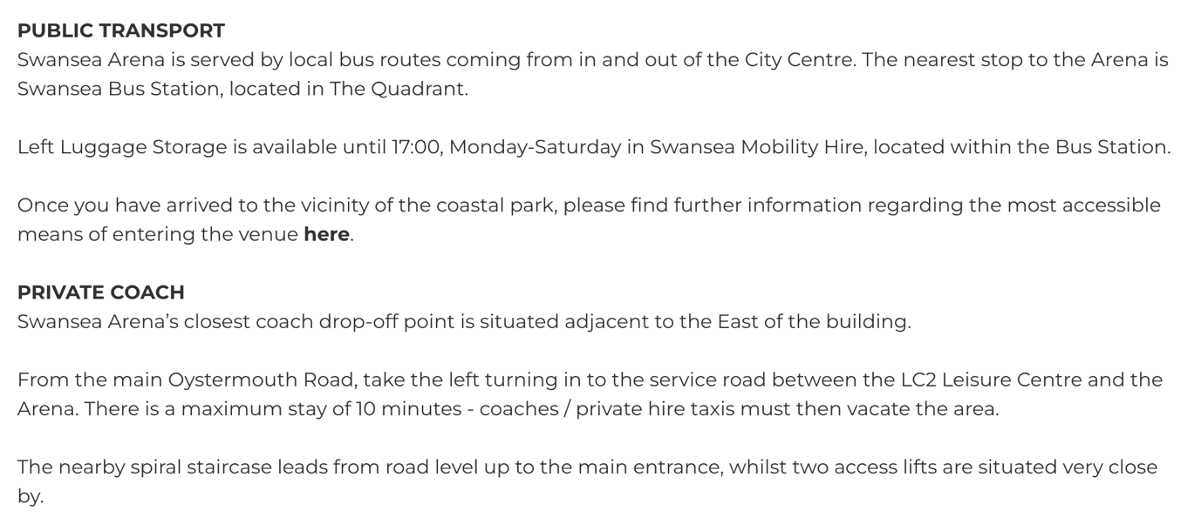
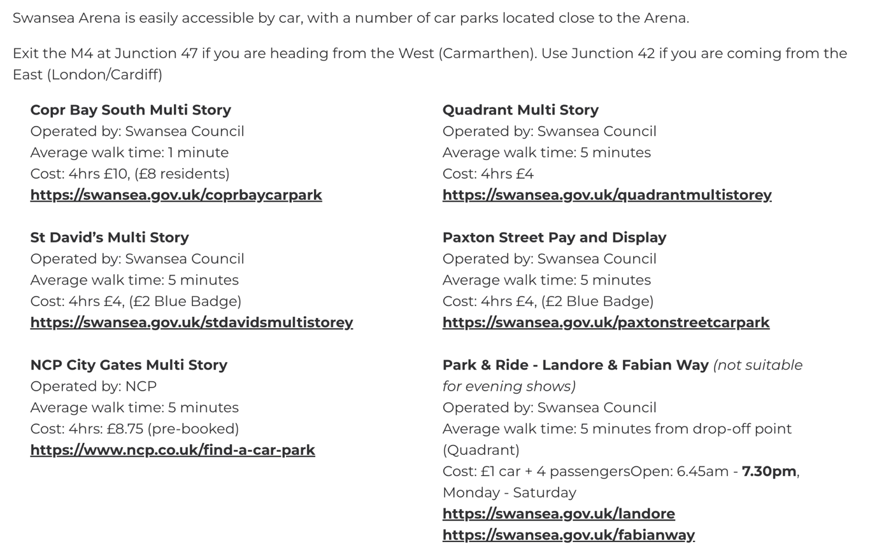
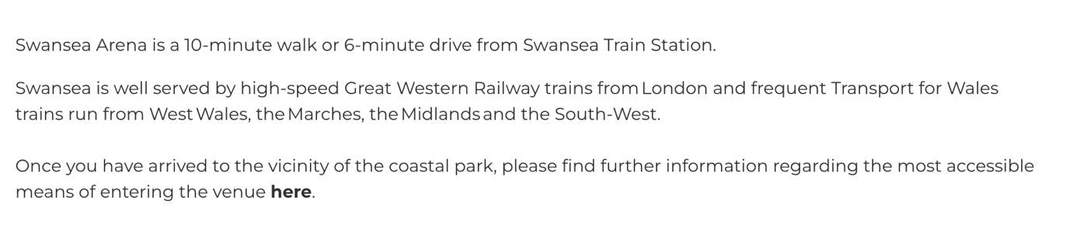

Reference list

- Alexander, D. (2002) Principles of emergency planning and management. Harpenden, Hertfordshire Terra Publ.
- Bedwell, W.L., Ramsay, P.S. and Salas, E. (2012) ‘Helping fluid teams work: A research agenda for effective team adaptation in healthcare’, Translational Behavioral Medicine, 2(4), pp. 504–509. Available at: https://doi.org/10.1007/s13142-012-0177-9.
- Beebe, S.A. and Masterson, J.T. (2003) Communicating in small groups principles and practices. Glenview, Ill. [U.A.] Scott, Foresman.
- Belbin, R.M. (2010) Management Teams : Why They Succeed or Fail. 3rd edn. London: Routledge Taylor & Francis Group.
- Biljana Teohareva, F. (2012) ‘Analysing customer profiles using data mining techniques’, in IEEE. International Conference on Information Technology Interfaces, 2012,.
- Bloom, N. (2009) ‘The Impact of Uncertainty Shocks’, Econometrica, 77(3), pp. 623–685. Available at: https://doi.org/10.3982/ecta6248.
- Bolton, L.E., Warlop, L. and Alba, J.W. (2003) ‘Consumer Perceptions of Price (Un)Fairness’, Journal of Consumer Research, 29(4), pp. 474–491. Available at: https://doi.org/10.1086/346244.
- Bowler, M.C. and Woehr, D.J. (2006) ‘A meta-analytic evaluation of the impact of dimension and exercise factors on assessment center ratings.’, Journal of Applied Psychology, 91(5), pp. 1114–1124. Available at: https://doi.org/10.1037/0021-9010.91.5.1114.
- Burke, C.S. et al. (2006) ‘What type of leadership behaviors are functional in teams? A meta-analysis’, The Leadership Quarterly, 17(3), pp. 288–307. Available at: https://doi.org/10.1016/j.leaqua.2006.02.007.
- Buxmann, P. et al. (2004) ‘Usage and evaluation of Supply Chain Management Software - results of an empirical study in the European automotive industry’, Information Systems Journal, 14(3), pp. 295–309. Available at: https://doi.org/10.1111/j.1365-2575.2004.00172.x.
- Caves, R.E. (2007) Multinational enterprise and economic analysis. Cambridge ; New York: Cambridge University Press.
- Chandrashekaran, R. and Jagpal, H. (1995) ‘ Is there a well-defined internal reference price?’, ACR North American Advances. [Preprint].
- Claudio, B. (2009) ‘Assessing the Risk of Banking Crises – Revisited’, BIS Quarterly Review [Preprint].
- David Frederick Ross (2004) Distribution Planning and Control : managing in the era of supply chain management. Berlin: Springer.
- Desai, V. (2019) ‘International Journal of Trend in Scientific Research and Development’, International Journal of Trend in Scientific Research and Development, 5(Digital marketing: A review.). Available at: https://doi.org/10.31142/ijtsrd.
- Employment and Training Administration and U.S Department of Labour (2010) www.dol.gov. Available at: https://www.dol.gov/agencies/eta.
- Events, M. (2023) 5 Benefits of Event Marketing, www.linkedin.com. Available at: https://www.linkedin.com/pulse/5-benefits-event-marketing-mplifyevents.
- exeed college (2019) Importance of Operations Management in Business Organizations, Exeed College. Available at: https://exeedcollege.com/blog/importance-of-operations-management-in-business-organizations/#:~:text=Operations%20management%20is%20important%20in (Accessed: 10 January 2024).
- Fernandez, R. et al. (2008) ‘Toward a Definition of Teamwork in Emergency Medicine’, Academic Emergency Medicine, 15(11), pp. 1104–1112. Available at: https://doi.org/10.1111/j.1553-2712.2008.00250.x.
- Forsyth, D.R. (2009) Group Dynamics. Belmont, California: Wadsworth Cengage Learning.
- Frohlich, M.T. and Westbrook, R. (2002) ‘Demand chain management in manufacturing and services: web-based integration, drivers and performance’, Journal of Operations Management, 20(6), pp. 729–745. Available at: https://doi.org/10.1016/s0272-6963(02)00037-2.
- Gallioni, G. (2005) ‘Inventory-driven costs’, Harvard Business Review, 83(3), pp. 135–141.
- Gayeski, D. (2005) Dialogues as a means of collective communication. New York: Kluwer Academic/Plenum Publishers.
- Gayeski, D.M. and Business, O. (2000) Managing the communication function : capturing mindshare for organizational performance. San Francisco, Ca: International Association Of Business Communicators, Cop, p. 378.
- Gittell, J.H. et al. (2008) ‘Is the doctor in? A relational approach to job design and the coordination of work’, Human Resource Management, 47(4), pp. 729–755. Available at: https://doi.org/10.1002/hrm.20242.
- Hoffer Gittell, J. (2002) ‘Coordinating Mechanisms in Care Provider Groups: Relational Coordination as a Mediator and Input Uncertainty as a Moderator of Performance Effects’, Management Science, 48(11), pp. 1408–1426. Available at: https://doi.org/10.1287/mnsc.48.11.1408.268.
- Hoffman, J.M. and Mehra, S. (2000) ‘Efficient consumer response as a supply chain strategy for grocery businesses’, International Journal of Service Industry Management, 11(4), pp. 365–373. Available at: https://doi.org/10.1108/09564230010355386.
- Hutton, A. et al. (2015) ‘The Use of Haddon’s Matrix to Plan for Injury and Illness Prevention at Outdoor Music Festivals’, Prehospital and Disaster Medicine, 30(2), pp. 175–183. Available at: https://doi.org/10.1017/s1049023x15000187.
- Kahneman, D. and Tversky, A. (1979) ‘Prospect Theory: an Analysis of Decision under Risk’, Econometrica, 47(2), pp. 263–292. Available at: https://doi.org/10.2307/1914185.
- Kor, Y.Y. (2006) ‘Direct and interaction effects of top management team and board compositions on R&D investment strategy’, Strategic Management Journal, 27(11), pp. 1081–1099.
- Kozlowski, S. and Bell, B. (2008) ‘Team learning, development, and adaptation.’, Work group learning Mahwah, NJ:: Lawrence Erlbaum, 2008(In: Sessa VI LM, ed.).
- Malone, T.W. and Crowston, K. (1994) ‘The interdisciplinary study of coordination’, ACM Computing Surveys, 26(1), pp. 87–119. Available at: https://doi.org/10.1145/174666.174668.
- Martins, M. and Monroe, K. (1994) ‘Perceived price fairness’, A new look at an old construct, ACR North American Advances.
- Masterman, G. (2005) Innovative marketing communications. 1st Edition. Routledge, p. 27.
- Mehlman, S.K. et al. (2010) ‘BETTER PRACTICES FOR MANAGING INTELLECTUAL ASSETS IN COLLABORATIONS Integrating the practices identifi ed in this study into your fi rm’s fabric will help to maximize the value of its external innovation.’, Research Technology Management, 53(1), p. 55.
- Moore, T. and Lakha, R. (2006) ‘Tolley’s Handbook of Disaster and Emergency Management’, Principles and Practice, Routledge(3rd Edition).
- Okhuysen, G.A. and Bechky, B.A. (2009) ‘10 Coordination in Organizations: An Integrative Perspective’, Academy of Management Annals, 3(1), pp. 463–502. Available at: https://doi.org/10.5465/19416520903047533.
- Philbrick, J.L. and Cleveland, A.D. (2015) ‘Personal Branding: Building Your Pathway to Professional Success’, Medical Reference Services Quarterly, 34(2), pp. 181–189. Available at: https://doi.org/10.1080/02763869.2015.1019324.
- Rani, A. (2023) The Importance of Storytelling in Event Marketing: Crafting Compelling Narratives to Engage Your Audience, Eventflare. Available at: https://eventflare.io/journal/the-importance-of-storytelling-in-event-marketing-crafting-compelling-narratives-to-engage-your-audience (Accessed: 10 January 2024).
- Seturi, M. and Urotadze, E. (2018) ‘About the importance of brand as a system’, Cybernetics and Systems. Social and Business Decisions, 1st Edition. Chapter: About the importance of brand as a system. Publisher:(Routledge. Taylor & Francis Group London, 65–69.).
- Smith-Jentsch, K.A., Salas, E. and Brannick, M.T. (2001) ‘To transfer or not to transfer? Investigating the combined effects of trainee characteristics, team leader support, and team climate.’, Journal of Applied Psychology, 86(2), pp. 279–292. Available at: https://doi.org/10.1037/0021-9010.86.2.279.
- Swink, M. (2006) ‘Building collaborative innovation capacity.’, Research Technology Management, 49(37 – 47.).
- Todua, N. and Urotadze, E. (2022) ‘The Effect of Social Media Marketing on Consumer Behavior of Tourism Destinations’, Strategic Planning and Marketing in the Digital World., University of National and World Economy(Publishing Complex UNWE. Chapter, 13: 123–133.).
- Training, L.C. (2023) The Power of Efficiency: Fueling Business Success, Corporate Training Courses Company. Available at: https://www.lct.co.uk/the-power-of-efficiency-fueling-business-success/ (Accessed: 10 January 2024).
- Tschan, F. et al. (2006) ‘Leading to Recovery: Group Performance and Coordinative Activities in Medical Emergency Driven Groups’, Human Performance, 19(3), pp. 277–304. Available at: https://doi.org/10.1207/s15327043hup1903_5.
- Vipin Nadda, Arnott, I. and Sealy, W. (2020) Legal, safety, and environmental challenges for event management : emerging research and opportunities. Hershey, Pa: Business Science Reference.
- Yankelovich, D. (2001) The magic of dialogue : transforming conflict into cooperation. New York: Simon & Schuster.

