Social Media Post
Below is a poster picture that would be posted on York Museum trust’s various social media accounts.

Accompanying text on Twitter and Facebook posts :
Shattered History
A window into the past through damaged personal items
An all new exhibition coming to the York Art Gallery in winter 2024. Explore Local and ancient Egyptian history with a series of personal artefacts, now so damaged some are barely recognizable. Featuring artefacts from the Cyfarthfa Castle Museum and Art Gallery, Merthyr Tydfil, Wales

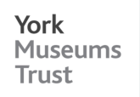
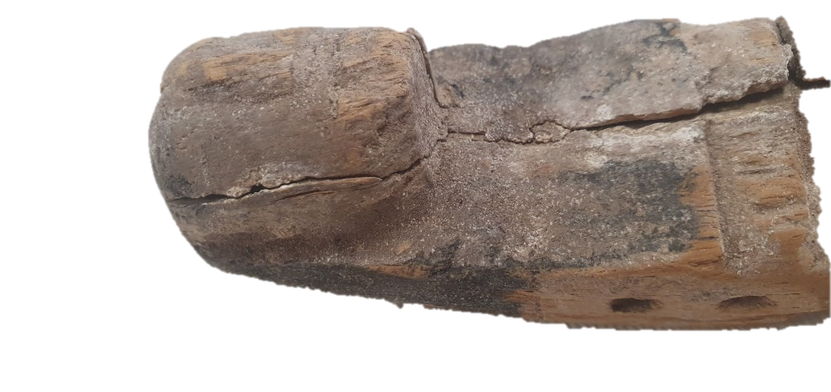

Shattered History

A window into the past through damaged personal items

Coming to York Art Gallery Winter 2024

