NAME : ALINA PRECUP
STUDENT NUMBER : 1816777
MODULE TITLE : THE GLOBAL BUSINESS ENVIRONMENT

MODULE LECTURES NAME : DR.
KENNY alue Chain and Conclusion.............................................................5

Table of Contents :
☆Introduction.......................................................................................2
- Porter's Value Chain ...................................................................3
☆Conclusion................................................................................4
- Business opportunities.................................................................4
☆Fig.1 & Fig.2 ...........................................................................6
C) Business to be continued........................................................7
☆Reference.................................................................................9

1

Introduction :
Manufacturing companies create value by acquiring raw materials and using them to produce something useful.
The value that's created and captured by a company is the profit margin :
Value Created and Captured- Cost of Creating that Value = Margin
Understanding how the company creates value , and looking for ways to add more value, are critical elements in developing a competitive strategy. Michael Porter discussed this his influential 1985 book “Competitive Advantage”, in which he first introduced the concept of the value chain.
A value chain is a set of activities that an organization carries out to create value for its customers. Porters proposed a general- purpose value chain that companies can use to examine all of their activities.

2

A)Porter's Value Chain

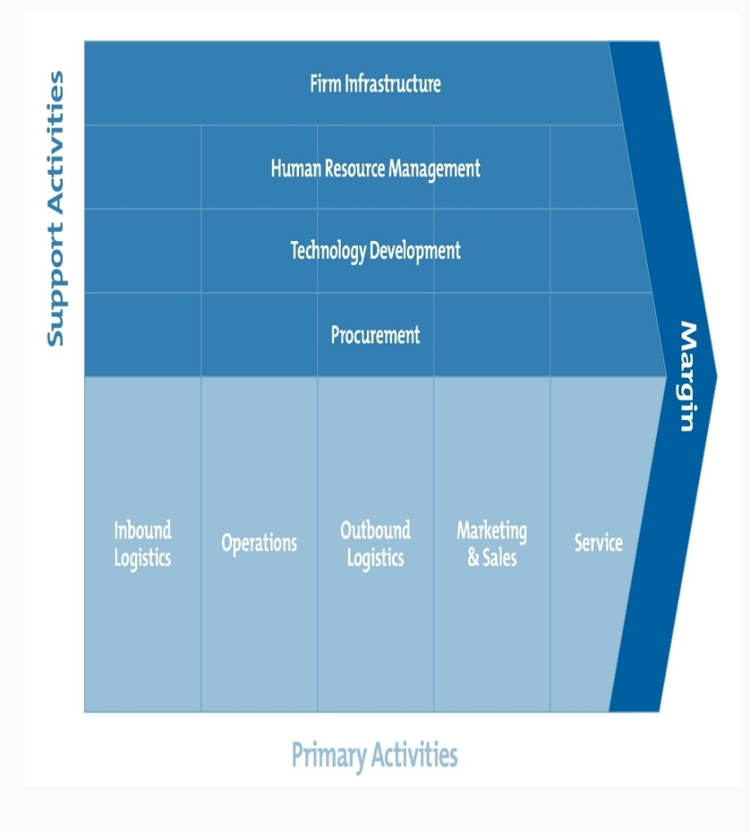
Rather than looking at departments or accounting cost types, Porter's Value Chain focuses on systems, and how inputs are changed into the outputs purchased by consumers. Using this viewpoint.
Primary activities related directly to the physical creations, sale, maintenance and support of a product or service. They consist of the following:
● Inbound logistics - These are all the processes related to receiving, storing and distributing inputs internally ;
●Operations – These are the transformation activities that change inputs into outputs that are sold to customers.
●Outbound logistics – These activities deliver your product or service to your customer ;
●Marketing and sales – These are the processes you use to persuade clients to purchase from you instead of your
3

competitors ;
●Service – These are the activities related to maintaining the value of your product or service to your customers, once it's been purchased.
Conclusion :
Strategic planning frameworks provide a means of combining internal data about the firm's capabilities with external information about the competitive environment in a manner designed to guide resource allocation. The Value Chain approach strategic planning, as described by Michael Porter in his book “Competitive Advantage “ (1985).

- Business opportunities and future directions :

The current approach for many manufacturing enterprises is to centralize product development , product production and product distribution in a relatively few physical locations. These locations can decrease even further when companies off-shore product development, production, and/or distribution to other countries/companies to take advantage of lower resource, labor or overhead costs. The resulting concentration of employment leads to region of disproportionately high underemployment and/or unemployment. As a result, nations can have regions of under population with consequent national problems such as infrastructure being underutilized and long term territorial integrity being compromised.
(Beale, Rural Cond Trends 11(2):27-31,2000)
International operations are increasing a prerequisite for survival, competitiveness growth of Entrepreneurial ventures. In Europe where the small and medium-sized enterprises and entrepreneurs play a significant role in the economy, they operate in complex environments affected by diverse and intense
pressure of national cultures. Responses of entrepreneurs in
4
meeting these challenges can be supported by developing a deeper theoretical understanding of variables pertinent to international entrepreneurship.
A method and apparatus for evaluating business opportunities
for supplying goods and services (such as business forms and5 services) to potential customers needs , and the user's ability to supply those needs , to see what the area of opportunity for the user to supply that need is . Calculation can also be made comparing the user's ability to fulfill the needs to some absolute standard , to also determine an area emerging technology. A series of questions relating to the customers level of sophistication for predefined categories are inputted into a computer , as well as the responses, and weights and and values are assigned to the questions responses to indicate a level of sophistication for each possible response of each business technique for each separate category. The user's capability of supplying the potential customer's needs are also evaluated and this data is inputted intonation second computer which calculates, taking into a second computer which calculates, taking into account the weights and values, for each separate category a potential customer's score, the user's score, and the area of opportunity (which is the difference between the customers score and the user's score).Then using a computer controlled printer, the calculations are printed out in graphical form on a sheet of paper, along with other human readable indicate, from which an evaluation of the opportunity, as well as a tool to close a business deal, are supplied.

5
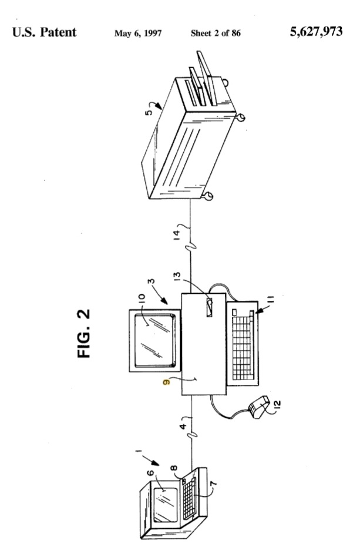

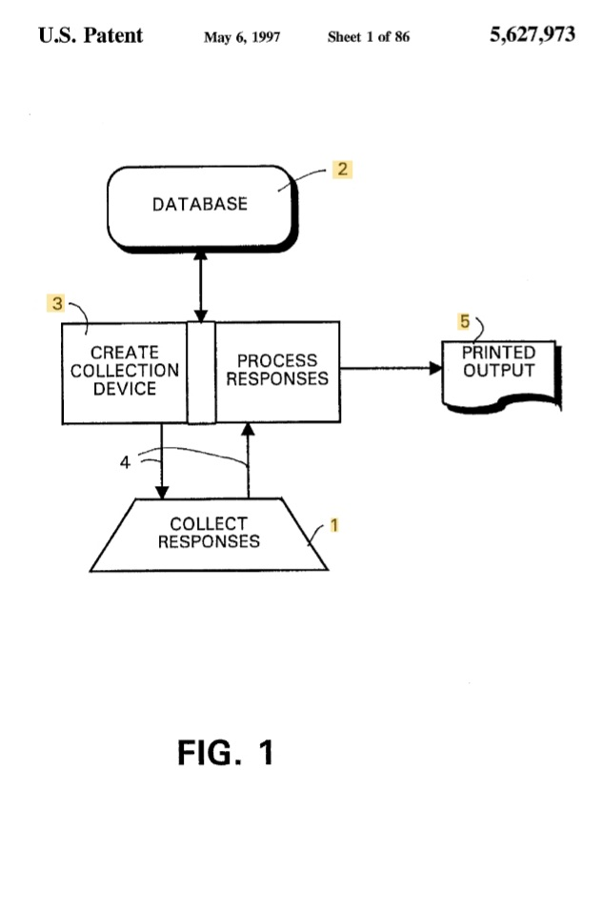

6

- Business to be continued :

What explains American corporate bankruptcy, with it’s time-consuming and expensive reorganization process? Accepted wisdom is that bankruptcy protects an insolvent debtor's asset's from its creditors who would otherwise dismantle the debtor in a frenzied attempt to collect on their loans.
Small Businesses Minister Craig Foss says the Talking Care of Business roadshow has been so successful, more events are likely next year .
“Over 5 months , more than 2000 business owners and operators attended 22 Taking Care of Business events around the country , from Invercargill to Whangarei” , Mr. Foss says.
Every event to bigger and better and the feedback from attendees was outstanding”.
We expanded the roadshow twice , adding five additional locations and two Auckland-based events specifically designed to support the Korean and Indian businesses communities “.
The Blenheim event scheduled for November 14 – the day of the 7.8 magnitude quake- has been postponed.
“The information and advice available through Taking Care of Business will now be even more important for businesses owners and operators in the part of the country.”
“The Blenheim event will be rescheduled as soon as it's appropriate and practical to do so . I hope to announce additional locations at the same time.
“Taking Care of Business is about helping businesses owners engage with agencies more effectively and efficient by taking government to business, notbthe other way around “.
Many of the tools and resources featured in the roadshow are available online at : www.Business.govt.nz
Businesses activity in the U.S. , European and Japan continued to fall in May this year, though at a slower pace than in prior months , offering early signs that the global economy may have already experienced the worst of the economic damage from
7
coronavirus outbreak.
Still, the data realised Thursday suggest that economic recovery will be painfully slow.
Surveys of purchasing managers showed private-sector activity fell for the third straight month in May, despite the tentative reopening of many economies around the world. The cumulative decline in eurozone activity between March and May is the largest on record, according to IHS Markit, the group that compiles the data. The surveys pointed to continued job cuts, despite a range of government programs in Europe designed to cover the wages of idled workers. That rise is unemployment will likely act as a drag on any recovery as affected households cut back on spending.
“Demand is likely to remain extremely weak for a prolonged period, putting further pressure companies to make more aggressive job cuts" , said Chris Williamson, IHS Markit’s chief business economist. “We therefore expect.... a full recovery to take several years".
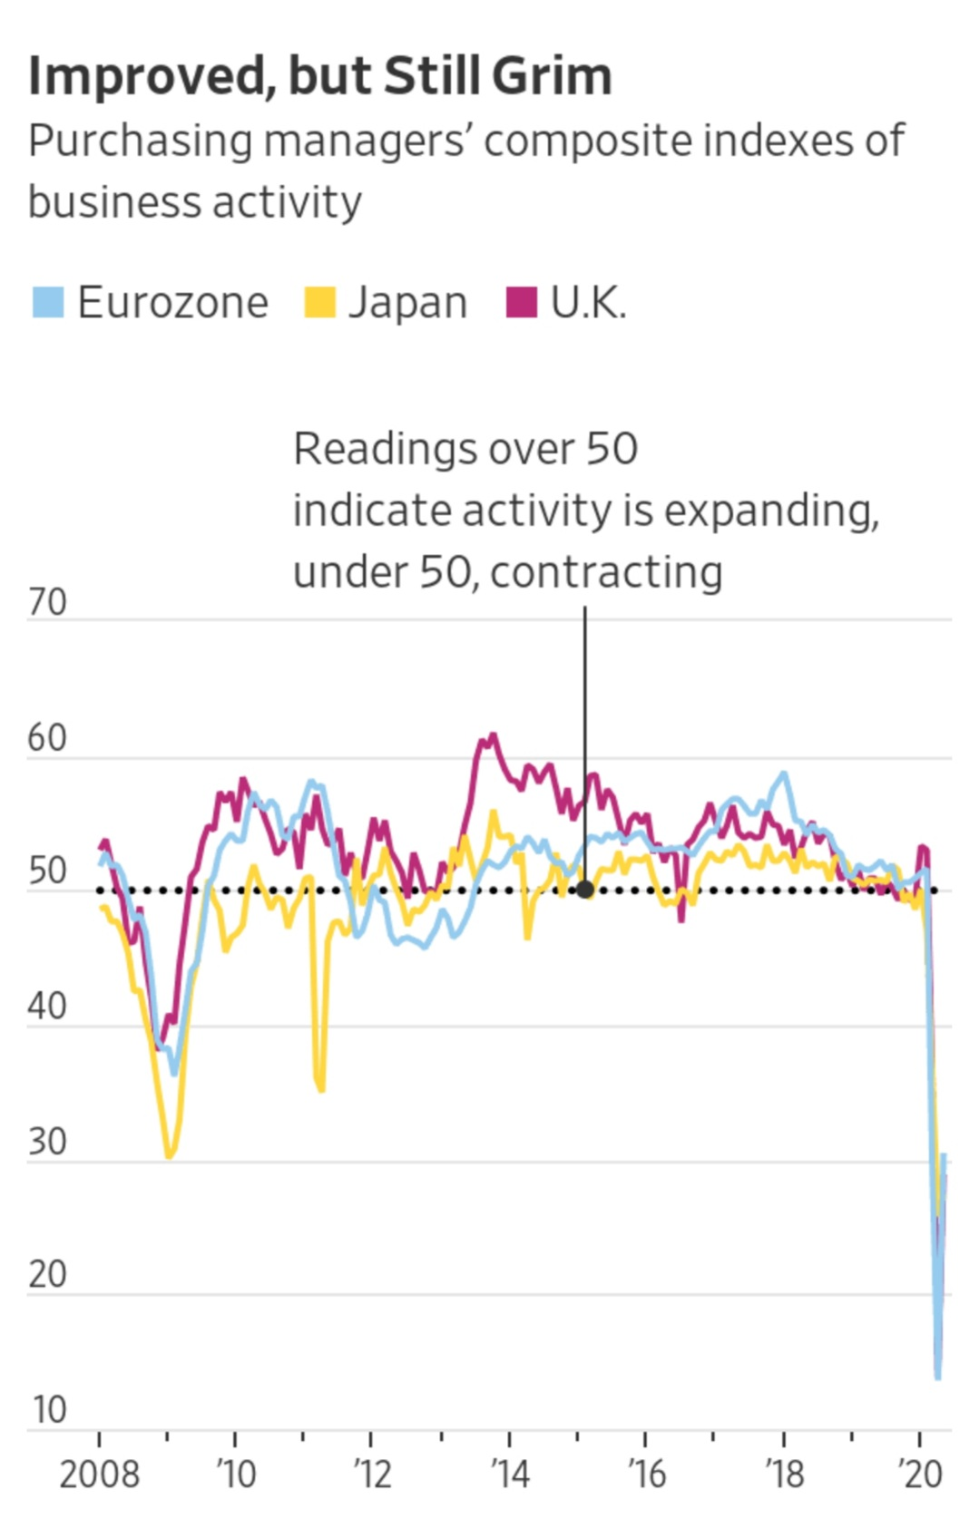
8
☆References:

●Peter Hines
The international Journal of Logistics Management 4(1),13-22,1993
● Michael Herbert , Deigan Morris
Strategic Management Journal (10) 2, 175-188 , 1989
●Ian Gibson, Doxid Rosen , Brent Stucker
Additive Manufacturing Technologies, 475-486,2015
●Olga Muzychenko
European Management Journal 26(6),366-377,2008
● Hugh E Armstrong, Brad B. Bailey, Gregory T. Lynch, Judith A. Mcmoran, Kareen L . U.S. Patent 5,627,973,1997
●Alan Schwarz
THE Yole Low Journal 107 (6) , 1807_1851 , 1993

9

