
Student Name: Meet Dilipbhai Patel
Student ID: 2532591
Module Name: International Marketing: Principles and Practices (LCMB7026)
Lecturer Name: Tola Odugbesan
Word Count: 5089
Submission Deadline: 13th August 2026
Table of Contents
A. Section 1: Marketing Report 3
1. Introduction 3
2. Comparative Analysis of the Market 4
2.1 PESTEL Analysis 4
2.2 Hofstede Cultural Analysis 12
2.3 Critical discussion 15
3. Comparative Analysis of STP 17
3.1 Segmentation 17
3.2 Targeting 19
3.3 Positioning 19
4. Comparative analysis of international marketing mix 22
5. Market entry strategy 25
6. Ethical issues 27
7. Recommendations 28
8. Conclusion 29
B. Section 2: Reflective Report 30
Introduction 30
Application of Gibbs’ reflective model 30
Description 30
Feelings 31
Evaluation 31
Analysis 32
Conclusion 32
Action plan 33
Conclusion 34
References 35

A. Section 1: Marketing Report

1. Introduction
Toyota Motor Corporation (or Toyota) is a reputed automobile manufacturing MNC with a varied portfolio including passenger vehicles, commercial vehicles, hybrid electric vehicles, battery electric vehicles and others. In 2025, the organisation reported a consolidated revenue of 48.03 trillion yen or $315 billion (Annual Report, 2025).
The report aims to analyse the international market entry strategy and marketing mix of Toyota in the USA and India. The comparative evaluation provided a detailed overview on how Toyota has applied its mission and vision statements to make market-specific changes in USA and India.
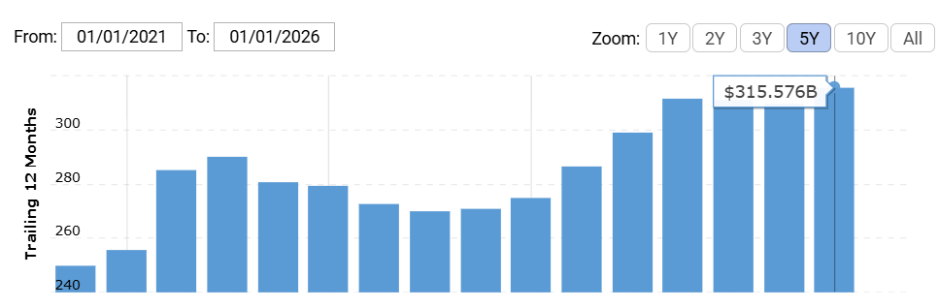
Figure 1: Revenue generation for Toyota (2021-2025)
(Source: Macrotrends, 2025)

2. Comparative Analysis of the Market

2.1 PESTEL Analysis
Political
The USA market is politically attractive as the existing automotive policies support the domestic manufacturing, emissions reduction, customer protection, and electrification quite strongly. Toyota seems to already align with this direction, such as Toyota Motor North America has reported an investment of US$912 million in 5 manufacturing plants in the USA (Toyota, 2025).
India seems to be politically supportive, whereas the political stability of the nation has been identified as -0.79, which can raise difficulties for Toyota to conduct business smoothly in the long term (The Global Economy, 2024). The PM E-DRIVE scheme in this nation was notified with an outlay of Rs. 10,900 crores, ensuring greater support for e-buses, EV subsidies, testing agencies, and charging stations (Pib.gov.in, 2025; figure below).
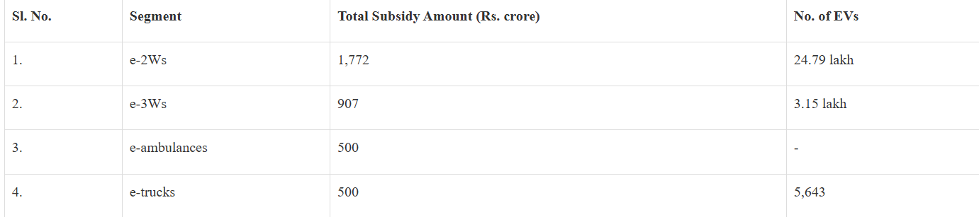
Figure 2: Allocation under the scheme
(Source: Pib.gov.in, 2025)
Favourable/unfavourable discussion
- For Toyota, the USA is quite favorable for the marketing hybrids, electrified vehicles, and SUVs, as policy and consumer demand are going in the same direction.
- Higher favourability in scalability can be obtained as 10 billion USD additional investment plan over the next 5 years has been considered for USA.
- India is also favourable, as here, government policy strongly supports the cleaner mobility along with domestic production, whereas passenger-car incentives are quite less direct than in the USA.
- The focus on affordability, local manufacturing, electrification of the public transport and “Make in India” has contributed to higher favourability in the Indian market (Pib.gov.in, 2025).
Similarities and differences
- Both countries politically encourage the local value creation as well as cleaner mobility.
- The difference is that the USA is more suitable for marketing the electrified passenger vehicles, whereas India requires Toyota to market the affordability.
Economic
In 2025, the nominal GDP of the USA was US$30.76 trillion, and it is US$32.38 trillion in 2026, with a GDP growth rate of 2.3% and GDP per capita of US$94,430 (Worldometers, 2026).
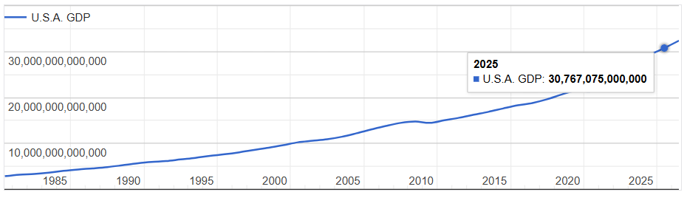
Figure 3: USA GDP from 1985 to 2026
(Source: Worldometers, 2026)
The GDP of India has been identified as US$3.91 trillion in 2025, and by 2026, it is US$4.15 trillion in 2026 with a growth rate of 6.5% and a GDP per capita of US$2,813 (Worldometers, 2026).
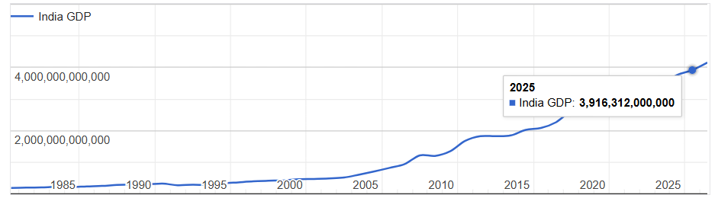
Figure 4: India GDP from 1985 to 2026
(Source: Worldometers, 2026)
Moreover, 2024 electrified vehicle sales of Toyota have been observed as 1,006,461 units, which was up 53.1% from the previous year in North America (Toyota, 2025).
Favourable/unfavourable discussion
- USA is favorable for the higher-margin models, whereas the unfavourable side is the high competition and slow growth structure.
- India is more favorable than the USA as higher growth in passenger vehicle sales is seen, such as 1.7 million by Maruti Suzuki and 2.7 million by “Toyota Kirloskar Motor” in 2025, which can be favourable for Toyota (figure below).
- Higher favourability in India has been observed as sales figures reached 3,26,329 units in 2025, a 40% growth from the previous year (Toyotabharat, 2025).
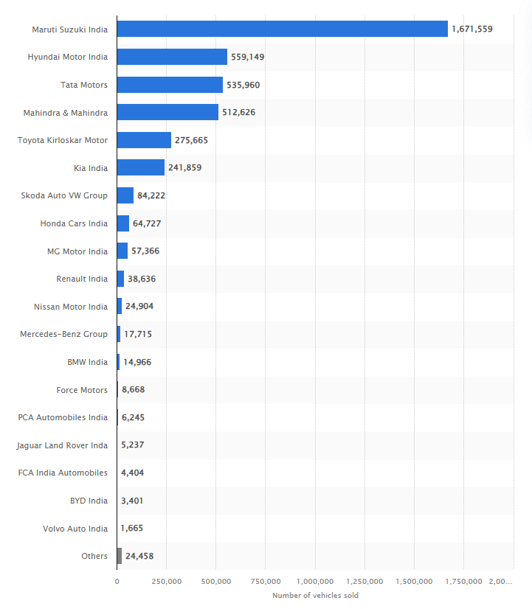
Figure 5: Volume of passenger cars sold in India in 2025
(Source: Statista, 2025)

Similarities and differences
- Both markets highlight the demand for the utility vehicles and SUVs.
- However, the key difference is that the marketing in the USA mostly focuses on technology, lifestyle, and performance, whereas India’s marketing mainly focuses on the value and family use.
Social
The USA seems to be highly urbanized, and the total population has been observed as 349,035,494 as of 2026, which means nearly 82.8% of the nation’s total population (Worldometers, 2026). However, India seems to be less urbanized, with 37% of the total population, which is responsible for affecting the marketing perceptions of Toyota (Worldometers, 2026).
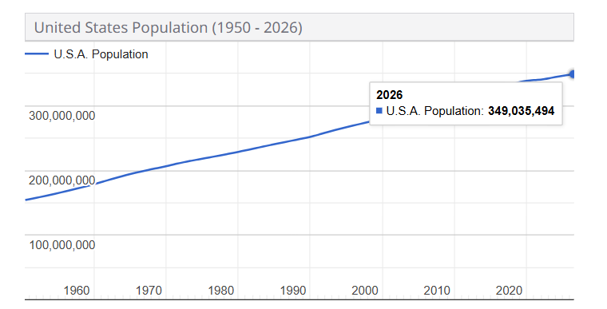
Figure 6: Population of the USA from 1960 to 2026
(Source: Worldometers, 2026)
Favourable/unfavourable discussion
- The USA is most favourable for Toyota, as here the brand already has strong trust in the areas of reliability, practical ownership, and hybrid technology.
- As US buyers value greater convenience, safety and hybrid efficiency, higher favourability of launching premium cars for Toyota is noticed.
- India is not as favourable as the USA, as the Indian portfolio is much more premium than several mass-market rivals. Therefore, marketing needs to justify the price structure through trust, service quality, and savings for the long-term.
Similarities and differences
- In both the USA and India, Toyota benefits from a greater reputation for reliability.
- However, the difference is associated with consumer motivation, as in the USA, Toyota is able to sell lifestyle and electrification, whereas in India, it needs to sell practicality.
Technological
In the USA, Toyota highlighted the rollout of different digital platforms like SmartPath and Monogram (Toyota, 2025). On the other hand, the technological environment of India is improving, whereas the EV infrastructure is still in the development phase, and in 2025, EV sector funding was US$1.4 billion, which was up 27% YoY (figure below).
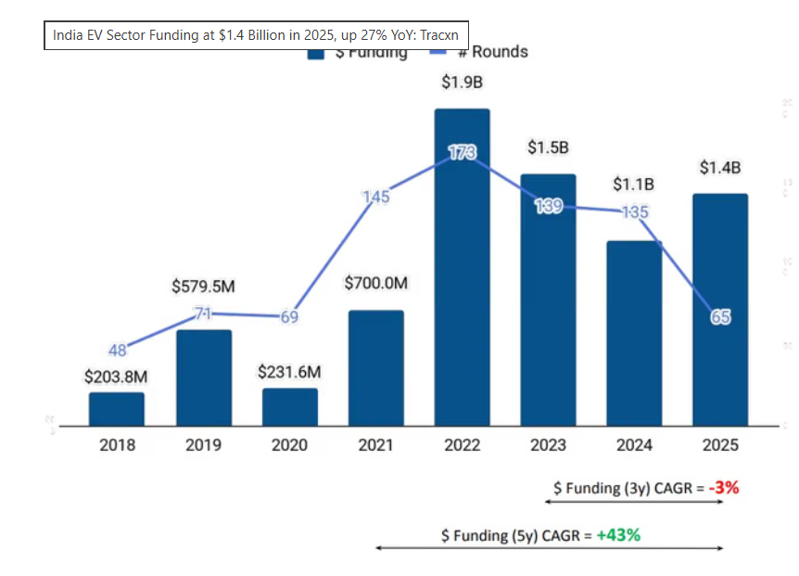
Figure 7: EV sector funding of India from 2018 to 2025
(Source: Murali, 2025)
Favourable/unfavourable discussion
- USA is more favourable for the marketing of connected features in newly launched vehicles along with hybrids and BEVs.
- However, India is also favourable for the hybrid technology only, as it helps to reduce the range anxiety and fits the developing charging network.
Similarities and differences
- Both markets are moving towards the electrification.
- The USA seems to be ahead in the customer readiness, whereas India is still building the infrastructure.
Environmental
The USA transportation is responsible for about 28% of the total greenhouse gas emissions, which makes it the largest contributor (Epa.gov, 2025). However, in India, emissions have been identified as 3.22 billion tons in 2025, which was quite lower (Drishtiias, 2025).
Favourable/unfavourable discussion
- The USA is less favourable as the firm can face severe criticism if the competitors move faster with full EVs.
- India is much more favourable as there is no such strict presence of competitors.
- Higher favourability in India can be observed as issues of pollution and urban congestion causing challenges in urban mobility can be addressed through Toyota’s solutions (Drishtiias, 2025).
Similarities and differences
- Both nations have the cleaner automotive messaging.
- USA has stricter emission regulations, whereas in India, affordability constraints are observed mostly.
Legal
The legal environment of the USA is quite stricter regarding vehicle safety, emissions, and advertising claims. However, in India, legal expectations are also developing through the Bharat NCAP, which gives enough customer safety ratings for the M1 vehicles with GVW up to 3500 kg (Bncap.in, 2026).

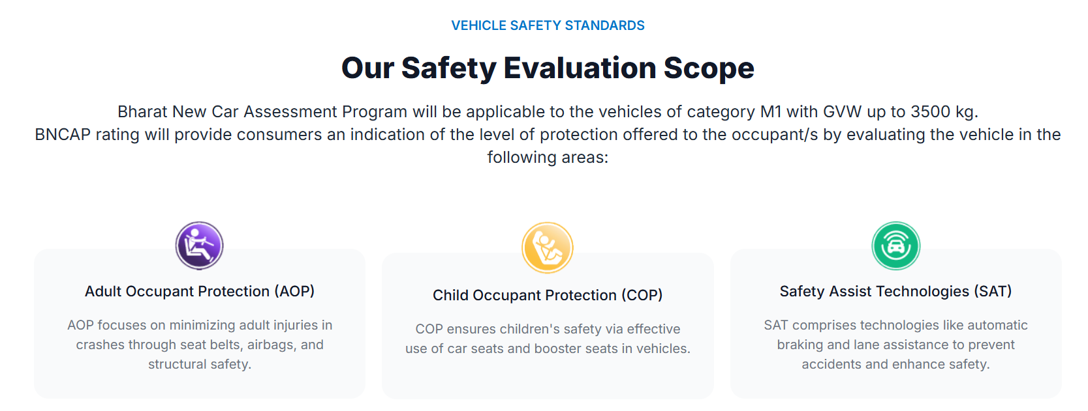
Figure 8: Safety evaluation scope
(Source: Bncap.in, 2026)
Favourable/unfavourable discussion
- In India, the Bharat NCAP provides 14% higher opportunity for Toyota to ensure the market safety.
- The unfavourable side in the USA is associated with emission claims that can damage brand trust.
Similarities and differences
- Both countries have stricter legal boundaries regarding safer products.
- The USA has a more mature legal environment, whereas India’s legal environment is still developing.

2.2 Hofstede Cultural Analysis
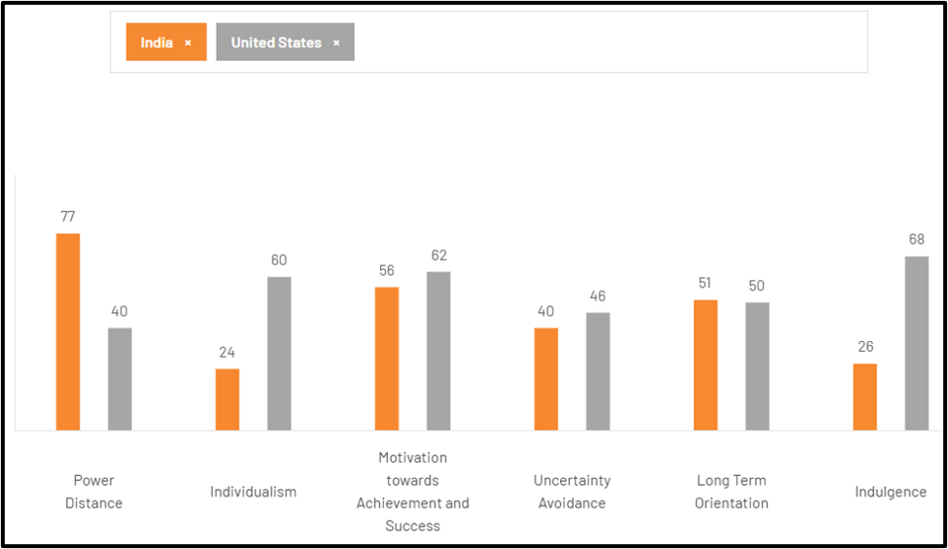
Figure 9: Cultural comparison between India and the USA
(Source: The Culture Factor, 2025)
PDI
In PDI, India scores 77, whereas the USA scores 40, which indicates Indian customers prefer hierarchy, status, and authority, whereas USA customers expect open communication and equality (The Culture Factor, 2025).
Impact on Toyota
- In India, Toyota can consider the “status-based marketing”, premium ownership, as well as trust within the expert advice (Toyota, 2025).
- In the USA, Toyota can keep focused on the customer empowerment and transparent comparison.
Favourability
- Higher favourability in India is supported due to launching models such as “Innova HyCross” to promote innovative features.
- The USA seems to be favorable for the practical marketing.
IDV
In case of individualism, India scores 24 whereas the USA scores 60, which indicates the USA has a more individualistic culture (The Culture Factor, 2025).
Impact on Toyota
- Toyota's Indian marketing must be focused on family safety, reliability, and the long-term trust.
- In the USA, the firm prefers to highlight the personal lifestyle of individuals most, along with performance, freedom, and technical benefits.
Favourability
- Both nations are favorable whereas require different messaging perceptions, such as “family-centered positioning” in India but “individual benefit positioning” in the USA.
MAS
Scores in this factor have been identified as 56 and 62 for India and the USA, respectively (The Culture Factor, 2025). Both markets are quite achievement-oriented, whereas the USA is strong enough to celebrate the personal success.
Impact on Toyota
- In India, social status and premium appearance mostly matter for Toyota to attract the customer base.
- In the USA, focus must be provided on innovation, capability, and an achievement-focused lifestyle.
Favourability
- Both markets are favourable based on incorporating premium features to highight innovation and practicality for consumers.
Uncertainty avoidance
For the USA, this scores 46, and for India, it is 40 (The Culture Factor, 2025). This indicates both markets are open to uncertainty, whereas the USA is more structured (Toyota, 2025).

Impact on Toyota
- In India, Toyota has to reduce the risk factors for buyers through an effective service network, warranty, and greater “fuel-efficiency claims”.
- In the market of the USA, Toyota must push its hybrid innovation.
Favourability
- Higher rate of hybrid vehicle adoption increases favourability for Toyota vehicles in both Indian and US markets.
Long-term orientation
India obtained a score of 51 while the USA secured 50 in LTI analysis. It indicates that both countries share a similar approach in making long-term decisions (The Culture Factor, 2025).
Impact on Toyota
- The brand has faced challenges in long-term ownership due to frequent changes in policies associated with ICE vehicles and EVs in the USA and India.
- As purchasing frequency and purchasing volume of Toyota’s vehicles are affected due to varied representation of fuel efficiency and resale value of cars, a moderate-to-high LTI score can enhance resilience of production and marketing systems.
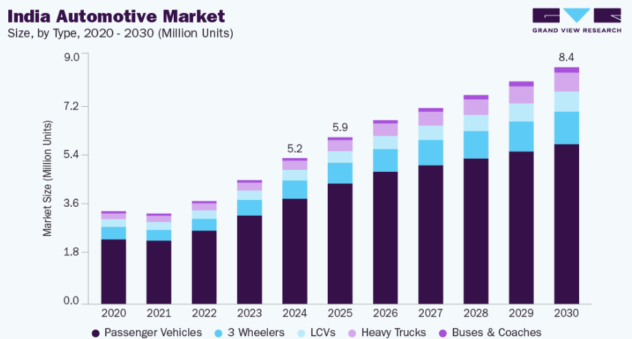
Figure 10: Scope of growth in Indian automotive market
(Source: Grand View Research, 2025)
- Long-term planning can be beneficial in taking advantage of developing local supply chains in India through ‘Make in India’ programmes.
- Taking advantage of the PM E-DRIVE scheme has helped to manufacture 388,801 units in India by 2025 (Das, 2025).
Favourable/unfavourable discussion
Higher favourability can be noticed as support from regulatory environments helps in developing long-term resilience to industry shocks.
Indulgence vs restraint
The scores for ‘indulgence vs. restraint’ for USA and India are 68 and 26, respectively. Higher indulgence in the USA and a relatively low indulgence in India have been noticed (The Culture Factor, 2025).
Impact on Toyota
- Prioritisation of convenience and lifestyle alignment with customers is expected for customers in the USA.
- India shows greater preference for value-for-money and higher functionality, which implies variation of marketing practices in India and the USA.
- Focus on affordability and fuel economy can contribute to 14% sales growth for Toyota in India (Ghosh et al., 2025).
Favourability
Toyota has been applying diverse marketing strategies so that market content favours the premium feel of using cars in the USA while highlighting key aspects of other benefits for Indian customers.

2.3 Critical discussion
Based on the above-conducted PESTEL and Hofstede analysis, it can be stated that rather than applying the standardised global marketing strategy, Toyota must acquire the localised (glocalisation) approach, as consumer expectations, regulatory environments, and purchasing power differ most between the two nations. In the USA, such a strong regulatory environment, individualistic culture, and high disposable incomes justify the investment of Toyota in the digital retailing, hybrid vehicles, and premium models like Lexus. This strategy seemed to be effective as EV sales in North America strong incrsed and exceeded 1 million units in 2024, facilitating the competitive position of Toyota in the global sustainability market (Toyota, 2025).
Conversely, in India, Toyota prioritises affordability and localisation through the “Toyota Kirloskar joint venture” as government initiatives and price sensitivity mostly favor the locally manufactured vehicles. This approach has strongly contributed to the record sales growth, whereas a limited product portfolio in the Indian market constrains its market share most. Hence, the international marketing strategy of Toyota is effective as it strongly balances the global brand consistency with the local market adaptation, although continuous innovation is essential.

3. Comparative Analysis of STP

3.1 Segmentation
Segmentation Variable | USA | India | Similarities and Differences
Demographic | Families and professionals (Managers, engineers, entrepreneurs and corporate employees) of 30-60 age years with annual household income US$60,000–120,000 (BLS, 2026) | Families of middle- and upper-middle-income (annual income ₹12–25 lakh) and professionals (corporate employees, business owners and government employees) with an age range of 30–55 years (PIB, 2026) | Similar instances of market stability yet higher purchasing power for customers in USA
Geographic | Urban and suburban regions, specifically, California, Texas and Florida, with vehicle ownership and transport expenditure of about US$1,000 per month | Metropolitan, Tier-1 and Tier-2 cities with monthly expense of ₹50,000–100,000 indicating vehicle affordability | Price-sensitivity in Indian markets yet improvements in SCM tech in both countries
Psychographic | Lifestyle focuses on sustainability awareness, embedded with technology | Lifestyle highlights value-consciousness and family focus | Product reliability is evident
VALS | Innovators, Achievers and Thinkers | Achievers, Believers and Strivers | Focus on innovation in USA while cost-sensitivity and resource optimisation in Indian market.
Benefit Segmentation | Hybrid, connectivity and safety benefits ensured 47.7% (1.18 million units) of US sales in 2025 (Nalin, 2026) | Fuel efficiency, durability and affordability recorded 337,148 units in sales in FY2024-2025 (Toyota Bharat, 2025). | Functional benefits are the primary concern while sustainability and affordability balance US and India Sales.
Usage and commitment | 17.6% increase in EV sales facilitated by loyal customers | 29% annual growth is evident with emergent consumers and brand-loyal family members | High brand loyalty is prominent against price sensitivity and switching behaviour
Table 1: Comparative analysis of segmentation
(Source: Sri and Khan, 2026; Lecture 5)
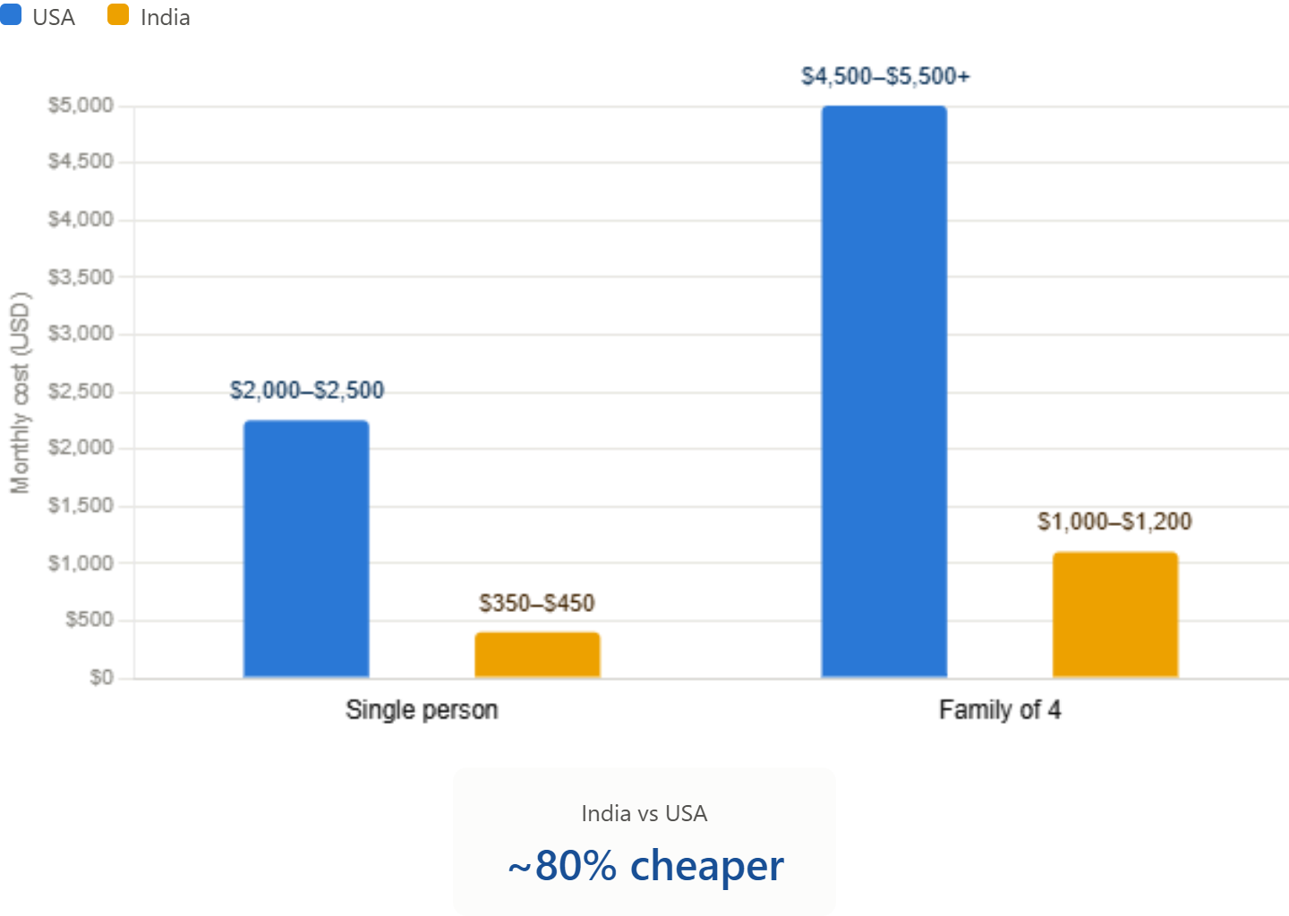
Figure 11: Comparing the monthly expenses of USA and India
(Source: BLS, 2026)
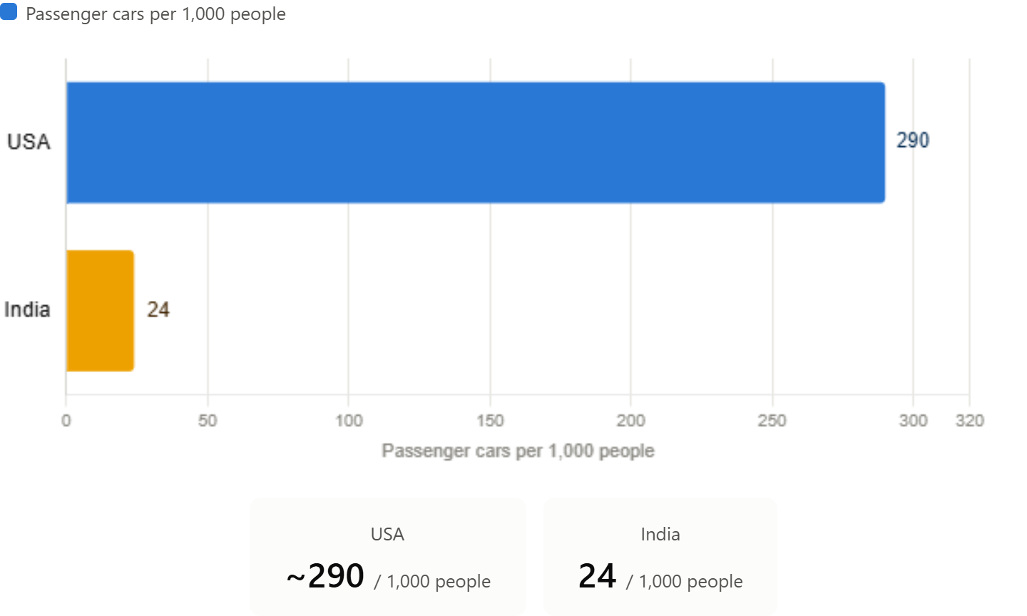
Figure 12: Car ownership comparison
(Source: S&P Global Mobility, 2025; Mohan et al., 2025)

3.2 Targeting
A differentiated targeting strategy for the USA and India is justified to create balance in meeting the diverse requirements of customers.
- USA: Luxury models with sustainability concerns and technology-embedded features, such as the Prius, RAV4, and Lexus, are prioritised by high-income consumers, along with hybrid and electric models (Toyota Global, 2025).
- India: Models such as Innova Hycross, Fortuner and Urban Cruiser have been launched to mostly target middle and upper-middle income families to address affordability and practicality.
- Similarities and differences: differentiated targeting strengthened customer acquisition through diversified offers. On the contrary, sustainability and innovation are core aspects in the USA, while the value for money concept is present in India.

3.3 Positioning
The competitive positioning for Toyota fulfils the requirements of risk aversion and stable positioning in both markets.
- USA: Hybrid innovation, advanced safety features and sustainability are prioritised, which creates a position of high technology and a premium price.
- India: Family-oriented consumers with a preference for affordable, durable and fuel-efficient vehicles called for a position of high reliability and moderate pricing.
- Similarities and differences: Both the markets demonstrated opportunities for a high-quality and reliable automotive brand like Toyota. On the contrary, innovation priorities have been valued in the USA, while price sensitivity remains a top priority for Toyota in India.
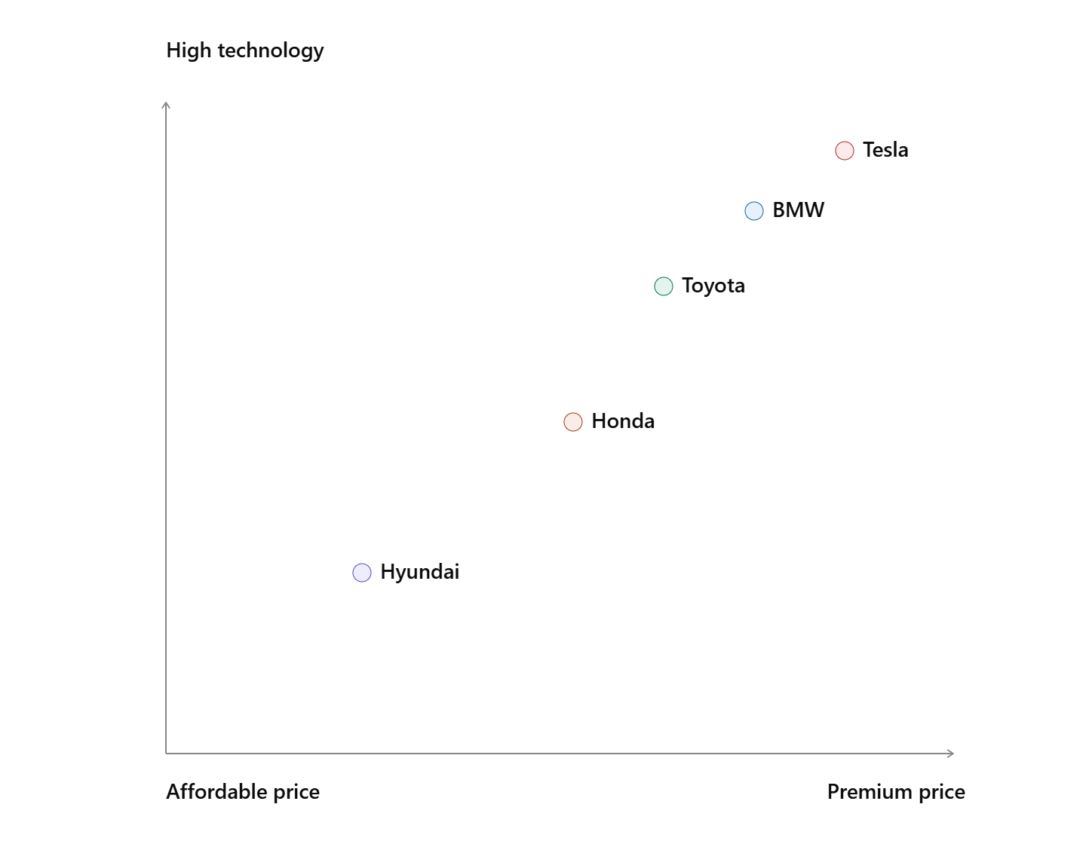
Figure 13: Perceptual map of USA
(Source: Self-developed)
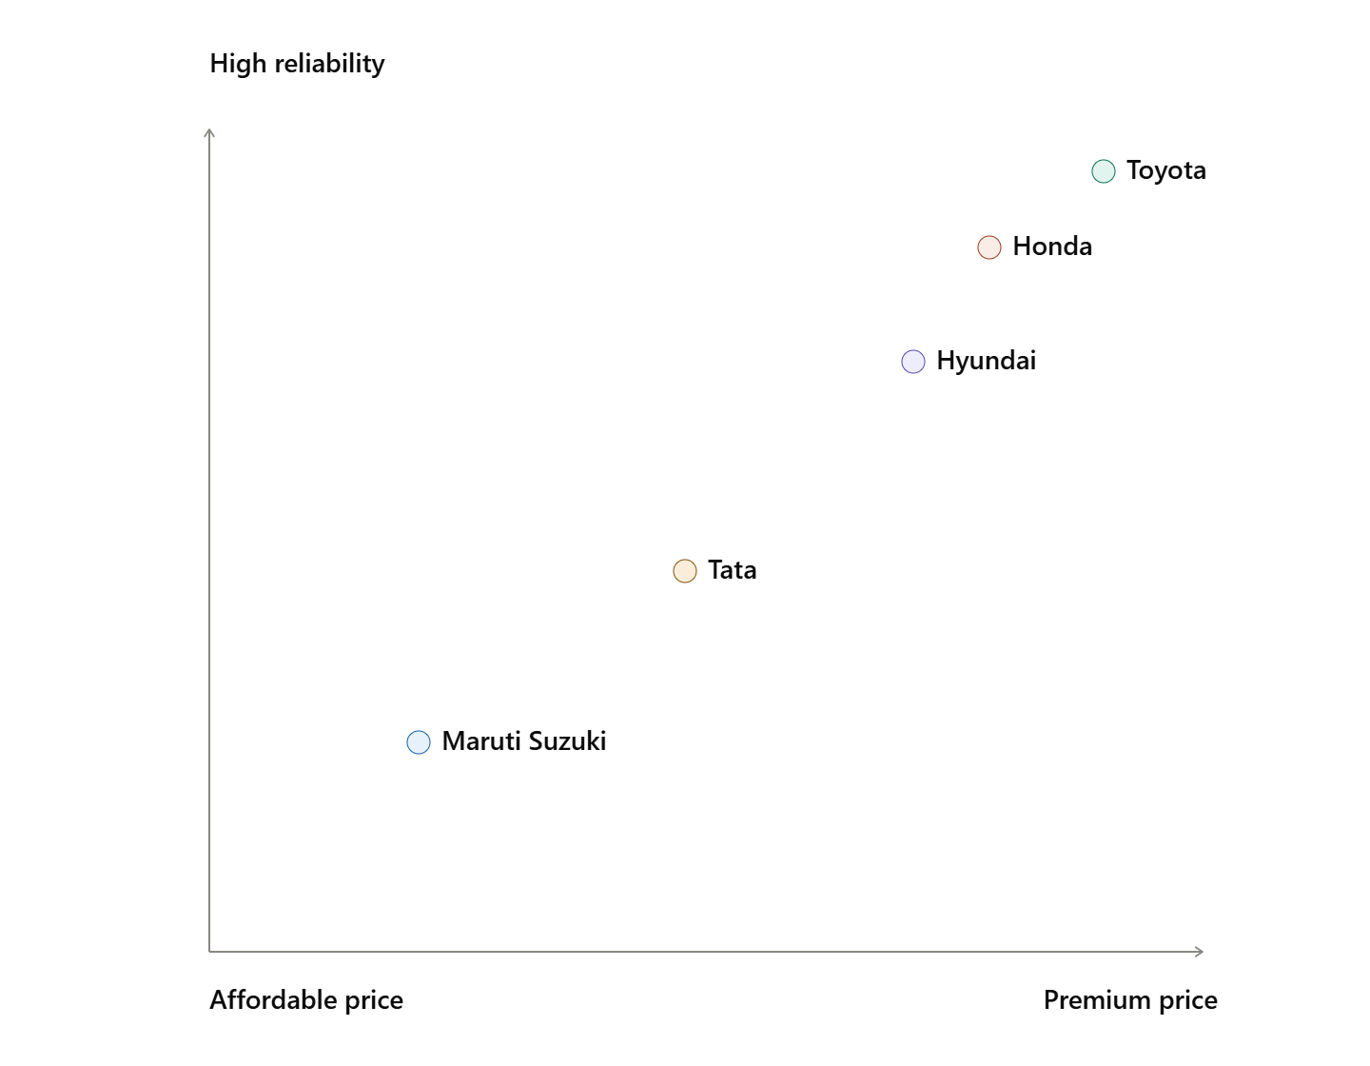
Figure 14: Perceptual map of India
(Source: Self-developed)
Value proposition: Toyota provides vehicle options with reliability, fuel efficiency and innovative mobility solutions with long-term value, safety and customer satisfaction.

4. Comparative analysis of international marketing mix
Factors | Toyota - USA | Toyota - India
Product | - Presence of a broader portfolio includes models such as sedans (e.g., Camry), trucks (e.g., Tacoma) and EVs  - In 2025, vehicle sales in the US crossed 2.8 million units (Yahoo Finance, 2025) | - Greater focus on MPVs and SUVs with Innova, Fortuner, Camry and others  - In 2025, Toyota sold 3,88,801 units in India (Toyota India, 2025)  - Collaboration with Suzuki helped in improving the diversification efficiency of Toyota
Price | - Financing facilities have been provided for customers  - Multiple pricing models have been considered to beat competition and cater to regular and premium segments (Week 4, Slide 7)  - The customer lifecycle value for Toyota in the USA is $150,000-$175,000 by 2025 | - Due to intense competition in the lower market segments, premium pricing (e.g., Fortuner) has been preferred  - Customers with an aspirational lifestyle have been targeted to ensure a 7%-9% rise in product prices.
Place | - Extensive dealer network in 50 states  - Toyota Financial Services has ensured 25% higher digital retailing | - Nation-wide distribution focused on manufacturing centres at Bidadi  - Collaboration with Suzuki contributed to higher mobility into smaller cities and emerging markets
Promotion | - Focus on heavy investing in TV ads and sports media  - Environmental sustainability and community engagement campaigns are preferred | - Social media-based and TV-based ads have been preferred with a focus on collective happiness or a sense of status linked to purchasing a car  - A focus on fuel efficiency and celebrity endorsement influenced 40% promotional affairs of Toyota
People | - A culture of incremental innovation has been standardised with the help of the Toyota Production System (TPS)  - Certified technicians and the ToyotaCare program led to the development of a professional atmosphere and a 15% higher employee satisfaction rate (Toyota Care, 2026) | - A focus on dealer service quality has led to improvement in customer relationships for Toyota  - Higher efficiency in service management has been achieved through dedicated after-sales service
Process | - Digital purchase journey has been refined through TPS so that it can increase engagement of customers | - Standardisation of service processes has been achieved to maintain consistency across showrooms and dealerships
Physical Evidence | - Modern architecture, vertical integration, interactive showrooms and digital configurators have been preferred (Week 4, Slide 9) | - Premium leadership (for Lexus) along with standard outlets improve luxury positioning
Table 2: 7P analysis
(Source: Self-developed)
Comparative evaluation
In comparative analysis, it can be said that a comprehensive product portfolio for every segment improved customer engagement for Toyota in the US market. Moreover, an extensive dealership and manufacturing network led to generating 23% higher efficiency in the digital retail ecosystem for the brand (Ito and Kato, 2025). On the contrary, increased adoption rate of hybrid and electrified mobility solutions has led to incorporation of aggressive marketing techniques for Toyota to increse market share in the USA. As per the diffusion of innovation model, the US market has been viewed as an ‘innovator’.
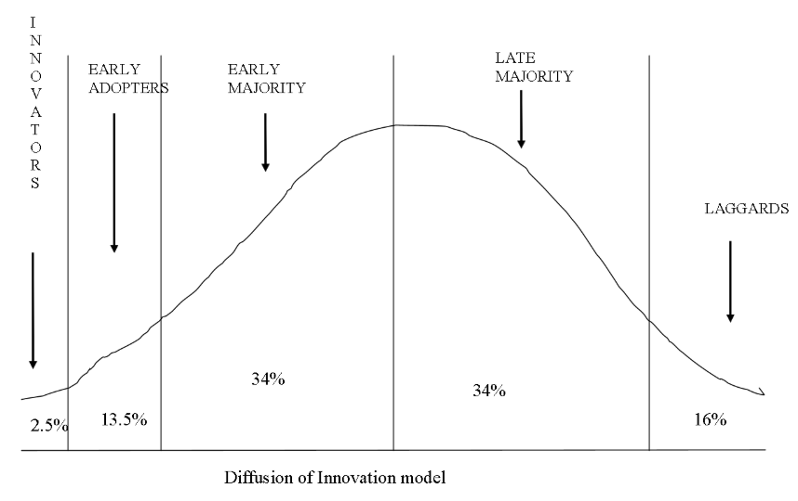
Figure 15: Diffusion of innovation model
(Source: Lund, 2025)
In the case of India, an application of the diffusion of innovation model shows that it has been an early adopter of EVs and modern cars to address the demand of the Indian market. In India, the organisation has taken advantage of a successful hybrid strategy and a 19% higher rate of EV adoption in the market (Putri et al., 2025).

5. Market entry strategy
Market entry method | Barriers | External factors | Opportunities | Feasibility | Suitability | Acceptability | Advantages | Disadvantages
Exporting | High shipping cost; exchange rate fluctuations | Change in trade policies | Low initial investment | 5 | 4 | 5 | Low risk, improved scope of market testing | Less competitive pricing
Franchising | Inconsistencies in standardising manufacturing process | Changes in franchise laws and regulations | Expansion of service networks | 4 | 4 | 4 | Expansion of dealerships at a rapid pace at low cost | Unsuitable for vehicle manufacturing due to poor quality control
Joint Venture | Involvement of multiple stakeholders in the decision-making process | Influence of local regulations and interference from local partners | Access to local knowledge and suppliers | 8 | 8 | 8 | Sharing investment recovery risk with adequate regulatory support | Sharing of profit and scope of business conflicts
Licensing | Intellectual property risks | IP protection laws | Rapid market entry, low investment | 4 | 5 | 4 | Low investment with faster scope of growth | Drop in product quality and profit margin
Strategic alliance | Coordination challenges | Industry-level collaboration and partnerships | Collaborative product development and expansion of market | 6 | 6 | 5 | Expansion of product portfolio and reducing development costs due to higher scalability | Risk of unauthorised access and exploitation of proprietary knowledge
Wholly owned subsidiary | High investment, complexity in operations; higher operational risks | Change in FDI policies and labour laws | Scope of leveraging local manufacturing with full control of manufacturing or distribution | 5 | 5 | 6 | Full control and production systems with suggested incremental innovation from TPS | High investment; High risk of operational failure and delayed capital recovery
Table 3: Market entry strategies
(Source: Adapted from Week 5, Slide 3)
Toyota entered India through the “Toyota Kirloskar Motor” (TKM) joint venture that enables the organisation to combine the advanced manufacturing expertise of the firm with the Kirloskar's local market knowledge, network of the suppliers and regulatory understanding. This strategy effectively reduced the entry risk while supporting the localisation strongly and ensuring greater compliance with the Industrial policies. The joint venture seemed to be successful such as in 2025, it made a record sale of 388,801 vehicles, that strengthen the presence of Toyota through the local manufacturing and effective collaboration with the Maruti Suzuki (Das, 2025). However, limitations are also there in terms of shared decision-making, high dependency on the local partners, and having a smaller product portfolio that restrict the firm’s market share in the Indian market.

6. Ethical issues
In terms of product safety and quality, Toyota had to recall 1.02 million vehicles in the US due to flaws in rear-view cameras (Reuters, 2025). In India, 11,529 units of Toyota Urban Cruiser Hyryder and 969 units of Toyota Land Cruiser have been recalled in 2025 and 2026, respectively (Times of India, 2025). An analysis of environmental sustainability issues shows that Scope 1 emissions have been reduced by 20%, yet 100% recycling of manufacturing waste cannot be ensured (Figueiredo et al., 2025).
Alleged violation of labour rights in the context of cultural and structural clashes has occurred for Toyota. In addition, extensive regulatory oversight due to the evolution of compliance ethics has caused delays in US-based EV production in 2026 (Taylor et al., 2026). These ethical issues have strongly affected the confidence level of stakeholders by facilitating regulatory scrutiny and raising concerns regarding the product quality as well as corporate accountability. Although the firm eventually responded through the recalls, enhanced the monitoring of suppliers, and its Environmental challenge 2050, such repeated incidents would weaken the brand trust along with customer loyalty (Toyota, 2025).

7. Recommendations
Recommendation 1: Expansion of hybrid and EV portfolio
Based on the discussion, it is recommended that EV portfolio expansion can address its smaller product portfolio compared with competitors and strengthen its position in the rapidly growing EV segment in India. Expansion into plug-in hybrids with an 8-year warranty on battery packs can increase the rate of adoption by 25%, resulting in positive growth in profit margin (Malek, 2025). Moreover, the strategy will be effective in addressing the issue of limited competitiveness in an evolving electrification market of India.
Recommendation 2: Focus on localised manufacturing and supply chains
A focus on local manufacturing and supply chains can lead to a reduction in production costs and address the challenge of price sensitivity identified in the Indian market analysis for Toyota. Support from national schemes such as ‘Make In India’ can ensure further regulatory support and an increase in ‘ease of doing businesses’. Improvement in after-sales services can be achieved (Tinwala et al., 2025). Additionally, this strategy will be suitable in strengthening Toyota's value proposition while improving affordability and operational efficiency, as identified challenges previously.
Recommendation 3: Increase in collaborative projects with Maruti Suzuki and investment in digital transformation
Increasing collaborative projects can lead to an increase in product portfolio and distribution network for Toyota in India. Limited market penetration issues can be addressed with this strategy in Tier-2 and Tier-3 cities with a narrow competitive product range. 40% improved penetration can be achieved in Tier-2 and Tier-3 cities supported by digital transformation for improved engagement and dealership efficiency (Kumar, 2025).

8. Conclusion
The report presented a detailed analysis of the macroenvironment through PESTLE analysis, which helped in developing an international marketing strategy for Toyota. Based on Hofstede’s cultural dimensions, marketing strategies have evolved to create optimum results. A comparative analysis of the 7P marketing mix has been presented for both the USA and India. Favourable market entry strategies have been discussed, where the role of joint venture for the Indian market has been justified. The ethical issues in one key market (India) have been reported along with ethical issues.

B. Section 2: Reflective Report

Introduction
Reflecting on the research process of Toyota business propensity, Gibbs’ Reflective Cycle is appropriately applied to understand business research capabilities to draw relevant conclusions. The cycle has included six stages of reflection such as description, feelings, evaluation, analysis, conclusion and action plan. The systematic framework of Gibbs’ model helps to evaluate experiences to identify opportunities for future improvement. The use of international marketing frameworks combined with secondary market research models and the Research Onion Model helped in effective decision-making.

Application of Gibbs’ reflective model

Description
The international marketing report on Toyota is completed through comparative analysis of international marketing strategies focusing on the USA and India. The research conducted an evaluation of macro-environmental factors through the PESTEL framework and evaluated the cultural influences using Hofstede's Cultural Dimensions model to determine the international market conditions. Moreover, STP strategies, international marketing mix (7P) and Ansoff matrix-oriented market entry strategy evaluation created details on market opportunities and setbacks for Toyota in both the USA and Indian markets. The research onion model has been considered to justify data collection, data analysis and interpretation (Yu, 2025; Lecture 8). The secondary research method employed in this study helped to collect information from literature, industry reports, government archives and company reports to strengthen systematic and evidence-based analysis.
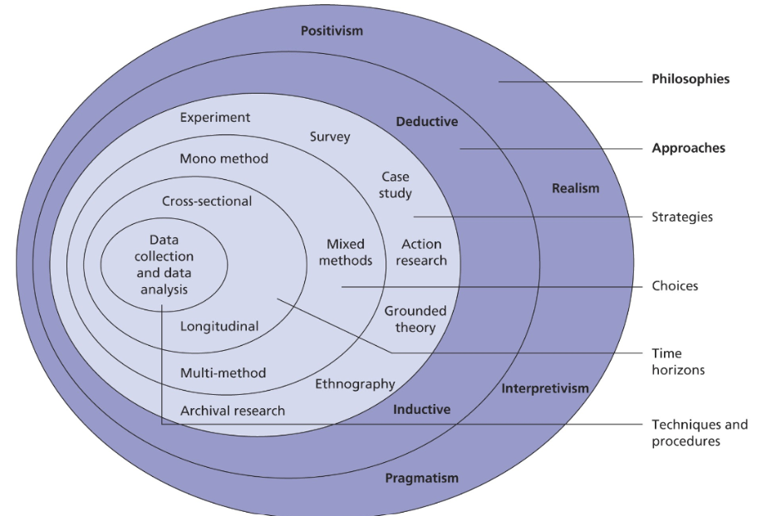
Figure 17: Research Onion model
(Source: Lecture 8, week 5)

Feelings
At the initial stage, I was confident about the theoretical application of frameworks to define the international marketing position of Toyota in the Indian and the USA markets. The concepts of Hofstede, PESTEL, STP and 7Ps helped me in progressing the research through the identification of challenges and the international business environment. However, I have faced limitations in analysing due to an overload of information from literature and industry reports. The sorting of statistical data and theoretical support seemed overwhelming, and identifying credible information required critical skills in analysis. On the contrary, the use of combined data sources has helped me in producing an evidence-based report with a professional outlook, while boosting my confidence in academic research skills. In the process, I have learnt that international marketing is extensively dependent on business environment analysis as reflected here.

Evaluation
International marketing analysis is effective when secondary research methods are implemented, which is time-effective and provides genuine information on the company's performance. Additionally, it aligned with the lecture material to ensure cost-effectiveness while accessing global datasets on the company and selected markets. However, challenges were evident when contradictory data was found in academic literature, statistical databases and company reports. For instance, the integrated report of Toyota 2025 mentioned 9.44 million units of vehicle sales, whereas CNBC showed sales of 10.7 million in 2024 (Toyota Global, 2025; CNBC, 2025). Nonetheless, I understood that avoiding discrepancies through data triangulation can achieve better results in international marketing analysis. Additionally, the knowledge obtained here showed that data control and analytical processes must address source evaluation to ensure data validity and research credibility.

Analysis
The research report followed a secondary research method for accessing extensive information on the international market within a specific time period. As per the views of Hechavarria et al. (2025), secondary data shows high accessibility with cost and time efficiency while supporting broad market coverage, which enabled a comparative market analysis of the USA and India for Toyota. Moreover, the Research Onion Model provided standard guidelines to select and implement the secondary research strategy. Primary research was not practical here as it would direct the research to collect data from consumers and stakeholders in both markets.
On the contrary, instances of inconsistencies or discrepancies in secondary data sources required optimisation of findings from multiple research phases. For instance, FY2024–25 sales of Toyota differ in the Toyota Kirloskar Motor report and the global annual report by 51,653 units (Toyota Bharat, 2025; Toyota Global, 2025). Nonetheless, the data triangulation and evaluation of multiple sources before drawing the interpretation had helped this report. Notwithstanding the challenges, the procedure helped me gain ample knowledge about the professional application of data sources and evaluate the authenticity of well-known databases.

Conclusion
From the assignment, I acknowledge its influence to improve my theoretical understanding of international market research and professional outlook on critical evaluation of information from multiple resources for deriving diverse effects of business factors. The theoretical framework application and guidance from the Research Onion Model indicated the significance of an integrative practice that supports evidence-based decision-making. Nonetheless, I gained knowledge of systematic secondary research from reliable sources to maintain the validity of findings. Finally, the experience has increased my appreciation for the cross-bridge of theoretical foundations with complex international business scenarios successfully.

Action plan
Goals | Actions taken | Required resources | Timeline
To enhance reliability and research quality in future international business projects | Data source triangulation using multiple sources and datasets from 2024-2026 | Company annual reports, IBISWorld, World Bank databases, along with scholarly sources | Next academic semester
To improve critical evaluation skills along with data accuracy | Accessing multiple databases for data triangulation | Approved databases and the company's annual report | 6-12 months
To strengthen research methods concepts | Implementing complex methodological systems with a systematic approach | Class guidelines, textbooks and scholarly articles | Ongoing
Table 4: Action plan
(Source: Self-developed)

Conclusion
From the overall reflective discussion, it can be concluded that the current research study on Toyota has been a successful approach to integrating secondary research methods while critically evaluating diverse databases and information to derive the conclusion and suggest a suitable market expansion region. Applying the Gibbs’ reflective cycle, it became evident that critical understanding of research methods and the theoretical foundation for international market analysis created the base for the report. On the other hand, the practical implications of the research through statistical data evaluation have been obtained to develop the evidence-based assessment report. The strong alignment of business details and international marketing concepts helped to improve critical thinking, analytical skills and source evaluation techniques.

References
Annual Report (2025). Annual Report. [online] Sec.gov. Available at: https://www.sec.gov/Archives/edgar/data/1094517/000119312525142326/d925022d20f.htm. (Accessed: 12 June 2026)
BLS (2026). CONSUMER PRICE INDEX – MAY 2026. [Online]. Available at: https://www.bls.gov/news.release/pdf/cpi.pdf [Accessed on: 24/06/2026]
BLS (2026). Median weekly earnings were $1,204 in 2025. [Online]. Available at: https://www.bls.gov/opub/ted/2026/median-weekly-earnings-were-1204-in-2025.htm [Accessed on: 20/06/2026]
Bncap.in, (2026). Safety Beyond Regulation. Available at: https://www.bncap.in/ (Accessed: 16 June 2026).
CNBC (2025). Toyota sells 10.8 million vehicles in 2024 to remain world’s top-selling automaker. [Online]. Available at: https://www.cnbc.com/2025/01/30/toyota-remains-worlds-top-selling-automaker.html [Accessed on: 23/06/2026]
Das, A. (2025). Turning Rupees into Results: Assessing the Effectiveness of State EV Incentives. UC Berkeley. doi:https://doi.org/10.7922/g2mk6b8r.
Drishtiias, (2025). India’s Carbon Emission Growth Slows in 2025. Available at: https://www.drishtiias.com/daily-updates/daily-news-analysis/india-s-carbon-emission-growth-slows-in-2025 (Accessed: 15 June 2026).
Epa.gov, (2025). Carbon Pollution from Transportation. Available at: https://www.epa.gov/transportation-air-pollution-and-climate-change/carbon-pollution-transportation (Accessed: 14 June 2026).
Figueiredo, O.C. de, Oliveira, U.R. de, Aprigliano Fernandes, V., França, S.L.B. and Lemos, W. de M. (2025). Lean and sustainability in automotive organizations: a comparative analysis with Toyota. Gestão & Produção, 32. doi:https://doi.org/10.1590/1806-9649-2025v32e11424.
Ghosh, T., Kanitkar, T. and Srikanth, R. (2025). Enhancing inclusiveness and sustainability: impact of accessibility and affordability on public transportation in an Indian megacity. Deleted Journal, 2(1), pp.1–31. doi:https://doi.org/10.1080/29941849.2025.2449830.
Grand View Research (2025). India Automotive Market Share & Trends Report, 2020-2027. [online] www.grandviewresearch.com. Available at: https://www.grandviewresearch.com/industry-analysis/india-automotive-market. (Accessed: 13 June 2026)
Hechavarria, D.M., Carsrud, A. and Pandey, P., (2025). Leveraging large-scale secondary data in entrepreneurship research. In Handbook of Research Methods and Applications in Entrepreneurship and Small Business, Second Edition (pp. 42-68). Edward Elgar Publishing.
Ito, H. and Kato, K. (2025). Redefining Toyota’s Woven City as a ‘glocal’ innovation ecosystem for integrated sustainable development. Journal of Innovation and Entrepreneurship, 14(1). doi:https://doi.org/10.1186/s13731-025-00488-7.
Kumar, N. (2025). Harnessing India-Japan Economic Partnership for Supply Chain Resilience in the Context of Global Trade Policy Uncertainties. [online] Available at: https://isid.org.in/wp-content/uploads/2025/09/WP301.pdf.
Lund, B. (2025). Diffusion of innovations: still a relevant theory for studying library technology in the age of AI? Library Hi Tech News. doi:https://doi.org/10.1108/lhtn-12-2024-0209.
Macrotrends (2025). Toyota Revenue 2012-2025 | TM. [online] www.macrotrends.net. Available at: https://www.macrotrends.net/stocks/charts/TM/toyota/revenue. (Accessed: 14 June 2026)
Malek (2025). Maintenance, diagnostics and repair of traction batteries for hybrid vehicles. [online] Available at: http://www.aaejournal.com/Maintenance-diagnostics-and-repair-of-traction-batteries-for-hybrid-vehicles,214935,0,2.html.
Mohan, D. S., Elango, S., Mallya, H. and Jain H. (2025). How Will India’s Vehicle Ownership Grow? CEEW The Council. [Online]. Available at: https://www.ceew.in/publications/how-will-indias-private-and-passenger-vehicle-ownership-grow-by-2050 [Accessed on: 21/06/2026]
Murali, K., (2025). India EV Sector Funding at $1.4 Billion in 2025, up 27% YoY: Tracxn. Available at: https://www.autocarpro.in/news/india-ev-sector-funding-at-$14-billion-in-2025-up-27-yoy-tracxn-130153 (Accessed: 13 June 2026).
Nalin, A. (2026). Toyota Absolutely Dominated Hybrid Sales In 2025 — 4.4 Million Sold. Yahoo Finance. [Online]. Available at: https://finance.yahoo.com/sectors/energy/articles/toyota-absolutely-dominated-hybrid-sales-220036493.html [Accessed on: 23/06/2026]
PIB (2026). Economic Survey 2025-26. [Online]. Available at: https://www.pib.gov.in/PressReleasePage.aspx?PRID=2220800&lang=2&reg=3 [Accessed on: 22/06/2026]
Pib.gov.in, (2025). PM e-DRIVE AND PLI SCHEMES. Available at: https://www.pib.gov.in/PressReleasePage.aspx?PRID=2147042&lang=2&reg=48 (Accessed: 09 June 2026).
Putri, K.A., Nasukha, K.S., Febriyanti, M.Y. and Rasyid, S. (2025). A Comparative Study of Honda and Toyota Brands in Hybrid Vehicle Sustainability Using the Competitive Profile Matrix (CPM) Framework. EPJ Web of Conferences, [online] 328, p.01037. doi:https://doi.org/10.1051/epjconf/202532801037.
Reuters (2025). Toyota recalling 1.02 million US vehicles over rear camera flaw. Reuters. [online] 5 Nov. Available at: https://www.reuters.com/business/autos-transportation/toyota-recall-over-million-us-vehicles-over-camera-flaw-nhtsa-says-2025-11-05/. (Accessed: 11 June 2026)
S&P Global Mobility (2025). U.S. Vehicle Age Rises Again to 12.8 Years in 2025, According to S&P Global Mobility. [Online]. Available at: https://press.spglobal.com/2025-05-21-U-S-Vehicle-Age-Rises-Again-to-12-8-Years-in-2025,-According-to-S-P-Global-Mobility [Accessed on: 22/06/2026]
Sri, J.D. and Khan, R., (2026). THE ROLE OF MARKET ANALYSIS IN PRODUCT DEVELOPMENT AND INNOVATION STRATEGIES AT HARSHA TOYOTA. International Journal of Data Science and IoT Management System, 5(2 (3)), pp.216-223.
Statista (2025), Toyota Motor Corporation's retail vehicle sales from 2017 to 2024. [Online]. Available at: https://www.statista.com/statistics/267274/worldwide-vehicle-sales-of-toyota-since-2007/?srsltid=AfmBOopu9z5D-s12J8ymGvdVMqr7xejqIjVH7Tz9Q8rCFC4cIOLLitGE [Accessed on: 24/06/2026]
Statista, (2025). Volume of passenger cars sold across India in financial year 2025, by original equipment manufacturer. Available at: https://www.statista.com/statistics/1090709/india-car-sales-volume-by-oem/?srsltid=AfmBOopPZxBwRq3l2a70BFmOxYBmzvOoRBxhFOJ7CyGYW2RYPVu6sVSX (Accessed: 12 June 2026).
Taylor, T., Naimoli, S., Latham, S., Shok, K., Fertik, T., Rayef, R., Pinchot, A. and Johnson, R. (2026). TRACKING THE STATE OF U.S. EV MANUFACTURING. [online] Available at: https://atlaspolicy.com/wp-content/uploads/2025/01/Tracking-the-State-of-U.S.-EV-Manufacturing.pdf.
The Culture Factor, (2025). Country Comparison tool. Available at: https://www.theculturefactor.com/country-comparison tool?countries=india%2Cunited+states (Accessed: 17 June 2026).
The Global Economy, (2024). India: Political stability. Available at: https://www.theglobaleconomy.com/India/wb_political_stability/ (Accessed: 10 June 2026).
Times of India (2025). Toyota Urban Cruiser Hyryder recalled in India: Check if yours is affected. [online] The Times of India. Available at: https://timesofindia.indiatimes.com/auto/cars/toyota-urban-cruiser-hyryder-recalled-in-india-check-if-yours-is-affected/articleshow/125536796.cms. (Accessed: 13 June 2026)
Tinwala, M., Singh, V. and Jignesh Vidani (2025). A Comparative Study on Urban Cruiser of Toyota V/S Harrier of Tata Engine, Mileage and Safety Among Consumers in Ahmedabad City. International Journal of Management Analytics, [online] 3(1), pp.21–42. doi:https://doi.org/10.59890/ijma.v3i1.145.
Toyota (2025). Toyota Customer Service. [online] Toyota.com. Available at: https://support.toyota.com/s/article/What-are-Toyotas-Miss-7654?language=en_US. (Accessed: 10 June 2026)
Toyota Bharat (2025). Toyota Kirloskar Motor Records Best-Ever Fiscal Performance in FY24-25 with 28% Growth. [Online]. Available at: https://www.toyotabharat.com/news/2025/tkm-records-best-ever-fiscal-performance-in-fy24-25-with-28-growth.html [Accessed on: 22/06/2026]
Toyota Care (2026). Maintenance plans. [online] www.toyota.com. Available at: https://www.toyota.com/maintenance-plans/. (Accessed: 11 June 2026)
Toyota Global (2025). FINANCIAL SUMMARY FY2025. [Online]. Available at: https://global.toyota/pages/global_toyota/ir/financial-results/2025_4q_summary_en.pdf [Accessed on: 24/06/2026]
Toyota Global (2025). Integrated Report 2025. [Online]. Available at: https://global.toyota/pages/global_toyota/ir/library/annual/2025_001_integrated_en.pdf?utm_source=openai [Accessed on: 25/06/2026]
Toyota India (2025). Toyota Kirloskar Motor Records 3,88,801 Units Sales in CY 2025. [online] Toyotabharat.com. Available at: https://www.toyotabharat.com/news/2026/tkm-records-388801-units-sales-in-cy-2025.html. (Accessed: 12 June 2026)
Toyota, (2025). Toyota Announces $912 Million Investment in U.S. to Expand Hybrid Vehicle Production Capacity. Available at: https://global.toyota/en/newsroom/corporate/43577463.html (Accessed: 09 June 2026).
Toyota, (2025). Toyota Motor North America Reports 2024 U.S. Sales Results. Available at: https://pressroom.toyota.com/toyota-motor-north-america-reports-2024-u-s-sales-results/ (Accessed: 12 June 2026).
Toyotabharat, (2025). Toyota Kirloskar Motor Records Its Highest Ever Calendar Year Sales in 2024 by Selling 3,26,329 Units. Available at: https://www.toyotabharat.com/news/2025/tkm-records-its-highest-ever-calendar-year-sales-in-2024-by-selling-326329-units.html (Accessed: 12 June 2026).
Worldometers, (2026). India GDP (2026). Available at: https://www.worldometers.info/gdp/india-gdp/ (Accessed: 11 June 2026).
Worldometers, (2026). India Population (LIVE). Available at: https://www.worldometers.info/world-population/india-population/ (Accessed: 13 June 2026).
Worldometers, (2026). United States GDP (2026). Available at: https://www.worldometers.info/gdp/us-gdp/ (Accessed: 11 June 2026).
Worldometers, (2026). United States Population (LIVE). Available at: https://www.worldometers.info/world-population/us-population/ (Accessed: 11 June 2026).
Yahoo Finance (2025). U.S. car maker wins 2025 sales race with 2.8 million vehicles sold. [online] Yahoo Finance. Available at: https://finance.yahoo.com/news/u-car-maker-wins-2025-170300839.html. (Accessed: 13 June 2026)
Yu, Q., (2025). Constructing a Design Research Model—Exploration of Research Paradigms Based on Research Tree Diagram. Methodology Insight, 1(1), pp.35-49.

