Name; Mussarut Hassan
Number; 1805517
Lecturer; Maria Heffernan
Submission date; 29/3/19
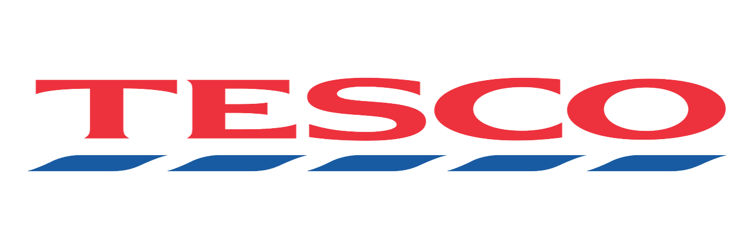

Executive Summary
The report aims to look at and judge modification management at Tesco’s, a serious distributor that has undergone appreciable strategic and operational modification over the last five years following major economic and structure troubles. In presenting this case, the report is split into variety of sections to explain different statistics.

Tesco is the largest British retailer and the third largest grocery retailer in the world with outlets throughout Europe, the United States and Asia. The business started in 1919 with one man, Jack Cohen, selling food from a stall in London's East End; his first day's profit was £ 1 and sales were £ 4 from his first day.
This report will outline all the crisis issues that Tesco have to overcome and what they have done to resolve this. This will also be presented with referencing and screenshots to reflect all information given in this report.

Contents Page
Page 1 : Title
Page 2 : Executive Summary
Page 3: Content Page
Page 4: Introduction
Page 5: terms of references
Page 6: Procedure
Page 7 & 8 : Finding
9 - 12: Options and Impact
13 : Conclusion

Introduction
The researcher investigates the history of Tesco and has a look at the history of how Tesco started, and how it developed alongside all their crisis issued in today’s market. What impact they had and what problems they had to face and how they overcame it. Tesco is one of the leading supermarkets of food, clothing and homeware, which also offers financial services which was introduced in 2009 as Tesco Bank.
The Tesco brand first appeared five years later in 1924 when he bought a shipment of tea from a Mr T. E Stockwell. The initials and letters were combined to form Tes-co and in 1929 Mr Cohen opened the flagship Tesco store in Burnt Oak, North London.

1.0 Terms of Reference
Maria Heffernan requested this report on Tesco, due date for submission is the 29/3/19.Purpose of the report is to analyse a brief outcomes of the problems faced by the company.The report was compiled by Mussarut Hassan, how to have an overcome on the problems Tesco supermarket had and how to expand and maintain the company. The date of submission for my report is the 05/04/2019.

2.0 Procedure

I have prepared the report by looking in to websites and new articles which contain information about Tesco’s history.
The first website used was
https://www.telegraph.co.uk/finance/markets/2788089/A-history-of-Tesco-The-rise-of-Britains-biggest-supermarket.html.
I first took the time to read old news articles online regarding tesco’s Crisis over the last 5 years and it’s competitors. This helped form my finding and understanding.
https://www.theguardian.com/business/2014/oct/23/tesco-timeline-the-highs-and-lows
I investigated some important timeframe of Tesco which was found from the link above.
https://www.thetimes.co.uk/article/tesco-crisis-is-over-as-profits-and-sales-jump-lnlwxhp97
Crisis overview of Tesco discussing their profits and competitors.
https://www.ft.com/content/2c008dbc-8b16-11e6-8cb7-e7ada1d123b1
This website gave an insight of what Tesco’s attempt to bring loyal customers back to their supermarket.
https://www.bbc.co.uk/news/business-43722494
This website gave this investigation exact figures of sales and an insight of their crisis since the last 10 years.
https://www.managementtoday.co.uk/tesco-finally-move-its-accounting-scandal/reputation-matters/article/1428882
Tesco scandal information
https://www.theguardian.com/business/2015/apr/22/tesco-suffers-record-64bn-loss
Tesco Loss

3.0 Findings
Tesco is one of the leading retailers within the UK industry, and is also one of the largest food retailers in the world. Tesco store was found in 1919 when Jack Cohen started selling additional groceries from a stall within the East End market of Brixton which is in London. Mr Cohen made a £ 1 profit from £ 4 sales on the first day. However, the Tesco brand become visible in five years and then later within 1924, when Mr. Cohen bought a shipment of tea from Mr. T.E Stockwell. Which was then combine later with the initials letters to form Tes-co and Mr Cohen opened a flagship Tesco store in Burn Oak, North London.
The Tesco brand continued to rise in the 1930s, and Mr. Cohen decided to build a headquarters warehouse in northern London, and Tesco became a private limited company (PLC) in 1932.
The cracks started to show in 2012, as cash-strapped shoppers started to turn in their droves to budget supermarkets Aldi and Lidl.
Mainstream supermarkets including Tesco, Morrisons and Sainsbury’s suffered as increasingly savvy shoppers shopped around for the best deals: looking for cut-price essentials at the budget supermarkets and trading up for affordable luxuries at Waitrose and Marks & Spencer. Tesco shocked the market with its first profit warning in almost 20 years and the revelation saw shares plunge by as much as 15 per cent.
The situation deteriorated as the discounters went from strength to strength. Tesco reported its first fall in annual profits in 19 years in April last year, with post-tax profits tumbling almost 96 per cent in a year. It decided to ditch its chain of US stores Fresh & Easy, which despite more than a billion pounds of investment failed to turn a profit.
It also had to write off £804million for land bought at the height of the property boom, which following the financial crisis it decided would not be developed. It decided to change its focus from offering discounts and special offers to luring shoppers in with the promise of low prices on basics week in week out.
Dave Lewis has spent two years persuading customers to return to the aisles of Tesco to spend their cash rather than at cheaper options down the road at Aldi and Lidl. When he first spoke to analysts who were investigating this issue “it was in the context of crisis,” Mr Lewis refered to his first months after taking the chief executive job in 2014 at a time when Tesco stores were at the lowest point of a long-term decline beginning in 2010.
Tesco shares surged 10 per cent on hopes that Britain’s largest grocer was finally back on track, adding £1.5bn to the company’s market capitalization in the space of a few hours. Promising to deliver £1.2bn in operating profit this year, Mr Lewis said that while the market was still “tough and uncertain”, the uncertainty was “not the same today as in April”. This is due to competitors now also offering similar products and value which makes it really tough to survive and make a profit.

Tesco plans to return to an operating margin to between 3.5 and 4.0 per cent by 2020, from 2 per cent in 2016.An average store has shifted more merchandise in every quarter since his arrival. Mr Lewis spruced up the chain’s stores, hired 12,000 extra staff, and gave every Tesco store assistant a pristine uniform and instructions to serve Britain’s shoppers a little better every day. At the same time, he slashed prices, in part to win back customers who were drifting towards discount operators Aldi and Lidl for at least some of their weekly shop, and sold non-core businesses accumulated under previous management.
Analysts credit these initiatives with breaking Tesco out of a downward spiral, in which the grocer kept prices high in an effort to compensate for the profit lost as customers defected, ultimately driving still more customers to look elsewhere. “The long-term winner is increasingly apparent,” says David McCarthy, an analyst at HSBC. “Tesco’s strategy of lowering prices to win volume share is bad news for competitors.” This brought tension to competitors and to Tesco staff as they really tried to bring sale volumes back to maximum level as previous years.
The diagram below shows the decrease in profit over the years.
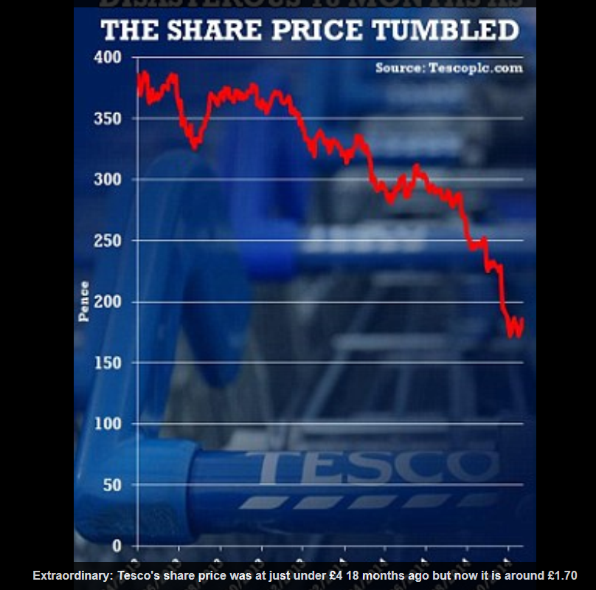

As this diagram shows that since more competitors have increased, their volume of sales decreased.
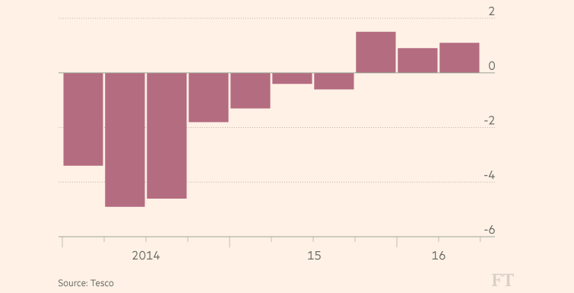
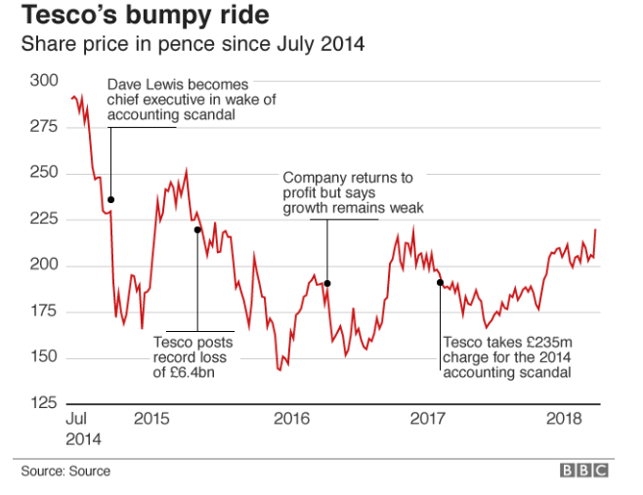

The jump follows years of disappointing results for Tesco after an accounting scandal and overambitious expansion. The retailer said the grocery market remained challenging due to ongoing pressure on costs.

In every organisation have competition, the current position is to look at other organisations and have the ability to compete, looking at the problem and how to make customers happy and not to fall out on investments. Asda and Sainsbury have cheap products, which attract customers and even more designs that customers like. Communicating and changing retailers can help as every retailers has different price and different way of doing business.
Researcher found that looking at the nature of the problem and how big the issue is, which position the business is in and resolving the matter and overcome it, and build the business and stay and compete with other organisations.
After years of growth in the UK, Tesco suffered five profit warnings last year as analysts said it had opened too many large stores, let prices rise and shop floor standards slip. All supermarkets are under pressure as shoppers switch to the internet, small local shops and discounters such as Aldi and Lidl, but Tesco has been hardest hit as a result of its scale. Lewis, who has never run a retailer before, was brought in to provide a fresh approach. Analysts said Tesco had invested about £200m into cutting prices and improving service in the past year.
However, since Tesco has cut prices, is simplifying its ranges and improving service in stores bringing more sales into the supermarket. But the annual financial results made clear the scale of the challenge for Lewis. Group sales fell 3% and trading profit, which excludes the impact of one-off costs, dived by 58% to £1.4bn. Trade at established UK stores improved in recent months, but sales still slid 1% in the final quarter compared to 3.6% for the year as a whole.
Bringing more and more Tesco Expresses in to the UK has achieved sales growth at established stores. The grocer’s Extra hypermarkets, superstores and smaller city Centre Metro outlets all experienced a decline in sales amid a dramatic switch in consumer shopping habits. However, as Tesco Expresses are all over the UK and are open more convenient timings, there will be customers in there who will always shop there as it is providing the essentials needed. They are also easy findable and makes it easy and convenient for customers.

3.4. Swot analysis

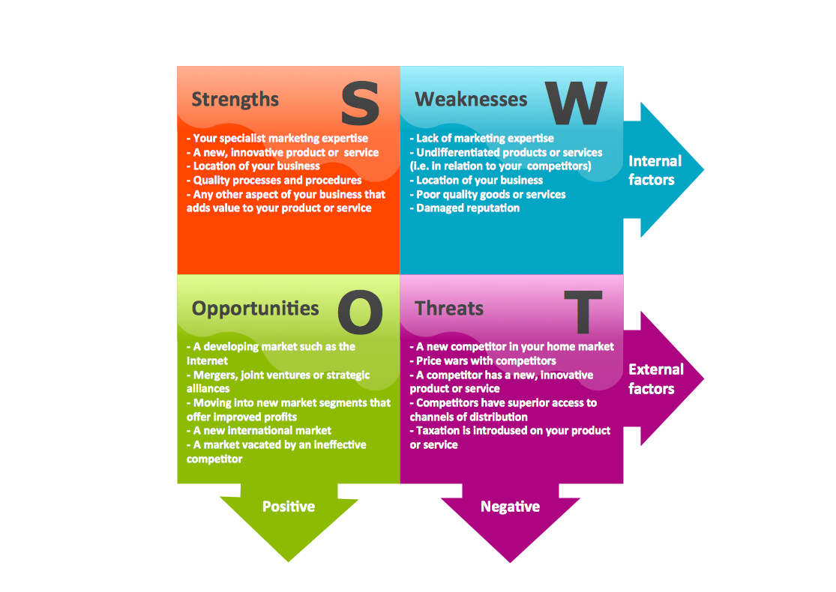

STRENGTHS;
Stores have large trading space.
Brand.
Interiors, decorating
Well experienced retailers.
Operation.
It provides recyclable eco.
International coverage.

WEAKNESS
Weak public relation campaigns and expensive shopping.
Changes.
Dependent on suppliers.
Less promotional activity for stores and company.
Clothing

OPPORTUNITIES;
More advertisement and promotion.
keep track of customers' demands.
Online shopping facility
Entering into new market segments.
Understanding competitors for complementary products.
Achieving.
THREATS;
Price competition and expensive.
New competitors.
Changing buyers.
Growing competitive pressures.
Rising sales.
Liability.
Growing customers and suppliers.

3.4.2. Pestle critical
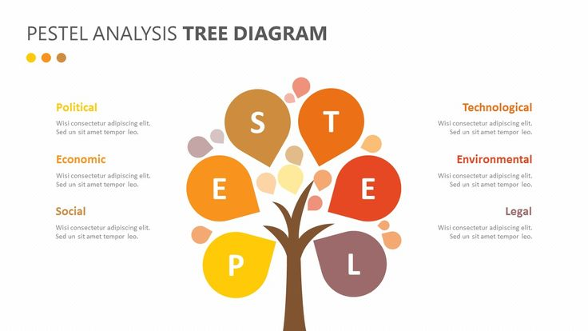

Stakeholder

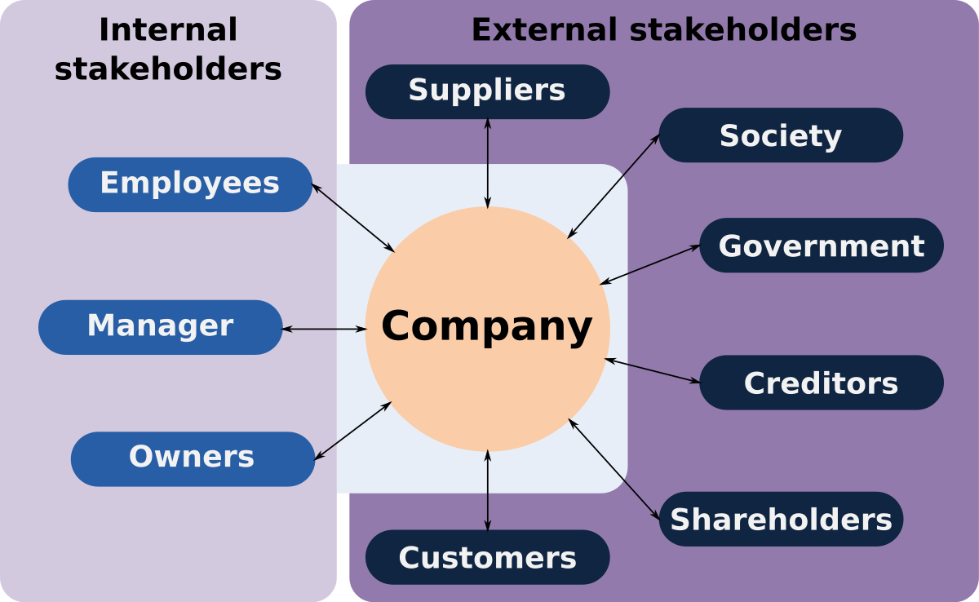

Conclusion

This conclusion will cover the report as an overall with its benefits and what problems have they have to overcome over the years. Selecting higher merchandiser and victimization skills created them higher in business, having skills they managed to beat they issues. Cutting the value had a control on the expansion, levelling the business towards other aspects other than food appeared to be the solution. For example, electrical, banking etc. They created some changes when they launched their finance in banking to re-establish the value position by sharpening costs and to reinforce service by putt additional staff into stores in 2009. These actions, combined with the troublesome commerce conditions, can have associate adverse impact on profit within the short-run. It’s very necessary for Tesco to happen a gentle balance between its long permanent singularity of tradition and sterilisation manner business and besides its expected for them to convey in an exceedingly balance in anxiousness they face for shopper, their male person power and also the close and also their ability to accommodate and the heaviest one to regenerate things and in an exceedingly higher mode. throughout this study.
The important finding of truth is that Tesco holds prospering concern schemes and market programs, the problem is that this price is non maintained by them instead some blessings have clothed to be a drawback for them. Tesco has a lot of competitors such as Aldi, Lidl, Asda and so forth. So it is really important that they are always maintain their advertisement within the community alongside deals which will help them maintain their balance of profit. Tesco developed a brand new concern theme, this was marked as an amount of alteration for the complete organisation. In thought that instructive what area unit operation direction and operations theme is definitely heavy.
Concluding this report, this shows that Tesco has been suffering over last 5 years due the scandal and expansion of other brands. However, Tesco is now trying to build customer’s confidence and maximise their sales and profits. They are still one of the largest supermarkets and have expanded by opening more express stores in more convenient locations for customers which makes it easier for customers to get too.

References :

https://www.theguardian.com/business/2014/oct/23/tesco-timeline-the-highs-and-lows

https://www.telegraph.co.uk/finance/markets/2788089/A-history-of-Tesco-The-rise-of-Britains-biggest-supermarket.html.

https://www.theguardian.com/business/2017/mar/28/tesco-agrees-fine-serious-fraud-office-accounting-scandal

https://www.ft.com/content/2c008dbc-8b16-11e6-8cb7-e7ada1d123b1

https://www.bbc.co.uk/news/business-43722494

https://www.managementtoday.co.uk/tesco-finally-move-its-accounting-scandal/reputation-matters/article/1428882

https://www.theguardian.com/business/2015/apr/22/tesco-suffers-record-64bn-loss

