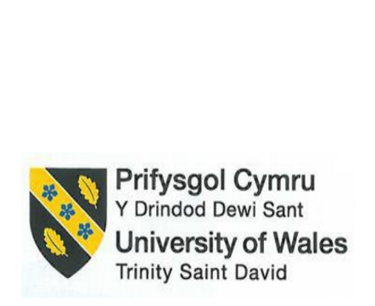
The advancement of HRM allows the planned development of Hilton Hotels and Resorts via personnel planning, recruiting, and selection

Module Title: Personnel Resourcing and Development
Module Code: BMIH5005
Student Name: Sabbir Ansar Hussain
Student ID: 2233891
Lecturer: Scott James

Introduction
Hilton Resorts & Hotels keeps altering its human resources approach to continue with the growth of the company. Hilton carries its workers along with the objective of the organisation by establishing proper human resource management. It is an activity of forecasting the talent needed, shortages of skills, and future market changes that may affect the predicted advancement of the efficiency professionals who are intended to accompany achievement.
The selection process at the Hilton organisation varies from hiring individuals who can barely deal with present responsibilities to management. The fundamental reason for the method is an organisation that shares the purpose and targets long-term planning (Gilch, and Sieweke, 2021). Hilton leverages the latest technologies and its unique strategies that involve the use of social networks and other sources to acquire a compilation of highly productive labour by individuals.
Recruitment techniques at Hilton help to recruit people not only based on their talents but also their cultural fit and growth prospects inside the organisation. It enforces interviews, tests, and challenges so that the top workers who can deal with the rapid, focused customers in the Hilton setting are identified.
To accomplish this, Hilton has purposefully constructed its HRM procedures for the workers to enable them to not only handle the current difficulties but also to manage future difficulties. That is why the hotel consistently survives better than its rivals by always adjusting to unanticipated developments in the field of hospitality (Altındağ, and Bilaloğlu Aktürk, 2020).
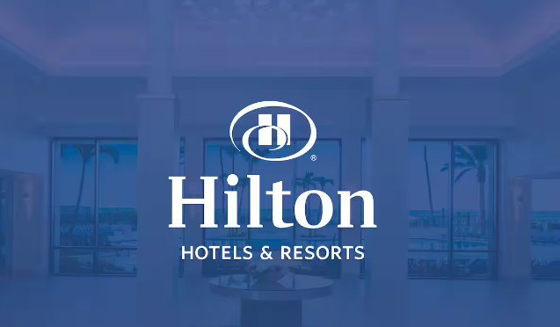
Figure: Logo of Hilton Hotels and Resorts
Source: (Hilton., n.d)
Main body

Hilton Hotels and Resorts has become known for its distinct strategy in the field of human resources management since it has observed an astonishing shift in its methods throughout the years. At the onset, Hilton's attention to standard HR responsibilities such as recruiting & training has now evolved to a strategic approach to forging connectivity between the human resources department and the business objectives of the firm. This is an approach to development that comprises actions like shaping and executing talent initiatives, diversity, and staff involvement, among others (Basu et al., 2023). Hilton contributes to the enhancement of the morale of the workforce and leads to better employee retention rates (da Silva et al., 2022). In addition, Hilton's culture of continual learning and innovation stimulates team members to readily adjust to current market conditions, so organisational innovation is preserved and success is secured.

The numerous roles and significance of human resources services offered by Hilton Hotels and Resorts define the company's performance. Recruitment tactics, screening, and keeping individuals with a wide range of skills ought to accompany training and establish programs that increase skills and competencies (Shamaileh et al., 2022). HR practices indicate the creation of an environment where staff engagement and health matter because it is only satisfied employees that lead to happy guests (Townsend et al., 2022). With the programs of inclusion and diversity, HR staff promotes the changeability and competency of the company. The management of performance systems, which function clearly and deliver demands and feedback, is particularly important, requiring ongoing progress. Leveraging technology as well as information provides the door for better operations in important activities, such as recruiting, selecting, and planning. With the achievement of its strategic purpose, HR at Hilton demonstrates that it is the major stakeholder of superior organisational performance, a remarkable workplace culture, and, therefore, a competitive edge in the hotel industry.

The internal components of addressing potential growth, such as anticipated expansion, and adjustments, should be taken into consideration (Lozano, Rey-Maquieira, and Sastre, 2021). The administration of leaders of the division in posts and advanced operational perspectives create a lot of knowledge regarding particular departmental needs, which typically vary from each other (Wilson et al., 2020). In this sense, the technology is employed by the Hilton Hotel company for worker management. This helps make the employee's duties more understandable and precise.
Scenario planning requires Hilton to establish strategies to handle unexpected and unanticipated situations, enabling the business to adjust personnel numbers as required. Therefore, the company starts to handle strategic planning concerns like recruitment techniques, talent program growth, and retention rate procedures and then takes decisions based on the predicted labor requirement and supply. By integrating all of these elements and employing a sort of data-driven thinking, Hilton ensures they have appropriate individuals in the ideal place at the correct time, which in turn lifts the standard of their customer service as well as costs throughout.

Goal formulation, as well as strategy development at Hilton Hotels and Resorts, hold that high position, which enables it to realise its purpose of being the most welcoming organisation on the entire globe. The process contains numerous important steps:
- Hilton sets its approach by its mission of producing outstanding experiences in the hospitality industry (Tan, and Despotis, 2021).
- Hilton detects the developing patterns in the hotel business by doing a detailed market analysis. Moreover, it emphasises client preferences and the degree of competition in the region.
- Hilton works with every stakeholder and especially listens to them to identify what they want.
- Smart goals for long-term expansion and long-term viability of Hilton, following the boundaries of its strategic plan and marketing approach, will be formed by a rigorous evaluation of the market (Edeh, and Dialoke, 2020).
- In Hilton, as in many other companies, strategic actions have to be taken over the company's attainment of the desired objectives, like the evaluation of emerging markets for possible expansion, the development of customer experiences through creativity, fostering staff growth and training, and ultimately adopting environmental programs (Piso, 2022).
- Hilton utilises key performance indicators, or KPIs, to assess its staff effectiveness to meet its goals. Moreover, it continually evaluates the data to govern its staff operations according to its strategic goals.
A number of specific goals have been determined by Hilton, along with carrying out strategic plans and tracking performance, to stay at the top of the competition in the tourism sector.

The implementation and evaluation methods at the Hilton brand of hotels and resorts are fairly tough, and they are meant to ensure that the organisation succeeds in the execution of its strategic objectives and acquires consistent operational outcomes.
As for the evaluation, Hilton creates KPIs, that are associated with the stated goals. Gathering and interpreting the data is crucial (Robina-Ramírez, Isabel Sánchez-Hernández, and Díaz-Caro, 2021). The metrics may range from visitor ratings of their satisfaction to financial performance indicators.
The performance of Hilton versus its rivals is a measure of the efficacy of the firm, and in this way, the areas of development will be discovered. The outcome of an evaluation being validated keeps on rebounding between the company's strategic choices in addition to its upgrade activities (Yusoff et al., 2020).
In addition, Hilton creates an environment where the staff are empowered to develop, innovate, and alter if required to build a strategy for enhancing the efficiency of each hotel unit whenever evaluation happens. This cyclical mode guarantees that programs are improved so they are connected to current visitor preferences, market realities, and corporate objectives.
By embedding efficient operational implementation and evaluation procedures, Hilton maintains serving the demands of their clients while reaching both operational and environmental sustainability stages, which constitute the high-competitive areas in the industry of tourist business.
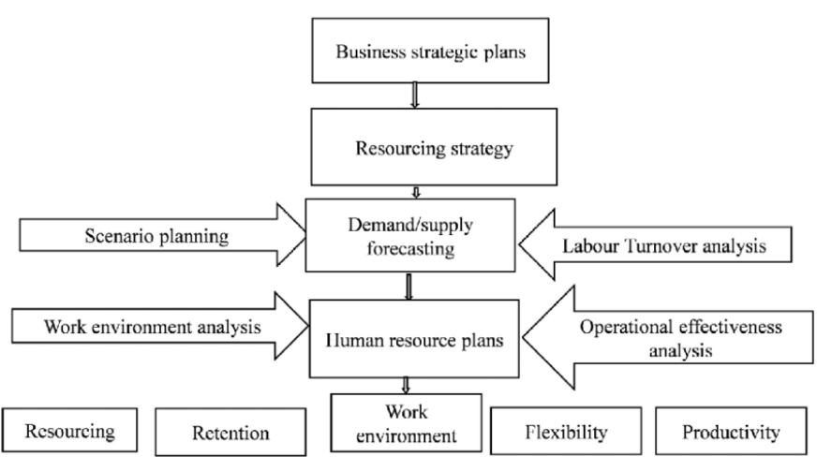
Figure: Process of HR planning
Source: (Ivan et al., 2020)

Hilton Hotels & Resorts enhances the growth of units as it manages the implementation of programs aimed at boosting employees’ workforce skills, making them enthusiastic, satisfied, and passionate about the hotel industry more efficiently (Madan, 2022). Numerous examples can be cited:
- Hilton determines standards of excellence based on complete development and training independently for each division. Through this sort of program, corporations might build management, technical knowledge, and certification programs, enabling individuals not only to improve individually but also to flourish in their employment while giving a company a stronger structure and success.
- Hilton employs a strategy for a succession of events to analyse great individuals within the organisation and push them up the ladder of success (Salkar, 2022). Through developing high-grade staff into potential managers, Hilton's workforce maintains stability and refreshes itself upon individuals when old ones depart, thus creating a space for long-term performance and overall organisational stability.
- Hilton employs performance management indicators such as setting objectives, constant feedback, and supporting workers throughout work divisions based on these actions (Kristal, 2022). Employees would rather be driven by a sense of satisfaction about the organization they're working for, not only because they want to demonstrate their devotion to the company.
- Hilton continues its staff engagement activities, including reward programs, promotion of wellness, and employee feedback techniques as a strategy for integrating a health-based work environment throughout all business divisions. Participation by staff members is the primary basis upon which productivity, creativity, and dedication to the fulfilment of corporate goals are established (Zeng, 2021). This in turn boosts the efficiency of the unit and the business as a whole, thereby adding to the company's success.
- Hilton takes out staffing planning operations that comprise projecting future demands within the organisation and executing recruitment efforts to employ a good quantity of excellent talent. Providing that the best individuals remain in the best jobs, Hilton is increasing its operating unit abilities for achievement in this highly competitive environment.
Thus, Hilton Resorts and Hotels employ human resources management as a foundation to manage a devoted, high-performing, and content team to operate diverse business divisions as well as support sustainable growth and achievement in the challenging hospitality sector via these activities.
Hilton Hotels & Resorts has concerns regarding the management of human resources methods and practices linked with strategic recruiting via the use of thorough selection processes that focus on top workers and put into action the business unit objectives. Examples are as follows:
- Hilton recognises and stimulates unique qualities and expertise in the recruitment process, through which individuals are approved who suit the best requirements of each business unit (Hayes, 2021). Hilton looks for individuals who already show leadership qualities and industrial working expertise.
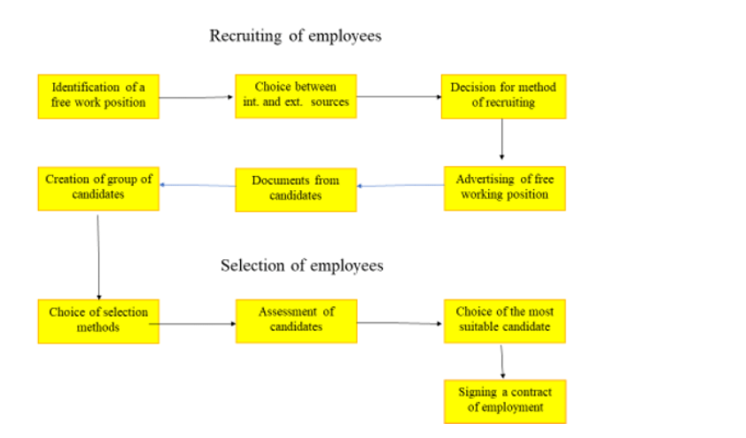
Figure: Stages of recruitment
Source: (Stofkova, and Hraskova, 2020)
- Hilton is dynamic in promoting inside the organisation by encouraging workers to have the option to look into new business sectors (Dewi, Astawa, and Armoni, 2023). Through that, individuals might build cross-functional partnerships both by receiving diverse abilities from one another and by expanding as specialists in their vocations. This assists the company with its divisions' success.
- Hilton applies specialised recruiting tactics like a resume based on competence analyses assessment and evaluation process, and workplace simulation to analyse the ability of the applicants to fill the job opening in the company's unit. Therefore, in addition, this ensures that the candidates have the required credentials and standards.
- Hilton’s hiring procedures encourage diversity and inclusion, with an effort being made to discover various employees for unit business jobs (MAZARAKI, 2022). However, Hilton’s encouragement towards diversity serves two purposes. It gives different viewpoints from every aspect of the company. An opportunity to contribute their ideas and experiences enables innovation, creativity, and excellence.
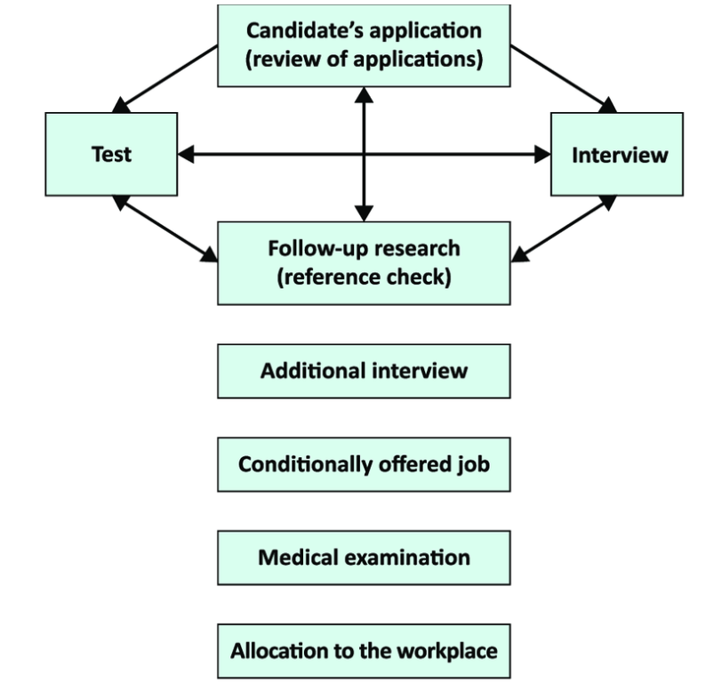
Figure: Process of selection
Source: (Čerović, 2020)
By taking advantage of these hiring and choosing methods, Hilton readily enters into interactions with individuals whose expertise and experience will have an essential effect on the continued success of the business, thus ensuring the company’s continued growth and position as a leader in the industry of hospitality.

Conclusion
The properly established HRM systems of Hilton Hotel & Resort have been an essential element in the expansion of the hotel business within the hospitality and tourism business. It is important to see how recruiting, developing, and keeping great Hilton workers via corporate-directed HR procedures connected to company objectives helps Hilton serve its clients at higher levels of excellence, which leads to their long-term satisfaction. The staff training and assessment processes employed by Hilton are oriented on establishing, improving, and sustaining skilled, capable, and ambitious employees, which in turn allows for increased processes' efficiency and innovation. Further, extraordinary HRM tactics generate a delightful working atmosphere and, stimulate the staff members’ participation, which subsequently boosts the organisation's effectiveness and ultimately profitability for Hilton. As a rule, the unified aspect of Hilton's human resources management activities, to some degree, encourages the company's activities at Hilton Hotels and Resorts and thus helps the company reach the peak of the hotel industry.

References
Altındağ, E. and Bilaloğlu Aktürk, H., 2020. The impact of new generation management approaches on the firm performance: The Moderating Role of Strategic Human Resource Management Applications. Sage Open, 10(3), p.2158244020948845. Available at: https://journals.sagepub.com/doi/pdf/10.1177/2158244020948845 (Accessed: 23 April 2024)
Basu, S., Majumdar, B., Mukherjee, K., Munjal, S. and Palaksha, C., 2023. Artificial intelligence–HRM interactions and outcomes: A systematic review and causal configurational explanation. Human Resource Management Review, 33(1), p.100893. Available at: https://eprints.whiterose.ac.uk/182852/12/Basu%20et%20al%202022%20HRMR%20AI%20and%20HRM.pdf (Accessed: 23 April 2024)
Čerović, S., 2020. IN HOSPITALITY INDUSTRY. Available at: https://www.researchgate.net/profile/Slobodan-Cerovic-2/publication/341001937_US_-_Human_resource_management_in_hospitality_industry/links/5ea96fbfa6fdcc705097d1b2/US-Human-resource-management-in-hospitality-industry.pdf (Accessed: 23 April 2024)
da Silva, L.B.P., Soltovski, R., Pontes, J., Treinta, F.T., Leitão, P., Mosconi, E., de Resende, L.M.M. and Yoshino, R.T., 2022. Human resources management 4.0: Literature review and trends. Computers & Industrial Engineering, 168, p.108111. Available at: https://bibliotecadigital.ipb.pt/bitstream/10198/25457/1/Da-silva-2022-Human-resources-management--literat.pdf (Accessed: 23 April 2024)
Dewi, N.P.I.M.P., Astawa, I.K. and Armoni, N.L.E., 2023. The implementations of green employee relations in supporting environmental performance at Hilton Bali Resort. Journal of Applied Sciences in Travel and Hospitality, 6(2), pp.117-128. Available at: https://ojs2.pnb.ac.id/index.php/JASTH/article/view/1247 (Accessed: 23 April 2024)
Edeh, F.O. and Dialoke, I., 2020. Effect of human resource planning on organizational performance of the hospitality sector in Nigeria. Business Perspective Review, 2(1), pp.1-12. Available at: https://www.riiopenjournals.com/index.php/business-perspective-review/article/view/71 (Accessed: 23 April 2024)
Gilch, P.M. and Sieweke, J., 2021. Recruiting digital talent: The strategic role of recruitment in organisations’ digital transformation. German Journal of Human Resource Management, 35(1), pp.53-82. Available at: https://journals.sagepub.com/doi/pdf/10.1177/2397002220952734 (Accessed: 23 April 2024)
Hayes, D.K., 2021. Human-resource management in the hospitality industry. Available at: http://elibrary.gci.edu.np/bitstream/123456789/3191/1/Bt.433%28by-David-K.-Hayes%2C-Jack-D.-Ninemeier%29-Human-Resou-900308-.pdf (Accessed: 23 April 2024)
Hilton., n.d. Available at: https://www.hilton.com/en/brands/ (Accessed: 23 April 2024)
Ivan, B., Turyareeba, D., Wagima, C., Wemesa, R., Ssebbaale, E.M. and Moses, K., 2020. Human Resource Planning Process and Its Influence to the Performance of Health Sector in Uganda: A Case Study of International Hospital Kampala (IHK). Open Journal of Business and Management, 8(05), p.2248. Available at: https://www.scirp.org/html/20-1531450_102911.htm (Accessed: 23 April 2024)
Kristal, T., 2022. Employer brand image of Kämp Collection Hotels. Available at: https://www.theseus.fi/bitstream/handle/10024/785086/Kristal_Tairi.pdf?sequence=2 (Accessed: 23 April 2024)
Lozano, J., Rey-Maquieira, J. and Sastre, F., 2021. An integrated analysis of tourism seasonality in prices and quantities, with an application to the Spanish hotel industry. Journal of Travel Research, 60(7), pp.1581-1597. Available at: https://www.researchgate.net/profile/Javier-Lozano-5/publication/343779584_An_Integrated_Analysis_of_Tourism_Seasonality_in_Prices_and_Quantities_with_an_Application_to_the_Spanish_Hotel_Industry/links/646b1a469533894cac83295d/An-Integrated-Analysis-of-Tourism-Seasonality-in-Prices-and-Quantities-with-an-Application-to-the-Spanish-Hotel-Industry.pdf (Accessed: 23 April 2024)
Madan, K., 2022. Cultural influences on recruitment: a comparative study of four-star hotels in Sydney and Singapore. Available at: https://researchdirect.westernsydney.edu.au/islandora/object/uws:70504/datastream/PDF/view (Accessed: 23 April 2024)
MAZARAKI, A., 2022. POSITIVE IMAGE OF «HILTON» HOTEL CHAIN INTERNET DISTRIBUTION SYSTEM. International hotel and restaurant business trends: articles’s collection of master programs students/executive editor AA Mazaraki.–Kyiv: State University Trade of and Economics, 2022.–55 p., p.32. Available at: https://knute.edu.ua/file/MjkwMjQ=/98448cca47519ed0112cf0fd0fe267cd.pdf#page=32 (Accessed: 23 April 2024)
Piso, A., 2022. Controlling the clock: Working hours in the UK hotel sector. Research in Hospitality Management, 12(1), pp.1-11. Available at: https://www.ajol.info/index.php/rhm/article/view/230160 (Accessed: 23 April 2024)
Robina-Ramírez, R., Isabel Sánchez-Hernández, M. and Díaz-Caro, C., 2021. Hotel manager perceptions about corporate compliance in the tourism industry: an empirical regional case study in Spain. Journal of Management and Governance, 25(2), pp.627-654. Available at: https://www.researchgate.net/profile/Rafael-Ramirez-3/publication/341642554_Hotel_manager_perceptions_about_corporate_compliance_in_the_tourism_industry_an_empirical_regional_case_study_in_Spain/links/5f0cbcc7a6fdcca32ae971a6/Hotel-manager-perceptions-about-corporate-compliance-in-the-tourism-industry-an-empirical-regional-case-study-in-Spain.pdf?_sg%5B0%5D=started_experiment_milestone&_sg%5B1%5D=started_experiment_milestone&origin=journalDetail (Accessed: 23 April 2024)
Salkar, M.V., 2022. Hilton Goa Resort (Doctoral dissertation, Goa University). Available at: http://iqac.unigoa.ac.in/criterion1/1.3.4-Salkar-Varshali-Ramnath.pdf (Accessed: 23 April 2024)
Shamaileh, N., AlHamad, A., Al-Qudah, M., Mohammad, A., Alhalalmeh, M., Al-Azzam, M. and Alshurideh, M., 2022. The effect of e-HRM on organizational performance and talent management: A strategic evolution perspective. International Journal of Data and Network Science, 6(4), pp.1043-1048. Available at: https://m.growingscience.com/ijds/Vol6/ijdns_2022_107.pdf (Accessed: 23 April 2024)
Stofkova, Z. and Hraskova, D., 2020. Company personnel policy as part of new management approaches in globalization. In SHS Web of Conferences (Vol. 74, p. 04028). EDP Sciences. Available at: https://www.shs-conferences.org/articles/shsconf/pdf/2020/02/shsconf_glob2020_04028.pdf (Accessed: 23 April 2024)
Tan, Y. and Despotis, D., 2021. Investigation of efficiency in the UK hotel industry: a network data envelopment analysis approach. International Journal of Contemporary Hospitality Management, 33(3), pp.1080-1104. Available at: https://pure.hud.ac.uk/ws/files/34921450/CHECKED_IJCHM_revised_manuscript_02012021.pdf (Accessed: 23 April 2024)
Townsend, K., Dundon, T., Cafferkey, K. and Kilroy, J., 2022. Victim or master of HRM implementation: the frontline manager conundrum. Asia Pacific Journal of Human Resources, 60(1), pp.79-96. Available at: https://www.researchgate.net/profile/Kenneth-Cafferkey/publication/355212466_Victim_or_master_of_HRM_implementation_the_frontline_manager_conundrum/links/62b3daa9d49f803365b2c003/Victim-or-master-of-HRM-implementation-the-frontline-manager-conundrum.pdf (Accessed: 23 April 2024)
Wilson, R.A., Barnes, S.A., May-Gillings, M., Shyamoli, P. and Bui, H., 2020. Working Futures 2017-2027: long-run labour market and skills projections for the UK: main report. Department for Education. Available at: https://wrap.warwick.ac.uk/134235/1/WRAP-Working-futures-long-run-labour-market-skills-UK-main-report-Barnes-2020.pdf (Accessed: 23 April 2024)
Yusoff, Y.M., Nejati, M., Kee, D.M.H. and Amran, A., 2020. Linking green human resource management practices to environmental performance in hotel industry. Global Business Review, 21(3), pp.663-680. Available at: https://d1wqtxts1xzle7.cloudfront.net/89865046/Fardapaper-Linking-Green-Human-Resource-Management-Practices-to-Environmental-Performance-in-Hotel-Industry-libre.pdf?1660813512=&response-content-disposition=inline%3B+filename%3DLinking_Green_Human_Resource_Management.pdf&Expires=1713868256&Signature=GZSC1wEpqVdUlm5gJSOZ3bXN-LKnskjEHF145gPbFHiYkYqBXxpkVQeCaMyTx21LvyETiocYOmEHavHVSsEN15KPrgFbV4t86GgRpuuzBEF1fyYlUAs8nXUi0f1MdE~8-HliewdavyIuLxLswI8mSfMl6faaNu0lVLhFKQ1HH-lrCPt4e9CM1G8D5UBijDXYed7GCTN~m0zYPhO~rpKFMHtUxWRHB832GmEagSLffZCXq9GOTd3Zmm08S2h0NrXRawFxVIGpHVBKhNCjkRIbcMJ5LVPz9QHXub2IgQgOTf6q7qBw3vas9-R6i~8B5et5H11dn66NZdjGvFfNZLLojw__&Key-Pair-Id=APKAJLOHF5GGSLRBV4ZA (Accessed: 23 April 2024)
Zeng, L., 2021. Analysis of Hilton Worldwide Hotel Group’s Transnational Operation Strategy. Academic Journal of Business & Management, 3(11), pp.20-27. Available at: https://francis-press.com/uploads/papers/6WdwdrACthtaKangNJVKP6kmJOGaCSMmyeMcnTHG.pdf (Accessed: 23 April 2024)

