Ibrahim Balogun

Build, deploy, configure and manage a Type 2 Hypervisor platform based Virtualised network

Contents
Practical Work 2
Observational Tasks 9
Type 1 and Type 2 Hypervisors 9
Significance of the subnet mask in IPv4 addressing 9
Cloud computing 9
Different terminologies and its purposes 9
References 11

Practical Work
Building the network, there will be a few steps that will need to be performed to ensure the virtual machines are optimised and running all their correct software. Creating the server and assigning the right number of resources is essential, as shown in figure 1, 2 and 3.
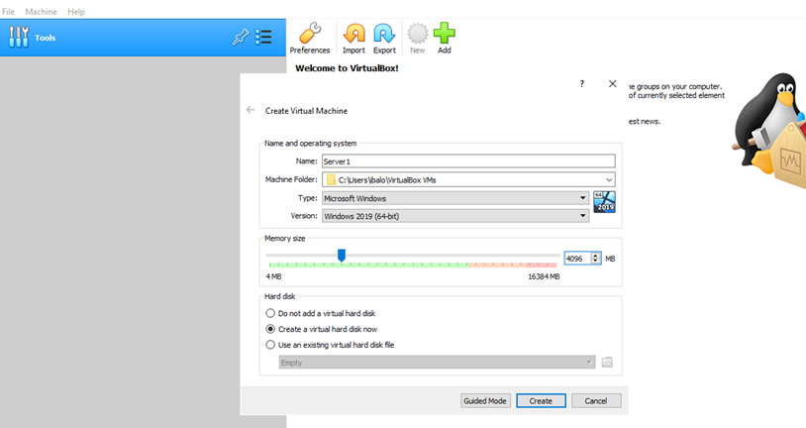
Figure 1, showing the ram allocated to the server

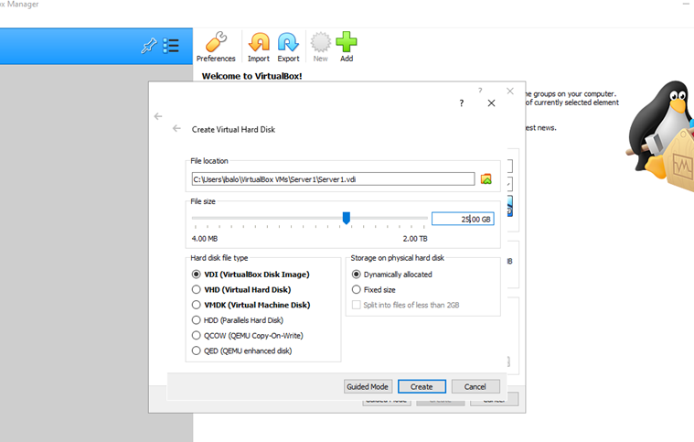
Figure 2, showing the amount of disk space given

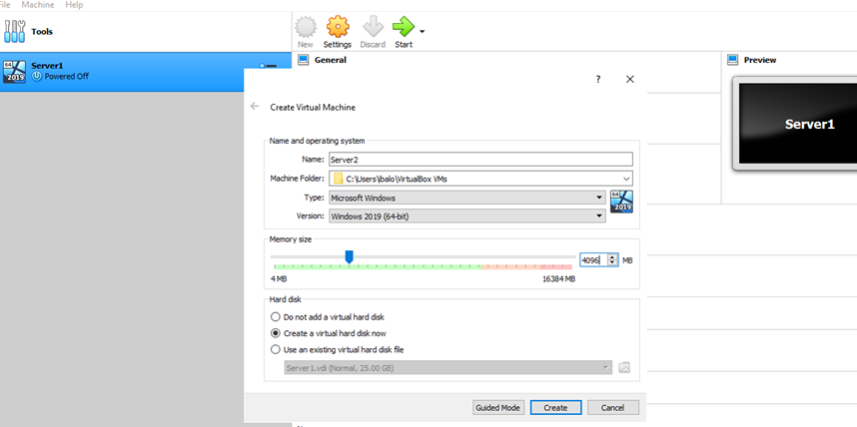
Figure 3, the same process with done with server 2

Selecting the correct operating system was the next phase of building the virtual machine, as shown in figure 4 and 5; this was repeated for all the other virtual machines.
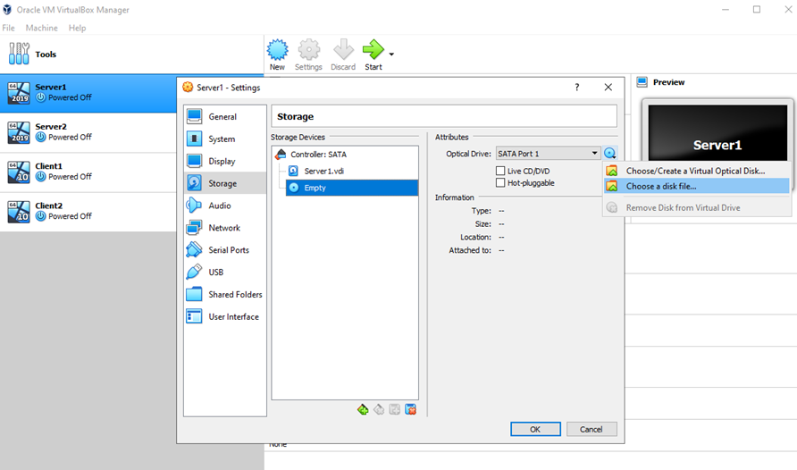
Figure 4, choosing the operating system boot

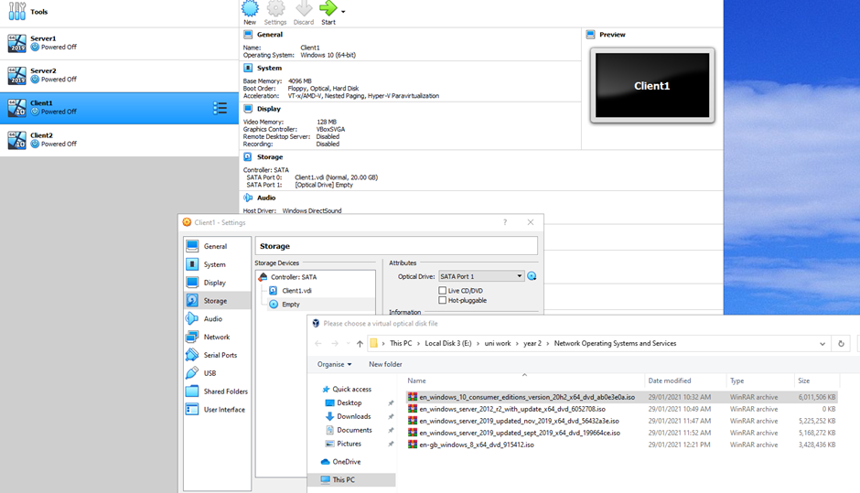
Figure 5, choosing the operating system for client 1's machine

When the suitable files are chosen, and the operating systems were downloaded and installed, as shown in figure 6,7 and 8, setting the network connections was the next step in building the network.
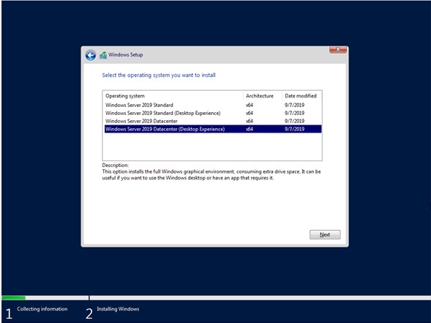
Figure 6, selecting the windows install option for the server

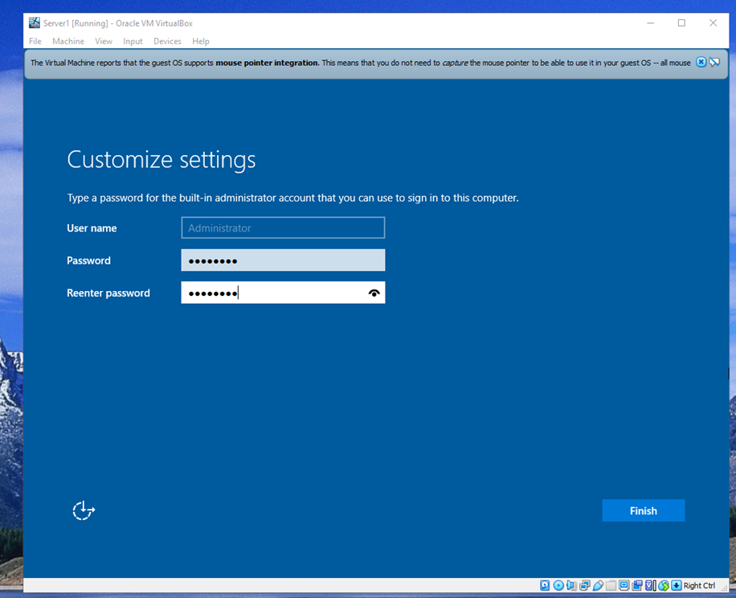
Figure 7, setting up the password used to sign in to the server

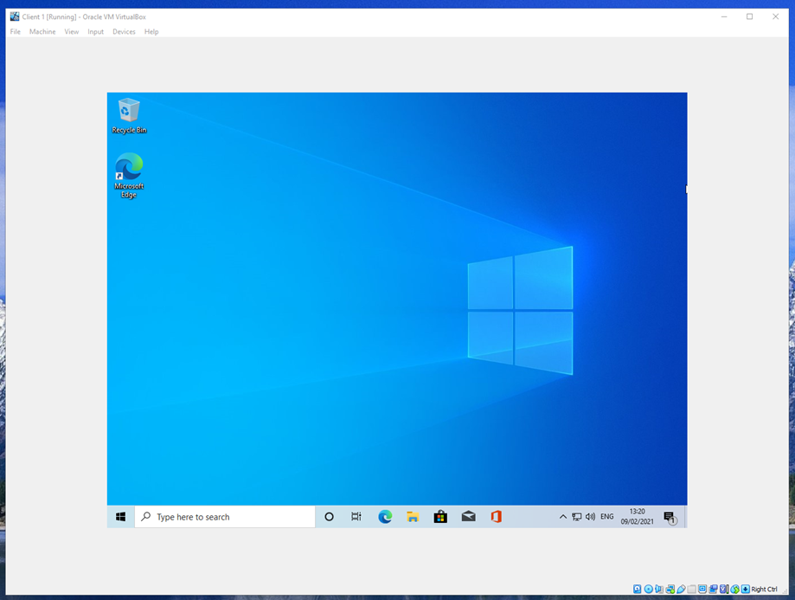
Figure 8, a completed install of windows 10 pro
Giving the servers and the client's systems an IP address was next as this allows the machines to communicate with one another through pinging; this also makes sure that the systems IP's are running correctly, figure 9,10,11 and 12, shows this process.
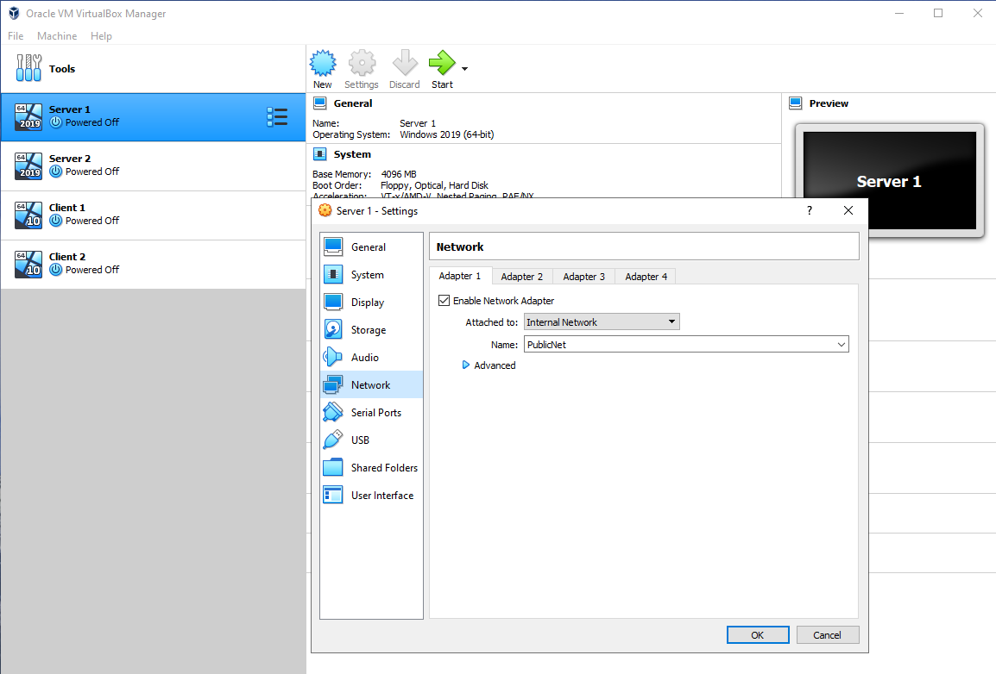
Figure 9 shows the enabling of the network adapter on server 1

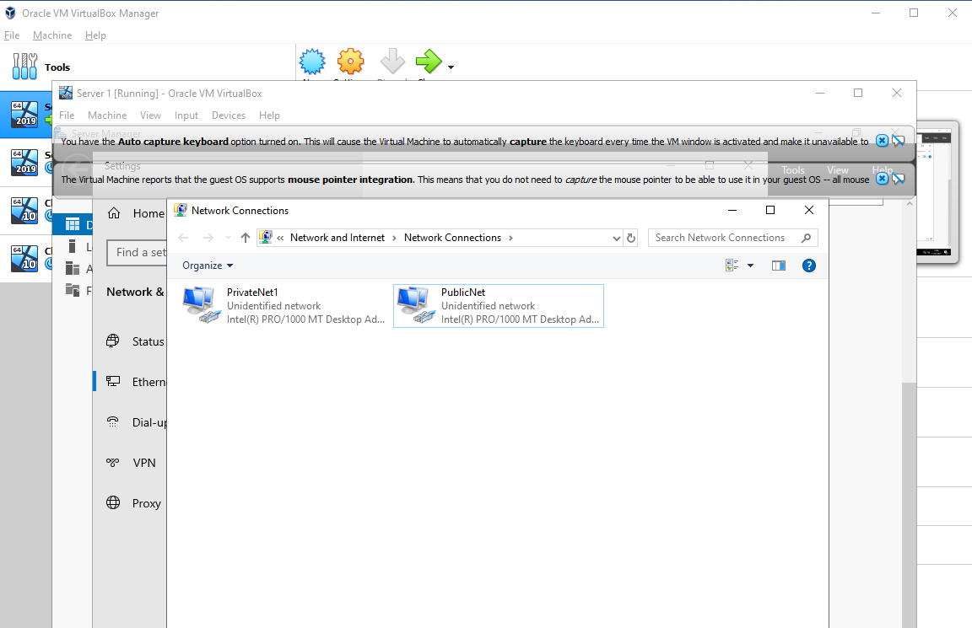
Figure 10, changing the names of the networks on server 1

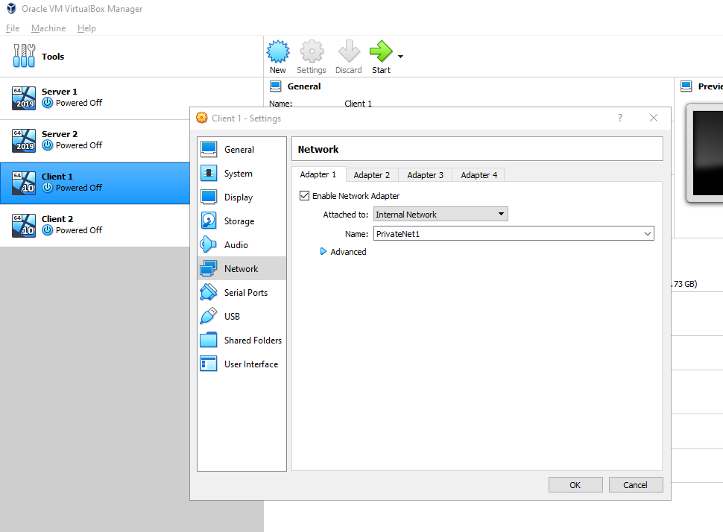
Figure 11, creating and enabling the network adapter for client 1

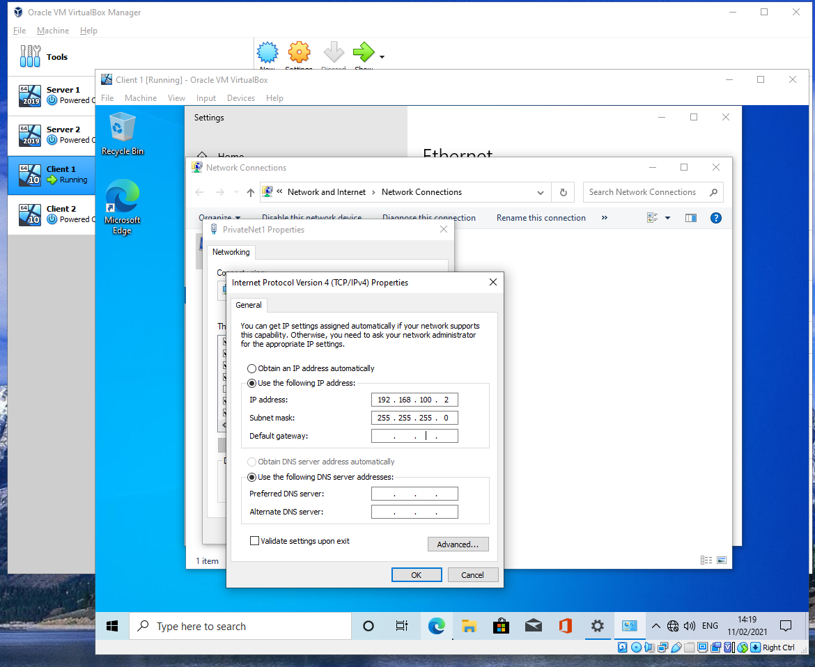
Figure 12 shows the setup of client 1s IP address
Sending pings is essential; it shows that the system and a connection with one another, as shown in figure 13 and 14
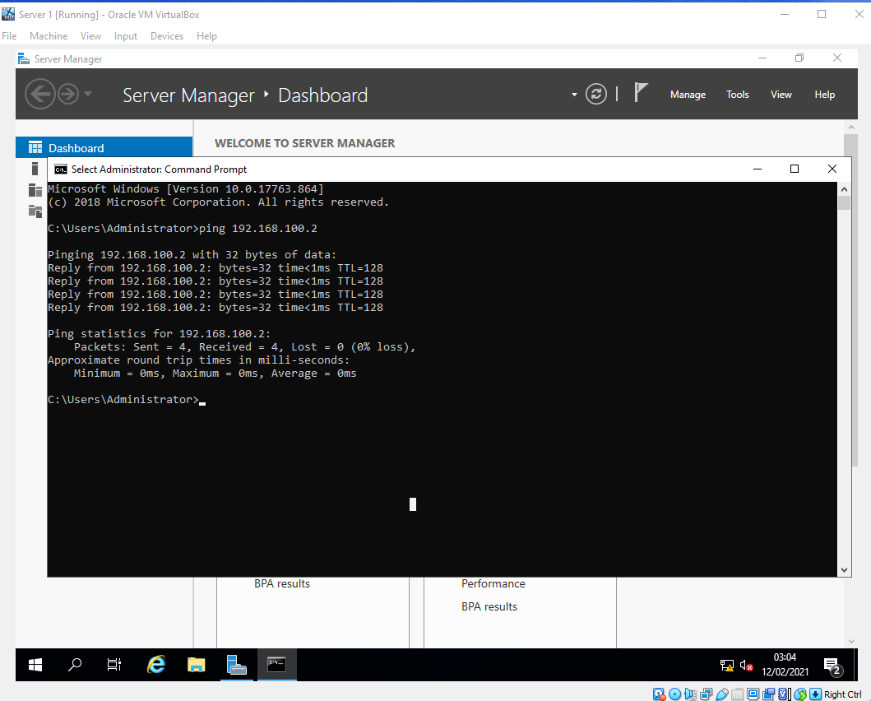
Figure 13 shows server 1 sending a ping to client 1

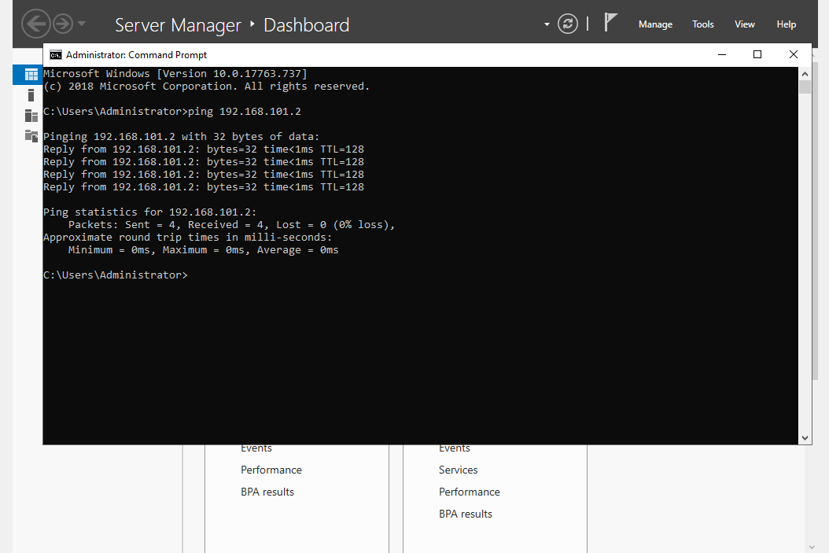
Figure 14 shows server 2 sending a ping to client 1

Observational Tasks

Type 1 and Type 2 Hypervisors
To understand the differences between Type 1 and Type 2 Hypervisors, you first need to understand what a hypervisor is and its functions. A hypervisor allows users to run multiple virtual machines independent of each other on their single system, as the resources to run the virtual machines are shared between them. [1] This sort of practices is trendy in the cloud computing enterprises as its cheap to run and does not take up as much space because multiple machines can fit into the same area as one machine. Type 1 hypervisors do not require the use of the hosts operating system to run multiple virtual machines, as it is run directly on the host machine. This is because running numerous virtual machines on physical hardware adds a layer of security as all the virtual machines are separated from each other, so in case of an attack, the infected virtual machines cannot spread to other virtual machines on the host system. [2] Type 1 hypervisors can also be used to time-consuming breakdown workloads, as each virtual machine is separated as advanced failover features, assigning each machine a task to optimise their performance. [3] However, type 1 hypervisors will need a separate system, a machine that manages the virtual machines and controls the host hardware. [4] There are a few examples of Type 1 hypervisors vendors, e.g., Citrix/Xen Server, VMware ESXi and Microsoft Hyper-V. [3] Type 2 hypervisor operates the same way as type 1 hypervisor, the only difference is type 2 hypervisor relies on the use of the host machines operating system, as the hosts operating system will manage requests to the storage, memory, CPU, and network resources. [3] By allowing the host system operating system to manage the virtual machines, this introduces obvious latency issues, as the virtual machines activities and workload must pass through the host operating system, [3] this could also lead to a security breach because the host operating system id directly connected to all the virtual machines and if a breach were to occur it will affect the host machine and the virtual machines. [2] These are some examples of type 2 hypervisors, e.g., Oracle Virtual, Box VMware Fusion, Microsoft Virtual PC and VMware Workstation [4]

Significance of the subnet mask in IPv4 addressing
The purpose of an IPv4 address subnet mask is that the IP address is broken into the host and network addresses by the subnet, determining which part of the IP address belongs to the computer system and which part belongs to the network. [5]

Cloud computing
Cloud computing is constructed by a diverse collection of computers that can perform extraordinary tasks when combined, specifically data backup, disaster recovery and virtual desktops; because the computers are built on the cloud, the users can access them anywhere. [6] The benefits of cloud computing are the reduces cost for the end-user, as cloud computing is mainly built up of multiple computers, which will be expensive to run and even more expensive to pay staff wages to operate them for you; they are also scalable, for example, if a user was running virtual machines, but they need more resources to run more virtual machines, these can be instantly added on, and all the customer would have to do is pay extra for the exception. [7] On the other side, when using any cloud computer, you will need a consistent and strong connection to the internet when used; the cost to pay 3rd party provides to host your cloud computer can slowly increase as you add more and more features to your package. [8] Some vendors who still sell cloud computing resources are Amazon Web Services, Microsoft Azure, Google Cloud Platform, Alibaba Cloud, IBM.

Different terminologies and their purposes
Ping
Ping serves two function, to determine how long it takes for a message to be sent from system to system and to check if the recipient's network is active. In any modern operating system, the ping command is standard and performed using the command-line interface, which all operating system have; the way ping works is that the host machine enters the recipient's IP address, and multiple pings will be sent out and an average ping will be shown to the host system, [9] however if the IP address is entered wrong or the recipient's network is down, this will result in the ping failing.
Firewall
Firewalls are an essential part of any network public or private as it acts similarly to a net, this allows for some objects to move through without getting caught and some will be stopped by the net. A firewall can be configured to filter out incoming traffic on a network that could be malicious or inappropriate for the users and system. [10] As all firewalls in each operating system work, the same comparing them will be ineffective.

References

[1] | K. Taylor, "Two Types of Hypervisor: Type 1 and Type 2," [Online]. Available: https://www.hitechnectar.com/blogs/hypervisor-type-1-vs-type-2/. [Accessed 18 February 2021].
[2] | "Type 1 and Type 2 Hypervisors: What Makes Them Different," 24 May 2019. [Online]. Available: https://medium.com/teamresellerclub/type-1-and-type-2-hypervisors-what-makes-them-different-6a1755d6ae2c. [Accessed 18 February 2021].
[3] | S. J. Bigelow, "What's the difference between Type 1 vs. Type 2 hypervisor?," 13 January 2021. [Online]. Available: https://searchservervirtualization.techtarget.com/feature/Whats-the-difference-between-Type-1-and-Type-2-hypervisors. [Accessed 18 February 2021].
[4] | I. C. Education, "Hypervisors," 8 May 2019. [Online]. Available: https://www.ibm.com/cloud/learn/hypervisors. [Accessed 18 February 2021].
[5] | “Subnet Mask,” [Online]. Available: https://avinetworks.com/glossary/subnet-mask/#:~:text=The%20subnet%20mask%20splits%20the,part%20belongs%20to%20the%20network.. [Accessed 22 February 2021].
[6] | S. Ranger, "What is cloud computing? Everything you need to know about the cloud explained," 13 December 2018. [Online]. Available: https://www.zdnet.com/article/what-is-cloud-computing-everything-you-need-to-know-about-the-cloud/. [Accessed 20 February 2021].
[7] | "Benefits of cloud computing," 21 July 2017. [Online]. Available: https://www.business.qld.gov.au/running-business/it/cloud-computing/benefits. [Accessed 20 February 2021].
[8] | A. LARKIN, "Disadvantages of Cloud Computing," 7 August 2019. [Online]. Available: https://cloudacademy.com/blog/disadvantages-of-cloud-computing/. [Accessed 20 February 2021].
[9] | “Home : Internet Terms : Ping Definition,” 15 August 2018. [Online]. Available: https://techterms.com/definition/ping. [Accessed 26 February 2021].
[10] | "What is a Firewall? - Definition & Explanation,” kaspersky, [Online]. Available: https://www.kaspersky.co.uk/resource-center/definitions/firewall. [Accessed 26 February 2021].

