Music has been study for thousands of years, widely used across cultures as a good source to regulate moods. Many people use music to help comfort their pain and emotions while going thought different issues in their life. Music has been known to be power tool in helping motivate people when their feeling low energy some music can cause people to have uplifting and joyful moments, it also can give people focus to achieve certain goals while making them feel more energized while doing tasks.
It helps soothe their souls. There is a lot of emotional power though music it the main motivations for people devoting time, energy and money is to make different frequencies and wave lengths to help people heal and relax. These have been proven and used to achieve many goals for people health and wellbeing, reducing many issues in life on daily bases.
Music bring a lot amotions and feeling to the surface some people cry when hearing certain music bring a sense of awe and admiration. The body can respond in different ways some people get goosebumps and motivation for improvement of their self and society.
When listening to music it can change perception of time it a stimulus that changes our relationship within the time frame. When listening to happy music it diverts attention away from time processing, calm the body causing a case of low arousal with slow tempo.
Music is used in many different forms of emotional help and in our daily lives like waiting rooms to ease waiting times, in supermarkets to encourage people to stay for longer and buy more by playing slow music, company use music in workplaces to keep workers happy boring and repetitive work.
While look at music it can widely affects peoples in many ways changing and altering people motivation, moods and emotions. Using different level low and high vibrations can affect people in different ways and make people feel sad or happy just by certain song. This has been proven for many years that why its used and made all around the world for emotional support and profit to entertainment people and change people mood daily.
Reference
How Listening to Music Affects Your Mood | Psychology Today
Shahram Heshmat Ph.D. Science of Choice Posted November 8, 2022 | Reviewed by Abigail Fagan

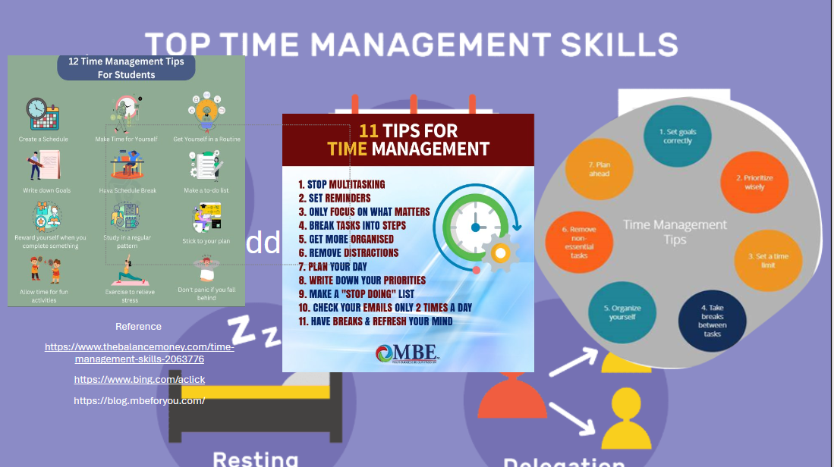

Title Essay plan for music and emotions

Introduction

Short paragraph about music, background and information that will be discussed in paragraph.

First main point (strongest)

Background to music.

How music makes you feel.

Second main point (second strongest)

Different music for different moods.

How emotions are affected by certain music frequencies.

Third main point (weakest)

Study’s done on music for different health issues.

Information from people and how certain music makes them feel.

Conclusion

Restate topic

Summarise three main points

Revisit introduction or tie all ideas together

Books and sources used.

Internet sources

Books

Journals

Studies on music

Studies on how people felt listening different music

