ECED7004 Assignment 1 – Professionalising Advocacy

Critically explore the implications of professionalising advocacy services and reflect on the potential impact of services becoming controlled by government agencies.

By Emma-Louise Johnson

MA Equity and Diversity
Department: Social Justice and Inclusion
Lecturer: Sharon Cole
University of Wales Trinity Saint David

15th May 2023

‘Who watches the watchers?’
(see Appendix 1)

Abstract:

The perpetual question of the accountability of power, aptly summarised in the above variant of the Roman poet Juvenal’s line (1998, p. 45), ‘Who is to stand guard over the guards themselves?’ underpins this critical appraisal of the impact on advocacy of professionalisation and governmental control. Due to the many types of advocacy available (Social Care Institute for Excellence (SCIE), 2022a, section 3, para. 2), the focus will be on independent advocacy (The Advocacy Project, 2023). A positional model of advocacy (see Appendix 2) will be used to compare and contrast the regulation of services as a recognised indication of professional status. This paper will thus contend that independent advocacy is uniquely placed to achieve its primary goals of social justice and inclusion (Advocacy QPM, 2014, p. 4), which are realised by holding other services accountable in practice and policy. Changing that position would alter perceptions and power dynamics within the advocacy partnership and the relationship of advocacy providers with other organisations. A careful evaluation of both positive and negative outcomes will be conducted, and this paper will conclude with a possible solution to any negative impacts of government-controlled advocacy and a final word on the need to be watchful.

Introduction:

The concept of advocacy as speaking up for someone or oneself has long been known (Kate Mercer Training, 2016), but its services began to take off in the UK during the 1970s and 80s (Dalton and Carlin, 2014, p. 23). Independent advocacy derives many of its aspects from the early citizen advocacy of Wolf Wolfensberger (Thomas, 2017) but differs in several ways in that it is paid, short-term, and issue-based. The word ‘advocate’ (2023) comes from the Latin ‘advocare’ (2023), meaning to ‘add a voice’ to support someone. An advocate can help people understand their rights and access services (Advocacy QPM, 2014, p. 4) as part of advocacy’s egalitarian aim of redressing the power imbalance between the individual and the state (Bateman, 2000, p. 42). Empowerment through partnership is, therefore, a core advocacy principle (see Appendix 3) and a vital part of inclusion. In England, independent advocacy is not yet a ‘regulated profession’ (Department for Business and Trade, 2021, para. 1) under UK legislation, unlike children and young people’s services in Wales (Welsh Government, 2019), in which advocacy providers must comply with section 27 of the Act (Regulation and Inspection of Social Care (Wales) Act 2016). Although the English government has not explicitly stated its intention to follow suit, there has been a research briefing (Laing and Garratt, 2023, p. 26) on the Mental Health Act 1983 reforms suggesting that regulation of advocacy could raise standards, as well as a closed consultation on when regulation is necessary (Department of Health and Social Care, 2022a). Based on these developments, independent advocacy in England and in Wales’s adult services might be professionalised further through regulation in the future.

Of course, whether the government as part of ‘state’ (2009) control is benign or harmful depends on a person’s ‘worldview’ (Guba and Lincoln, 1994, pg. 107). Historically, pre-Enlightenment philosopher Thomas Hobbes (1981) saw the state as Leviathan, the title of his most famous work, the influence of which can be seen in Thomas Paine’s (1997, p. 3) view of government as a ‘necessary evil’. Conservative counterpart, Edmund Burke (1986, p. 195), saw government as partnering with society for the common good. The benefits and drawbacks of professionalising advocacy will now be assessed from these different vantage points.

The case for professionalising advocacy

Professional advocacy already exists within some community roles like that of social workers (Dalrymple and Boylan, 2013, p. 9) or nurses. Inherent bureaucratic conflicts of interest characterise social and health care sector roles, with workers expected to ration resources (Lipsky, 1980, p. 39) and adhere to their employers’ and peers’ expectations (McKeown et al., 2014, p. 399). Arguably, the introduction of paid independent advocacy has already taken a step towards professionalisation, a ‘process whereby occupations have become, or seek to become, publicly recognised’ (Hoyle, 2001). Independent advocacy can be ‘instructed or non-instructed’ (The Advocacy Project, 2023) where the person lacks capacity and has no appropriate person to help them. It can also be statutory, which is when the commissioning body has a legal duty to secure advocacy for a person and can include appointing an ‘independent mental health advocate (IMHA)’ under section 30 of the Mental Health Act 2007 and an ‘independent mental capacity advocate (IMHA)’ under section 35 of the Mental Capacity Act 2005a. Legal entitlement legitimises statutory advocacy and gives it the ‘rational’ (Weber, 2019, p. 341) and efficient bureaucratic rule that underpins its authority. Professionalism often calls for educational attainment, with advocacy providers requiring advocates to complete two-year diplomas (Mercer, 2018) and upskill with additional specialised units if needed. Specific specialisms of knowledge add to what Bourdieu (1984, p. 81) calls ‘educational capital’ and confer a rationalistic ‘right to office’ (Larson, 1979, p. 616). If advocacy is regulated, that ‘capital’ would increase, and advocates could have higher salaries than they have now (CharityJob, 2023) and job stability instead of contract work.

The difficulties advocacy users experience when accessing advocacy, such as variable provision (Care Quality Commission (CQC), 2020, p. 18) and lack of finance, could also be solved by regulation and central government funding. Independent advocacy retains its relative freedom by being run by organisations with charitable status (ASIST, 2022a; POhWER, 2016b), separate from the local authority commissioners. These advocacy providers rely on local government grants and donations to survive but lack guaranteed funding. A uniform, government-funded advocacy service, which includes training for advocates, could increase provision throughout the country and, in doing so, address another common obstacle to advocacy’s effectiveness, which is the general lack of understanding of the independent advocate’s role (Carver and Morrison, 2005).

In addition, statutory advocates such as IMCAs have been viewed with suspicion by other professionals, like medical clinicians, who have advocacy as part of their role (Luke et al., 2008, pg. 73). Regulation and professionalisation may enhance an advocate’s reputation as an ‘expert knower’ (Vandenburg, 1988, p. 10; Dybicz, 2019, p. 212) equal to that of social workers and comparable to their journey to professionalism which began early in the twentieth century and culminated in their gaining official regulatory status in 2001 (Cromarty, 2018, para. 2). Sir Francis Bacon’s (2012, pg. 22) famous assertion that ‘knowledge itself is a power’ may not be an exact equation, but acquiring knowledge is a central part of how the modern-day ‘professional’ (2023) is defined. Advocacy and its practitioners do not typically seek a Weberian (2019, p. 134) coercive power in their relationships. However, the combination of professional and ‘social capital’ (Field, 2008, pg. 1) in positioning advocacy closer to other professions (see Appendix 2) could help them to better support and empower their partner with a transfer of relationship capital to the individual in need whose lesser ‘socioeconomic status’ (Kraus and Keltner, 2009) adds to their vulnerability.

If the government agencies, rather than the local authorities, commission advocacy, more cohesive services may be available (Social Care Institute for Excellence (SCIE), 2022b, para. 17). People often require different types of advocacy according to their circumstances. For instance, a person in a mental health unit might have an IMHA during that time they are sectioned, but when discharged, they could need ‘Care Act Advocacy’ (Advocacy Focus, 2023) to help with care plans and reviews if there is no suitable person to assist them. Central funding, provision and data management could help coordinate consistent care (National Institute for Health and Care Excellence (NICE), 2022, p. 14, para. 4) and ensure nobody falls through the service gaps. It could also allow for the national collection of information (Mercer, 2019) that could be used to shape services and better meet people’s needs. Additionally, research and analysis could boost lobbying for further services – advocating for advocacy.

Government-controlled advocacy may also overcome the party-political rivalries of the past that have contributed to the failure to protect children (BBC News, 2021b), with left-leaning councils fighting conservative governments. The state already controls other forms of advocacy, such as in the social worker’s role. Extending this to statutory and community advocacy could create a bulwark against the influences of neoliberalism (Vallier, 2021, section 7) which has seen globalised capitalist forces and privatised management styles negatively affect social workers’ ability to carry out their work. Johnson and Stoner (2021, p. 7) and Spolander et al. (2014, p. 301) see social workers as having an almost universal mission to reduce inequalities. As independent advocacy seems to have the same objective, it should be similarly financed and controlled by the government, not charitable organisations, some of which do not always have altruistic motivations (Oliver, 1990, p. 115).

Current advocacy guidelines define an advocate’s role as not expressing an opinion or judgement about what is best for their partner (Advocacy QPM, 2014, p. 9). Statutory advocates have more powers than non-statutory advocates. They can represent a person at a Safeguarding Enquiry or Adults Review (Advocacy Focus, 2023) and challenge decisions (POhWER, 2016a, para. 3). However, they cannot make ‘best interests’ decisions, as defined under section 4 of the Act (Mental Capacity Act 2005b). Advocates are potentially disempowered not being able to give their views in meetings with senior practitioners and by their final exclusion from the decision-making process. Regulating advocacy might strengthen an advocate’s authority and, consequently, their confidence to confront systemic abuses like that at Cawston Park (BBC News, 2021a), where three patients with learning disabilities died. The subsequent review (NHS England, 2023, p.15) of these events in Norfolk found that advocacy makes vulnerable people feel safer. Therefore, advocacy as a safety provider could be extended more equally in its provision and be more equitable in its mission by bringing advocacy services back into the welfare fold and away from the mixed/market (Adams, 2012, pg. 54), consumerist economy models that have affected people’s relationship with state-sponsored services. The following section will show how the benefits of professionalisation should be carefully weighed against the drawbacks.

The case against professionalising advocacy

Professionalisation necessitates a shift of power; it indicates enhanced status, and whilst the concept of power is nebulous (Dahl, 1957), it could have significant ramifications for practice and policy if independent advocacy gives in to the gravitational pull of the state (see Appendix 2). Regulating a service does not constitute the only method of professionalisation, but it is the most evidently recognised method by the public and other professionals. The government decides which services should be regulated based on mitigating harmful risks to the public (Department of Health and Social Care, 2022a, section 3, paras. 1–4), with increased professional status seen as unimportant. As such, regulated advocacy may deter rogue providers, but an unintended harm may be that non-statutory advocacy, already reduced by its non-legislative position (Bates, 2023, para. 8), is further marginalised (see Appendix 2).

The highly regulated legal profession shows how monopolisation, which Larson (1979, p. 609) believes is the main objective of professionalising, brings monetary gain and a steady supply of employees through limited educational opportunities. Expertise can create inequality (Turner, 2001), and the law may have added to that divide. Marginalised groups, including those who are disabled, often cannot access legal aid and are often poorly treated by a system that neither protects them (Perske, 1991) nor represents them (Clear, 2022). Evans (1993, p. 8) explains how the law does not seek the truth but a favourable opinion of its cause – Justicia is not so much blindfolded as asleep. Yet, legal advocates command high fees and have a high interprofessional regard for each other regardless of public opinion (Parliament. House of Lords, 2007, Ch 4, paras. 142–143). Independent advocates can learn a lot from the courtroom’s art of negotiation (Bateman, 2000, p. 160). However, they should not allow what Scourfield (2021, pg. 78) calls their ‘quasi ‘professionalism’’ to detract from their grassroots egalitarian cause. Instead, advocates can take comfort from knowing their services create a ground-level justice the law has yet to reach.

There has also been criticism that social workers experiencing structural and organisational pressures from neoliberalism are losing their purpose of challenging social inequalities (Specht and Courtney, 1994). The rise of parent-carer blame (Clements and Aiello, 2021) shows a concerning inclination towards oppressive and discriminatory practices contrary to social work theory (Payne, 2021, p. 19). The causes are complex but may partly relate to professionalisation elevating social workers into a bureaucratic ‘ruling class’ (Constas, 1958, p. 400), which has considerable ‘discretionary’ powers (Lipsky, 1980, p. 24) that can be open to abuse. With government plans to end NHS coverups (Department of Health and Social Care, 2016) like that of East Kent Trust (Department of Health and Social Care, 2022b) and regular reports of police corruption (Home Office, 2021), it could be said that state-run services are not the definition of an integrous ‘professional’ (2023) they should be. An advocate may consider themselves above untrustworthy behaviour, but unfortunately, in most spheres of public life, the adage that ‘power corrupts’ (Dictionary.com, 2023) is proven true.

In contrast to the legal and social care sectors, advocacy is a democratically conceived service of and for the people. Its distinct strength is its independence, which would be diminished if further professionalised through regulated status, where ‘regulate’ means to ‘bring under the control of law’ (2023). Whilst the law appears to be separate from the government and holds it to account, the UK’s ‘parliamentary sovereignty’ (UK Parliament, 2022) means that MPs can make or repeal any law. As previously stated, the government decides which professions are regulated and which are not. ‘Licensing’ (Department for Business, Energy and Industrial Strategy, 2020, p. 16) is the highest and strictest form of regulation. If advocacy were regulated the same way, advocates would not be able to practice without attaining a degree of educational standards. As the government has acknowledged (Department of Health and Social Care, 2022a, section 3, para. 4), these restrictions would exclude capable advocates with learning disabilities or non-academics and lead to good advocates leaving the profession or prevent candidates from applying for vacancies. Advocacy would therefore suffer a loss of talent because not all of its desired skills are theory-based. Other attributes, such as emotional intelligence and empathy, can also be crucial to the advocate’s role.

The alternative to strict regulation is that the profession opts for an accreditation award called the ‘Quality Performance Mark’ (Advocacy QPM, 2023). This official stamp of approval is meant to show that qualifying conditions are met and maintained and is an assurance for the people using its services and commissioners. Yet neither accreditation nor regulation guarantees or is evidence of higher standards (Harris, 2003, pg. 97). It may be a sign that advocacy is becoming an over-commercialised, highly trained industry that is unintentionally undermining the advocacy partners by moving away from co-production. Advocacy providers and their employees could inadvertently transform into state agents that define the needs of those they help, much like how doctors prescribe the diseases they treat. In short, they could become one of the ‘disabling professions’ (Illich et al., 1977, pg. 11) and reduce agency.

The counterbalance to this is the promotion of self-advocacy as empowerment (see Appendix 3), but this is not always possible in situations where a person has limited mental capacity. In these situations, an advocate uses the ‘watching brief’ (ASIST, 2022b) to make their partner heard. The advocate becomes a ‘witness observer’ (Freeman, 2010, pg. 5), checking that a prescribed set of criteria are met and holding decision-makers responsible in a non-combative way. The watching brief approach in non-instructed advocacy highlights the importance of the advocate in bearing witness (Kumar, 2013), although this may not work as well under the government’s close, watchful gaze. Surveillance means to ‘watch over’ (2023), and though it has negative connotations (Vagle, 2016, para. 2), it can have a positive protective function in the context of advocacy for disadvantaged people. Advocacy services and advocates are advantageously positioned with a macroscopic view (see Appendix 2) of their partners’ socioeconomic environment. From a unique perspective, they can challenge blanket policies and write policy-shaping reports that bring about social change, which may partly explain why advocacy can be feared or unwelcome in health and social care settings.

In yet another scandal of abuse like Cawston Park (NHS England, 2023), reports on Whorlton Hall highlighted an ‘illusion of advocacy’ (Social Care Institute for Excellence (SCIE), 2023, 14:37) for those most in need and how many professionals, including advocates, missed the warning signs of abuse (Murphy, 2020, p. 2). However, it is uncertain whether advocacy support would improve when delivered in-house by the government with a possible consequence that advocates are less able to challenge the ‘epistemic injustice’ (Newbigging and Ridley, 2018, p. 36) their partners regularly experience (Newbigging et al., 2014) when encountering those knowledge laden professionals of various institutions. Research has shown that independence is a main concern for people who use social care (Equality and Human Rights Commission, 2023, p. 17) and, as Bateman notes (2000, p. 42), when the government take over services, they are unlikely to fund the advocacy which challenges them.

Conclusion:

As previously discussed, advocacy is already professionalised as a component of various social and healthcare roles. The implications of further professionalising independent advocacy depend on its positionality (see Appendix 2) and its being subject to neoliberal forces and state constraints in ways that do not align with advocacy’s rationale. Government agency control would bring advocacy into the insider position (see Appendix 2) and help it build a rapport with other professionals, but collaboration could easily turn to collusion (Scourfield, 2021, p. 66). There is a power to independent advocacy maintaining the outsider position (Cattani and Ferriani, 2021) and a unique perspective and psychological autonomy (Scourfield, 2021, p. 65) that has allowed it to help the most vulnerable in society be heard. Without that, advocacy could lose its identity, its purpose, and the trust of the people it supports. If Plato’s (2021, p. 312) view of all democracies springing from tyranny is accurate, then state-sponsored advocacy could become allied with the type of government agents (Bourke, 2007) that have oppressed its most vulnerable citizens. An option to resolve the apparent loss of advocacy independence would be to have a legally binding version of the ‘social contract’ (2016) between new commissioners and trainers to ensure that the government does not interfere with advocacy’s key principles (NDTi, 2018) and that advocacy services are still able to hold public sector organisations to account. Should independent advocacy unwittingly become the progeny of Hobbes’ (1981, p. 73) ‘Leviathan’, its ability to perform its social justice role may be significantly compromised. For that reason, until society enters an equitable nirvana where the need for advocacy no longer exists, the question that any advocate should ask themselves is, ‘Who watches the watchers?’ (see Appendix 1), and the answer should be: ‘We do’.

Reference list
Adams, A. (2012) ‘Rights, risks and responsibilities in an age of uncertainty’, in G. Koubel and H. Bungay (eds) Rights, risks and responsibilities. Hampshire; New York: Palgrave Macmillan, pp. 43–61.
Advocacy Focus (2023) Independent Care Act advocacy. Available at: https://advocacyfocus.org.uk/services/independent-care-act-advocacy/ (Accessed: 22 Apr 2023).
Advocacy QPM (2014) A Code of practice for advocates, pp.1–19. Available at: https://qualityadvocacy.org.uk/wp-content/uploads/2018/05/Code-of-Practice-1.pdf (Accessed: 10 Apr 2023).
Advocacy QPM (2023) Home | How QPM works. Available at: https://qualityadvocacy.org.uk/ (Accessed: 28 Apr 2023).
‘Advocate’ (2023) Vocabulary.com. Available at: https://www.vocabulary.com/dictionary/advocate (Accessed: 10 Apr 2023).
Amplified Study Bible (2017) Michigan 49546: Zondervan.
ASIST (2022a) About | ASIST Advocacy Services In Staffordshire | Stoke-on-Trent. (online) Available at: https://www.asist.co.uk/about (Accessed: 16 Mar 2023).
ASIST (2022b) Watching Brief. Available at: https://www.asist.co.uk/watching-brief (Accessed: 29 Apr 2023).
Bacon, F. (2012) Sacred Meditations. Radford VA: Wilder Publications, LLC.
Bateman, N. (2000) Advocacy skills for health and social care professionals. London; Philadelphia: J. Kingsley.
Bates, P. (2023) The distinctive role of non-statutory advocacy providers. Available at: https://peterbates.org.uk/home/garden-shed/the-distinctive-role-of-non-statutory-advocacy-providers/ (Accessed: 25 Apr 2023).
BBC News (2021a) ‘Cawston Park: vulnerable patient deaths prompt hospitals warning’. Available at: https://www.bbc.co.uk/news/uk-england-norfolk-58466839 (Accessed: 8 Apr 2023).
BBC News (2021b) ‘Culture of coverup saw hundreds of children abused in Lambeth, report finds’. Available at: https://www.bbc.co.uk/news/uk-57984924. (Accessed: 8 Apr 2023).
Bourdieu, P. (1984) Distinction: a social critique of the judgement of taste. Cambridge: Harvard University Press.
Bourke, J. (2007) Tyranny in disguise. Available at: https://www.theguardian.com/commentisfree/2007/sep/30/tyrannyindisguise (Accessed: 9 May 2023).
Burke, E. (1986) Reflections on the Revolution in France. Harmondsworth, Middlesex: Penguin Books.
Canva (2023) Home page. Available at: https://www.canva.com/ Accessed: (1 May 2023).
Care Quality Commission (CQC) (2020) Out of sight – who cares? Available at: https://www.cqc.org.uk/sites/default/files/20201218_rssreview_report.pdf (Accessed: 6 May 2023).
Carver, N. and Morrison, J. (2005) ‘Advocacy in practice: the experiences of independent advocates on UK mental health wards’, Journal of Psychiatric and Mental Health Nursing, 12(1), pp.75–84. Available at: https://doi.org/10.1111/j.1365-2850.2004.00797.x
Cattani, G. and Ferriani, S. (2021) How outsiders become game changers. Available at: https://hbr.org/2021/08/how-outsiders-become-game-changers (Accessed: 7 May 2023).
CharityJob (2023) 35 independent mental capacity advocate jobs. Available at: https://www.charityjob.co.uk/mental-health-advocate-jobs?jobId=892194 (Accessed: 12 Mar. 2023).
Clear, S. (2022) Judicial diversity in the UK is in decline – here’s why that is a problem. Available at: https://www.bangor.ac.uk/news/2022-09-05-judicial-diversity-in-the-uk-is-in-decline-heres-why-that-is-a-problem#:~:text=The%20latest%20statistics%20show%20that (Accessed: 6 May 2023).
Clements, L. and Aiello, A.L. (2021) Institutionalising parent carer blame. University of Leeds, pp.1–53. Available at: https://cerebra.org.uk/wp-content/uploads/2021/07/Final-Parent-Blame-Report-20-July-21-03.pdf (Accessed: 3 Nov 2022).
Constas, H. (1958) ‘Max Weber’s two conceptions of bureaucracy,’ American Journal of Sociology, 63(4), pp. 400–409. Available at: https://www.jstor.org/stable/2774140 (Accessed: 8 May 2023).
Cromarty, H. (2018) Social Work Regulation (England). Available at: https://commonslibrary.parliament.uk/research-briefings/cbp-7802/ (Accessed: 24 Apr 2023).
Dahl, R.A. (1957) ‘The concept of power’, Behavioural Science, 2(3), pp. 201–215. Available at: https://doi.org/10.1002/bs.3830020303
Dalrymple, J. and Boylan, J. (2013) Effective advocacy in social work. [Google Books]. Available at: https://books.google.co.uk/books?hl=en&lr=&id=DZTCAQAAQBAJ&oi=fnd&pg=PP1&dq=Independent+advocacy&ots=FZ3XUVySza&sig=d5wF8D9-POOan2F3e3iALjHsQHM&redir_esc=y#v=onepage&q=Independent%20advocacy&f=false (Accessed: 24 Apr 2023).
Dalton, S. and Carlin, P. (2014) ‘Independent advocacy: a brief look at its past and present. Is its future under threat?’, International Journal of Mental Health and Capacity Law, 6, (2001), p. 21. Available at: https://doi.org/10.19164/ijmhcl.v0i6.351
Department for Business and Trade (2021) UK regulated professions and their regulators. Available at: https://www.gov.uk/government/publications/professions-regulated-by-law-in-the-uk-and-their-regulators/uk-regulated-professions-and-their-regulators (Accessed: 21 Apr 2023).
Department for Business, Energy & Industrial Strategy (2020) The recognition of professional qualifications and regulation of professions call for evidence, pp. 1–26. Available at: https://assets.publishing.service.gov.uk/government/uploads/system/uploads/attachment_data/file/911936/recognition-professional-qualifications-professions-cfe.pdf (Accessed: 28 Apr 2023).
Department of Health and Social Care (2016) Plans to end the coverup culture in the NHS. Available at: https://www.gov.uk/government/news/plans-to-end-the-cover-up-culture-in-the-nhs (Accessed: 8 May 2023).
Department of Health and Social Care (2022a) Healthcare regulation: deciding when statutory regulation is appropriate. Available at: https://www.gov.uk/government/consultations/healthcare-regulation-deciding-when-statutory-regulation-is-appropriate/healthcare-regulation-deciding-when-statutory-regulation-is-appropriate (Accessed: 7 Apr 2023).
Department of Health and Social Care (2022b) Maternity and neonatal services in East Kent: ‘Reading the signals’ report, pp. 1–192. Available at: https://assets.publishing.service.gov.uk/government/uploads/system/uploads/attachment_data/file/1111992/reading-the-signals-maternity-and-neonatal-services-in-east-kent_the-report-of-the-independent-investigation_print-ready.pdf (Accessed: 9 May 2023).
Dictionary.com (2023) Definition of power tends to corrupt absolute power corrupts absolutely | Dictionary.com. Available at: https://www.dictionary.com/browse/power-tends-to-corrupt-absolute-power-corrupts-absolutely (Accessed: 28 Apr 2023).
Dybicz, P. (2019) ‘Practice wisdom of expert inquirers’, Practice Wisdom, 3, pp. 211–224. Available at: https://doi.org/10.1163/9789004410497_018
Equality and Human Rights Commission (2023) Challenging adult social care decisions in England and Wales, pp. 1–36. Available at: https://www.equalityhumanrights.com/sites/default/files/inquiry-challenging-adult-social-care-decisions-in-england-and-wales-report.pdf (Accessed: 7 Apr 2023).
Evans, K. (1993) The golden rules of advocacy. London: Blackstone Press Limited.
Field, J. (2008) Social capital. 2nd edn. London: Routledge.
Freeman, M. (2010) ‘Understanding advocacy for children and young people’, Children & Society, 24(5), pp. 426–427. Available at: https://doi.org/10.1111/j.1099-0860.2010.00301.x.
Guba, E.G. and Lincoln, Y.S. (1994) ‘Competing paradigms in qualitative research’, in NK. Denzin and Y.S. Lincoln (eds) Handbook of qualitative research. Thousand Oaks, CA: Sage Publications Inc., pp.105–117.
Harris, J. (2003) The social work business. London; New York: Routledge.
Havel, V. (2018) The power of the powerless. Translated by P.R. Wilson. London: Vintage.
Hobbes, T. (1981) Leviathan. Harmondsworth: Penguin.
Home Office (2021) Daniel Morgan independent panel report. The National Archives, pp.1–1256. Available at: https://webarchive.nationalarchives.gov.uk/ukgwa/20220331103928/https:/www.danielmorganpanel.independent.gov.uk//wp-content/uploads/2021/06/CCS0220047602-001_Daniel_Morgan_Inquiry_Web_Accessible.pdf (Accessed: 29 Apr 2023).
Hoyle, E. (2001) Professionalisation – an overview | ScienceDirect topics. Available at: https://www.sciencedirect.com/topics/social-sciences/professionalisation (Accessed: 22 Apr 2023).
ICLR (2023) Knowledge | Quis custodiet ipsos custodes? Available at: https://www.iclr.co.uk/knowledge/glossary/quis-custodiet-ipsos-custodes/ (Accessed: 22 Apr 2023).
Illich, I., Zola, I.K., McKnight, J., Caplan, J. and Shaiken, H. (1977) Disabling Professions. London: Marion Boyars Publishers Ltd.
Johnson, E.-L. (2023) Advocacy Outsider/Insider Model. [Venn Diagram Model] Canva.
Johnson, K.E. and Stoner, A.M. (2021) ‘Neoliberal managed care and the changing nature of social work practice’, Social Work and Social Sciences Review, 22(2), pp.7–22. Available at: https://doi.org/10.1921/swssr.v22i2.1534
Juvenal (1998) Juvenal: the sixteen satires. 3rd Edition edn. Translated by P. Green. London: Penguin Books.
Kate Mercer Training (2016) The history of advocacy, pp.1–2. Available at: https://www.speakeasyadvocacy.org.uk/wp-content/uploads/2016/11/History-of-Advocacy-Oct16-Kate-Mercer.pdf (Accessed: 12 May 2023).
Kraus, M.W. and Keltner, D. (2009) ‘Signs of socioeconomic status’, Psychological Science, 20(1), pp.99–106. Available at: https://doi.org/10.1111/j.1467-9280.2008.02251.x
Kumar, R. (2013) The power of bearing witness. Available at: https://www.huffpost.com/entry/conscious-relationships_b_4333957 (Accessed: 24 Apr 2023).
Laing, J. and Garratt, K. (2023) Reforming the Mental Health Act. Available at: https://researchbriefings.files.parliament.uk/documents/CBP-9132/CBP-9132.pdf (Accessed: 26 Apr 2023).
Larson, M.S. (1979) ‘Professionalism: rise and fall’, International Journal of Health Services, 9(4), pp.607–627. Available at: https://www.jstor.org/stable/45130485 (Accessed: 25 Feb 2023).
Lipsky, M. (1980) Street-level bureaucracy: dilemmas of the individual in public services. New York: Russell Sage.
Luke, L., Redley, M., Clare, I. and Holland, A. (2008) ‘Hospital clinicians’ attitudes towards a statutory advocacy service for patients lacking mental capacity: implications for implementation’, Journal of Health Services Research & Policy, 13(2), pp.73–78. Available at: https://doi.org/10.1258/jhsrp.2007.007084
McKeown, M., Ridley, J., Newbigging, K., Machin, K., Poursanidou, K. and Cruse, K. (2014). ‘Conflict of roles: A conflict of ideas? The unsettled relations between care team staff and independent mental health advocates,’ International Journal of Mental Health Nursing, 23(5), pp. 398–408. Available at: https://doi.org/10.1111/inm.12069
Mental Capacity Act 2005a, c.9.35. Available at: https://www.legislation.gov.uk/ukpga/2005/9/part/1/crossheading/independent-mental-capacity-advocate-service (Accessed: 24 Feb 2023).
Mental Capacity Act 2005b, c.9.4. Available at: https://www.legislation.gov.uk/ukpga/2005/9/section/4 (Accessed: 27 Apr 2023).
Mental Health Act 1983.c.20. Available at: https://www.legislation.gov.uk/ukpga/1983/20/contents (Accessed: 26 Apr 2023).
Mental Health Act 2007, c.12.30. Available at: https://www.legislation.gov.uk/ukpga/2007/12/notes/division/6/1/3/6 (Accessed: 24 Feb 2023).
Mercer, K. (2018) Certificate in independent advocacy practice (1 specialist unit) £1100 + VAT. Available at: https://www.blackbeltadvocacy.com/blank-1/certificate-in-independent-advocacy-level-3 (Accessed: 25 Mar 2023).
Mercer, K. (2019) Advocacy: the problem with not having any national data. Available at: https://www.ndti.org.uk/news/advocacy-the-problem-with-not-having-any-national-data (Accessed: 25 Apr. 2023).
MIND (n.d.) Legal rights to advocacy. Available at: https://www.mind.org.uk/information-support/guides-to-support-and-services/advocacy/legal-rights-to-advocacy/ (Accessed: 22 Apr 2023).
Montanye, J.A. (2014) Book Review | The great debate: Edmund Burke, Thomas Paine, and the birth of right and left, by Yuval Levin. Available at: https://www.independent.org/publications/tir/article.asp?id=1020 (Accessed: 7 May 2023).
National Institute for Health and Care Excellence (NICE) (2022) Advocacy services for adults with health and social care needs, pp.1–67. Available at: https://www.nice.org.uk/guidance/ng227/evidence/f-what-does-effective-advocacy-look-like-pdf-11258473795 (Accessed: 6 May 2023).
NDTi (2018) New advocacy charter v4.1. Available at: https://www.ndti.org.uk/resources/new-advocacy-charter (Accessed: 23 Feb 2023).
Newbigging, K. and Ridley, J. (2018) ‘Epistemic struggles: The role of advocacy in promoting epistemic justice and rights in mental health’, Social Science & Medicine, 219, pp.36–44. Available at: https://doi.org/10.1016/j.socscimed.2018.10.003
Newbigging, K., Ridley, J., McKeown, M., Machin, K. and Poursanidou, K. (2014) ‘When you haven’t got much of a voice’: an evaluation of the quality of Independent Mental Health Advocate (IMHA) services in England’, Health & Social Care in the Community, 23(3), pp. 313–324. Available at: https://doi.org/10.1111/hsc.12153
NHS England (2023) Safe and wellbeing reviews: thematic review and lessons learning, pp.1–30. Available at: https://www.england.nhs.uk/wp-content/uploads/2023/02/PR1889-Safe-and-wellbeing-review-thematic-review-and-lessons-learned.pdf (Accessed: 7 Apr 2023).
Oliver, M. (1990) The politics of disablement. Basingstoke, Hampshire, Etc.: Macmillan.
Paine, T. (1997) Common sense. Mineola, NY: Dover Publications.
Parliament. House of Lords (2007) House of Lords – constitution – sixth report, session 2006-07. (HL 2006–2007). [online]. London: The Stationery Office. Available at: https://publications.parliament.uk/pa/ld200607/ldselect/ldconst/151/15106.htm#a34 (Accessed: 10 May 2023).
Payne, M. (2021). A–Z of social work theory. Los Angeles etc.: Sage.
Perske, R. (1991) Unequal justice? What can happen when persons with retardation or other developmental disabilities encounter the criminal justice system. Nashville: Abingdon Press.
Plato (2021) Republic. London: William Collins.
POhWER (2016a) Independent Mental Capacity Advocacy (IMCA). Available at: https://www.pohwer.net/independent-mental-capacity-advocacy-imca. (Accessed: 21 Feb 2023).
POhWER (2016b) Home page. Available at: https://www.pohwer.net/ (Accessed: 21 Feb. 2023).
‘Professional’ (2023) Merriam-Webster dictionary. Available at: https://www.merriam-webster.com/dictionary/professional (Accessed: 1 May 2023).
Quality Care Commission (CQC) (2022) Home | We’re CQC, the independent regulator of health and social care in England. Available at: https://www.cqc.org.uk/ (Accessed: 28 Apr 2023).
‘Regulate’ (2023) Merriam-Webster dictionary. Available at: https://www.merriam-webster.com/dictionary/regulate (Accessed: 1 May 2023).
Regulation and Inspection of Social Care (Wales) Act 2016.27 Available at: https://www.legislation.gov.uk/anaw/2016/2/section/27/enacted (Accessed: 22 Apr 2023).
Scourfield, P. (2021) Using advocacy in social work practice. 1st edn. [Routledge eBooks], pp.1–154. Available at: https://doi.org/10.4324/9781003041122
Social Care Institute for Excellence (SCIE) (2022a) Commissioning independent advocacy. Available at: https://www.scie.org.uk/advocacy/commissioning#inclusion (Accessed: 9 May 2023).
Social Care Institute for Excellence (SCIE) (2023) Webinar: learning from the Whorlton Hall safeguarding adult review, 00:00–57:23. [Presentation]. Available at: https://www.scie.org.uk/safeguarding/adults/reviews/whorlton-hall-webinar (Accessed: 30 Apr. 2023). 00:00–57:23.
Social Care Institute for Excellence (SCIE) (2022b) Commissioning independent advocacy. Available at: https://www.scie.org.uk/advocacy/commissioning#difficulty (Accessed: 18 Mar 2023).
‘Social contract’ (2016) Encyclopaedia Britannica. Available at: https://www.britannica.com/topic/social-contract (Accessed: 8 May 2023).
Specht, H. and Courtney, M.E. (1994) Unfaithful angels: how social work has abandoned its mission. New York: The Free Press.
Spolander, G., Engelbrecht, L., Martin, L., Strydom, M., Pervova, I., Marjanen, P., Tani, P., Sicora, A. and Adaikalam, F. (2014). ‘The implications of neoliberalism for social work: reflections from a six-country international research collaboration’, International Social Work, 57(4), pp.301–312. Available at: https://doi.org/10.1177/0020872814524964
‘State’ (2009) Encyclopaedia Britannica. Available at: https://www.britannica.com/topic/state-sovereign-political-entity (Accessed: 8 May 2023).
‘Surveillance’ (2023) Merriam-Webster dictionary. Available at: https://www.merriam-webster.com/dictionary/surveillance (Accessed: 1 May 2023).
The Advocacy Project (2023) Types of advocacy. Available at: https://www.advocacyproject.org.uk/home/advocacy/how-we-work/types-of-advocacy/ (Accessed: 2 Mar 2023).
The Regulated Advocacy Services (Service Providers and Responsible Individuals) (Wales) Regulations 2019. Available at: https://www.legislation.gov.uk/wsi/2019/165/contents/made (Accessed: 22 Apr 2023).
Thomas, S. (2017) Citizen advocacy | Wolf Wolfensberger. Available at: https://wolfwolfensberger.com/life-s-work/citizen-advocacy (Accessed: 26 Apr 2023).
Turner, S. (2001) ‘What is the problem with experts?’, Social Studies of Science, 31(1), pp. 123–149. Available at: https://doi.org/10.1177/030631201031001007
UK Parliament (2022) Parliament’s authority. Available at: https://www.parliament.uk/about/how/role/sovereignty/ (Accessed: 25 Apr 2023).
Vagle, J. (2016) Surveillance is still about power. Available at: https://www.justsecurity.org/29240/surveillance-power/ (Accessed: 24 Apr 2023).
Vallier, K. (2021) Neoliberalism. Summer 2021 edn. Stanford Encyclopaedia of Philosophy. Available at: https://plato.stanford.edu/entries/neoliberalism/#CritNeol (Accessed: 21 Apr 2023).
Vandenburg, W.H. (1988) ‘Political imagination in a technical age’, in RB Day, R. Beiner and J. Masciulli (eds) Democratic theory and technological society. New York; London: M. E. Sharpe, Inc.
Wagner, P.M., Ocelík, P., Gronow, A., Ylä-Anttila, T. and Metz, F. (2023) ‘Challenging the insider outsider approach to advocacy: how collaboration networks and belief similarities shape strategy choices’, Policy & Politics, 51(1), pp. 1–24. Available at: http//doi.org/10.1332/030557322x16681603168232
‌

Weber, M. (2019) Economy and society: a new translation. Translated by K. Tribe. Cambridge, Massachusetts: Harvard University Press.
Welsh Government (2019) Guidance for providers and responsible individuals of regulated advocacy services. Available at: https://www.gov.wales/sites/default/files/publications/2019-04/guidance-for-providers-and-responsible-individuals-of-regulated-advocacy-services.pdf (Accessed: 3 May 2023).
‘Who watches the watchers?’ (2022) Farlex Dictionary of Idioms. Available at: https://idioms.thefreedictionary.com/Who+Watches+the+Watchers (Accessed: 10 May 2023).
‌

‌

Appendices

Appendix 1:

The phrase ‘Who watches the watchers?’ (2022) is derived from the Latin phrase by the Roman poet Juvenal (c.55–127AD), ‘Quis custodiet ipsos custodes?’ (ICLR, 2023), which translates as ‘Who is to stand guard over the guards themselves?’ (Juvenal, 1998, p. 45). Now part of common usage and popular culture, it asks the age-old question of the accountability of those judging others.

Appendix 2:

The Advocacy Outsider/Insider Model (Johnson, 2023) illustrates the position of independent advocacy compared to other types of advocacy and their relationship to the state, which includes government and the bureaucratic system (shown in mid-grey) that supports it.

The serpentine ‘legal code’ (Havel, 2018, p. 105) wraps around the government and its agencies like Hobbes’ (1981, p. 73) ‘Leviathan’, creating protection, legitimacy and a threat to those who challenge its authority. Legal advocacy has the most legitimacy, and as a long-established protector of government, it rarely devours its own.

Statutory advocacy is positioned within the bounds of the law and given credence by its appointed status. Meanwhile, non-statutory advocacy becomes a satellite outside of state control and is comparatively reduced in its status by the other forms of professional advocacy. It is connected to statutory advocacy by its shared principles (see Appendix 3),

Independent statutory advocacy may operate within the perimeter of the law now, with specially created roles of ‘Independent Mental Capacity Advocates (IMCAs) and Independent Mental Health Advocates (IMHAs)’ (MIND, n.d. section 1), but its position in the diagram suggests it is not entirely accepted by other professionals who practise advocacy as part of their role. Therefore, when independently provided, there are strengths and weaknesses to the current outsider/insider position of advocacy (Wagner et al., 2023).

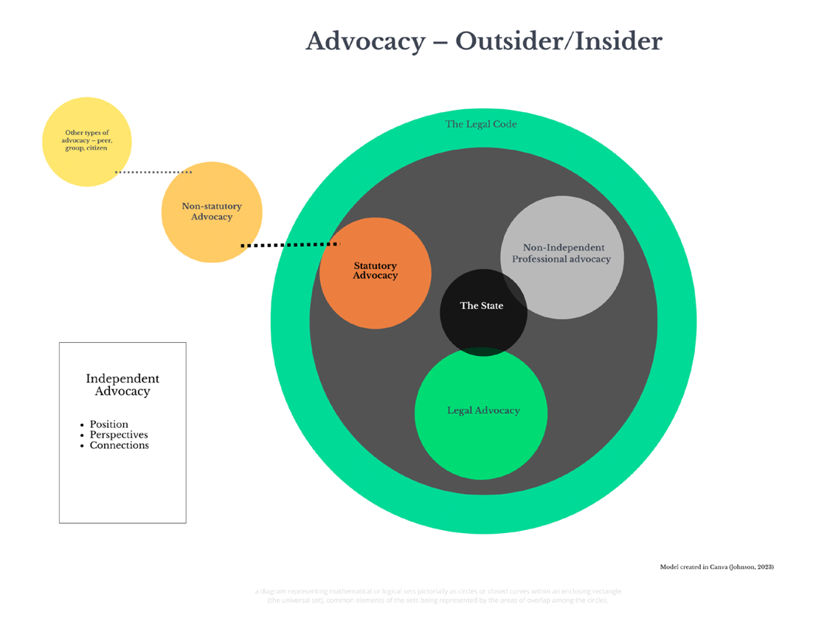

Above: The author’s (Johnson, 2023) model was created in Canva (2023).
Appendix 3:

The latest version of ‘The Advocacy Charter’ (NDTi, 2018) shows the key principles for advocates and advocacy providers.

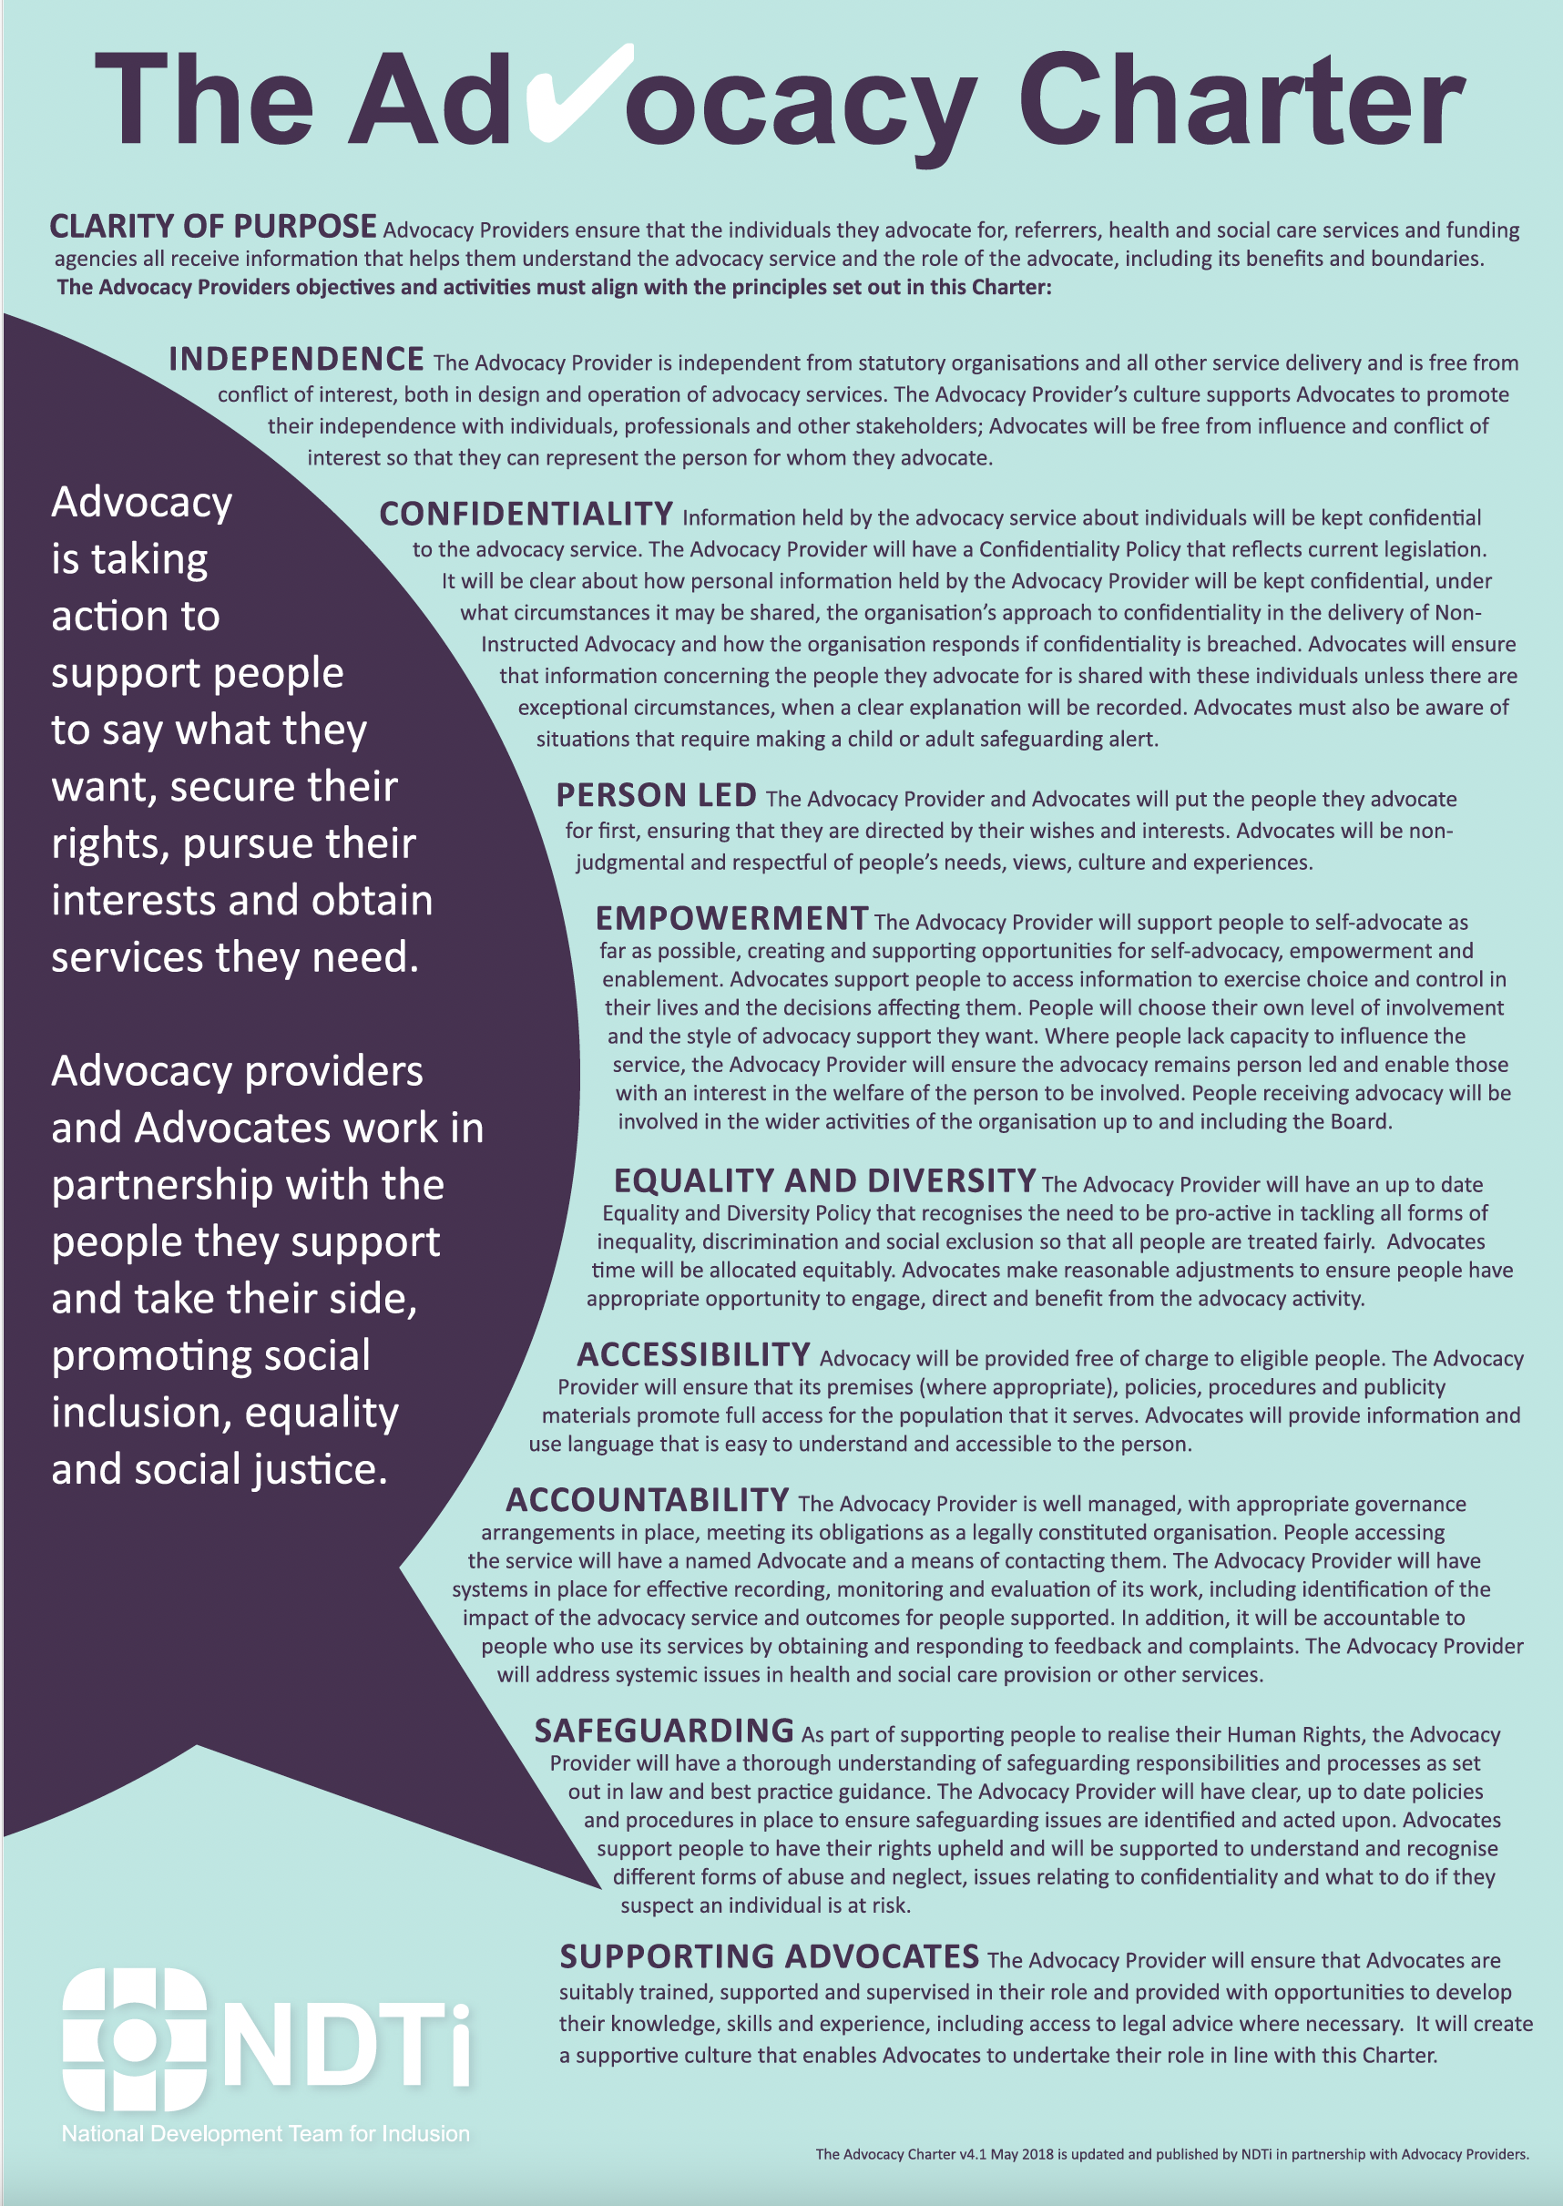

Burke (1986) and Paine (1997) are thought to represent opposite ends of the political spectrum (Montanye, 2014). Neither of them shared Hobbes’ (1981) belief in absolutism.
The Leviathan is a terrifying, Old Testament sea monster that is best described in the book of Job (Amplified Study Bible, 2017, Job 41:1–34).

