

Programme: BA Business Management
LCBB5001 - Entrepreneurship

Assessment 2
My Topic: Mobile Catering “Grill on Wheels”

Module Lecturer Name:
Dr John-Paul Okeke

Petru Voloceai (2008342)
2008342@student.uwtsd.ac.uk

Table of Contents
BUSINESS DESCRIPTION / MARKET OPPORTUNITY 2
INDUSTRY ANALYSIS 3
OPERATIONS AND MANAGEMENT TEAM 5
MARKETING 7
FINANCIALS 8
REFERENCES 10

BUSINESS DESCRIPTION / MARKET OPPORTUNITY
Development of an innovative business idea is important for the success of all entrepreneurial ventures (Barringer and Ireland, 2019). The business idea that is being considered in this business plan is that of a street food van (mobile catering services). “Grill on Wheels” is the name selected for the street food van that is aimed at being introduced. The business is going to sell a range of food and beverages that customers can purchase and take home or have it by sitting somewhere in the street easily. The food van will roam around different locations in London such as Bromley, Bexley, Greenwich, Newham and such other areas. According to Ghimire (2020), a mission statement declares the purpose of a venture and the way it serves customers. The mission statement of Grill on Wheels is as follows –
“To offer moderately priced, high-quality, tasty and fresh food and beverages to food lovers and satisfying the hunger of people on the streets”
The products of Grill on Wheels include burgers, sandwiches, tea, coffee, pasta, non-alcoholic beverages, noodles, chips and dips, fries, chicken tenders, fish sticks, finger chips and such others. In this way, a range of food items and beverages are going to be offered as products of the company to customers.
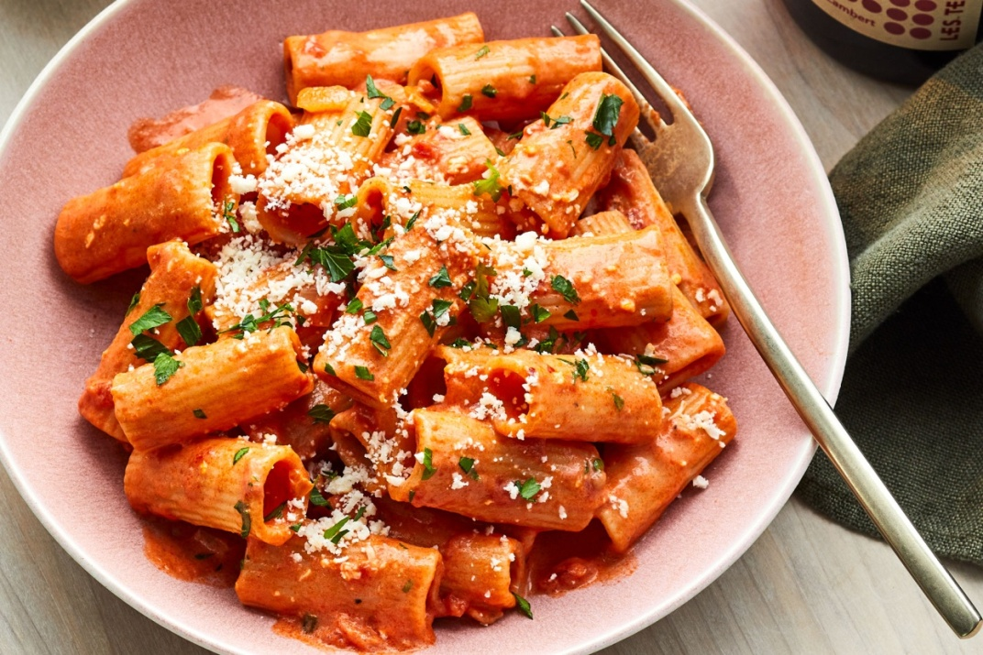
Figure 1: Pasta
(Source: Food & Wine, 2021)
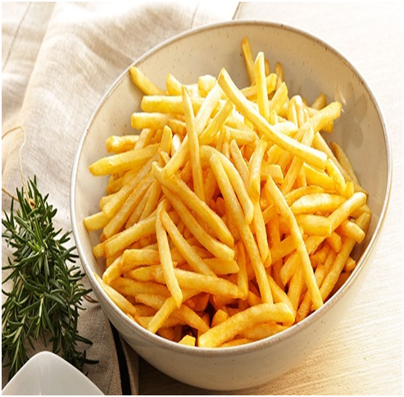
Figure 2: Finger chips
(Source: kfoods.com, 2022)
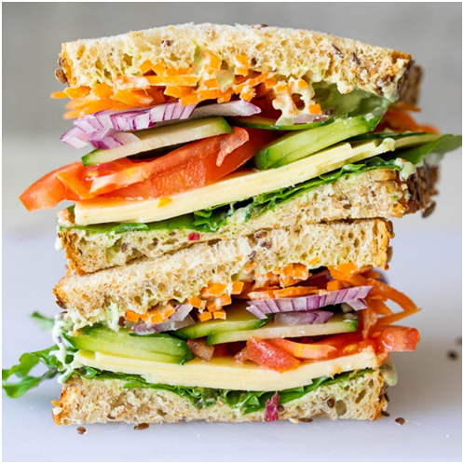
Figure 3: Sandwich
(Source: Food & Wine, 2022)
The products of the street food van is going to ensure that people can eat tasty and best-quality food even on the streets and not just by visiting luxury dine-in restaurants. In the product and service elements of Grill on Wheels, the innovative element is the fact that street food vans are largely beneficial in the post Covid-19 world.
This is because in the post Covid-19 world, people usually avoid visiting restaurants that are crowded to prevent themselves from the deadly virus (Yang et al., 2020). They prefer sitting in lonely places or at the comfort of their homes to have tasty food. As Grill on Wheels is a street food van, customers can buy food and beverages from the van and have them wherever they prefer. There is no need to sit in a closed air-conditioned environment that is crowded to have the food that desire in the post Covid-19 world. Moreover, the income of various people has been affected due to the Covid-19 pandemic, which has affected their spending capacity (D’Arpizioet al., 2020). Since food vans or trucks have comparatively low investments and low operating costs, people can have their desired food at affordable prices from Grill on Wheels.
Since it is a start-up business, milestones have not yet been achieved by it. The ownership structure of Grill on Wheels is that of a sole trader, as the owner of the venture is only one. All risks and liabilities of the business are going to be borne by its owner while all profit generated would be taken by the owner. This structure has been chosen the registration process of this business is simple and fewer fixed overheads existing in it. Moreover, there is maximum privacy in this business structure and the owner can keep all profits. The start-up costs of starting a sole trader business are low as well. Thus, by considering all these reasons, this legal structure has been chosen. The partnership structure has not been considered because in a partnership business, there is loss of autonomy and sharing of profit. Moreover, difficulties exist in ownership transfer, there is unlimited liability of the partners and there are high chances of partnership disagreements.

INDUSTRY ANALYSIS

Threat of new entry
The threats of new entry are moderate to high for Grill on Wheels. This is because after the Covid-19 pandemic, food trucks have become an innovative and low investment business. Various food truck businesses are now coming into the market. The food truck business has increased largely over different parts of the world after the pandemic. For example, according to Hannon (2021), four food trucks in Santa Cruz County started taking orders through a website and an app with delivery directly to customers, which in 2021 served almost 300 people per day and $5000 in terms of sales. According to Auad et al. (2021), the global food truck market is expanding rapidly and is expected to reach 2631 million USD by 2025. Thus, all these data indicate that the threats of new entry are high for Grill on Wheels.

Threat of substitutes
According to Maynard (2021), food trucks are currently a $2.7 billion industry, which shows huge food number of food trucks operating in different parts of the world. As stated by Dunn (2015), Bell & Brisket, Fishdog, Pizza Pilgrims, Rainbo, You Doughnut, Mother Clucker, The Orange Buffalo, Bhangra Burger and various such food trucks produce food that are substitutes for Grill on Wheels. The percentage of these businesses in London is almost 15% of the entire food industry in London. However, substitutes have moderate threats on Grill on Wheels. This is because the food and beverages that are sold by the business are available in different restaurants and food trucks in the market. However, the affordability, taste and quality are difficult to be matched.

Bargaining power of customers
Customers have high bargaining power, as the food and beverages are available in ample all over London. Moreover, the switching costs are also not substantial for customer if they select any other restaurant or food van over Grill on Wheels due to high number of restaurants and food trucks available in London.

Bargaining power of suppliers
Suppliers have low bargaining power in the market. This is because there are a large number of suppliers present in the market who supply raw materials to restaurant and catering businesses and switching costs are low for a business to change its supplier. There are huge number of suppliers present within the UK. The total number of food manufacturing businesses in London is about 1685 (Statista, 2022). On the other hand, Rare Raws Ltd, Afrorganic Ltd, Oribera Limitred, Trafalgar Foods Ltd and a large number of food suppliers are present within London, which provide consistent and quality supplies to restaurants and cafes in the city (go4worldbusiness.com, 2022). Thus, due to these reasons, suppliers have low bargaining powers.

Competitive Rivalry: who are your main competitors and how can you differentiate yourself from them
Threats that are posed to Grill on Wheels from competitors are high. London is famous for food trucks. According to roaminghunger.com (2022), starting from catering Acai and Afghan food to ending with World Fare and Wraps, there is probably no cuisines that the food trucks in London fail to serve to its customers. In every other food truck, there is some innovative and new food item for customers to try. These aspects prove that the food truck industry is highly competitive. The following is a discussion on the main competitors of the business Grill on Wheels –

Name of competitor | Differentiation
The Duck Truck | The Duck Truck specialises mostly with duck-centric food items, which is different from the offerings of Grill on Wheels.
Shades Food Truck | Shades Food Truck specialises in terms of a variety of popular Caribbean food items, which Grill on Wheels do not offer to customers.
Ely’s Yard Food Trucks | Ely’s Yard Food Trucks can be differentiated from Grill on Wheels, as it sells mostly fried chicken that are buttermilk soaked, tea brined and twice battered.

OPERATIONS AND MANAGEMENT TEAM

OPERATIONS
The operations and management team in a business plan outline the business processes of a new venture, its revenue sources and various such elements while discussing the skills and experience of its managers (McKenzie and Sansone, 2019).
Since Grill on Wheels is a street food van, the business process of the venture include the following steps –
- Procurement of raw materials
- Transforming them into semi-finished products through cutting, peeling, chopping, boiling and other activities
- Preparation of food with the semi-finished products as and when customer orders are received
- Serving customers with the orders they have placed
Supplies are going to be achieved in Grill on Wheels from two definite suppliers, one of them providing vegetables, fruits and grocery items while other one providing fish, meat and eggs. Equipment and tools needed in the business include ovens, mixers, slicers, food processors, chimneys, freezers, refrigerators and such others kitchen essentials. The suppliers will make transportation of supplies to the van while equipments purchased will be transported through hiring motor vehicles. All food and beverages will be prepared in the food van itself so that food can be served fresh and hot to customers, which would be served to customers directly from the food van. Others involved in the process include the management team and kitchen workers of Grill on Wheels.
How would you generate revenue for your business?
E.g., How would you prevent loss of revenue?
Grill on Wheels is going to generate revenue for the business through supplying quality and fresh food and beverages to customers at affordable and lower prices compared to other food trucks. The loss of revenue of the business is going to be prevented by the maintenance of quantity or portion of the food served to customers alongside quality and price. A strong 4Ps of marketing is going to be developed for the business, which is going to be its primary marketing strategy. The pricing of Grill on Wheels, contrastingly, will be done using the cost-plus pricing strategy. Moreover, the courteous behaviour of staff in the food van and the quick handover of orders to customers are also going to be preventing the loss of revenue. The customer service strategy of Grill on Wheels includes the 3Cs of customer service, which are Caring, Co-operating and Communication.

MANAGEMENT TEAM
The management team comprises of mainly three people, the names, skills and what they bring to the business of whom are mentioned below –
Name | Skills | What do they bring to the firm
Owner and General Manager of the firm (xxx) | - Leadership and Management Skills  - Communication, Team Building and Interpersonal Skills  - Conflict Management and Negotiation Skills | The owner and general manager brings into Grill on Wheels the skills of managing the new business venture and lead it towards success through effective leadership and management, communicating with subordinates, managing conflicts and building a strong team.
Customer Service Manager (Mr. James Charlie) | - Communication and Empathetic Skills  - Problem Solving Skills  - Interpersonal Skills  - Patience, Diplomacy and Creative Thinking Skills | The customer service manager at Grill on Wheels brings effective customer service skills into the firm such as communication and empathetic skills, interpersonal skills and such others. The skills and competencies are in turn going to ensure good services provided to customer and achieve their satisfaction.
Kitchen Manager (Mr. Olive Joseph) | - Organisational Skills  - Supply Management and Procurement Skills  - Flexibility, Communication Skills and Delegating Abilities | The kitchen manager is going to bring into Grill on Wheels good kitchen management skills such as supply management, delegating, procurement and various others. These skills and competencies are going to ensure that the kitchen activities of the business are properly executed and stock is maintained to serve customer orders timely.

MARKETING
The 4Ps of marketing, also called the marketing mix, is one of the key marketing strategies of a business (Pepels, 2021). Following is the marketing strategy developed for Grill on Wheels –
Product: Brief description of your product
The product of Grill on Wheels involve various types of food and beverages, which include burgers, sandwiches, tea, coffee, pasta, non-alcoholic beverages, noodles, chips and dips, fries, chicken tenders, fish sticks and finger chips.

Price:How much would you charge for your product and what is the basis for the price chosen?
Different food and beverages would be charged differently in Grill on Wheels, based on the cost of preparation. However, all prices will be lower than the average price of similar food and beverages in the market. An average price of food and beverages in the business is £5. The basis for chosen price is the cost-plus pricing strategy in which a marginal mark up is going to be added to the costs spent for producing food and beverages to determine their price.
Promotional Mix: What techniques would be used in promoting your product?
The promotion of the products of Grill on Wheels is going to be done through social media platforms such as Instagram and Facebook to reach a wider number of customers and grab their attention. Moreover, leaflets and menu cards will be distributed from the street food vans itself for people who pass by the van. A loyalty point system will be introduced with which loyalty points are going to accumulate and these points can be redeemed by purchasing food from Grill on Wheels.
Place (Distribution strategy): How would your product be distributed?
The products of Grill on Wheels will be distributed directly from the street food van that is going to be moving around different areas of London such as Bexley, Greenwich, Newham and such others. Food will be prepared and made available to customers all over the London City with the food van travelling around it all throughout the day.

FINANCIALS

Sources of funds: where would you be getting funds from?

There are several sources of funds needed within entrepreneurial ventures (Bplans, 2022). The establishment of an entrepreneurial venture and starting its operations require considerable amount of funds (Cavallo et al., 2019). In the context of Grill on Wheels, funds are going to be sourced from two main sources, which include owner’s contribution and bank loan. The total estimated funds required for starting the business is £20,000. Owner’s contribution is an internal source of funding, from which an amount of £5,000 is going to be obtained for funding Grill on Wheels. On the other hand, the bank loan is an external source of funding from which £15,000 is expected to be raised. There are no interest payment or repayment requirements in owner’s contribution. However, the bank loan has to be repaid at fixed monthly payments in addition to the interest charged by the bank for the loan.

Use of funds
Financial Forecast showing the uses of funds in Grill on Wheels for first 6 months
 | Month 1 | Month 2 | Month 3 | Month 4 | Month 5 | Month 6
Revenue from operations (Sales)
Cash Sales | £ 1,750 | £ 4,400 | £ 6,750 | £ 9,000 | £ 11,500 | £ 16,000
Collection of credit sales from debtors | £ - | £ - | £ - | £ 250 | £ 500 | £ 300
 | £ 1,750 | £ 4,400 | £ 6,750 | £ 9,250 | £ 12,000 | £ 16,300
Fixed Costs
Rent of food truck | £ 600 | £ 600 | £ 600 | £ 600 | £ 600 | £ 600
Salaries and wages | £ 1,000 | £ 1,000 | £ 1,000 | £ 1,000 | £ 1,000 | £ 1,000
Insurance expenses | £ 150 | £ 150 | £ 150 | £ 150 | £ 150 | £ 150
Interest on loan | £ 100 | £ 100 | £ 100 | £ 100 | £ 100 | £ 100
Telecommunication charges | £ 50 | £ 50 | £ 50 | £ 50 | £ 50 | £ 50
Marketing and promotions | £ 300 | £ 300 | £ 300 | £ 300 | £ 300 | £ 300
 | £ 2,200 | £ 2,200 | £ 2,200 | £ 2,200 | £ 2,200 | £ 2,200
Variable Costs
Purchase of raw materials | £ 525 | £ 1,320 | £ 2,025 | £ 2,775 | £ 3,600 | £ 4,890
Packing expenses | £ 35 | £ 88 | £ 135 | £ 185 | £ 240 | £ 326
Light, gas and heat | £ 140 | £ 352 | £ 540 | £ 740 | £ 960 | £ 1,304
Electricity and other utilities | £ 100 | £ 220 | £ 300 | £ 480 | £ 600 | £ 800
Fuel charges | £ 175 | £ 440 | £ 675 | £ 925 | £ 1,200 | £ 1,630
Other miscellaneous expenses | £ 100 | £ 150 | £ 200 | £ 300 | £ 450 | £ 600
 | £ 1,075 | £ 2,570 | £ 3,875 | £ 5,405 | £ 7,050 | £ 9,550
Profit | - £ 1,525 | - £ 370 | £ 675 | £ 1,645 | £ 2,750 | £ 4,550

REFERENCES
Auad, L., Ginani, V., Raposo, A. and Zandonadi, R. (2022) Food Trucks in Times of COVID-19: An Overview. [online] Available at: <https://www.longdom.org/open-access/food-trucks-in-times-of-covid19-an-overview-70861.html> [Accessed 21 April 2022].
Barringer, B., and Ireland, D. (2019) Entrepreneurship: Successfully Launching New Ventures. Sixth edition; Global edition. Harlow, England: Pearson.
Bplans. (2022) #1 Business Plan Template for a Small Business. [online] Available at: <https://www.bplans.com/downloads/business-plan-template/> [Accessed 13 April 2022].
businesswire.com. (2020) Pre & Post COVID-19 Market Estimates-Mobile Food Services Market 2019-2023 | Benefits of Mobile Food Service to Boost Growth | Technavio. [online] Available at: <https://www.businesswire.com/news/home/20200423005029/en/Pre-Post-COVID-19-Market-Estimates-Mobile-Food-Services-Market-2019-2023-Benefits-of-Mobile-Food-Service-to-Boost-Growth-Technavio> [Accessed 13 April 2022].
Cavallo, A., Ghezzi, A., Dell'Era, C. and Pellizzoni, E. (2019) Fostering digital entrepreneurship from startup to scaleup: The role of venture capital funds and angel groups. Technological Forecasting and Social Change, 145, pp.24-35.
D’Arpizio, C., Levato, F., Fenili, S., Colacchio, F. and Prete, F. (2020) Luxury after Covid-19: changed for (the) good. Bain & Company.
Dunn, K. (2015) 10 of London's Most Popular Food Trucks. [online] Eating Europe. Available at: <https://www.eatingeurope.com/blog/london-popular-food-trucks/> [Accessed 21 April 2022].
Food & Wine. (2021) 51 Best Pasta Recipes for All Seasons. [online] Available at: <https://www.foodandwine.com/pasta-noodles/pasta> [Accessed 21 April 2022].
Ghimire, R.P. (2020) Practical Applications of Social Entrepreneurship in Business Community Innovation.
go4worldbusiness.com. (2022) British Food Raw Materials Suppliers, Manufacturers, Wholesalers and Traders | go4WorldBusiness.com . Page - 1. [online] Available at: <https://www.go4worldbusiness.com/suppliers/united%20kingdom/food-raw-materials.html> [Accessed 21 April 2022].
Hannon, K. (2021) How Food Trucks Endured and Succeeded During the Pandemic. [online] Nytimes.com. Available at: <https://www.nytimes.com/2021/05/24/business/food-trucks-pandemic-covid.html> [Accessed 21 April 2022].
kfoods.com. (2022) Patato Finger Chips. [online] Available at: <https://kfoods.com/recipes/patato-finger-chips_rid9974> [Accessed 21 April 2022].
Kurpayanidi, K.I. (2020) Corporate industry analysis of the effectiveness of entrepreneurship subjects in the conditions of innovative activity. Экономика и бизнес: теория и практика, (2-1).
Maynard, M. (2021) Food Trucks Are Steering Around The Pandemic, And Getting A Friendlier Reception. [online] Forbes. Available at: <https://www.forbes.com/sites/michelinemaynard/2021/01/25/food-trucks-are-steering-around-the-pandemic-and-getting-a-friendlier-reception/?sh=45995b694231> [Accessed 21 April 2022].
McKenzie, D. and Sansone, D. (2019) Predicting entrepreneurial success is hard: Evidence from a business plan competition in Nigeria. Journal of Development Economics, 141, p.102369.
Pepels, W. (2021) The 4Ps in Marketing-Mix. Research and development, 35, p.38.
roaminghunger.com. (2022) Food Truck Catering - London, UK - Roaming Hunger. [online] Available at: <https://roaminghunger.com/london-united-kingdom/food-truck-catering/> [Accessed 21 April 2022].
Ryder, A. (2022) Easy Healthy Salad Sandwich - Simply Delicious. [online] Simply Delicious. Available at: <https://simply-delicious-food.com/easy-healthy-salad-sandwich/> [Accessed 21 April 2022].
Statista. (2022) Food manufacturing enterprises UK 2020 | Statista. [online] Available at: <https://www.statista.com/statistics/729174/manufacture-of-food-products-number-of-enterprises-in-the-united-kingdom-uk/> [Accessed 21 April 2022].
Yang, Y., Liu, H. and Chen, X. (2020) COVID-19 and restaurant demand: early effects of the pandemic and stay-at-home orders. International Journal of Contemporary Hospitality Management.

