Strategic Management
A Critical Evaluation of Lidl’s Use of Competitive Strategy



NOVEMBER 2019

MODULE NAME: STRATEGIC MANAGEMENT & SUSTAINABILITY (M3X9111)
STUDENT NAME: EMMA-LISA BEAUMONT
STUDENT NUMBER: 1804423

TABLE OF CONTENTS

Contents
1. EXECUTIVE SUMMARY 3
2. INTRODUCTION 5
2.1 REPORT REMIT 5
2.2 BACKGROUND OF THE ORGANISATION 5
2.3 DEFINITIONS OF MAJOR CONCEPTS 6
2.3.1 Strategy 6
2.3.2 Business-Level Strategy 6
2.3.3 Competitive Advantage 7
2.3.4 Porter’s Generic Strategies 7
2.3.5 Defining Characteristics of Strategy Options 8
2.3.6 Analysis of Generic Strategies 8
3. LIDL AND STRATEGIC CHOICE 9
3.1 IMPLEMENTATION OF STRATEGY 9
3.3 EFFICACY OF ADOPTED STRATEGY 10
3.4 ADVANTAGES AND DISADVANTAGES OF COST LEADERSHIP 11
Advantages 11
Disadvantages 11
4. CONCLUSION 11
4.1 RECOMMENDATIONS 11
5. REFERENCES 13

LIST OF FIGURES
Figure | Title | Page
1 | Graph demonstrating Lidl’s increase of edible grocery sales in the UK from 2010 to forecast 2020 | 3
2 | Chart demonstrating Porter’s Generic Strategy Options | 7

LIST OF TABLES
Table | Title | Page
1 | Table demonstrating defining points of each strategy option |  | 8

1. EXECUTIVE SUMMARY
This report has been commissioned with the aim of evaluating the efficacy of competitive strategy implemented by Lidl Stiftung & Co. KG. The report will then provide recommendations in relation to its findings.
Lidl Stiftung & Co. KG (hereby referred to as Lidl) is a multinational grocery retailer, initially founded in current form in 1973 in Germany. Lidl experienced rapid growth within its home country, establishing over 300 stores across Germany in the 1980s. In the early 1990s, Lidl expanded outside of Germany and moved into1 the French and UK markets (Lidl, 2017). Today, Lidl operates in excess of 10,000 stores in over 28 European countries and has 68 stores within the United States (Lidl, 2019a). Currently, Lidl employs over 315,000 staff worldwide; with 22,000 employed within the UK alone (Lidl, 2019b). Lidl has consistently experienced the growth of edible grocery product sales year on year within its UK operation (see Fig. 1).
The report outlines the theories behind several business level strategies and identifies that Lidl has adopted a cost leadership strategy. The report outlines findings to support Lidl’s strategy, and evaluates their effectiveness. It shows that Lidl has achieved a strong strategy and continues to grow using this method. The findings of the report in regard to Lidl’s strategic application are positive.
The report recommends that the company:
- Continue to focus on cost leadership strategy by increasing market share with expansion of private labels.
- Expand environmental focused policy to ensure sustainability of eco-focused consumer base, in line with or exceeding market standard.
- Consider fresh marketing campaigns to combat perception of low quality, to ensure customer base can increase.
- Increase focus on KPIs in order to reduce waste, increase efficiency and manage store performance.

2. INTRODUCTION

2.1 REPORT REMIT
This report has been commissioned with the aim of evaluating the efficacy of competitive strategy implemented by Lidl Stiftung & Co. KG. The report will then provide recommendations in relation to its findings.

2.2 BACKGROUND OF THE ORGANISATION
Lidl Stiftung & Co. KG (hereby referred to as Lidl) is a multinational grocery retailer, initially founded in current form in 1973 in Germany. Lidl experienced rapid growth within its home country, establishing over 300 stores across Germany in the 1980s. In the early 1990s, Lidl expanded outside of Germany and moved into1 the French and UK markets (Lidl, 2017). Today, Lidl operates in excess of 10,000 stores in over 28 European countries and has 68 stores within the United States (Lidl, 2019a). Currently, Lidl employs over 315,000 staff worldwide; with 22,000 employed within the UK alone (Lidl, 2019b). Lidl has consistently experienced the growth of edible grocery product sales year on year within its UK operation (see Fig. 1).
Lidl’s vision statement is “To enhance the lives of our customers, by providing quality products at a market-leading value, whilst ensuring that customer satisfaction is at the heart of everything we do” (Lidl, 2019c). Their mission statement consists of four main aims:
  - To deliver outstanding customer satisfaction.
  - To ensure market leading quality and value by constantly innovating and optimising our efficient processes, driven by technology and people.
  - To work with business partners in sustainable relationships, contributing positively to local communities.
  - To achieve long term success by investing in the recruitment, training, and development of our people (Lidl, 2019c).
In August 2019, Lidl attained its biggest market share in the UK to date at 5.9%, following a large increase in store openings. In the three months prior to 11th August 2019, sales for Lidl in the UK jumped 7.7%, an increase of around 500,000 sales in comparison with the same period of 2018 (Markortoff, 2019).

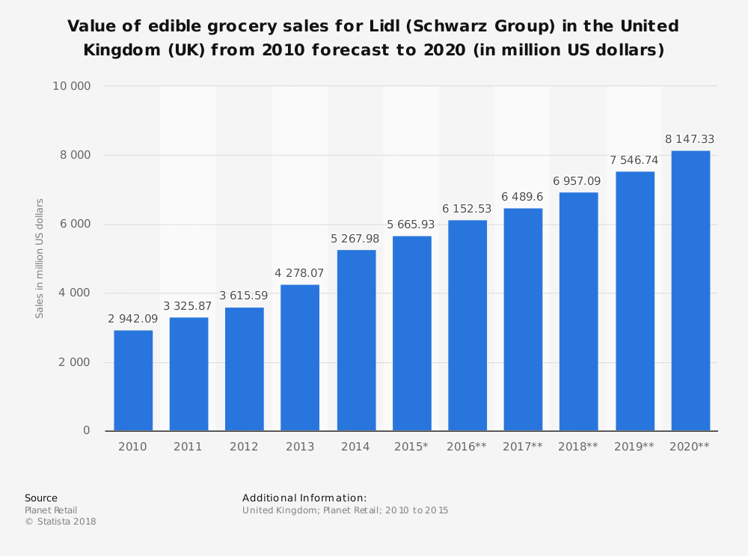
Figure 1: Graph showing Lidl’s increase in edible grocery sales in the UK from 2010 to forecast 2020 (Source: Statista, 2018)

2.3 DEFINITIONS OF MAJOR CONCEPTS

2.3.1 Strategy
Haderberg and Rieple (2008) explain that business strategy is comparable to a path which an organisation takes in order to be an effective performer within an economic setting. Strategy can be purposefully undertaken or can be accidental. However, strategy is ultimately the way in which an organisation develops resources and uses them to deliver their product or service, in a way that is pleasing to its users. Conversely, the Friedman Doctrine (1970) argues that an organisation’s primary function must be to use their resources to increase profit. Although there are differing perspectives on why strategy is important, it is agreed that businesses need a strategy in order to proceed with their objectives. To obtain an accurate picture of an organisation’s strategy, it is important not just to consider the mission statement and values of that organisation. It is equally, if not more, important to notice what they are doing. This holistic view of an organisation is where strategy is most likely to be understood.

2.3.2 Business-Level Strategy
Business-level strategy is focused on achieving objectives; whether financial or otherwise. These objectives are detailed action plans aimed at gaining competitive advantage by exploiting core competencies in order to secure or elevate a company’s standing within a market (Albany University, 1999).
In a peer-reviewed study undertaken by Nandakumar, Ghobadian and O’Regan (2010) it was found that business-level strategy was key in navigating the way to improved financial performance within the wider competitive business environment. It is therefore imperative that an organisation both identifies the environment in which they are operating, and that they have developed a business-level strategy accordingly. This is echoed by Rajasekar and Moideenkutty (2007) who detail the importance of repositioning through business-level strategy in order to successfully navigate the global business environment.
Identifying and understanding the environment in which an organisation is operating, is crucial to the successful implementation of any business-level strategy. This is called situational analysis which is split into two parts; internal and external analysis.

2.3.3 Competitive Advantage
Using situational analysis an organisation should be able to identify the strengths of their competition. This is otherwise known as competitive advantage, a key area of any competitive strategy. According to literature (Hult 1998; Slater and Narver, 1995) market-based learning has been recognised as a key source of creating sustainable competitive advantage.

2.3.4 Porter’s Generic Strategies
In the early 1980s Professor Michael Porter wrote that in any given environment there were only four key strategic options to all businesses, otherwise known as Porter’s Generic Strategy Options:
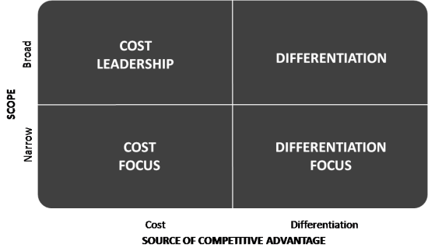
Figure 2: Chart demonstrating Porter’s Generic Strategy Options (Source: Cleverism, 2014)
Porter’s strategy has been split into two key areas; cost and differentiation. Cost-based strategy holds its primary focus in having the lowest costs in the industry, and differentiation is a distinctive product which allows for higher pricing. These strategies can be placed in a broad or narrow target within the market.

2.3.5 Defining Characteristics of Strategy Options

Strategy Option | Defining Points
Cost Leadership | - Aim to create a business environment that is low cost from production to labour and beyond.  - Goal to set the market’s price floor as the lowest-cost producer (Porter 1985).  - Exploits economies of scale (Hill, 1988)  - Low differentiation.  - Low market segmentation.  - High profitability
Cost Focus | - Focus on low-cost advantage in one or very few market segments.  - Aim to produce goods and services at a lower cost than competitors within the market.  - Goal to set the lowest cost prices for consumers to gain increased market share.  - Higher market segmentation.  - Low differentiation
Differentiation | - Concentrated on a specific area within a market or producing a unique product.  - Aims to create a premium price based on a targeted niche market.
Differentiation Focus | - High market segmentation.  - Focus on differentiation in one or very few markets.  - Likely higher profitability than rivals.  - Requires specialisation in core competencies.  - High product differentiation
Table 1: Table demonstrating defining points of each strategy option (Adapted from Stead J, Stead W, 2017)

2.3.6 Analysis of Generic Strategies
Strategic wilderness exists in the “gap” between cost leadership, cost focus and differentiation focus. Although Porter’s Generic Strategies is a highly cited, seminal theory in both business science and strategic management, criticism of the theory can be readily found. Mintzberg et al. (2008) identified that by following an extensively cost focused strategy, a company may cross over into differentiation, by way of branding, quality and design. Prahalad & Hamel (1990) argue that to outperform others within a cost based competitive market will inevitably lead the firm into differentiation. Therefore, critics identify that differentiation remains fundamental to competitive advantage (Stonehouse, Snowdon, 2007).
Cost leadership, when successful, gains a highly competitive edge as market segmentation is low (Hill, Jones, 2013). Companies working with this strategy have the flexibility to change prices if substitute products threaten competitive advantage (Lynch, 2005). Consequently, Banker et al. (2014) observed that cost leadership was significantly less likely to be sustainable over differentiation-based strategy.
Differentiation strategy runs a far higher risk of threat from rival companies imitating their product or service. The use of this strategy requires premium price due to the costs involved in remaining unique or premium. Porter (1985) himself suggests that due to need for exclusivity, that differentiation and high market share are not compatible. This means the product must be unique enough to warrant such a premium price that this method is sustainable.
With all focus or niche strategy, reputation can be built which can prove invaluable to a business. One market segment that implements this strategy is luxury brands. These brands rely on high value products, which are sought after based on reputation. This strategy delivers profitability without the need for high volumes of sales. However, this market can be difficult to enter into, as reputation takes time and investment to build.

3. LIDL AND STRATEGIC CHOICE
Lidl has adopted the core strategy of cost leadership.

3.1 IMPLEMENTATION OF STRATEGY
Lidl has always been an efficiency focused company, for the benefit of cost – the advantages of which can be passed on directly to the consumer. The company has executed this by having a core competency in efficient logistics. Lidl developed their warehouses by implementing an automated case picking system in its logistics centre in Kircheim, Germany. By using the Schaefer Case Packing System (SCP) the company can guarantee efficiency in packing, as well as reducing transport costs, with perfectly packed pallets. This form of warehouse is scalable and therefore can be increased indefinitely (Logistics Manager, 2013) which increases it’s sustainability. This idea was expanded into its UK distribution services by adopting a “just in time” operations model, which keeps warehouses small and reduces stock holding, therefore reducing overheads. Key performance indicator (KPI) measurement is utilised heavily within the company, from the point of production onwards, leading to efficient vehicle utilisation and reduction in fuel consumption (Lidl, 2019d).
Lidl implements the cost leadership strategy particularly effectively by their extensive use of private brands. This is an especially effective method of supplying low-cost products at high profit to the company. In the UK, private brands account for around 41% of value share within the UK grocery market (Nielsen, 2018) which is growing around 4% a year across the European market (WARC, 2018). Lidl’s strong implementation of this strategy was further adopted within their marketing strategy, launching the #LidlSurprises campaign in 2014 (Ben-Yehoshua, 2016). The campaign aimed to increase market share by introducing Lidl to customers who would normally avoid own brand products and to turn the brands low budget image into one of quality.
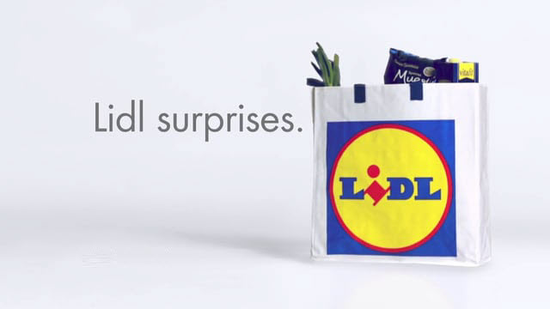
Figure number: An example of Lidl’s private label marketing campaign – “Lidl Surprises” (Source: Lidl, 2017)
In 2018, Lidl began to focus on environmental impact and energy efficiency. The company retrofitted LED lighting in 104 stores and two distribution centres, which has decreased energy consumption by 63.4% (Lidl NI, 2019). By decreasing their energy consumption, Lidl will save significantly on energy overheads and boost their appeal to energy conscious customers. This is further indicative of Lidl’s focus on cost leadership strategy as it lowers cost and improves market share. Furthermore, Lidl set goals to reduce their plastic waste – currently a very topical issue within the UK. The company set goals in 2019 to decrease their own plastic waste by 20%, to use 100% recyclable or reusable packaging by 2025 and to use 50% recycled content across all packaging. This can certainly be described as a move in order to maintain and grow market share due to the current interest in plastic waste.
Lidl have shown initiative in cutting overheads in order to maintain low cost operations. A simple but effective example of this can be seen by their move to remove blank space and unnecessary detail from their receipts – saving over £150,000 a year in paper costs. According to Lidl’s UK Chief Executive, Christian Härtnagel: “The initiative is part of a “continuous drive” to identify the tiniest details in the retail process that might reduce the company's overheads and keep its prices low” (Chambers, 2019).

3.3 EFFICACY OF ADOPTED STRATEGY
An effective method of understanding the efficacy of a company’s core strategy is to look at their EBIT (earnings before interest and taxes) margin. Lidl had an EBIT of 4% in the financial year 2017, its lowest since 2012 (Van Rompaey, 2019). Sales within Lidl internationally accounted for 60% of their overall turnover in 2017-18 (European Supermarket Magazine, 2019).
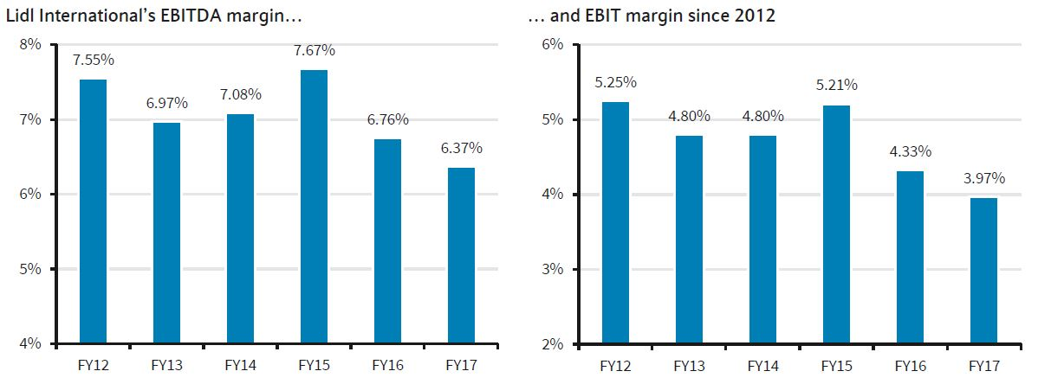
(Source: RetailDetail)

3.4 ADVANTAGES AND DISADVANTAGES OF COST LEADERSHIP
As with any strategy, there are advantages and disadvantages of applying the cost leadership approach.

Advantages
- Higher profitability – with higher profit margins within the supermarket industry the company is more likely to withstand price wars without losing market share.
- Increased market share - in the current economic climate, low cost can translate to low price products to the consumer, which can in turn increase market share over higher priced competitors.
- Sustainability – by maintaining low cost, the company is more likely to develop a sustainable model to succeed year on year.
- Capital for growth – using a low cost strategy, the company can use remaining capital to expand the business, increase property portfolio etc.
- Competitive advantage – by increasing market share and growth, the company can gain competitive advantage over other retailers.

Disadvantages
- Perceptions of quality – if quality becomes too low customers will seek alternatives and the company will lose market share.
- Sales volume - must be large due to small margins. If products are too low cost, they will require a substantial amount of sales in order to make reasonable profit. Too high and they will not be popular within a cost leadership retailer.
- Lack of spending – other facets of retail could be lost due to low spending, for example customer service or online presence.
- Technological advances – a lack of spending or avoiding overheads could lead to missing out on services or efficiency which other companies in the industry are investing in. This could again lead to losing market share or competitive advantage.
- Price wars – operating within a market in which many competitors are also utilising cost leadership strategy can lead to price wars, which may mean losing profit margins or market share as other competitors lower prices.

4. CONCLUSION
Lidl have implemented cost leadership strategy from the company’s inception. The success of this strategy can be demonstrated by their consistent growth in market share year on year. It can also be seen in an increase of EBIT rating and profits for the company, both in the UK and internationally. Lidl have overcome disadvantages of cost leadership, for example with their #LidlSuprises campaign which emphasised quality for customers who would otherwise not buy private label products from a low cost supermarket. By creating their own supply chain and using majority private brands, Lidl can avoid losses in price wars over branded goods. As Lidl has increased its number of stores vastly it has therefore maintained the necessary large volume of sales to compete within the market. Lidl has used technological advances in its distribution centres and within its energy efficiency efforts, both to the advantage of cost. These factors demonstrate overall that cost leadership strategy is working for Lidl.

4.1 RECOMMENDATIONS
- Continue to focus on cost leadership strategy by increasing market share with expansion of private labels.
- Expand environmental focused policy to ensure sustainability of eco-focused consumer base, in line with or exceeding market standard.
- Consider fresh marketing campaigns to combat perception of low quality, to ensure customer base can increase.
- Increase focus on KPIs in order to reduce waste, increase efficiency and manage store performance.

5. REFERENCES
Albany University (1999) Business Level Strategy Available at: https://www.albany.edu/faculty/es8949/bmgt481/lecture4.html (Accessed 5 October 2019).
Ansoff H. I. (1957) Strategies for Diversification. Available at: http://sgpwe.izt.uam.mx/files/users/uami/sppc/13O/Gestion_y_Control_Estrategico_I/Lectura_10._Ansoff_Igor_Strategies_for_Diversification.pdf (Accessed 9 November 2019).
Banker, R. D. Mashruwala R and Tripathy A (2014) Does a differentiation strategy lead to more sustainable financial performance than a cost leadership strategy?, Management Decision. doi.org/10.1108/MD-05-2013-0282.
Chambers, S. (2019) Smaller receipts help Lidl cut paper costs by £150,000 The Times, Available at: https://www.thetimes.co.uk/article/smaller-receipts-help-lidl-cut-paper-costs-by-150-000-2sct8gs9w# (Accessed 18 November 2019).
Dafna B. Y. (2016) ‘#LidlSurprises: a Genius Marketing Campaign for a Discount Supermarket Chain’, 3 Door Digital, 10 March. Available at: http://3doordigital.com/lidlsurprises-marketing-strategy/ (Accessed 20 October 2019).
Datta, Y. (2010) A critique of Porter’s cost leadership and differentiation strategies, Chinese Business Review, 09(04). doi.org/10.17265/1537-1506/2010.04.004.
ESM Magazine (2019) Lidl’s Margin At Lowest Level Since 2012 In International Business: Barclays, ESM Magazine. Available at: https://www.esmmagazine.com/retail/lidls-margin-lowest-level-since-2012-international-business-barclays-70891 (Accessed 9 November 2019).
Friedman, M. (2007) ‘The Social Responsibility of Business Is to Increase Its Profits’, in Zimmerli W C, Holzinger M, and Richter K (eds.) Corporate Ethics and Corporate Governance. Berlin, Heidelberg: Springer Berlin Heidelberg, pp. 173–178. doi.org/10.1007/978-3-540-70818-6_14.
Haberberg, A. and Rieple, A. (2008) Strategic management: theory and application. Oxford ; New York: Oxford University Press.
Hanbury, M. (2017) A German grocery chain that’s coming to America is already dominating Walmart on prices — here’s why it’s so cheap, Business Insider. Available at: https://www.businessinsider.com/how-lidl-keeps-its-prices-down-2017-6 (Accessed 1 October 2019).
Hill, C. W. L (1988) Differentiation Versus Low Cost or Differentiation and Low Cost: A Contingency Framework, Academy of Management Review, 13(3), pp. 401–412.
Hill, C. W. L and Jones, G. R. (2013) Strategic management: an integrated approach. 10th ed. Mason, OH: South-Western, Cengage Learning.
Huebsch, J. and Thompson, J. (2019) Cost Leadership & Competitive Advantage. Available at: https://smallbusiness.chron.com/cost-leadership-competitive-advantage-35159.html (Accessed 20 October 2019).
Hult, G.T.M. (1998), “Managing the International Strategic Sourcing Process as a Market-Driven Organizational Learning System,” Decision Sciences, 29 (1), 193–216.
IGD Retail Analysis Lidl: significant investment in the UK (2019). Available at: https://retailanalysis.igd.com/retailers/lidl/news-article/t/lidl-significant-investment-in-the-uk/i/22587 (Accessed 20 October 2019).
Ladd, B. (2018) Lidl USA: What Went Wrong And What It Can Do To Recover, Forbes. Available at: https://www.forbes.com/sites/brittainladd/2018/07/08/lidl-usa-what-went-wrong-and-what-it-can-do-to-recover/ (Accessed 1 October 2019).
Lidl (2017) Lidl – Our History. Available at: https://careers.lidl.co.uk/en/our-history-1819.htm (Accessed 5 October 2019).
Lidl (2019a) About Us. Available at: https://www.lidl.co.uk/about-us (Accessed 5 October 2019).
Lidl (2019b) Transport - Lidl. Available at: https://www.abettertomorrow-lidl-ni.co.uk/transport/ (Accessed 20 October 2019).
Lidl (2019c) Vision and Mission Statement Available at: https://www.lidl.co.uk/about-us/vision-and-mission-statement (Accessed 5 October 2019).
Lidl (2019d) Plastics – Lidl Great Britain Available at: https://corporate.lidl.co.uk/sustainability/plastics (Accessed 5 October 2019)
Lidl US (2019) Lidl History | Quality Products Low Prices Available at: https://www.lidl.com/about-us (Accessed 5 October 2019).
Lynch, R. L. (2006) Corporate strategy. 4th ed. Harlow, England ; New York: FT/Prentice Hall.
Makortoff, K. (2019) ‘Lidl attains its biggest UK grocery market share at 5.9%’, The Guardian, 20 August. Available at: https://www.theguardian.com/business/2019/aug/20/lidl-attains-biggest-uk-market-share (Accessed 1 October 2019).
Marketing91 (2017) SWOT analysis of Lidl - Lidl SWOT analysis explained. Available at: https://www.marketing91.com/swot-analysis-of-lidl/ (Accessed 1 October 2019).
Marketline (2016) MarketLine Company Profile: Lidl Dienstleistung GmbH & Co. KG pp. 1–9. Available at: https://ezproxy.uwtsd.ac.uk/login?url=https://search.ebscohost.com/login.aspx?direct=true&db=bth&AN=115392777&site=ehost-live (Accessed 20 October 2019).
Meldrum, M. and McDonald, M. (1995) ‘The Ansoff Matrix’, in Meldrum M and McDonald M (eds.) Key Marketing Concepts. London: Macmillan Education UK, pp. 121–126. doi.org/10.1007/978-1-349-13877-7_24.
Mintzberg H., Ahlstrand, B. W. and Lampel, J. (2009) Strategy safari: the complete guide through the wilds of strategic management. 2nd ed. Harlow, UK: FT Prentice Hall.
Morgan, Neil A., Bruce H. Clark, and Richard A. Gooner (2002), “Marketing Productivity, Marketing Audits, and Systems for Marketing Performance Assessment: Integrating Multiple Perspectives,” Journal of Business Research, 55 (5), 363–75.
Nandakumar, M. K., Ghobadian, A. and O’Regan, N. (2010) Business-level strategy and performance: The moderating effects of environment and structure, Management Decision; London, 48(6), pp. 907–939.
Neilsen (2018) The Rise and Rise Again of Private Label. Available at: https://www.nielsen.com/wp-content/uploads/sites/3/2019/04/global-private-label-report.pdf (Accessed 20 October 2019).
Porter, M. E. (1985) Competitive Advantage: Creating and Sustaining superior performance. New York : London: Free Press ; Collier Macmillan.
Porter, M. E. (1985) The Competitive Advantage: Creating and Sustaining Superior Performance. NY: Free Press, 1985.
Prahalad, C, K. and Hamel, G. (2009) The Core Competence of the Corporation. Available at: https://papers.ssrn.com/sol3/papers.cfm?abstract_id=1505251 (Accessed 20 October 2019).
Rajasekar, J. and Moideenkutty, U. (2007) Oman Air: Challenges of Repositioning Through Business Level Strategy, Asian Journal of Management Cases, 4(2), pp. 117–141.
ResearchGate (2016) An introduction to research paradigms. Available at: https://www.researchgate.net/publication/325022648_An_introduction_to_research_paradigms (Accessed 26 October 2019).
Statista (2018) Sales forecast for Lidl United Kingdom 2010-2020. Available at: https://www.statista.com/statistics/618267/edible-grocery-sales-forecast-for-lidl-united-kingdom-uk/ (Accessed 5 October 2019).
Stonehouse, G. and Snowdon, B. (2007) Competitive Advantage Revisited: Michael Porter on Strategy and Competitiveness, Journal of Management Inquiry, 16(3), pp. 256–273.
Van Rompaey, S. (2019) Strong growth rate affects Lidl’s profits, RetailDetail. Available at: https://www.retaildetail.eu/en/news/food/strong-growth-rate-affects-lidls-profits (Accessed 9 November 2019).
WARC (2018) From private label to private brand | WARC. Available at: http://www.warc.com/newsandopinion/news/from_private_label_to_private_brand/40731 (Accessed 20 October 2019).
WARC (2018) From Private Label to Private Brand Available at: https://www.warc.com/newsandopinion/news/from_private_label_to_private_brand/40731 (Accessed 20 October 2019).
Zigu (2019) LIDL SWOT Analysis | Competitors & USP | BrandGuide, MBA Skool-Study.Learn.Share. Available at: https://www.mbaskool.com/brandguide/lifestyle-and-retail/2038-lidl.html (Accessed 1 October 2019).

