ECED7002 Assignment 3

2114728

Word Count 2083

Contents

Abstract – 3

Images 1 & 2 – 4

Background for Images – 5 - 9

Reference List – 10 - 13

Abstract
This submission will compare two images that portray similar, though contrasting, representations of black males wearing hoodies within the United Kingdom (UK) to understand the impact of negative and positive portrayals. Image 1. will be regarded as a positive portrayal, and Image 2. will be considered a negative portrayal. The rationale for these images will be explored throughout the submission.

Image 1. Why 56 Black Men Are Posing in Hoodies
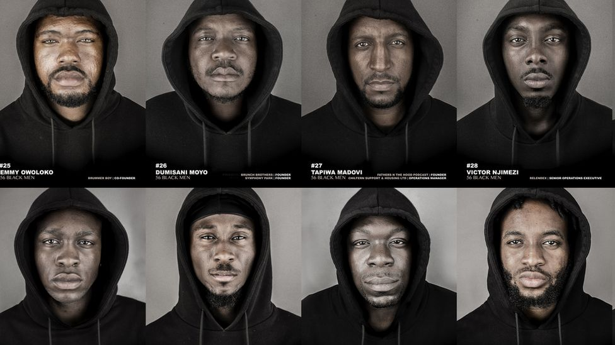
BBC News (2022)
Image 2. Thug Wearing Hoodie Holding Knife Photo
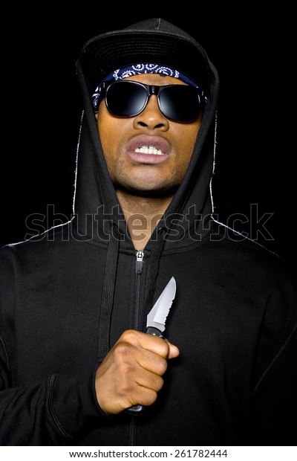 Shutterstock (2021).
Background
As demonstrated in Images 1. & 2., both entail black males wearing hoodies; however, the male in Image 2. is holding a knife, unlike the males in Image 1. Neither image shows any sinister wrongdoing, but according to Vir et al., (2018), the experiences of some individuals from black African and black African-Caribbean backgrounds feel societal perceptions will regard them as such. The aforenamed authors infer the media are integral to portraying suchlike individuals as being involved with gangs, crime, and associated harmful activities (Vir et al., 2018, p. 25). These portraits are also likely to deduce noted sample as less educated and of lower socioeconomic status (Vir et al., 2018, p. 25), also supported by Ashby (2021). Furthermore, of this cohort, Vir et al., (2018) suggest young black males feel most marginalised and misrepresented both within society and upon the media and entertainment platforms which they infer typecast black characters to appear as having similar akin traits (Vir et al., 2018, p. 25), as supported by Gates (2018). Holtzman and Sharpe (2014) concur and suggest that in doing so, the popular media are integral towards culturally diverse misconceptions. Vir et al., (2018) suggest this has resulted in fewer positive examples of black representation and portrayals within the media (Vir et al., 2018, p. 26).
Eddo-Lodge (2020, p. 32) supports and indicates misrepresentation like this could be consciously or unconsciously orchestrated. Bryant & Oliver (2009) infer agreeance and acknowledge that comparable for broader society and individuals has existed for many years. Sewell et al., (2021, p. 34) support and argue the importance of understanding how this occurred and why. Harrison et al., (2009) propose stigma and stereotyping could be instrumental and refer to Goffman (1971), who suggested these potentially arose through societal identification categorisations, which considered individual characteristics or attributes as forms of identification, cited in Harrison et al., (2009, p. 5). Both Kraus & Martins (2017) and Rodriguez & Dimitrova (2011) support and propose this to be what Goffman (1974) regarded as framing, a form of cognitive structuring which assists individuals in making sense of the world, cited in Rodriguez & Dimitrova (2011, p.49). However, Sewell et al., (2021) caution against comparable categorising and propose consideration must be awarded to how these ideologies, in turn, become collectively shared or held, as inferred by Giddens and Sutton (2021). Evidence provided thus far indicates that where these perceptions are negatively cast, those afflicted are unfairly judged and potentially limited by the previously mentioned lack of positive portrayals proposed by Vir et al., (2018) & Holtzman and Sharpe (2014).
Such sentiments are shared in a recent article by the British Broadcasting Corporation (BBC News, 2022), which reported on ‘56 Black Men’ who are recounted as intent on challenging such deficit through the medium of photography (BBC News, 2022). Cephas Williams founded the ‘56 Black Men’ campaign in the UK to create the image shown in Image 1, consisting of 8 out of the 56 male members posing in hoodies (BBC News, 2022). These men are accomplished in their rights, for example, politicians, directors, and teachers, but feel judged on of their choice of attire which appear to dissolve any accomplishments (BBC News, 2022). All 56 men echo support for Vir et al., (2018) and Ashby (2021), suggesting they feel as though society does consider them to be sinister and especially when wearing the hoodies being demonstrated in Image 1 (BBC News, 2022). Williams believes he has encountered similar societal profiling by suggesting examples of when individuals appear to be holding on to their bags or personal belongings more tightly upon passing (BBC News, 2022). Marin-Lamellet (2020) supports by proposing those who wear hoodies are often affiliated with drugs, criminal activities, or weapons.
Although Brands et al., (2015) point out the hoodie, which is naturally an inanimate object, is not sinister, but agree societal perceptions for their owners could appear them to be. Van Dijk (2015) agrees and suggests similar stereotypical classifications promote fearmongering within society. Williams supports and references examples that have resulted in public transport patrons seeking alternative seats until one member indicates that he ‘gestures to let them know it is safe to sit down next to me’ (BBC News, 2022). Pickard (2021) refers to Goffman (1963), who suggested negative labelling impedes identity (Pickard 2021, p. 14). Markland and Tobin (2010) caution that such comparable loss further restricts an individual’s sense of belonging, associated with overall development and well-being. Williams infers support by exclaiming that he is ‘tired’ of being wrongly judged and that situations like these were integral to forming ‘56 Black Men’ to raise awareness and tolerance (BBC News, 2022). Hence, Williams proposes the idea to wear the ‘demonic’ hoodie, as in Image 1, which was born to tackle both these societal prejudices and negative portrayals of black men (BBC News, 2022). Image 2 could be considered one such example; it could appear sinister because it captures a black man wearing a hoodie while holding a bladed knife against his chest. Although it is not evident any crime has taken place, it may still appear dangerous; therefore, it does little to dispel the prejudices that the 56 Black Men hope to rectify (BBC News, 2022). Williams infers suchlike through caution that he has witnessed too many people become what they were portrayed to be. Merton (1948) argued akin to self-fulfilling prophecies, which arise from ignorance but radiate doubt towards afflicted individuals.
Ashby (2021) infers support and proposes such misconceptions are associated with statistics that identified black males, aged 18 to 24, as being approximately 19 times more likely to be stopped and searched under section 60 of the Criminal Justice and Public Order Act 1994 (Ashby, 2021, p. 4). Noted Act allows the police to conduct searches on anyone they suspect of engaging with drugs, stolen goods, or weapons. Ashby (2021) cautions black males are nearly 30 times more likely to be searched for potentially possessing such weapons (Ashby 2021, p. 5). Ashby (2021) suggests disproportion like this has caused deep distrust towards the police, not only from targeted men but also from wider communities across the globe. Barrie (2020) refers to George Floyd, who was innocently killed in 2020 by the police in America, as cited in Samayeen et al., (2020). The aftermath of George Floyd’s murder caused global outrage and created mass demands for such racism to be eradicated. Williams infers support by proposing 56 Black Men will challenge suchlike stereotypes and promote the necessity for more positive representations of black men within the media (BBC News, 2022). Williams exclaims suchlike positive portrayals of role models will expose young black boys to the prospects of achievements and success, rather than the current discussions or representations which ordinarily revolve around gangs, violence, and knife crime (BBC News, 2022). Hence, Williams argues this campaign "serves as a reminder that for every black man you see represented doing something negative, there are 56 of us that aren't" (BBC News, 2022).
For this reason, it seems ironic that Image 1 was only manufactured to offset portrayals like Image 2; evidence provided thus far suggests both Images 1 & 2 will possibly be perceived in the same negative manner, regardless. Sewell et al., (2021) support with evidence they conducted for the ‘Commission on Race and Ethnic Disparities: The Report’ for the UK government to explore race and ethnic disparities in the UK. which identified there to be many misrepresentations in the media. Vir et al., (2018, p. 4) support and argue examples like Scottish characters appearing to be more hostile or Welsh ones to be timid (Vir et al., (2018, p. 4). Adams-Bass et al., (2014) appear to agree and reference Gorham (1999) as proposing comparable media utilisation of racial stereotypes, in turn, fuel racial myths. Atkinson (2007) regards it similar as to framing, like what Kraus & Martins (2017) & Rodriguez & Dimitrova (2011) previously described. A structure like this has the potential to be powerful as it requires less thought, possibly due to either appearing or feeling familiar. Therefore, Gates (2018) argues media platforms are integral towards addressing any misconceptions, also inferred by Holtzman and Sharpe (2014).
According to Stephenson (2021), at the beginning of the millennium, the UK media began portraying a new subgenre called ‘hoodie horror’ where characters wearing such were considered unruly and potentially sinister, also supported by Lamble (2013). Moreover, around the same time, media coverage of comparable real-life characters also appeared and resulted in this sample being targeted through both government and media debates. Hubbard (2017) supports one example of such arose when a shopping outlet refused entry to all hoodie wearers; by doing so, this sample became considered an underclass (Hubbard, 2017). This class became primarily associated with young males, typically from lower socioeconomic backgrounds, who might have displayed yobbish behaviours. Stroińska (2019) infers support for Harrison et al. (2009) and the previously discussed impact of such negative labelling, suggesting this caused forms of alienation that are believed to have been causal towards UK riots erupted soon after lasted for five days. Lamble (2013) supports adding this resulted in, for example, acts of looting, theft, or other such crimes, which Stroińska (2019) supports. Spinner-Halev (2012) infers support for such correlations between those who have had to endure injustice and are also expected to continue to take such injustice. Dorling and Lee (2016) & Quilter-Pinner and Hochlaf (2018) acknowledge suchlike by proposing poverty as being instrumental for many.
Moreover, in line with previous evidence provided throughout, black men appear to be even more marginalised (Dorling and Lee 2016; Quilter-Pinner and Hochlaf 2018). Gillborn et al., (2012) agree and argue these men have an increased likelihood of living in cramped or overcrowded homes situated within the poorer communities. Furthermore, Stevenson and Rao (2014) infer black graduates are paid less than white graduates. Hill et al. (2016 p.30) caution against intersectionality like this as it creates additional layers that further deepen such social inequity, as Dorling (2017) supported. According to Hussain et al., (2021), the Equality Act (2010) provides legal protection within the United Kingdom to ensure individuals are not discriminated against within society and at work due to having one of nine perceivable characteristics
age, disability, gender reassignment, marriage and civil partnership, pregnancy and maternity, race, religion or belief, sex, and sexual orientation (Equality Act, 2010).

However, Eddo-Lodge (2020) concurs the necessity for those experiencing suchlike inequity to be firstly acknowledged, for only then can it be suitably tackled, also supported by Sewell et al., (2021, p. 233); Giddens & Sutton (2017); Hoyt (2014) & Haskins and Singh (2015, p. 291). Moreover, this, in turn, could reduce the many associated stigmas and misconceptions discussed throughout, all of which further deepen inequalities and mistrust for both individuals and societies. Consequently, Atkinson (2007) suggests such forms of stereotyping could be balanced through ethnographic holism approaches, which would capture accurate and contextual representations of the targeted audience’s culture, also inferred by Davidson (2020). Butkowski, et al., (2020) argue this could also assist in reducing the pressures for women who they suggest feel compelled to look and behave in the specific ways models in the media might look. Finally, Sharda (2014) & Butkowski et al., (2020) further propose any future actions that need to incorporate cross-cultural approaches.
To conclude, this submission considers the approaches as potentially integral to future solutions, which will hopefully assist in eradicating many of the negativities described throughout. Furthermore, evidence suggests such inequity is likely to create labels that inhibit and impact well-being and possibly vilify. Supporting evidence throughout indicates there are links between media representations and possible typecasts. This submission has presented two types, one positive and one negative. Both Images 1 & 2 visually appear similar, apart from the knife, but due to the very nature of images lacking further context, it would be challenging to determine suchlike. Therefore, based on evidence provided throughout, this submission believes that although neither image shows any sinister wrongdoing, society might perceive it as such.

Reference List
Adams-Bass, V.N., Stevenson, H.C. and Kotzin, D.S. (2014) ‘Measuring The Meaning Of Black Media Stereotypes And Their Relationship To The Racial Identity, Black History Knowledge, And Racial Socialization Of African American Youth’ Journal of Black Studies, 45 (5), 367-395.
Alfred, M. (2011) Chapter 14 ‘Poised to Shatter the Glass Ceiling in the Ivory Tower’ In Women of Color in Higher Education: Changing Directions and New Perspectives. Yorkshire: Emerald Group Publishing Limited
Ashby, M. (2021) ‘Stop and Search in London: January to December 2020’ Institute for Global City Policing, 1-9
Atkinson, P. (2007) Ethnography: Principles in Practice. London: Routledge.
Barrie, C. (2020) ‘Searching Racism After George Floyd’ Socius, 6, 2378023120971507.
BBC News. (2022) Why 56 Black Men Are Posing in Hoodies. [online] <https://www.bbc.co.uk/news/uk-47298111> [Accessed 6 February 2022].
Brands, J., Schwanen, T. and Van Aalst, I. (2015) ‘Fear of Crime And Affective Ambiguities In The Night-Time Economy’ Urban Studies, 52 (3), 439-455.
Bryant, J., and Oliver, M.B. eds. (2009) Media Effects: Advances in Theory and Research. London: Routledge.
Butkowski, C.P., Dixon, T.L., Weeks, K.R. and Smith, M.A. (2020) ‘Quantifying the Feminine Self (i.e.): Gender Display And Social Media Feedback In Young Women’s Instagram Selfies’ New Media & Society, 22 (5), 817-837.
Canon, D.T. (2020) Race, Redistricting, And Representation: The Unintended Consequences Of Black Majority Districts. Chicago: University of Chicago Press.
Davidson, E. (2020) ‘Social Justice Or Social Control? An Ethnographic Study Of Detached Youth Work in Scotland’ Scottish Affairs, 29 (2), 254-276.
Davies, C.M. and Robison, M. (2016) ‘Bridging the Gap: An Exploration of The Use and Impact of Positive Action in The United Kingdom’ International Journal of Discrimination and The Law, 16 (2-3), 83-101.
De Coster, S. and Thompson, M.S. (2017) ‘Race and General Strain Theory: Microaggressions as Mundane Extreme Environmental Stresses’ Justice Quarterly, 34(5), 903-930.
Dorling, D. (2017) ‘Austerity and Mortality’ The Violence of Austerity, 44-50.
Dorling, D. (2019) Inequality and The 1%. Verso Books
Eddo-Lodge, R. (2020) Why I am No Longer Talking to White People About Race. London: Bloomsbury Publishing.
Equality Act 2010. [online] Available at: <http://www.legislation.gov.uk/ukpga/2010/15/contents> [accessed 25.01.2022]
Gates, R.J. (2018) Double Negative: The Black Image and Popular Culture. Durham: Duke University Press.
Giddens, A., and Sutton, P.W. (2021) Essential Concepts in Sociology. Chichester: John Wiley & Sons.
Gillborn, D., Rollock, N., Vincent, C. and Ball, S. (2012) ‘You Got a Pass, So What More Do You Want?’: Race, Class and Gender Intersections in The Educational Experiences of The Black Middle Class’ Race Ethnicity and Education. 15 (1). 121-139
Goffman, E. (2018) ‘Stigma And Social Identity In Deviance & Liberty (24-31). London: Routledge
Harrison, K., Lawrence, S.M., Plecha, M., Scott Bukstein, J.D., and Janson, N.K. (2009) Stereotypes and stigmas of college athletes in Tank McNamara’s cartoon strip: Fact or fiction. Journal of Issues in Intercollegiate Athletics, 1(Special Issue), pp.1-18.
Haskins, N.H. and Singh, A. (2015) ‘Critical Race Theory and Counsellor Education Pedagogy: Creating Equitable Training’ Counsellor Education and Supervision, 54 (4), 288-301.
Hermes, J. (2010) On Stereotypes, Media, and Redressing Gendered Social Inequality. Contemporary Readings in Law and Social Justice, 2 (2), 181-187.
Hill, C.P., Bilge, S. and Bilge, S. (2016) ‘Intersectionality’ Key Concepts Series. Cambridge: Polity Press
Holtzman, L. and Sharpe, L. (2014) Media Messages: What Film, Television, And Popular Music Teach Us About Race, Class, Gender, And Sexual Orientation. London: Routledge.
Hoyt Jr, C. (2012) ‘The Pedagogy Of The Meaning Of Racism: Reconciling A Discordant Discourse’ Social work 57 (3), 225-234.
Hubbard, P., 2017. The Battle for the High Street: Retail Gentrification, Class and Disgust. London: Springer.
Hussain, Z., Rizvi, L.J. and Sheikh, H. (2021) ‘The Equality Act (2010) Pre and Post Pandemic Historic Development on Equality and Discrimination Issues for Employers: Review of Literature’ International Journal of Law and Management.
Kraus, A. and Martins, N. (2017) ‘On the Street: A Content Analysis Of Body Imagery In Streetstyle Fashion Blogs’ Journal of Broadcasting & Electronic Media, 61(2), pp.351-367.
Lamble, S. (2013) The Quiet Dangers Of Civilized Rage: Surveying The Punitive Aftermath Of England’s 2011 Riots. South Atlantic Quarterly, 112 (3), 577-585.
Marin-Lamellet, A.L. (2020) ‘Mad, Bad and Dangerous to Know? Hoodies in Contemporary British Horror Cinema’ Angles: New Perspectives on the Anglophone World, (10).
Markland, D., and Tobin, V.J. (2010) ‘Need Support And Behavioural Regulations For Exercise Among Exercise Referral Scheme Clients: The Mediating Role Of Psychological Need Satisfaction’ Psychology of Sport and Exercise, 11 (2).91-99.
Merton, R.K. (1948) The Self-Fulfilling Prophecy. The Antioch Review, 8 (2), 193-210.
Monk-Turner, E., Heiserman, M. and Johnson, C. (2010) The Portrayal of Racial Minorities on Prime-Time Television: A Replication of the Mastro and Greenberg Study.
Pickard, H. (2021) ‘Addiction and the Self’ Noûs, 55 (4), 737-761.
Quilter-Pinner, H. and Hochlaf, D. (2018) ‘There Is an Alternative: Ending Austerity in the UK’ Institute for Public Policy Research
Rodriguez, L. and Dimitrova, D.V. (2011) ‘The Levels of Visual Framing’ Journal of visual literacy, 30 (1), 48-65.
Samayeen, N., Wong, A. and McCarthy, C. (2020) ‘Space To Breathe: George Floyd, BLM Plaza and The Monumentalization of Divided American Urban Landscapes’ Educational Philosophy and Theory, 1-11.
Sewell, T., Aderin-Pocock, M., Chughtai, A., Fraser, K., Khalid, N., Moyo, D., Muroki, M., Oliver, M., Shah, S., Olulode, K. and Cluff, B. (2021) ‘Commission On Race And Ethnic Disparities: The Report’ London: Commission on Race and Ethnic Disparities.
Sharda, A. (2014) ‘Media and Gender Stereotyping: The Need For Media Literacy’ International Research Journal of Social Sciences, 3 (8), 43-49.
Shutterstock., P. (2021) Thug Wearing Hoodie Holding Knife Photo [online] Available at: https://www.shutterstock.com/image-photo/thug-wearing-hoodie-holding-knife-coming-261782444 [Accessed 6 Feb. 2022].
Spinner-Halev, J. (2012) Enduring Injustice. Cambridge University Press.
Stephenson, L (2021) ‘Eden Lake and the British Hoodie Horror Genre: How They Reinforced Policies To Demonise The Working Class’s’ The Conversation [online] Available at https://ray.yorksj.ac.uk/id/eprint/5620/1/eden-lake-and-the-british-hoodie-horror-genre-how-they-reinforced-policies-to-demonise-the-working-class-168701 [19/01/2022]
Stevenson, J. And Rao, M. (2014) ‘Explaining Levels of Wellbeing in Black and Minority Ethnic Populations in England’ The University of East London, Institute for Health and Human Development London: University of East London
Stinson, D.A., Logel, C., Shepherd, S. and Zanna, M.P. (2011) ‘Rewriting the Self-Fulfilling Prophecy Of Social Rejection: Self-Affirmation Improves Relational Security And Social Behaviour Up To 2 Months Later’ Psychological Science, 22 (9), 1145-1149.
Stroińska, M. (2019) ‘Can There Be a Safe Haven for Trauma Survivors in this Social Media Dominated World?’ TRAMES 23 (2), 223-238
Van Dijk, T.A. (2015) Racism and the Press. London: Routledge.
Vir, J., Hall, K. and Foye, R. (2018) ‘Representation and portrayal of audiences on BBC television’ Kantar Media.

