Network and Cybersecurity Essentials

ACCA4024

Synthesize a Solution to a Potential Real-Life Scenario

Carys Rees

2003859

BSC Computing (Data and Information Systems)

Table of Contents
Introduction 3
Related Work 3
Techniques 4
Design Overview 6
The Importance of Digital Signatures and The Principles of Data Encryption 8
IT Security Policies Strategy 9
Conclusion 9
Reference List 10

Introduction
This documeny will be outlining the possible vulnerabilities, threats and attacks that could happen while accessing Che-Si’s systems from various personal internet devices and locations, recommend techniques to mitigate the above listed techniques without impacting their productivity and performance. To explain the importance of digital signatures and the principles of data encryption, and lastly to create a written policy to update Che-Si’s existing IT security policies.

Related Work
From reading the scenario, it is clear to see that the company is permitting their staff/clients/users to use their personal internet devices and various locations. And therefore, have come to the realisation that restricting personal mobile internet devices is not a very optimistic approach, and that the company will need to allow the users access, by doing so securely.

By using personal internet devices from various locations, that increases their vulnerability by exposing them to threats and cyber-attacks. The most common form of attack is a phishing attack; this is when the attacker lures the user into believing they are from a credible source and therefore sharing sensitive information to them. This is normally done via email and the attackers disguise the message to look professional, giving the user a false sense of security, and then they give them valuable information. The scenario states that Che-Si stay connected online with their clients and site offices, therefore it is safe to assume they use email in order to stay connected, in turn opens up the opportunity for attackers to forge their identity.

In the scenario, they state that they use Video Conferencing facilities to communicate with their clients and site offices 24/7 to effectively manage their operations, this means that they are vulnerable to attackers joining that call. Reports have surfaced that the Zoom app is being ‘hijacked’, also known as ‘zoom-bombing’ [2]. It is said that there has been an instance of ‘leaked passwords’ and ‘hackers hijacking video calls midway through conferences’ [1]. This is a security concern for zoom itself as their levels of authentication are not the best, which allowed the passwords to be leaked in the first place. This means that Che-Si could be in danger of this happening to them; therefore, it is important to add multiple levels of authentication to the video call so that only authorised users can access it.

Che-Si are said to use cloud storage facilities; therefore, they should be aware of the risks that come with it. Although the cloud is rather secure, it also comes with its own security issues, such as data privacy. This means the company does not want unauthorised users to gain access to the data, however as the data is stored elsewhere, it is near impossible to know just how secure it is, meaning that they have a lack of control of it. If the system was to suddenly fail, then they are relying on that company to keep the data secure and to ensure it is made secure again, however giving an attacker enough time to gain access to such sensitive information.

Techniques
By the staff using their personal internet devices in various locations, they are exposing themselves to a variety of threats, such as hacking, although they can be protected by using a VPN. This is an effective form of security as VPN makes it near impossible for hackers to decrypt the code. A VPN will protect all of the vulnerabilities listed above (Video conferencing and cloud storage), which in turn protects the staff’s personal data business data and the client’s data. A VPN ensures that the communication between staff and client’s is secure which helps the company ‘increase their productivity’ and ‘enhance operational efficiencies’ [1].

Should the company implement the use of a VPN, it will allow the staff to securely work remote from a variation of devices and locations. For example, should they want to work from their laptop, in a café, which is a public network, then they will be safe. As long as they have a VPN on all of their working devices then the probability of being attacked is low. Obviously, it would be a lot more secure should the worker be on their home network compared to a public network as there is a lot less traffic on it, they are also able to get a firewall for the home network. This adds another level of security as it means that the network will be much more complex for the hacker to decrypt, and therefore allow them to work on any of their home devices, that is connected to that network. This allows them to work efficiently and without interruption, therefore not impacting their productivity and performance.

One of the most common attack in organisations is tailgating. This means that the attacker is gaining unauthorised access to the data simply by manipulating the user. And the main purpose of the attack is to steal confidential data for malicious purposes. Therefore, to avoid this kind of attack on the company, it would be beneficial to increase the number of authentication steps. This can be done by simply adding passwords, PIN numbers, biometrics, etc. A result of this would be that the data is more secure and although it may take longer for an employee to gain access to the relevant data, it will not impact the productivity and performance of said employee.

Another common attack is password sniffing. Although it is a common attack, businesses do have protocols in place that people must enter strong encryptions for passwords. Password sniffing is an ‘attack that destroys the confidentiality trait of network security’ [3]. In simple terms meaning, an attack is made to identify usernames and passwords from the network in a company. The user is always left wondering why an attacker would do such thing, however the main objective of a sniffer is to ‘crack passwords and other login information of the victim’[3], essentially giving them the important and confidential business data. It is easily achievable to avoid this from happening. Firstly, they could have protocols in place where the staff’s passwords must include upper/lower cases, numbers and symbols as this makes it more difficult for the attacker to guess the password. Also, the system should notify a user when the password needs changing, on a regular basis, which could be every two to three weeks. This means that the system will be more secure and reduces the risk of an attack, whilst also not affecting the productivity and performance of said user. Nevertheless, the best solution to deal with this kind of attack is to ‘use data tiggers which manipulate the value of the passwords’ [3], meaning that should the sniffer break down the confidentiality trait then they would be able to ‘disclose all the data’ [3]. Should the company use a ‘one time password’ or an ‘encryption system’ then the attacker will not allow the victim to create a ‘new session’ as most websites browse with both http and https. An example of password sniffing is below.
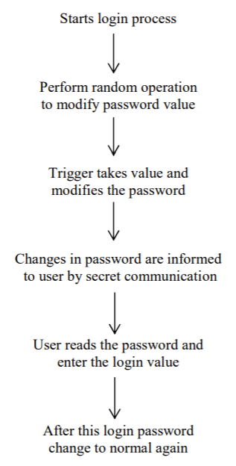[3].

Design Overview
Here is a diagram of a sniffer, which is there to recognise when there is someone trying to gain unauthorised access to the switch/system. As mentioned above, a sniffer is an important aspect to have in the company as it detects when there is someone trying to hack into the system and will block all of their attempts.

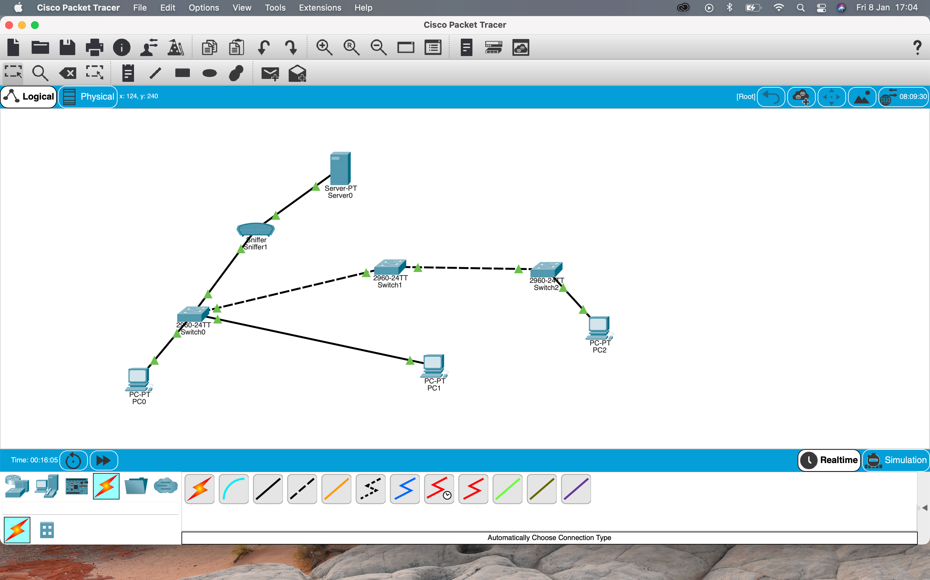
The screenshot above shows how there could be vulnverabilities in the system. Within the pcs there are text files created in which only certain users can access, which were pre determined. Here are the authorised users below.
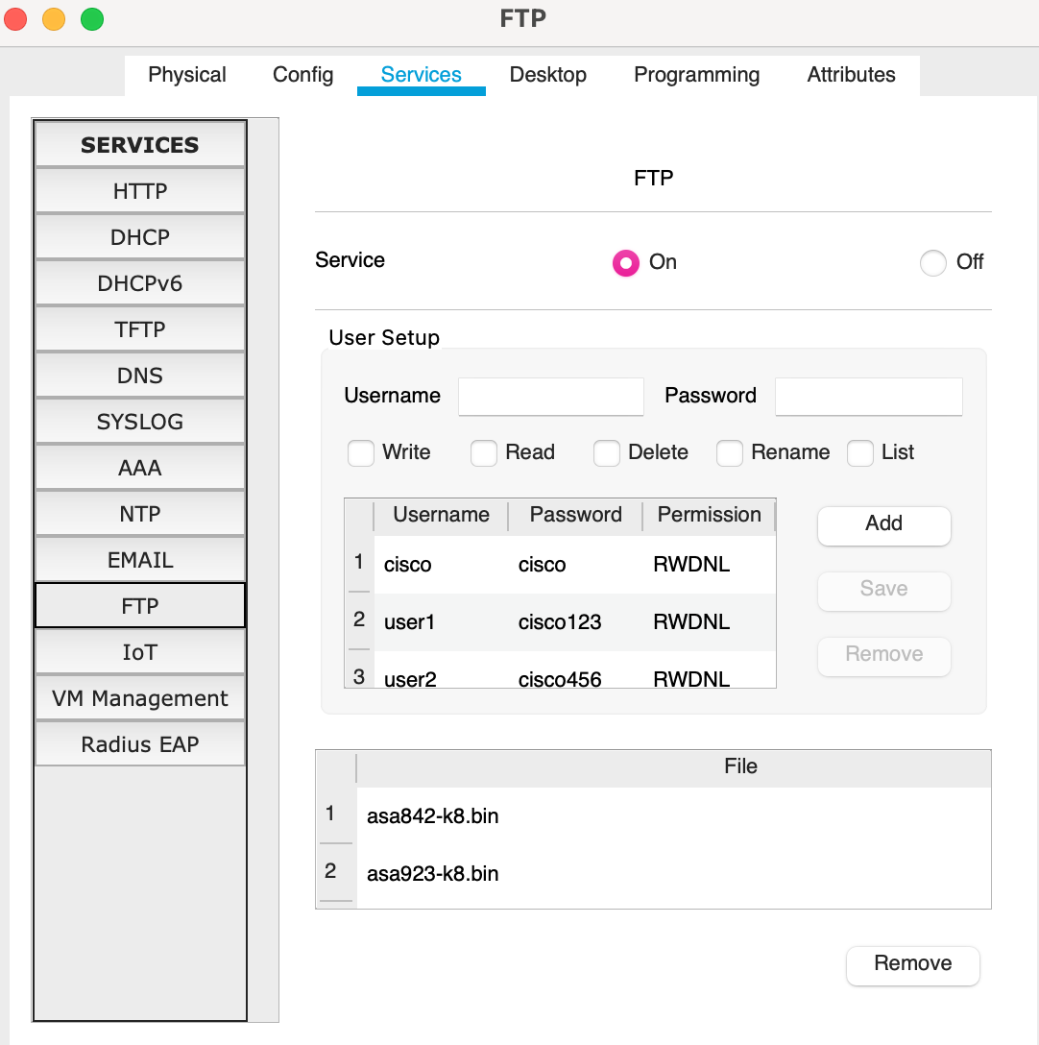
These are determined within the server, therefore if an attacker was to go sniffing within the company, then that’s where they would go first. The two users created were given full access to everything, which includes read, write, delete, rename and list.
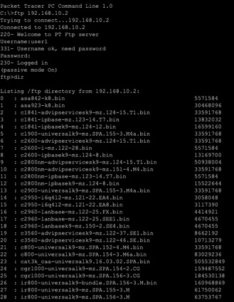This screenprint shows that on the command prompt, the user is prompted to input their credentials (username and password), then they have access to everything within the system. Therefore, the username and password need to be very secure and should be changed on a regular basis so that an attacker is less likely to gain access to any confidential data.
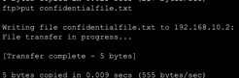This screenprint shows how a text file was created on a pc, containing confidential data. So that when the user enters their credentials then they can call up this text file and see its contents, which makes it that much more important that the username and password is changed on a regular basis to decrease the chances of an attacker gaining access to everything. A good way to mitigate the attack is for the user to be prompted to change their password after every use. Although this may make it difficult for the user to remember their passwords, it is an effective way of blocking an attacker as they will be jumping through loop holes each time, they attempt to gain access. Another way would be to add more firewalls to the system, which delays the time the attacker can gain access. All of these things should be done in order to protect the company.

The Importance of Digital Signatures and The Principles of Data Encryption
Digital signatures work in the same way as handwritten signatures for electronic documents, in which it is used to determine if someone edits a document after the user signs it. It is also a mathematical method used to check the authenticity and integrity of a message, digital document, or software. In many countries, digital signatures have the same legal importance as a manually signed document. They also provide repudiation.
Digital signatures are added to packets, meaning that when a packet is sent without a signature then it is considered random and unsafe, leading to it being blocked by the computer. However, if the packet did have a digital signature, then it can be matched up and the computer system will allow it to be received as it will be considered safe.
Although this is good, it can also cause some damage, as an attacker could use that signature and then send something imposing to the user, which they thought was a safe packet, resulting in damage being done. The same can be done by an attacker intercepting the data transfer, because if they had the encryption key, they could send something malicious to the receiving user, whether it is the employee or client.
According to the European Directive 1999/9 (1999), only ‘cryptographic digital signatures’ [5] satisfy the requirements for certain types of ‘electronic signatures’, such as the ‘advanced or qualified signatures’ [5].
Data encryption can easily be done with keys. For example, when an employee sends an email, they can do so securely with an encryption key, so that the receiving user will have the decrypting key in order to gain access to the sensitive data. Having encryption keys makes it very difficult, near impossible, for an attacker to decrypt it themselves, which makes it a secure form of communication. Che-Si should start using encryption keys as it would allow them to communicate securely with their employees and clients. A ‘private key algorithm’ [6] does the encryption and are typically faster than public key ones, meaning that the company will need to have a private key algorithm for the employees as the ‘public key algorithms’ [6] are too slow to be used for ‘most data transmissions’[6].

IT Security Policies Strategy
For their security policy strategy, they should implement the use of a VPN as it is the best course of action to take. It is the most secure method of communication in various locations on their personal mobile internet devices to the office and to clients. Not only will it protect the data being transferred but also the employees and clients.
A VPN will strongly encrypt the data and it would take a hacker a long period of time, if ever, to decrypt the code to gain unauthorised access to the data. The benefits of a VPN are endless, such as the cost to the company, increase their productivity and ‘enhance operational efficiencies’ [4]. The benefits for a VPN are endless, so here are a few more:
- Performance - Improved company network capacity is supported by increased bandwidth utilisation and increased network resiliency.
- Flexibility - With increased speeds, businesses may use an array of access methods that are designed to each location.
- Security - Privacy, encryption, and authentication help secure data travelling over the network with slight or no performance effects.
- Scalability - Installation, setup, and re-configuration are made simpler as the network expands. Upgrading a network of legacy networks is also costly and time-consuming.
Another method they should implement, is installing firewalls on their different personal mobile internet devices so that if a hacker was to try and gain access to the system through a public network then it will make it very hard to get into said system. However, if the employee or client was using their home network then they should also have a firewall on there so that the hacker would need to gain access onto the network before they would be able to try and gain access to the device they are using.

Conclusion
In conclusion, should Che-Si adopt all the techniques listed above, then they will be able to access the company data externally using their personal devices from any location, whilst also staying safe online so that they are keeping the staff’s personal data, business data and client’s data safe. They will also be able to keep productive and superfast operations so that they can keep up performance to keep the clients satisfied. There is a demonstration that shows how easy it is for an attacker to gain access to the system, if more security measures are not put in place, with recommendations on how to mitigate this.

Reference List
- Clark, Gene. Opportunity Knocks.
https://web-b-ebscohost-com.ezproxy.uwtsd.ac.uk/ehost/pdfviewer/pdfviewer?vid=1&sid=90b35d41-af20-4e91-9a40-566bc3317505%40pdc-v-sessmgr04
- Uppal, Rsjesh. Cyber risks of video-conferencing apps like zoom, popular with professionals working from home globally. April 10, 2020.
https://idstch.com/cyber/cyber-risks-of-video-conferencing-apps-like-zoom-popular-with-professionals-working-from-home-globally/
- Kulshrestha, Anubhi. Kumae Dubey, Sanjay. A literature review on sniffing attacks in computer network.
https://d1wqtxts1xzle7.cloudfront.net/34703254/A_Literature_Review_on_Sniffing_Attacks_in_Computer_Network.pdf?1410475126=&response-content-disposition=inline%3B+filename%3DA_Literature_Review_on_Sniffing_Attacks.pdf&Expires=1618835145&Signature=Olvh2VY80~1r6UV-ZGEuznzVLSq9T3uy~5LrhdfoWF43hRyLUFU8UVLtPlOvpqcNqRseCruODFKdmS1ou3Xiox~s93MH7V87rWkNMkefJ36m9lXJIov9ElaWPZlaua8F3jq0AhRTFhlMTjwxMyjWG-DQ6jRya40se9~91KeOZo~RUhEs1rrRmHOI3NvTsulv7Crt4zHlvZudGji5hS2F-n0wDEpCtVXaB0lk53VA34yoKtOE2i7GIGL3Ii3kwCKpOAY8BcO19T~bShrystrequYETLOVJ96xy8KiziVHndo-Ki3E7AmrtZWlofO2kFmWP~i-Uco75khDO3iEpse66g__&Key-Pair-Id=APKAJLOHF5GGSLRBV4ZA
- Clark, Gene. Opportunity Knocks: outsourced VPNs offer huge benefits for enterprises – and amazing opportunities for providers.
https://web-b-ebscohost-com.ezproxy.uwtsd.ac.uk/ehost/pdfviewer/pdfviewer?vid=1&sid=654751d6-0f42-498b-b83a-df208875f0a0%40pdc-v-sessmgr01

- Hernandez-Ardieta, Jorge L ; Gonzalez-Tablas, Ana I ; de Fuentes, Jose M ; Ramos, Benjamin. Computers & security, 2013-05, vol.34, p.67-112.
https://www-sciencedirect-com.ezproxy.uwtsd.ac.uk/science/article/pii/S0167404812001794
- Landau, Susan. Standing the test of time: The data encryption standard. March 2000.
https://www.ams.org/notices/200003/fea-landau.pdf?q=standing-the-test-of-time-the-data-encryption-standard

