Contents Page
Part 1 - Study Timetable - Pages: 2, 3
Part 2 - AI Activity - Pages: 4,5,6
Reference list – Page 7
Part 3 - Poster and Reference list - Page: 8
Part 4 - Link to oral presentation also shared with lecture team: Page: 9

Basic Acknowledgement format of AI tool use
I acknowledge the use of Microsoft 365 Copilot https://copilot.microsoft.com on 10th September 2026 to purpose my work. I used the
Prompts:
Initial Prompt. Please could you give me a list of techniques that will help me make the best use of my study time
1.Please could I have more information on the Balanced Study Routine
2.Please could I have more information on the Pomodoro Technique
3.Can you provide a reference list on where you got this information from please?

I confirm that I have not presented any Ai generated text as my own work. I confirm I have copies of my drafts, notes and other resources I used before, and after the use of AI tools which may be asked to provide in evidence.
Time | Monday | Tuesday | Wednesday | Thursday | Friday | Saturday | Sunday
00:00 – 06:29 | Sleep | Sleep | Sleep | Sleep | Sleep | Sleep | Sleep
06:30 – 07:29 | Coffee, let dogs out and feed all pets | Coffee, let dogs out and feed all pets | Coffee, let dogs out and feed all pets | Coffee, let dogs out and feed all pets | Coffee, let dogs out and feed all pets | Coffee, let dogs out and feed all pets | Coffee, let dogs out and feed all pets
07:30 – 08:29 | Get washed and dressed, straighten bed, make packed lunches | Get washed and dressed, straighten bed, make packed lunches | Get washed and dressed, straighten bed, make packed lunches | Get washed and dressed, straighten bed, make packed lunches | Get washed and dressed, straighten bed, make packed lunches | Stay in Pajamas,  another coffee  (possibly away supporting grown up children with their sports) | Stay in Pajamas,  another coffee  (possibly away supporting grown up children with their sports)
08:30 – 09:29 | Travel and arrive at work | Travel and arrive at work | Travel and arrive at work | Travel and arrive at work | Travel and arrive at work | Travel into see Mum and MIL | Stay In Pajamas  Chill
09:30 –  12:29 | Work | Work | Work | Work | Work | Mum and MIL | Catch up on jobs
12:30 – 13:29 | Lunch. Respond to emails and messages | Lunch. Respond to emails and messages | Travel home from work. Lunch. Respond to emails and messages | Travel home from work. Lunch. Respond to emails and messages | Travel home from work. Lunch. Respond to emails. | Travel home from Mum and MIL  Grab snacks. | Walk dogs with family and have lunch together
13:30 – 15:29 | Work | Work | Walk the dogs (headphones on and listen to any university videos)  Laundry and cleaning | Walk the dogs (headphones on and listen to any university videos)  Laundry | Take dogs to visit Mum and MIL | Uni Work  Refreshment break and take dogs out. | Meet up with friends for coffee and do the food shop.
15:30 – 16:29 | Travel to university | Travel home, Prep dinner | Laundry, Cleaning. | Laundry, Cleaning | Mum and MIL  Travel home | Uni work | Travel home. Shopping away.
16:30 – 16:59 | Coffee, read notes | Short walk for dogs | Prep dinner | Prep dinner | Prep dinner | University work | Any jobs that need doing
17:00 – 19:29 | University on campus | Family time, dinner. | Family time, dinner. | Family time dinner. | Family time dinner. | Family time dinner. | Family time dinner.
19:30 – 20:29 | University on campus | University work | University work | University work | University work | Free time | Free time
20:30 – 21:29 | Travel home | University work | University work | University work | University work | Free time | Free time
21:30 – 22:29 | Catch up with family. Shower | University work | University work | University work | Plan to turnitin | Shower.  TV and relaxation | Shower.  TV and relaxation
22:30- 23:29 | TV and relaxation | Shower. Netflix on in background university referencing | Shower. Netflix on in background university referencing/researching | Shower. Netflix on in background university referencing | Shower. TV and relaxation | TV and relaxation | TV and relaxation
23:30- 23:59 | Sleep | Sleep | Sleep | Sleep | Sleep | Sleep | Sleep

Initial prompt entered: Please could you give me a list of techniques that will help me make the best use of my study time
Copilot response: Here is a clear, practical list of study techniques that will help you make the best use of your time — perfect for the assignment you’re working on in your document 👇
🕒 1. Time-Blocking Divide your day into dedicated blocks for specific tasks (e.g., 9–11 AM for reading, 2–4 PM for writing). Why it works: It prevents multitasking, builds structure, and ensures every hour has a purpose.

🍅 2. Pomodoro Technique Work in short, focused bursts — 25 minutes of study followed by a 5-minute break. Why it works: Keeps concentration high and reduces fatigue. After four cycles, take a longer break.

🧩 3. Active Recall Instead of rereading notes, test yourself regularly — use flashcards or practice questions. Why it works: Strengthens memory and helps you identify gaps in understanding.

🔁 4. Spaced Repetition Review material at increasing intervals (e.g., 1 day, 3 days, 1 week). Why it works: Reinforces long-term retention and prevents cramming before exams.

🧠 5. The “Big 3” Daily Priorities Each day, choose three high-impact tasks that move your progress forward. Why it works: Keeps you focused on what truly matters and avoids overwhelm.

🌿 6. Balanced Study Routine Alternate between study and wellbeing activities — exercise, rest, or social time. Why it works: Protects your energy and prevents burnout, making study time more effective.
Would you like me to help you choose two techniques from this list to develop in detail for your assignment (as your “final study techniques” section)? I can show how to structure your prompts and responses for those.
Refined prompt 1: Please could I have more information on the Balanced Study Routine

Refined prompt 2: Please could I have more information on the Pomodoro Technique
Prompt 3 used to identify sources: Can you provide a reference list on where you got this information from please?
I chose two techniques that focussed on time management, something I feel will benefit me in the time management of my own studies, now in my early days and will still continuously support me as I progress through my academic studies.
The Balance Study Routine is a technique used to help support time and balance and not to overwork oneself, by providing necessary breaks. Almost like a timetable, with blocks of time carefully thought out, planned and personalised for the duration in weeks. Allowing and setting time aside to eat, socialise, sleep and enjoy other aspects of life, thinking about what is needed overall and not only focusing on studying means one will be happier and more productive. If the Balance Study Technique has correctly been put in place and is being used, then it will naturally and positively support all aspects of future learning, wellbeing and development.
The Pomodoro Technique is another technique that is used to break up study time, however, it works by spreading out and breaking up a single block of study time and is supported by setting up a timer, encouraging to take a 5-minute break to move about, stretch, have a drink, then, returning for another period of study time and repeating. It can help with staying focused and reducing how tired you can become. Returning to studying after a short break can help keep the motivation and the task in front more manageable and achievable. Being able to set and adapt the timer lengths for longer and shorter periods of time, the Pomodoro Technique could be beneficial for future learning.
Both techniques assist with becoming a successful learner. Setting early manageable boundaries, building confidence and gaining on being proactive and reducing the opportunity for procrastination to happen.
“Recognising that successful study is largely about understanding the field, developing good study habits, and applying good approaches and techniques – rather than how ‘bright’ you are” (Cottrell, 2024, p. 91)
Reflection on using Microsoft 365 Copilot for Academic Study
Whilst using Microsoft 360 Copilot for my academic work and researching the techniques, I realized how easy it was to ask questions. To be honest, a little too easy, initially I felt that Microsoft 360 Copilot being immediate with responses was just what I needed! However, when going forward with the information, I struggled to know if what was being given was true. Each prompt was met with easy to read information but it was difficult to find where the information had come from, and even when I asked Microsoft 360 Copilot, I was not convinced it was creditable, accurate and reliable. My findings were that Copilot was not current and had given me information from a research source dating back as far as 1885 and could not provide a direct link. This was concerning and made me realise that although Copilot can give an answer very quickly, this does not necessarily mean the answer is right. It brought to my attention about my own responsibility and that I should always be aware, question it and make further enquiries when needed. Another challenge I noticed when using Microsoft 360 Copilot was at the end of each answer I received, came a helpful next option for me to consider and agree to do, it felt like my very best friend who wanted to take the lead.
Taking on this part of the module and having the opportunity to see both the positives and the challenges that come with using AI has been a good learning curve. I found it useful when I'm unsure of where to begin, as it can give me ideas and help me understand in simpler terms on the other hand, I have learned that I should not allow it to replace my own research and thinking.
I have come to the conclusion that I will use Microsoft 360 Copilot in the future as a starting point due to the help in understanding and how good it is at quicky breaking down the initial information but being very careful, mindful and aware on how and where to proceed with that information.
My experience is relevant with Lee et al. (2025), who observed that confidence in generative AI can reduce critical thinking, and by Yang and Whitfield (2025), who noted that Microsoft Copilot’s responses often lack clear source attribution. Similarly, Jacob et al. (2026) found that Copilot’s proactive guidance can influence reflective writing, echoing my sense that it sometimes “takes the lead.”

Reference list
Brown, K. (2026) The Pomodoro Technique: A Complete, Practical Guide. Berlin: Francesco Cirillo
Cirillo, F. (2006) The Pomodoro Technique. Berlin: Francesco Cirillo
Copilot. (2026) Copilot response to Rebecca Morse, 10 September 2026. Microsoft 365 Copilot
Cottrell, S. (2024) The study skills handbook. 6th edn. London: Bloomsbury Academic.
Ebbinghaus, H. (1885) Memory: A Contribution to Experimental Psychology. New York: Teachers College Press
Jacob, S. M., Patterson, S., & Opara, C. (2026)
Lee, H.-P., Sarkar, A., Tankelevitch, L., Drosos, I., Rintel, S., Banks, R., & Wilson, N. (2025)
Yang, S. Q., & Whitfield, S. (2025)

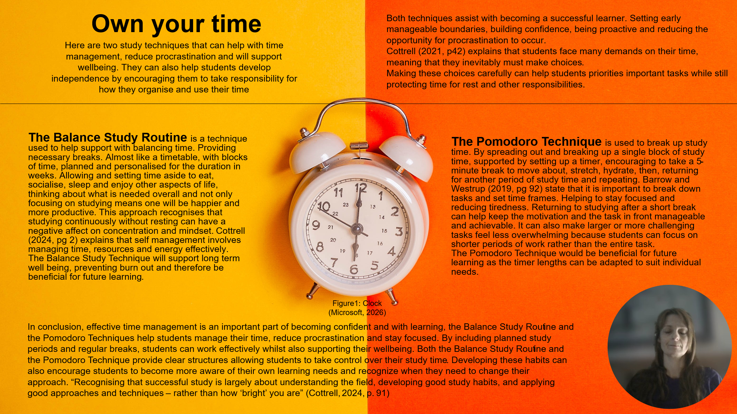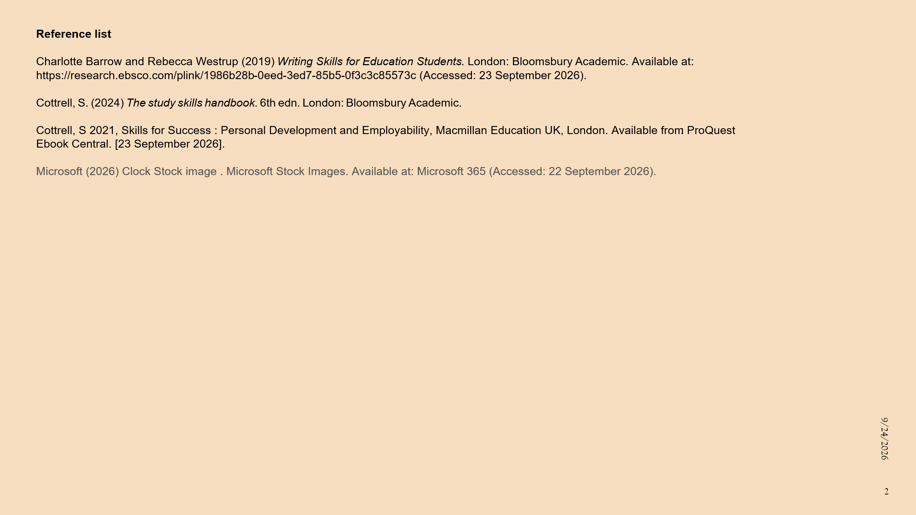

https://uowtsd-my.sharepoint.com/:p:/g/personal/2609837_student_uwtsd_ac_uk/IQAwH1yoCv_fR4IF9F2Ohds2AUs__qqWhYKAKHsxuFwOL54?e=7Nxa0u

