Applied Internship
Reflective Diary
 January 2019
Applied Internship
Nia James
1705762
The Glynn Vivian Art Gallery is a not for profit organisation run by the council that hosts art exhibitions and events weekly to their audience (Swansea-Glynn Vivian Art Gallery, 2018). I have just completed a 122-hour internship placement over the time frame of 10 weeks. I worked closely with their Marketing Manager and therefore I was her ‘Marketing Assistant’. My roles and duties during my placement consisted of assisting the Gallery’s Marketing Manager in the implementation of various marketing plans, events, and exhibitions and collection displays, assisting and contributing to social media platforms; Facebook, Twitter, Flickr, Vimeo, YouTube, Pinterest, Instagram, and the Gallery blog. I also observed their customers during the day and at their events to see how their target audience react to the gallery.
The organisations management structure is very small as there are around 23 people who work there (Haberberg et al, 2001). Starting from the bottom of the hierarchy, they have 6 Gallery Assistants who greet customers, show them around etc. they then have a Gallery Administrator who is in charge of them. They have 2 Technicians with a Technical Officer in charge. Next, there’s someone who works in the Library alone with a Documentation Officer in charge, with 2 Conservation and Collections Officers in charge of them. In the exhibitions section they have the Exhibitions Assistant and the Exhibitions Officer. Next, there is a Learning Co-ordinator, Learning Assistant, and a Learning and Participation Officer. Going up the hierarchy, there are the Gallery Curator and the Marketing Officer, followed by the Strategic Manager, then finally at the top is The Head Of Cultural Services. Throughout my time working at the gallery, everyone takes their roles seriously and after observing I noticed they collaborate well together, they all work very well as a team and are comfortable asking for support when needed.
Gibbs reflective cycle encourages people to think systematically about the phases of an experience or activity and encourages use of all of the headings to structure your reflection (Gibbs, 1988). As you can see from the image below the heading include description, feelings, evaluation, analysis, conclusion, and action plan.
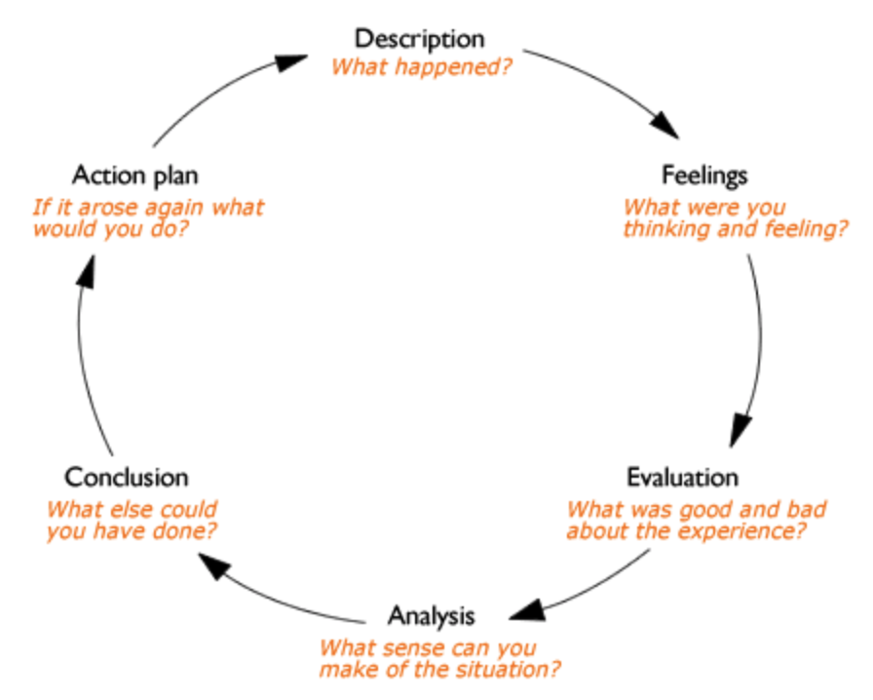

Reflective writing: About Gibbs reflective cycle (1988). Available at: https://www.brookes.ac.uk/students/upgrade/study-skills/reflective-writing-gibbs/.

Description – during my time at the Glynn Vivian I underwent many different tasks which involved creating social media posts, planning new activities and events, planning a new food menu for the café, observing their events and many more.
Feelings – I really enjoyed doing all of these tasks as I got to express my ideas in a real-life organisation which is what I want to do in the future. Although, their budget was my biggest barrier, I wasn’t given a budget for my ideas so therefore I came up with exciting, but reasonable ideas, albeit none of my ideas were put forward due to time and money, although, I do believe they will use some ideas in the future.
Evaluation – the strengths were the fact that I was able to express myself into how I think the organisation can better themselves and increase their target audience which is their main aim. Although, the negatives of my experience, was the lack of involvement I had with plans that actually went ahead and the fact that I often copied and pasted the same words and images to different social media platforms instead of making it more appealing to new people, so this role was more about observing.
Analysis – I could sense that time and money is a huge problem for the organisation as they liked my ideas but couldn’t actually put them into action. I did understand this struggle though because they have a small budget per year (Schaltegger et al, 2017).
Conclusion – I think I could have put forward my thoughts to the Marketing Manager and vocalised my concerns that too much time was being spent copy and pasting the same information to different social media platforms and more time is needed on market research to find out what their existing and new potential consumers really want (Darden et al, 1994). Artist, Banksy, has recently made graffiti in a run-down area of Port Talbot and according to BBC News (2018), 2,000 people visited it in one night which just shows that art is still alive and current but people want to be excited by this so maybe the gallery needs to introduce new, current, pieces of art to excite people.
Action plan – if the problem occurred again in the Glynn Vivian or anywhere then I will definitely voice my thoughts and opinions to the right person before the problem becomes a big concern for the organisation (Yiu, 2002).
I learned their mission is to gain a wider audience as currently they are only targeting children under 12 years old and older people aged 55 and over. Mullins (2008), states that fulfilling your mission statement you must ‘initiate, develop, evaluate and disseminate management thinking, tools, techniques and practices.’ But, the Glynn Vivian hasn’t been doing this, they have got lots of ideas to capture a bigger audience but currently aren’t doing anything about it which is a massive issue for them (Jaafar, 2011). The Gallery is spending a lot of time sharing on social media including Facebook, Instagram, Twitter, Flickr etc. but they have a very small following which leads to a lack of awareness and reactions, so they really need to spend more time building on their audience and new potential audience (Nunan et al, 2018). Social media is a strong and informative way to interact with your audience, but the gallery isn’t doing it right (Kim et al, 2012). They are simply copying and pasting the same information and images from their website to their social media platforms and this isn’t going to get new customers, they need to host events targeted to the age group that doesn’t currently come to the gallery which is what I spent a few sessions doing during my work placement. For example, I came up with ideas such as a live band in their garden with a gin bar to attract people aged 18-40 as this is a current trend for the age group (Nicholls, 2012). They could even hire the venue out to people or do joint ventures as there is so much possibility with the gallery.
Performance wise, the Glynn Vivian put on a number of events each week. Events like the 55+ class and the children’s film club always have attendees and typically consist of the same people, but these events aren’t anything to do with the art in the gallery, they are drawing classes and films which can be done in any organisation. The café is a big problem for them, performance wise, they don’t get any customers who come to the gallery and order food/snack/drink throughout their time spent being there. It was my job to come up with ideas for the gallery to attract more people to their café such as at Christmas time to have a festive mince pie and mulled wine at the gallery, but these ideas were ignored, I don’t know why but I think it could be a financial issue as they only have a £5,000 budget per annum which isn’t big at all, and they currently have bigger problems to resolve such as a leak in the roof which put a big dent in the budget (Poon et al, 1999).
To conclude my internship placement at The Glynn Vivian Art Gallery, I can say that I thoroughly enjoyed my time there as I got to experience exactly what it’s like to work within a Public Sectors Marketing department and shadow the Marketing Manager, as my future career goal is to become a Marketing Manager. I especially benefited from observing their events to see the types of questions people asked, the things people did and didn’t do, and if they were satisfied or not. Even though I really enjoyed, I was a bit disappointed that none of my ideas got put forward due to financial reasons. I did also think the organisation spent too much time on copy and pasting when that time should have been spent on marketing research.

References
BBC News - Banksy: Thousands make Christmas pilgrimage to Port Talbot art, (2018), Available at: https://www.bbc.co.uk/news/uk-wales-46649760. Accessed 11th of January 2019.
Darden, W.R., Babin, B.J., Griffin, M. and Coulter, R., (1994), Investigation of products liability attitudes and opinions: A consumer perspective, Journal of consumer affairs, 28, pp. 54-80.
Gibbs, G. (1988), Learning by Doing: A guide to teaching and learning methods, Further Education Unit, Oxford Polytechnic: Oxford.
Haberberg, A. and Rieple, A., (2001). The strategic management of organisations. FT Prentice Hall.

Jaafar, M., Abdul-Aziz, A.R., Maideen, S.A. and Mohd, S.Z., (2011). Entrepreneurship in the tourism industry: Issues in developing countries. International Journal of Hospitality Management, 30(4), pp.827-835.
Kim, A.J. and Ko, E., (2012). Do social media marketing activities enhance customer equity? An empirical study of luxury fashion brand. Journal of Business Research, 65(10), pp.1480-1486.

Mullins, L.J., (2008), Essentials of organisational behaviour, Pearson Education.
Nicholls, J., (2012). Everyday, everywhere: alcohol marketing and social media—current trends. Alcohol and alcoholism, 47(4), pp.486-493.

Nunan, D., Sibai, O., Schivinski, B. and Christodoulides, G., (2018). Reflections on “social media: Influencing customer satisfaction in B2B sales” and a research agenda. Industrial Marketing Management.

Poon, S. and Swatman, P.M., (1999). An exploratory study of small business Internet commerce issues. Information & management, 35(1), pp.9-18.

Reflective writing: About Gibbs reflective cycle (1988). Available at: https://www.brookes.ac.uk/students/upgrade/study-skills/reflective-writing-gibbs/. Accessed 11th of January 2019.
Schaltegger, S. and Burritt, R., (2017), Contemporary environmental accounting: issues, concepts and practice, Routledge.
Swansea – Glynn Vivian Art Gallery website, (2018), Available at: https://www.swansea.gov.uk/glynnvivian. Accessed 11th of January 2019.

Yiu, E.M., (2002), Impact and prevention of voice problems in the teaching profession: embracing the consumers view, Journal of Voice, 16, pp.215-229.

