A handbook for early years practitioners:
A guide to transitions
Vectorstock (2017)


1
Content page number
- What are transitions 3-4
- What do children need 5-6
- The role of the adult/ practitioner 7-8
- Partnership and communication 8-9
- Importance of the environment 10
- Interventions 11
- Proposed outcomes 11-12
- Reference list 12-13

2
After reading this handbook you will be able to understand what transitions are, how to support children through them, and why they’re important. You will also understand children’s needs, what the role of the adult is and why the adult role is so important, how an environment can heavily impact a child’s development, why partnership and communication is essential between carers, practitioners and professionals and What interventions there are to support your child and proposed outcomes.
What are transitions?
Oxford languages 2022 quotes Transitions: ‘The process or a period of changing from one state or condition to another.’
Transitions are when a child experiences something new such as moving home, starting school, a new sibling or baby in the family, a divorce between parents, death, and so on. Transitions affect children in 4 main ways, these are emotionally (may feel a range of emotions and don’t know how to understand them), physically (vomiting, loss of appetite, or not eating could lead to weight loss. Or they may comfort eat which could lead to weight gain), intellectually (starting nursery or going from nursery to school) and physiologically (twinkle).
Attachment theory
An attachment in childhood is when two people (an adult and a child) have an emotional bond with each other and the child feels the need to be in close proximity to this person to feel safe.
When children are in environments that they are familiar with or with a familiar person they usually seem more confident, and outgoing, explore more and are more comfortable. Therefore it is very important that practitioners and nurseries do their best to help the child when transitioning to a nursey so that they are able to feel confident and reach their full potential.
Simply psychology (A) (2022) suggests that john Bowlby created the attachment theory and that he believed when children are born they instinctively form an attachment usually to their primary caregiver as they are the person who is going to give them the best chance at surviving, as
3
this person should ensure their basic needs are met such as food, comfort, shelter, and love. When an infant is upset or feels threatened, they usually want to be close to their care giver or they may become distressed.
Therefore when a child is starting in a nursery it is important that they form a healthy attachment to a key worker in order to transition confidently but it is also important that the key worker tries to ensure that the attachment isn’t unhealthy and that the child can still feel confident whilst that key worker is not beside them.

4

Children’s needs
Children are all unique and different and have their own individual needs, therefor creating a bond and relationship with a child is important as It will help you identify what their needs are. Communication is important between practitioners, guardians, and professional workers. Practitioners, caregivers, and professional workers must have good communication and teamwork to be able to work holistically to support the development of the child. More information on teamwork is on the page () but there can be challenges that may make communication more difficult between practitioners and children.
For example
- Additional needs- this can make it more challenging for children to express and regulate their feelings, and therefore make it more difficult for practitioners to pick up on their emotions and what they need, this is why it is important that key workers know their children and know how they express their needs.
- Non-verbal- if a child is non-verbal it can make communication more difficult as you must read their body language and facial expressions.
- Extreme emotions- if a child is feeling anxious, scared, excited or overwhelmed they may find it difficult to express their needs and feelings.
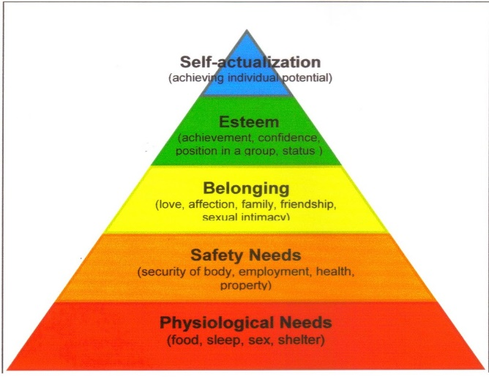
Children must have their basic needs met to develop and grow as an individual. Abram Maslow believed that children and young people needed their basic needs met in a specific order to reach their full potential, he portrayed this in a form of a pyramid with 5 different stages, the bottom 4 levels were deficiency needs and the top level were being needs. Basic needs were at the bottom of the pyramid and self-actualization was at the top. He believed that every need must be met before moving up a level on the pyramid and if one of these needs were not met then you could not reach self-actualization. Rajivvij (2014) page 5

This five-stage model can be divided into deficiency needs and growth needs. The first four levels are often referred to as deficiency needs (D-needs), and the top level is known as growth or being needs (B-needs). simply psychology (B) (2022).
It is important that practitioners and nurseries create a bond and trust with the children in their care as it will support their development and help them transition more comfortably. Birth to 5 matters(no date) suggests that children can feel vulnerable when they are going from an environment they know to an environment they are unfamiliar with, as they do not know if their needs will be met as they don’t know anyone and therefore there is no bond or trust. Every child is different therefore some may be resilient to transition, on the other hand, some children may be anxious and more vulnerable, and so it is important that every child feels confident that their needs will be met.

6

The role of the aduld/ practitioner
The role of any adult that is caring for a child is to provide their basic needs, provide a safe environment and prevent harm, support their development and help them reach their full potential, and always put the child first.
Parents/ guardian
Parents know their child better than anyone and therefore it is important that they give the correct information to nurseries. Some nurseries provide all about me’s which are a great way for practitioners to know what a child enjoys and doesn’t enjoy, but for this to be effective it is important that the parent gives the correct information. This can help support the child through their transition as the nursery can create a more customized Itransition for the individual. it is also important that the parent works in partnership with the nursery to overcome any obstacles that may occur during their transition.
Key worker
The role of the key worker is to create a bond and positive relationship with their key children and to ensure their needs are being met. Having a key worker can help support a child transitioning as they will be with the child often and this creates familiarity and a healthy attachment, the practitioner will also get to know the child more and know what they enjoy and don’t enjoy, and they will know what skills the child has and therefore create activities to support their development.
It is important that practitioners in the early years:
- Welcome every family and child, and treat them equally
- Provide a stimulating environment
- Create challenges for every child to support their development for example if a child is more or less advanced it is important to change the activity/experience, if possible, as a child can not learn or develop new skills if it is too easy or too difficult.
- Provide feedback to parents/ carers on the child’s development and how they are doing
Beaconnursery (2021).
7
Overall key workers play an essential role in transitions for children as they can support a child through creating a bond and an attachment and being someone the child can rely on for support.
The importance of partnership and communication
Effective communication and partnership are extremally important in any job but it is especially important in childcare as it is important that all workers and adults work in a holistic way to support all aspects of development in children and that they all work toward the same goal. In a nursery, the main adults that would be working in partnership would be the family of the child, key worker, manager and professional workers.
This diagram shows some of the people nurseries may work in partnership with: slideshare (2017)
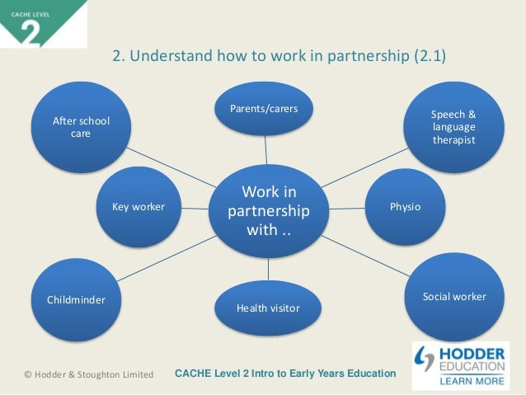
Here are a few examples of partnerships in a nursery:
Partnership and communication between the nursery and parents
It is important that nurseries and settings work in partnership with parents, as parents and carers know the most about their child and they know the information the nursery may need such as allergies, fears, likes, and dislikes. It is important that practitioners communicate how the child is for example what they’ve eaten, activities, sleep, any accidents and general development as this will allow nurseries and carers to learn how to improve their development, for example, a child may not wish to participate in the activities a practitioner sets up but perhaps after good communication, they could adapt the activity to include something the child likes.
8

Partnership between manager and key worker
The partnership between the manager and key worker is extremally important as the manager is the person who manages everything and informs the key worker what their job role is and what is expected of them. It is important that the key worker feels comfortable going to the manager about any concern. It is important that the settings manager and key worker work in partnership to create a plan to help support the development of every child. And it is extremally important because if a key worker suspects there’s a safeguarding issue concerning a child then they must communicate it effectively to their manager to ensure something is done to prevent this.
Partnership between the nursery and professional workers
It is extremally important that key workers and professional workers communicate effectively to ensure that they are working in a holistic way and that they are getting the right professional worker to support the childs needs.

9

Importance of the environment
It is important to have a multicultural environment for example have a book with prayers, different races of dolls, and books that are diverse. This will make every child feel that they belong and fit in.
In a child’s environment, it is important that it supports the child’s development in every aspect. An effective environment can help support a child’s independence, fine motor and gross motor skills, confidence, language etc.
It is important that a child has access to play as this is how they learn about the world and develop. Play is when a child has access to physical and mental activities that they do to enjoy. This can be with others or on their own. It is extremely important that settings give children access to play as it is the main way a child learns and develops.
To support a child transitioning it is important to have a structured routine because the child will know what to expect, if a child knows what to expect this can help reduce anxiety and stress.
Verywellmind (2022) quotes
Vygotsky's Theory
- Social factors influence the development
- Development can differ between cultures
Piaget's Theory
- Childhood interactions and explorations influence the development
- Development is largely universal
Therefore in conclusion Piaget and vygotskys theories help support children because their environment and the people they are aroud plays a crucial role in their learning and development.

10
Interventions to support children going through transitions
Oxford languages (2022) intervention- the action or process of intervening.
There are many interventions and things settings that can put into place. Here are some examples:
Settling in sessions- settling in sessions are where a child goes to a nursery for a couple of hours a day, so that a key worker can get to know the child and parent and for the child to get used to the environment and routine, every setting is different but usually this is done for a few days. This method also supports john bowlbys attachment theory as the child has time to create an attachment to their key worker.
All about me forms- all about me forms are where a parent or carer fills out a form saying the childrens dislikes, likes and important information that the nursery needs to know, such as allergies, sleep time, milk times and more. This helps a child transition as the nursery staff know what things they enjoy and therefor can bring these into the routine to help make the child more relaxed and comfortable.
Going to a quiet place- a nursery setting can be busy, loud and overwhelming for children who are starting in nursery. A good way to support a child is to take them somewhere quiet and go down to their level as a child could find it intimidating if you are towering over them, and once they’ve started to adjust not being with their parents/carers then you can slowly start introducing them into the busy environment.
Bringing a comforter or toy from home- a comforter like a teddy, dummy or toy can help a child feel like they are not alone as they have something that is familiar to them and that links to home.

11
Proposed outcomes
Every child is different and unique therefore it is important to remember that they will all react differently when experiencing a transition and the outcomes could be different. It is a practitioner’s job to help and support every child and treat them all equally, giving them all equal support. This does not mean that every child would be treated the same as every child is unique and therefore some children may be more comfortable and confident and therefore may not need as much support whereas some other children may need a lot of support.
References
Oxford languages (2022) [website] available at: intervention meaning - Search (bing.com) access date 1st December 2022.
Oxford languages (2022) [website] available at: intervention meaning - Search (bing.com) access date; 4th December 2022.
Twinkle. (2022) Different types of transition in child development. [website] available at: Different Types of Transitions in Child Development - Twinkl access date: 3rd December 2022.
Simply psychology. (A) (2022) Maslow’s hierarchy of needs. [website] available at: Maslow's Hierarchy of Needs - Simply Psychology access date: 2nd December 2022.
Birth to 5 matters. (no date) transitions. [website] available at: Transitions – Birth To 5 Matters access date: 2nd December 2022.
Simply psychology. (B) (2022) what is attachment theory? [website] available at: Attachment Theory: Bowlby and Ainsworth's Theory Explained (simplypsychology.org) access date: 4th December 2022.
Beaconnursery. (2021) key person policy. [website] available at: Key Person Policy – The Beacon Nursery access date: 2nd December 2022.
Verywellmind. (2022) what is sociocultural theory? [website] available at: Sociocultural Theory: Understanding Vygotsky's Theory (verywellmind.com) access date: 3rd December 2022.
Vectorstock (2017) Caucasian boy growing stages with in royalty vectorstock. [online] available at: Baby Growing Up Cartoon - Bing access date: 3rd December 2022. 12
Rajvvij (2014) Maslow need hierarchy theory. [online] available at: maslow's hierarchy of needs - Bing access date:2nd December 2022.
Slideshare (2017) unit 5 session 1-14. [online] available at: who has to work in partnership in a nursery diagram - Bing access date: 3rd December 2022.

13

