University of Wales Trinity Saint David

International Business Communications (LCBB6001)

Assessment 1 – OCTOBER 2022

Student’s Name: Mr. Radoslav Bozhkov
Student Number: 2010794

Professor’s Name: Mr. Husam Alharahsheh

Table of Contents
Introduction 3
A brief Introduction to Indonesia 4
Application of theories of international and intercultural communication 6
Critical evaluation of cultural sensitivity when doing business in Indonesia 8
Importance of networking – research into the relative importance of languages including the extent to which the language of the buyer should be used 10
Discussion and analysation of different communication barriers 11
Appropriate communication strategies and other relevant recommendations 12
Conclusion 13
Reference List 14

Introduction
From a certain aspect, international business communication takes place among different countries and across different cultures, affecting the business landscapes. In the current time, internationalisation can be referred to as a mega trend and many organisations are trying to venture into different developing countries other than their native ones. According to the aspects of internationalisation, business communication has great importance and influence on organisational performance along with the upliftment of the employees (Kalogiannidis and Papaevangelou, 2020). Communication truly has a major consideration and based on this any organisation which is trying to move across the international border can gain satisfaction and enhanced progression.
Here in this task, Indonesia will be the chosen developing country and first of all a brief introduction about Indonesia will be given along with theories of international communication within the chosen organisation. The cultural sensitivity will be further critically evaluated along with giving an insight into the importance of networking. Lastly, different communication barriers will be discussed along with preferable communication strategies and recommendations for betterment. The chosen organisation for this task will be Graze which is a UK-based healthy snack manufacturing organisation, having headquartered in Greater London, UK. Nature Delivered Limited, trading under Graze distributes healthy snack boxes within the UK and has generated net revenue of about 37.4 million British pounds in the fiscal year 2020 (statista.com, 2022).

A brief Introduction to Indonesia
It has to be mentioned that Indonesia is the largest economy and rapidly developing country in Southeast Asia and considering the population, it remains in the fourth position within the world. Being a progressive country, Indonesia recently has acquired some disturbances in the socioeconomic perspective. After the Global surge of Covid-19 growth has been disrupted and a certain recession has been encountered by the country (oecd.org, 2022). Within the country, there is an immense opportunity for spreading any business as within this country the basic attributes such as agriculture, economy, education, environment, government, jobs and society. Through these the operation can be efficient along with technological advancement and innovative approaches for predictable upliftment.
For any organisation, trying to venture into Indonesia, scopes of success are over there as this is the 10th largest economy within the whole world along with a good range of purchasing power parity. Over the last few years, they grow in a gradual manner reducing the poverty effectively as the economic planning also has been done up to the financial year 2025 (worldbank.org, 2020). For a sustainable progression, the country is chiefly focused on strengthening competitiveness and resilience, enhancing the infrastructure capacity and improving the capabilities of the human workforce. Inflation is also reducing conditions in the current time within this country as reported, in November 2022, it remained at 5.42% from October’s 5.71% (tradingeconomics.com, 2022).
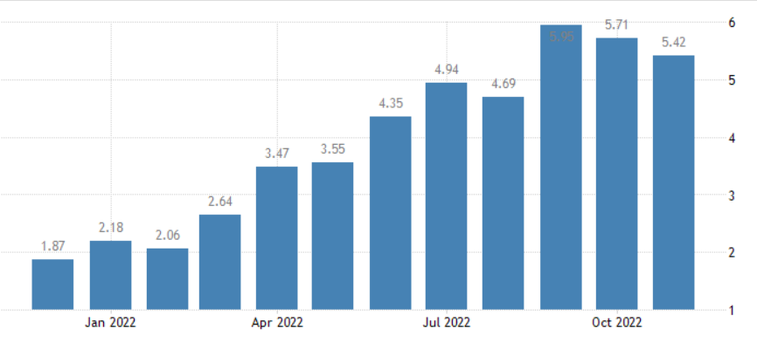
Figure 01: Inflation rate of Indonesia
(Source: tradingeconomics.com, 2022)
To venture into Indonesia, any organisation has to be focused on household income considering all the external factors. According to the report of 2021, the average household income remained at 587.69 British pounds and in December 2021, this measurement reached 870 British pounds (ceicdata.com, 2021).
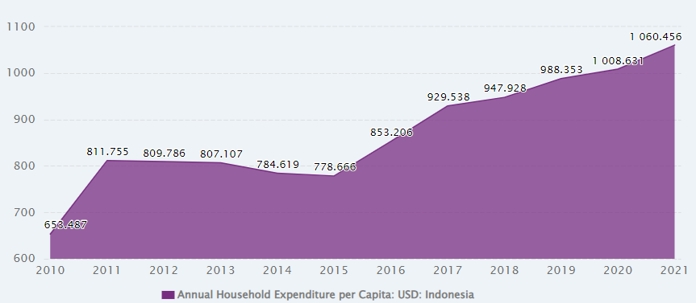
Figure 02: Annual Household Expenditure of Indonesia
(Source: ceicdata.com, 2021)

Application of theories of international and intercultural communication
Within different countries, cultures are the major barrier in order to exploring the business market and on that note, the concept of intercultural communication emerged by certain means. To be more specific, for any business organisation, intercultural communication and international cultural competence play a major role in pursuing the desire for internationalisation outside their own world (Makhmudov, 2019). There are many cultural attributes that must be considered within the Indonesian context such as personal relationship and harmony as they believe that harmonious relationship is the key to business success. Furthermore, Indonesian business culture relies on hierarchical succession and leadership is based on a paternalistic approach. In order to compare the Indonesian cultural aspects with the United Kingdom, Hofstede’s cultural dimensions are the most effective.
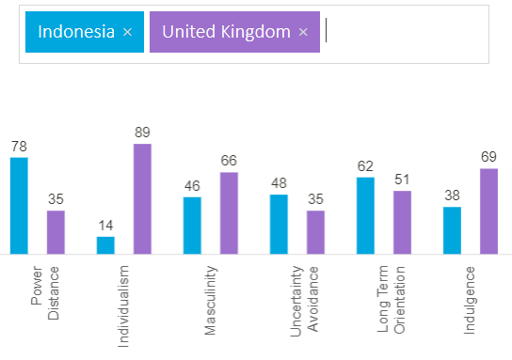
Figure 03: Culture comparison between UK and Indonesia
(Source: hofstede-insights.com, 2022)
From the above analysis, it is clear from different perspectives, cultural attributes differ from the Indonesian aspect to the UK context. As mentioned earlier Indonesia is based on hierarchical power as the graph of power distance took a sharp incline with the score of 78. Apart from this, Indonesia and UK, scoring 14 and 89 respectively. Highly differ in the context of individualism as according to the above statistics, Indonesia prefers teamwork over an individual approach as within this country innovation is highly acknowledged. In order to mention masculinity, Indonesia is almost gender-neutral as the score of 46 implies but the UK business environment is more masculine-oriented scoring around 66 (hofstede-insights.com, 2022). For the organisation Graze, one certain opportunity is uncertainty avoidance as Indonesia scores better than the UK in this regard, 48 and 35 respectively. Also, opportunities can be obtained from the long-term orientation also as Indonesia is majorly focused on sustainability and long-lasting it scores about 68 in statistical analysis. Lastly, Indonesia is a relatively less indulgent country than the United Kingdom, based on the respective score of 38 and 69 and it is clear that the Indonesian people are less likely to acquire their own willingness to their impulses.

Critical evaluation of cultural sensitivity when doing business in Indonesia
From a certain aspect, cultural sensitivity is a major concern for every organisation, trying to spread their business within any developing country or others. To define this, it can be said that cultural sensitivity includes a good range of awareness of the different organisations about their own cultural attributes and the differences in cultural attributes along with similarities when comparing with another country or any other business environment (hamidzay, 2018). Cultural sensitivity better amplifies the concept of gathering knowledge and understanding different cultural and sub-cultural insights for better interaction among people of different cultures. This certainly helps any business organisation to create a better relationship which can be significant for the upliftment of the business progression.
In order to do business within the Indonesian Cultural attributes and related practices, the snack-producing organisation, Graze has to consider a lot of factors. Within the UK, Graze is chiefly focused on customer service and their eventual satisfaction to grow within the business environment. The focus relies on the health, taste buds and convenience of the consumers of Graze and apart from this the sustainable approach considering the cultural aspects, Graze takes a lot of responsibility to better contribute to the environment. All the packaging of this organisation is recyclable and they aimed to develop 95% of their packaging to be recyclable by the year 2023 (graze.com, 2022). By the year 2030, they are also assumed to be coming up with zero carbon efficiency. For better health concerns, the organisation made all its production of them 1000% vegan without any use of artificial colours and flavours.
Besides, in order to give an insight into the cultural sensitivity of the developing country, Indonesia, the business landscape is highly hierarchical in nature. Most people, based on the western culture, are individualistic and social activities and teamwork are certainly recommended for this developing nation (indonesia-investments.com, 2022). Considering the business strategies, they are more focused on building relationships by an individual approach to develop a harmonious relationship. Within Indonesia, there are a lot of cultural groups based on the definite location such as Sundanese from West Java, Javanese from central and east Java, Lesser Sundaes and Balinese from the islands of Bali and Madurese from Madura and East java. In this regard, religion plays a major role within Indonesian society and in this issue, ethics, Morales along with all the cultural perceptions influence Indonesian cognition (indonesia-investments.com, 2022).
The main opportunity for this organisation while establishing its business within the Indonesian culture is the Indonesian people’s passion for healthy food. After the global Covid surge, the Indonesian government has taken a lot of measures to refurbish social protections along with uplifting agricultural equipment which includes plant protection devices and fertilisers (thestar.com.my, 2022). Being a producer of vegan product certainly help Graze when operating from Indonesia. However, on the other hand, there are also some cultural barriers which can disrupt the business orientation of Graze. Indonesia has a lack of entrepreneurial mindset in a lot of parts of the nation which is actually critical for growing the national economy. Almost the majority of Indonesian people are financially incompetent which is a major reason for the maximum failure of businesses as financial skills are basic skills of any business success. In March 2020, market stress was at its highest point and the eventual foreign currency debt is certainly a high risk for the financial stability of the country along with all the foreign invaders (oecd.org, 2021).

Importance of networking – research into the relative importance of languages including the extent to which the language of the buyer should be used
From the organisational perspective, Networking is the process of getting more customers on board and acquiring prospective leads for the business progress. In the context of internationalisation and exploring different cultures and markets, networking has an immense impact on gaining a better brand reputation, increasing visibility and long-term orientation. A stronger support network can certainly uplift business growth adding more effective and efficient business connections. In order to venture into the Indonesian market, Graze from the UK has to rely on language variation for developing a harmonious relationship through communication. The leadership and management have to gain communication and language skills to overcome all the barriers to communication empowering people for gaining religious-like values in communication (Darics, 2020).
In today’s world of globalisation and for many organisations it becomes a prior need and to accomplish this need language and translation have acquired immense importance for obtaining business success. By targeting a large number of people of different cultural backgrounds and of different language preferences within the Indonesian business market, the language ability of Graze can attain more exposure developing more awareness of their brand within the broad range of Indonesian culture. Also, the translation ability is supposed to gain better receptiveness, which will encourage the buyers to be more attached to Graze. From a certain aspect, gaining the skill to be coped with a different culture can certainly enhance the understanding of different cultures of definite social groups (globalmarketingprofessor.com, 2022).
The knowledge of languages can certainly come up with many advantages as languages help any organisation to improve their decision-making capabilities for any unavoidable circumstances in a foreign land. Furthermore, it can reduce communication errors and any organisation with partners in a foreign country can plan better for a progressive outcome (scottish-enterprise.com, 2022). Lastly, organisations such as Graze have to set a target audience and market segment to gain competitive advantages. Languages can certainly reinforce this issue. On the other hand, if the skill is not acquired, language can be a huge barrier and certainly detrimental as different language backgrounds can create a huge miscommunication and reduce the internationalisation potential (Soni, 2022). Also, buyers and potential employees will be less likely to be associated with a company such as Graze when they found the language barrier is performing within.

Discussion and analysation of different communication barriers
In the process of internationalisation and spreading businesses in foreign countries, communication may acquire different barriers which certainly disrupt the organisational fluency and effectiveness of the efficiency of the human workforce. For enhancing organisation growth, within any country, communication is important as this involves the effort of the employees for creating a common ground of understanding (Papandreou and Dragouni, 2022). A few major communication barriers are mentioned below,
Language differences: This happens when two or more people work on a common task and communicate in different languages based on their brought-up backgrounds. In this regard, any foreign business can attain a huge breakdown in the organisation’s efficiency in a different country.
Cultural differences: This kind of communication barrier often creates a good range of disturbance in business practices. When two or more people within a team work collaboratively but there is a huge gap in communication due to the cultural background.
The difference in communication style: there are four common types of communication styles such as passive, assertive, aggressive and lastly passive-aggressive. Certainly, every individual has their own kind of communication style (online.alvernia.edu, 2018). Two people working together with different communication styles can affect the final outcome due to a lack of effective communication.
For the organisation Graze when spreading their business in Indonesia from its native UK, it has to mention that from the year 2013, The ministry of manpower in the Indonesian government ruled that every foreign business has to acquire an understanding of the Indonesian language to communicate with each other (Surianta, 2020). Furthermore, within Indonesia, Due to the Covid-19 surge, health hazards came up with huge hazards and resulted in some reduction in the national income due to the recovery of the disease. Different cultures saw this in different perceptions and this affected their behavioural aspects and eventual effectiveness. Due to this economic breakdown, many businesses are shut down reducing national income further, and making living more difficult (Suciska and Nurdin, 2022). Technologically also, Indonesia faces a huge gap from the rest of the world. Legal and monetary barriers to technological advancement and uplifting the digital capacity can affect any organisation, trying to invade the Indonesian business environment.

Appropriate communication strategies and other relevant recommendations
In order to be globalised, organisations must acquire some communication strategy to better impact the working condition, getting rid of all the communication barriers. Graze UK must attain some capabilities to evaluate themselves along with the cultural and behavioural attributes of the foreign country, here Indonesia. They also should be focused on the particular mode of communication and how the people interact and work together within the nation. The next major concern should be the empowerment of the employees with the awareness of different barriers and effective strategies to overcome those. To be effective communication, one-to-one interaction and personal specification are most important. All leaders and managers are supposed to deliver specific and effective instructions to all the workers which further must be clear. The organisation along with the human workforce must acquire an innovative and open mind to attain every challenge as the scope of progress. Furthermore, achievement, reward and recognition can motivate people for betterment.
In the Indonesian context, to get rid of the language barrier it is recommended for any organisation they should gain knowledge and use certain communicable and plain language to interact. They also can take help from reliable translation services which on the other hand can be cost-effective. Visual methods of communication are another option to explain people’s complex concepts (harryclarktranslation.co.nz, 2022). Further, by being respectful and loyal towards the cultural aspects of the foreign country, any organisation can overcome both the cultural and language backdrops in the context of Indonesia.

Conclusion
In the current days, internationalisation and exploring different developing countries are a prior concern for any organisation. The most important things to consider are the cultural aspects and intercultural communication which can certainly uplift any organisation’s exposure and brand image, enhancing the progression of business in any business land. In order to venture into the Indonesian market, any organisation has to be aware of its cultural sensitivity and practices to be proactive within the nation. Networking and skills to overcome the language barrier have further importance for any organisation, here Graze, for gaining more buyers along with more intense competitive advantages. Any foreign business also encounters a lot of communication barriers from which they have to come out with definite and effective communication strategies. Certainly, apart from all these factors, international and intercultural communication can certainly enhance knowledge, empathy, resilience, open-mindedness and other organisational capabilities for better esteem and performance.

Reference List
ceicdata.com, 2021. Indonesia Household Expenditure per Capita [Online] Available at: https://www.ceicdata.com/en/indicator/indonesia/annual-household-expenditure-per-capita#:~:text=Indonesia%20Annual%20Household%20Expenditure%20per%20Capita%20data%20is%20updated%20yearly,170.291%20USD%20in%20Dec%202001 [Accessed 16 December 2022]
Darics, E., 2020. E-leadership or “how to be boss in instant messaging?” The role of nonverbal communication. International Journal of Business Communication, 57(1), pp.3-29.
globalmarketingprofessor.com, 2022. The Importance of Language in International Market Communication [Online] Available at: https://globalmarketingprofessor.com/the-importance-of-language-in-international-market-communication/ [Accessed 16 December 2022]
graze.com, 2022. graze impact report 2021 [Online] Available at: https://www.graze.com/uk/about/sustainability [Accessed 16 December 2022]
Hamidzay, A., 2018. What is Cultural Sensitivity? [Online] Available at: https://www.linkedin.com/pulse/what-cultural-sensitivity-abdulmarof-hamidzay [Accessed 16 December 2022]
harryclarktranslation.co.nz, 2022. 7 Tips on How to Overcome Language Barriers [Online] Available at: https://harryclarktranslation.co.nz/7-tips-overcome-language-barriers/ [Accessed 16 December 2022]
hofstede-insights.com, 2022. COUNTRY COMPARISON [Online] Available at: https://www.hofstede-insights.com/country-comparison/the-uk/ [Accessed 16 December 2022]
Kalogiannidis, S. and Papaevangelou, O., 2020. Impact of Business Communication on the Performance of Adult Trainees. International Journal of Academic Research in Progressive Education and Development, 9(3), pp.213-222.
Makhmudov, K., 2020. Ways of forming intercultural communication in foreign language teaching. Science and Education, 1(4), pp.84-89.
oecd.org, 2021. OECD Economic Surveys [Online] Available at: https://www.oecd.org/economy/surveys/indonesia-2021-OECD-economic-survey-overview.pdf [Accessed 16 December 2022]
oecd.org, 2022. Indonesia [Online] Available at: https://www.oecd.org/indonesia/ [Accessed 16 December 2022]
online.alvernia.edu, 2018. 4 Types of Communication Styles [Online] Available at: https://online.alvernia.edu/articles/4-types-communication-styles/#:~:text=Every%20person%20has%20a%20unique,and%20why%20individuals%20use%20them [Accessed 16 December 2022]
Papandreou, M. and Dragouni, K.E., 2022. “He will see my drawing and we will play blindman’s bluff together” Overcoming communication barriers in a multicultural kindergarten classroom. Journal of Early Childhood Education Research, 11(1), pp.272-296.
scottish-enterprise.com, 2022. Benefits of learning a language in international business [Online] Available at: https://www.scottish-enterprise.com/learning-zone/success-stories-and-case-studies/components-folder/success-stories-listing/benefits-of-language-skills-in-international-business [Accessed 16 December 2022]
Soni, N., 2022. How Are Language Barriers Affecting Your International Business? [Online] Available at: https://www.linkedin.com/pulse/how-language-barriers-affecting-your-international-business-soni#:~:text=International%20language%20barriers%20can%20pose,threaten%20their%20business%20plans%20abroad [Accessed 16 December 2022]
statista.com, 2022. Revenue of Nature Delivered Limited in the United Kingdom (UK) from financial year 2012 to 2020* [Online] Available at: https://www.statista.com/statistics/873734/nature-delivered-limited-revenue-united-kingdom-uk/ [Accessed 16 December 2022]
Suciska, W. and Nurdin, B.V., 2022. Covid-19 health communication barriers in multicultural communities in Indonesia. Jurnal Studi Komunikasi, 6(3), pp.827-840.
Surianta, A., 2020. Language barriers blocking business in Indonesia [Online] Available at: https://www.eastasiaforum.org/2020/08/22/language-barriers-blocking-business-in-indonesia/ [Accessed 16 December 2022]
thestar.com.my, 2022. Safeguarding Indonesia’s food resilience [Online] Available at: https://www.thestar.com.my/news/focus/2022/06/19/safeguarding-indonesias-food-resilience [Accessed 16 December 2022]
tradingeconomics.com, 2022. Indonesia Inflation Rate [Online] Available at: https://tradingeconomics.com/indonesia/inflation-cpi#:~:text=Inflation%20Rate%20in%20Indonesia%20averaged,percent%20in%20March%20of%202000 [Accessed 16 December 2022]
worldbank.org, 2020. Overview [Online] Available at: https://www.worldbank.org/en/country/indonesia/overview#2 [Accessed 16 December 2022]

