Postgraduate/Distance Learning
Assignment coversheet & feedback form

THIS SHEET MUST BE THE FIRST PAGE OF THE ASSIGNMENT YOU ARE SUBMITTING (DO NOT SEND AS A SEPARATE FILE)

For completion by the student:
Student Name: Clarissa Jane Fowler

Student University Email: 2310967@student.uwtsd.ac.uk
Module code: HPCA7028  Module title: Sacred Skies | Student ID number:  2310967 |  |  | Educational support needs:  Yes/No
Assignment title: A Critical Examination of the Sky in Relation to Material Culture

Assignment due date: 01/05/2025
This assignment is for the 1st 2nd 3rd 4th 5th 6th module of the degree
I confirm that this is my original work and that I have adhered to the University policy on plagiarism.
Signed ………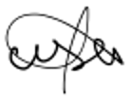……………………………………………………
Email submission:if you are submitting this form via email, please tick this box □
(as a substitute for your signature) to confirm that you agree to the above declaration.
Assignment Mark
1st Marker’s Provisional mark
2nd Marker’s/Moderator’s provisional mark
External Examiner’s mark (if relevant)
Final Mark

NB. All marks are provisional until confirmed by the Final Examination Board.

For completion by Marker 1 :
Comments:

Marker’s signature: |  |  | Date:
For completion by Marker 2/Moderator:

Comments:

Marker’s Signature: |  | Date:
External Examiner’s comments (if relevant)

External Examiner’s Signature: |  | Date:

MA CAA Sacred Skies Essay 2 draft 5
This essay will critically examine the cultural expression of the sky in the following two examples of two-dimensional structures: Vincent Van Gogh’s ‘Starry Night’, with NASA’s ‘Cosmic Cliffs’ image of the Carina Nebula.
Word count: 4713

Introduction

This essay will critically examine the cultural expression of the sky by comparing two, two-dimensional representations: Vincent Van Gogh's painting The Starry Night (1889), and the contemporary scientific image Cosmic Cliffs, of within the Carina Nebula, captured by NASA's James Webb Space Telescope (JWST) and released in 2022. The objective of this research is to comparatively analyse them, considering who created them, when, how, and for what purposes, exploring similarities and differences in their expressions of the cosmos, to understand what they reveal about the sky from the perspective of the cultures in which they emerged. The chosen case studies were selected to explore how cultural perceptions and representations of the sky have significantly shifted alongside science and technology. This research looks at the transition of primarily individual, emotionally driven artistic interpretations characteristic of the late 19th century to collective, scientifically informed, and technologically mediated expressions of the 21st century, exploring evolving societal values, epistemological frameworks, and capabilities in engaging with the cosmos. This cultural astronomical study focuses on ethnoastronomy, using ethnographic and anthropological viewpoints, dealing with practices relating to, and representations of, the sky of different human societies and their processes of construction and change. Understanding the ‘cultural expression’ of the sky involves examining the manifestation of a group's beliefs and values and how each ‘representation’, or portrayal, engages with the celestial subject matter. The concept of ‘skyscape’, which emphasises the relationship between the sky and worldview beyond purely astronomical data, is a framework for this analysis, as scholars like Silva and Campion highlight, considering the ‘skyscape’ is crucial for understanding past societies. This research extends that consideration to both artistic and scientific modern contexts. It is important to note that "Culture' is said to be one of the two or three most complex words in the English language, justifying a nuanced exploration of how it is expressed through these celestial representations. Furthermore, different cultures might have access to the same sky but ‘see’ completely different skyscapes. This essay will first contextualise Van Gogh's The Starry Night and JWST's Cosmic Cliffs. Following these contextual analyses, the research will then complete a comparative analysis to explore themes of representation versus reality, the role of the creator, historical context, and the human-cosmos relationship. Ultimately, the aim is to highlight how the celestial realm is perceived, interpreted, and imbued with meaning across different cultural contexts, grappling with the question posed by Tim Ingold, “What is the sky?”.

Contextualising Case Study 1: The Starry Night
The 1889 painting Starry Night by the post-impressionist pioneer Vincent Van Gogh has been widely debated, raising an array of themes, including the relationship between the mind and the cosmos, which this research will focus on. Created with oil on canvas, measuring 73.7×92.1 cm, it was "inspired by the view from his window at the Saint-Paul-de-Mausole asylum in Saint-Remy, in southern France, where the artist spent twelve months in 1889-1890 seeking reprieve from his mental illnesses". This Modernist period (mid-nineteenth to mid-twentieth centuries) was an era defined by rapid socio-economic, cultural, and technological change, opening up artistic freedom, often drawing distorted inspiration from perceived reality. This idea of transformation aligns with Terry Eagleton's view that the concept of 'culture' charts ‘humanity's own historic shift from rural to urban existence', which is encapsulated in Van Gogh's work.
The Starry Night is not merely an observation but a subjective interpretation of the sky, presenting the sky as not stationary but an animated entity. Van Gogh achieves this through his painting and brushwork, which is dominated by a vortex of deep blues, swirling currents of lighter blues and white, with thick impasto style paint. This visible texture gives it a more tangible feel. It reflects his tumultuous feelings coming to the surface, aligning with the Post-Impressionist objective of using colour and form to express subjective feelings and the artist's inner reality. As Fabio Silva observes, "Van Gogh's skyscape is as realistic as it is filtered by the perceptual lens of the artist..." highlighting that visual representations of the sky are inherently culturally constructed and imbued with personal meaning. While grounded in observation, Van Gogh translated his view from his asylum window into a personal skyscape. The village, featuring a prominent church spire, is fictionalised, and the cypress tree is repositioned, blending observation, memory, and imagination, not just documenting his view or mental state but actively constructing a symbolic skyscape that showed his internal world and his felt relationship with the cosmos. This practice shows how art functions as ‘non-textual documents’ and ‘primary source’ material that provides visual information about cultural worldviews, specifically perceptions of the sky. As Gunzburg suggests, images "can and should also influence how we understand a period or culture"; Van Gogh's Starry Night powerfully serves this purpose by revealing a cultural perception of the sky deeply intertwined with individual subjective experience and the turbulence of modernity. The painting resonates because it "both resonates with our experience of what it feels like to be under the stars and affords us the means to dwell upon it", inviting the viewer into Van Gogh's intensely personal, "star-struck" vision.
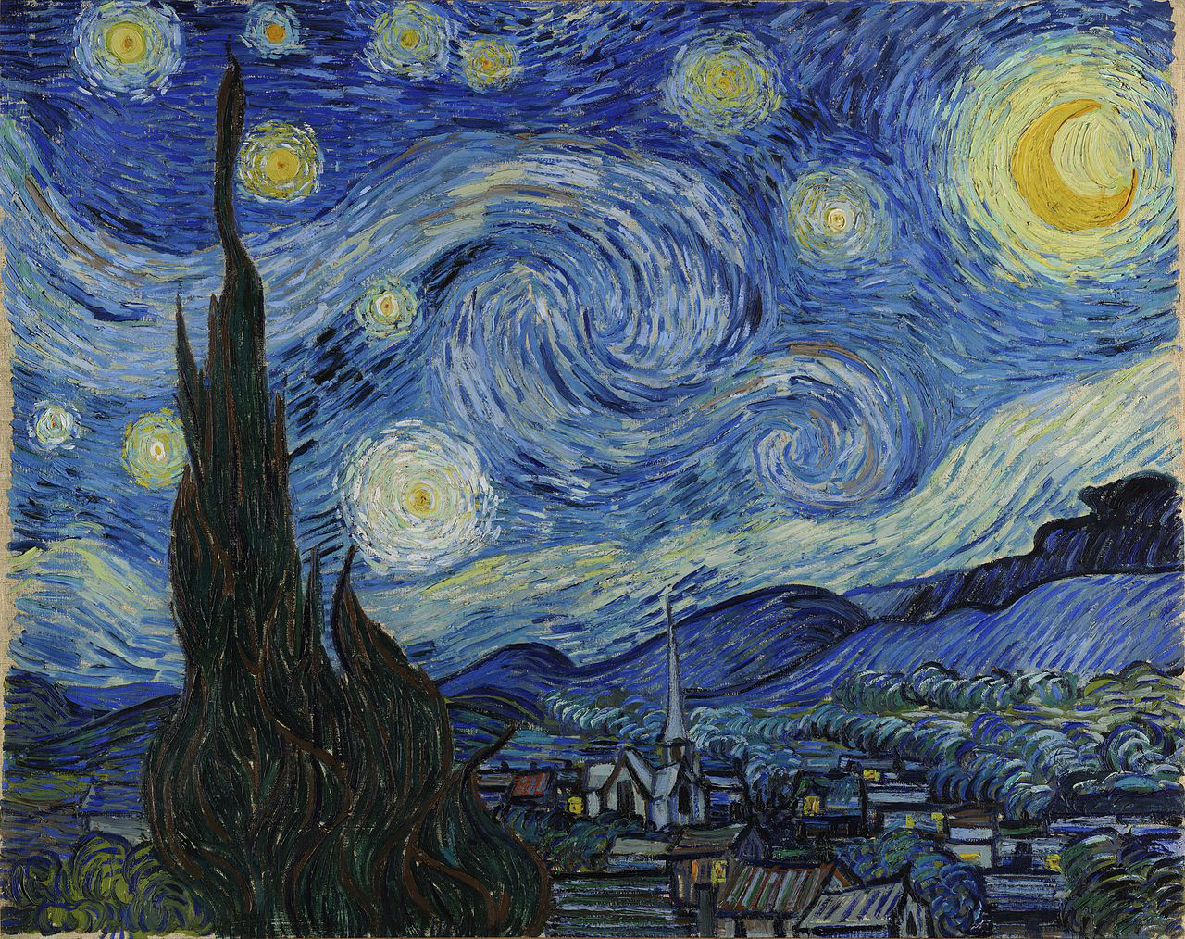
Figure 1. Vincent van Gogh (1853-1890), The Starry Night, 1889, Oil on canvas, 73.7×92.1 cm, Museum of Modern Art, New York. Image: [Source of your image file, e.g., MoMA].

Contextualising Case Study 2: the 'Cosmic Cliffs'
The Cosmic Cliffs image (Fig. 2), released to the public on July 12th, 2022, has a very different but equally culturally revealing representation of the sky. Showing a region within the larger Carina Nebula, approximately 7,600 light-years away, Cosmic Cliffs shows mountain-like swirls with an incredible starry backdrop. The dominant features are towering 'cliffs' and pillars of hot ionised gas and dust, sculpted by radiation from young stars, indicative of active star birth processes. The Cosmic Cliffs image is a product of sophisticated technological reconstruction from the James Webb Space Telescope's (JWST), grounded in empirical measurement, with the infrared capabilities revealing phenomena previously obscured. However, the beautiful colour palette is a created representation and a necessary translation of invisible infrared wavelengths detected by instruments like NIRCam and MIRI into visible colours. This technique is known as representative colour and requires deliberate choices in data processing; this aestheticisation can have significant cultural implications. While arguably making "utterly alien phenomena more accessible and relatable" by borrowing landscape aesthetics and assigning specific colours, the transformed visualisation potentially anthropomorphises the sky. It presents a specific, curated view of reality; Zotti notes, such over-elaborate reconstructions, although valuable for public presentation, this can sometimes be critically viewed as leaning towards "fantasy best used for tourists" rather than purely 'scientific' documents, highlighting how even representations from empirical data are subject to human interpretation and cultural framing, shaping perception rather than simply reflecting an unmediated reality.
There are a few intentions behind the Cosmic Cliffs, reflecting the nature of 'Big Science' in the 21st century. Scientifically, the main goal was specific data acquisition to study star birth processes. Technologically, the image is a demonstration of JWST's cutting-edge capabilities. Culturally, its release was strategically aimed at engaging a global public, communicating the wonder of discovery and justifying the public investment in the project. This echoes a long historical tradition: "State and/or royal funding has provided one of the most common means of support for astronomers in many cultures". Thanks to the modern world of media and internet access, the image had a rapid, widespread cultural impact, highlighting current contemporary interests in science, technology, and visually compelling content, showing how "popular culture reflects the interests, values, notions, themes, and sensibilities of mainstream culture".
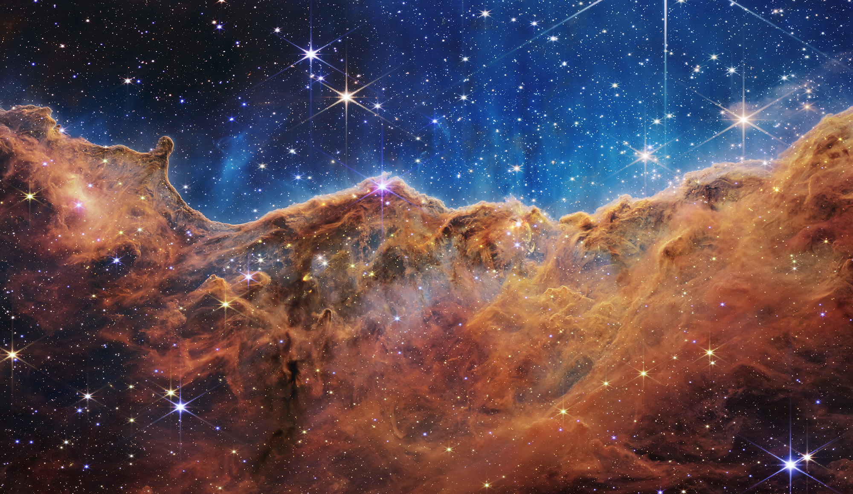
Figure 2. NASA, ESA, CSA, STScI, Cosmic Cliffs in the Carina Nebula (NIRCam Image), 2022, JWST NIRCam Image. Image: NASA, ESA, CSA, STScI.

Comparative Analysis:
This section undertakes a direct comparative analysis of Vincent van Gogh's The Starry Night (Fig. 1) and the JWST's Cosmic Cliffs (Fig. 2) to explore what their similarities and differences reveal about the cultural expression of the sky in their respective eras. This analysis will examine four key themes: representation versus reality, the role of the creator, historical context, and the human-cosmos relationship. As a part of the lived-in, experienced, and socially constructed world, the concept of skyscapes serves as a framework, highlighting that cultural perceptions of the sky are vital in fulfilling one of humankind's most basic needs, to comprehend the universe we inhabit. The sky is a natural phenomenon turned into a cultural skyscape through human agency, and both images exemplify this process, albeit through vastly different cultural lenses and technological means. Knowing how other cultures might have 'access' to the same sky but 'see' completely different skyscapes is a core concept that underscores this comparative analysis.

Theme 1: Representation and Reality
Firstly, there is a notable difference between how the two images interpret and express reality, giving a glimpse into their epistemological and cultural foundations. Van Gogh's Starry Night painting is an artistic interpretation where subjective experience and symbolic meaning are at the forefront of the expression, trumping a naturalistic depiction. Although grounded in observing the view from his asylum window, the ‘Starry Night’ filtered this perceived reality, resulting in a sky that conveys an emotional rather than strictly physical truth. The ‘reality’ prioritised here is primarily internal and affective, mediated through artistic convention and individual psychology. As Fabio Silva notes how Van Gogh’s reality is ‘filtered’ through the lens of the artist, demonstrating that visual representations of the sky are not necessarily straightforward depictions of astronomical reality but are profoundly shaped by cultural and individual interpretation, imbued with layers of meaning beyond the literal, requiring informed approaches to their cultural analysis, as Ruggles highlights.
In contrast, the Cosmic Cliffs image is a scientific visualisation, with its claim to ‘reality' based on empirical measurement, translating non-visible infrared data into a visual format accessible to human perception. The primary objective of JWST was to acquire and communicate objective knowledge about physical processes, such as star formation, with such clarity. However, creating the Cosmic Cliffs image involved choices in processing the data and assigning visible colours to different infrared wavelengths, guided not simply by scientific criteria, but also by aesthetic considerations. As Zotti notes, a digital model is distinct from a raw "document"; it is a "reconstruction" involving interpretation, and the Cosmic Cliffs image functions precisely as such a reconstruction, translating data and making aesthetic choices (like borrowing landscape aesthetics as seen in Fig 2) that significantly shape the final visual form and, consequently, public perception. Zotti's concept of reconstruction proves particularly pertinent here, as the deliberate aestheticisation makes the infrared data visible and arguably creates a specific emotional response through familiar landscape tropes, demonstrating how scientific visualisation actively participates in cultural meaning-making beyond simple data transmission.
Overall, the images show drastically different cultural approaches in expressing the sky and their perception of ‘reality’ they uphold. The ‘Starry Night’ uses the visible world as a catalyst for subjective expression, prioritising an internal, felt reality even while drawing on empirical observation. Conversely, the Cosmic Cliffs translate invisible empirical data into a visual form intended to convey information about external physical reality, operating within the rigorous protocols of modern science yet remaining reliant on technological mediation, construction, and aestheticisation processes. Both images show how natural phenomena like the sky can be transformed into a cultural skyscape through human agency, reflecting disparate cultural contexts and priorities. While both engage with the cosmos, they embody contrasting ways of knowing and seeing: one filtered predominantly through individual artistic consciousness and the media culture of its time, the other mediated through complex technological systems and collective scientific processes operating on digital data, drastically shaping their forms, cultural functions, and how they position the viewer relative to the sky/universe.

Theme 2: The Creators and Intention
Looking at the creators and intentions behind the two images can reveal a lot about their cultural expressions of the sky. Van Gogh’s intense, tumultuous expression of the sky, could have been amplified by his mental state and stay at the asylum, showing a profoundly personal cultural expression of the sky, almost as if it just as much as much a sky observation as it is a confrontation of his inner world and relationship with the cosmos. The style of his work serves as a direct trace not just of the cultural context in which he lived, engaging with Post-Impressionist ideas, but also serves as a reflection of his psychological state at the time, with the painting's cultural authority primarily stemming posthumously.
On the other hand, the Cosmic Cliffs image is the product of a great international collaboration by the James Webb Space Telescope project, involving institutions like NASA, ESA, and CSA. This undertaking is characteristic of 'Big Science', where complex technological systems and large teams replace the single creator. And so, the image's authority comes not from individual cultural expression but from a collective cultural and scientific endeavour, not a product of psychology, but by complex technology and standardised protocols, the resulting image's smooth, detailed surface, with its ‘perfection’ or mastery lying in its more rigid technological precision rather than personal expressive psychology, showing a change in cultural priorities and ideals. The Cosmic Cliffs project had a broader range of intentions. Scientifically, it was to acquire specific data about star formation, technologically, to demonstrate the cutting-edge capabilities of the JWST, and culturally, to engage a global public, fostering awe and communicating discovery. Furthermore, this public engagement often carries the intention of justifying the immense public investment required for 'Big Science' projects, this public engagement role aligns with what John M. Steele describes as the historical 'symbolic' uses of astronomy, serving 'as a means to illustrate cosmic harmony and by providing the means for a ruler to demonstrate his power and enlightened governance through the patronage of scholars'. Unlike Van Gogh's work, which gained cultural influence organically over time, the visual impact and authority of the Cosmic Cliffs image were carefully managed for widespread, immediate circulation across global media platforms, targeting both specialists and the general public.
These images demonstrate a major cultural shift in how authoritative representations of the cosmos are created and legitimised. While Van Gogh's work reflects a late 19th-century belief in individual artistic genius as a channel for subjective truth, communicated through traditional media with influence developing over time, the JWST image represents an early 21st-century reliance on collective scientific enterprise and advanced technology to produce and strategically disseminate knowledge, achieving immediate global reach. In considering this shift, the creation of Cosmic Cliffs, as a product of extensive collaboration and shared goals, aligns more with sociologist Raymond Williams' idea (as discussed by Terry Eagleton) that culture is prevalent only when it is collectively made, contrasting with more individualistic notions of cultural production. Thus, while both images are products of human agency directed towards representing the cosmos, the nature of that agency, the driving intentions, their modes of mediation, and their relationship with perceived truth and audience differ significantly, reflecting the distinct cultural positions and values assigned to art and large-scale science in their respective eras.

Theme 3: Historical and Cultural Context
Cosmic Cliffs and Starry Night are distinctive representations of their cultural and historical backgrounds, showing their differences in worldviews, technological capabilities and the human-cosmos relationship, becoming cultural skyscapes. The late 19th century was an era of intense European social, technological, and scientific change. Industrialisation rapidly changed daily life and landscapes, while scientific advancements challenged traditional beliefs about the universe and humanity's place within it. Artistically, Post-Impressionism rose as a reaction against Impressionism's focus on objective visual perception. It hoped to gain emotional depth and symbolic meaning through subjective interpretation, a cultural impulse evident in Van Gogh's expressive use of colour and form. This period really grappled with the unsettling nature of modernity fast approaching. Van Gogh's sky could be interpreted as a reflection of this turbulence, perhaps retaining a sense of the Romantic sublime even as traditional frameworks for understanding the universe dissolve. As Terry Eagleton notes, the very word culture "charts within its semantic unfolding humanity's historical shift from rural to urban existence, pig-farming to Picasso, tilling the soil to splitting the atom", a trajectory that profoundly encompasses the period of Van Gogh's work and its engagement with a changing world.
Just as Starry Night can be signposted within its culture, Cosmic Cliffs is undeniably a product of the early 21st century, an era of globalisation, majorly advanced technology, and a dominance of 'Big Science'. In the case study of Cosmic Cliffs, the image’s reliance on modern technology seems central to its cultural meaning, with technology not merely as a tool but a key part in the representation. Applying Eagleton's broad idea of culture as shared values and practices, the JWST image embodies contemporary Western values placed on empirical scientific knowledge, technological achievement, and global collaboration, distributed instantly by digital networks. While The Starry Night reflects a cultural moment turning towards subjective feeling to interpret the universe amidst external change, the Cosmic Cliffs image demonstrates a culture that primarily seeks to understand the cosmos through technologically mediated observation and data analysis, constructing its 'skyscape' through scientific visualisation.
Moreover, politics (insert quote about politics and culture from Terry Eagleton) has also had a complex relationship with astronomy and how their culture expresses and experiences the sky. For Van Gogh, the 'politics' might have been more personal or local, tied to his circumstances in the asylum and the art market of the time. For the JWST and collaborators, the political dimension is inherent in the massive state and international funding required, influencing priorities and the need for public justification, and considering William Stoeger's hypothesis, as presented by Terry Eagleton in ‘The Idea of Culture’, regarding astronomy's potential 'integrating impact on culture' further highlights these contextual differences. While Van Gogh's Starry Night facilitates integration on a personal, emotional, and perhaps spiritual level, inviting a form of self-transcendence rooted in subjective feeling, the Cosmic Cliffs, born of advanced technology and collective effort, fosters a different sense of integration by expanding the public's visual horizon to previously inaccessible cosmic realms. This can cultivate a sense of collective wonder and self-transcendence through contemplating the universe's immense scale and complexity, understood through data. However, Van Gogh's embodied vision is much more personal, although it can also bring a sense of self-transcendence through its altered reality and individual cultural relationship, rather than the intellectually mediated image of the Carina Nebula. Each image, therefore, powerfully reflects the ‘idea of culture’ of its time: one through individual artistic endeavour amidst burgeoning modernity, the other through collective scientific feat in a technologically saturated, globalised age, arguably became 'cultural icons', partly due to their potent 'astronomical connotations' capturing public interest.

Theme 4: Human-Cosmos Relationship and Affect
Finally, The Starry Night and the Cosmic Cliffs reveal vastly different ways of relating to and expressing the cosmos. They can shape a viewer's perceived position within the universe and contribute to meaning-making and worldview construction as they enter the cultural sphere. The cosmos's complexity and mystery are perpetual sources of wonder and inspiration, a fundamental human motivation that Van Gogh's painting and the JWST image tapped into. Van Gogh's painting appears deliberately designed to provoke powerful reactions, with swirling, energetic brushwork and intense, non-naturalistic colours, with the quiet village and cypress tree, creating a palpable sense of togetherness, emotional intensity, and perhaps spiritual longing or unease, as Campion notes, “While the belief that the cosmos is benign (cosmophilia, or love of the cosmos) appears to be dominant, its opposite, cosmophobia (fear of a malign cosmos), is found within some religious traditions…”.Further, Hemmings notes in her exploration of affect theory, affect constitutes the "stuff that goes on beneath, beyond, or even parallel to signification", an intensity that can "throw us off balance, that unsettles us into becoming someone other than who we currently are".
The human-cosmos relationship in Starry Night comes across as incredibly personal and somewhat overwhelming, seeming to have the power to draw the viewer into its field, repositioning the viewer not as detached but immersed in an animated swirling skies, creating a sense of connection to the universe. This highlights how much we can feel tied to everything around us, encouraging us to reflect on our emotions and experiences in the endlessness of space. Although Zotti highlights the difficulty of incorporating the 'spiritual' component in archaeological reconstructions, a painting like Van Gogh's, through its conveyance of subjective and spiritual dimensions, potentially overcomes this limitation in representing a cultural relationship with the sky. As previously discussed, the Cosmic Cliffs image also has the power to stir up strong emotions and contemplation from a different angle. Cosmic Cliffs' ability to do this lies in the immense scale, detail, and sheer beauty represented in carefully chosen colours. Moreover, quite different to Starry Night, Cosmic Cliffs presents an inaccessible sky to the daily viewer, perhaps adding to its awe, or even evoking cosmophobia in those contemplating the vastness, whilst also offering an opportunity for deeper thought on the cosmos. The human-cosmos has had much time to develop and change between 1889 and 2022. When Starry Night was painted, Pluto was not even a planet; not much has changed in that regard, other than it has been discovered. The culture of science changed a lot over that time though, drastically affecting the human-cosmos relationship, with science and cosmology becoming a huge part of popular culture, particularly after the Space Age and the boom in sci-fi after the 1960s.
Moreover, it could be argued that, just as Pederson's discussion of ontology, the images could present different underlying ontologies - views on reality. This is evident in the two images' contrasting expressions, with Starry Night expressing an animated, accessible sky with almost whimsical subjective feelings, suggesting a reality intertwined with phenomenological experience. And the JWST's Cosmic Cliffs image shows a universe ruled by physical laws that can be seen via scientific data, bringing up feelings of awe and wonder as one visualises the huge scale and complexity behind it. It's important to note that while there are significant differences in how they interpret and express to the sky, this doesn't diminish the universal human desire to connect with something more significant or to search for meaning in our lives, shaped and expressed in reflection to our different cultures, and histories - personally and chronologically. As Ruggles outlines, ethnoastronomy reveals how cultures have perceived and interacted with the sky, often integrating celestial observation deeply into cosmology and social practice in ways distinct from both Western examples. Both Western examples, while powerful cultural expressions, represent specific, culturally situated ways of engaging with the sky, different from the other diverse possibilities of human cosmological experience demonstrated globally.

Discussion
The comparative analysis of Vincent van Gogh's The Starry Night (Fig. 1) and the JWST's Cosmic Cliffs (Fig. 2) provides compelling evidence for a significant transformation in the cultural expression of the sky within Western contexts between the late 19th and early 21st centuries. The analysis shows more than stylistic or technological differences, but also a shift in the epistemological frameworks, the locus of creative authority, and the ways of relating to the cosmos, impacting how the sky is culturally perceived and assigned meaning through its expression. While rooted in observation, Starry Night was created in a cultural and personal context of subjective experience and emotional truth, using expressive distortions of the sky and visible brushwork to show a reflection of his inner reality and cosmic view, perhaps adapting his own or even others' cosmologies. In contrast, the Cosmic Cliffs image shows how our 21st-century culture values a more grounded sense of reality by using and celebrating such advanced technology. However, critically, its status as a technologically mediated translation, employing aesthetic choices to render non-visible data, reveals that even scientific representations are cultural constructs. While aiming for accuracy with data, this ‘curated fidelity’ shapes how we see things rather than just showing reality as it is, suggesting that what we consider a ‘true’ picture of the cosmos depends on our cultural viewpoint, shifting from valuing heartfelt emotion to trusting data built by technology. It also reinforces the idea of ‘skyscapes’ as skies understood through culture, showing how we transform the natural world through unique ways of understanding and interpreting things across different times, as Silva points out.
Furthermore, this epistemological shift is closely linked to who gets to create these images and why. Van Gogh's singular authorship, driven by his own artistic and personal expressions, contrasts sharply with the dispersed, collaborative, and technologically dependent making of the JWST image, which can profoundly affect the cultural function and authority of cosmic expressions. They reflect broader cultural changes valuing large-scale scientific enterprises as a primary mode of cosmic exploration and meaning-making in the contemporary era, potentially influenced by the historical relationship between astronomy and politics, with differing cultural expressions seen in The Starry Night and the Cosmic Cliffs exemplifying Steele's point that the 'complex relationship between astronomy and politics has had a demonstrable impact on how and in which directions astronomy has developed...'. The differences in comparing these works - who created them, when they were created, how they were made and why they were created reveal a lot about their cultural contexts and therefore epistemiological and ontological frameworks of those times. For example, Van Gogh's painting resonates with a late 19th-century grappling with modernity, mediated through traditional artistic technology. In contrast, the Cosmic Cliffs embodies an early 21st-century context saturated by digital technology, globalisation, and 'Big Science', where technology is not just a tool but central to the image's cultural meaning. These different windows into the cosmos have drastically different ways of expression, which, for the viewer and potentially cultures, can influence the human-cosmos relationship differently. This allows for various avenues of contemplation, brining different emotions and constructing different world views, both offer pretty views on the cosmos One within personal reach and the other on a scale perhaps incromprehendable to many in the earlier culture, the Starry Night takes the viewer on an immersive, subjective encounter, suggesting an ontology where the cosmos is primarily felt, and Cosmic Cliffs' takes the viewer on a journey 7,600 light years away, contemplating vast, data-revealed scales from a mediated, observational distance, suggesting an ontology where the cosmos is known and understood through empirical data, changing the viewers perceived place in the universe. Overall, this research has revealed that the cultural expression of the sky is not static; it evolves with cultural values, technological means, and dominant ways of understanding reality, shaping our collective perception of the universe and our place within it. As Stoeger suggests, astronomical and cosmological knowledge substantially impacts how we see ourselves, our culture, values, and systems of meaning.

Conclusion

This research and comparative analysis of Vincent Van Gogh's painting The Starry Night (1889), NASA's JWST image Cosmic Cliffs from within the Carina Nebula (2022), reveals a significant transformation in the cultural expression of the sky, shifting from predominantly individual, subjective interpretations to collective, technologically mediated scientific constructions between the late 19th and early 21st centuries. Through an enthoastronomical and anthropological viewpoint, this study viewed the evolving societal values, epistemological frameworks, and capabilities in engaging with the cosmos that these two different cultural expressions of the sky embody. The critical examination showed a clear shift from a culture where the sky was expressed primarily through individual, subjective, and affective artistic interpretations towards one capable of collective, data-driven, and technologically mediated scientific constructions. Consequently, this changes a human-cosmos relationship, shifting from one emphasising immersive, subjective feeling to one fostering distanced, intellectual wonder derived from technologically extended vision. From Van Gogh's turbulent, felt sky to the JWST's technologically constructed and data-driven view, it highlights how the cultural expression of the sky evolves with societal values, technological capabilities, and epistemological and ontological frameworks. These transformations shape our collective perception of the universe and our place within it, highlighting the significant and ongoing impact of astronomical knowledge and its representation on culture. Moreover, while the analysis highlighted these shifts in cultural expression and two different modalities of human-cosmos engagement, it also shows how as humans we have an enduring, pan-cultural impulse to engage with the celestial realm and seek meaning from it, and that neither individual artistic subjectivity nor technologically mediated scientific visualisation constitutes a universal or inherently superior mode of relating to the sky. The comparison shows how it is not just about different styles or better technology, but how we see knowledge or culture, who gets to create it, and our relationship with the cosmos. Van Gogh’s painting shows his inner feelings, taking a very personal view of the sky, resonating with a time when people were trying to make sense of a rapidly changing world through their emotions and expressions. The Cosmic Cliffs image took a collaborative scientific and technological effort, reflecting our modern reliance on science and data to understand our skyscapes.

Bibliography
Museum of Modern Art, 'The Starry Night', Museum of Modern Art https://www.moma.org/collection/works/79802
NASA, ESA, CSA, STScI, 'Webb Reveals Cosmic Cliffs, Glittering Landscape of Star Birth', WebbTelescope.org, 12 July 2022 https://webbtelescope.org/contents/news-releases/2022/news-2022-031
Eagleton, Terry, The Idea of Culture (Oxford: Blackwell, 2000)

Silva, Fabio, and Nicholas Campion, eds, Skyscapes: The Role and Importance of the Sky in Archaeology (Oxford: Oxbow Books, 2015)

Silva, Fabio, 'The Role and Importance of the Sky in Archaeology: An Introduction', in Skyscapes: The Role and Importance of the Sky in Archaeology, ed. by Fabio Silva and Nicholas Campion (Oxford: Oxbow Books, 2015), pp. 1-7

Campion, Nicholas, 'Skyscapes: Locating Archaeoastronomy within Academia', in Skyscapes: The Role and Importance of the Sky in Archaeology, ed. by Fabio Silva and Nicholas Campion (Oxford: Oxbow Books, 2015), pp. 8-19

Darvill, Timothy, 'Afterword: Dances Beneath a Diamond Sky', in Skyscapes: The Role and Importance of the Sky in Archaeology, ed. by Fabio Silva and Nicholas Campion (Oxford: Oxbow Books, 2015), pp. 140-148

Gunzburg, Darrelyn, ed., The Imagined Sky: Cultural Perspectives (Sheffield: Equinox, 2016)

Gunzburg, Darrelyn, 'Giotto's Sky: The Fresco Paintings of the First Floor Salone of the Palazzo della Ragione, Padua, Italy', in The Imagined Sky: Cultural Perspectives, ed. by Darrelyn Gunzburg (Sheffield: Equinox, 2016), pp. 88-111

Ingold, Tim, 'Reach for the Stars! Light, Vision and the Atmosphere', in The Imagined Sky: Cultural Perspectives, ed. by Darrelyn Gunzburg (Sheffield: Equinox, 2016), pp. 215-232

Steele, John M., 'Astronomy and Politics', in Handbook of Archaeoastronomy and Ethnoastronomy, ed. by C. L. N. Ruggles, 1st edn (New York, NY: Springer New York, 2015), pp. 93-101.

Krupp, Edwin C., 'Archaeoastronomical Concepts in Popular Culture', in Handbook of Archaeoastronomy and Ethnoastronomy, ed. by C. L. N. Ruggles, 1st edn (New York, NY: Springer New York, 2015), pp. 263-285.

Zotti, Georg, 'Visualization Tools and Techniques', in Handbook of Archaeoastronomy and Ethnoastronomy, ed. by C. L. N. Ruggles, 1st edn (New York, NY: Springer New York, 2015), pp. 445-457.

Ruggles, Clive L. N., 'Nature and Analysis of Material Evidence Relevant to Archaeoastronomy', in Handbook of Archaeoastronomy and Ethnoastronomy, ed. by C. L. N. Ruggles, 1st edn (New York, NY: Springer New York, 2015), pp. 353-372.

López, Alejandro Martín, 'Cultural Interpretation of Ethnographic Evidence Relating to Astronomy', in Handbook of Archaeoastronomy and Ethnoastronomy, ed. by C. L. N. Ruggles, 1st edn (New York, NY: Springer New York, 2015), pp. 341-352.

Campion, Nicholas, 'Astrology as Cultural Astronomy', in Handbook of Archaeoastronomy and Ethnoastronomy, ed. by C. L. N. Ruggles, 1st edn (New York, NY: Springer New York, 2015), pp. 103-116.

Hemmings, Clare, 'INVOKING AFFECT: Cultural theory and the ontological turn', Cultural Studies, 19.5 (2005), 548-567

Stoeger, William R., 'Astronomy's Integrating Impact on Culture: A Ladrièrean Hypothesis', Leonardo, 29.2 (1996), 151-54

Pedersen, Morten Axel, 'Anthropological Epochés: Phenomenology and the Ontological Turn', Philosophy of the Social Sciences, 50.6 (2020), 610–46

Campion, Nicholas, 'Cosmos / Cosmologies', in Vocabulary For The Study Of Religion, ed. by Robert A. Segal and Kocku von Stuckrad, Volume 1: A–E (Leiden; Boston: Brill, 2015)

Fabio Silva, 'The Role and Importance of the Sky in Archaeology: An Introduction', in Skyscapes: The Role and Importance of the Sky in Archaeology, ed. by Fabio Silva and Nicholas Campion (Oxford: Oxbow Books, 2015), pp. 1-7 (p. 2)
Darrelyn Gunzburg, 'Giotto's Sky: The Fresco Paintings of the First Floor Salone of the Palazzo della Ragione, Padua, Italy', in The Imagined Sky: Cultural Perspectives, ed. by Darrelyn Gunzburg (Sheffield: Equinox, 2016), pp. 88-111 (p. 88)
Gunzburg, 'Giotto's Sky', p. 88
Ingold, 'Reach for the Stars! Light, Vision and the Atmosphere', p. 220.
Georg Zotti, 'Visualization Tools and Techniques', in Handbook of Archaeoastronomy and Ethnoastronomy, ed. by C. L. N. Ruggles, 1st edn (New York, NY: Springer New York, 2015), pp. 445-457 (p. 446)
John M. Steele, 'Astronomy and Politics', in Handbook of Archaeoastronomy and Ethnoastronomy, ed. by C. L. N. Ruggles, 1st edn (New York, NY: Springer New York, 2015), pp. 93-101 (p. 94)
Edwin C. Krupp, 'Archaeoastronomical Concepts in Popular Culture', in Handbook of Archaeoastronomy and Ethnoastronomy, ed. by C. L. N. Ruggles, 1st edn (New York, NY: Springer New York, 2015), pp. 263-285 (p. 264)
Terry Eagleton, The Idea of Culture (Oxford: Blackwell, 2000), p. 1
Clare Hemmings, 'INVOKING AFFECT: Cultural theory and the ontological turn', Cultural Studies, 19.5 (2005), 548-567 (p. 555)
William R. Stoeger, 'Astronomy's Integrating Impact on Culture: A Ladrièrean Hypothesis', Leonardo, 29.2 (1996), 151-54 (p. 152)
Terry Eagleton, The Idea of Culture (Oxford: Blackwell, 2000), p. 1
Terry Eagleton, The Idea of Culture (Oxford: Blackwell, 2000), p. 45
Silva, 'The Role and Importance of the Sky', p. 2
Silva, 'The Role and Importance of the Sky', p. 2
Silva, 'The Role and Importance of the Sky', p. 2
Silva, 'The Role and Importance of the Sky', p. 2
Silva, 'The Role and Importance of the Sky', p. 2
Tim Ingold, 'Reach for the Stars! Light, Vision and the Atmosphere', in The Imagined Sky: Cultural Perspectives, ed. by Darrelyn Gunzburg (Sheffield: Equinox, 2016), pp. 215-232 (p. 216)
Steele, 'Astronomy and Politics', p. 94
Steele, 'Astronomy and Politics', p. 94
Zotti, 'Visualization Tools and Techniques', p. 451
Zotti, 'Visualization Tools and Techniques', p. 456
Clive L. N. Ruggles, 'Nature and Analysis of Material Evidence Relevant to Archaeoastronomy', in Handbook of Archaeoastronomy and Ethnoastronomy, ed. by C. L. N. Ruggles, 1st edn (New York, NY: Springer New York, 2015), pp. 353-372 (p. 357)
Alejandro Martín López, 'Cultural Interpretation of Ethnographic Evidence Relating to Astronomy', in Handbook of Archaeoastronomy and Ethnoastronomy, ed. by C. L. N. Ruggles, 1st edn (New York, NY: Springer New York, 2015), pp. 341-352 (p. 342)
Hemmings, 'INVOKING AFFECT', p. 549
Ruggles, 'Nature and Analysis', pp. 354,368
Morten Axel Pedersen, 'Anthropological Epochés: Phenomenology and the Ontological Turn', Philosophy of the Social Sciences, 50.6 (2020), 610-646 (p. 614)
Vincent van Gogh, The Starry Night, 1889, Oil on canvas, 73.7 x 92.1 cm, Museum of Modern Art, New York, https://www.moma.org/collection/works/79802.
NASA, ESA, CSA, STScI, 'Cosmic Cliffs in the Carina Nebula (NIRCam Image)', WebbTelescope.org, Release ID 2022-031, 12 July 2022 https://webbtelescope.org/contents/news-releases/2022/news-2022-031
Krupp, 'Archaeoastronomical Concepts in Popular Culture' (2015), p. 264
Nicholas Campion, 'Cosmos / Cosmologies', in Vocabulary For The Study Of Religion, ed. by Robert A. Segal and Kocku von Stuckrad, Volume 1: A–E (Leiden; Boston: Brill, 2015), p. 360

