Module Name: Professional Development within Health and Social Care
Module Code: LCHS4009
Assignment Title: Personal Development Portfolio
Student Name and ID:
Submission Date:

Table of Contents
Introduction 1
Task 1 1
Task 2 3
Task 3 3
Task 4 7
Conclusion 9
References 10
Appendix 11

Introduction
This is a portfolio that will include a CV and personal statement to get a job in the health and social care sector.
I want to start my career in the health and social care sector as a ‘Care Assistant’ at Cedar Care Homes. I have found the job advertisement on LinkedIn. I want to develop my career in this sector with a view to helping vulnerable people with regular activities such as mobility, bathing, eating and so on. I am interested in doing a job in this sector for the keen personal satisfaction of helping someone’s life.

Task 1
Mohammad Miah
Email: miahm3@yahoo.com
Mobile: 07400619039
Contact Address: 176 Bevington Road, Aston, Birmingham, B6 6HT.
Creer Objectives
I want to start my career in the health and social care sector and want to be a reliable and compassionate professional. Using my work experiences and educational skills, I will deliver excellent support to the people effectively. Starting my work as a Care Assistant at Cedar Care Homes, I want to secure an entry-level job to implement my academic knowledge, professional skills and contribute to the health and social care sector successfully.
Summary of Professional Skills
I am multi-skilled, industrious and well-organised with a proven track record to ensure the flexible and smooth functions and operation of all production activities. I am interested in working overtime on short notice. I have also worked diverse shift patterns, and I am willing to play a role in process efficiencies and improvements.
Working Experience
Uber Company
2019 to Present
Job Responsibilities
- Keeping the vehicle tidy and clean.
- Receiving customers and dropping to their destination.
Express Mould Ltd.
2008 to 2019.
Job Responsibilities
- Moving stock around physically and carrying out all orders carefully.
- Receiving, checking and storing incoming products.
- Inspecting and checking products.
- Labelling, packing and picking products.
- Loading, unloading lorries and preparing deliveries for the van drivers
Educational Qualification
7GCSE
Broadway School
1991 – 1996
GNVQ Level 3
Mathew Boulton College
1996 – 1998
Key Skills and Experiences
- Hardworking and efficient with a verified track record of operating everything smoothly.
- A good team leader and capable of following standard operating procedures and working systematically.
- My attention to detail skills help me work for a long time.
- I am proficient in the monitoring process.
- I am capable of understanding people’s problems deeply.
- I have strong knowledge of computer literacy.
- I have knowledge of controlling the whole operational process.
Language Skill
I am proficient in the English Language.
References
- Smith John
Sr. Manager
Express Mould Ltd.
John.smith@gamil.com
- Hughes Sylvia
Head of HR
Uber Company
Sylviya.hughes@gmail.com

Task 2
Personal Statement
I am willing to join Cedar Care Homes as a Care Assistant to develop my career in the health and social care sector. The sector is career-oriented and offers an opportunity to develop my career in this competitive job environment. I believe this role will help me develop my skills. More importantly, the organisation offers employee training and ongoing assistance, which will be useful to me for maximising my professional skills and experiences. At the same time, Cader Care will be supportive and well-known for its supportive employees and career-oriented environment. The pension scheme with the contribution of the employer and the in-house reward scheme attracts me to apply for this job significantly. From the very beginning of my studies, I have been attentive to doing my tasks regularly. In addition, I am a good team player because I played a role in different sectors such as language and debating clubs, sports events and many more. While studying at Matthew Boulton College, I participated in different events and seminars, which developed my presentation and public speaking skills effectively. I participated in a debate competition, which developed my communication and language skills. I am hardworking and skilled at doing multiple tasks at a time, which proves my multitasking abilities. I believe these skills and experiences will help me in doing good in my role as a Care Assistant. I have a long working experience in different departments of different organisations. I have more than 18 years of professional experience, through which I can maximise my professional skills and experiences. In addition, I developed my inspection skills because I played a role in inspecting and checking the quality of products. Apart from these, working at the Uber Company is beneficial to me. Working at this company increased my customer service skills by assisting customers and dropping them off at their destinations. More importantly, I obtained practical knowledge on different policies and laws regarding customers, labour and employees. This knowledge will help me in delivering service here carefully and sincerely. In addition, I developed my digital literacy skills, which will aid me in doing my duties properly. These professional skills and qualities are relevant to the job I am interested in doing because serving people at Care Cader requires these qualities to provide the best services to the people when needed.
Sincerely,
Mohammad Miah

Task 3
Personal SWOT Analysis
Strengths | Weaknesses
*Strong enthusiasm skills – with enthusiasm skills I am able to delegate my role to meet the expectations of others. I show my trustworthiness and responsible attributes in my profession.  *Creative and innovative skills – I tend to utilise my creative skills to find solutions to any problems. This skill is demonstrated by my patience and discipline in establishing a network with customers and colleagues.  *Strong self-confidence – I am strong-minded to do my best when delivering services by addressing problems, and this attitude helps me avoid conflicts with colleagues and customers. | *Lower decision-making skills – Due to lower skills in the decision-making process, I sometimes overthink, and I show low performance at my workplace.  *Inefficient communication skills – I am conservative in mind, so this hinders my communication process to establish a network with people frequently.  *Low cultural competency – I am not adaptable and am unable to communicate with people from different backgrounds, languages, and cultures.
Opportunities | Threats
*Employment opportunity – The health and social care sectors offer a wide range of employment opportunities to develop a career and an advantageous future (Karadzhov, 2025).  *Learning opportunity: The courses on health and social care offer an opportunity to apply the learned theories into practice and help in improving professional skills and experiences. | *Experienced applicant – The presence of a qualified and experienced candidate will create a threat to me to get the job and developing my career.  *Different working environment – The working environment in health and social care is different, so it might be difficult to adjust to this environment (Puyt, Lie and Wilderom, 2023).
Personal Development Plan
SMART Objectives
- To strengthen decision-making skills within 12 months by utilising structured thinking exercises and visual tools.
- To improve communication skills within 14 months by practising active listening, maintaining clarity and attending an online course.
- To increase cultural competencies within 24 months by attending local cultural programmes, discovering one's own biases, and learning new things.
PDP plan
Objectives | What is required to be done? | Required resources and support | Success Criteria | Time Bound
To strengthen decision-making skills | Decision-making skills are necessary in the health and social care sector because it ensure the safety of the patients, respect human rights and encourage equity (Barr and Dowding, 2022). To develop my decision-making skills, I have to follow a clear and concise process stating the problem clearly, collecting facts and defining the good and good sides of this decision. | Personal SWOT analysis, decision matrix, and different analytical tools. | When I complete a task without making any disruption, I will consider my decision-making skills are good. | 12 months
To improve communication skills | In the health and social care sector, effective communication skills are base of quality care and help in preventing harmful mistakes (Vallín, 2022). So, to improve communication skills, I have to practice active listening and organise my thoughts. In addition, I need to be concise and clear when delivering a message to others. | Books, different online and offline courses, websites, videos, and presentations delivered by experts. | I will consider my success when I establish communication with people and deliver a message clearly. | 14 months
To increase cultural competencies | Cultural competencies are necessary for understanding and responding to others according to their beliefs and needs (Constantinou et al., 2022). So, I have to increase my cultural competencies to serve properly. I have to practice self-reflection, build cultural humility and learn about others. Most importantly, I have to improve my communication skills to pay attention to others' needs. | Self-education, enrolling in Commisceo Global Awareness Courses, multicultural mental health resource kit and many more. | When I will respect, communicate with people considering their background, I will consider my success. | 24 months
Ways of Monitoring and Evaluating My Progress
To evaluate my progress in communication skills, leadership skills and cultural competencies, I will collect feedback anonymously from teachers and peers. In addition, I will test my speaking clarity by asking others to say their opinion about my communication skills. In addition, to evaluate my decision-making skills, I will set a clear goal with indicators. In this case, scorecards, decision matrix will help in evaluating the progress of decision-making skills (Mukhiddinova, Sodiqova and Jurayeva, 2021). Besides, to evaluate the progress of cultural competencies, I will utilise validated tools such as the Intercultural Development Inventory IDI). This will help me in showing how well I adapt to cultural differences.

Task 4
Using Gibbs’ Reflective Cycle, I will explore my learning experience on a presentation about the necessity of communication skills in health and social care settings. Gibbs’ reflective cycle is a framework which helps learners to express their experience in the learning journey through six stages: description, feelings, evaluation, analysis, conclusion and action plan (Channell, 2023).
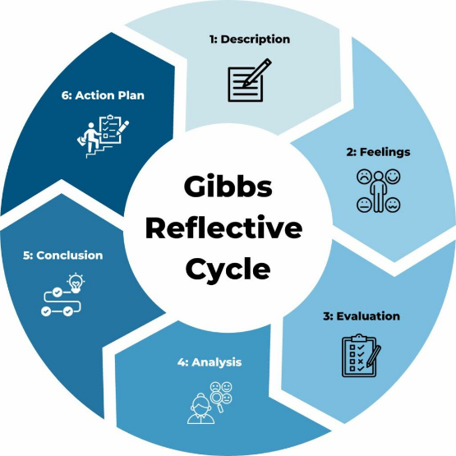
Figure 1: Gibbs’ reflective cycle.
Source: (Channell, 2023).
Description – The learning scope of this component was effective. While preparing the presentation on important employability skills like communication, I learned diverse things effectively. The presentation topic was broken into small topic like the relevance and importance of communication skills in the health and social care sector, implementation of communication skills in this sector (Ener and Yaman, 2024). Therefore, I would like to say that the topic helped me in developing my presentation skills.
Feelings – I felt happy to get an opportunity to complete this presentation. A meeting was held before completing the presentation, where I developed my communication skills properly. However, when I submitted my plan to complete the project, my plan was denied by one of my peers. In this situation, I felt defensive and worried.
Evaluation – I did well to prepare the presentation because it was informative and looked good. In addition, the information I included was authentic. However, I got feedback from my teachers that when I presented, I was reading word for word off the screen. Besides, I felt nervous speaking in front of the audience. Apart from these, I could not connect theories to the real-world examples.
Analysis – Although I made the presentation informative and attractive, I presented it by reading word for word because I am weak in presentations. At the same time, due to my lower level of confidence, I could not speak confidently in front of the audience. I could not connect theories with a real-world example due to my lower reading skills. However, finally, I completed the tasks with the help of my teachers and peers.
Conclusion – The presentation has assessed the important employability skills, such as communication skills. Communication skills are necessary in the health and social care sector to complete daily work (Machost and Stains, 2023). From the presentation, I realised I need to improve my speaking skills in front of audiences, along with my reading skills, to connect theories and concepts with real-world examples.
Action Plan –
I need to improve my reading skills by reading more and more books to include information and connect theories with real-world examples. At the same time, I have to develop my presentation and public speaking skills by participating in seminars, teamwork, group meetings and many more. Besides, I have to learn by doing to develop my presentation skills.

Conclusion
The portfolio has included a CV and a statement for the job of ‘Care Assistant’ at Cader Care Homes. A personal SWOT analysis has been conducted to assess strengths, weaknesses, opportunities and threats regarding the job of Care Assistant. Communication skills, leadership skills, cultural competencies, self-confidence, and enthusiasm are necessary in health and social care systems. A personal development plan has been prepared, mentioning the ways of improving different skills relevant to health and social care. At the end of the portfolio, a reflective statement has been included considering the learning experiences of the importance of communication skills in health and social care.

References
Barr, J. and Dowding, L. (2022). Leadership in Health Care. 5th ed. SAGE.
Channell, M. (2023). Gibbs Reflective Cycle – A Practical Guide. [online] TSW Training. Available at: https://www.tsw.co.uk/insights/gibbs-reflective-cycle/ [Accessed 7 July 2026].
Constantinou, C.S., Andreou, P., Nikitara, M. and Papageorgiou, A. (2022). Cultural Competence in Healthcare and Healthcare Education. Societies, 12(6), p.178.
Ener, D. and Yaman, F. (2024). The Communication Skills of Healthcare Professionals as Opposed to Those Working Outside The Healthcare Sector. Journal of International Health Sciences and Management, 10(20), pp.160–173.
Karadzhov, V. (2025). How to create the best SWOT analysis. International Journal of Research and Review, 12(1), pp.66–75.
Machost, H. and Stains, M. (2023). Reflective Practices in education: A Primer for Practitioners. CBE—Life Sciences Education, 22(2), pp.1–11.
Mukhiddinova, D.M., Sodiqova, S.T. and Jurayeva, Z.S. (2021). Developing Effective Communication Skills. Oriental renaissance: Innovative, educational, natural and social sciences, [online] 1(5), pp.966–972. Available at: https://cyberleninka.ru/article/n/developing-effective-communication-skills [Accessed 7 July 2026].
Puyt, R.W., Lie, F.B. and Wilderom, C.P.M. (2023). The Origins of SWOT Analysis. Long Range Planning, 56(3), p.102304.
uk.linkedin.com (2026). Cedar Care Homes hiring Care Assistant in Bristol, England, United Kingdom | LinkedIn. [online] LinkedIn. Available at: https://uk.linkedin.com/jobs/view/care-assistant-at-cedar-care-homes-4405123080?refid=%2frkzvsxk9nljuxkisip3jq%3d%3d&trackingid=j%2fkwrltymnxnfktq1xe7eg%3d%3d [Accessed 7 July 2026].
Vallín, V.P.-D. (2022). Development of communication skills in the health sector. Seminars in Medical Writing and Education, 1, p.5.

Appendix
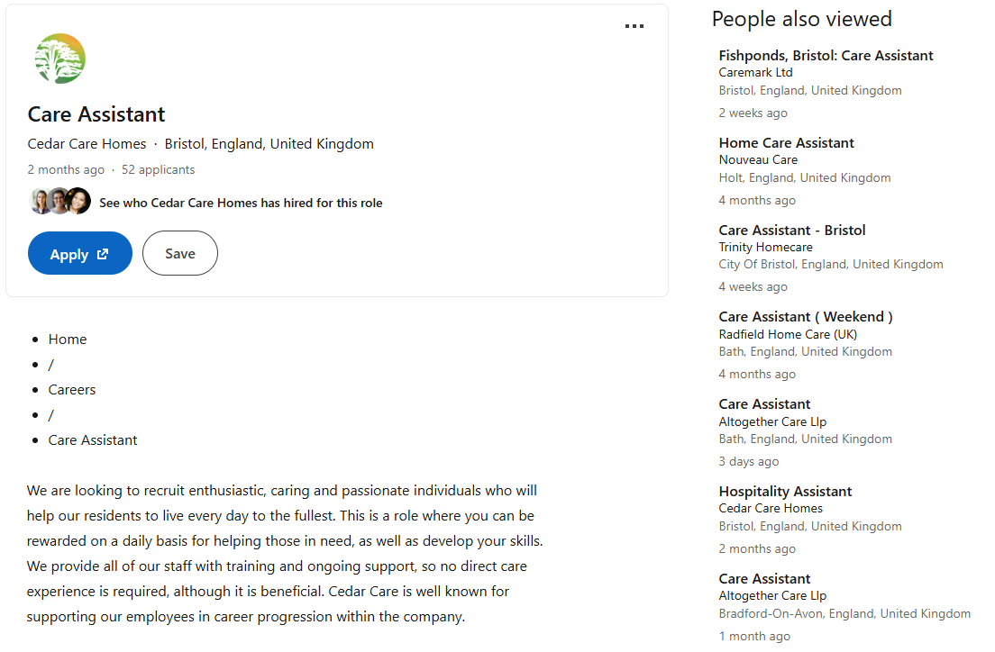
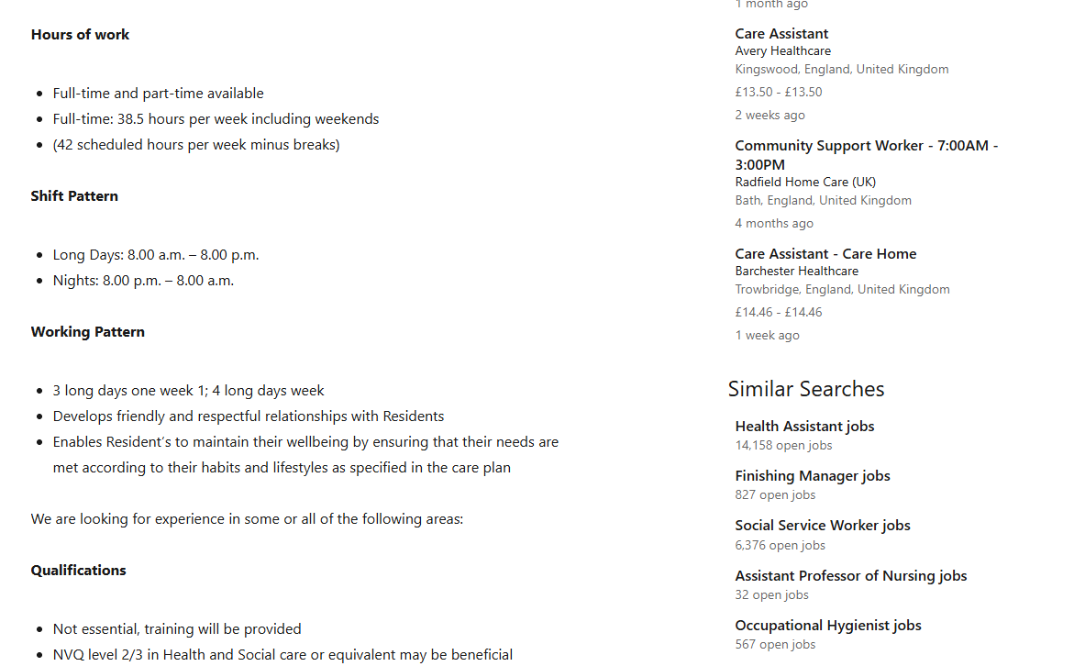
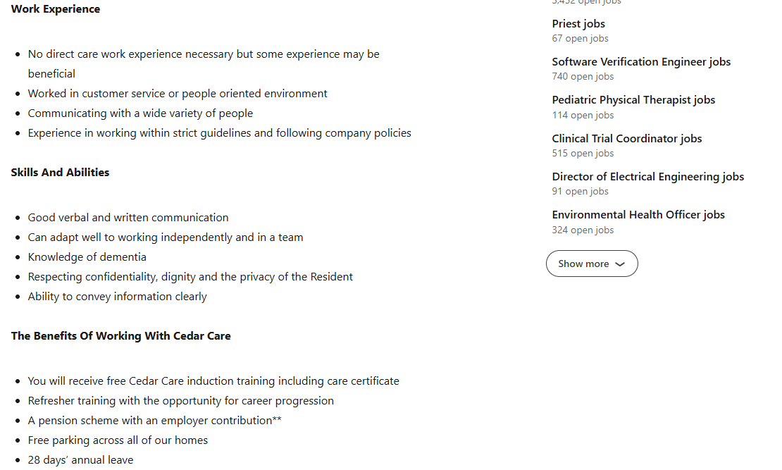
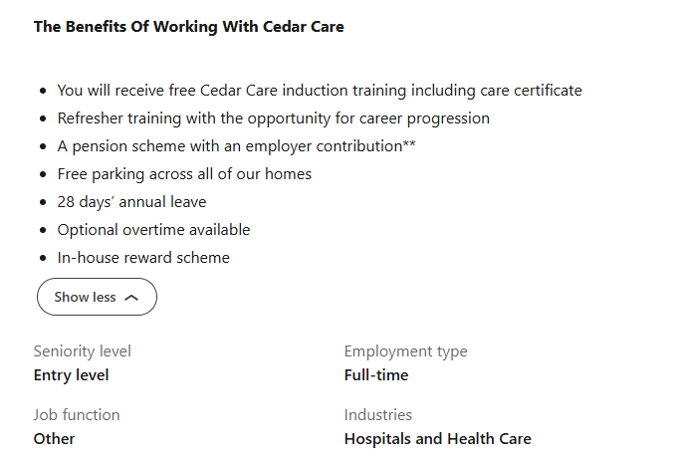
Source: (uk.linkedin.com, 2026).

