University of Wales Trinity Saint David
Wales Institute of Science & Art



Engineering Technical Report
Workshop & Practice – ACHA4011
Muntadher Rahman
2112510
04/12/2022

Contents
1 Introduction 3
2 Engineering team structure 4
3 Product development 5
4 Issues, legislation & standards 6
5 Personal development plan 7
6 Conclusion 8
7 Reference list 9

Introduction

In this technical report, I will be demonstrating the role of a team leader and the head of an engineering project, this report will include the different factors of the engineering process, for example, the product development process, environmental and sustainability aspects of the project and various factors that need to be conducted for the project to be successful. I will also be going through the process my team had to take to develop a foldable table going through the thought process and then the action process. My project is a four-seater foldable table that can be folded to be light and easy for the users, taking into consideration that this is a wide field this project is in and there are various designs and models already out available for the public therefore we aimed to produce something more efficient for all costumers.

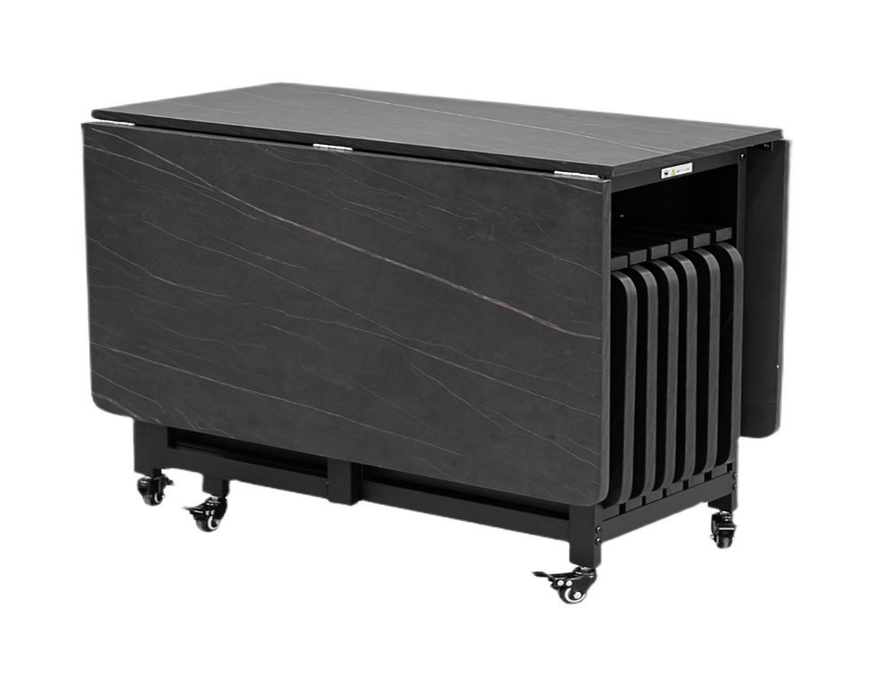 (Figure 1)

Engineering team structure

Behind every successful engineering project, many aspects need to be covered, an important aspect is the initial team structure, for example for the beginning state you will need the product developers to design the product before the start of manufacturing. For my foldable table project, we had a team consisting of initial designers, material researchers, market researchers and final design producers.
Initial designers- this role is for foresight and gathering information that can ensure the project will be carried out professionally and steadily with each sector of the project highlighted to the correct working department. An important part of the start-up stage is truth-telling, this is as any small mistake that may be hidden at the start could lead to the failure of the end product. Once
Market researchers- this team of the project will find the correct target audience along with the research for the advertising price, what the clients need and most importantly what clients we want to reach. This team covers all the technical side of the project, knowing the responsibility this team has to the project and being able to follow the objectivity accurately.
Material designers- material designers have the job to research and picking out the necessary materials that will be applied to the project, they need to consider the type of material that suits the initial design, it is said ‘Material designers are skilled professionals who are responsible for conceiving and executing designs related to colours and materials used to produce the finished products’ [1]. This is considered to pick material that is suitable for the safety of children and the elderly, not flammable and light.
Final design producers- this is the team that takes charge of the finished product and production stage, from testing the safety of the products to the last bit of manufacturing all materials. Making sure all products are ideal, safe and ready to be sold to the public. Once the project reaches this stage the team must all be confident having undergone several tests and prepared for the launch of the project.

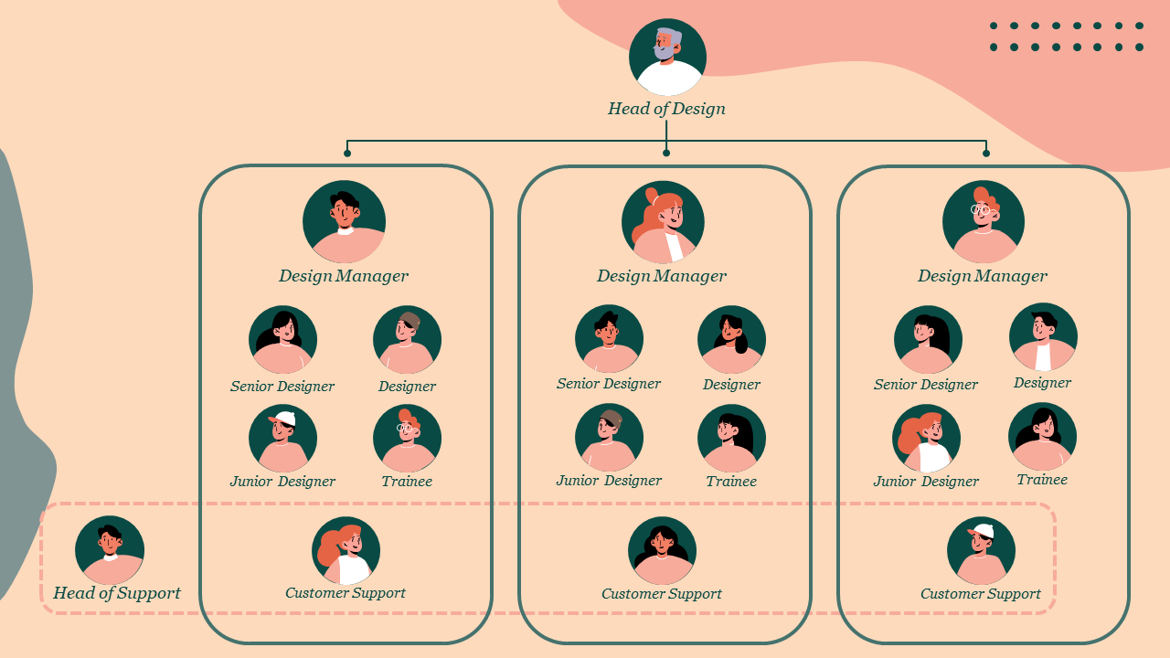
(Figure 2)

Product development

As easy as the idea of the folding table was there were many challenges each team of the project had to face and deal with, minimising all potential risks and meeting customer standards. The most difficult part of the project is the initial design as my team had to spend a lot of time looking into the best builds and how our project could stand out and be more efficient for the users. ‘Design is one of the most important factors when building a brand. If you don't put time, effort and even money into this, it may result in an unsuccessful business. The design is what will set you apart from your competition and help you garner the desired emotion or feeling from costumers.’ [2] this is a very well piece of information showing the importance of the designing stage and how simple designs that have had time spent on them are more touching to the users than quick and meaningless designs.
The market researchers had an issue with picking out the correct target audience as this project has a wide range of customers from low-end to high-end personalised tables, however knowing the purpose of the table to be more efficient, child-friendly and light allowed the team to decide with the pros and cons of the options. 'Good design makes a product understandable. It clarifies the structure of the product. Better still, it can make the product talk. At best, it is self-explanatory' [3], the market researchers also understood the fact that the product we are designing is what will attract customers, therefore just needed a larger platform for more presence in the market.
Materials need to be picked, reviewed, tested, and then chosen, for this project the materials the team had to pick needed to be strong, have long durability and also light enough to be picked up without a struggle. The team also had to decide from a selection of all different materials for what material will be best to use for this specific project, considering the team needed to go for a material which won’t break, chip, scratch or easily crack the material that was chosen was Quartz. This material fits perfectly into the design wanted for the project as not only it gives a luxury feeling but also is completely hygienic, resistant to impact such as scratching and lasts a lifetime.
The final designers play a very important role as they process the tests, consisting of strength and quality of the finished product also testing materials for electrical properties, thermal properties, resistance to corrosion etc. these are important factors that need to be double-checked as any unpredicted outcome can be the cause of costumers suing the company. Final designers must be very wary of every aspect of the design as anything that may have been inaccurate is expected to be flagged up by the team and dealt with. The reason for the two different teams to have to review the same work is as having a different point of view/perspective can allow people to see something they may be missing. ‘Seeing from another person’s perspective helps you understand things in a different light and opens up the path for a whole lot more of understanding’ [4]. An example of this is the team had been struggling to keep the weight of the product as designed, the team were too focused on the materials being used for the face of the table being heavy until another member of the project shifted their thoughts to the bolts holding the components together, the team later came up with the solution of having the materials welded together.

Issues, legislation & standards

Designing and creating the perfect product is what everyone wishes to achieve but without following, legislation and regulations can be the reason why a product massively fails. Most importantly all products must meet the health and safety criteria, my team has covered the most common risks that occur with tables, one of which is the flammability level of the table. Therefore, my team completely wiped the risk by adding quartz which does not burn, also designed for all types of customers my team decided to use quartz as it is eco-friendly and unharmful for the environment. The team understood that the more our project complies with the HSE and other known safety standards used around the world would allow our design to reach the maximum level of safety and customer satisfaction. Not following Health and safety legislations can put your product and company at risk, without following health and safety standards you may be putting customers and users of the product at risk of being injured which may lead to a customer taking the company to court that usually come with outcomes that put the company at financial risk or even bankruptcy.

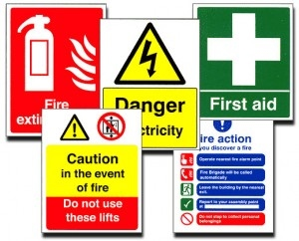 (Figure 3)

Personal development plan

This project and leading a team has enabled me to not only work with other individuals but also it has allowed me to work on myself, improving my communication skills, team skills and also allowing me to work with people who may not work at the same pace as me. I believe this has taught me to be more patient as I don't know the ability of everyone around me therefore, I had to analyse the situation and adapt to everyone's capabilities whilst at the same time trying to get work done as quickly and efficient as possible. In the future I see myself working as a company manager whether it would be my company or not, the reason I believe this job role will be good for me is that I love to stick to a plan and meeting dates that have been set, making sure not to crumple everything closer to its due date. I also see myself in this role as I am the type of person that loves educating people so for me to be in that position I need to have a lot of experience, when an employee requires help he knows coming to me will fulfil his questions. I believe learning from being practical will allow me to reach where I want to be in the future, this encourages self-learning, familiarises me with tools and equipment used in the industry and also the ‘One cannot become an expert overnight; greater the practice, greater the expertise’ [5], employees work better and understand the task when a manager leads by example, this reassures them of doing things correctly and being able to communicate in a time of unsureness or difficulty.

Knowing my self-value is also important, knowing if I am heading the correct way or if I'm leading the group the correct way and if not, what can be done to constantly improve and reach set targets. As a leader having a vision is very important as it allows us to manage time correctly and efficiently as well as achieve goals. I believe I have the strains to become a good leader as throughout this project I have shown an inspiring vision, motivated the team and inspired them to engage with the vision and lastly managed to deliver the vision. To reach my maximum potential I need to have more experience therefore I will need to work and study the industry for 3 years before managing a project, taking notes of all teaching, communication, time management and all factors that my team will need to carry out a successful project.

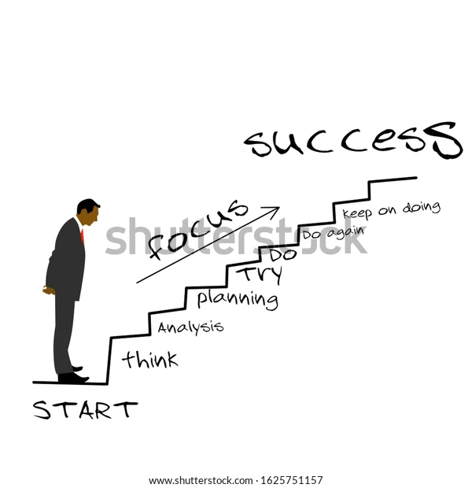 (Figure 4)

Conclusion

In summarisation of my report, I have learnt that being a team leader is more than just having an overview of what is going on but inquires a lot of involvement in every sector of the process and I believe to be a leader you need time, patience, be understanding and most importantly stay professional. This project showed me that as a leader not everything may go as planned but dealing with unplanned situations makes a team stronger. A project leader has to have an understanding and consider that not every person can work the same; one person may be quicker in one section than another, having knowledge of the people in the team and a reasonably timed plan that can be seen by all members can set you to your highest potential as a group. I accept that as a team leader having a good relationship with the team individuals can lead you to a successful development project.



Reference list
Figure 1-
(no date) Modern 1/2/5/7 pieces foldable dinette set black wood dining table set for kitchen - black 47"l x 35"W dining room sets. Available at: https://www.litfad.com/modern-1257-pieces-foldable-dinette-set-black-wood-dining-table-set-for-kitchen-s-2071581.html?language=en¤cy=GBP&gclid=Cj0KCQiA4aacBhCUARIsAI55maHmx-NuGxjDaF7Un-KX3KVakh62gmuthnMLqmiJM7rATHESWK7nB6EaAnFOEALw_wcB (Accessed: November 22, 2022).
Figure 2-
How to structure an in-house design team for Success (no date) 24 Slides. Available at: https://24slides.com/presentbetter/how-to-structure-an-in-house-design-team-for-success (Accessed: November 22, 2022).

Figure 3-
Health and Safety at Work Act - Daniel C Massage (no date) Google Sites: Sign-in. Available at: https://sites.google.com/site/danielcmassage/professional-ethics/health-and-safety-at-work-act (Accessed: November 23, 2022).

Figure 4-
Ladder success Vektor Illustration Focusmanstep Stock Vector (royalty free) 1625751157 (no date) Shutterstock. Available at: https://www.shutterstock.com/image-vector/ladder-success-vektor-illustration-focus-1625751157 (Accessed: November 23, 2022).

- Carla Albinagorta- (albinagorta, 2022)

[1]
What does a color and materials designer do (2020) Zippia. Available at: https://www.zippia.com/color-and-materials-designer-jobs/what-does-a-color-and-materials-designer-do/ (Accessed: November 22, 2022).
[2]
The importance of design (no date) Blackninja The Importance of Design Comments. Available at: https://www.black.ninja/the-importance-of-design/ (Accessed: December 1, 2022).
[3]
Domingo, M.G. (2022) Dieter rams: 10 timeless commandments for good design, The Interaction Design Foundation. Interaction Design Foundation. Available at: https://www.interaction-design.org/literature/article/dieter-rams-10-timeless-commandments-for-good-design#:~:text=Good%20design%20makes%20a%20product%20understandable.,%2C%20it%20is%20self%2Dexplanatory. (Accessed: November 29, 2022).

[4]
Perspective matters (no date) Wittenborg University of Applied Sciences. Available at: https://www.wittenborg.eu/perspective-matters.htm (Accessed: November 29, 2022).

[5]
pune, S.R.C.O.E. (2016) Why practical knowledge is more important than theoretical knowledge?, Medium. Medium. Available at: https://medium.com/@srespune/why-practical-knowledge-is-more-important-than-theoretical-knowledge-f0f94ad6d9c6#:~:text=Practical%20work%20encourages%20self%2Dlearning,the%20practice%2C%20greater%20the%20expertise. (Accessed: November 29, 2022).

