ACADEMIC AND EMPLOYABILITY SKILLS

Student Name: GHIURO ARCADELA LAVINIA
Student Number:1906171
Assignment Title: ACADEMIC AND EMPLOYABILITY SKILLS
Module Lecturer’s Name: SYLVIA HOFFMANN
Table of Contents
Introduction 3
Impact of Academic and employability skill in my career 3
Topics learned 5
Conclusion 9
Reference list 10
Appendix 12

Introduction
Academic skills help an individual to achieve high learning without any remediation while employability skills helps students in the utilisation if their academics within the context of work and development of career. In this report, a reflective report on the impact of the module on my career is assessed with the help of Kolb and Gibb’s model of reflection. The topics that I have learned during this module such as Cover letter writing, time management skill, Curriculum vitae writing (CV writing), public speaking skill and referencing skill are discussed in detail.

Impact of Academic and employability skill in my career
During this module, I have learnt about the skills of time management, communication, and public speaking skills. In this reflection, I have used Kolb's reflection model and Gibbs Reflection model to analyse my learning.
Kolb's Reflection model
Abstract conceptualisation: At first, I had an abstract idea regarding developing a cover letter and curriculum vitae. Therefore, I just generally used to write the cover letter without maintaining any proper guidelines.
Active Experimentation: While studying this module, I have learnt about the structure of cover letter and curriculum vitae that have helped me in conducting my career as a hairstylist. At first, I maintained a targeted subject line and then focused on the opening statement. Besides these features, there lie many features including the bulleted body and so on. This learning has helped me in order to get my job as a hairstylist. Through this module, I have also learnt about the structure of curriculum vitae. I have learnt that I must first include the contact information and the career objective. Along with these features, I have learnt about the other features that have helped me in developing good curriculum vitae. Therefore, through this module, I am able to develop my learning skills that have helped me in getting the job (Chiu and Lee, 2019).
Concrete Experience: After developing these skills, I have been able to brood over the skills. I have implemented these skills in respect of my work. As a result, I have come across such facts and learnt a lot of things from those facts. As a result, these skills have helped me in gaining an experience (Watson et al., 2019).

Reflective observation: At this stage, I have learnt that I have gained a lot of knowledge regarding my career. These skills have helped me in making me more disciplined, focussed and deserved to build my career. I have become more conscious and determined in accomplishing my goals (Chiu and Lee, 2019).
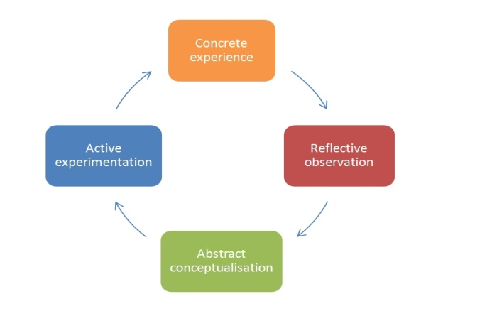
Figure 1: Kolb's Reflection Model
(Source: Watson et al., 2019)
Gibbs' Reflective cycle
Description: While studying this module, I have learnt about the time management skill, important of communication and the significance of public speaking skills. Through these various skills, I have developed good learning skills that have helped me in getting the job as a hairstylist at my workplace. I have learnt about the importance of decision-making and setting a proper goal that can solve the problem and, in this way, I have developed a good learning about the time management skills (Sekarwinahyu et al., 2019).
Feelings: Before studying this module, I was feeling that the communication can be developed by telephonic conversation and I used to do that. But while studying this module, I have learnt that communication is needed to be developed by both formally and informally. For formal communication, I have learnt the benefits of email and for informal communication, I have learnt about the benefits of social media. I thought my poor vocal tone can be developed by a good reading skill. But during studying the module, I have learnt that I have to be confident in delivering the speech publicly. My presentation style has been improved by keeping practices and in this respect, my body language has been enhanced. Therefore, during the module, these learning have helped me in order to become a hairstylist (Sekarwinahyu et al., 2019).
Evaluation: The good thing is that I have developed a good learning and the bad thing is that I had come across with some several problems including my poor vocal tone and poor communication skill.
Action plan: In future, I will develop my communication skill. I will develop my time management skill by setting a goal and make planning on it to be accomplished. I will take some training classes in order to improve my vocal tone and body language (Li et al., 2020).
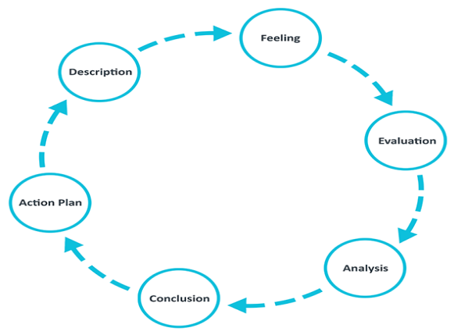
Figure 2: Gibbs Reflective cycle
(Source: Li et al., 2020)

Topics learned
Cover letter writing
To write a proper cover letter, an individual must provide all the necessary information in brief and to the point. A cover letter comprises of the personal introduction of the individual, proper mentioning of the job for which he/she is applying, skills and experience of the individual as matched with the mentioned job (Turner, 2019). Apart from that, there is a mention of appearing for the interview. A cover letter should not be a long one and it must be properly addressed to the concerning individual. During this module, I learned how to write a cover letter.

Time Management Skills
In order to achieve any objectives, management of the time is crucial. The time management skills include various steps such as Organisation, Prioritisation, Goal setting, Communication, Planning, Delegation and Stress Management (VanOrder and Wisniewski, 2018). I learned that an individual needs to develop each of these skills for successful management of time. Staying organised benefits an individual to have a proper vision of what is needed to be done and when. In case of prioritisation, the proper objective is needed to be prioritised. This is advantageous for an individual for the accomplishment of his/her objectives. Proper setting of goals is the primary step of becoming an efficient time manager. This helps in the clear understanding of the goal that is needed to be achieved at the end. Moreover, development of strong communication skills and proper planning keep the individual a step ahead of successful time management (Dehraj and Gopang, 2019). Delegating of tasks is also needed to be done properly. Apart from that, management of stress is a vital aspect of time management skill. Therefore, proper handling of stress enables a person to perform effectively and timely. A successful time management helps an individual to gain better opportunities in professional life along with the enhancement of reputation. Moreover, it also relies on greater efficiencies, good management of workforce and proper maintenance of work-life balance. This model taught me how to manage time in a correct manner.
Curriculum Vitae (CV) writing
A curriculum vitae is a document that contain the educational qualifications and professional qualifications of an individual along with some other details. It helps the person to apply for any job. A curriculum vitae includes the personal details of the person, objectives, his/her academic qualifications, skills and professional experiences (Kalra, 2020). Apart from that, there are any other information such as hobbies and personal interests, which are not mandatory. Often the curriculum vitae of a person attracts the recruiters. A CV should not be a long one and it should not contain any irrelevant information (Ahmar, 2017). During this model, I learned how to write proper curriculum vitae.
In the appendix, I have developed CV for an anonymous person to show my CV development skill.

Public Speaking Skill
Public speaking is a way of communicating with the audiences. It includes a good critical thinking and verbal/non-verbal communication skill. During this module, I learned how to speak fluently in public. This module taught me that a good orator needs to possess a good communication skill and a high level of self-confidence. Self-preparation is the vital aspect of speaking confidently in public (Situmorang, 2016). Practising of speech is necessary to prepare ourselves. Moreover, I also learned that an individual needs to assess his/her strength and weaknesses as a public speaker. A person should focus on the starting of his/her speech as that enables the audiences to show their engagement to listen to the speech. Apart from that, the most significant aspect of public speaking is to get comfortable with the environment. This gives a major boost to the speaker. Apart from that, the appearance of the person is also a crucial aspect as proper attire creates a sense of positivity and self-confidence within him/her (Estrada and Ortega, 2016). Moreover, a person needs to have a pleasant personality and must possess a smile while speaking in public. However, proper scheduling of time is also necessary. The module gave me a clear understanding of the skills of public speaking.
Referencing skill
In order to concede the contribution of other researchers and scholars, referencing is used. It is process of giving credit to the writers whom idea has been borrowed by someone for his/her writing. Although I was familiar with the referencing styles but during this module, my referencing skills has been enhanced. There are five different types of referencing. They are APA, MLA, Oxford, Harvard and Chicago (Rahman, 2016). Each style has its own way of referencing. The individual should note down the references as the research is going on. This also saves effort and time. Apart from that, a person should focus on the manual writing of the references and should avoid referencing generators. The writer should focus on the fact that the citations and the references should be clear, besides maintaining consistency in format. Moreover, one should give importance to the quality of the sources more than the quantity. The writer should mention the reference of all the sources that have been used and not only the journals and the books. Apart from that, proofreading of the reference list and the in-text citations at the end are the most important things (Beauchemin-Roy et al., 2019). This helps the writer to identify any mistakes in the referencing as unnecessary mistakes can result in the deduction of marks.

Conclusion
Academic skills and Employability skills helps to utilise the academics within the context of work and that helps to develop career. In this report, a reflective report on the impact of the module on my career has been assessed with the help of Kolb and Gibb’s model of reflection. Apart from that, the topics that I have learned during this module such as Cover letter writing, time management skill, Curriculum vitae writing (CV writing), public speaking skill and referencing skill have been discussed in details.

Reference list
Ahmar, M., 2017. Curriculum Vitae April2019. Director.
Beauchemin-Roy, S., Cadieux, A. and Peters, M., 2019. Use of referencing software among university students: Experience is key.
Chiu, S.K. and Lee, J., 2019. Innovative experiential learning experience: Pedagogical adopting Kolb’s learning cycle at higher education in Hong Kong. Cogent Education, 6(1), p.1644720.
Dehraj, M.A. and Gopang, Z.H., 2019. Study the Impact of Video Games on Students’ Outcomes and Time Management Skills. Journal of Educational Sciences, 6(2), pp.63-72.
Estrada, L.A.T. and Ortega, D.V., 2016. Teaching speaking skill through language games in a fifth grade of a public school from Pereira (Doctoral dissertation, Universidad Tecnológica de Pereira. Facultad de Bellas Artes y Humanidades. Licenciatura en Enseñanza de la Lengua Inglesa).
Kalra, P., 2020. Unit-7 Writing Your Curriculum Vitae (CV). IGNOU.
Li, Y., Chen, W., Liu, C. and Deng, M., 2020. Nurses’ Psychological Feelings About the Application of Gibbs Reflective Cycle of Adverse Events. American Journal of Nursing, 9(2), pp.74-78.
Rahman, M.R., 2016. Referencing an Academic Obligation. Delta Medical College Journal, 4(2), pp.52-54.
Sekarwinahyu, M., Rustaman, N.Y., Widodo, A. and Riandi, R., 2019, February. Development of problem-based learning for online tutorial program in plant development using Gibbs’ reflective cycle and e-portfolio to enhance reflective thinking skills. In Journal of Physics: Conference Series (Vol. 1157, No. 2, p. 022099). IOP Publishing.
Situmorang, R.N., 2016. The Effect of Public Speaking by Using Manuscript Speech On Students’ Achievement In Speaking Skill Of Twelveth Grade At SMA N 11 Medan.
Turner, K., 2019. ExpLORing Best Practice for Writing Effective Letters of Recommendation.
VanOrder, T. and Wisniewski, S.J., 2018. Chief Resident Skills: A Study on Resident Perceptions of Skill Importance and Confidence. Spartan Medical Research Journal, 3(1), p.6466.
Watson, M.K., Pelkey, J., Noyes, C. and Rodgers, M.O., 2019. Using Kolb’s Learning Cycle to Improve Student Sustainability Knowledge. Sustainability, 11(17), p.4602.

Appendix
Sample CV
Name | Andrew Jones
Personal details | - Date of birth: 14/02/1994  - Father’s Name: Bill Jones  - Mothers’ Name: Kate Jones  - Nationality: British  - Languages known; English, Spanish, Polish
Address | 3 Springfield Road London WC35 0ZS
Contact No. | +44 2300 230091
Email | andrewjones.98@gmail.com
Academic details | - Schooling from ACS Cobham International School from 1997-2012  - Bachelor degree in Business Management from Imperial College of London from 2012-2015
Personal Skills | - Customer service operation  - Communication skills  - Interpersonal skills
Professional details | - Worked as a telesales executive at Warrington from June 2015 to August 2017.  - Worked as a team leader in Amazon from September 2017 to July 2019.  - Working as a business development manager at Man2 from August 2019 to present
Hobbies | - Skiing and snowboarding  - Thrifting  - Reading storybooks  - Photography  - Paintball
Objectives | - To secure a challenging designation in a reputed organisation to enhance my skills and knowledge.  - To make valuable contribution to the success of my organisation.

