Samuel Carpenter 1714425
M7X01268 Food Supply Chains
5859 words

Critical Evaluation of a Food Supply Chain – Madagascan Vanilla

Introduction

Vanilla is a flavouring that comes from the processing of the vined fruit (bean) of the vanilla orchid. (Ackerman, 2003) Originally cultivated by the Totonac Empire in Mexico, once conquered by the Aztec it was used to flavour the chocolate drinks of Aztec noble families. It entry into Europe is accredited to Spanish expedition. In 1519, when it was discovery by Hernan Cortez and returned to Europe through Spain where it was seen as a luxury item due to its scarcity. (Rao & Ravishankar, 2000) It was only when a process of hand-pollination was ascertained that Vanilla cultivation was able to be effectively replicated in different areas to create a scale of production to globalise the product. (Zubinsky, et al., 2008)
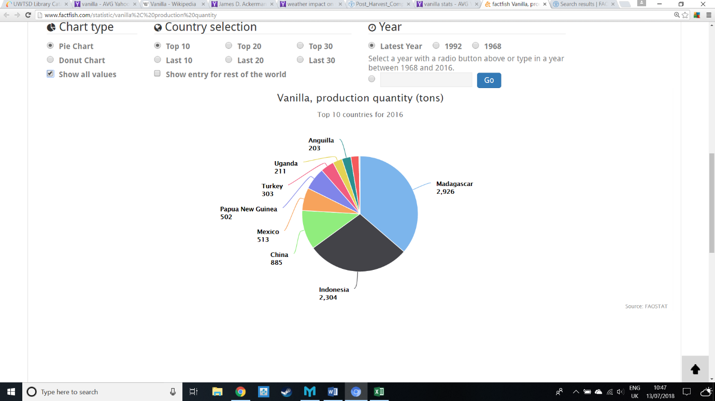
A variety of vanilla plant exist, with differing properties suiting different markets. Vainilla pomponi is cultivated in small quantities in Guadeloupe and Martinique, with its strong flavour making it well suited to pharmaceuticals. Vainilla tahitiensis is also cultivated in small quantities in Taihiti and Moorea with its sweet notes in high demand for Italian gelato. The majority of countries that grow vanilla use the original plant, vainilla planifolia including Madagascar, Indonesia, Mexico and Tonga. It is grown in large quantities with over 8000 tons produced globally per year, with Madagascar as the largest producer, accounting for over a third of the world’s vanilla. (Figure 1) (Food & Agriculture Organisation, 2016)
Figure 1: Vanilla production statistics by country (tons). (Food & Agriculture Organisation, 2016)
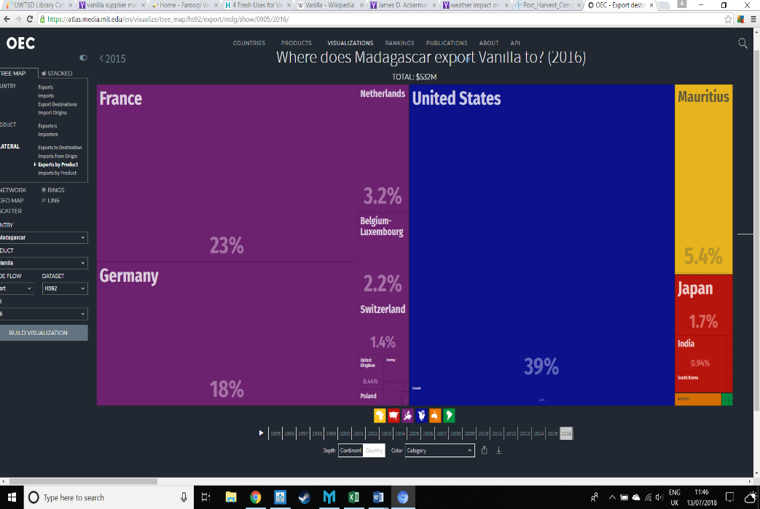
In 2016, Madagascar exported £2.16B of goods with vanilla accounting for £405M of total exports from the country. With much of the exports heading for the food market in Europe and the USA, the Madagascan economy is heavily reliant on the vanilla trade. (Figure 2) (The Observatory of Economic Complexity, 2016)
Figure 2: Madagascan vanilla exports by country (The Observatory of Economic Complexity, 2016)
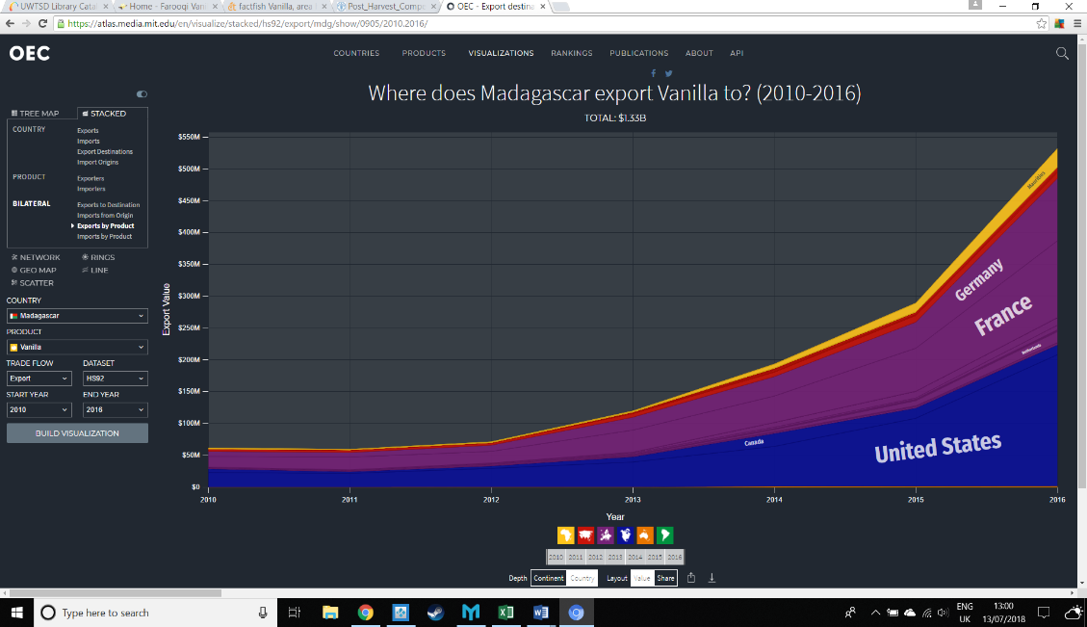
The value of Madagascan Vanilla exports have soared since 2010, with increased demand, inconsistent yield cited as market influences. (Figure 3) (The Observatory of Economic Complexity, 2016) Processed vanilla bean in 2015 was bought by manufacturer at £59 per kilogram, but rose to £144 per kilogram in just 12 months. (The Guardian, 2016)
Figure 3: Export value of Madagascan Vanilla (2010 - 2016) (The Observatory of Economic Complexity, 2016)
The fluctuation is an indication that a number of factors and processes within the supply chain are exposed to risks, which is impacting on the price variance of vanilla. This assignment will analyse those risks, make recommendations to improve resilience and assess how supply chain performance can be measured.

Overview of the Madagascan Vanilla Supply Chain

Schematic
Figure 4: Madagascan Vanilla Supply Chain
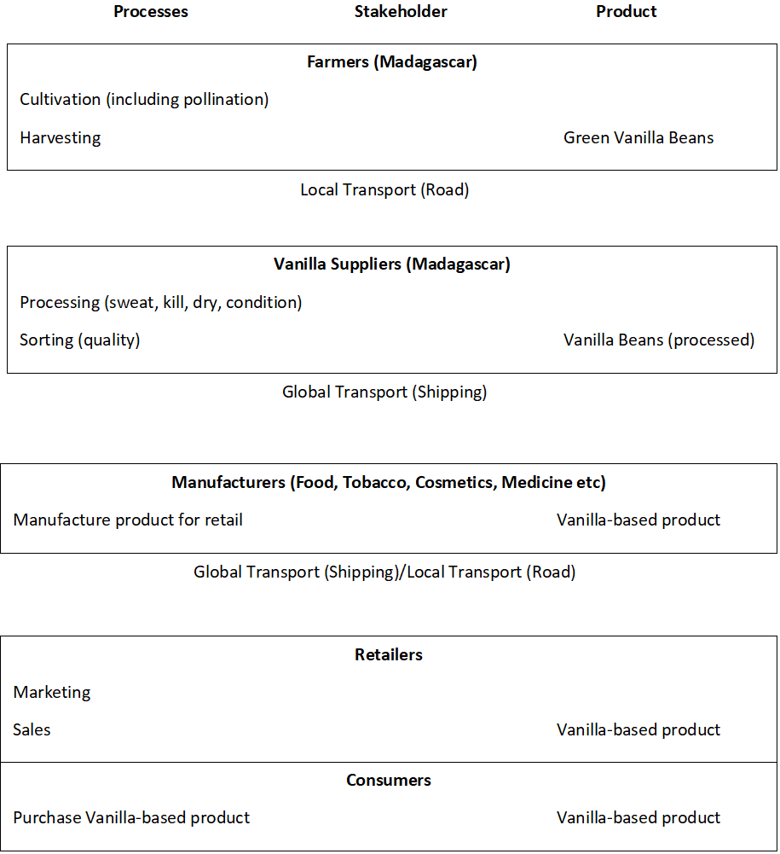

Cultivation
Primarily grown in the fertile Sava region of Madagascar, Vanilla is farmed by family run estates in rural areas of the country due to the environmental conditions including specific weather, soil conditions and the ability to disperse vines. Any changes to these factors will lead to a decreased quality of yield. (Food & Agriculture Organisation, 2009) Hand-pollination of a crop occurs in spring; a labour intensive process that is essential to ensure crops yield beans. (Anilkumar, 2004)

Harvesting
A crop is ready for harvest 6-9 months after pollination, with only a small amount of direct labour costs during that time. When the beans are considered sufficiently mature to harvest, there is a 2 month period in which to harvest all the beans. Harvesting too early will decrease the quality of the bean, with harvesting too late leading to the bean splitting, reducing the grading and therefore the value. Cutting the beans from the vine is also done by hand to ensure that there is no physical damage to them; another labour intensive task. (Food & Agriculture Organisation, 2009)

Packaging & Transport
The beans are then graded and packaged for transport, with care taken not to damage the beans. They must be kept dry to ensure to ensure they do not spoil in transit with the boxes lined with wax paper. They are placed at the side of the roads and collected by the vanilla suppliers in trucks. (Food & Agriculture Organisation, 2009)

Processing & Repackaging
On arrival to a processing plant, the beans are graded based on their quality and size. The beans are then killed, put in boiling water or hot oven to prevent degradation of the bean. This ensures that it is not overly susceptible to fungal infections or spoiling. The lower the quality of bean, the less time immersed in water. The next phase is known as sweating, which involves the transfer of the beans into a sealed box, where they are left for up to 48 hours and being to develop an aroma. After sweating, the beans are dried slowly, in ambient humidity controlled environments or using the sun. In Madagascar particularly, the process of drying happens in large tunnels with hot air blown through. The process of sweating and drying is alternated until the bean has reduced in mass by around half and has a dark brown colour. When repackaged, and again sorted by quality, the container must remain airtight to avoid pest damage and spoilage.

Shipping
The processed vanilla beans are then shipped globally from Toamasina port (Madagascar) to various vanilla-based manufacturers around the globe to make their items. Sometimes the vanilla is bought and exported as extract depending on the requirement downstream. Average shipping times are as follows: 28 days to France, 30 days to Germany, 36 days to USA (East Coast) and 42 days to USA (West Coast). (SeaRates, 2018)

Manufacture, Retail and Consumer
With the exception of the catering industry who may use the beans directly in cooking, the dried vanilla beans are then incorporated into a product. The industries vary from vanilla ice cream, aromatic candles to therapeutic medicinal vanilla to assist with sufferers of sickle cell anaemia in some countries. The product is then undergoes marketing, packaging, local or global distribution, before being sold to the consumer that mirrors traditional retail supply chains.

Risk Analysis

Approach
In order to critically evaluate the risks associated with the vanilla supply chain in Madagascar, it is appropriate to use a supply chain risk model. In this example, a Failure Mode and Effect Analysis (FMEA) model will be applied to the key risks within the supply chain. For each factor, there is a failure mode which in turn will cause an effect on the supply chain. (See Annex A)
Severity is the impact that is likely to have on the supply chain (1 low impact to 10 very high impact). Occurrence is the probability of that failure mode happening, including the frequency of the effect. (1 highly improbably to 10 highly probable). Detection is how easy it is to be aware of it happening, including predictability (1 detectable immediately with warning signs to 10 totally undetectable with no warning). Risk Priority Number is the multiplication of the figures and will determine how important the risk is to the supply chain.

Poor Weather
Vanilla cultivation requires a temperature range of 21 to 32 °C, an evenly distributed annual precipitation of 1500 mm or more, 80% relative humidity and altitudes of 0 to 600 m above sea level. (Food & Agriculture Organisation, 2009) Poor weather in this instance relates to prolonged periods of time in which the weather deviates from the optimal conditions to cultivate vanilla. The impact of this is not only a reduced yield of beans per tree, but also a decrease in the quality of the bean. A reduction in quality will have an increase in the value of natural vanilla extract, as the decreased vanillin means more is required to create the desired product intensity. A reduction in quantity, with the current increased demand will see a deficit in the required supply. (International Fund for Agricultural Development, 2018) This has a large impact on all stakeholders in the supply chain, driving prices up from the supplier and causing added financial pressure to the farmer.
An example of this was a lack of rainfall in 2015, when drought caused a significant decrease in vanilla quality, before storms and excessive rainfall in March 2016 caused significant crop damage in the North of the country. The likelihood of such issues are increasing, with climate change coupled with the effects of El Nino leading to ever more uncertain weather. (The Guardian, 2016)

Extreme Weather
In 2015, Madagascar was named in the top-10 countries for climate risk based on the level of exposure and vulnerability to extreme weather events. (German Watch, 2017) In March 2017, Cyclone Enawo, the worst cyclone in 13 years, damaged over 30% of the entire yearly crop. Due to a shortfall in supply, the price of processed vanilla around the world reached £450 per kilogram, leading to consumer price hikes on vanilla-based products and in some cases shortages. (Reuters, 2017) In some cases farmers are reporting over 95% of crops destroyed, driving them further into poverty. (Reuters, 2017)
The impact across the supply chain is vast due to the markets reliance on Madagascar for Vanilla production. Extreme weather is likely to be country wide, so the effect of a cyclone is likely to be felt across all farms in the region. The infrastructure is also likely to be damaged, with roads and processing factories unable to continue operations even if the crop is unaffected. Prior warning and detection of poor weather and extreme weather is straightforward. Weather prediction is relatively accurate however the upfront costs cost of flood-defences, irrigation and cyclone-proofing of crops ensures that weather remains a critical risk within the supply chain.

Deforestation
In the last 60 years, over 40% of Madagascar’s rainforest has been cut down to make way for resources excavation and agriculture; including vanilla farming. (Harper, et al., 2007) Although vanilla is shade-tolerant, (doesn’t require full deforestation) the impact is still felt as it leads to destroying of habitats for wildlife and removal of unique fauna. 80% of all Madagascan wildlife is unique to the country due to its isolation from mainland Africa and unique climate. (British Broadcasting Company, 2018) This has led to increased pressure from wildlife and environmental conservationists, such as the Wildlife Conservation Society and Conservation International. (Land-cover / Land-use Change Program, 2018)
The increased conservation areas limit the potential of scaling-up farming operations to address the increasing demand. Due to the diversity and unique nature of some of the countries wildlife and vegetation there is potential for this to increase further.

Pests
Pest are a common problem affecting the yield of vanilla farming, particularly with a growing demand for organic vanilla. In some cases, a combination of pests and drought has seen raw vanilla bean yield decrease by a fifth when compared to yield in optimal conditions. (Mexico News Daily, 2015) Vanilla Bug is noted as one of the pests with the most impact, with severe economic damage seen in India. This shows the significant risk, with the probability being high as the similar pests are recorded wherever vanilla is being cultivated. (Prakash, et al., 2002)
Pesticides are common place, although their use may have an impact on the organic status of the vanilla. A pesticide was applied to the crop immediately after Cyclone Enawo due to a mosquito epidemic. The result of which was that the entire crop lost its organic status, which will take time to recover. (Yes - The Organic Intimacy Company, 2018) This will cause a price decrease across the supply chain.

Crop infection and disease
Vanilla cultivation is subjected to fungal and viral infection that can have widespread impact on the supply chain, as it can spoilt crops and limit the supply of vanilla beans. (United States Department of Agriculture, 2008)
Colletotrichum gloeosporioides is the most common of fungal disease in vanilla, with studies suggesting it affects up to 30% of plants, inhibiting bean growth and decreasing yield. Effective sterile pruning can mitigate against these infections, as well as the use of fungicides. Lack of intervention can lead to rapid spreading of the infection to any crop in proximity to the affected plant; severe implications on supply. Physical examination of plants is required to detect this risk, which is man-power intensive and reliant on education of symptoms. (Ashoka & Hegde, 2006)
Cymbidium mosaic virus is the most common viral infection, and similarly to fungal disease can cause a decrease in quantity and quality of vanilla bean. (Khentry, et al., 2006) Detection and effective sterile pruning is also key to combatting the infection in order to limit contamination of other plants. Education and physical checking of plants is the only means to detect the risk; again with a reliance on knowledge of symptoms key to this man-power intensive task.
Although crop infection levels are not significant, as farmers currently conduct visual checks on the plants, if left uninterrupted both viral and fungal infection can spread rapidly. If the entire of a mature plant is affected then it must be replaced, with new plants taking up to 3 years to produce vanilla beans in any significant quantity or quality; compounding the supply issue. (Food & Agriculture Organisation, 2009)

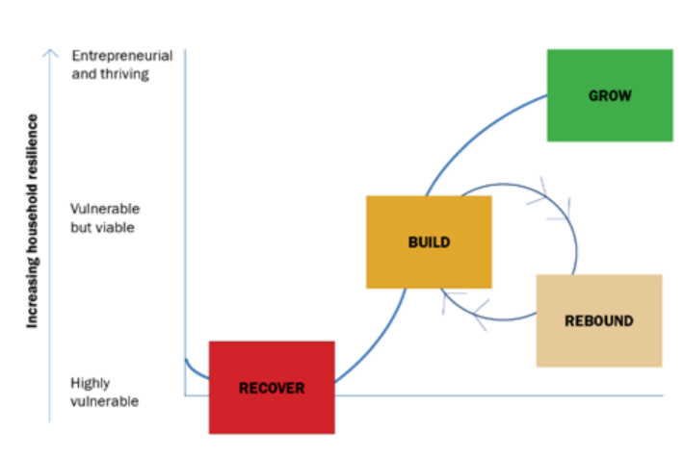
Poverty
Figure 5: Business viability compared to yield vulnerability (Catholic Relief Service, 2013)
Poverty is rife amongst the vanilla farming communities in Madagascar; unusual with a high value product. Much of this is related to the environmental factors leading to inconsistencies in yield, however there are a number of social factors. Issues such as increasing land-prices within Madagascar, reduced expansion opportunities, fluctuating labour demands within the agricultural processes and high start-up costs. In regular supply chains, all stakeholders get a share of value chain; however in vanilla, the farmers are getting less than 10% of the exported price value of cured vanilla, and less than 5% of the total price after shipping and packaging costs. (Catholic Relief Service, 2013) This means they have a huge reliance on the money from each yield in order to feed their families during the ‘hungry season.’ (Al Jazeera, 2017)
A lack of capital also means that they are unable to pay for education for their children, diversify in their crops or expand or improve their farming operation. If a yield is bad, they are highly vulnerable and may struggle to recover, or even survive. If the yield is better they are able to continue their operation, but lack the ability to grow their business due to very small profit margins. (Catholic Relief Service, 2013)(Figure 5) Poverty of farmers underpins much of the unsustainable decision making in the cultivating phase.

Corporate exploitation
In Madagascar, most of the farms are owned and run by local land-owners, with some supply companies implementing vertical integration, often exploiting vulnerable farmers by buying land after a poor yield. As well as this, the early market prices are usually higher. There is speculation that the company-owned farms are harvesting crops early to take advantage of the high prices. This causes all farmers to cut their crop early to compete, but due to not having the scales of economy of the companies, the local farmers struggle to make any profit. (The Guardian, 2016)
The company-owned farms are also curing and packaging their own vanilla, so have a larger cut of the value chain; thus are less affected by decreased costs. They also have access to vacuum packing; which preserved the vanilla at a cost to quality. That means they can save their vanilla pods to sell at when the price rises again. The local farmers are unable to do this, so regularly sell for the lowest prices.
This is having large impacts on local farmers and the quality of raw vanilla bean entering the market. It is happening regularly, and although there is a local ban in place on the trading of raw vanilla before a certain date to stop this, it is poorly enforced.

Labour uncertainty
The processes involved in cultivating, and indeed processing the raw vanilla is seasonal due to the nature of the harvest. This means that the pollenating and harvesting phases are very man-power intensive, requiring a large uplift in labour. (Food & Agriculture Organisation, 2009) As poverty amongst farmers is common, it is not viable to retain the workforce permanently as the cost would be too great and the workload too low.

Child Labour
One way in which farmers are addressing this issue is the use of family members, including children. The legal age of employment in Madagascar to 15 (Bureau of International Labor Affairs, 2016), however there are reports suggesting that in 2016 there were 20,000 children working on vanilla farms and in vanilla suppliers. (The Guardian, 2016) The numbers involved suggest that children are being employed outside of their own families
The impact of this is large financially, as it is culturally and ethically unacceptable for consumers from Europe and USA to use products from a supply chain fuelled by child labour. If an intervention occurs that removes all child workers from farms due to the reliance on children to harvest, the farming operation would be at risk; particularly if it happened during the harvest or pollination. The inability to harvest or pollenate would decrease yields and reduce supply of vanilla in the chain. The probability of this happening is reasonable, as consumers have increased awareness and place demands on suppliers to have child labour free products.
The social impact in taking children out of school in order to assist with farming is also vast. With increased education, children are less likely to live in poverty regardless of their involvement within vanilla farming. If outside of the vanilla industry, education will increase their chances of employment. If they remain within the industry they could learn agricultural practices and business strategies that would allow them to grow their business.

Temporary Labour
Another way in which farmers address the labour fluctuations is by using temporary workers. During the peak times, there is a migratory effect in the vanilla farming regions as people move to the area to reap the benefits of available work. This causes instability as there is not enough accommodation and infrastructure to support the extra workers which lead to poor working conditions. (Food & Agriculture Organisation, 2009)
In order to use temporary workers, there must be money available. A lack of capital often limits small-scale rural farmers in their ability to do this, putting their yield at risk. The uncertainty of temporary work including assurance of pay means that the workforce is not always guaranteed and the price of labour fluctuates. All this puts additional pressure on the farmer and risks the viability of his business.
The risk of there being insufficient workers available is low, however brings the social problems with it. The risk of the price being inflated, or there being interventions due to work conditions is higher, having severe effects on their ability to harvest or pollenate the vanilla. An inability to do either of these key processes will impact negatively on supply.

Forced Labour
As instability and poverty levels have risen, so has criminality. It is reported that many criminal organisations are involved in vanilla farming due to the opportunities to exploit vulnerable people for financial gain coupled with the opportunity to launder money and resources through the supply chain. Where this is prevalent, forced labour is also common. (The Guardian, 2016)
Lending farm-owners money and buying land from struggling farmers has led to an increase in this type of labour. Many are desperate and have no alternative as the fear of retribution from gangs is absolute, with the government doing little to intervene. Deemed to be the ideal workforce for harvesting, due to their smaller sized hands, children are also targeting. Criminal gangs will hold families to ransom in order to secure their workforce during peak-labour times.
The risk of the workforce being liberated is low, as government intervention is scarce. The most likely intervention is a ban on operations enforced by manufacturers who are keen to distant themselves from criminality. Due to how common forced labour is, this would have a similar effect as child labour interventions (as above).

Local Theft
Criminal organisations are stealing crops from local farmers in order to illegally sell them to suppliers. (Al Jazeera, 2017) Traditionally, raw vanilla beans were left in bundles by the side of the road for suppliers to collect, who would then pay them in pre-arranged intervals. The bundles were stamped to indicate which farm produced the raw beans; an arrangement based on trust. Now opportunistic individuals and criminal organisations are targeting the bundles for their own financial gain, stealing them from the side of the road if unsupervised or taking the produce by force. This is largely ignored due to governmental corruption.
The impact is huge on farmers, as they sell less product to the supplier and their operation may become unviable. The increased labour costs for security is also an economic strain. Ultimately the vanilla still enters the supply chain via illegal sale to the supplier however the price is often reduced. The

Governmental Corruption
According to Transparency International, Madagascar is the 155 out of 180 countries in terms of levels of least corruption with a cleanliness rating of 24/100. (Transparency International, 2017) The corruption levels are particularly high in government where executive power and personal relationships give precedent over laws. Most of the governmental corruptions relates to the illegal exportation of rare woods and minerals but also of vanilla. As of 2014, there has been a new government however the corruption ranking and rating have dropped since then, indicating a status-quo in governmental and societal corruption. (Transparency International, 2014)
The impact of this is that the some members of the government are using the vanilla industry to launder money from illegal logging and mining as well as profiteering from illegal vanilla trade. Their links to criminal gangs conducting these activities offer immunity from justice for the perpetrators by the use of their executive powers. Examples of this include ignoring obvious theft of raw vanilla by gangs and the imprisonment of whistle-blowers and protesters.
The impact is large and regularly occurring, with farmers having to provide security to their produce at all times. (Al Jazeera, 2017) The loss of crop will impact on the farmer financially, but will also decrease the cost of vanilla to the suppliers as they buy illegal vanilla from gangs. This contributes to instability and poverty within the region. (The Guardian, 2018)

Transportation spoilage
Raw vanilla beans are transported from farm to supplier by road in rural areas. The local infrastructure in such areas is particularly poor, as is road safety training standards. Many of the vehicles used to transport the beans are old, including vans and motorbikes. The culmination of these factors are physical damage of the bean through rough transportation or road traffic incidents. (Overseas Security Advisory Committee, 2016) If there is physical damage to the bean it splits, rapidly increasing bacterial contamination and spoiling the bean and rendering it useless.
With poor transportation in rural areas, this is highly probable and can be applied across much of the rural country, decreasing levels of raw vanilla bean entering the supply chain. This will fail to meet demand and could cause price fluctuations.

Shipping
Due to Madagascar’s island status, poor interconnected land transport through Africa and location to the east of Tanzania; shipping is main form of transport for the cured vanilla bean exported. Once cured and packaged, especially if vacuum packed, vanilla is unlikely to be contaminated and has a long expiry date which means shipping is an ideal cost-effective solution to global distribution. (Food & Agriculture Organisation, 2009)
Main locations to Europe involve use of the Suez Canal, while export to the east coast of USA involve crossing the southern tip of Africa and crossing the Atlantic. Shipping to the west coast of USA involves using the Strait of Malacca. (SeaRates, 2018) The supply chain is vulnerable to the cost of using such shipping route which are becoming increasingly congested, driving prices up.
This element of the supply chain is also exposed to the fluctuating cost of shipping; directly related to oil prices. Current reductions in oil prices coupled with an oversupply of container ships is causing lower transportation costs, however this is subject to market variance.
Piracy is also prevalent, especially around the Horn of Africa. Although the vanilla is high value and may be targeted, it is unlikely. More likely is that there is disruption in the area causing delay and decreasing assurance within transportation.
The impact of oil will always have a serious risk, especially where sustainability is concerned. Part of the shipping risk is that the price is exploited and absorbed by whoever owns the responsibility for transport.

Resilience
The list of risks is not exhaustive, with many differing risk factors having the same or similar effects. While some risks are more generic to global supply chains, such as shipping it is obvious that most risks are associated with the elements within Madagascar itself. In this section recommendations will be made to mitigate against the risks and increase resilience within the supply chain.

Visibility
It is clear from the FMEA that visibility of vanilla in the supply chain is limited until the product leaves Madagascar. There is very few ways of tracking the source back to the farm, so illicit and exploitative practices are not made aware to the consumer. In France, Germany and USA it is not culturally acceptable to consume products associated with exploitation, corruption and criminality.
In order to decrease poverty and drive these risks out the supply chain is it important for the manufacturers to use initiatives to ensure their supply of vanilla from a reputable supplier that doesn’t use any of these practices. Making agreements like Fairtrade a prerequisite for vanilla supply is the desired end-state, as it gives all farmer a fairer percentage of the value chain. This is difficult to enforce, but must be driver from the consumer to the manufacturer who then uses their larger capital to put pressure on suppliers to prove that their product complies. It would reduce the impact of illegal trade, as the supplier would have to prove which farm it was from and ensure children would also be free to return to education.
The increased profits will allow the farmers to reinvest in their business, apply business strategy without the pressure of poverty or criminals. By having visibility from the farm, interruptions or inefficiencies within the supply chain can be tracked, with appropriate action taken. For example, if there was a high number of thefts during transport at a particular time from a farm to a supplier, additional security could be arranged by the supplier or farmer to mitigate against the risk.
Visibility will also ensure that governmental corruption cannot adversely impact the vanilla production. Ensuring manufacturer audit on visibility will decrease the opportunity for the government to use the vanilla industry to launder money and transport illegal exports.

Vertical Integration
Previously vertical integration has occurred where suppliers take control of farming practices, often exploiting their increased scale of operation to drive down competition of small-scale rural farmers. In order to address this, with the assistance, investment and support of the manufacturers, farmers should be take control of the processing techniques in order to gain a larger percentage of the value chain.
The Livelihoods Fund has already begun this process, with the support of Danone, Firminich, Mars and Prova working with non-governmental organisation Fanamby to provide financial investment and training in sustainable and ethical practices to the farmers. The impact is vast, with 3000 farms currently supported, showing 3 times the profit on average per farm and over 6000 hectares of sustainable vanilla farms. By doing this, it also addresses the issue of labour peaks in the farming procedures, as there is a steady labour force required throughout the year when curing reducing the need for temporary workers. This is a good start, however the concept should be supported further and by more manufacturers to increase stability at the source level.

Introduction of temporary labour support contractors
To mitigate against the cost fluctuations within temporary labour force during pollination and harvesting, a labour-based temporary contractor should be introduced. The International Labour Organisation, an agency of the United Nations has already set up a temporary labour support organisation to improve local infrastructure in the wake of extreme weather with success. (International Labour Organisation, 2012)
By using an agency system, low-skilled work, such as harvesting, clearing roads after extreme weather and other agricultural practices can be managed to ensure fair and consistent prices. For example, a worker could be contracted to pollenate vanilla beans for a month. For the next 3 months he could work to harvest fruit from another farm, followed by 6 months in clear-up operations after extreme weather.
This would provide coherence for low-skilled workers in fluctuating and ad-hoc labour markets while decreasing the fluctuations in price for temporary workers in the production of vanilla and in other industries across the country.

Weather-resistant farming
Much of the supply chain risk comes with uncertain weather and poor mitigation against undesirable and extreme weather. In order to combat this, with investment from manufacturers and NGOs farmers must begin to limit the severity in which cyclones affect their yield.
Implementing changes such as an increase of vines under 1m, robust weather sheets to provide shelter and increasing the health of their plants through pruning will all help to ensure that some of the crop survives in instances of cyclone. (Terrain NRM, 2012)

Integrated Farming
Integrated Farming is simultaneous farming of multiple produce in order to maximise resources. Due to the spacing of plants involved in vanilla farming, this may be possible. Vanilla is a high value product, so it unlikely that integration of other crop will yield direct economic benefits as is traditionally sought, it could however provide other benefits.
Introducing staple crops for personal consumption will mitigate against the risk of starvation and malnutrition in farmer; something widespread in rural Madagascar currently. Growing of rice is useful in such a climate and is less affected by weather conditions. This would give security to the rural community and place less importance on the economic gain from selling vanilla. Poultry is another viable option, with economic benefits possible as well as staple food. (Symrise, 2018)
This can also appease conservationists the integration need not be limited to farming. Vanilla plants are capable of being cultivated without significant impact to the wildlife habitats or causing mass deforestation. By encouraging integration of flora and fauna, at risk of becoming extinct, or allowing animals that are not a detriment to the crop to use it as habitat it will reduce the impact of environmental lobbyist impeding cultivation.

Education
Apply strategies to increase resilience in the supply chain will create more money to implement training for the current generation of farmers and workers. In doing so they will increase their knowledge to improve efficiencies in their practises, such curing the bean, weather-proofing their operation, improving detection of plant infection and maintaining plant health amongst others. That will increase yield quality, but most importantly will ensure the sustainability of their operation. Due to the prevalence of agriculture within the country, it will also allow future generations to study agriculture in depth and bring more advanced knowledge and expertise at the lowest level of the industry.

Improved Rural Infrastructure
If rural roads are improved, the product is less likely to be damaged in transit which will improve supply of vanilla. Ensuring the roads essential to local vanilla transport are cyclone-proof; of good quality material with tree clearance either side will reduce the chance that they vanilla will be unable to be transported to the suppliers.

Measuring Supply Chain Performance
Different supply chain performance models are available depending on the nature and maturity level of your industry. (Estampe, et al., 2013) Based on the analysis on the vanilla supply chain, it is appropriate to measure performance based on the Supply Chain Operational Reference model (SCOR), which analyses the following dimensions: reliability of commercial performance, flexibility, responsiveness, overall cost of the supply chain and the return on invested capital.

Commercial Performance
This related to delivering the correct product to the correct place, at the correct time, in the correct condition, in the correct quantities with the correct documentation to the correct customer. (APICS, 2018) Currently the quality, condition and documentation may be in question due to the risk currently present in the supply chain. As this improves with the measures to improve resilience, these elements should also improve, as the quality is more consistent and visibility provides more information on documentation.

Supply Chain Responsiveness
This is the speed at which the supply chain provide products to the customer. This is a good generic metric, as although the product is cured to increase its shelf-life, many of the vanilla-based products are dairy, and are perishable. This is particularly important when considering transportation from manufacturers to retailer and retailers to consumers.

Supply Chain Flexibility
This is the agility of the supply chain to adapt to change in supply or demand. In the vanilla supply chain this is vital as the majority of risk lie with the initial supply of raw products; the yield of vanilla. The improvements in flexibility of vanilla supply from Madagascar following extreme weather will give an indication if the resilience strategies are working. In this instance, the damage limitation of cyclone-proofing the crop will hopefully allow a better reaction than if the crop wasn’t cyclone-proofed.

Supply Chain Costs
Increased costs across the supply chain limit profit for all stake-holders. Important to sustainability, the costs should be aggregated against the stake-holder to assess the increased portion of the value chain taken by the farmer to assess when they become self-sustainable. This will also monitor transportation costs, in particular shipping and chilled transportation of fresh vanilla-based products

Return on Invested Capital
The recommendations to increase resilience require a large amount of capital investment to be made from the suppliers. In order to assess their, success they should be judged by the amount of investment required to support the enduring sustainable farming operations and the profit it has given by decreasing the inflated market price of vanilla. Once investment draws down, this will indicate self-sustainable farming.

Summary
The vanilla supply chain is high-risk due to the numerous issues associated with the processes within Madagascar. In order to gain market stability, sustainable farming is the essential. Addressing poverty in the region is the cornerstone of this, as it currently forces farmers into unsustainable practices. Corruption blights the country, with both the government and other individuals exploiting poor farmers for their own gain. The only true measure of performance within the supply chain is relative consistency in the price of vanilla, as this will ensure that all stakeholders can continue with viable business plans for the foreseeable future. Manufacturers hold the power in this, as they are the largest value adding stake-holder and can put pressure on other stake-holders are not too distant to have influence like consumers.

Annex A – Vanilla supply chain FMEA
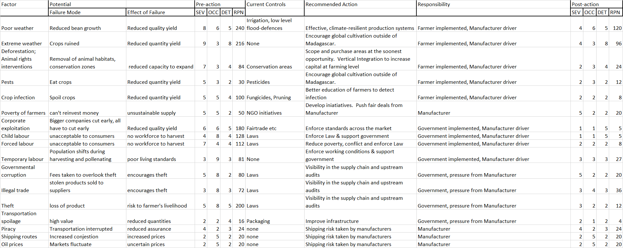

References
Ackerman, J. D., 2003. Vanilla. Flora of South America, 26(4), p. 507.
Al Jazeera, 2017. The bitter taste of magascar vanilla. [Online]
Available at: https://www.aljazeera.com/indepth/features/2017/01/bitter-taste-madagascar-vanilla-170131073036652.html
[Accessed 17 July 2018].
Anilkumar, A. S., 2004. Vanilla cultivation: A profitable agri-base enterprise. Kerala Calling, 26(1), pp. 26-30.
APICS, 2018. Supply Chain Operations Reference (SCOR) model. [Online]
Available at: http://www.apics.org/apics-for-business/frameworks/scor
[Accessed 18 July 2018].
Ashoka, S. & Hegde, Y. R., 2006. Scenario of fungal diseases of Vanilla planifola in Karnataka. Internation Journal of Plant Sciences, 1(2), pp. 269-272.
British Broadcasting Company, 2018. Madagascar. [Online]
Available at: http://www.bbc.co.uk/nature/places/Madagascar
[Accessed 16 July 2018].
Bureau of International Labor Affairs, 2016. Findings on the worst forms of child labor. [Online]
Available at: https://www.dol.gov/agencies/ilab/resources/reports/child-labor/madagascar
[Accessed 18 July 2018].
Catholic Relief Service, 2013. Revitalizing Vanilla in Madagascar. [Online]
Available at: https://www.crs.org/sites/default/files/tools-research/revitalizing-vanilla-in-madagascar.pdf
[Accessed 17 July 2018].
Estampe, D., Lamouri, S., Paris, J.-L. & Brahim-Djelloul, S., 2013. A framework for analysiing supply chain performance evaluation models. International Journal of Production Economics, 142(2), pp. 247-258.
Food & Agriculture Organisation, 2009. Vanilla: Post-Harvesting Operations. [Online]
Available at: http://www.fao.org/fileadmin/user_upload/inpho/docs/Post_Harvest_Compendium_-_Vanilla.pdf
[Accessed 13 July 2018].
Food & Agriculture Organisation, 2016. Vanilla, production quantity (tons) - for all countries. [Online]
Available at: http://www.factfish.com/statistic/vanilla%2C%20production%20quantity
[Accessed 13 July 2018].
German Watch, 2017. Global Climate Risk Index. [Online]
Available at: https://germanwatch.org/en/12978
[Accessed 16 July 2018].
Harper, G. J. et al., 2007. Fifrt years of deforestation and forest fragmentation in Madagascar. Journal of Environmental Conservation, 34(4), pp. 1-9.
International Fund for Agricultural Development, 2018. Madagascar. [Online]
Available at: https://www.ifad.org/web/operations/country/id/madagascar
[Accessed 16 July 2018].
International Labour Organisation, 2012. Madagascar. [Online]
Available at: http://www.ilo.org/emppolicy/countries/madagascar/lang--en/index.htm
[Accessed 18 July 2018].
Khentry, Y. et al., 2006. Incidence of Cymbidium mosaic virus in Thailand Crop Protection. Journal of Crop Protection, 25(9), pp. 926-932.
Land-cover / Land-use Change Program, 2018. Deforestation - Madagascar. [Online]
Available at: http://lcluc.umd.edu/hotspot/deforestation-madagascar
[Accessed 16 July 2018].
Mexico News Daily, 2015. Prices & pests among the challenge for vanilla. [Online]
Available at: https://mexiconewsdaily.com/news/prices-pests-among-challenges-for-vanilla/
[Accessed 16 July 2018].
Overseas Security Advisory Committee, 2016. Madagascar: Crime & Safety Report. [Online]
Available at: https://www.osac.gov/pages/ContentReportDetails.aspx?cid=19735
[Accessed 18 July 2018].
Prakash, K. V., Sudarshan, M. R. & Radhika, N. S., 2002. Study on insect pests of Vanilla in Karnataka. Mysore, India, Central Coffee Research Institute.
Rao, S. R. & Ravishankar, G. A., 2000. Vanilla flavour: production by conventional and biotechnological routes. Journal of the Science of Food and Agriculture, 80(2), pp. 289-304.
Reuters, 2017. Madagascar vanilla producers says cyclone damaged 30% of crops. [Online]
Available at: https://www.reuters.com/article/us-madagascar-cyclone/madagascar-vanilla-producers-say-cyclone-damaged-30-percent-of-crop-idUSKBN16L26X
[Accessed 16 July 2018].
SeaRates, 2018. Rate finder. [Online]
Available at: https://www.searates.com/
[Accessed 13 July 2018].
Symrise, 2018. Sustainable cultivation. Vanilla: a way of life. [Online]
Available at: https://vanilla.symrise.com/sustainable-cultivation
[Accessed 17 July 2018].
Terrain NRM, 2012. Vanilla farming in cyclone country - hosted by YouTube. [Online]
Available at: https://www.youtube.com/watch?reload=9&v=_9TVEilFC5Q
[Accessed 18 July 2018].
The Guardian, 2016. Madagascar climate change plagues the poor. [Online]
Available at: https://www.theguardian.com/global-development/2016/jul/07/madagascar-climate-change-plagues-poor-the-water-rose-so-fast
[Accessed 16 July 2018].
The Guardian, 2016. Madagascar vanilla farmers face volitile times after poor harvest. [Online]
Available at: https://www.theguardian.com/global-development/2016/jun/21/madagascar-vanilla-farmers-face-volatile-times-after-poor-harvest
[Accessed 17 July 2018].
The Guardian, 2016. Madagascar's £152m vanilla industry soured by child labour and poverty. [Online]
Available at: https://www.theguardian.com/global-development/2016/dec/08/madagascar-152m-vanilla-industry-soured-child-labour-poverty
[Accessed 18 July 2018].
The Guardian, 2016. Vanilla shortage could lead to ice-cream price rise, makers warn. [Online]
Available at: https://www.theguardian.com/business/2016/mar/25/vanilla-shortage-ice-cream-price-rise-uk-madagascar
[Accessed 13 July 2018].
The Guardian, 2018. Madagascar's vanilla price war: prized spice drives death and deforestation. [Online]
Available at: https://www.transparency.org/files/content/corruptionqas/Country_profile_Madagascar_2014.pdf
[Accessed 18 July 2018].
The Observatory of Economic Complexity, 2016. Madagascar. [Online]
Available at: https://atlas.media.mit.edu/en/profile/country/mdg/
[Accessed 13 July 2018].
Transparency International, 2014. Overview of corruption and anti-corruption in Madagascar. [Online]
Available at: https://www.transparency.org/files/content/corruptionqas/Country_profile_Madagascar_2014.pdf
[Accessed 18 July 2018].
Transparency International, 2017. Corruption Perceptions Index. [Online]
Available at: https://www.transparency.org/news/feature/corruption_perceptions_index_2017#table
[Accessed 18 July 2018].
United States Department of Agriculture, 2008. Effective strategies for sustainable vanilla in Hawaii. [Online]
Available at: https://portal.nifa.usda.gov/web/crisprojectpages/0214871-effective-strategies-for-sustainable-vanilla-production-in-hawaii.html
[Accessed 16 July 2018].
Yes - The Organic Intimacy Company, 2018. YES OB Vanilla and the Madagascan Vanilla Shortage. [Online]
Available at: https://www.yesyesyes.org/blog/yes-ob-vanilla-and-the-madagascan-vanilla-shortage
[Accessed 16 July 2018].
Zubinsky, P. et al., 2008. Origins and Dispersal of Cultivated Vanilla. Economic Botany, 62(2), pp. 127-138.

